Thermal conductivity of an epoxy resin enhanced with a polythiophene/graphene complex and aluminum nitride
Tatsuo Maruyama,^{a,b,}* Yudai Tominaga,ª Junko Kado,ª Kenta Morita,^{a,b} Tomoko Moriwaki,ª Yoshi Kusamoto,ª Tomohiro Yoshitomi,ª Atsunori Mori,^{a,b} and Takashi Nishinoª
ªDepartment of Chemical Science and Engineering, Graduate School of Engineering, Kobe University, 1-1 Rokkodaicho, Nada-ku, Kobe 657-8501, Japan
^{b}Research Center for Membrane and Film Technology, Kobe University, 1-1 Rokkodaicho, Nada, Kobe 657-8501, Japan

Experimental Section
Materials. Graphite flakes were provided by Sekisui Chemical Co., Ltd. (Tokyo, Japan). Other chemicals were purchased from Wako Pure Chemical Industries, Ltd. (Osaka, Japan). Water used was deionized (Milli-Q, >15 MΩ cm⁻¹) using a Milli-Q Advantage A100 system equipped with an Elix UV 3 system (Millipore, Molsheim, France). The epoxy monomer (JER 828) was obtained from Mitsubishi Chemical Corp. (Tokyo, Japan). Methyl-tetrahydro-phthalic anhydride (HN-2200, a hardener) and 1-cyanoethyl-2-ethyl-4-methylimidazole (2E4MZ-CN, a catalyst) were obtained from Resonac Corp. (Tokyo, Japan). Aluminum nitride (AlN), whose mean particle size was 1.0 µm, was obtained from Tokuyama (Tokyo, Japan).
Preparation of P3HT and the P3HT/graphene complex. P3HT was synthesized using our previously reported procedure.
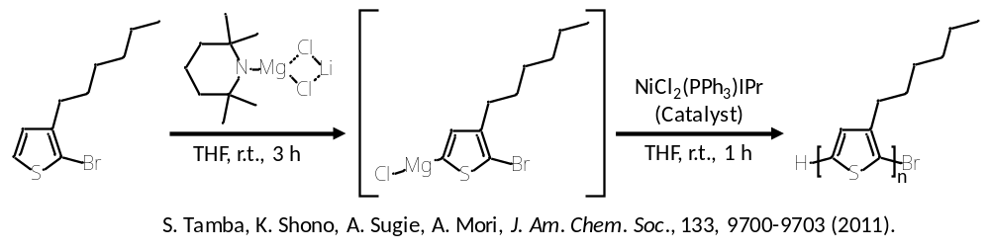
Briefly, 2-bromo-3-hexylthiophene (1.59 mmol) was added at 25 °C to a THF solution (20 ml) containing TMPMgCl·LiCl (1.90 mmol). After stirring at 25 °C for 3 h, THF (20 mL) and NiCl₂(PPh₃)IPr (34.3 mg, 0.044 mmol) were successively added. The resulting mixture was then stirred at 25 °C for 1 h. Hydrochloric acid solution (0.1 M, 10 mL) and methanol (10 mL) were added to form a precipitate. The mixture was filtered and the residue was washed with n-hexane to obtain a dark purple solid. The precipitate was dried under reduced pressure to yield P3HT (yield, 160 mg, 61%). The molecular weight (M_{n}) and the molecular weight distribution (M_{w}/M_{n}) of P3HT were 6000 and 1.10, respectively, which were estimated by the size exclusion chromatography analysis (eluent: CHCl₃) using polystyrene as the molecular weight standard.
Chloroform (10 ml) containing graphite flakes (5 mg) was ultrasonicated using an Ultrasonic Cleaner VS-D100, 31 kHz (AsOne Corp., Osaka, Japan) at 25 °C for 1 h, after which it was mixed with chloroform (3 g) containing P3HT (5 mg). The resulting mixture was ultrasonicated at 25 °C for 1 or 3 h, followed by evaporation of chloroform at 25 °C over 3 days. The resultant P3HT/graphene complex was mixed with the epoxy monomer (JER 828) at a given content.
Preparation of epoxy resin films. The epoxy monomer containing the hardener and the catalyst were mixed at a weight ratio of 50/49.8/0.2 for 0.5 h, followed by mixing under reduced pressure for 1 h at room temperature. A filler was added to the mixture and mixed for 1 h and then mixed under reduced pressure for 1 h for deforming. The mixture was poured into a cell composed of a pair of aluminum plates with a Teflon film (210 µm thick) sandwiched between them as a spacer, followed by curing at 120°C for 2 h.
Characterization of epoxy resin films. TEM images were obtained using a JEOL 2100F transmission electron microscope (JEOL, Akishima, Tokyo, Japan) operated at 200 kV. Thin films (20–30 nm thick) were prepared using an ultra-microtome with a diamond knife. The thin films were placed on a copper grid covered with elastic carbon films (Okenshoji Co., Ltd., Tokyo, Japan).
The AlN powder and the cross-section of the epoxy resin film containing 30 wt% AlN were observed using a field-emission scanning electron microscope (FE-SEM) (JSM-7500F, JEOL, Tokyo, Japan) operating at an accelerating voltage of 7 kV. Each sample was sputter-coated with an ultra-thin osmium layer using an osmium coater (Neoc-STB, Meiwafosis Co., Ltd., Tokyo, Japan) prior to the FE-SEM observation.
Thermal conductivity of the epoxy resin films were measured using Thermowave Analyzer TA3 (Bethel Co., Ltd. Hudson Laboratory, Tsukuba, Ibaraki, Japan). The thermal conductivity κ was calculated by κ = αρCp, where ρ is the bulk density and Cp is the specific heat capacity measured by a differential scanning calorimeter. The bulk density of an epoxy resin film was measured using the sink-float method with a pycnometer at 30°C.
Thermogravimetric analysis was performed in an air atmosphere with a heating rate of 10 °C/min at a Pt crucible, using a thermal analysis apparatus (Rigaku, Thermoplus EVO 2 TG8121, Japan).
X-ray computed tomography (CT) was conducted for the observation of AlN in an epoxy resin film using a high-resolution 3D X-ray microscope (nano3DX, Rigaku Corporation, Tokyo, Japan). Measurements were conducted at 35 kV and 24 mA, with a Cu Kα1 (λ = 1.54 Å, 17.5 keV) radiation source, at 0.54 μm per pixel resolution.
Electrical resistance measurements were performed using a four-point-probe ohmmeter (LorestaAX MCP-T370, Nittoseiko Analytech Co., Ltd., Yamato, Kanagawa, Japan).
Results
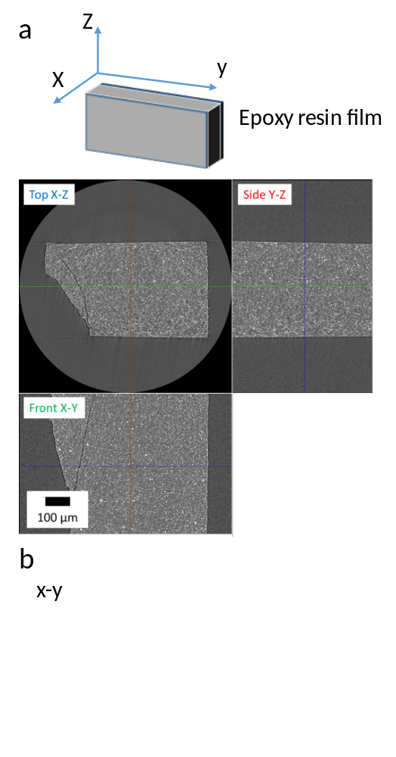
Fig. S1 X-ray CT analysis. a) Coordinate axis and X-ray CT images of the epoxy film containing 30 wt% AlN. b) X-ray CT image of the epoxy film containing 0.9% P3HT/graphene complex.

