Supplementary Information: Smart ellipsometry with physics-informed deep learning
Xiuguo Chen^{1,2}, Shuo Liu¹, Shiyuan Liu^{1,2}
¹State Key Laboratory of Intelligent Manufacturing Equipment and Technology, Huazhong University of Science and Technology, Wuhan 430074, China
²Optics Valley Laboratory, Wuhan 430074, China
Corresponding author: Xiuguo Chen (xiuguochen@hust.edu.cn) or Shiyuan Liu (shyliu@hust.edu.cn)
Equally contributed authors: Xiuguo Chen, Shuo Liu

S1. Uniqueness of ellipsometry data analysis
Ellipsometry determines the unknown parameters of samples by minimizing the error between measured and model-calculated spectra. However, there may exist multiple possible solutions that correspond to almost the same spectra due to the correlations among unknown parameters. Currently, there is no rigorous theory yet that can predict the conditions for the unique solution of the ellipsometric equation. A variety of empirical approaches have been proposed in the literature with the philosophy of trying to improve the diversity of measurement information to reduce the correlation between the thickness and optical constants of a unknown film layer, such as multi-AOI analysis, multi-sample analysis, interference enhancement, and simultaneous analysis of SE data (Ψ, Δ) and transmitted intensity (T). Multi-AOI analysis refers to the simultaneous analysis of SE data for a thin-film sample collected at different AOIs. Multi-sample analysis stands for the simultaneous analysis of SE data for multiple samples having the same film material prepared on different substrates or with different film thicknesses. Interference enhancement requires adding a transparent film between the unknown film layer and substrate to provide interference in the dispersion of the unknown film.
The uniqueness test provides a way to evaluate the effectiveness of the above empirical approaches, which is realized by fixing a test parameter at a series of values while adjusting the remaining fitting parameters to find the best-matching spectra quantified by RMSE. In this section, several thin films with materials covering metals, semiconductors and dielectrics were chosen as the test samples for uniqueness analysis. The film thickness was fixed at different values as the test parameter, while the dielectric functions were parameterized by the KK B-spline model with the spline coefficients being adjusted to find the best RMSE. The placement of knots used for KK B-spline was the same as that used for generating the training dataset.
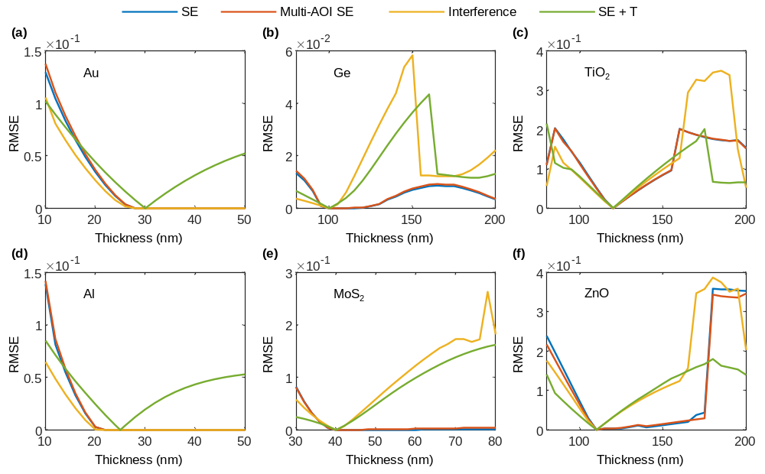
Fig. S1 Uniqueness test results for (a) Au, (b) Ge, (c) TiO₂, (d) Al, (e) MoS₂, and (f) ZnO thin films. The legend “SE” represents the SE analysis at a single AOI of 65°, “Multi-AOI” represents the simultaneous SE analysis at AOIs of 65° and 70°, “SE + T” represents the simultaneous analysis of SE data and transmittance, and “Interference” represents the analysis based on interference enhancement. In the single AOI, multi-AOI, and interference enhancement analyses, all thin films were on silicon substrates. In the SE + T analysis, all thin films were on 0.6 mm fused silica substrates for transmittance simulation. In the inference enhancement analysis, a SiO₂ film layer with a thickness of 200 nm was added between the investigated thin films and silicon substrates.
Figure S1 presents the uniqueness test results for six illustrative thin-film examples. The nominal thicknesses of the Au, Ge, TiO₂, Al, MoS₂ and ZnO thin films were set to be 30, 100, 120, 25, 40 and 110 nm, respectively. A flat region around the nominal value in the RMSE curve indicates that there are multiple possible solutions due to the strong correlations among unknown parameters. In comparison, a bottom valley centered at the nominal value in the RMSE curve is an indicator of the existence of a unique solution in the analysis. As can be observed from Fig. S1, multi-AOI analysis actually has a similar performance to that of the single-AOI analysis. Compared with the multi-AOI analysis, the SE + T and interference enhancement analyses have a better performance, especially for semiconductor and dielectric thin films. However, for metal thin films, the SE + T analysis is recommended to ensure a unique solution. In addition, there are other approaches, such as multi-sample analysis, which we do not introduce here due to the high requirement in sample preparation in practice. In a nutshell, the test results in Fig. S1 show that the SE + T analysis is a more effective and easy-to-implement approach to improve the uniqueness of the ellipsometry data analysis. It is also worth pointing out that limiting the measuring range of thickness is a useful trick in practical analysis to ensure the convergence to a global minimum and enhance the uniqueness of the solution.

S2. Details of the SENet
Architecture of the DNN prediction model. As described in Fig. S2, we construct a one-dimensional convolutional DNN prediction model based on the residual network architecture (ResNet), but note that the architecture is not limited to this. The input of the prediction model is the (N, C, S, T) spectra, and the corresponding output includes the film structural parameters x (thickness, roughness, and inhomogeneity) and the B-spline coefficients b (including the parameters of the pole model). There are two type of residual blocks: blocks 1 is to increase the computing power with the stride of convolutional layer of 1 and blocks 2 is to extract high-level features with stride of 2. Three fully connected layer are added at the end of the prediction model to process the extracted features and output the desired results. And ReLU activation functions are used to increase the nonlinearity of the prediction model.
There are two operating modes in the DNN prediction model, namely the training and working modes. The prediction model in the training mode, without any processing after its output, is employed to initialize the weights of the neural network. While the prediction model in the working mode is composed of the trained prediction model and other two activation functions. The use of the tanh activation functions allows to control the measuring range of film structural parameters. To ensure the KK B-spline model compute the imaginary part ε₂ of the complex dielectric constant without non-physical negative values, we set the softplus activation functions behind the outputs b of the prediction model, while the linear activation functions are still used for parameters of the pole model.
In practical applications, when the transmittance measurement is not applicable, the input channels of the prediction model associated with the transmittance spectrum T can be simply set to null. When roughness or inhomogeneity parameters are not required to describe thin film structures, we can simply ignore the corresponding output of the prediction model, which does not affect the implementation of SENet.
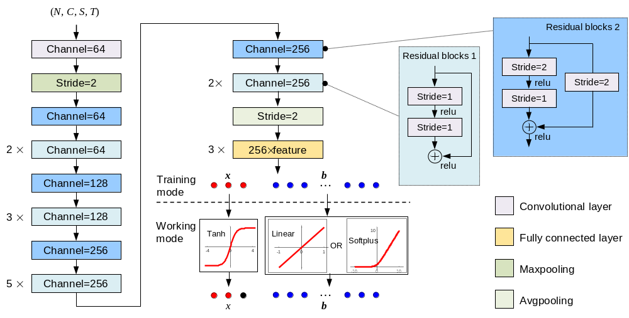
Fig. S2 Architecture of the DNN prediction model, where the "n×" indicates that there are n identical blocks. The kernel size of the first convolutional layer is 5, while the others are 3. The “feature” represents the dimension of the extracted feature before entering the fully connected layer.
Training data generation. To establish an effective mapping from the spectra space to the parameter space, the DNN prediction model was pretrained on a simulated (N, C, S, T) spectra dataset. The simulated dataset was generated using the parallel TMM for thin films with different materials and structural parameters on 0.6 mm fused silica substrates at the AOI of 65° for the (N, C, S) spectra and normal incidence for the T spectra. We collected dielectric functions of 164 different materials in generation of the training dataset. The number of dielectric functions was further expanded to 1640 by data augmentation methods such as translation and scaling. The photon energy range was set to be 1.26–4.13 eV (spectral range of approximately 300–984 nm) with an interval of 0.01 eV (totally 288 spectral points). We placed 42 equidistant knots within the photon energy range for the KK B-spline model. The real part $ε_{1}$ of the dielectric function could be calculated by the imaginary part $ε_{2}$ using the KK relations, which involves integration over a photon energy range from 0 to ∞. Thus, absorptions outside the considered photon energy range will also affect the $ε_{1}$ curve. To ensure a correct curve shape for $ε_{1}$, we added another 7 knots at 0.66 eV, 0.86 eV, 1.06 eV, 4.63 eV, 5.13 eV, 6.13 eV, and 8.13 eV outside the above photon energy range, respectively. The spline coefficients can be obtained via a linear regression analysis. The ranges of the film structural parameters, i.e., thickness, roughness and inhomogeneity, were set to be 15–300 nm, 0–10 nm, and −1–1, respectively. The spectra dataset was generated by combing each dielectric function with 100 sets of randomly selected thin-film structural parameters within their associated ranges.
SENet training. The training of SENet was implemented by using a computer workstation with an Intel Xeon E5-2643v4 @3.4 GHz central processing unit (CPU), three graphics processing units (GPU) board NVDIA GeForce RTX 2080 Ti, and 128 GB access memory. The training iterations and batch size of data were set to be 400 and 2000, respectively. The mean square error between predicted and target parameters was chosen as the loss function. Then, we chose the Adam optimizer to train the SENet with a learning rate of 0.0001.
Data preprocessing in implementation. In practical implementation, the experimental (N, C, S, T) spectra input into the SENet will be preprocessed first. Without loss of generality, we assume that the photon energy range of the (N, C, S, T) spectra is from $E_{min}$ to $E_{max}$ in experiments. To accommodate the number of nodes in the input layer of the SENet, each spectrum was linearly interpolated to 288 evenly sampling points within the range of $\left[E_{min}, E_{max}\right]$. In addition, the number of nodes associated with the KK B-spline model in the output layer of the SENet was kept to be 48 within the range of $\left[E_{min}, E_{max}\right]$. Hence, the knot locations of the KK B-spline model will change when the photon energy range in experiments is different from that in the generation of the training dataset. To ensure a correct curve shape for $ε_{1}$, 7 additional knots, i.e., $E_{min}-0.6 eV$, $E_{min}-0.4 eV$, $E_{min}-0.2 eV$, $E_{max}+0.5 eV$, $E_{max}+1.0 eV$, $E_{max}+2.0 eV$, and $E_{max}+4.0 eV$, were automatically added in the SENet.

S3. More analysis results of thin films on fused silica substrates
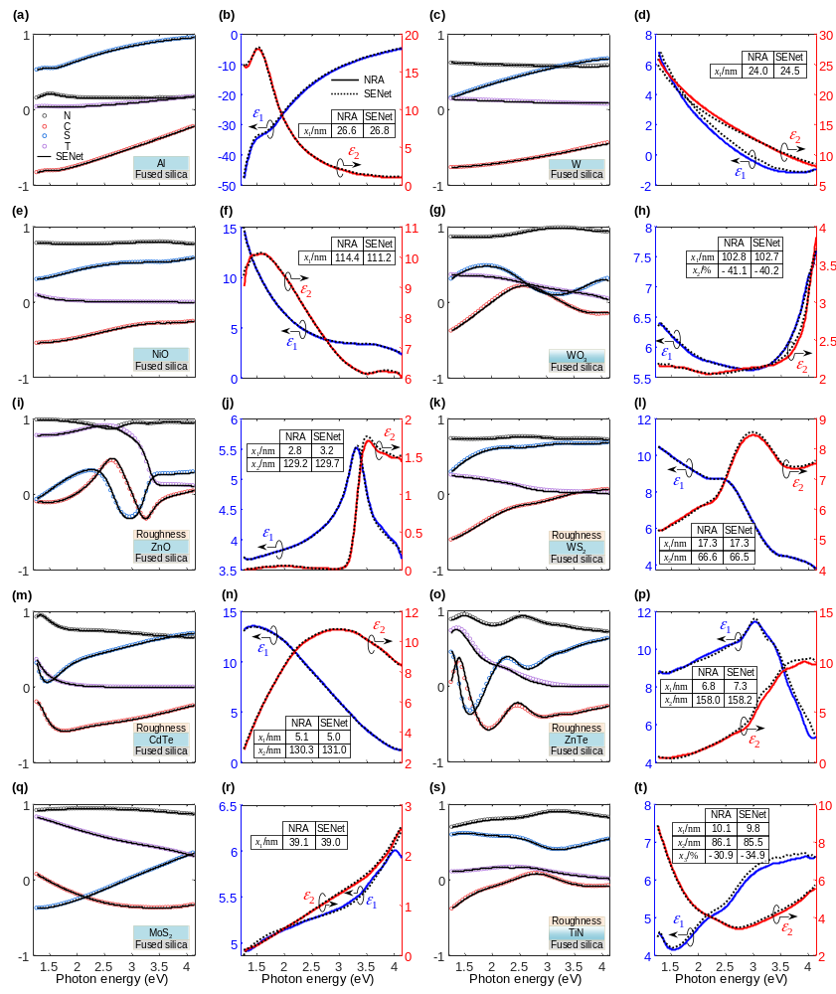
Fig. S3 Analysis results of SENet on various thin films prepared on fused silica substrates. Unclaimed measurement conditions are identical to those in the generation of the training dataset.

S4. More analysis results of thin films on other different substrates
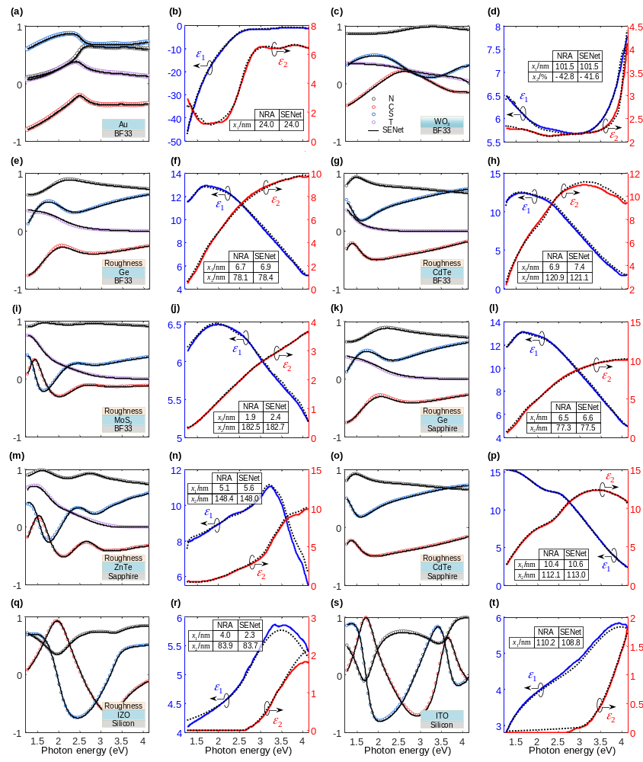
Fig. S4 Analysis results of SENet on various thin films prepared on other different substrates. a–j Thin films on BF33 substrates; k–n Thin films on double-sided polished sapphire substrates; o–p Thin film on a single-sided polished sapphire substrate; q–t Thin films on silicon substrates. Unclaimed measurement conditions are identical to those in the generation of the training dataset.

