Supplementary Material
Mucoadhesive and thermosensitive Bletilla striata polysaccharides/chitosan hydrogel loaded nanoparticles for rectal drug delivery in ulcerative colitis
Shiyi Zhaoa, Junbo Zhanga, Mengyu Qiua, Yusen Houa, Xuebo Lia, Guofeng Zhonga, Kaijun Goub, Jingjing Lic, Chen Zhang*a, Yan Qu*a, Xiao Wang*b
a State Key Laboratory of Southwestern Chinese Medicine Resources，School of Pharmacy, Chengdu University of Traditional Chinese Medicine, Chengdu, 611137, China;
b School of Pharmacy, Southwest Minzu University, Chengdu, 610225, China；
c Department of Rehabilitation Sciences, Faculty of Health and Social Sciences, Hong Kong Polytechnic University, Hong Kong SAR, 100872，China

Figure S1. ζ-potential of Pur@zein NPs, Pur@HA-zein NPs and Pur@HA-SH-zein NPs.

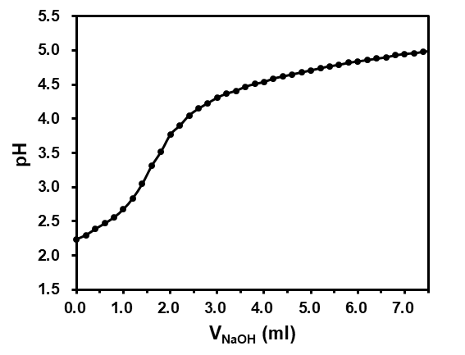
Figure S2. Purification titration curve of OBSP

Figure S3. State of OBSP/CS thermosensitive hydrogels with different concentrations at different temperatures.

Figure S4. The in vivo biodegradation and biocompatibility of Pur@HA-SH-zein NPs in Hydrogel (Scale bar: 500 μm).

Table S1. Disease activity index (DAI) scoring rules.
Score | Weight loss  (%) | Stool consistency | Occult/gross blood
0 | 0 | Normal | Negative
1 | 1-5 |  | Occult blood-positive
2 | 5-10 | Loose | Blood traces in stool visible
3 | 10-20
4 | >20 | Diarrhea | Gross bleeding

