Mutating BnEOD1 via CRISPR-Cas9 increases the seed size and weight in Brassica napus
Jianwei Gu^{1,2}, Jianyin Chen¹, Chenqi Zhao¹, Dengfeng Hong¹
1 National Key Laboratory of Crop Genetic Improvement, Huazhong Agricultural University, Wuhan 430070, China
2 College of Life Science and Technology, Hubei Engineering University, Xiaogan 432000, China

Supplementary Materials

Table S1. The primers used in present report.
Name | Sequences
sgRNA1 | GGTAGGATCAGAAAGCCGA
sgRNA2 | CTTCTCCAGGAAAAGAGCA
XX-DT1-BsF | ATATATGGTCTCGATTGN-19 bp-NGTT
XX-DT1-F0 | TGN-19 bp-NGTTTTAGAGCTAGAAATAGC
XX-DT2-R0 | AACN-19 bp-NCAATCTCTTAGTCGACTCTAC
XX-DT2-BsR | ATTATTGGTCTCGAAACN-19 bp-NCAA
505-F | GAAGTACTCGATCGGCCTCG
505-R | TCAGGAAATGGCCCCTGAAC
U626-IDF | TGTCCCAGGATTAGAATGATTAGGC
U629-IDR | AGCCCTCTTCTTTCGATCCATCAAC
UBP15-A6-F | GGTGTCTTATGTGTGAACTTGAGC
UBP15-A8-F | GGTTTACTTGATCACTTCTGACAGC
UBP15-C5-F | TTGGAACAGGTTCTGGGAAAG
UBP15-C8-F | GTCACTCTTTCTAATAGGTTCTGG
UBP15-A6-R | CCAAGGGCGTAATCAGTAGTGTCA
UBP15-A8-R | GCTTTAACATATCCAGCGCACC
UBP15-C5-R | CGCATAATCAGTCTTGCGTCATC
UBP15-C8-R | CTATTGTGAGAATGTTAGGTGC
UBP15-A6-F(HiTom) | ggagtgagtacggtgtgcTTAGAGCATCTGGAGGTCCC
UBP15-C5/A8/C8-F(HiTom) | ggagtgagtacggtgtgcTTAGAGAATCTGGAGGTCCA
UBP15-A6-R(HiTom) | gagttggatgctggatggCCAACAAAGAAGAACAAGC
UBP15-A8-R(HiTom) | gagttggatgctggatggGAAGAAGCGAATTTGGAGTATGG
UBP15-C5-R(HiTom) | gagttggatgctggatggCGCACCTGCATTTTCAATTACG
UBP15-C8-R(HiTom) | gagttggatgctggatggCCACAGAAGAAGAACAATTTGG
UBP15-Off1-F | ggagtgagtacggtgtgcGTTTGGTTCAACCTTGGATC
UBP15-Off1-R | gagttggatgctggatggGTAAAGCTTTGGGCCTGGAT
UBP15-Off2-F | ggagtgagtacggtgtgcGGGAGTTACATTCTTATT
UBP15-Off2-R | gagttggatgctggatggAGCCAAAGACAATGTGGTT
UBP15-Off3-F | ggagtgagtacggtgtgcGTTGAAATGATGAATCCGATG
UBP15-Off3-R | gagttggatgctggatggAAGCCTTGTTCTCTCACCCTT
UBP15-Off4-F | ggagtgagtacggtgtgcGTTGAGATGATGAATCCAATG
UBP15-Off4-R | gagttggatgctggatggCTATTAGTCTGTCTCTCTCC
F-1 | ACTCTTTCCCTACACGACGCTCTTCCGATCTgcttGCGTtggagtgagtacggtgtgc
F-2 | ACTCTTTCCCTACACGACGCTCTTCCGATCTgcttGTAGtggagtgagtacggtgtgc
F-3 | ACTCTTTCCCTACACGACGCTCTTCCGATCTgcttACGCtggagtgagtacggtgtgc
F-4 | ACTCTTTCCCTACACGACGCTCTTCCGATCTgcttCTCGtggagtgagtacggtgtgc
F-5 | ACTCTTTCCCTACACGACGCTCTTCCGATCTgcttGCTCtggagtgagtacggtgtgc
F-6 | ACTCTTTCCCTACACGACGCTCTTCCGATCTgcttAGTCtggagtgagtacggtgtgc
F-7 | ACTCTTTCCCTACACGACGCTCTTCCGATCTgcttCGACtggagtgagtacggtgtgc
F-8 | ACTCTTTCCCTACACGACGCTCTTCCGATCTgcttGATGtggagtgagtacggtgtgc
F-9 | ACTCTTTCCCTACACGACGCTCTTCCGATCTgcttATACtggagtgagtacggtgtgc
F-10 | ACTCTTTCCCTACACGACGCTCTTCCGATCTgcttCACAtggagtgagtacggtgtgc
F-11 | ACTCTTTCCCTACACGACGCTCTTCCGATCTgcttGTGCtggagtgagtacggtgtgc
F-12 | ACTCTTTCCCTACACGACGCTCTTCCGATCTgcttACTAtggagtgagtacggtgtgc
2P-F | AATGATACGGCGACCACCGAGATCTACACTCTTTCCCTACACGACGCTCTT
R-A | GACTGGAGTTCAGACGTGTGCTCTTCCGATCTctgtGCGTtgagttggatgctggatgg
R-B | GACTGGAGTTCAGACGTGTGCTCTTCCGATCTctgtGTAGtgagttggatgctggatgg
R-C | GACTGGAGTTCAGACGTGTGCTCTTCCGATCTctgtACGCtgagttggatgctggatgg
R-D | GACTGGAGTTCAGACGTGTGCTCTTCCGATCTctgtCTCGtgagttggatgctggatgg
R-E | GACTGGAGTTCAGACGTGTGCTCTTCCGATCTctgtGCTCtgagttggatgctggatgg
R-F | GACTGGAGTTCAGACGTGTGCTCTTCCGATCTctgtAGTCtgagttggatgctggatgg
R-G | GACTGGAGTTCAGACGTGTGCTCTTCCGATCTctgtCGACtgagttggatgctggatgg
R-H | GACTGGAGTTCAGACGTGTGCTCTTCCGATCTctgtGATGtgagttggatgctggatgg
2P-R1 | CAAGCAGAAGACGGCATACGAGATCGCTGATCGTGACTGGAGTTCAGACGTGTGCTCTT
2P-R2 | CAAGCAGAAGACGGCATACGAGATACCGTAGTGTGACTGGAGTICAGACGTGTGCTCTT
2P-R3 | CAAGCAGAAGACGGCATACGAGATGACTAGCTGTGACTGGAGTTCAGACGTGTGCTCTT
2P-R4 | CAAGCAGAAGACGGCATACGAGATTGCATGCAGTGACTGGAGTTCAGACGTGTGCTCTT
The barcode sequences are marked in red; The index sequences are marked in green

Table S2. Analysis for the type of gene editing in T0 generation plants
No. | BnaEOD1.A04 |  | BnaEOD1.C04
No. | sgRNA1 | sgRNA2 | sgRNA1 | sgRNA2
1 | +1bp | -2bp | +1bp | -2bp/-4bp
19 | +1bp | +1bp/-2bp | +1bp | -2bp
27 | +1bp | +1bp | +1bp | +1bp/-5bp
43 | WT | +1bp/-2bp | WT | +1bp/-20bp
44 | WT | +1bp | +1bp | +1bp/-5bp
46 | WT | +1bp | +1bp | +1bp/-5bp
68 | +1bp | +1bp | -6bp | +1bp
110 | WT | WT | WT | +1bp
111 | +1bp | -23bp | +1bp | -2bp/-12bp
141 | WT | -2bp/-4bp/-18bp | WT | +1bp/-2bp
149 | WT | -3bp | -77bp | -77bp
151 | +1bp | -3bp | +1bp | +2bp/-3bp
157 | -9bp | -10bp | +1bp | -2bp/-12bp
160 | WT | -11bp/-10bp | WT | -2bp/-8bp
162 | +1bp | -2bp | +1bp | +1bp
189 | +1bp | +1bp | +1bp | -2bp
216 | +1bp | -2bp | +1bp/WT | WT/-1bp
217 | +1bp | -2bp/-3bp | -3bp | -21bp
220 | WT/-9bp/+1bp | WT/-10bp/+1bp | +1bp | +2bp/-3bp
226 | WT | +1bp/WT/-1bp/ -2bp | WT | -60bp
226 | WT | /-3bp/-4bp/-5bp | WT | -60bp
232 | WT/+1bp | WT/+1bp | +1bp | -38bp
239 | +1bp | +1bp | +1bp | +1bp
246 | +1bp | -8bp | +1bp | -6bp
261 | +1bp | +1bp | +1bp | -2bp/WT
270 | WT | -2bp/-18bp | WT | +1bp
293 | WT/+1bp | -3bp/WT/-9bp | -77bp | -77bp
297 | +1bp | -23bp | +1bp | -7bp
315 | +1bp | +1bp | +1bp | -2bp
340 | +1bp | -3bp/-9bp | +1bp | +1bp
344 | +1bp | +1bp/-2bp | +1bp | +1bp/+2bp
386 | -4bp/+1bp | -21bp/-4bp | +1bp | +1bp/-5bp
387 | +1bp | -2bp | -1bp/WT | -5bp/WT
390 | +1bp | -13bp | +1bp | -2bp/-15bp
393 | +1bp | -13bp | +1bp | +1bp/-15bp
397 | +1bp | -2bp | -1bp | -5bp
399 | -4bp/+1bp | -21bp/-4bp | +1bp | +1bp/-5bp
remaining 23 plants | chimerism | \ | chimerism | \

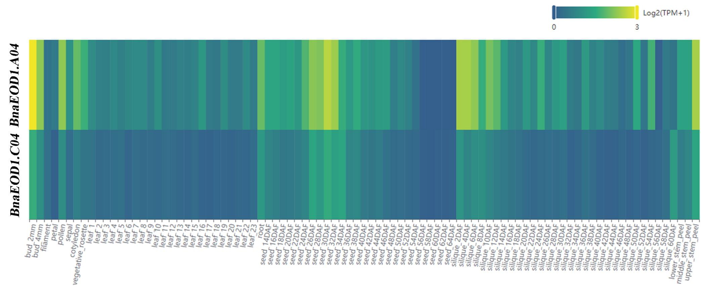
Figure S1. The expression profile of BnaEOD1s.

