SUPLEMENTAL MATERIAL
A piecewise thickness-function to the interferometric measurement of the optically transparent thin films
D. Gasca-Figueroa¹, F. J. García-Rodríguez², R. Castro-Beltrán³, F. J. Perez-Pinal⁴, R. D. Vélez-García⁵ and
G. Gutiérrez-Juárez^{3*}

Relative reflectivity function
The interference phenomenon is described in Fig. 1(c). An electromagnetic field $E_{i_{1}}$, with wavevector $k_{i_{1}}$ aligned perpendicularly to the ORS, is directed to the air-liquid interface. A fraction of this field $\left(E_{r_{1}}\right)$ is reflected at the point $A$ ($k_{r_{1}}$) on the air-liquid interface at an incident angle $θ_{r_{1}}=θ_{i_{1}}$, which is the reflective angle. The rest of the field is refracted at an angle $θ_{t_{1}}$ into the liquid. $θ_{i_{1}}$ and $θ_{t_{1}}$ are related by Snell’s law, $n_{1}\sin{θ_{i_{1}}}=n_{2}\sin{θ_{t_{1}}}$, here $n_{1}$ and $n_{2}$ are the refractive indices of the air and liquid droplet, respectively. The refracted field ($E_{t_{1}}$) travels a path $l_{1}$ from the air-liquid boundary to the liquid-ORS interface, where impinges at an angle $θ_{i_{2}}$ and reflected on the interface liquid-ORS (point $C$) at an angle $θ_{r_{2}}$, the wavenumber of this field $\left(E_{r_{2}}\right)$ is $k_{r_{2}}$. From the Fig. 1(c),
$$θ_{r_{2}}=θ_{i_{1}}-θ_{t_{1}}.$$ | (S1)
$E_{r_{2}}$ travels a distance $l_{2}$ until it reaches the liquid-air boundary. In this boundary, the field is refracted again on the liquid-air interface at the point $B$ and another portion is reflected. This process is repeated, causing multiple reflections inside the liquid. The interference is analyzed on point $B$ and it is referred to Fig. 1(c). The interference pattern is produced between the fraction of the reflected field on ORS with the field that comes from the source. These fields are phase shifted and produce constructive and destructive interferences on the liquid-air interface, which are observed over the droplet profile by interference fringes. The optical path length between points A and B causes the phase lag.
If the initial intensity of the light is $I_{0}$ then, after it travels a distance $d$, where $d=l_{1}+l_{2}$, it is attenuated as
$$I=I_{0}e^{-α^{'}d},$$ | (S2)
Where $α'$ represents the water-optical absorption coefficient. The complete behavior of the intensity $I$ along the droplet is described by the total electric field given by $E=E_{i_{1}}+E_{r_{2}}$, or in terms of intensity [60],
$$I=I_{1}+I_{2}+2\sqrt{I_{1}I_{2}}\cos{φ},$$ | (S3)
where $I=E⋅E$, with $I_{1}≡E_{i_{1}}⋅E_{i_{1}}$ and $I_{2}≡E_{r_{2}}⋅E_{r_{2}}$ and $φ$ is the angle between $E_{r_{2}}$ and$⋅E_{r_{2}}$, which corresponds to the phase shift.
Since $I_{0}$ is the intensity of the incident light at $A$ and $B$ as shown in Fig. 1c, and $I$ is the intensity on each interference point (point B in Fig. 1c.), then the reflectivity [61], [62] is given by
$$R=\frac{I}{I_{0}}={\left|R^{p}\right|}^{2},$$ | (S4)
where $R^{p}$ is the reflectance, which is a function of $φ$, refractive indexes, and assuming that, $l_{1}≈l_{2}$ [62], [63] this can be written as
$$R^{p}=\frac{r_{12}^{p}+r_{23}^{p}e^{-i2φ}}{1+r_{12}^{p}r_{23}^{p}e^{-i2φ}}.$$ | (S5)
In Eq. S5, $r_{ij}^{p}$ are the Fresnel coefficients, with $i=1,2$, and $j=2,3$. Following the notation of Figure 1c, 1, 2 and 3 are for air, liquid, and ORS, respectively. By assuming an electromagnetic wave polarization parallel to the incidence plane, the Fresnel coefficients $r_{12}^{p}$ and $r_{23}^{p}$ are
$$r_{12}^{p}=\frac{n_{2}\cos{θ_{i_{1}}}-n_{1}\cos{θ_{t_{1}}}}{n_{2}\cos{θ_{i_{1}}}+n_{1}\cos{θ_{t_{1}}}},$$ | (S6)
$$r_{23}^{p}=\frac{n_{3}\cos{θ_{t_{1}}}-n_{2}\cos{θ_{r_{2}}}}{n_{3}\cos{θ_{t_{1}}}+n_{2}\cos{θ_{r_{2}}}}.$$ | (S7)
Since $l_{1}≈l_{2}$ and assuming the reflective and refractive angles are less than$10°$, then $\cos{θ_{i_{1}}}≈\cos{θ_{t_{1}}}≈\cos{θ_{r_{2}}}≈1$, thus Eqs. S6 and S7 become $r_{12}^{p}≈\left(n_{2}-n_{1}\right)/\left(n_{2}+n_{1}\right)$ and $r_{23}^{p}≈\left(n_{3}-n_{2}\right)/\left(n_{3}+n_{2}\right).$ By combining Eqs. S4 and S5, the relative reflectivity can be expressed as a function of the refractive indexes and the phase shift as
$$R\left(φ\right)=\frac{α+β\cos{2φ}}{γ+β\cos{2φ}},$$ | (S8)
where $α={\left(r_{12}^{p}\right)}^{2}+{\left(r_{23}^{p}\right)}^{2}$, $β=2\left(r_{12}^{p}\right)\left(r_{23}^{p}\right)$ and $γ=1+{\left(r_{12}^{p}\right)}^{2}{\left(r_{23}^{p}\right)}^{2}$.
It is important to highlight that, although it is true that the interference occurs due to the difference in the optical path, in our approach, at normal incidence, it occurs due to the phase change of the electromagnetic wave when it is reflected on the reflecting surface. This observation is simulated in the next explicative gif file:

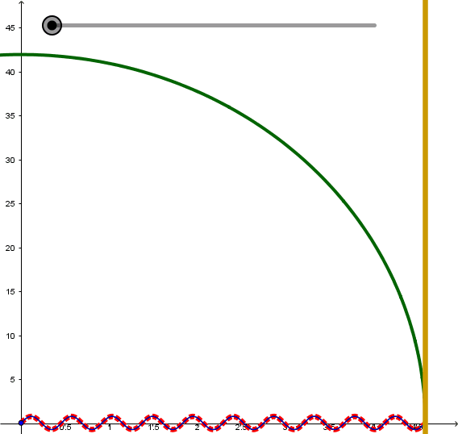
Figure S1. Here the red dotted points are the incident wave; the back continuous line is the transmitted wave and, the blue continuous line is the reflected wave. Moreover, the yellow vertical line is the border of the optical reflection surface (ORS), and the green continuous line is the simulated thickness profile of the meniscus.

