Supplementary Information
Target identification of Dolastatin 16: Network pharmacology, Molecular docking, and Molecular dynamics studies
Dewi Luthfiana¹, Didik Huswo Utomo^{1,2}
¹Bioinformatics Research Center, Indonesian Institute of Bioinformatics (INBIO), Malang, Indonesia
²Department of Biology, Faculty of Mathematics and Natural Sciences, Brawijaya University, Malang, East Java, Indonesia

- Network pharmacology analysis
Table 1 Target prediction of Dolastatin 16 using databases
Super PRED | SWISS Target | SEA Target
CTSD  NFKB1  GPR55  CTSB  TRIM24  LNPEP  NTRK3  CTSL  FKBP1A  MMP2  HDAC10  KEAP1  CDK5  DUT  CNR2  TMPRSS6  PTGS1  BLM  KDM1A  CYP19A1  GLRA1  PTPN2  CACNA1B  HRH3  ACHE  MMP8  GABRA1  KLF5  HDAC4  HIF1A  ABL1  PIK3CD  TLR8  ATG4B  CSNK2B  PKN1  PPIA  TDP1  MMP9  FPR1  CLK4  ITK  PSMB1  LDHA  S1PR5  NR1I2  MAOA  ADAM10  TOP2A  LGALS3  HDAC11  CHUK  STING1  ANPEP  ABCC1  EZH2  DUSP3  PRSS1  SLC9A1  GUSB  GRIN1  CYSLTR2  KLK5  PSMB9  BCHE  LDHB  MMP12  TRPA1  PIN1  SLC6A5  CAPN1  FPR2  FKBP5  SLC2A1  SLC40A1  CTSG  ADORA2B  GSTP1  HTR7  GHSR  PHF8  NT5E  MME  ITGB1  NR3C2  PSMB2  TYRO3  SPHK1  SERPINE1  WDR5  C5AR1  DCUN1D1  FCGRT  GPBAR1  FFAR2  NTSR2  AVPR1B  KLK7  ACE  ZAP70  TLR4  TOP1  AXL  SCD  ADORA1  CCR1  TACR2  PRCP  HSD17B10  SCN2A  PRKCB  HSD11B2  PDPK1  MMP14 | DGAT1  REN  MMP3  MMP9  MMP8  MMP1  CAPN2  ACE  MMP2  GHSR  F2  CASP3  P2RY12  ZAP70  CASP8  PSMB8  PSMB5  JAK3  JAK1  JAK2  OPRM1  FKBP1A  TSPO  CTSK  CASP2  HLA-DRB1  PDE10A  PPIA  CTSB  BACE1  PDE5A  SOAT1  PAM  CASP1  MMEL1  ABCB1  CASP7  XIAP  CDK5R1  MGAT2  BTK  DGAT2  MAPK14  PDE4B  PDE7A  CXCR3  HLA-A  CTSL  CTSD  AURKB  PRKCD  PRKCQ  AURKA  CALCRL  SYK  CETP  ANPEP  NMBR  CASP6  BCL2  PLA2G7  TYRO3  CTSS  LAP3  ELANE  PIK3CA  OXTR  GNRHR  OPRD1  F3  BDKRB2  CHRM3  MTOR  PSMB2  PSMB1  KNG1  PTK2B  MAPK10  XPNPEP1  XPNPEP2  IGF1R  CFD  ITK  CTSG  CTRB1  HCRTR2  HCRTR1  PTGS2  RORC  PFKFB3  HCK  MET  LYN  MAP4K2  ITGAV  EZH2  KDR  PTGER1  BRD9  BAD  CDK5  F7  RAMP1 | GHRL  VEGFA  HDAC4  GHSR  PPIA  ACKR3  BIRC3

Table 2 Degree value of core targets resulted from the topological analysis
Gene name | Degree
PIK3CA | 26
VEGFA | 22
CASP3 | 22
NFKB1 | 20
MMP9 | 20
LYN | 19
PRKCD | 18
ITGB1 | 17
KDR | 16
JAK2 | 16

Table 3 Target prediction accuracy based on 3 databases
Core targets | Accuracy
Core targets | Super PRED | SWISS Target | SEA Target
PIK3CA | - | √ | -
VEGFA | - | - | √
CASP3 | - | √ | -
NFKB1 | √ | - | -
MMP9 | √ (92.12%) | √ (6.4%) | -
LYN | - | √ | -
PRKCD | - | √ | -
ITGB1 | √ | - | -
KDR | - | √ | -
JAK2 | - | √ | -

- Molecular docking study
a)  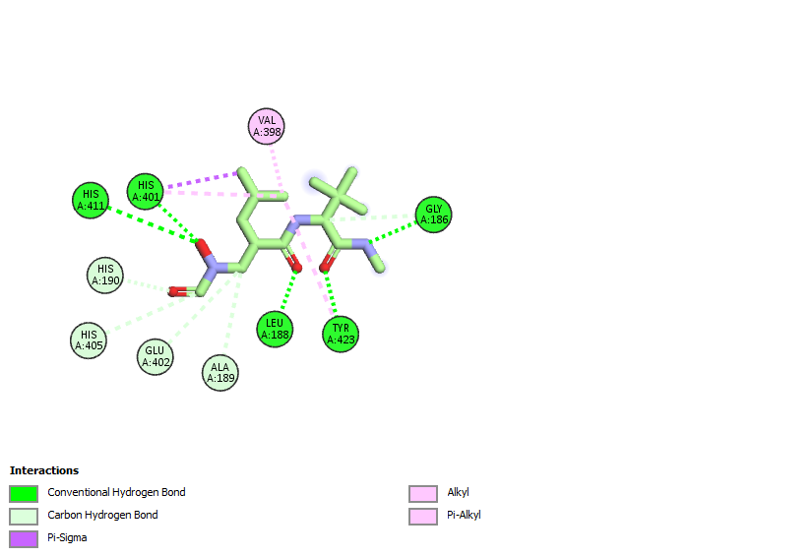 | 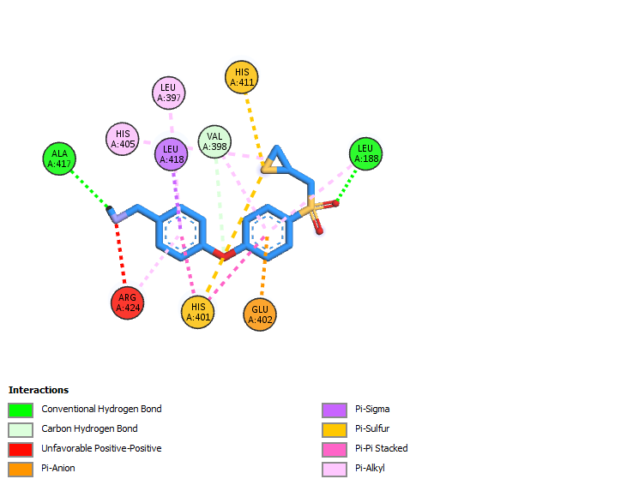  b)
Fig. 1 2D molecular interaction resulted from molecular docking simulation. a) Hydroxamate-MMP9 and b) (R)-ND-336-MMP9 complexes
Table 4 The grid box setting in the docking simulation
Targets | PDB ID | Dimensions |  |  | Center
Targets | PDB ID | X | Y | Z | X | Y | Z
PIK3CA | 4JPS | 25.775 | 27.964 | 33.663 | -0.744 | -11.399 | 16.927
CASP3 | 1RE1 | 35.667 | 35.153 | 30.183 | 42.000 | 99.648 | 21.370
NFKB1 | 4KIK | 23.058 | 21.845 | 26.038 | 48.173 | 30.523 | -57.606
MMP9 | 1GKC | 28.286 | 23.360 | 29.100 | 65.725 | 31.073 | 118.140
MMP9 | 1ITV | 25.802 | 17.766 | 18.144 | -49.037 | -43.047 | -13.593
LYN | 2ZVA | 23.046 | 26.325 | 28.076 | 18.202 | -10.068 | 24.129
KDR | 3WZD | 22.948 | 22.508 | 28.958 | 0.641 | -7.341 | 16.641
JAK2 | 6VGL | 22.367 | 22.011 | 17.329 | 57.097 | -7.283 | 23.978

Table 5 Binding affinity of Dolastatin 16 against the targets along with the interacting residue and the type of interaction
Targets | PDB ID | Binding affinity (kcal/mol) | Interacting residues similar to binding pocket | Type of interaction | Distances (Å)
PIK3CA | 4JPS | -9.0 | Lys802  Gln859  Asp933 | conventional HB  conventional HB  𝜋− anion | 2.65  3.10  4.70
CASP3 | 1RE1 | -8.1 | Trp340  Phe380  Glu381  Phe381B | 𝜋− alkyl  𝜋− π stacked  carbon HB, carbon HB  conventional HB | 5.21  4.34  3.69, 3.72  2.56
NFKB1 | 4KIK | -9.2 | Gly22  Val29  Lys44  Tyr98  Cys99  Glu149  Val152 | carbon HB  𝜋 − 𝜎  𝜋 − alkyl  𝜋 − alkyl  alkyl  carbon HB  alkyl | 2.81  3.98  5.48  5.04  5.33  2.56  4.54
MMP9 | 1ITV (hemopexin site) | -5.6 | Asn7  Ile8  Lys26 | carbon HB  alkyl  𝜋 − alkyl | 3.76  5.10  5.18
LYN | 2ZVA | -9.8 | Leu253  Ala273  Met294  Val303  Ala384 | alkyl  alkyl  𝜋 − sulfur  𝜋 − alkyl  𝜋 − alkyl | 4.63  4.36  4.98  4.91  4.09
KDR | 3WZD | -9.9 | Leu840  Gly841  Ala866  Val899  Val916  Phe918  Cys1045 | alkyl  conventional HB  alkyl  𝜋 − alkyl  𝜋 − alkyl  𝜋 − alkyl  𝜋 − alkyl | 3.76  2.89  4.61  5.21  4.49  5.17  5.35
JAK2 | 6VGL | -7.8 | Gly856  Val863  Ala880  Met929  Asn981  Leu983 | carbon HB  𝜋 − 𝜎, 𝜋 − 𝜎  𝜋 − alkyl  𝜋 − sulfur  carbon HB  𝜋 − 𝜎 | 3.09  3.83, 3.94  5.34  5.44  2.77  3.84

- Molecular dynamics simulation
a) | b)
Fig.2 a) RMSF plot of each residue of MMP9 protein and b) Radius of gyration plot for three systems during MD simulations
Table 6 RMSD-Cα values of the complexes during the whole MD simulations
Complex | Minimum and Maximum (Å) | Average (Å) ± Std
MMP9 | 0.36-3.34 | 2.58 ± 0.40
MMP9-RND336 | 0.55-3.58 | 2.49 ± 0.49
MMP9-Dolastatin 16 | 0.41-3.45 | 2.17 ± 0.56

Table 7 RMSD-Ligand Movement values of the complexes during the whole MD simulations
Complex | Minimum and Maximum (Å) | Average (Å) ± Std
MMP9-RND336 | 1.17-6.15 | 3.77 ± 1.02
MMP9-Dolastatin 16 | 0.84-8.09 | 4.67 ± 1.11

Table 8 The RMSF value for three systems during MD simulations
Complex | Minimum and Maximum (Å) | Average (Å) ± Std
MMP9 | 0.36-3.34 | 2.58 ± 0.40
MMP9-RND336 | 0.55-3.58 | 2.49 ± 0.49
MMP9-Dolastatin 16 | 0.41-3.45 | 2.17 ± 0.56

Table 9 The Rg value for three systems during MD simulations
Complex | Minimum and Maximum (Å) | Average (Å) ± Std
MMP9 | 14.738-15.314 | 15.101 ± 0.084
MMP9-RND336 | 14.679-15.573 | 15.233 ± 0.144
MMP9-Dolastatin 16 | 14.786-15.664 | 15.232 ± 0.162

Table 10 The Average binding energy value for the complexes during MD simulations
Complex | Minimum and Maximum (Å) | Average (Å) ± Std
MMP9-RND336 | (-285.334)-380.506 | 74.467 ± 79.473
MMP9-Dolastatin 16 | (-123.856)-302.604 | 154.908 ± 86.749

