Supplementary Information

Assessment of the Optimal Generation Period and Size of Human iPSC-Derived Cardiac Organoids for Cardiotoxicity Drug Testing
Sang Woo Lee^{1, 2}, MyeongJin Song³, Dong-Hun Woo³ and Gi Seok Jeong^{1, 2, *}

¹ Biomedical Engineering Research Center, Asan Medical Center, Seoul, 05505, Republic of Korea
² Asan Institute for Life Sciences, Asan Medical Center, Seoul, 05505, Republic of Korea
³ Department of Commercializing iPSC Technology, NEXEL Co., Ltd., Seoul, 07802, Republic of Korea

*Corresponding authors:
Gi Seok Jeong, Ph.D.
E-mail: gsjeong@amc.seoul.kr
Tel.: +82-2-3010-8665, +82-2- 3010-8595
Supplementary Figure 1. Fabrication procedure for the PDMS-microwell array and surface immobilization on this array for long-term suspension culture. The fabrication process of the PDMS-microwell array for generating 3D hiPSC-COs involves a total of nine steps. First, a master mold is used to fabricate the PDMS-microwell array and side-wall (i-iv). Next, the microwell array is modified through Oxygen-Plasma etching to enable sufficient supply of culture medium (v-vi). To ensure stable suspension culture conditions for long-term cultivation of 3D cellular products, the surface of the microwell array is immobilized and subsequently removed just before the experiment (vii-ix). Following this, the hiPSCs are seeded onto the surface-immobilized microwell array and incubated at 37°C, 5% CO2 for 24 hours (x), leading to the formation of 3D initial cellular aggregates within the microwells (xi).

Supplementary Figure 2. Schematic diagram of the step-by-step cardiac differentiation process in the generation of hiPSC-COs. 3D hiPSC-initial aggregates formed in microwells were differentiated into functional cardiac organoids for 49 days through a maturation process (Step 6) after four steps of differentiation (Steps 2-5).

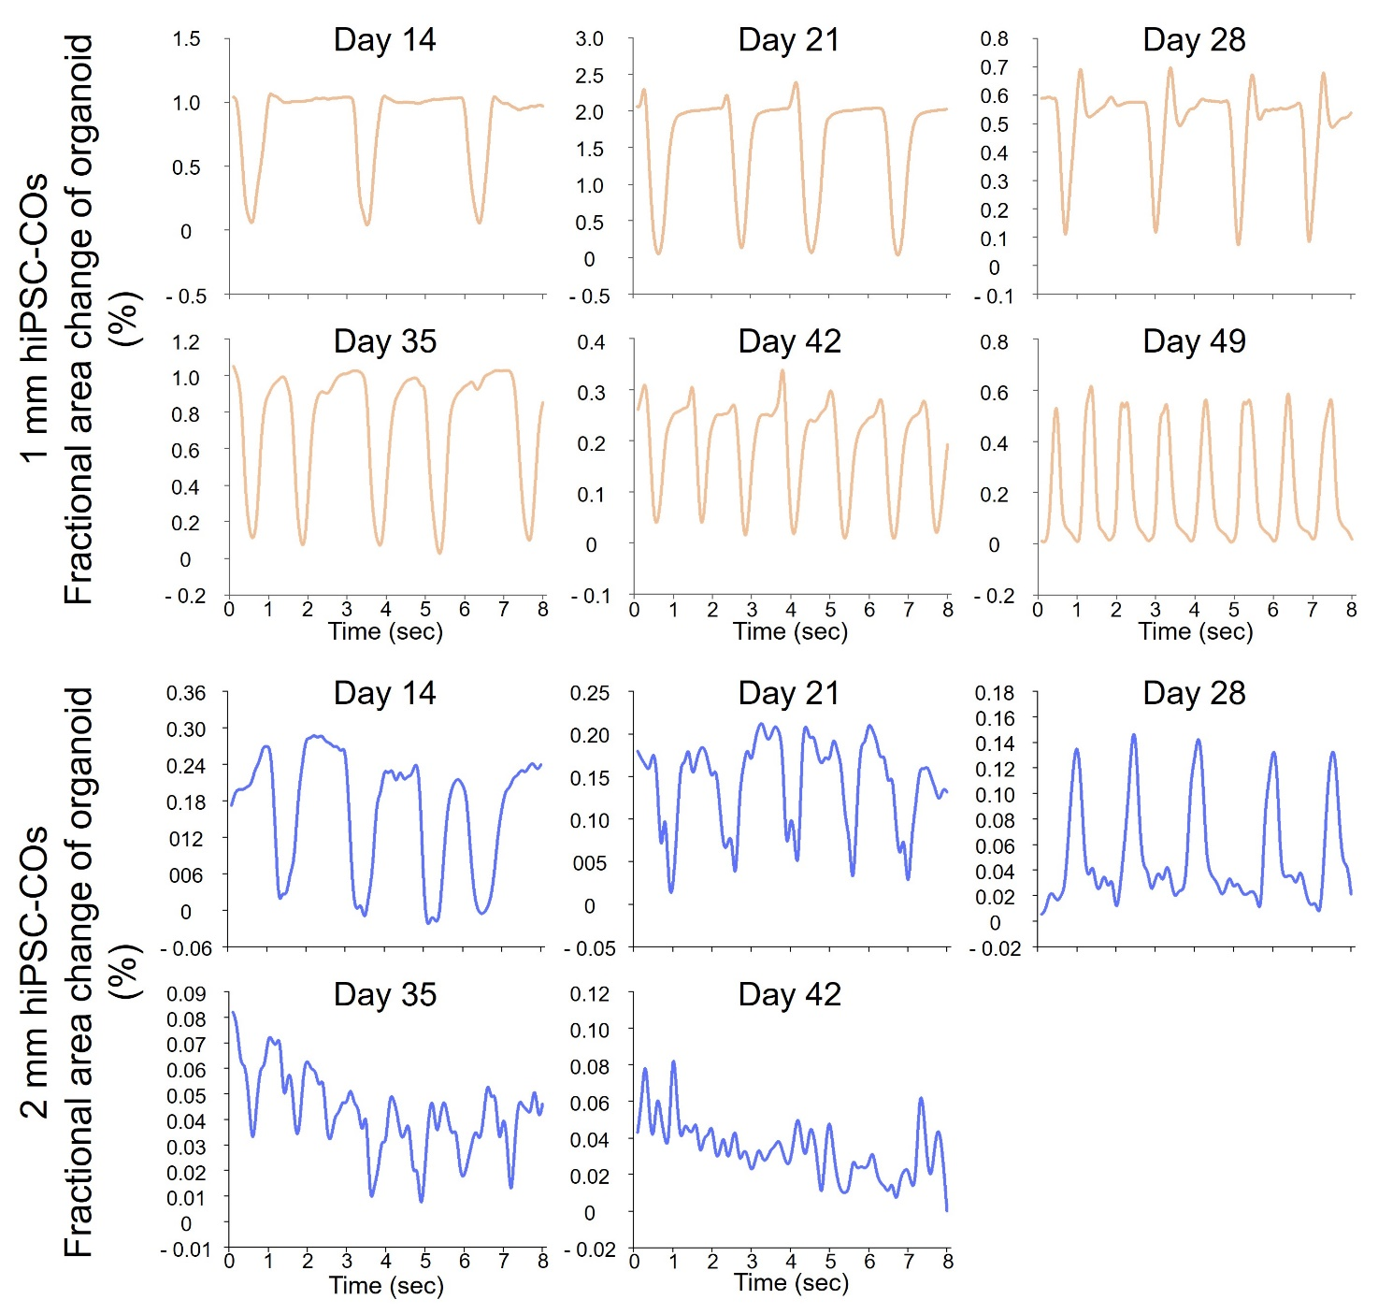
Supplementary Figure 3. Fractional area changes in the entire region of two size hiPSC-COs during cardiac differentiation period. After cardiac beating was detected, fractional area changes were evaluated in the entire organoid region of 1- and 2 mm hiPSC-COs at intervals of one week from differentiation day 14, when a stable structure was confirmed as a 3D product. Analysis of 2 mm hiPSC-COs on day 49 was not possible because cardiac beating was not detected.

Supplementary Figure 4. Fractional area changes in 1 mm hiPSC-COs by treatment of three drugs on day 35. This shows fractional area changes in the entire organoid region of 1 mm hiPSC-COs before and after the administration of Dasatinib, Doxorubicin and Imatinib on differentiation day 35. Meaningful response results were seen upon exposure of 1 mm COs to a drug that cause arrhythmias (Imatinib mesylate) by fractional area changes analysis.

Supplementary Figure 5. Cardiotoxicity drug response of 2 mm hiPSC-COs using eight heart failure-inducing drugs on day 35. (A) The cardiotoxic responses of the 2 mm COs to the panel of drugs, unlike those of the 1 mm COs, led to insignificant results for most agents. (B) Many dead cells were identified even in COs showing few changes in the beating rate analysis.

Supplementary Figure 6. Expression of α-actinin in the distinct region of 1 mm hiPSC-COs on day 35. Sarcomere (α-actinin) and activated cardiac myofibroblasts (αSMA) were clearly expressed in 1 mm COs on day 35. Of note in particular, α-actinin was expressed in the distinct region.

Supplementary Figure 7. Sarcomeric structures in the entire region of the 1 mm hiPSC-COs on day 15. The sarcomeric structure in 1 mm COs on day 15 showed a distinct and high expression when cardiac beating commenced and the organoid shape began to appear stable.

Supplementary video 1. Live imaging of calcium transients in 1 mm hiPSC-COs on day 35 (magnification X 40). Calcium transients were identified as lighting phenomena in the entire organoid region of the 1 mm hiPSC-COs on day 35.

Supplementary video 2. Live imaging of calcium transients in 1 mm hiPSC-COs on day 35 (magnification X 100). Calcium transients were identified as lighting phenomena in the entire organoid region of 1 mm hiPSC-COs on day 35.

Supplementary video 3. Live imaging of calcium transients in 2 mm hiPSC-COs on day 35 (magnification X 40). Calcium transients were identified in only a portion with cardiac beating in the entire organoid region of 2 mm hiPSC-COs on day 35.

Supplementary video 4. Live imaging of calcium transients in 2 mm hiPSC-COs on day 35 (magnification X 100). Calcium transients in the cardiac beating portion in 2 mm hiPSC-COs on day 35 were identified as lighting phenomena in a similar manner to those seem in 1 mm COs on day 35.

Supplementary video 5. Live imaging of calcium transients in 1 mm hiPSC-COs on day 49 (magnification X 40). Calcium transients were identified as wave-like phenomena in 1 mm hiPSC-COs on day 49.

Supplementary video 6. Live imaging of calcium transients in 1 mm hiPSC-COs on day 49 (magnification X 100). Calcium transients were identified as wave-like phenomena in 1 mm hiPSC-COs on day 49.

Supplementary video 7. Live imaging of calcium transients in 2 mm hiPSC-COs on day 49 (magnification X 40). No calcium transients were evident as there was no-beating.

Supplementary video 8. Live imaging of calcium transients in 2 mm hiPSC-COs on day 49 (magnification X 100). No calcium transients were evident as there was no-beating.

Supplementary video 9. Live imaging evaluation of cardiac beating in 1 mm hiPSC-COs on day 35 (magnification X 100). On day 35, 1 mm hiPSC-COs showed stable time-interval cardiac beats over the entire organoid area.

Supplementary video 10. Live imaging evaluation of cardiac beating in 2 mm hiPSC-COs on day 35 (magnification X 100). On day 35, cardiac beating was detected in only a portion of the organoid in 2 mm hiPSC-COs.

Supplementary video 11. Live imaging evaluation of cardiac beating in 1 mm hiPSC-COs on day 49 (magnification X 100). On day 49, 1 mm hiPSC-COs showed stable time-interval cardiac beats over the entire organoid area.

