Supplementary File

Supplementary Figures
Supplementary Figure S1. Bar plot of individuals admitted to ICU based on age percentile. The graph illustrates a discernible upward trend, indicating a higher likelihood of ICU admission as the age percentile increases.

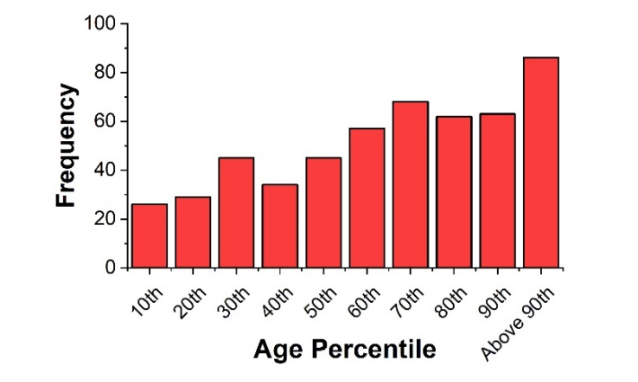

Supplementary Figure S2. Comparison of the mean observed values of the blood biomarkers for the patients admitted (labeled as Yes) and not admitted to ICU (labeled as No). (ns, non-significant; $*, p≤0.05; **, p≤0.01; ***, p≤0.001; ****, p≤0.0001)$. A two-sample Kolmogorov-Smirnov test is applied for each to examine whether the distribution of the two groups is statistically different or not.

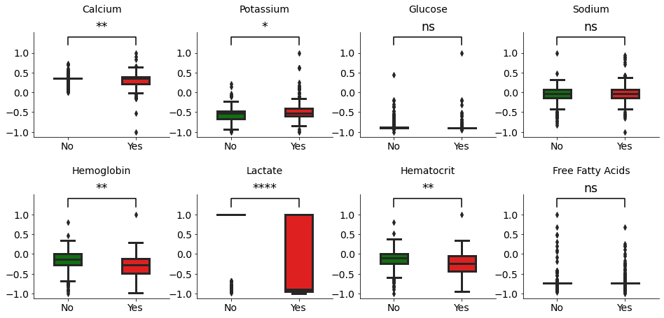

Supplementary Figure S3. Comparison of the maximum observed value of the vital signs for the patients admitted or not admitted to ICU, labeled as Yes or No, respectively. (ns, non-significant; $*, p≤0.05; **, p≤0.01; ***, p≤0.001; ****, p≤0.0001)$. A two-sample Kolmogorov-Smirnov test is performed to examine the difference in the distribution of those admitted and not admitted to the ICU.

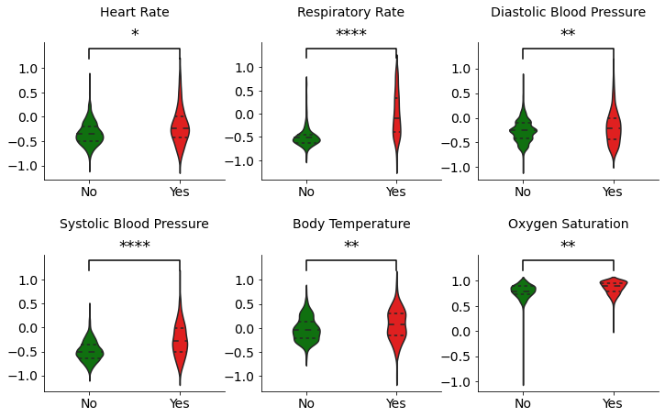

Hyperparameters of SERNA Algorithm
SERNA incorporates three groups of hyperparameters that can be fine-tuned to achieve optimal results: I) Base learners’ hyperparameters, II) SERNA-specific hyperparameters, and III) Meta-learner’s hyperparameters. The first set of hyperparameters is specific to the chosen base learners, and their selection varies accordingly. Supplementary Table S1 provides a summary of the hyperparameters in our study, considering the different base learners utilized. To optimize the hyperparameters of the base learners, we employed Bayesian optimization during the training phase. This technique utilizes the training set to identify the most suitable hyperparameters for each individual base learner. In our optimization process, the objective function focused on maximizing the recall metric. To assess the performance and generalization capability of the selected hyperparameters, a 5-fold cross-validation approach was applied.
Supplementary Table S1. Hyperparameters of the base learners used in the SERNA algorithm.
Method | Hyperparameters | Range/Choices
ETC | Number of estimators | [5, 200]
ETC | Max features to split | {square root, log}
ETC | Min fraction of samples required to split | (0, 1)
Ada | Number of estimators | [5, 200]
Ada | Learning rate | (0, 0.5)
RF | Max depth of the tree | [1, 40]
RF | Max features to split | {square root, log}
RF | Min fraction of samples required to be at a leaf node | (0, 1)
RF | Number of estimators | [5, 200]
LDA | Solver | {Singular value decomposition, Least-squares solution, Eigenvalue decomposition}
LDA | Shrinkage | (0, 1)
LogReg | Solver | {Newton-CG,  Limited-memory Broyden–Fletcher–Goldfarb–Shanno  (LBFGS),  Coordinate descent algorithm, Stochastic Average Gradient descent (SAG),  SAGA (extension of SAG)}
LogReg | Penalty | {L-1, L-2, elastic net, no penalty}
LogReg | C | (0, 10)

The SERNA-specific hyperparameters comprise $ℵ$, $M_{n}$ and $M_{r}$. One of the crucial hyperparameters of the SERNA algorithm is the neighborhood size $ℵ$. The bigger the size of the neighborhood, the smaller the variation, but the bigger the bias is expected to be. In this case, we may add unrelated observations by increasing the neighborhood size after a certain point and consequently increasing the bias. The extreme case occurs when we include the whole training samples as the neighbors, i.e., $ℵ=N$. In this case, we have the same evaluation results every time, thus zero variability but high bias. For the other extreme case, where $ℵ=1$, we have the same point as the closest neighbor for the training phase. In this case, the bias is 0, while the variability will be high. In the hyperparameter tuning procedure, we tried different neighborhood sizes from 5 to 50.
$M_{n}$ and $M_{r}$ are two other hyperparameters of SERNA. In this study, we used precision for both due to the better overall performance of the algorithm.
The last group of hyperparameters is related to the meta-learner. In Supplementary Table S2, the hyperparameters that are used to tune the MLP model are shown.
Supplementary Table S2. Hyperparameters of the meta-learner (MLP model)
Hyperparameter | Range/Choices
Number of hidden layers | {1, 2, 3}
Number of nodes in hidden layers | [10, 30]
Learning Rate | [0.0001, 0.15]
Optimizer | {Adam, SGD}

Evaluation Metrics
In this section, we compare the performance of the SERNA algorithm with that of the individual base learners. For our comparisons, we used the metrics shown in equations (S1) - (S4):
$$Accuracy=\frac{tp+tn }{tp+tn+fp+fn}$$ | (S1)
$$Precision=\frac{tp }{tp+fp}$$ | (S2)
$$Recall=\frac{tp}{tp+fn}$$ | (S3)
$$F1 score=\frac{2*precision*recall}{precision+recall}$$ | (S4)

$tp$: Number of patients admitted to ICU that are predicted as individuals in need of ICU.
$fp$: Number of patients not admitted to ICU that are predicted as individuals in need of ICU.
$tn$: Number of patients not admitted to ICU that are predicted as individuals, not in need of ICU.
$fn$: Number of patients admitted to ICU that are predicted as individuals, not in need of ICU.

Clustering Methods
Here, we discuss the specifics of each clustering method and the corresponding approaches used to determine the optimal number of clusters. For the k-means algorithm, the elbow method was employed. This method involves plotting the number of clusters against the inertia (sum of squared distances from each data point to its nearest centroid) and selecting the point at which the decrease in inertia begins to slow down, resembling an elbow shape. This point indicates the optimal number of clusters for k-means.
Agglomerative clustering is a bottom-up clustering procedure. In the beginning, this method considers all data points as individual clusters; then, in sequential steps, the model finds the two closest clusters to merge till all observations are in one cluster [1]. In agglomerative clustering, the linkage criterion specifies how the dissimilarity between clusters is measured, and the model merges the pairs of clusters accordingly. Usually, there are four types of linkages: Ward, complete, single, and average. The choice of linkage influenced how clusters were merged based on minimizing variance, maximum distances, minimum distances, or average distances between observations. The Euclidean distance is often used as the metric to calculate the linkage [1,2]. The number of clusters can be determined using a dendrogram that shows the merging process step by step [3].
DBSCAN is capable of clustering data with arbitrary shapes in the presence of noise and outliers [4]. This method has two main parameters: the minimum number of samples and epsilon. The minimum number of samples is the number of samples in a neighborhood of a data point, and epsilon is the maximum distance between two samples for one to be considered in the neighborhood of the other. The matrix of k-nearest neighbor distances is calculated to find the optimum number of clusters. This matrix includes the average distance of each point to the k-nearest neighbors. Then, the k distances should be plotted in ascending order. The knee in the plot can be used as the optimum value for the epsilon.
Fuzzy C-means is a clustering technique that assigns a membership degree, between 0 and 1, to each data point in a cluster. A higher membership degree represents a better match between the point and the cluster. In this regard, the Fuzzy Partition Coefficient (FPC) is defined as a metric to evaluate how well the model describes the data. The FPC is between 0 and 1, and higher values are preferable. So, to find the best number of clusters using the fuzzy C-means method, we plotted the FPC against the number of centers.

References
[1] Ackermann MR, Blömer J, Kuntze D, Sohler C. Analysis of agglomerative clustering. Algorithmica, vol. 69, 2014, p. 184–215. https://doi.org/10.1007/s00453-012-9717-4.
[2] Sasirekha K, Baby P. Agglomerative Hierarchical Clustering Algorithm-A Review. International Journal of Scientific and Research Publications 2013;3.
[3] Lukasov A. HIERARCHICAL AGGLOMERATIVE CLUSTERING PROCEDURE. Pattern Recognit 1979;11:365–81.
[4] Khan K, Rehman SU, Aziz K, Fong S, Sarasvady S, Vishwa A. DBSCAN: Past, present and future. 5th International Conference on the Applications of Digital Information and Web Technologies, ICADIWT 2014, IEEE Computer Society; 2014, p. 232–8. https://doi.org/10.1109/ICADIWT.2014.6814687.

