Supporting Information
Structural Transformation and Degradation of Cu Nanocatalysts during Electrochemical CO₂ Reduction Reaction

Soo Hong Lee^{1,2,9,13}, Jaime E. Avilés Acosta^{3,4,13}, Daewon Lee^{5,6}, David M. Larson^{1,2,10}, Hui Li^{1,2}, Junjie Chen^{4,7}, Sarah J. Blair^{4,7,11}, Alessandro Gallo^{4,12}, Haimei Zheng^{5,6}, Christopher J. Tassone⁸, Thomas F. Jaramillo^{*,4,7}, and Walter S. Drisdell^{*,1,2}

¹Liquid Sunlight Alliance and ²Chemical Sciences Division, Lawrence Berkeley National Laboratory, 1 Cyclotron Rd., Berkeley, CA 94720, United States.
³Department of Materials Science and Engineering, Stanford University, Stanford, CA 94305, United States.
⁴SUNCAT Center for Interface Science and Catalysis, SLAC National Accelerator Laboratory, Menlo Park, CA 94025, United States.
⁵Materials Sciences Division, Lawrence Berkeley National Laboratory, 1 Cyclotron Rd., Berkeley, CA 94720, United States.
⁶Department of Materials Science and Engineering, University of California, Berkeley, CA 94720, United States
⁷Department of Chemical Engineering, Stanford University, Stanford, CA 94305, United States.
⁸Stanford Synchrotron Radiation Lightsource, SLAC National Accelerator Laboratory, Menlo Park, CA 94025, United States.
⁹Present address: Chemical & Process Technology Division, Korea Research Institute of Chemical Technology (KRICT), Yuseong-gu, Daejeon 34114, South Korea
¹⁰Present address: Twelve Benefit Corporation, 614 Bancroft Way, Berkeley, CA 94710, United States
¹¹Present address: Chemistry and Nanoscience Department, National Renewable Energy Laboratory, Golden, CO 80401, United States.
¹²Present address: Sila Nanotechnologies, 2470 Mariner Square Loop, Alameda, CA 94051, United States
¹³These authors contributed equally to this work.
Corresponding Author
E-mail: wsdrisdell@lbl.gov; jaramillo@stanford.edu

Experimental Section

Unified fit model. SAXS data from complex structures often requires a comprehensive understanding of the relationship between correlated structural features at different size regimes, making it challenging to fit such complex SAXS curves. This is especially true if the size distribution is rather broad and covers a large size range or consists of aggregates. The fit model with predefined size distributions is unsuitable for particles with broad and large size ranges or aggregates because the larger particles dominate the SAXS signal, which scales with the square of the volume for spherical particles. The smaller particles, which contribute to the high q-range scattering intensity, have a weaker SAXS signal and make it difficult to use a distinct structural model.
The unified fit model can analyze scattering features from hierarchical systems with overlapping structural levels when a distinct structural model is unavailable.¹ This model accounts for the correlation between structural features at different size regimes. The hierarchical structure consists of several structural levels, each corresponding to a local scattering function of the particle within a specific size range. The smaller structural level forms the building block of the larger one; for instance, in our case, the primary Cu NPs constitute the smallest level, and the next level consists of aggregates of these Cu NPs.
In general, the SAXS spectrum can be divided into two regimes for each level, the power-law regime and the Guinier regime. At sufficient low scattering vector (q) ranges (qR<< 1, with R as a characteristic dimension of the particles), the scattered X-ray intensity, I(q), can be described by Guinier’s law:

${I\left(q\right)=G exp\left(-\frac{q^{2}R_{g}^{2}}{3}\right) G= N{ r}_{e}^{2} {∆ρ}_{e}^{2} V}^{2}$ (1)

where R_{g} is the radius of gyration, G is the Guinier prefactor, N is the particle number density, r_{e}² is the electron cross section, ∆ρ_{e} is the average electron density difference between particles and matrix, and V is the average particle volume.
For large q ranges, qR >>1, the scattered intensity I(q) can be described by a power-law following:

$I\left(q\right)=B q^{-P} B= 2πr_{e}^{2} N{∆ρ}_{e}^{2} S$ (2)

where B is the Porod prefactor, P is the power-law slope or mass-fractal dimension, and S is the particle surface area.
Guinier’s law can estimate the R_{g} value of the corresponding structural level in the Guinier regime (qR<< 1), while the power-law regime (qR >>1) can reveal the morphology of the underlying structure. For sharp and smooth interfaces, I(q) decays with P = 4, also known as Porod’s law. Deviation of P values from Porod’s law can be attributed to diffuse interfaces (P > 4), surface fractals (3 < P < 4), and mass fractals (1 < P < 3).²

Global unified fit. In a complex hierarchical system, the local scattering functions significantly overlap each other, so it is reasonable to derive a global unified function to fit the entire scattering curve. The local scattering laws described by Eqs (1) and (2) are directly used in the global unified scattering function to describe hierarchical systems composed of ‘n’ structural levels as follows:

$I\left(q\right)=\sum_{i=0}^{n}{G_{i}} exp\left(-\frac{q^{2}R_{g,i}^{2}}{3}\right)+ B_{i} (q^{*})^{-P} q^{*}= \frac{q}{{\left[\operatorname{erf}\left(\frac{kqR_{g}}{\sqrt{6}}\right)\right]}^{3}}$ (3)

where k has an approximate value of 1.06 for P=2 and 1 for P >3.³ The q* defines the low q cut-off of the power-law region of the underlying structural level and erf() is the error function.
The Porod invariant (Q) is total scattering over the whole of reciprocal space, and this value
is independent of particle shape and size distribution. The Porod invariant (Q) is defined by

$Q= \int_{0}^{∞}{q^{2}I\left(q\right)dq=2π^{2}{ N r}_{e}^{2} {∆ρ}_{e}^{2} V}$ (4)

The analysis of each structural level allows us to determine the corresponding R_{g}, P, and N. The number density of secondary aggregates can be calculated from the Porod invariant Q and the Guinier prefactor G as follows:

$N= \frac{Q^{2}}{4\left({ r}_{e}^{2} {∆ρ}_{e}^{2}\right)π^{4}G}$ (5)

The absolute contrast factor (${\text{r}}_{\text{e}}^{\text{2}} {\text{∆ρ}}_{\text{e}}^{\text{2}}$) for Cu in H₂O can be calculated from

$${ r}_{e}^{2} {∆ρ}_{e}^{2}= r_{e}^{2} {\left(\frac{N_{A}ρN_{e}}{M}\right)}^{2}= 3.596 × {10}^{23} {cm}^{-4}$$

where N_{A} is Avogadro’s number, N_{e} is the number of electrons in the Cu molecule, and M is the corresponding molecular weight.⁴ Based on in situ XANES data, we assume that Cu NPs were reduced fully to their metallic state before observing the first SAXS spectrum, which approximately takes 1 min for the measurements. Under the assumption of uniform density ρ of 8.96 g / cm³ for the Cu, the absolute intensity can directly reflect the number density of Cu aggregates.
The volume fraction of Cu aggregates in the irradiated volume, ϕ_{V}, can be evaluated from the Porod invariant Q, and the absolute contrast factor for Cu in H₂O, as follows:

$ϕ_{V}= \frac{Q}{2π^{2}\left({ r}_{e}^{2} {∆ρ}_{e}^{2}\right)}$ (6)

where ϕ_{V} can indicate the total volume fraction of aggregates in the electrode.⁴
We present the R_{g} values for both primary Cu NPs and their aggregates as the reaction proceeds because it is hard to determine a structure factor for each spectrum as the morphology evolves dynamically. In the case of spherically symmetric particles, which are similar to Cu NPs in the initial OCV state, the R_{g} is related to the radius by R_{g} = (3/5R)^{1/2}. The relationship between the R_{g} value and its parameters has been summarized in previous literature for a variety of structure models.¹ In addition, we modified Equation (3) as follows:
$$I\left(q\right)=\left[G_{2} exp\left(-\frac{q^{2}R_{g,2}^{2}}{3}\right)+ B_{2} exp\left(-\frac{q^{2}R_{sub}^{2}}{3}\right){q_{2}^{*}}^{-P,2}\right]$$
$+\left[G_{1} exp\left(-\frac{q^{2}R_{g,1}^{2}}{3}\right)+ B_{1} {q_{1}^{*}}^{-P,1}\right]$ (7)

where the cut-off radius of gyration differs from the substructural R_{g} values. This modification has been shown to accurately describe scattering from carbon black within a polymer matrix.⁵
We analyzed the SAXS data using the Irena package (version 2.71, IgorPro, Wave Metrics Inc.) with the unified fit model.⁶ The error bars on the fitting result indicate the uncertainty or variability of the fitted parameters. The fit minimizes the chi-squared function between the experimental data and the model function.

The size distribution of primary NPs. In the Cu NPs electrode, a significant overlap between the Guinier regime and power-law regime was observed as the reaction proceeded, indicating that the polydispersity and asymmetry of primary Cu NPs increased. The polydispersity of the particles can be estimated by the following ratio:

$PDI= \frac{BR_{g}^{4}}{1.62G}$ (8)

This unitless polydispersity index (PDI) can be directly calculated from the global unified fitting results without any assumptions regarding particle shape or the functionality of the size distribution.⁷ For monodisperse spheres, the PDI value is 1. Higher values of PDI indicate asymmetrical particle shapes or broad size distribution. For example, a PDI of 5.56 was evaluated for the self-preserving limit of aerosol growth.⁴
We evaluated the size distribution of primary Cu NPs with the assumption of a log-normal size distribution of spherical particles. For polydisperse spheres, two parameters are needed to describe the log-normal distribution, m, and σ_{g}, where m is the median radius and σ_{g} is the geometric standard deviation. The PDI value is directly related to σ_{g} as follows:

$σ=ln{σ_{g}= \sqrt{\left(\frac{\ln{(PDI)}}{12}\right)}}$ (9)
and
$m= {\left\{5R_{g}^{2} / [3\exp\left(14σ^{2}\right)]\right\}}^{1/2}$ (10)

Therefore, fitting the SAXS spectrum with the global unified function can yield the size distribution of primary Cu NPs with the assumption of a log-normal distribution of polydisperse spherical particles (P₁=4).
Supplementary Note 1. The effect of local pH and Cu dissolution on the structural transformation of Cu NPs.

During the CO₂RR, the concentration of protons and CO₂ near the electrode surface depends on the interplay between consumption from the electrode, diffusion from the bulk solution, and homogeneous buffer reactions. When the CO₂RR is conducted at high current densities or in electrolytes with limited buffer capacity and/or mass transport, it is widely recognized that the pH near the cathode surface tends to rise, deviating from the bulk value.⁸ Previous reports have shown that the local pH at the Cu cathode stabilizes at approximately pH 11.5 when using 0.5 M K₂CO₃ electrolytes and operating at current densities of 200 mA/cm² in a gas-diffusion electrode over continuous operation for ~11 hours.⁹ However, in our case, the average current densities under CO₂-purged 0.5 M KHCO₃ ranged from -0.89 mA/cm² at -0.45 V vs. RHE to -2.86 mA/cm² at -0.9 V vs. RHE. We anticipated that the local pH was effectively maintained with a reasonable deviation from the bulk pH at such low current densities. This situation applies to the sample operated under the Ar-purged 0.5 M phosphate buffer, which has a stronger buffering capacity. A previous study demonstrated that a 0.5 M phosphate buffer solution effectively maintained the local pH with a deviation within 1.5 from the bulk pH values up to 30 mA/cm².¹⁰ The mass transport properties near the electrode surface also have an impact on the local pH value, which can be influenced by the cell design and electrolyte flow rates. However, we conducted a control experiment using an Ar-purged 0.5 M KOH solution, representing a scenario where the local pH surges to a higher value compared to the bulk solution during the electrocatalysis.
At this pH level (> 13), based on the Pourbaix diagram of Cu in aqueous solution,¹¹ the Cu NPs are expected to undergo oxidation into Cu(OH)₂ during the OCV period (~25 mV vs. SHE). Additionally, the formation of Cu molecular species (HCuO₂─ in an alkaline environment) can occur, and the dissolution of Cu becomes more favored during the anodic OCV states.^{12,13} The reduction of Cu oxide/hydroxide, as well as the molecular species, contributes to a rapid decrease in the size of primary Cu NPs, as depicted in Supplementary Figure 16d, attributed to the instability of the Cu surface against dissolution in such high pH. Consequently, the high local pH near the electrode surface is not the primary factor explaining the observed enhancement in declustering behavior under Ar-purged phosphate buffer in Figure 3.

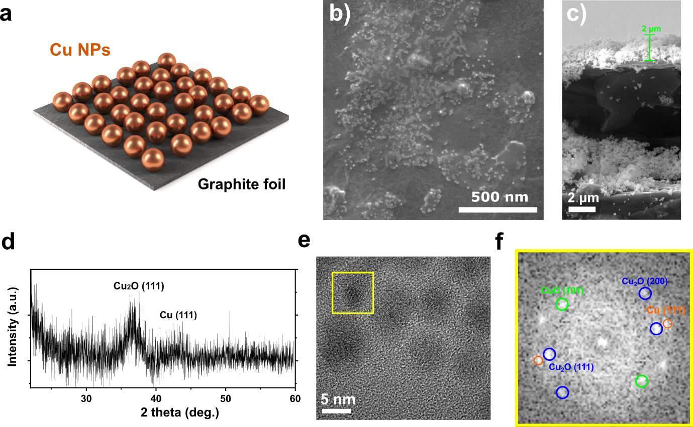

Supplementary Figure 1. Characterization of Cu NPs ensemble electrode. a, Schematic illustration of Cu NPs deposited on the graphite foil using the drop-casting method. b,c, SEM image (b) and cross-section SEM image (c) of as-synthesized Cu NPs electrode (0.25 mg/cm²). The film thickness of Cu NPs was estimated at 1~2 μm, with heterogeneity depending on the location. d, Grazing-incidence X-ray diffraction (GIXRD) pattern of as-synthesized Cu NPs at a depth of 355 nm. e,f, High-resolution TEM image (e), and corresponding fast Fourier transform (FFT) image (f) of as-synthesized Cu NPs. Cu₂O (111) and Cu (111) phases were observed in the FFT pattern, correlating with the GIXRD result. We also observed the CuO (101) phase, indicating the mixture of copper oxide and metallic Cu in the Cu NPs.

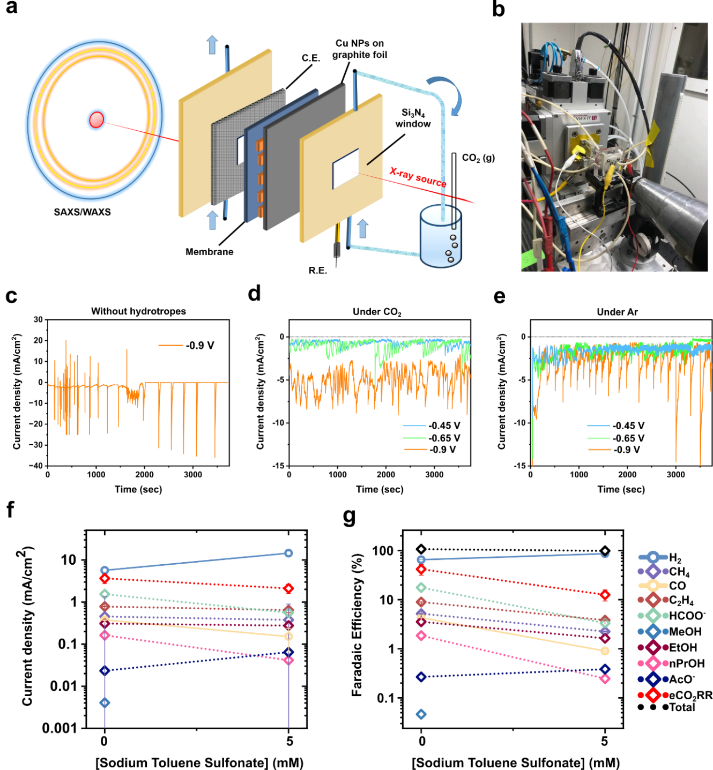

Supplementary Figure 2. An experimental setup for in situ small angle X-ray scattering (SAXS). a,b, A schematic view (a) and picture (b) of the experimental setup for in situ SAXS measurement during CO₂RR. c, Temporal changes in the total current density of Cu NPs electrode without 5 mM sodium p-toluenesulfonate as a hydrotrope. d,e, Geometric current densities of a Cu NPs electrode with 5 mM hydrotropes as a function of the applied potentials under CO₂-purged 0.5 M KHCO₃ (~pH 7.2, d) and Ar-purged 0.5 M K_{x}H_{3-x}PO₄ electrolytes (pH ~6.7, e). Although bubble blockage still resulted in an unstable current profile, the reaction proceeded without any disconnection. f,g, Partial current densities (f), and Faradaic efficiency (g) for all CO₂RR products obtained from the Cu NPs electrode with and without the hydrotropes (sodium p-toluenesulfonate, 5 mM) at -0.9 V vs RHE in a compressed cell that was reported previously. ¹⁴ The y-axis is logarithmic for clarity.
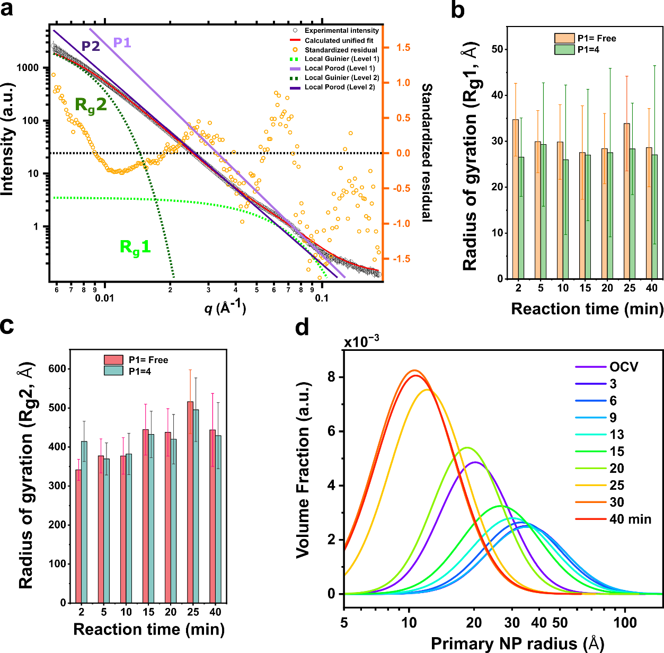

Supplementary Figure 3. Global unified function for SAXS data. a, Representative unified fits involving two structural levels. The one-dimensional SAXS data were obtained from Cu NPs electrode under CO₂-purged 0.5 M KHCO₃ at open circuit voltage (OCV). In the high q region (q > 0.07 Å), scattering intensity decays with a power law (P₁=4, pale purple line), indicating the presence of a sharp interface for the spherical Cu NPs. This Porod region is preceded at intermediate q (0.05 Å < q < 0.07 Å) by an exponential decay attributing to the Guinier region of the primary Cu NPs (green dotted line). At the lowest q region (q < 0.01 Å), another Guinier region was observed originating from the secondary aggregates (olive dotted line). The exponential behavior in this region is not fully distinct because of the interference from the next larger structure level, leading to relatively large errors in R_{g2} values. The power-law decay between these two Guinier regions (0.01< Å < q < 0.05 Å) shows a slope below 4, representing the fractal morphology of the aggregates (P₂ < 4, purple line). b,c, The calculated R_{g1} and R_{g2} values under the assumption of P₁ as a free parameter and P₁ = 4. The SAXS data were obtained from the Cu NPs at -0.9 V under the CO₂-purged electrolyte. d, The size distribution of primary Cu NPs derived from the global unified function.
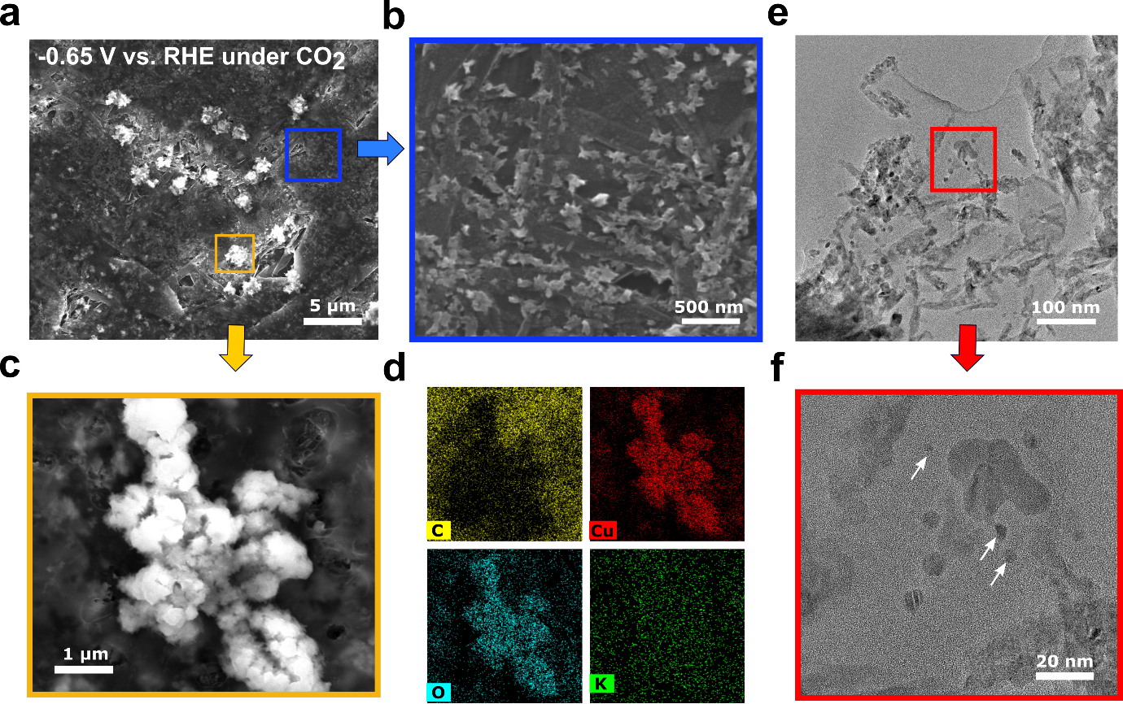

Supplementary Figure 4. Ex situ and post-mortem microscopic analysis of Cu NPs electrode at -0.65 V vs. RHE under CO₂ condition. a-c, SEM images of Cu NPs electrode after 1 hr of electrolysis. The resulting electrode showed a hierarchical structure with different length scales, consisting of nano-sized aggregates (b) and micro-sized agglomerates (c). The blue and yellow boxes correspond to b and c, respectively. d, EDS elemental mapping of the corresponding agglomerates in the SEM image. The Cu and O signals indicated that the agglomerate was copper oxide. e,f, TEM images of the nano-sized Cu aggregates. The red box in the e corresponds to f. The white arrows in (f) indicate the Cu clusters are about 4~5 nm in diameter, smaller than the average original Cu NPs that had a diameter of ~7 nm.

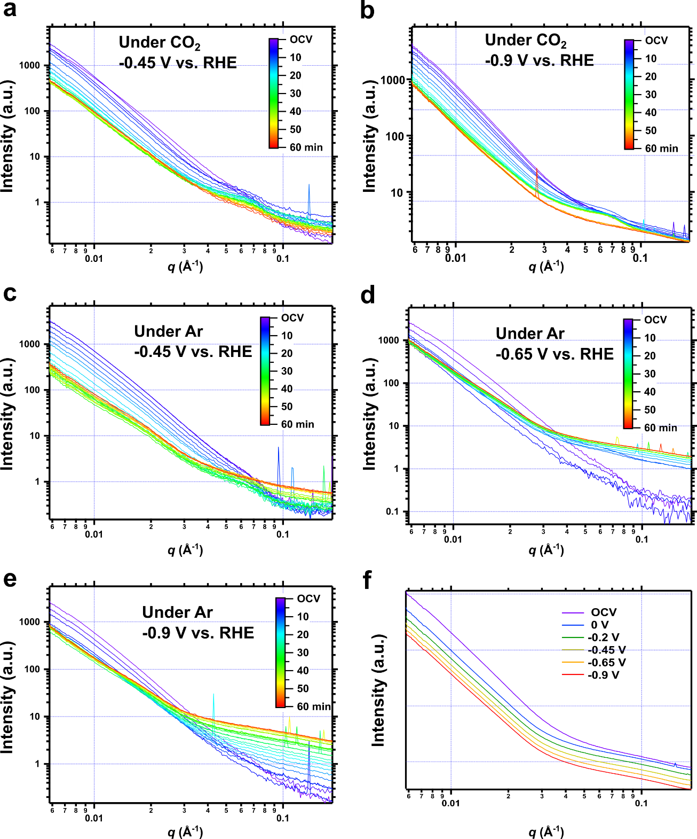

Supplementary Figure 5. In situ SAXS pattern of Cu NPs electrode under different reaction conditions. a-e, Temporal changes in one-dimensional background-subtracted SAXS patterns of the Cu NPs electrode under CO₂-purged 0.5 M KHCO₃ electrolyte at -0.45 V (a) and -0.9 V (b) vs. RHE. The SAXS pattern was also measured under Ar-purged K_{x}H_{3-x}PO₄ electrolyte at -0.45 V (c), -0.65 V (d), and -0.9 V (e) vs. RHE. f, One-dimensional SAXS data of graphite foil with the circulation of 0.5 M KHCO₃ electrolyte in the in situ cell as a function of the applied potentials were used for background subtraction. Both axes are logarithmic and patterns are offset for clarity.
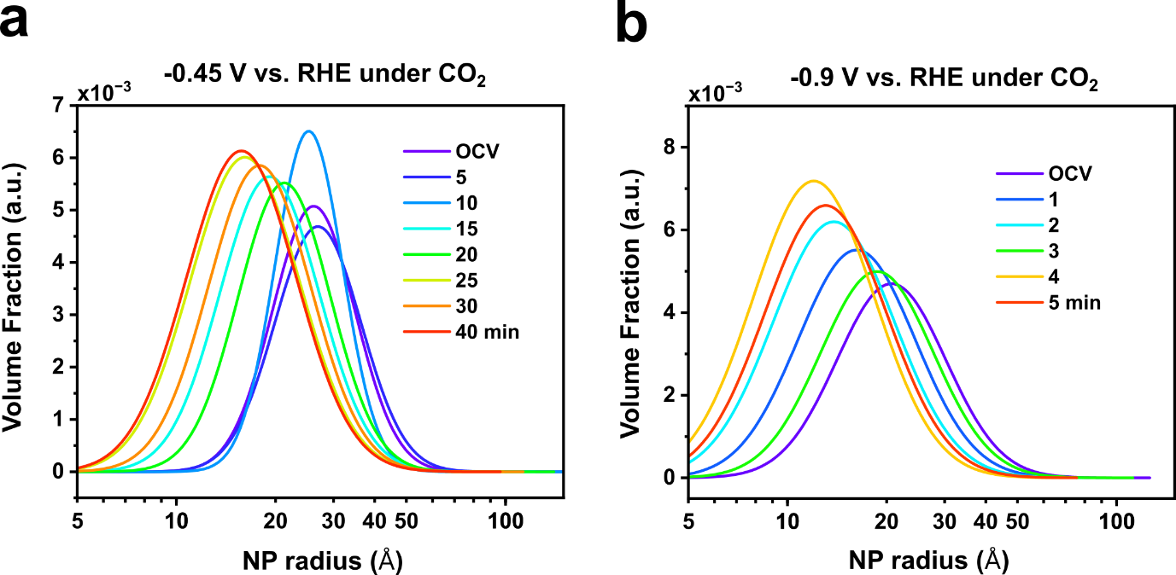

Supplementary Figure 6. Particle size distribution with different applied potentials. a,b, The estimated size distribution of primary Cu NPs under CO₂-purged 0.5 M KHCO₃ electrolyte at -0.45 V (a) and -0.9 V (b) vs. RHE. The size distributions can be calculated under the assumption of spherical particles (P₁=4) and log-normal distributions.

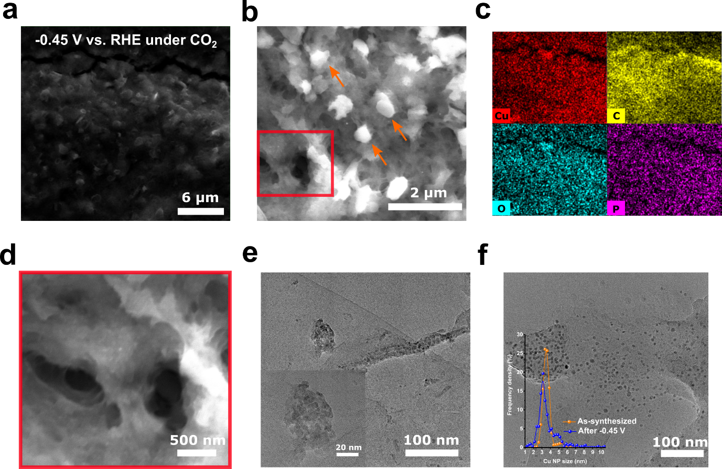

Supplementary Figure 7. Ex situ and post-mortem microscopic analysis of Cu NPs electrode at -0.45 V vs. RHE under CO₂ condition. a-f, SEM (a,b,d), EDS elemental mapping (c), and TEM (e, f) images of Cu NPs electrode after 1 hr of electrolysis at -0.45 V under CO₂-purged 0.5 M KHCO₃ electrolyte. The micrometer-sized particles in b (orange arrows) are expected to be the organic residues derived from the ligand molecules used during the synthesis of the Cu NPs (see the below Fig. S8 and Fig. S11 for further characterization). The red box in b corresponds to d. The inset in e represents the polycrystalline aggregates formed through the PMC process. The inset in f exhibits the size distribution of as-synthesized Cu NPs (orange) and after CO₂RR at -0.45 V (blue) confirmed by TEM analysis, indicating that an OR process occurred.

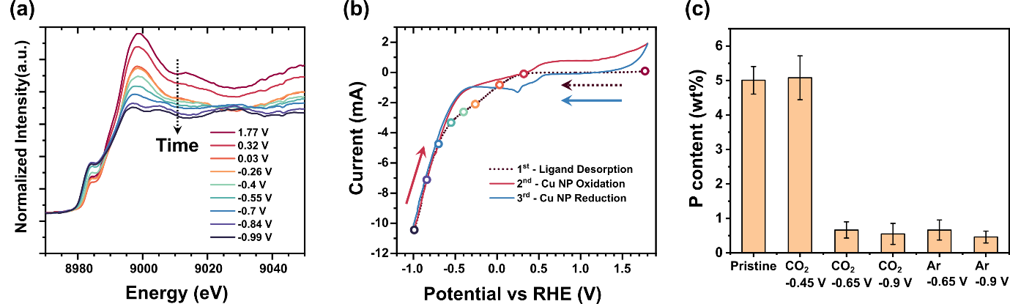

Supplementary Figure 8. The detachment of organic ligands on the surface of Cu NPs depends on the reaction conditions. (a) In situ XANES data of as-prepared Cu NPs on graphite foil taken at different potentials. The arrow indicates the change in spectra over time as more negative potentials are applied. (b) Cyclic voltammetry (5 mV s⁻¹) data were collected during the in situ XANES measurement. Arrows indicate the direction of potential sweeping at the indicated cycles. The hollow symbols indicate potentials where the XANES spectra were collected during the initial reductive desorption of ligands from the Cu NPs. (c) Weight percentages of P atoms were measured by using EDS mapping analysis after 1 hr of electrolysis at different reaction conditions. As reported previously, the phosphonic acid-based ligands can detach from the surface and form a detached layer of ligands in the nanoparticle vicinity at -0.68 V vs. RHE.¹⁵ Our result also demonstrates that the octadecyl phosphonic acid ligands remain on the electrode at -0.45 V vs. RHE. As the applied potential decreases, the organic ligands are desorbed from the metal surface under both CO₂ and Ar conditions. This behavior of the ligands during the reaction correlates with a previous report.¹⁶ Error bars are the standard deviation of elemental analysis from three different locations.

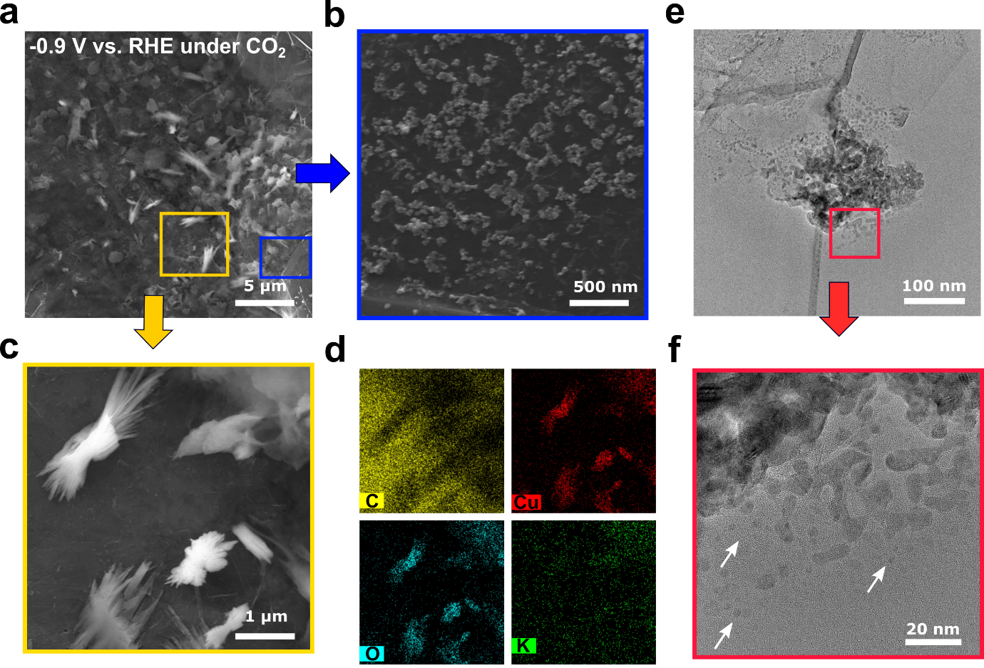

Supplementary Figure 9. Ex situ and post-mortem microscopic analysis of Cu NPs electrode at -0.9 V vs. RHE under CO₂ condition. a-f, SEM (a-c), EDS elemental mapping (d), and TEM (e,f) images of Cu NPs electrode after 1 hr electrolysis at -0.9 V vs. RHE under CO₂-purged 0.5 M KHCO₃ electrolyte. The blue and yellow boxes in a correspond to b and c, respectively. The EDS elemental analysis in d reveals that the micrometer-sized dendritic structure was composed of copper oxide. The red box in e corresponds to f, and the white arrows in f indicate Cu clusters smaller than the original Cu NPs.

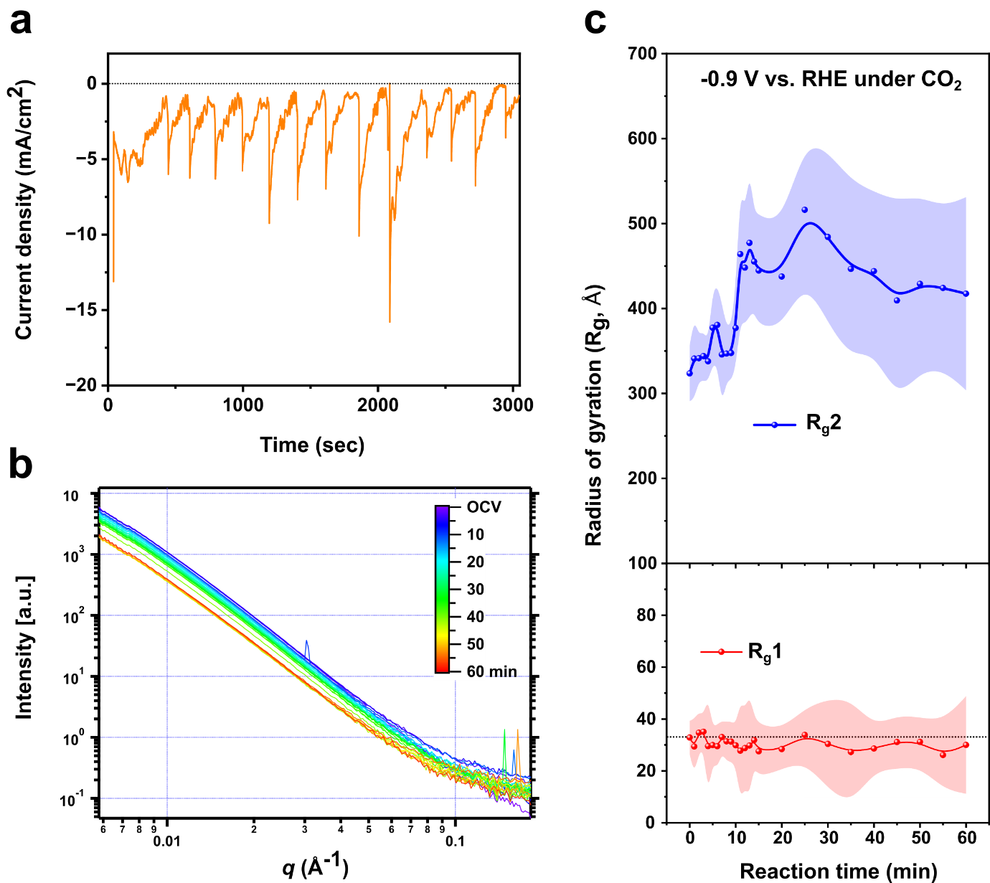

Supplementary Figure 10. Reproducibility of the structural transformation of Cu NPs during the CO₂RR. In situ SAXS data were obtained and analyzed from a different Cu NPs electrode. a,b, Temporal changes in the total current densities (a) and one-dimensional background-subtracted SAXS patterns (b) of the Cu NPs electrode at -0.9 V vs. RHE under CO₂-purged 0.5 M KHCO₃ electrolyte. c, Temporal changes in the radius of gyration values of both primary Cu NPs (R_{g1}) and secondary aggregates (R_{g2}). Error bars result from the fits to the SAXS data. The fitting results revealed that the R_{g1} values remained ~ 30 Å throughout the reaction time, with an error range of up to 20 Å. The fitting process carried higher uncertainty because only a small portion of primary Cu NPs was located within the irradiated area (0.15 mm²), thereby not contributing significantly to the overall spectrum. In contrast, Figure 2b exhibited relatively small error bars as a larger number of small NPs were detected. This disparity could be attributed to the heterogeneous distribution of initial Cu NPs prepared using the drop-casting method and local variations in the structural transformation process, which posed challenges in reproducing the same spectrum throughout the sample. Nevertheless, the consistent trend in the structural evolution, characterized by the growth of aggregates without an increase in the size of primary Cu NPs, was reproducible.
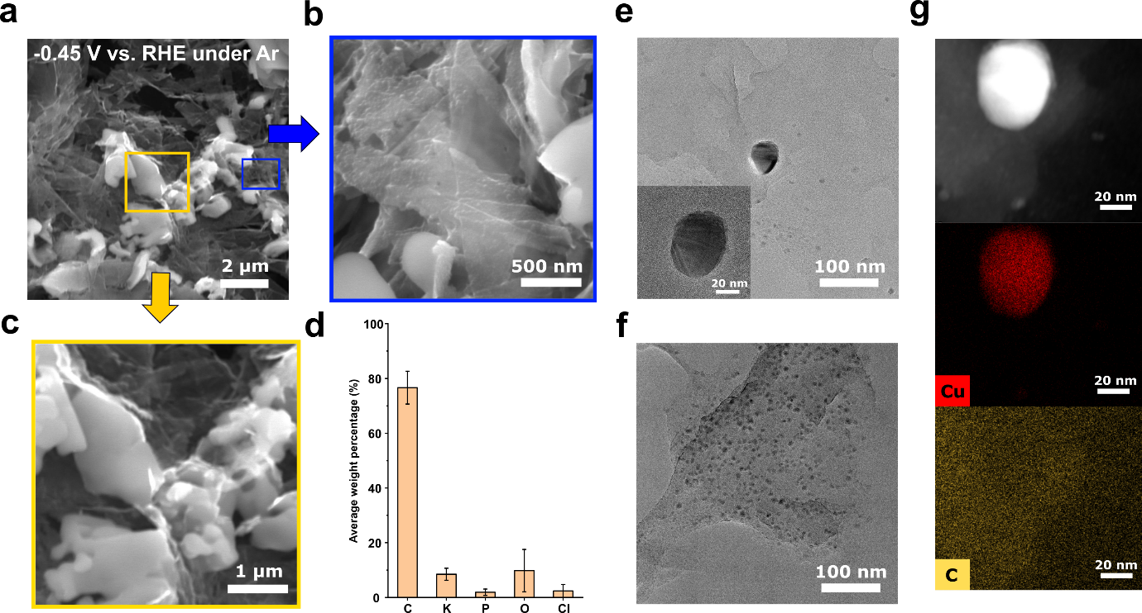

Supplementary Figure 11. Ex situ and post-mortem microscopic analysis of Cu NPs electrode at -0.45 V vs. RHE under Ar condition. a-f, SEM (a-c), EDS elemental analysis (d), TEM (e,f), and STEM-EDS (g) images of Cu NPs electrode after 1 hr electrolysis at -0.45 V vs. RHE under Ar-purged 0.5 M K_{x}H_{3-x}PO₄ electrolyte. The blue and yellow boxes in a correspond to b and c, respectively. The micrometer-sized particles in c were analyzed by EDS elemental analysis (d) and the result showed that the particles are mainly composed of organic residues from ligands and electrolytes. Error bars in d are one standard deviation of three independent measurements.

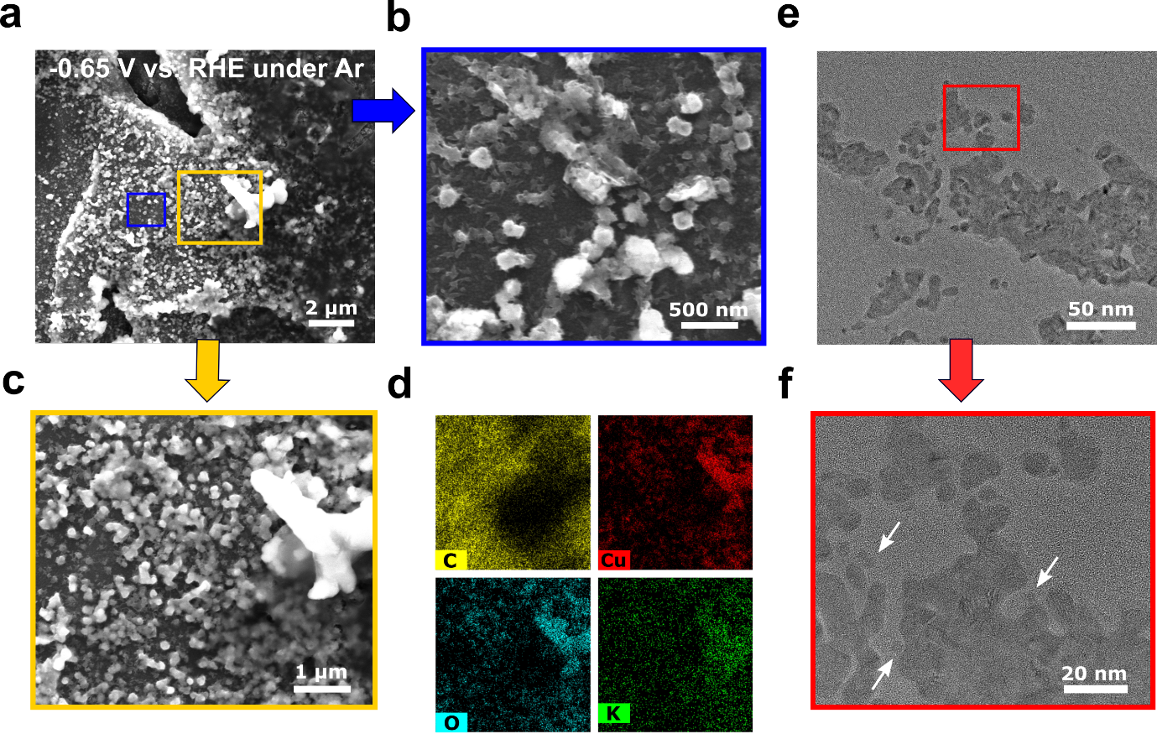

Supplementary Figure 12. Ex situ and post-mortem microscopic analysis of Cu NPs electrode at -0.65 V vs. RHE under Ar condition. a-f, SEM (a-c), EDS elemental analysis (d), and TEM (e and f) images of Cu NPs electrode after 1 hr electrolysis at -0.65 V vs. RHE under Ar-purged K_{x}H_{3-x}PO₄ electrolyte. The blue and yellow boxes in a correspond to b and c, respectively. The red box in e corresponds to f, and the white arrows in f indicate Cu clusters smaller than those of the original Cu NPs.

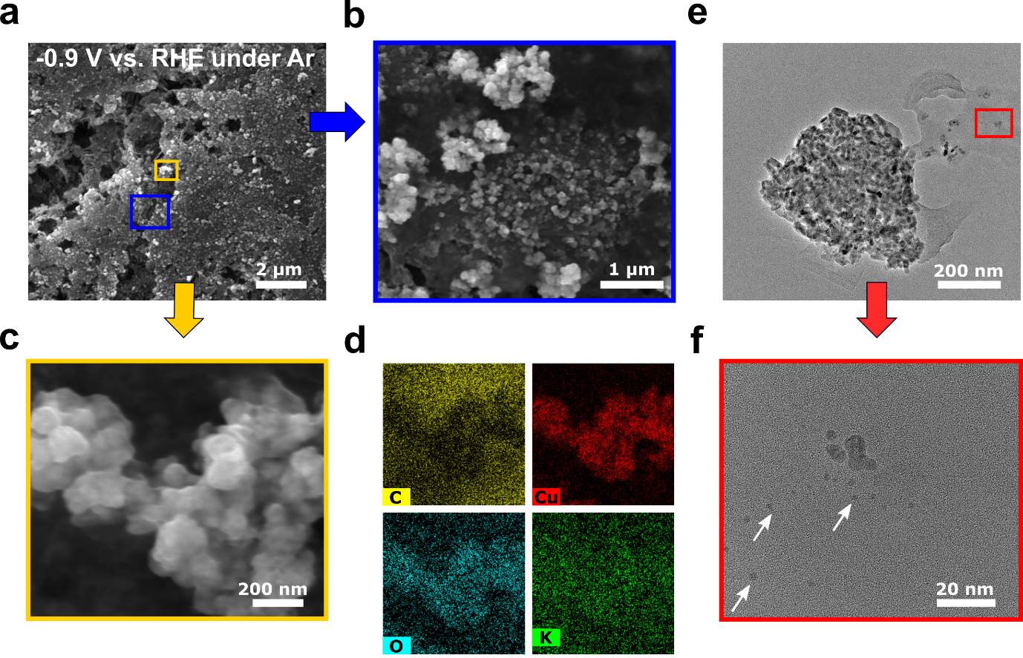

Supplementary Figure 13. Ex situ and post-mortem microscopic analysis of Cu NPs electrode at -0.9 V vs. RHE under Ar condition. a-f, SEM (a-c), EDS elemental analysis (d), and TEM (e, f) images of Cu NPs electrode after 1 hr electrolysis at -0.9 V vs. RHE under Ar-purged 0.5 M K_{x}H_{3-x}PO₄ electrolyte. The blue and yellow boxes in a correspond to b and c, respectively. The red box in e corresponds to f, and the white arrows in f indicate Cu clusters smaller than those of the original Cu NPs.

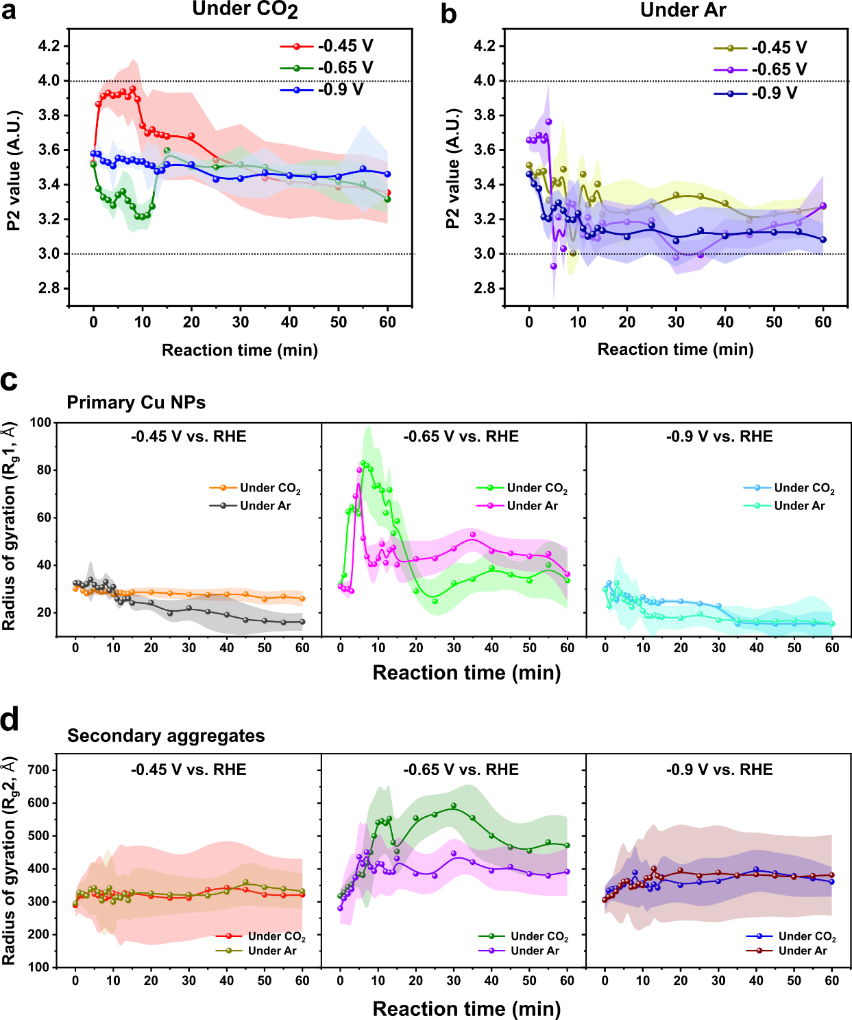

Supplementary Figure 14. The comparison of SAXS results under CO₂ and Ar conditions. a,b, Evolution of the Power-law slope as a function of reaction time under CO₂-purged 0.5 M KHCO₃ electrolyte (a) and Ar-purged 0.5 M K_{x}H_{3-x}PO₄ electrolyte (b) The dotted lines show the range of power-law slope that corresponds to surface fractals (3 < P₂ < 4). c,d, Temporal changes in the radius of gyration values of primary Cu NPs (R_{g1}, c) and secondary aggregates (R_{g2}, d) under CO₂-purged 0.5 M KHCO₃ electrolyte and Ar-purged 0.5 M K_{x}H_{3-x}PO₄ electrolyte at different applied potentials. Error bars result from the fits to the SAXS data. All the data were obtained from in situ SAXS data analysis. The data under CO₂ and Ar conditions are reproduced from Figures 1, 2, and 3, for comparison between two different reaction conditions.

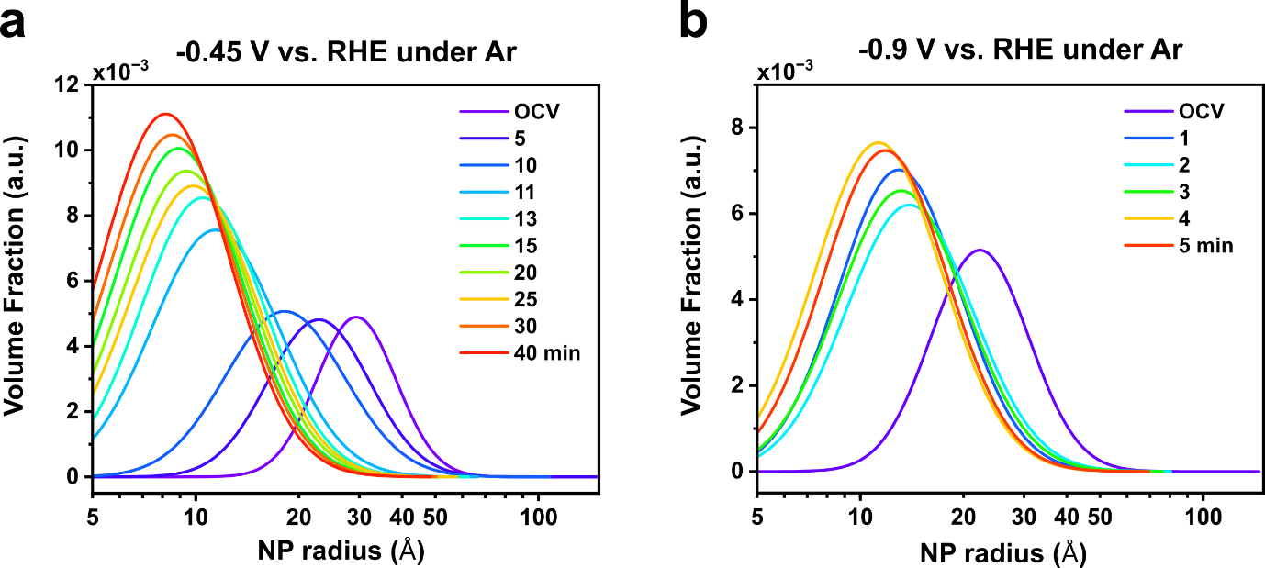

Supplementary Figure 15. Particle size distribution with different applied potentials under Ar conditions. a,b, The estimated size distribution of primary Cu NPs under Ar-purged 0.5 M K_{x}H_{3-x}PO₄ electrolyte at -0.45 V (a) and -0.9 V (b) vs. RHE. The size distributions can be calculated under the assumption of spherical particles (P₁=4) and log-normal distributions.

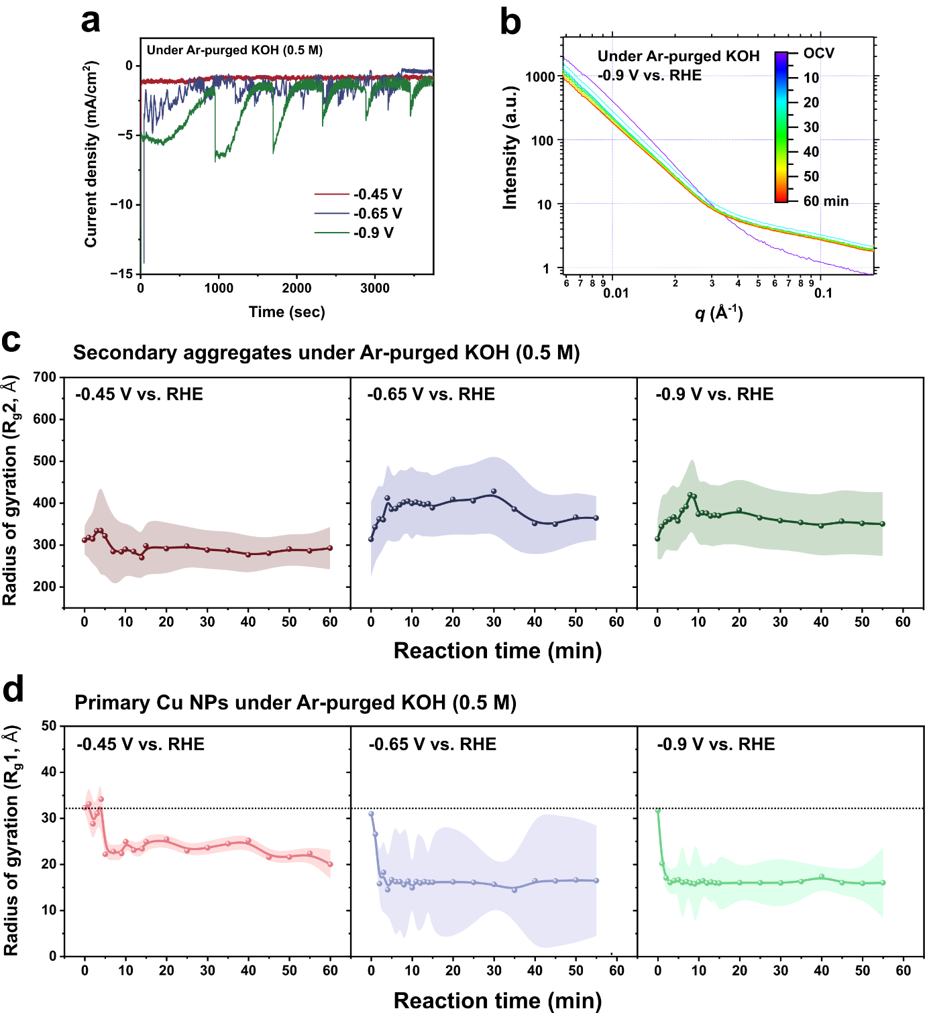

Supplementary Figure 16. In situ SAXS results of Cu NPs electrode under Ar-purged 0.5 M KOH. a, Geometric current densities of a Cu NPs electrode with 5 mM sodium p-toluenesulfonate as a function of the applied potentials. b, Temporal changes in one-dimensional background-subtracted SAXS patterns of the Cu NPs electrode under Ar-purged 0.5 M KOH electrolyte at -0.9 V vs. RHE as a representative example. c,d, Temporal changes in the radius of gyration values of primary Cu NPs (R_{g2}, c) and primary Cu NPs (R_{g1}, d) under Ar-purged 0.5 M KOH electrolyte ranged from -0.45 V to -0.9 V vs. RHE. Error bars result from the fits to the SAXS data. All the data were obtained from in situ SAXS data analysis. The dotted line in d indicates the initial radius of Cu NPs at the OCV state.
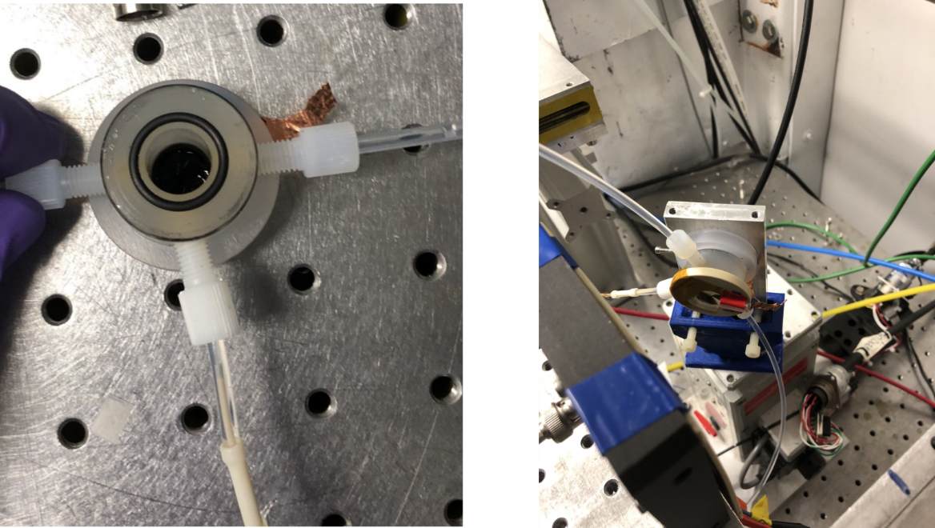

Supplementary Figure 17. The experimental setup for in situ XANES. Pictures of the XAS flow cell installed at SSRL beamline 2-2. The CO₂-purged 0.5 M KHCO₃ electrolyte circulates from the bottom to the top without using anion-exchange membrane separation. A graphite electrode was utilized as an anode.

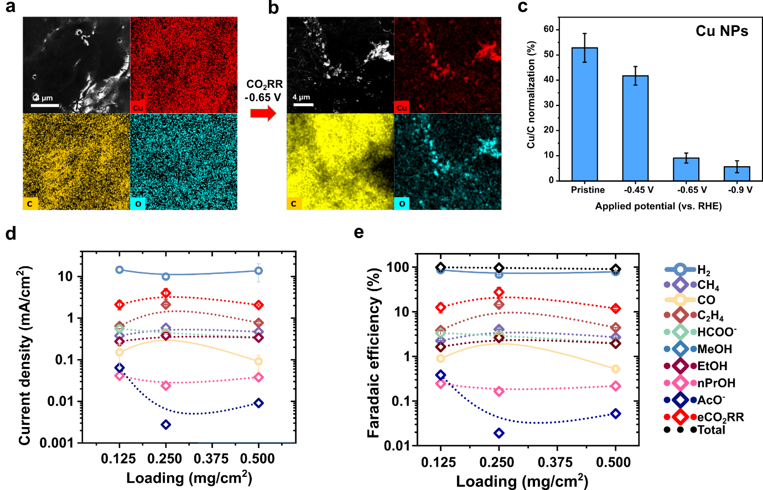

Supplementary Figure 18. The detachment of Cu NPs during the CO₂RR. a,b, EDS elemental analysis of Cu NPs electrode before (a) and after (b) 1 hr of electrolysis at -0.65 V vs RHE under CO₂-purged 0.5 M KHCO₃ electrolyte. c, Quantitative EDS analysis of Cu NPs electrode after 1 hr of electrolysis as a function of the applied potentials. Error bars are one standard deviation of three independent measurements. d,e, Partial current densities (d), and Faradaic efficiency (e) for all the CO₂RR products obtained from the Cu NPs electrode as a function of loading level at -0.9 V in the compressed cell. The y-axis is logarithmic for clarity. Error bars are one standard deviation of three measurements of gas products with the same sample at the indicated reaction conditions; each set of data points for one reaction condition represents one unique sample.

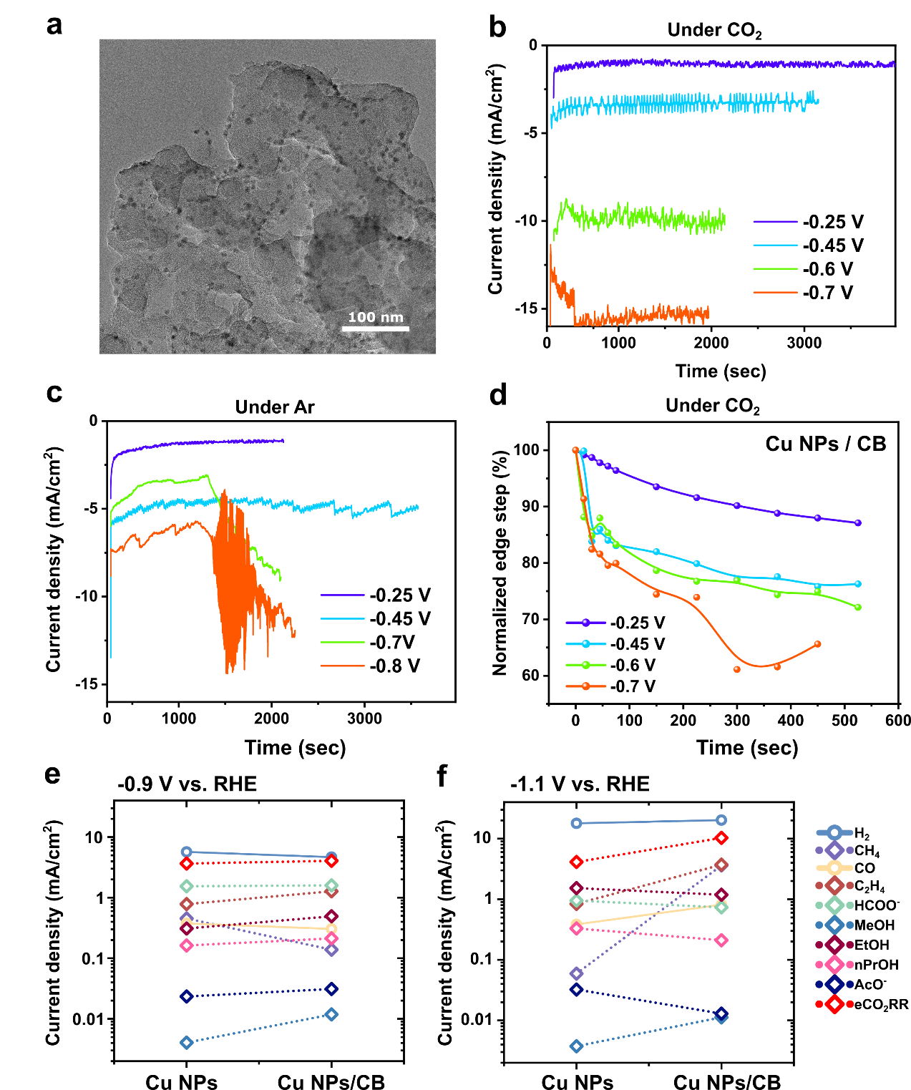

Supplementary Figure 19. Cu NPs supported on carbon black. a, TEM image of Cu NPs supported on carbon black (Cu NPs/CB). b,c, Geometric current densities of Cu NPs/CB as a function of the applied potentials under CO₂-purged 0.5 M KHCO₃ (b) and Ar-purged 0.5 M K_{x}H_{3-x}PO₄ (c) electrolytes. All the measurements were conducted in the XAS flow cell. d, Temporal changes in normalized edge step of Cu NPs/CB electrode depending on the applied potentials. The edge step was calculated from the corresponding in situ XANES data and normalized by the OCV values (t =0 min). All the measurements were conducted in the XAS flow cell. e,f, A comparison of partial current densities for all the CO₂RR products without and with carbon black supports at -0.9 V (e) and -1.1 V (f) under CO₂-purged 0.5 M KHCO₃ electrolyte. The loading level was fixed at 0.125 mg/cm².
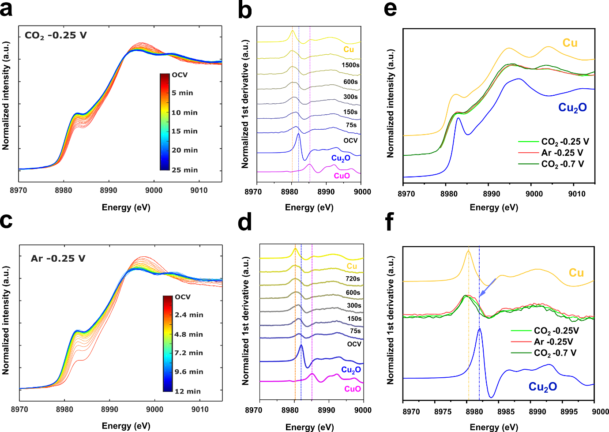

Supplementary Figure 20. Oxidation states of Cu NPs/CB electrode at -0.25 V vs. RHE. a-d, Temporal changes of Cu K-edge XANES spectra and its first derivatives at -0.25 V vs. RHE under CO₂-purged 0.5 M KHCO₃ (a,b) and Ar-purged 0.5 M K_{x}H_{3-x}PO₄ (c,d) electrolytes, respectively. The reference standards of Cu metal (yellow), Cu₂O (blue), and CuO (magenta) are plotted in panels b and d for comparison. e,f, in situ XANES spectra (e) and its first derivative (f) of Cu NPs/CB at -0.25 V vs. RHE after 25 min electrolysis under CO₂ conditions and 12 min electrolysis under Ar conditions. The XANES spectrum of Cu NPs/CB at -0.7 V vs. RHE under CO₂ condition, Cu metal (yellow), and Cu₂O (blue) are plotted for comparison.
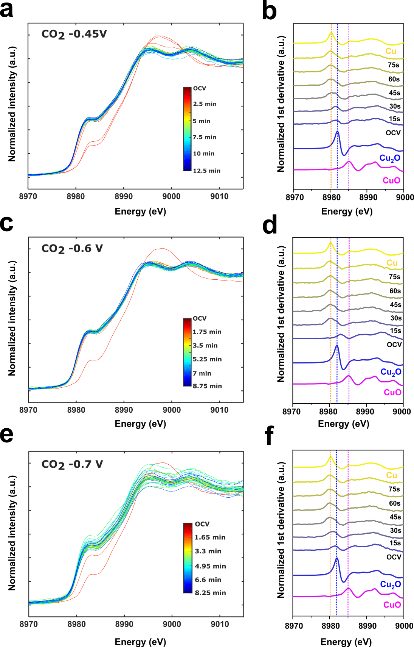

Supplementary Figure 21. Oxidation states of Cu NPs/CB electrodes during CO₂RR. a-f, Temporal changes of Cu K-edge XANES spectra and the first derivative of the corresponding XANES spectra acquired at -0.45 V (a,b), -0.6 V (c,d), and -0.7 V (e,f) vs. RHE under CO₂-purged 0.5 M KHCO₃ electrolyte. The reference standards Cu metal (yellow), Cu₂O (blue), and CuO (magenta) are plotted for comparison. The data in panels b,d, and f are derived from XANES spectra in panels a,c, and e, respectively.
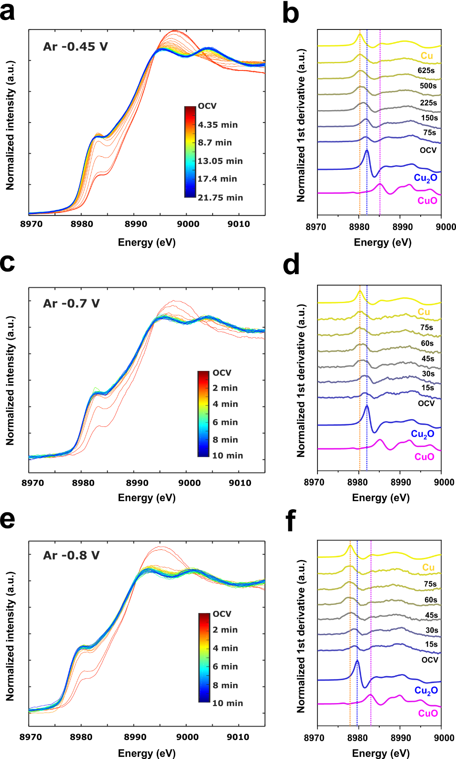

Supplementary Figure 22. Oxidation states of Cu NPs/CB electrodes under Ar-purged electrolyte. a-f, Temporal changes of Cu K-edge XANES spectra and the first derivative of the corresponding XANES spectra acquired at -0.45 V (a,b), -0.7 V (c,d), and -0.8 V (e,f) vs. RHE under Ar-purged 0.5 M K_{x}H_{3-x}PO₄ electrolyte. The reference standards Cu metal (yellow), Cu₂O (blue), and CuO (magenta) are plotted for comparison. The data in panels b,d, and f are derived from XANES spectra in panels a,c, and e, respectively.
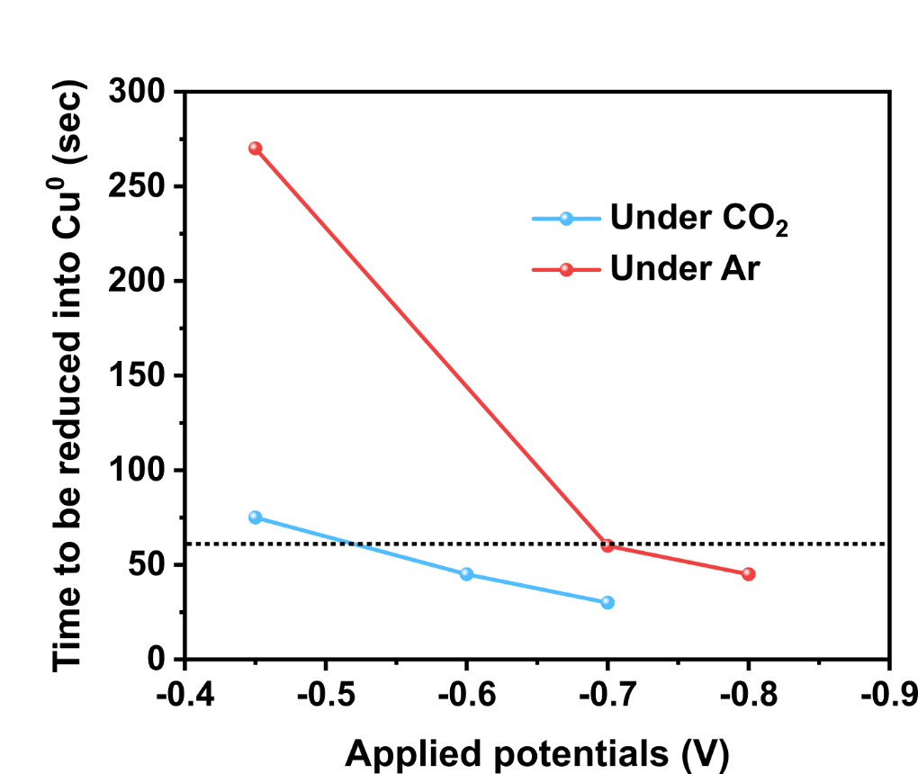

Supplementary Figure 23. Reduction of Cu NPs into metallic Cu⁰ states. The time required to be reduced fully into the metallic Cu states was estimated by comparing it to the reference XANES spectra. The last XANES spectrum that showed no further changes over time was selected and its first derivative was compared with those of reference spectra to confirm the oxidation states. The dotted line indicates the time required to acquire the first SAXS data after applying potentials (60 sec).

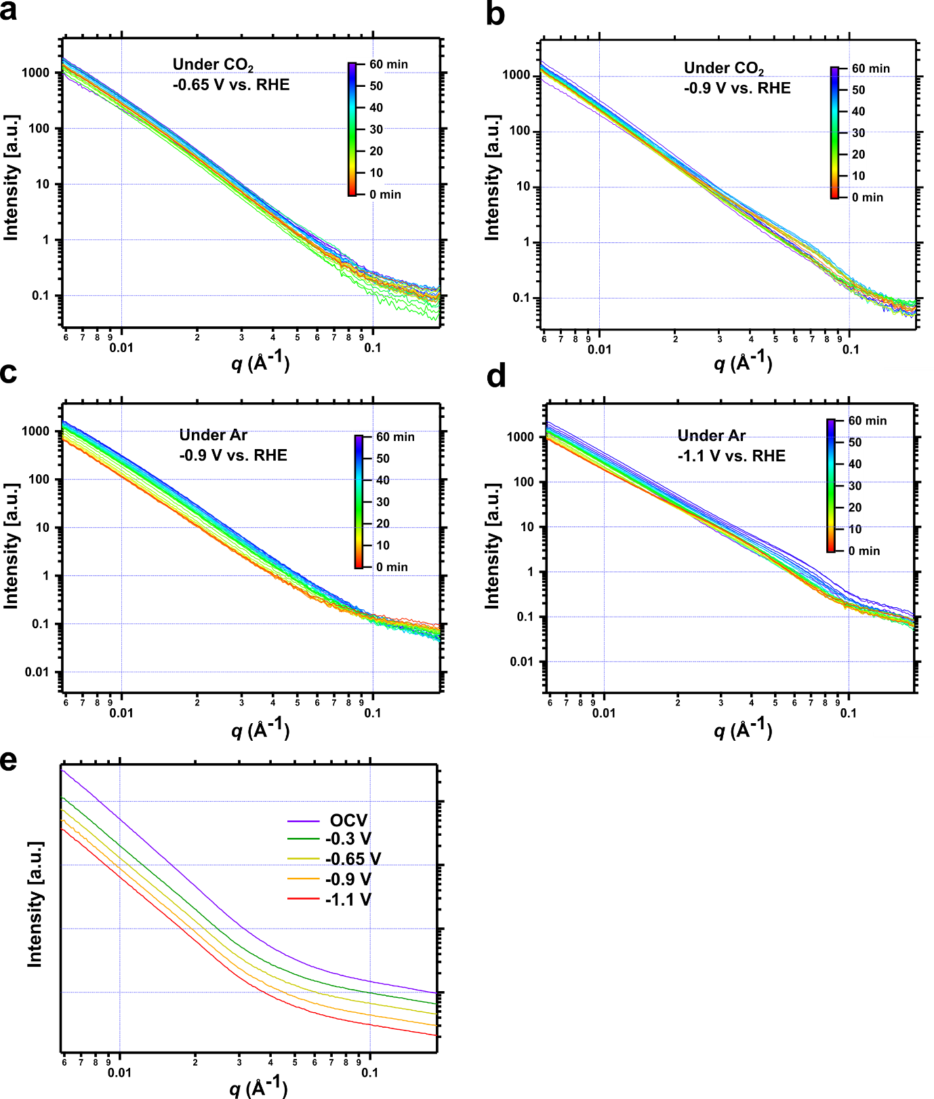
Supplementary Figure 24. In situ SAXS pattern of Cu NPs / CB under different reaction conditions. a-d, Temporal changes in background-subtracted SAXS patterns of the Cu NPs/CB electrode under CO₂-purged 0.5 M KHCO₃ electrolyte at -0.65 V (a) and -0.9 V (b) vs. RHE, and under Ar-purged K_{x}H_{3-x}PO₄ electrolyte at -0.9 V (c), and -1.1 V (d) vs. RHE. e, One-dimensional SAXS pattern of CB deposited on the graphite foil as a function of the applied potentials. The CO₂-purged 0.5 M KHCO₃ electrolyte was circulated through the in situ cell and the collected SAXS patterns were used for background subtraction. Both axes are logarithmic and patterns are offset for clarity.

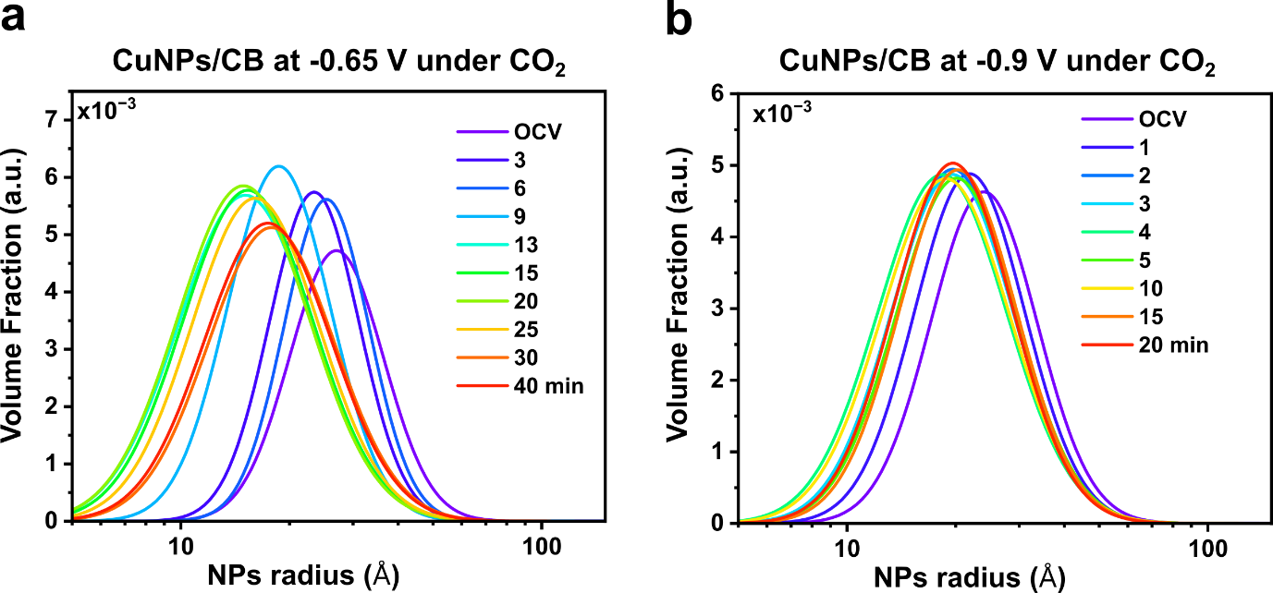

Supplementary Figure 25. Particle size distribution of Cu NPs/ CB with different applied potentials. a,b, The estimated size distribution of primary Cu NPs supported on carbon black under CO₂-purged 0.5 M KHCO₃ electrolyte at -0.65 V (a) and -0.9 V (b) vs. RHE. The size distributions can be calculated under the assumption of spherical particles (P₁=4) and log-normal distributions. In the case of the sample run at -0.65 V, the calculated NP radius was decreased as the reaction proceeded. However, the R_{g1} values of Cu NPs/CB run at -0.65 V remained at ~33 Å with an error range of up to ~12 Å throughout the reaction time (Fig, 5a). This difference comes from the assumption of the P₁ value when the global unified fit method was used. When the size distribution of primary Cu NPs was calculated, the same fitting process was repeated except the P₁ value was fixed as 4.

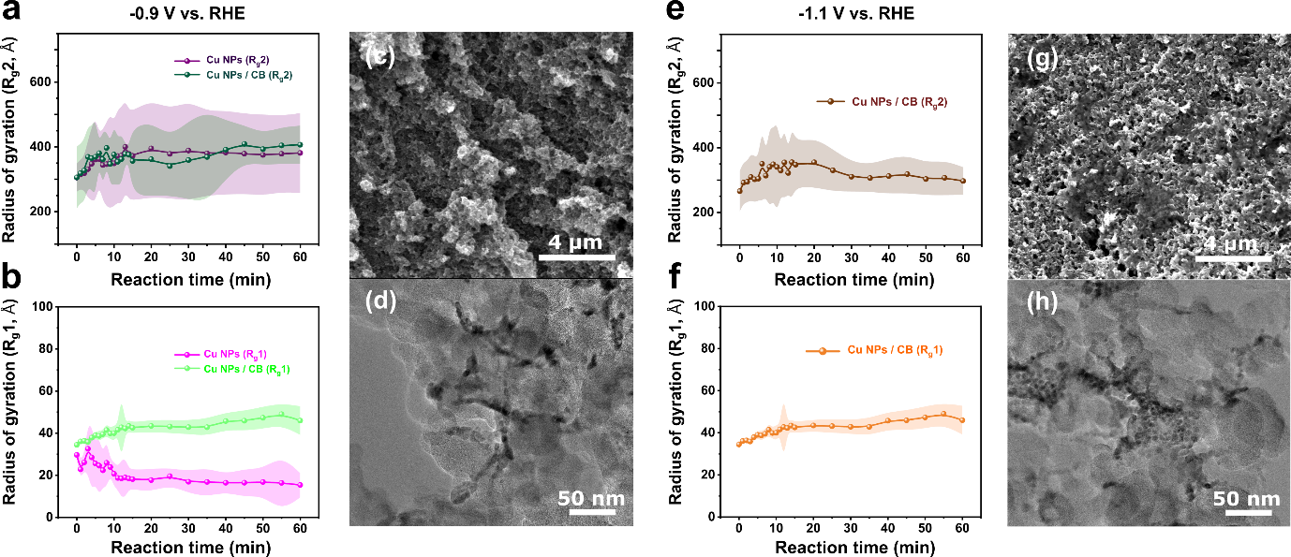

Supplementary Figure 26. In situ SAXS results of Cu NPs/CB electrode under Ar conditions. a,b Temporal changes in the R_{g} values of primary Cu NPs (a) and secondary aggregates (b) of Cu NPs/CB electrode as a function of the reaction time at -0.9 V under Ar-purged 0.5 M K_{x}H_{3-x}PO₄ electrolyte. (c,d) Post-mortem ex situ SEM (c) and TEM image (d) of Cu NPs/CB electrodes under the Ar-purged K_{x}H_{3-x}PO₄ electrolyte at -0.9 V. a,b Temporal changes in the R_{g} values of primary Cu NPs (e) and secondary aggregates (f) of Cu NPs/CB electrode as a function of the reaction time at -1.1 V under Ar-purged 0.5 M K_{x}H_{3-x}PO₄ electrolyte. (g,h) Post-mortem ex situ SEM (g) and TEM image (h) of Cu NPs/CB electrodes under the Ar-purged K_{x}H_{3-x}PO₄ electrolyte at -1.1 V.
The R_{g2} values of the Cu NPs/CB electrode at -0.9 V were found to be similar to those of the unsupported Cu NPs electrode. However, the R_{g1} values of the former electrode did not show any significant reduction during the operation, suggesting that the primary Cu NPs supported on carbon black exhibited greater resistance to the rapid broadening of particle size due to OR processes. Similar trends were also observed for samples operated under CO₂-purged 0.5 M KHCO₃ electrolyte. Furthermore, the Cu NPs/CB electrode operated at -1.1 V showed structural changes comparable to those of the Cu NPs/CB electrode operated at -0.9 V, indicating the potential of carbon supports and Nafion binder in mitigating the agglomeration of Cu NPs.

Table S1. Unified fitting parameters
Data  Curve | Level 1  (Primary Cu NPs) |  |  |  | Level 2  (Secondary aggregates) |  |  |  |  | Background intensity  [cm⁻¹] | Fitted  Q  ranges  [Å⁻¹]
 | G  [cm⁻¹] | R_{g}  [Å] | B  [cm⁻¹ Å⁻⁴] | P  [a.u.] | G  [cm⁻¹] | R_{g}  [Å] | B  [cm⁻¹ Å^{-P2}] | P  [a.u] | Invariant Q  [cm⁻¹ Å⁻³] | Background intensity  [cm⁻¹] | Fitted  Q  ranges  [Å⁻¹]
Figure 1c,d | 5.34  ± 1.95 | 31.99 ± 3.53 | 4.57e-5 ±3.94e-6 | 4 | 18984  ± 3129 | 317.62 ± 20.17 | 1.56e-4  ± 1.37e-5 | 3.52  ± 0.02 | 3.01e21 | 0.03  ± 0.01 | 0.006~0.18
Figure S3a | 3.28  ± 0.54 | 30.20 ± 1.58 | 1.71e-5 ±6.72e-6 | 4 | 5718.2  ± 1349 | 301.83 ± 30.21 | 6.37e-5  ± 1.04e-5 | 3.52  ± 0.04 | 1.13e21 | 0.12  ± 0.01 | 0.006~0.18

References
1 Beaucage, G. in Polymer Science: A Comprehensive Reference (eds Krzysztof Matyjaszewski & Martin Möller) 399-409 (Elsevier, 2012).
2 Beaucage, G. & Schaefer, D. W. Structural studies of complex systems using small-angle scattering: a unified Guinier/power-law approach. J. Non-Cryst. Solids 172-174, 797-805 (1994).
3 Beaucage, G. Small-Angle Scattering from Polymeric Mass Fractals of Arbitrary Mass-Fractal Dimension. J. Appl. Crystallogr. 29, 134-146 (1996).
4 Kammler, H. K., Beaucage, G., Kohls, D. J., Agashe, N. & Ilavsky, J. Monitoring simultaneously the growth of nanoparticles and aggregates by in situ ultra-small-angle x-ray scattering. J. Appl. Phys. 97, 054309 (2005).
5 Koga, T. et al. New Insight into Hierarchical Structures of Carbon Black Dispersed in Polymer Matrices: A Combined Small-Angle Scattering Study. Macromolecules 41, 453-464 (2008).
6 Ilavsky, J. & Jemian, P. R. Irena: tool suite for modeling and analysis of small-angle scattering. J. Appl. Crystallogr. 42, 347-353 (2009).
7 Beaucage, G., Kammler, H. K. & Pratsinis, S. E. Particle size distributions from small-angle scattering using global scattering functions. J. Appl. Crystallogr. 37, 523-535 (2004).
8 Birdja, Y. Y. et al. Advances and challenges in understanding the electrocatalytic conversion of carbon dioxide to fuels. Nat. Energy 4, 732-745 (2019).
9 Ma, M. et al. Insights into the carbon balance for CO₂ electroreduction on Cu using gas diffusion electrode reactor designs. Energy Environ. Sci. 13, 977-985 (2020).
10 Yang, K., Kas, R. & Smith, W. A. In Situ Infrared Spectroscopy Reveals Persistent Alkalinity near Electrode Surfaces during CO₂ Electroreduction. J. Am. Chem. Soc. 141, 15891-15900 (2019).
11 Celante, V. G. & Freitas, M. B. J. G. Electrodeposition of copper from spent Li-ion batteries by electrochemical quartz crystal microbalance and impedance spectroscopy techniques. J. Appl. Electrochem. 40, 233-239 (2010).
12 Speck, F. D. & Cherevko, S. Electrochemical copper dissolution: A benchmark for stable CO₂ reduction on copper electrocatalysts. Electrochem. Commun. 115, 106739 (2020).
13 Vavra, J., Shen, T.-H., Stoian, D., Tileli, V. & Buonsanti, R. Real-time Monitoring Reveals Dissolution/Redeposition Mechanism in Copper Nanocatalysts during the Initial Stages of the CO₂ Reduction Reaction. Angew. Chem. Int. Ed. 60, 1347-1354 (2021).
14 Kuhl, K. P., Cave, E. R., Abram, D. N. & Jaramillo, T. F. New insights into the electrochemical reduction of carbon dioxide on metallic copper surfaces. Energy Environ. Sci. 5, 7050-7059 (2012).
15 Kim, D. et al. Selective CO₂ electrocatalysis at the pseudocapacitive nanoparticle/ordered-ligand interlayer. Nat. Energy 5, 1032-1042 (2020).
16 Pankhurst, J. R., Iyengar, P., Loiudice, A., Mensi, M. & Buonsanti, R. Metal–ligand bond strength determines the fate of organic ligands on the catalyst surface during the electrochemical CO₂ reduction reaction. Chem. Sci. 11, 9296-9302 (2020).

