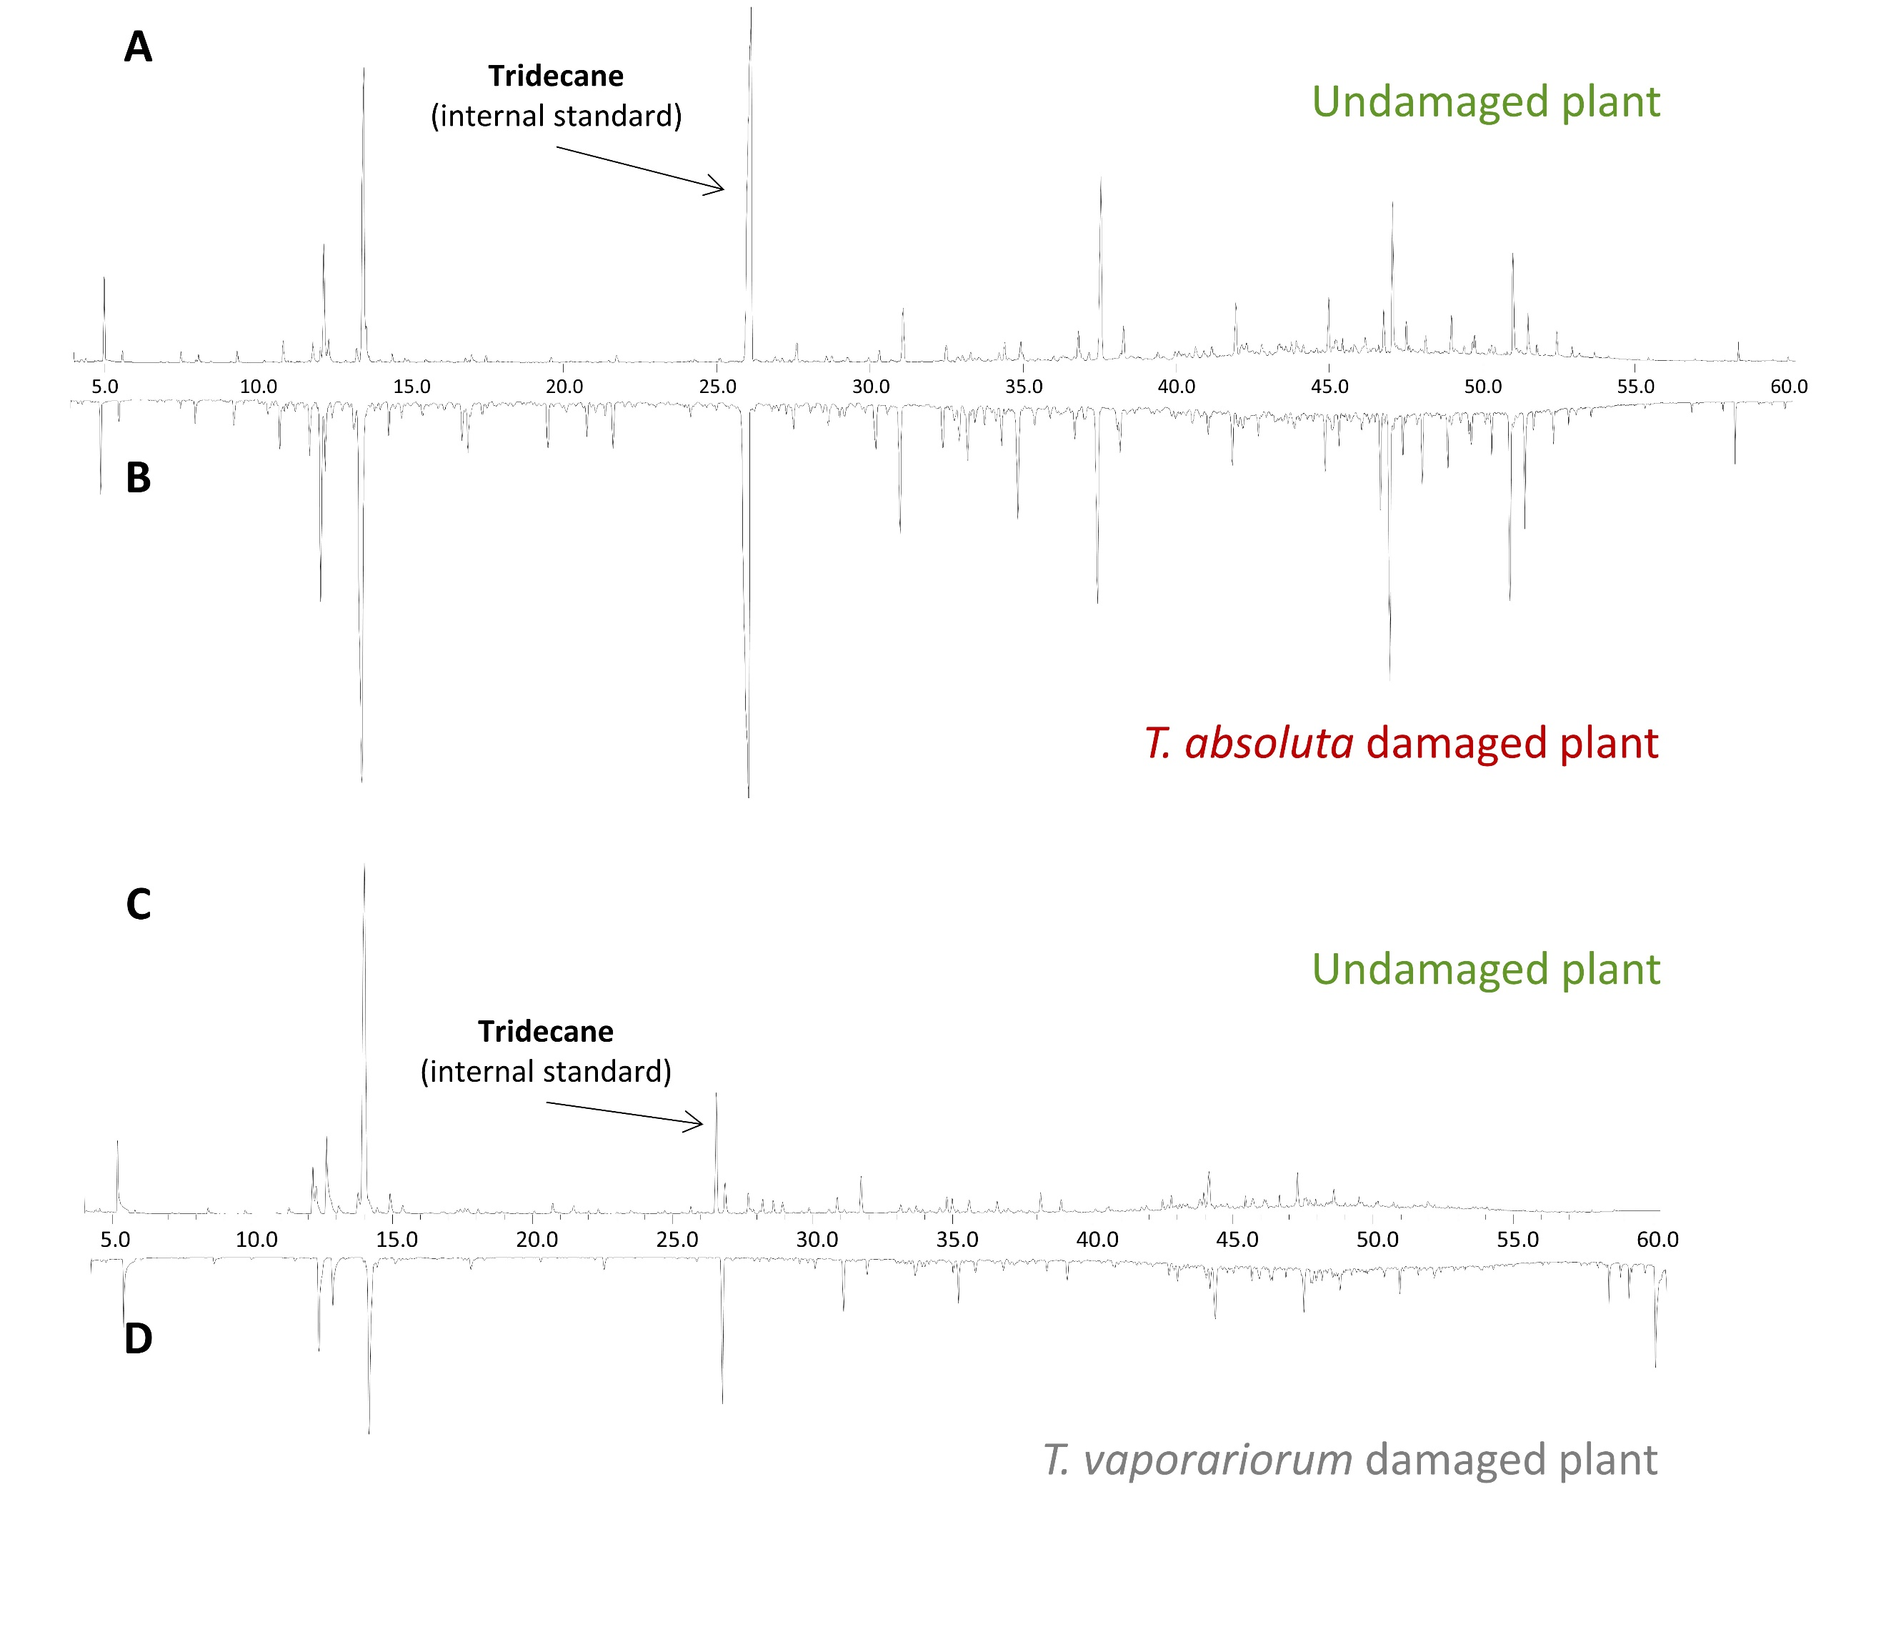
Fig. S1: Representative GC traces of volatile collections from undamaged plants before being damaged by T. absoluta (A) and the same plant after T. absoluta damage (B); and from undamaged plants before being damaged by T. vaporariorum (C) and the same plant after T. vaporariorum damage (B).
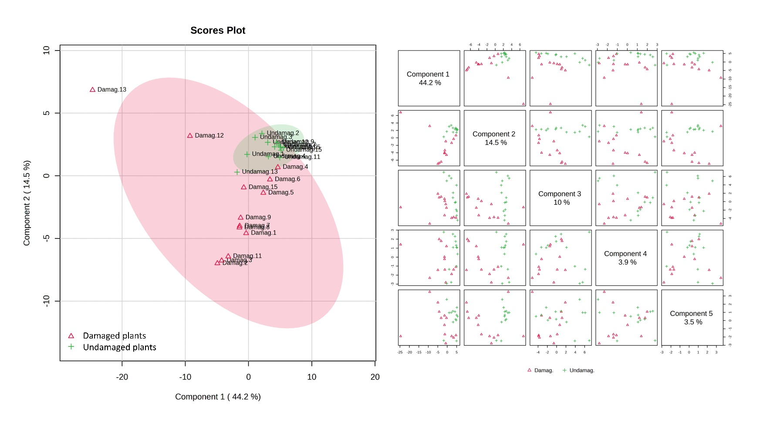
Fig. S2: PCA (singular value decomposition) of undamaged vs. T. absoluta damaged plants volatiles. The explained variances are shown in brackets.

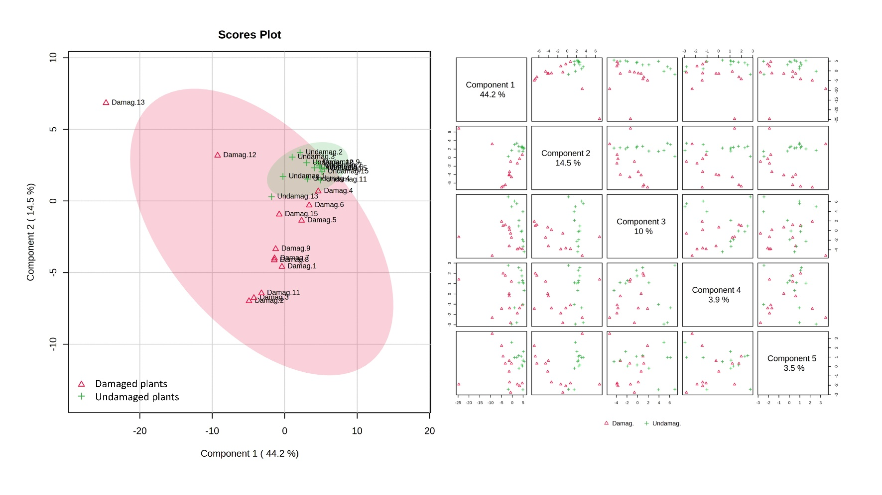
Fig. S3: PLS-DA of undamaged vs. T. absoluta damaged plants volatiles. The explained variances are shown in brackets.

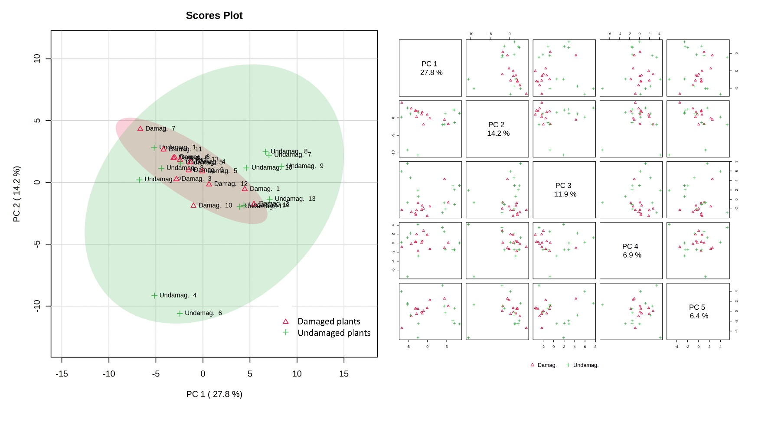
Fig. S4: PCA (singular value decomposition) of undamaged vs. T. vaporariorum damaged plants volatiles. The explained variances are shown in brackets.

