Supplementary materials.
Annex 1
Definition of terms
BCG: Bacillus Calmette–Guérin vaccine
Penta 3: Third dose of pentavalent vaccination
MCV1: Measles containing vaccine one.

Maternal health service coverage estimation method from EDHS data
EDHS data was used to triangulate routine health facility data in determining maternal health service utilization.
Before estimating maternal health service coverage from EDHS data of 2000 to 2019, we have generated poverty status from EDHS survey
We used EDHS data from 2000 to 2019 within the Addis Ababa urban cluster, among all births occurring in the previous five years. The EDHS intervention coverage indicators like ANC4 or more visits, iron folic supplementation, skilled birth attendance, caesarian section and postnatal care were determined. For iron folic supplementation we looked at supplementation during pregnancy, skilled attendance, whose birth was attended by health professional categories MOH accredited, and C-section is delivery conducted through surgical procedure. We also look at PNC within 48 hours for the mother.
Analyses of coverage indicators were disaggregated between the poorer 40% and richer 60%, using the wealth index score re-calculated for urban Addis Ababa only. The wealth index scores are created by DHS based on the assets for rural and urban places of residence separately, using a principal component analysis of dwelling materials, access to utilities and household assets. The use of 40% poorer aligns well with the proportion of the population living below standard of UNHABITAT.
Before running the Stata syntax, variables were created for the analysis. ANC4 was created using gen ANC4=m14_1 if midx_1==1 // recode ANC4 4/20=1 nonmiss=0(no,1-3,DK)
To create PNC within 2days for mother (5yrs preceding the survey) was created using the following syntax: recode rh_pnc_wm_timing (1= 1 "visit w/in 2 days") (0 2/4 9 = 0 "No Visit w/in 2 days"), g(rh_pnc_wm_2days)
label var rh_pnc_wm_2days "PNC check within two days for mother"
Finally, we have used STATA code “svy: mean variable, over (wealth) (running mean on estimation sample)” to generate service coverage, SE and CI over wealth status (poorer bottom 40% and richer top 60%).
Child immunization coverage was not estimated from EDHS data, as child immunization coverage remains high both in bottom 40% and top 60% districts from DHIS 2.

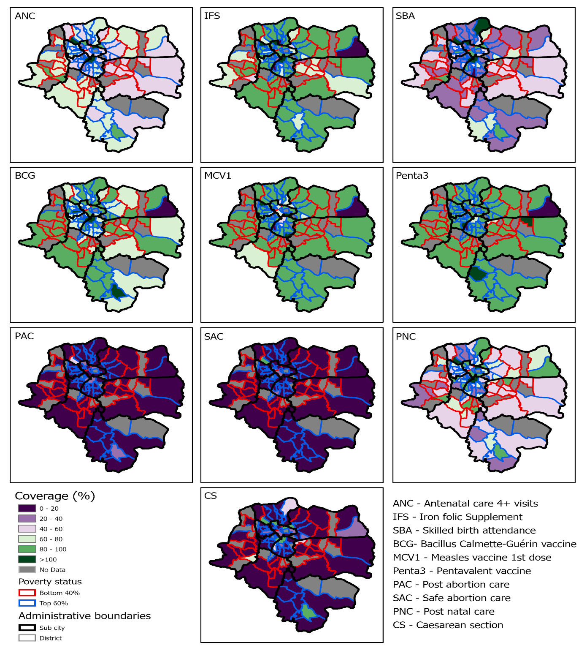
Figure 4: Geospatial distribution of maternal and child health services coverage at the district level from 2019 to 2021.

Comparing maternal health service coverage from EDHS and DHIS 2 data
The below figure compares trend of maternal health service coverage from EDHS and DHIS 2. Accordingly, in both cases maternal health service coverage is higher in top 60% than bottom 40%.

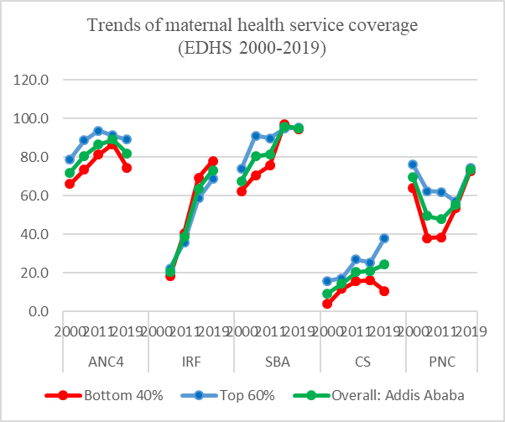
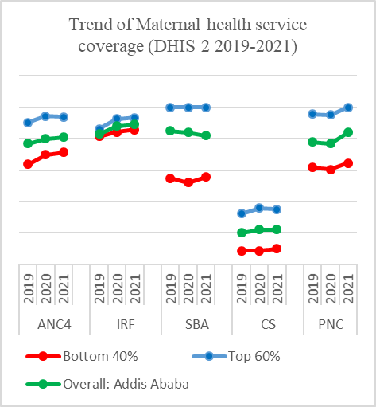

Figure 7: Comparing maternal health service coverage from EDHS 2000-2019 and DHIS 2 2019-2021 data.

Table2: Maternal health service coverage (EDHS 2000-2019) among bottom 40% and top 60% and 95% CL
variable | EDHS years | Bottom 40% | LB | UB | Top 60% | LB | UB
ANC4 | 2000 | 66.0 | 57.2 | 74.8 | 78.9 | 71.8 | 86.2
ANC4 | 2005 | 73.4 | 66.1 | 80.7 | 88.7 | 83.4 | 94.1
ANC4 | 2011 | 81.2 | 74.7 | 87.7 | 93.6 | 89.9 | 97.3
ANC4 | 2016 | 86.6 | 80.5 | 92.7 | 91.2 | 87.3 | 95.1
ANC4 | 2019 | 74.5 | 68.3 | 80.8 | 89.1 | 84.7 | 93.5
IRF | 2000
IRF | 2005 | 18.2 | 11.3 | 25.5 | 22.4 | 14.5 | 30.3
IRF | 2011 | 40.7 | 32.5 | 48.9 | 35.9 | 27.7 | 44.1
IRF | 2016 | 69.4 | 60.3 | 78.4 | 58.7 | 51.2 | 66.2
IRF | 2019 | 77.9 | 71.8 | 84.1 | 68.7 | 57.1 | 80.3
SBA | 2000 | 62.3 | 54.1 | 70.5 | 73.9 | 66.5 | 81.3
SBA | 2005 | 70.6 | 60.9 | 80.3 | 91.1 | 85.9 | 96.3
SBA | 2011 | 75.6 | 66.7 | 84.5 | 89.7 | 84.7 | 94.7
SBA | 2016 | 97.0 | 94.6 | 99.4 | 94.8 | 91.8 | 97.9
SBA | 2019 | 94.2 | 91.6 | 97.0 | 95.4 | 92.2 | 98.7
CS | 2000 | 3.9 | 1.4 | 6.3 | 15.7 | 10.6 | 20.7
CS | 2005 | 11.7 | 5.1 | 18.3 | 17.1 | 10.5 | 23.6
CS | 2011 | 15.5 | 9.7 | 21.2 | 26.9 | 17.5 | 36.2
CS | 2016 | 16.2 | 10.9 | 21.4 | 25.4 | 18.9 | 31.7
CS | 2019 | 10.5 | 4.2 | 16.8 | 37.9 | 29.2 | 46.7
PNC | 2000 | 63.8 | 56.0 | 71.6 | 76.1 | 68.4 | 83.7
PNC | 2005 | 37.9 | 28.1 | 47.9 | 62.4 | 53.4 | 71.4
PNC | 2011 | 38.5 | 28.3 | 48.6 | 61.8 | 49.4 | 74.1
PNC | 2016 | 53.7 | 40.4 | 67.1 | 56.8 | 45.9 | 67.6
PNC | 2019 | 72.8 | 59.9 | 85.8 | 74.2 | 64.2 | 84.2

