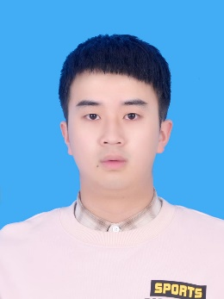
Linbei Jiang is a Master's student in the School of Mechanical Engineering, Hangzhou Dianzi University. His research interests are in the area of product Digital twins.

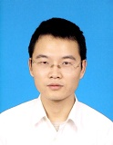
Shaohui Su completed his Ph.D. degree at Zhejiang University in 2007. He is currently a professor in the School of Mechanical Engineering at Hangzhou Dianzi University. His research subjects are engaged in Multi-domain unified modeling theory and technology, Mass customization and Digital twins technology.

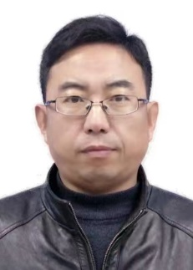
Changyong Chu is an associate professor from Hangzhou Dianzi University. He obtained his Ph. D from Nanyang Technological University. His area of research includes Model Base System Engineering, Digital Thread, and Intelligent manufacturing.

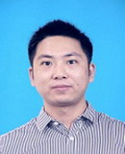
Chang Chen completed his Ph.D. degree at Huanzhong University of Science and Technology in 2013. He is currently a professor in the School of Mechanical Engineering at Hangzhou Dianzi University. His research subjects are engaged in Multi-domain unified modeling theory and technology, the design and application of soft robots, and electromechanical integration technology

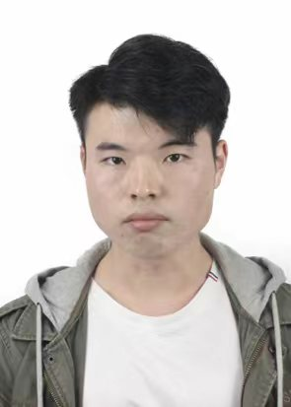
Wei Wang is a Master's student in the School of Mechanical Engineering, Hangzhou Dianzi University. His main research interest is digital twin modeling and simulation of production line

