Supplementary Information

Combined antifungal activity of cyclic lipopeptides and cinnamon extract: From in vitro experiments to the control of Fusarium wilt of banana

- Julieta M Ramírez-Mejía^{a,c}, Carolina Aguilera-Galvez^{b}, Gert H. J. Kema^{b}, Sebastián Zapata-Henao^{c}, Luis A. Gómezª, Valeska Villegas-Escobar^{a*}

ªCIBIOP group, School of Applied Sciences and Engineering, Universidad EAFIT, Crr 49 No 7 Sur 50, Medellín, Antioquia, Colombia.
^{b}Wageningen University and Research, Laboratory of Phytopathology, Wageningen, The Netherlands.
^{c}Asociación de Bananeros de Colombia, AUGURA- Centro de Investigaciones del Banano CENIBANANO. Carepa- Colombia.

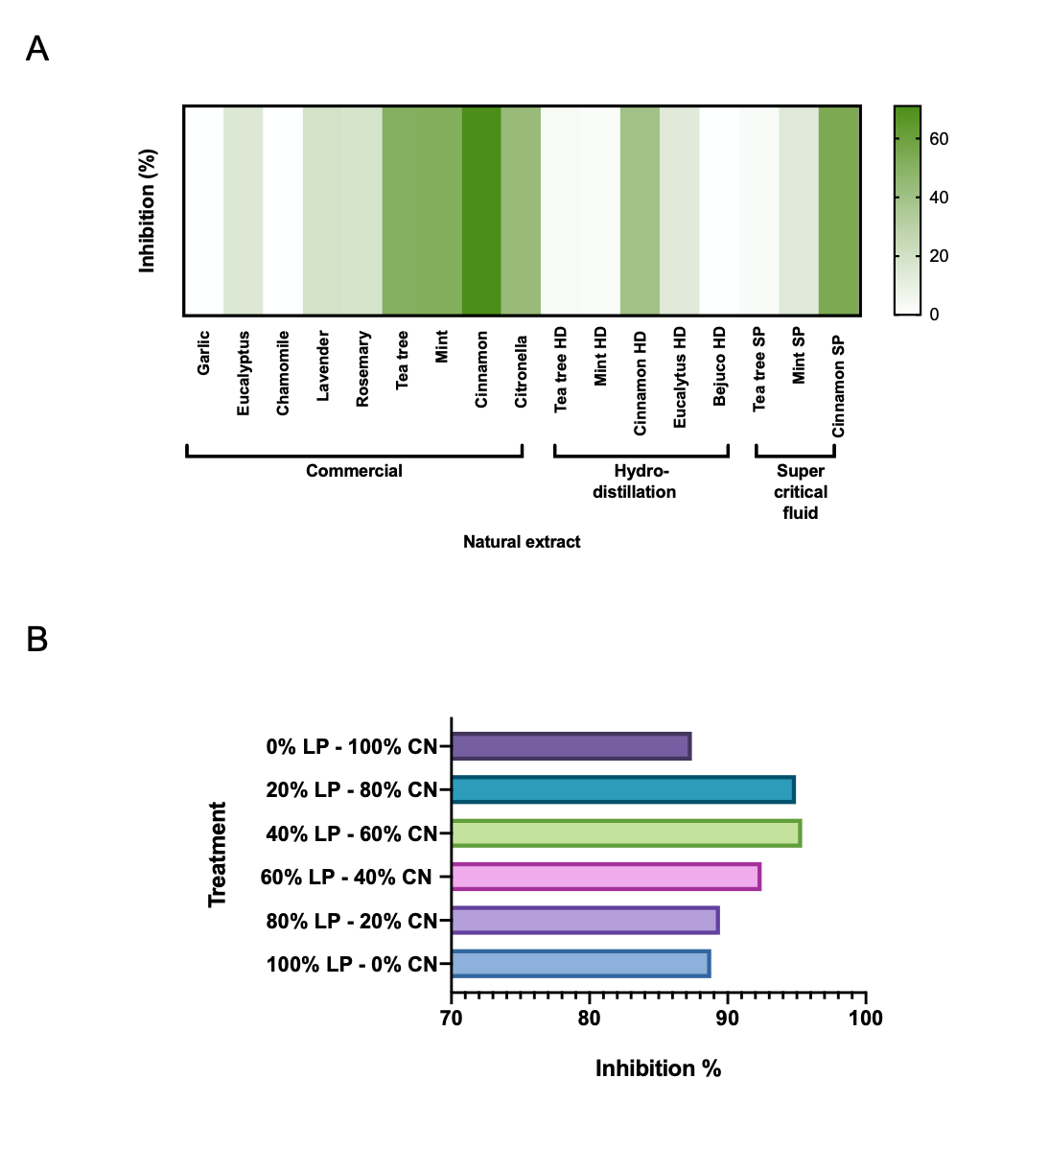

Fig. S1. Bioprospecting the antifungal effect of natural extracts against Fusarium oxysporum f. sp. cubense (IB). The inhibition (%) of fungal growth after treatments with 17 natural extracts (A) or after combined treatments of lipopeptides (64 ppm) and cinnamon extract using the hydro-distillation method (122 ppm) (B).

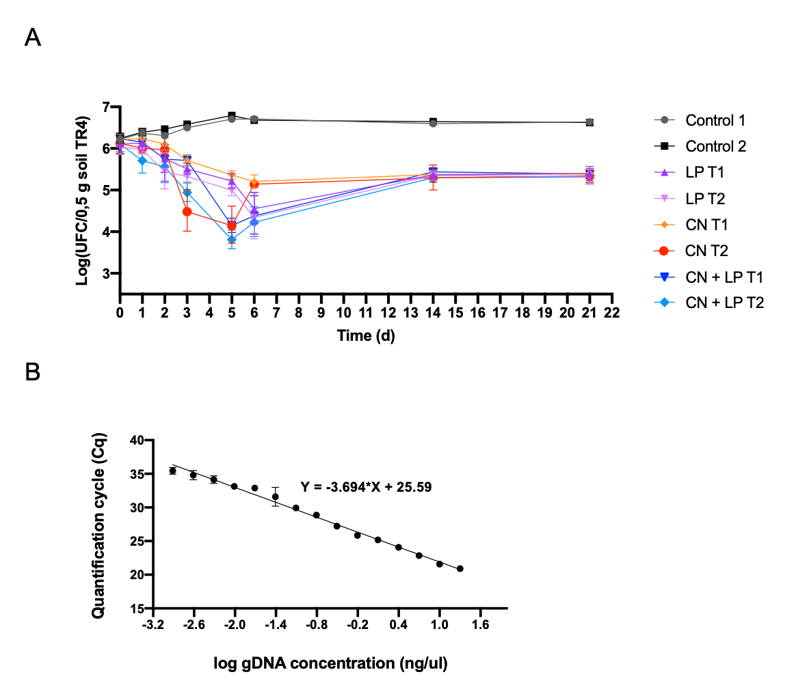

Fig. S2. (A) Dynamic analysis of TR4 during treatments with lipopeptides (LP) T1:128ppm and T2: 256ppm, cinnamon (CN) T1:244ppm and T2: 488ppm, CN + LP T1: cinnamon (244ppm) and lipopeptides (64ppm), and CN + LP T2: cinnamon (488ppm) and lipopeptides (128ppm) after 21 days. (B) Standard curve of the TR4-II5:GFP qPCR assay showing DNA concentration (ng) against the cycle threshold (Ct) values of a single qPCR run. The amount of DNA on the X-axis was plotted against the Ct values from 15 to 40 on the Y-axis. Linear regression equation of the standard curve was Y = -3.69X + 25.59.

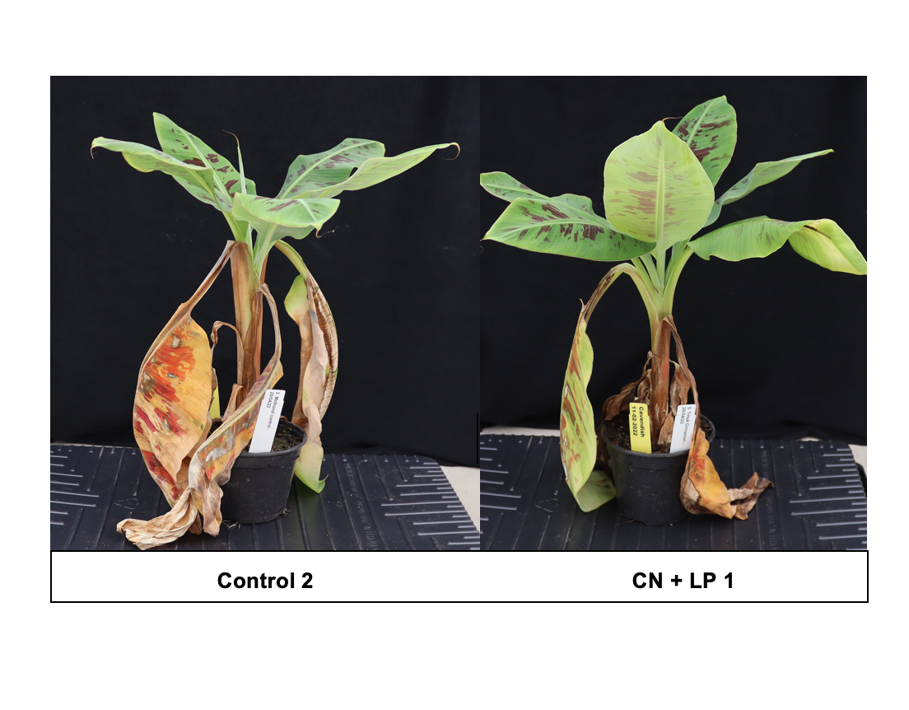

Fig. S3. External FWB symptoms of Cavendish banana plants after treatment with cinnamon and lipopeptides (CN + LP 1) 42 days after infection with TR4, compared to the control (Methanol + TR4).

