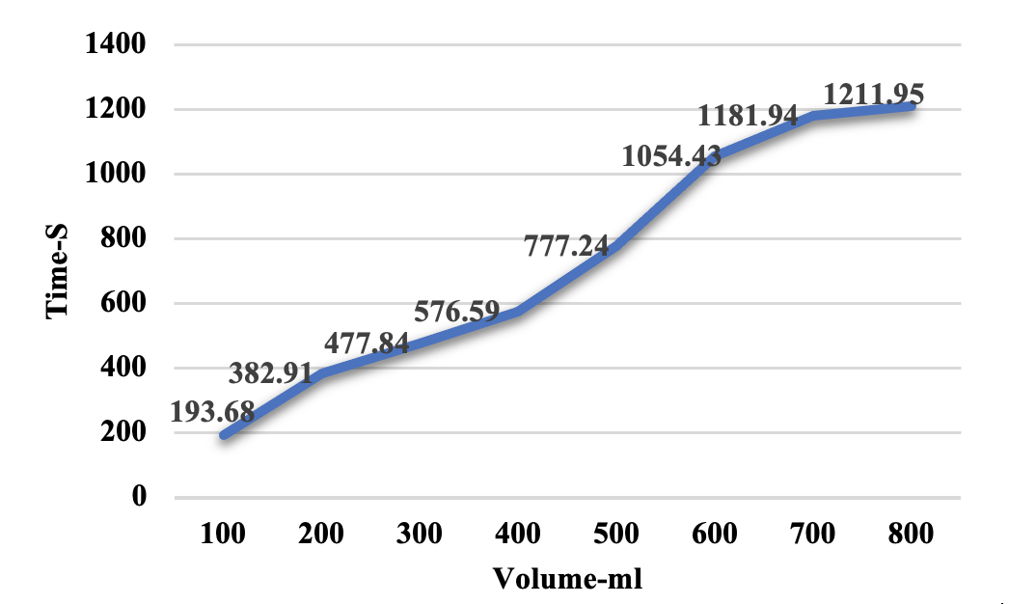 | 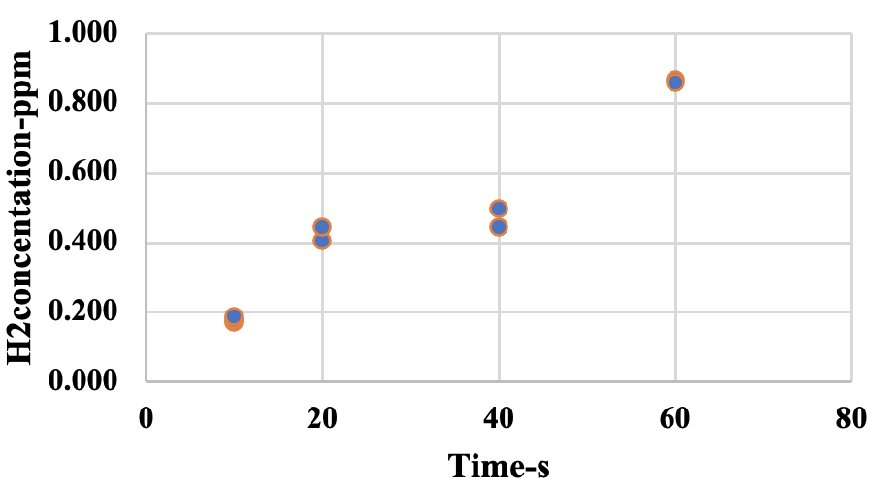
(a) | (b)
Figure 1. The rate of hydrogen production (ml/s) (a) and the scatterplot of hydrogen production with H₂ concentration (ppm) as a function of time (s) (b).

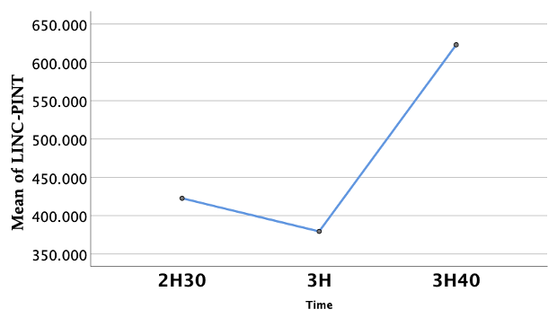 | 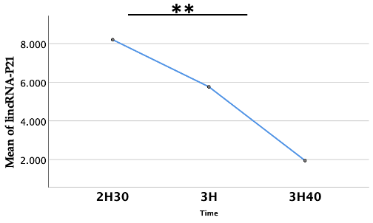
(a1) | (b1)
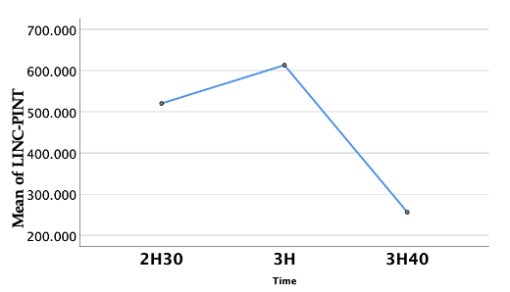 | 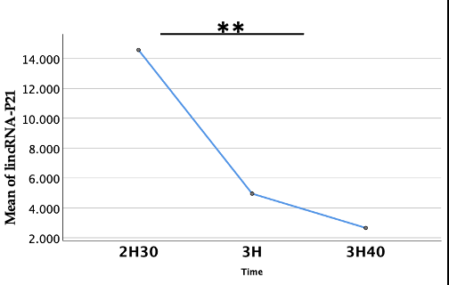
(a2) | (b2)
Figure 2. Expression of LINC-PINT (a) and lincRNA-P21 (b) in lung cancer cells after treatment with two H₂ concentrations for different time periods. (a1) 5% H₂ treatment for LINC-PINT; (a2) 10% H₂ treatment for LINC-PINT; (b1) 5% H₂ treatment for lincRNA-P21; (b2) 10% H₂ treatment for lincRNA-P21; Y-axis represents the mean of relative concentration levels (subtract the concentration of the reference gene-GAPDH) of LINC-PINT (a) and lincRNA-P21 (b); “*” indicates statistical difference (P<0.05) and “**” indicates significantly statistical difference (P<0.01).

