The Temozolomide-Doxorubicin paradox in Glioblastoma
in vitro-in silico preclinical drug-screening

Mariam-Eleni Oraiopoulou ^{1,2}, Eleftheria Tzamali ¹, Stylianos E. Psycharakis ^{3,4}, Giorgos Tzedakis ¹, Takis Makatounakis ⁵, Katina Manolitsi ⁶, Elias Drakos ^{4,6}, Antonis F. Vakis ^{4,6}, Giannis Zacharakis ³, Joseph Papamatheakis ^{5,7}, and Vangelis Sakkalis ^{1,*}
¹ Institute of Computer Science (ICS), Foundation for Research and Technology-Hellas (FORTH), Greece
² Cancer Research UK – Cambridge Institute, University of Cambridge, United Kingdom
³ Institute of Electronic Structure and Laser (IESL), Foundation for Research and Technology Hellas (FORTH), Greece
⁴ School of Medicine, University of Crete, Greece
⁵ Institute of Molecular Biology and Biotechnology (IMBB), Foundation for Research and Technology Hellas (FORTH), Greece
⁶ University General Hospital of Heraklion (PAGNI), Greece
⁷ Department of Biology, University of Crete, Greece
* Corresponding author: Vangelis Sakkalis (sakkalis@ics.forth.gr)

Supporting Information Text
In vitro-in silico drug-response study

We aim to provide a mathematical description of how in vitro spheroids evolve and respond to chemotherapeutic treatment. A simplistic description is provided, which however accounts for the most relevant underlying biological processes and which could be calibrated (at some extent) by the experimental data. Unconstrained parameters, which are not experimentally measured, are explored within the mathematical framework for their impact on spheroid dynamics.
We utilized parameter values measured in 2D in vitro cultures (i.e. proliferation rate, spontaneous death rate, drug response). The dose-response curve for each drug is converted to a dose-dependent probability for an event to occur (detailed description is provided in the following section). We computationally developed a spatiotemporal model for predicting drug responses in monotherapy (DOX, TMZ). A hybrid discrete-continuous mathematical approach is adopted. To resemble the 3D growth, the model accounts for diffusion gradients and space competition (mechanical cell contact inhibition) among cells. We calibrated the proliferation rate and the depth of the proliferative rim to fit the untreated (control) spheroid expansion. These parameters were kept fixed in all the simulations thereafter. The drug gradient was then calibrated in order for the model predictions to fit the experimental spheroid response curves (Figure S3). We assumed cellular properties like intrinsic cell death rate and lysis period the same for all cancer populations. Note that in our simplified modeling setup, the drug pharmacokinetics (i.e. drug accumulation within the cell, drug binding, and drug metabolism) are not explicitly considered. Therefore, the drug-induced cell fate depends on the external drug concentration. In that manner, by imposing drug gradients in the system, we directly alter the drug-induced effect on the cell.
Once the model is calibrated in the 3D geometry for monotherapy, it is used to describe combination therapy under the drug independence (no-interaction) assumption as a null model (see description in the following section). The combination probabilities are applied, and all other parameters are kept the same as in monotherapy (null model). Various concentrations of drug A can be tested against various concentrations of drug B estimating their combined effect under the probabilistic drug independence assumption (Figure S4).
Critical parameters that may affect the spheroid evolution and treatment response including the initial spheroid size (Figure S7), lysis period (Figure S8), latency period (Figure S9), and drug diffusion/penetration (Figure S10) are further explored. At first, we considered DOX as a purely cytotoxic drug and TMZ as a purely cytostatic drug. We then relaxed this hypothesis to explore how changes in this hard assumption affect the spheroid evolution (Figure S11). We also tested different dilution rates of the drug that indirectly regulate the post-treatment probabilities (Figure S12). The impact of the intersection probability in combination therapy is also explored (Figure S13).
The proposed computational model predicts the 3D in vitro experiments only after rejecting the null model meaning that conditions and assumptions applied in monotherapy are different when the two drugs are combined. Assuming different penetration of DOX in combination therapy relative to monotherapy (sensitizing in that manner the cells to the treatment), the simulations well-resemble the experimental curves of combination treatment.

In silico drug-response study
Translate the 2D dose-response curve into a probabilistic cellular decision making
The widely used endpoint 2D in vitro assay used in our experiments (MTT assay), quantifies the number of viable cells relative to the untreated population growth providing relative growth inhibition information, over a wide range of drug concentrations. The measurements were performed at the end of the treatment period, which in our experiments corresponds to 72 hours.
We assumed that both drugs act during mitosis. We assumed that the cell population is in the exponential phase for the duration of the 2D experiments. We assume that the drug-induced phenotypic events (i.e. cell death or cell cycle-arrest) occurring in a cell population can be described by a homogeneous Poisson process in which the long-term average event rate is constant. Assuming a Poisson process, the event rate reflects the probability with which such events occur in individual cells within short time intervals. Under that respect, the mean values of the dose-response curves for each drug are converted to a dose-dependent probability for an event to occur.
Specifically, we assume p the probability of a cell to remain unaffected by a specific drug concentration and proliferate. Thus, (1-p) is the probability of a cell to be affected by the drug. We assume λ the probability of an affected cell to undergo mitotic arrest (pause division) and (1-λ) the probability of an affected cell to die. Then, the probability of a cell to pause division equals to λ(1-p) and the probability of a cell to die equals to (1-p)(1-λ). Note that over time, the population of live cells equals to the proliferating cells and the cells that have undergo mitotic arrest, which accumulate over time. The probabilities of the drug-induced phenotypic events are assumed constant.
Discretizing the cell processes in time, we assume N_{o} an initial cell population. Let N_{k} be the current cell population at time step k (note that k=t/τ, where τ equals to cell’s doubling time), P_{k} be the percentage of live cells that proliferate, and G_{k} represent the percentage of cells that undergo mitotic arrest at the time step k. The live population at a particular time step k equals to:

${Live}_{k}=\sum_{n=0}^{k}{G_{n}^{L}}+ P_{k}=2λ\left(1-p\right)N_{o}\frac{1-{\left(2p\right)}^{k}}{1-2p}+{\left(2p\right)}^{k}N_{o}, for p≠\frac{1}{2}$ Equation S1
${Live}_{k}=\sum_{n=0}^{k}{G_{n}^{L}}+ P_{k}= 2λ\left(1-p\right)N_{o}k+{\left(2p\right)}^{k}N_{o}, for p=\frac{1}{2}$ Equation S2

Assuming a free, untreated growth, the population follows exponential growth that is ${Live}_{free}^{k}=N_{o}2^{k}$.
The survival curve at time k is then given by $S_{k}=\frac{{Live}_{k}}{{Live}_{free}^{k}}$.

We assume that the probabilities p, λ depend on the external drug concentration; they are applied every time the cell attempts to proliferate, and they are determined by the dose-response in vitro monolayer measurements, which are estimates of S_{k}. As the system is undetermined, meaning that various (p,λ) can produce the same effect, we will firstly assume two extreme scenarios; a purely cytotoxic drug, where λ is minimized (practically λ =0) and a purely cytostatic drug, where λ is maximized (practically λ =1). Later, we will relax this assumption. Note that in the absence of random death, if p equals to zero in a purely cytostatic drug, meaning that all cells undergo mitotic arrest, the cell population remains constant over time. Nevertheless, the survival decreases, reaching zero at long exposure times as the untreated population exponentially grows decreasing their ratio between treated and untreated populations.
We have assumed that cells, which undergo drug-induced mitotic arrest, remain in that state throughout the course of the experiment, implying permanent cell failure to resume cell division upon release from the drug or drug consumption/ degradation. Furthermore, prolonged mitotic arrest prior to cell death has not been considered in this framework.
Null hypothesis for combination therapy
When both drugs are applied simultaneously in the population, a cell might be affected either by the first drug only, or by the second drug only, or by both drugs (intersection of the probabilities) or even by none of them continuing its proliferation. Figure S5 depicts the main cell states, as well as the two extreme outcomes regarding the cell fate that may occur when a cell is affected by both drugs. If at the intersection drug A dominates, the combination probabilities follow the left tree, whereas under the dominance of drug B, the right tree is followed. We investigated how the cell fate at the intersection affects the growth dynamics. Various concentrations of drug A were tested against various concentrations of drug B estimating their combined effect under the probabilistic drug independence assumption.
Specifically, if $P_{A}$ is the probability of a cell to be affected by drug A (at a certain concentration) and similarly $P_{B}$ for drug B, then the probability of a cell to be affected by either drug A or drug B is equal to $P_{AB}=P_{A}+P_{B}-P(A∩B)$. Note that these probabilities are defined the opposite way here compared to how we have defined them in the previous paragraph. Assuming independence, the probability of a cell to be affected by both drug A and drug B equals to $\left(A∩B\right)=$ $P_{A} ∙P_{B}$. In the case where the two drugs have the same effect on a cell, i.e. cause cell division arrest or cytotoxicity, the application of the probability on cell fate under the presence of both drugs is more straightforward. Yet, if drug A is cytotoxic and drug B is cytostatic, the cell fate at the intersection of the probabilities is unknown. The two extreme outcomes regarding the cell fate that may occur when a cell is affected by both drugs are illustrated in the sequential drug application scheme. If at the intersection drug A dominates, the combination probabilities follow the sequential tree, whereas under the dominance of drug B, the simultaneous tree is followed. Reality can be anywhere between these extremes. Unless stated otherwise, the simultaneous drug application is used in our simulations with λ, the probability at the intersection equal to 0.5. However, we have also investigated how the cell fate at the intersection affects the growth dynamics and the overall response to treatment.
Simulating the spatiotemporal response to treatment
2D experiments can provide us with the pure probabilities of drug effect on cells during the exposure time. Yet, to further predict 3D tumor evolution, spatial competition among cells has to be considered (most cells are quiescent in this arrangement due to cell contact inhibition), drug penetration and post treatment dynamics which are highly unknown and challenging to be experimentally assessed. As already mentioned, we assume that the drug-induced event probabilities applied every time the cell undergoes mitosis depend only on the maximum external drug concentration in which the cell has been exposed to. Note that this is an oversimplification of the complex dynamics and the adaptive response of cells occurring during and after treatment.
The computational model was designed to resemble the central cross section of a 3D spheroid culture.
At the beginning of the simulations, each cancer cell is randomly assigned an age, which corresponds to the time spent in the cell-cycle and increases at each update of the model, until the cell completes mitosis and divides. For simplicity, the oxygen and nutrient limitation within the spheroid mass are not considered in the current formulation. Thus, mitosis occurs if there is available free space in the 3-Moore neighborhood, otherwise the cell becomes quiescent due to contact inhibition. The divided cells reset their age. At the time a cell is ready to divide, a probability is applied to decide whether the cell will complete mitosis, die or pause mitosis based on the drug under study and the concentration of which the cell is exposed to (see Figure S6). The proliferation rate, proliferation depth and spontaneous cell death are calibrated to fit the dynamics of the untreated spheroids. Contact-inhibited cells resume their mitosis in case free space near them becomes available.

Computational parameters
Initial spheroid size
Applying the respective estimated probabilities of drug-induced cell fate in a low cell density distribution of cancer cells, the dose-response curve (population inhibition across a variety of doses) of each drug is reproduced. Here, we explore how different initial spheroid sizes (compact configuration of cancer cells) might affect drug effectiveness. In order to keep it simple, in this set of experiments drug gradients are not considered. Note that in all other simulations, the initial radius is taken according to Table S1.
As expected, we observe that the effectiveness of a drug is considerably affected by the initial spheroid size. The larger the radius of the spheroid is (Figure S7a), the more it diverges from the 2D dose-response curve to lower inhibition levels. Smaller sized spheroids better approximate the inhibition levels of the 2D experiments (Figure S7b). The differences observed are attributed to the increased space competition (contact inhibition) of larger spheroids, which result in relatively smaller number of proliferating cells (limited to the proliferative zone) in which the anti-mitotic drugs target.
Lysis period
We varied the lysis period in both a cytotoxic and a cytostatic drug with the same 2D-endpoint dose-response curve (i.e. the in vitro dose-response of DOX) and explored dynamically the spheroid expansion. In order to evaluate the net effect of lysis, we neglect the drug gradients within the spheroid volume, similarly to the previous set of experiments.
While lysis period plays no role in 2D cell populations (or small spheroid sizes), it plays an important role in 3D spheroids. Overall, we observed that rapid lysis enhances drug effectiveness prolonging response to therapy particularly at high drug concentrations. In contrary, for smaller doses (2D inhibition levels below 80%) increased lysis period slightly promotes drug effectiveness. Assuming a prolonged lysis period, cells still occupy space, enhancing contact inhibition. Thus, fewer cells proliferate and therefore a reduction on both the spheroid expansion and viable cell population is observed. However, this affects the efficacy of the drugs that act on proliferating cells leading to an interesting interplay that eventually enhances spheroid expansion and viability at high doses and suppresses it at lower doses. Lysis has profound effect on the effectiveness of a cytotoxic drug where dying cells prevail (Figure S), and only slightly affects the dynamic response of spheroids exposed to a cytostatic drug (not shown). Lysis period also affects the distribution and concentration of necrotic cells, as it allows their accumulation for longer period (Figure S-bottom).
Drug latency period
We applied various latency periods to DOX treated spheroids. This period depends on the cell line, the given dose, and the culture conditions and can vary from cell to cell. For simplicity, we assume that all cells in our population need the same internalization period ranging between 24 and 48 hours, and we apply this latency only in the beginning of our simulations, when cells are exposed to DOX for the first time. We also assume the same latency period to hold in 2D and 3D cultures and be independent of the drug dose. During the latency period, the cell population follows the untreated growth. For each concentration, the response probabilities are readjusted in order to achieve the same 2D endpoint inhibition level including the latency period of free, untreated growth. Increasing the latency period, the probability of cells to be affected by a given concentration of DOX increases as well, as the same inhibition level should be reached in less time. In these experiments, we keep the initial spheroid conformation fixed and the diffusion gradients of the drug the same.
As can be seen in (Figure S), increasing the latency period from zero (dotted lines in Figure S) to 48 hours (solid line in Figure S), a dramatic increase in the temporal response to DOX is observed. For 2D inhibition levels above 90%, contrary to the scenario where the latency period is zero, no spheroid regrowth is observed when the latency period equals to 48hrs.
Drug penetration
Drug gradients can be formed by variations in the drug diffusion coefficient and the drug uptake rate. Thus, in general, the drug penetration length depends on the cancer cell type and the experimental settings. In particular, the drug diffusion may depend on spheroid-generation techniques and culture medium as can affect several factors including the medium of the intercellular space between cells and the compactness of tumor spheroid. As expected, the simulations show that the formation of drug diffusion gradients within the spheroid volume affect the drug effectiveness. Drugs with higher penetration lengths prolong their response to therapy (Figure S). As already mentioned, in our simplified modelling setup, in which the drug-induced cell fate depends on the external drug concentration, imposing drug gradients in the system directly alters the drug-induced effect on the cell. Thus, the drug gradients can be used as a coarse control parameter that alters the sensitivity of the cells to treatment.
Cytostatic/cytotoxic assumption
We also investigated whether differences can be observed in the temporal dynamics of treatment between a drug that acts as cytostatic and a drug that acts as cytotoxic, given the same endpoint dose-response curve. By construction, both drug behaviors are modelled to achieve the same inhibition level of the viable cell population at the end of the exposure time (72hrs). Yet, for the same inhibition level, the probability of a cell to pause mitosis is different from the probability to die because cells in the cell cycle-arrest state accumulate over time counting on the viable population.
We varied the probability λ from zero (cytotoxic) to one (cytostatic) in order to explore how these cell states affect the spheroid expansion. The probability λ is applied on the same 2D-endpoint dose-response curve (i.e. the in vitro dose-response of DOX). We can observe that at higher concentrations, the cytostatic drug is more effective relative to the cytotoxic drug, reducing the spheroid expansion and prolonging the response period (Figure S). Note, however, that if we apply the same probabilities for a cell to pause mitosis and for a cell to die, then the cytotoxic drug is superior relative to the cytostatic drug at high probabilities.
Drug dilution rate
The simulations follow the in vitro protocol where the treatment period is set to 72hrs and 50% medium replenishment is performed (the drug concentration is reduced by half) every two days post-treatment. As expected, lower elimination rates of the drug from the medium increase the spheroid responsiveness to the treatment.
Drug dominance in combination (intersection probability)
If drug A is cytotoxic and drug B is cytostatic, the cell fate (i.e. cell death or cell cycle-arrest) at the intersection ($P\left(A∩B\right)$) of the probabilities is unknown. Considering that cell death and cell cycle-arrest affect differently the spheroid dynamics, it is important to explore whether these differences have any profound effect on the drug concentrations in combination. As it can be seen in Figure S, only slightly differences are observed. JPS stands for the joint probability split and if equals to zero, cell death occurs at the intersections. JPS equal to 1 corresponds to cell cycle-arrest and when JPS is equal to 0.5 there is equal probability of a cell to undergo cell-cycle arrest and die at the intersection.
Compare in vitro combination experiments with null models
In principle, synergy is analysed by comparing the experimentally observed effect of the combined drugs under study with the mathematical reference effect of a null model. The null models are derived based on the effects of the individual drugs under specific assumptions. If the experimental effect significantly exceeds the effect predicted by the null model, synergy is detected.
The aim of our work is to develop a spatiotemporal model for predicting drug responses in monotherapy and in combination therapy (under the null hypothesis of drug independence) providing a mechanistic description of the main bioprocesses involved at the level of cells. Our proposed null model of drug combination has been calibrated to fit the monotherapy treatment response of the in vitro spheroids.
In the following, the in vitro combination experiments (blue bars in Figure S) are compared to the response additivity (red bars in Figure S), the Bliss independence model (yellow bars in Figure S) and our mechanistic null model (purple bars in Figure S) at various dose pairs and at different points in time (Figure S). The respective mean values of the inhibition levels for each case are depicted in Table S2.

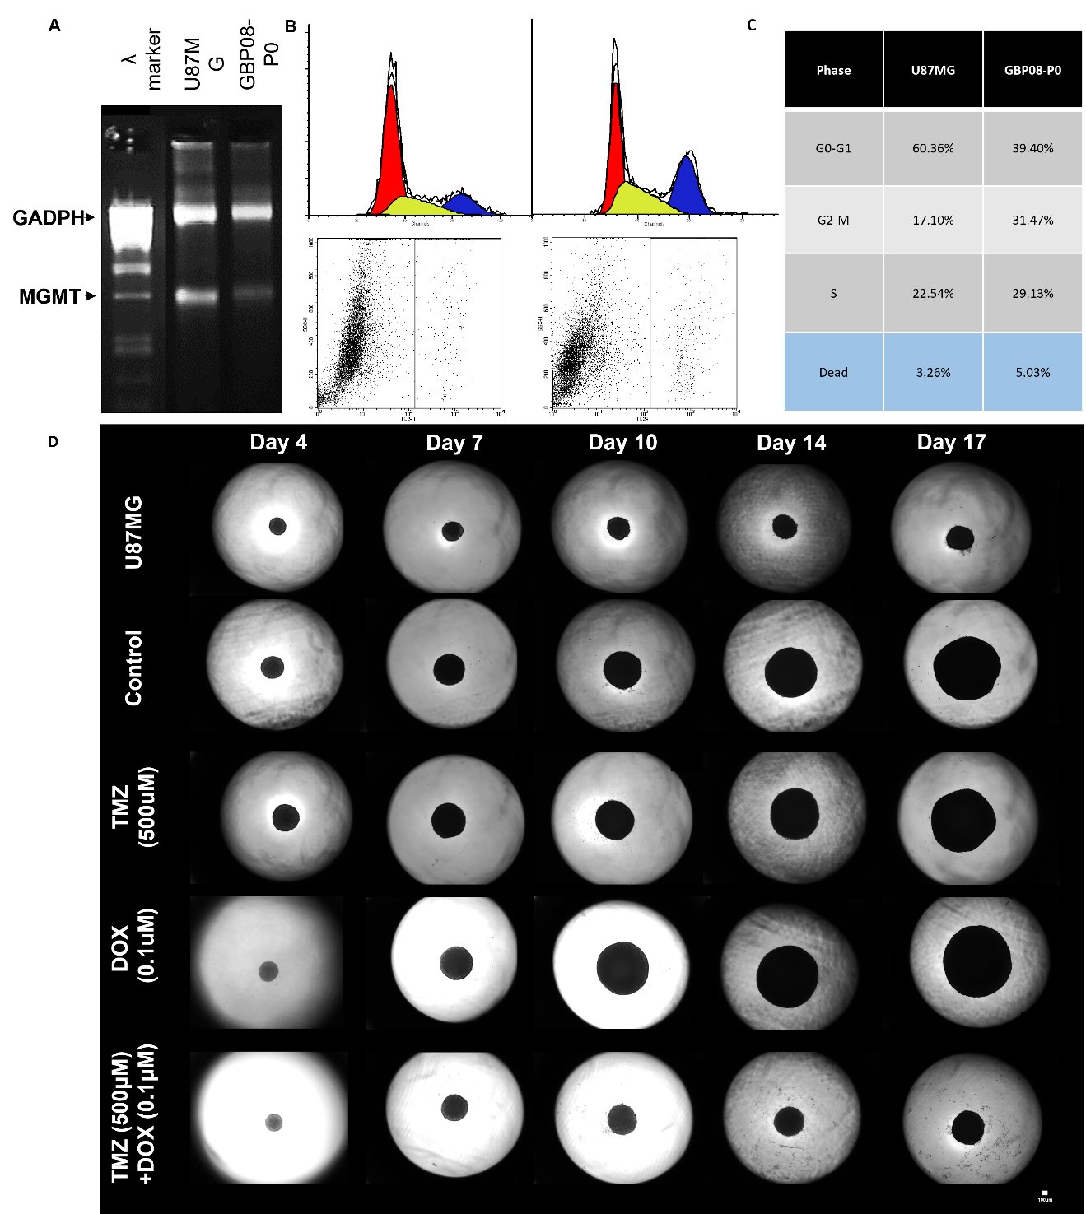

Figure S1. A. Northern blot of extracted RNA (left) and RTpcr mRNA quantification (right) of the GBP08-P0 primary cell line for the MGMT promoter status, as opposed to the U87MG secondary cell line.
B. Cell sorting results for the U87MG cells (left column) and the GBP08-P0 primary cells (right column) for the cell cycle (upper row) and the dead cells (low row), respectively. Indicative percentages are denoted on the table C. Note that the estimation of death and the cell cycle phases originate from different experiments. D. Brightfield images of representative spheroids at different timepoints for the different treatment conditions. U87MG spheroids are used as reference cell line. In the final timepoints of the combination treatment scheme notice the debris of dead cells around the spheroids. Images were captured at 4x magnification. Scale bar is set at 100 microns.

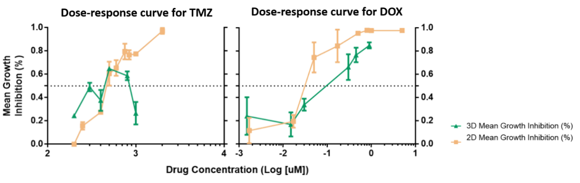

Figure S2. Dose response curves for Temozolomide- and Doxorubicin-treated GBP08-P0 primary GB cells in 2D and 3D cultures. Notice that there is no sigmoidal pattern for the Temozolomide-treated spheroids curve; GB cells are more sensitive in Temozolomide treatment as monolayers.

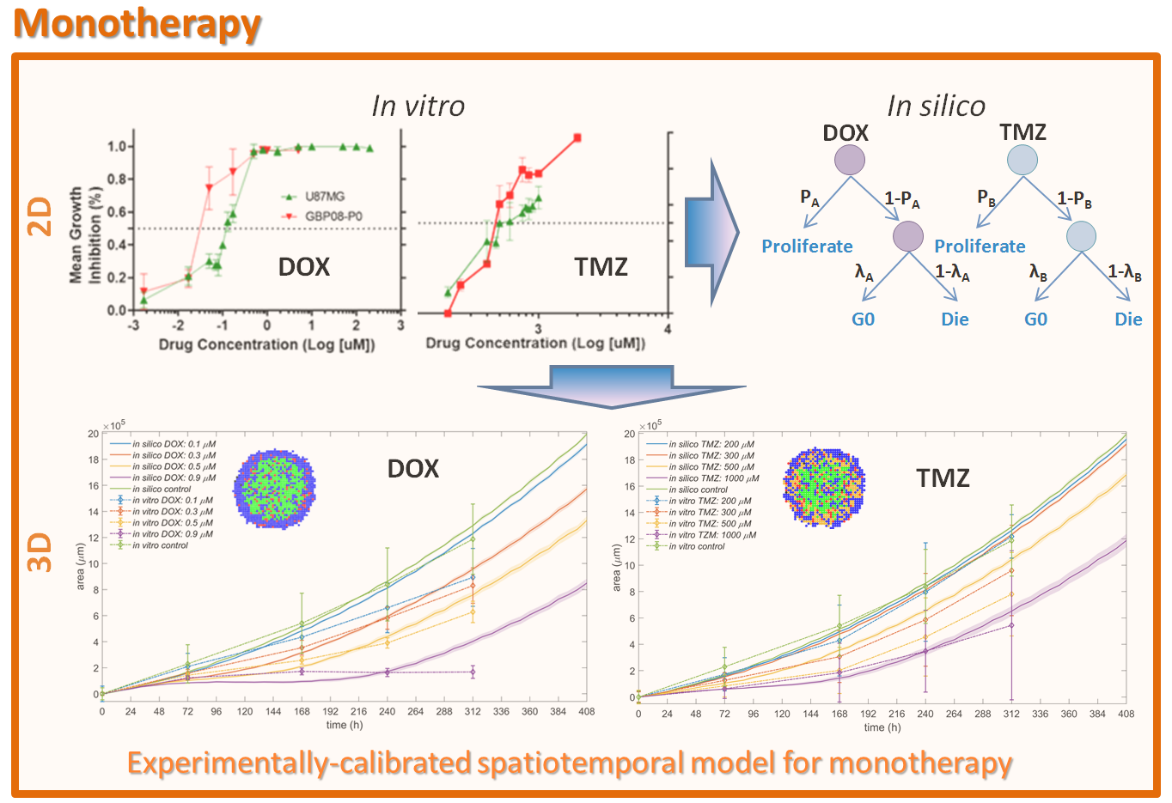

Figure S3. Illustrative framework – monotherapy. (First row) The dose-response curve of each drug is converted to a dose-dependent probability for an event (i.e. cell death or cell-cycle arrest) to occur. (Second row) The temporal evolution of the untreated and treated in vitro spheroids at various doses of each drug along with the estimated dose-dependent probabilities are used to calibrate the monotherapy 3D models accounting also for drug diffusion and space competition among cells.

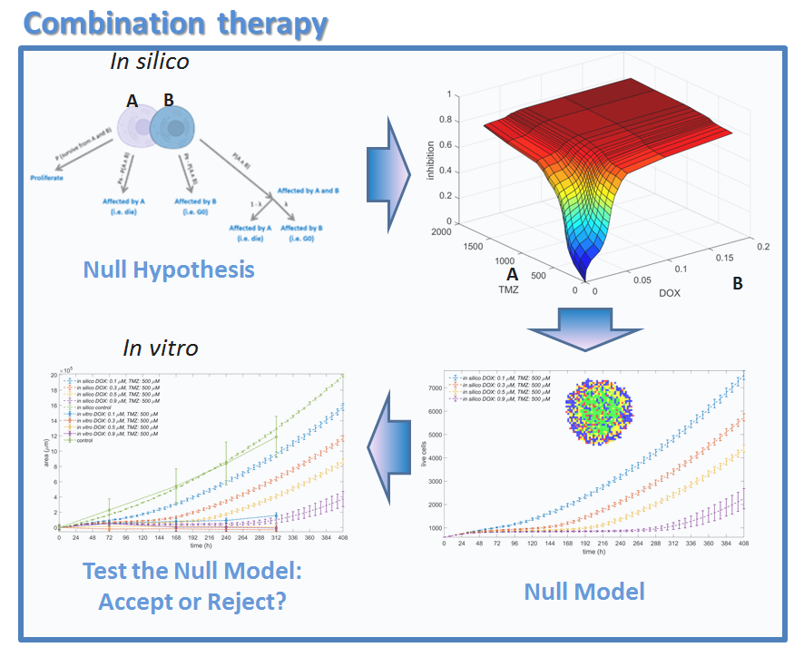
Figure S4. Illustrative framework – combination therapy.
(First row) The combination probability under the drug independence assumption is mathematically formulated from the probabilities derived in monotherapy. Various concentrations of drug A can be tested against various concentrations of drug B and their estimated combined inhibition is shown. (Second row) All the parameters used to describe the 3D monotherapy are used to describe the 3D combination therapy yet accounting now for the combination probabilities. The 3D null model is then compared to the 3D in vitro experiments. Alternative descriptions are tested based on the parameter study in an iterative manner aiming to fit both monotherapy and combination therapy experiments before a rejection or acceptance of the hypothesis.

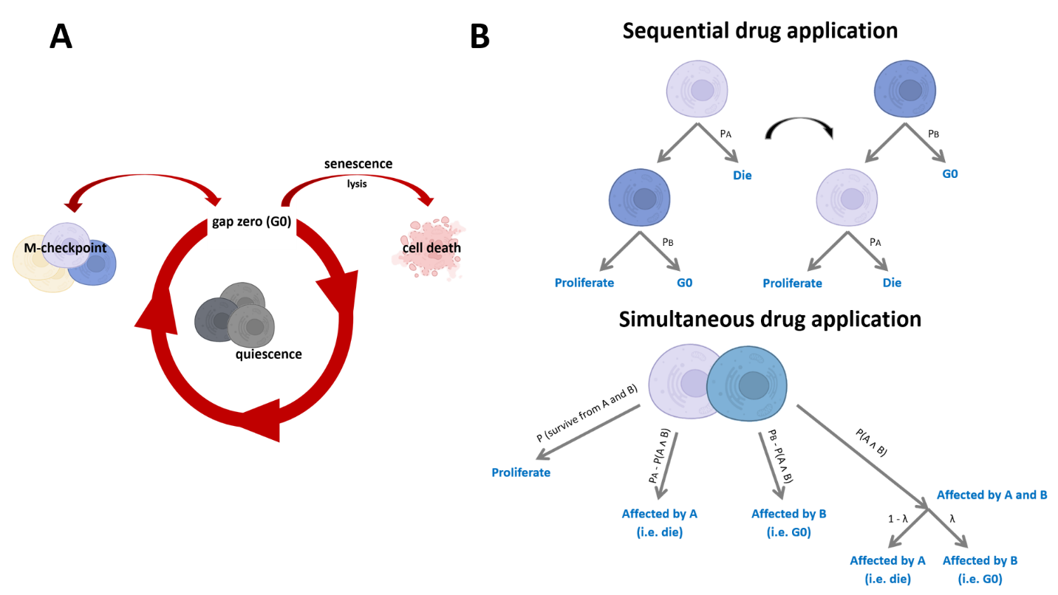
Figure S5. Cell fate assumptions.
A. Illustrated representation of cancer cells that undergo G0 phase. Non-dividing cells will become quiescent or senescent and eventually die according to the time spent in G0.
B. Probabilistic cell fate according to the drug presence in monotherapy or in combination. Drug A is assumed as cytotoxic and Drug B as cytostatic, respectively. In general, two drug applications can be considered in drug combination, sequential or simultaneous, respectively.

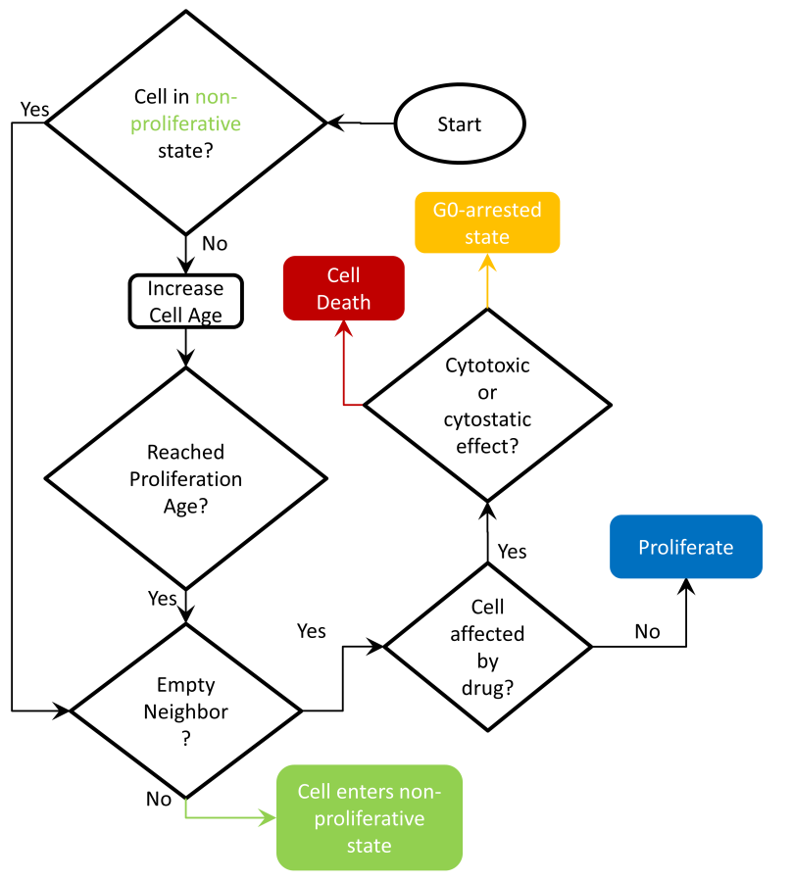
Figure S6. Discrete cell flow chart.

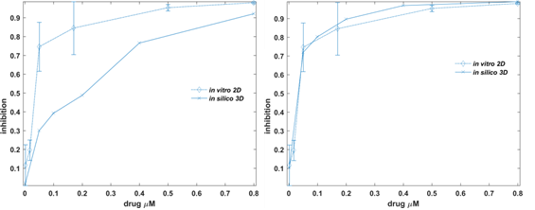
Figure S7. Effect of initial spheroid size in dose-response curves. Radius of initial spheroid size equals to a) 222μm, and b) 45μm.

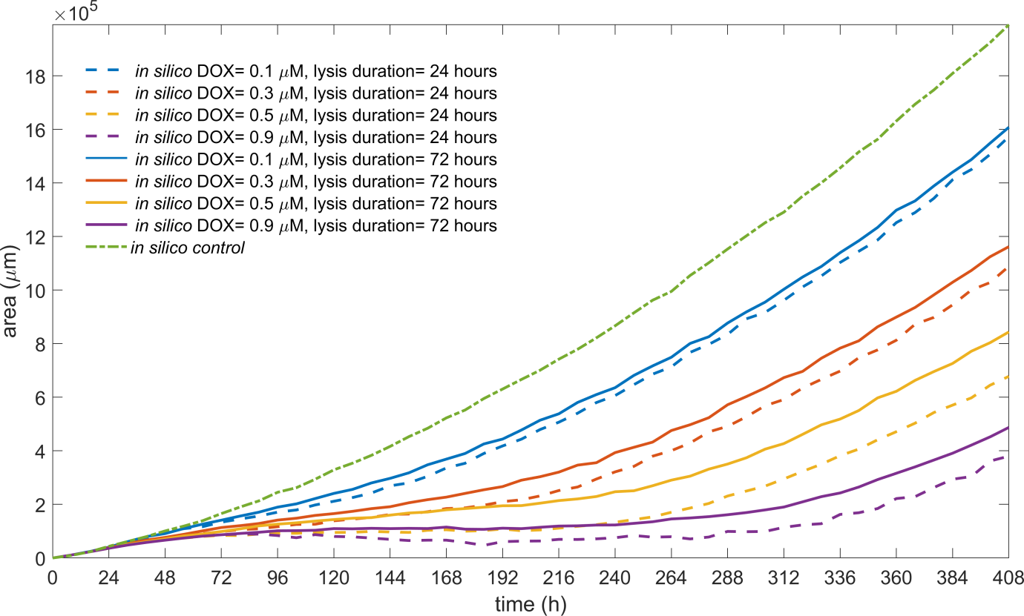
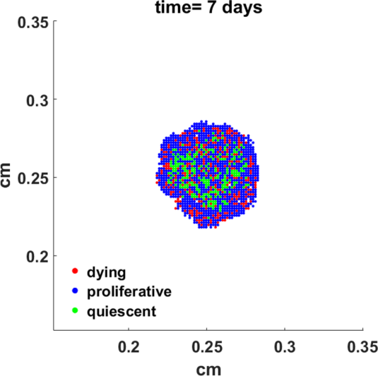
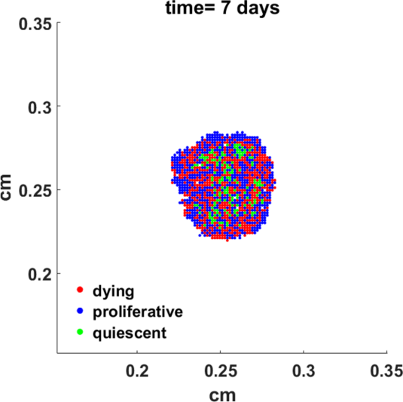
Figure S8. The predicted effect of lysis period on the temporal evolution of spheroid expansion, under the exposure of cancer cells in a cytotoxic drug. Rapid lysis enhances drug effectiveness of a cytotoxic drug at high doses. The predicted effect of lysis period on the spatial distribution of cells, under the exposure of cancer cells in a cytotoxic drug. DOX concentration equals to 0.2μM. The snapshots are taken at day 7: (left) lysis period equals to 24hrs, (right) lysis period equals to 72hrs.
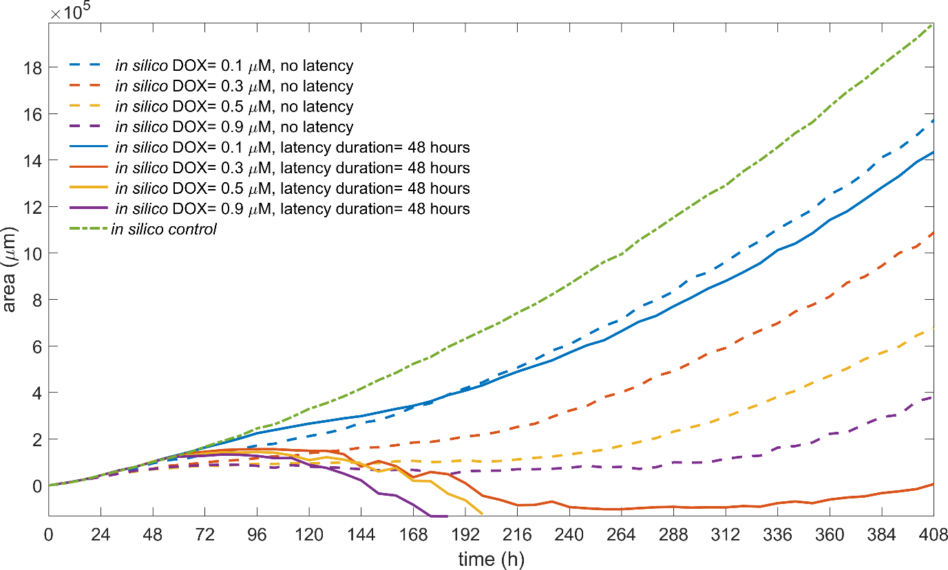
Figure S9. The effect of latency on the temporal evolution of spheroid expansion response for various concentrations of DOX. Latency period is zero (dotted lines) and latency period is 48hrs (solid lines).
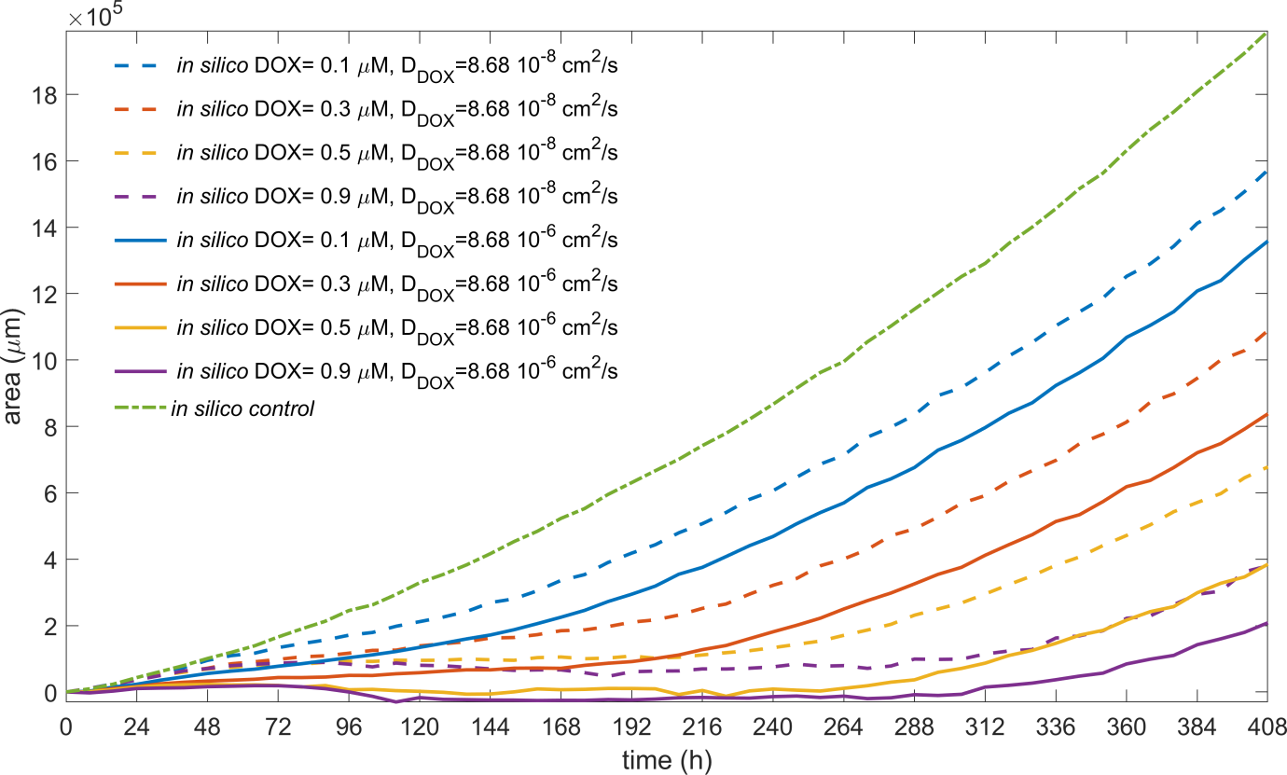
Figure S10. The effect of drug diffusion on the temporal evolution of spheroid expansion response for a given uptake rate under various drug concentrations. Low diffusion coefficient (dotted lines), and high diffusion coefficient (two orders of magnitude difference) depicted with solid lines are illustrated.

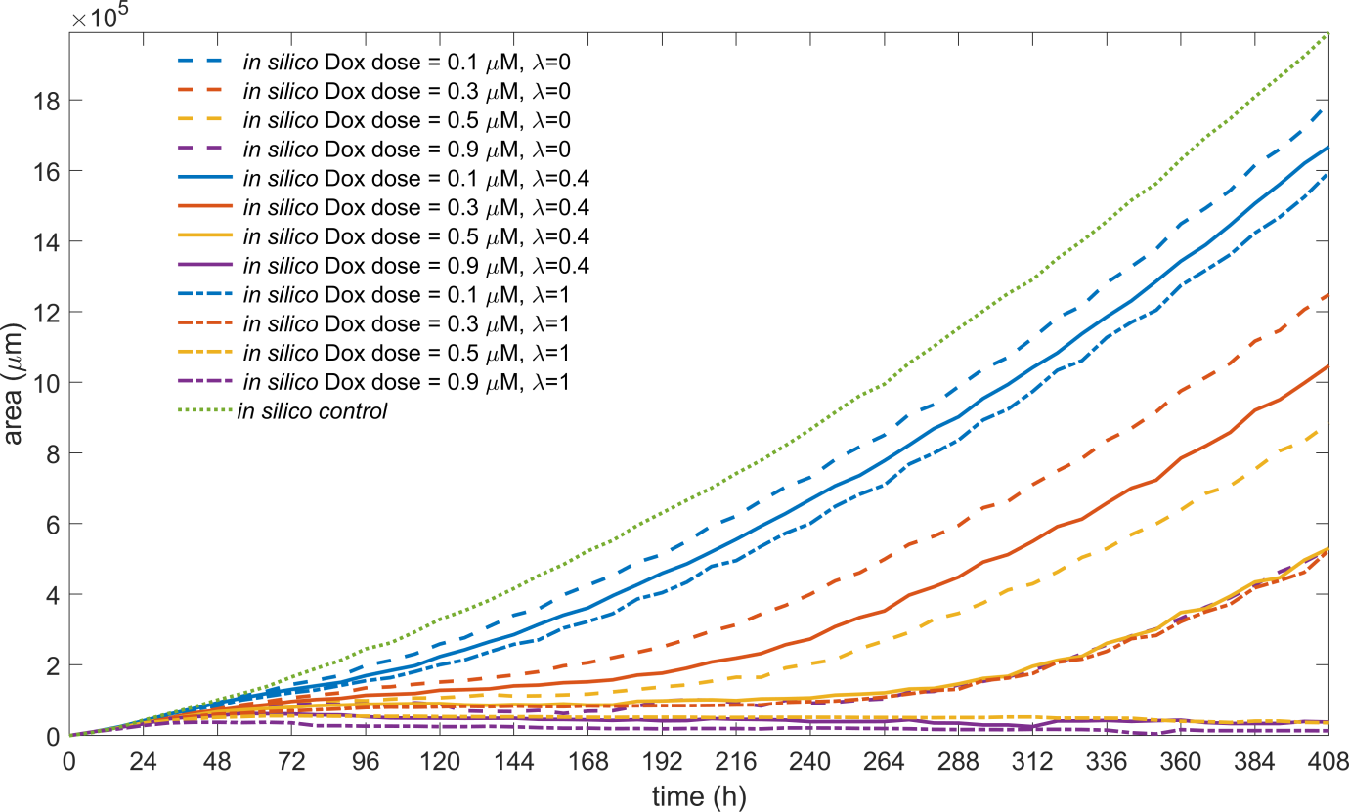
Figure S11. The effect of the cytotoxic versus the cytostatic drug mechanism on the spheroid expansion response. We show three cases of the same drug assumed to act as solely cytostatic (λ=1), solely cytotoxic (λ =0) and both 40% cytotoxic/ 60% cytostatic (λ=0.4).

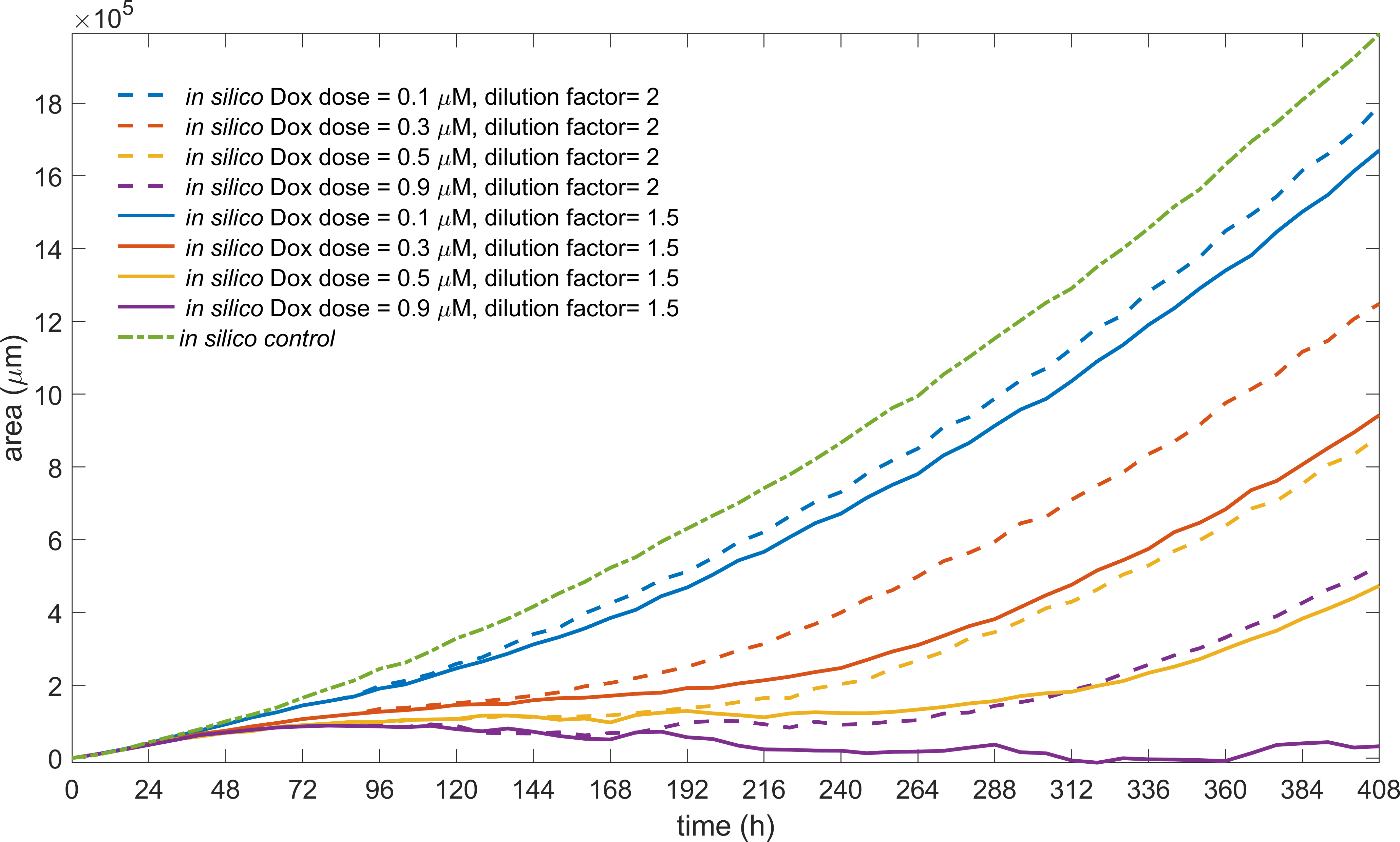
Figure S12. The effect of drug dilution for Doxorubicin monotherapy treatment. Two cases are illustrated; the drug concentration a) is 2/3 diluted every 2 days (solid lines) and b) is diluted by 2 (dotted lines).

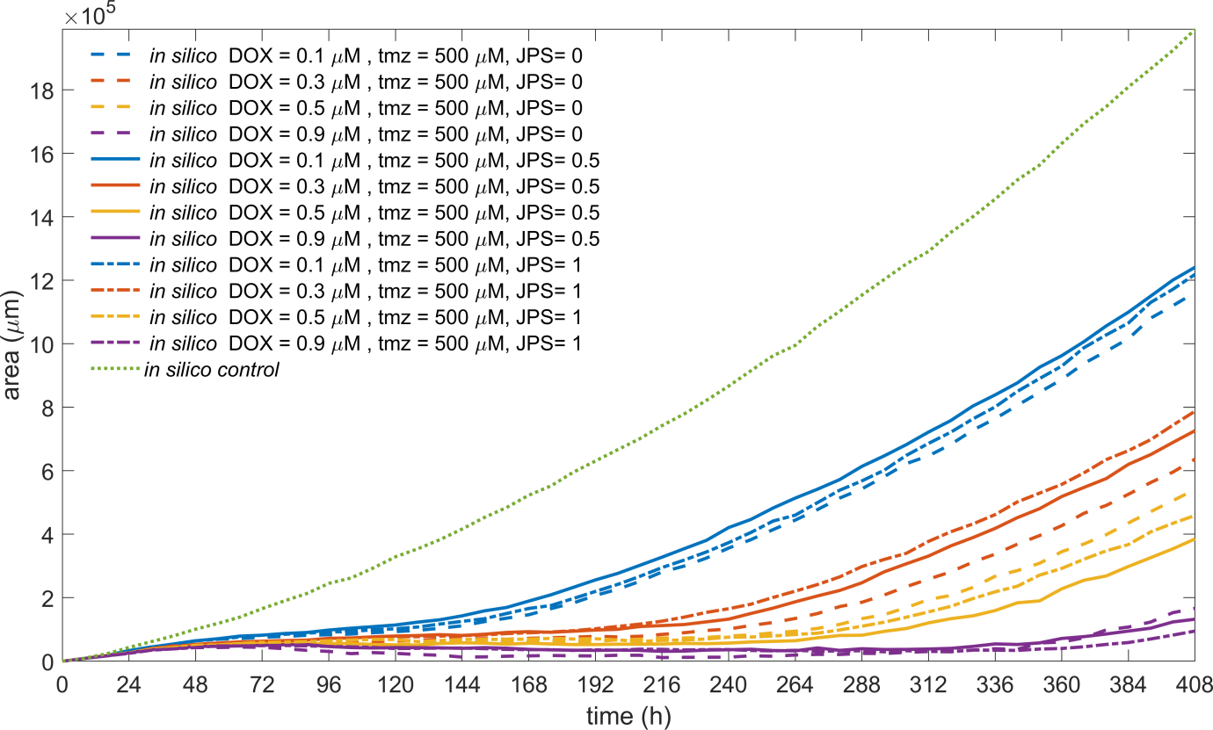
Figure S13. Drug dominance in combination.

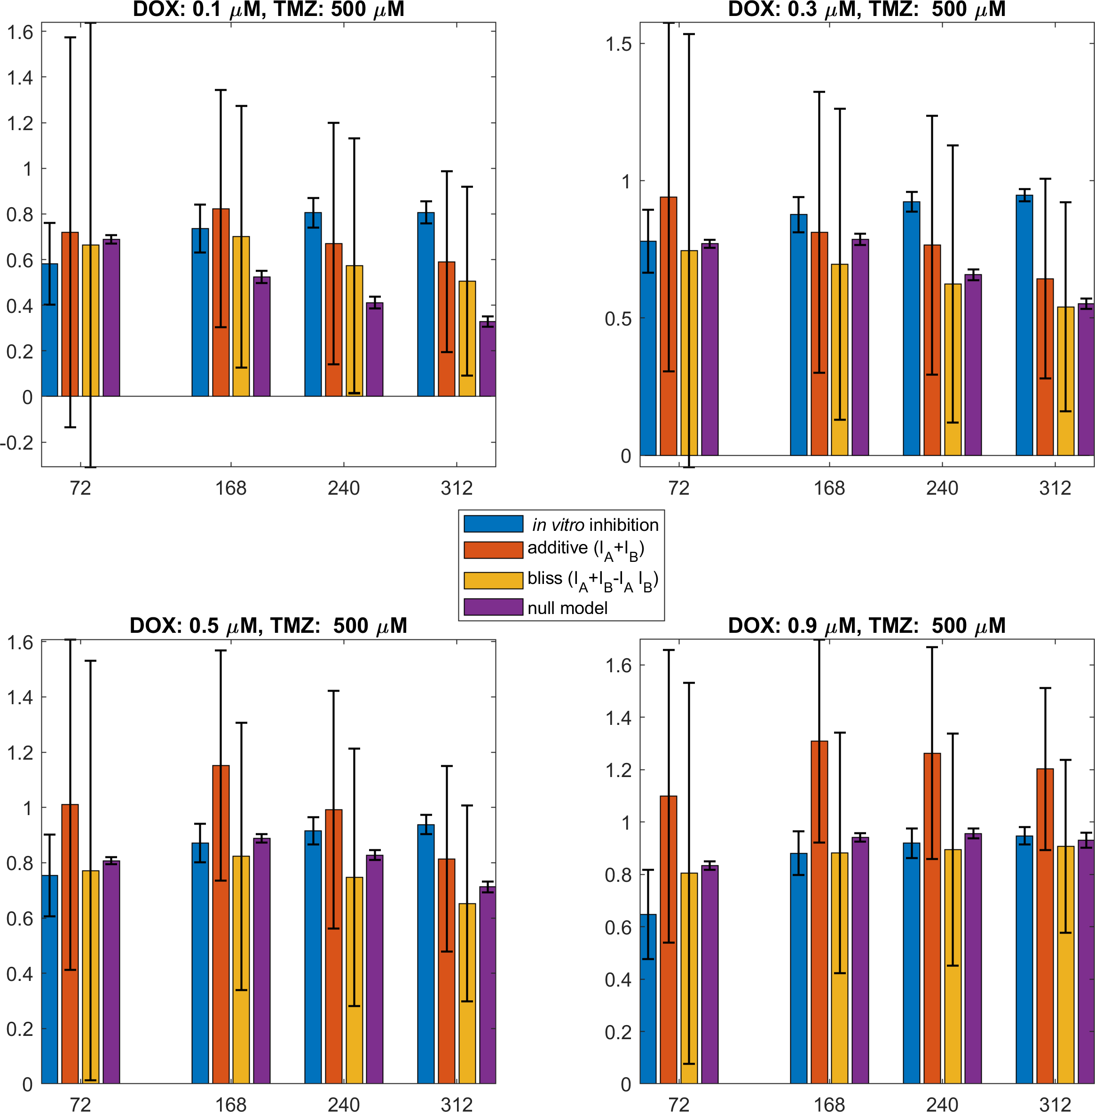

Figure S14. Compare in vitro combination experiments (blue bars) with the null models: response additivity (red bars), Bliss independence (yellow bars), and the proposed mechanistic null model (purple bars) at various drug pair concentrations and different timepoints.

Table S1. Computational parameters assumed for the initialization of the computational experiments.

Parameter | Value | Reference
Cell size | 15μm | experimental, (1)
Proliferation age | 22 hours | experimental, (1)
Proliferation depth | 3 cells (= 45μm) | experimental, (1)
Random death rate | 10% of proliferation rate | experimental, (1)
Lysis time | 24 hours | explored
Initial size: spheroid radius | 13.8 cells | experimental
Initial population density | 90% | (1)
TMZ uptake | 1.4^{e-10} M/(cell s) | explored
TMZ diffusion factor | 8.68^{e-07} cm²/s | explored
DOX uptake | 1.4^{e-13} M/(cell s) | explored  (based on (2))
DOX diffusion factor | 8.68^{e-08} cm²/s | explored  (based on (2))

Table S2. Mean inhibition in DOX-TMZ combination treatment of spheroids. Estimations based on the in vitro experiments (first column) and compared with different null models at various drug concentrations and different timepoints.

Doses | time (hrs) | in vitro inhibition | Response additivity | Bliss independence | in silico null model
DOX: 0.1 & TMZ: 500 | 72 | 0.762955006 | 0.719524777 | 0.664876233 | 0.68880324
DOX: 0.1 & TMZ: 500 | 168 | 0.890524711 | 0.823224357 | 0.700104031 | 0.52412367
DOX: 0.1 & TMZ: 500 | 240 | 0.905744911 | 0.670239232 | 0.572862766 | 0.41153357
DOX: 0.1 & TMZ: 500 | 312 | 0.867434033 | 0.590333434 | 0.505520558 | 0.32815297
DOX: 0.3 & TMZ: 500 | 72 | 1.054065505 | 0.940889507 | 0.746067835 | 0.77031810
DOX: 0.3 & TMZ: 500 | 168 | 1.03069307 | 0.812157992 | 0.695974025 | 0.78653981
DOX: 0.3 & TMZ: 500 | 240 | 1.030234952 | 0.765242302 | 0.624420682 | 0.65741089
DOX: 0.3 & TMZ: 500 | 312 | 1.025571088 | 0.643541696 | 0.540465907 | 0.55287118
DOX: 0.5 & TMZ: 500 | 72 | 0.935542929 | 1.010146524 | 0.771469751 | 0.80696069
DOX: 0.5 & TMZ: 500 | 168 | 0.976616418 | 1.151887503 | 0.822762292 | 0.88810516
DOX: 0.5 & TMZ: 500 | 240 | 0.990149056 | 0.991891393 | 0.747422545 | 0.82765281
DOX: 0.5 & TMZ: 500 | 312 | 0.994095303 | 0.813735657 | 0.652243423 | 0.71229032
DOX: 0.9 & TMZ: 500 | 72 | 0.773352025 | 1.098347082 | 0.803819731 | 0.83265518
DOX: 0.9 & TMZ: 500 | 168 | 0.992522111 | 1.308927577 | 0.881370209 | 0.94111537
DOX: 0.9 & TMZ: 500 | 240 | 0.99712913 | 1.262789283 | 0.894438115 | 0.95620353
DOX: 0.9 & TMZ: 500 | 312 | 1.00576837 | 1.202206596 | 0.90737772 | 0.92938317

SI References

1. M. E. Oraiopoulou et al., In Vitro/In Silico Study on the Role of Doubling Time Heterogeneity among Primary Glioblastoma Cell Lines. Biomed Res Int 2017, 8569328 (2017).
2. G. Tzedakis, E. Liapis, E. Tzamali, G. Zacharakis, V. Sakkalis, A hybrid discrete-continuous model of in vitro spheroid tumor growth and drug response. Conference proceedings : ... Annual International Conference of the IEEE Engineering in Medicine and Biology Society. IEEE Engineering in Medicine and Biology Society. Conference 2016, 6142-6145 (2016).

