supplementary data part 1
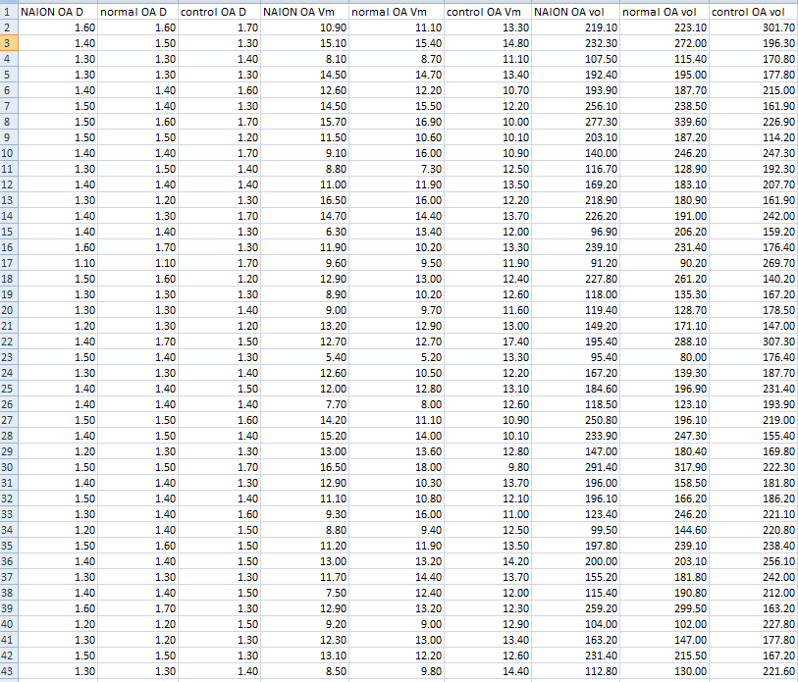
NAION OA D the diameter of ophthalmic artery (NAION eye), normal OA D the diameter of ophthalmic artery (the
fellow healthy eye), control OA D the diameter of ophthalmic artery in control group, NAION OA Vm the average
blood flow velocity of ophthalmic artery in the affected side of NAION patients, normal OA Vm the average blood
flow velocity of ophthalmic artery in the unaffected side of NAION patients, control OA Vm the average blood flow
velocity of ophthalmic artery in control group, NAION OA vol the blood flow volume of ophthalmic artery (NAION
eye), normal OA vol the blood flow volume of ophthalmic artery (the fellow healthy eye), control OA vol the blood
flow volume of ophthalmic artery in control group

supplementary data part 2
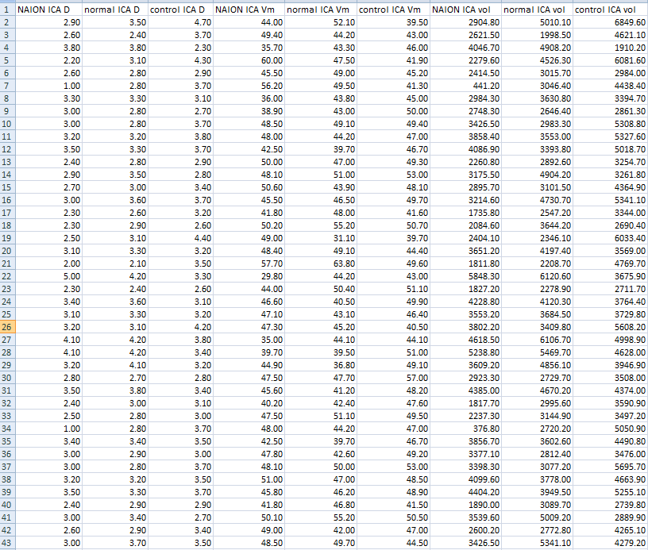
NAION ICA D the diameter of internal carotid artery in the affected side of NAION patients, normal ICA D the
diameter of internal carotid artery in the unaffected side of NAION patients, control ICA D the diameter of internal
carotid artery in control group, NAION ICA Vm the average blood flow velocity of internal carotid artery in the
affected side of NAION, normal ICA Vm the average blood flow velocity of internal carotid artery in the unaffected
side of NAION patients, control ICA Vm the average blood flow velocity of internal carotid artery in control group,
NAION ICA vol the blood flow volume of internal carotid artery in the affected side of NAION patients, normal ICA
Vol the blood flow volume of internal carotid artery in the unaffected side of NAION patients, control ICA vol the
blood flow volume of internal carotid artery in control group

supplementary data part 3
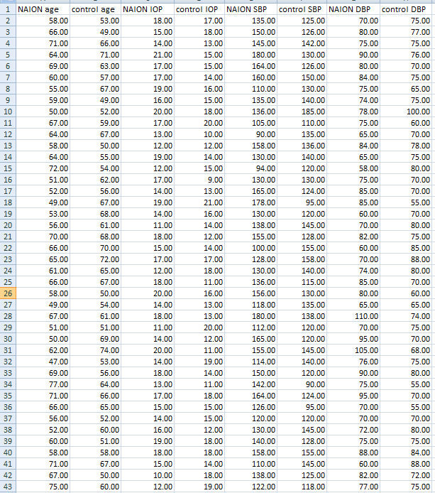
NAION age age of NAION patients, control age age of control group, NAION IOP intraocular pressure of NAION
Patients, control IOP intraocular pressure of control group, NAION SBP systolic blood pressure of NAION
patients, control SBP systolic blood pressure of control group, NAION DBP diastolic blood pressure of NAION
patients, control DBP diastolic blood pressure of control group

supplementary data part 4
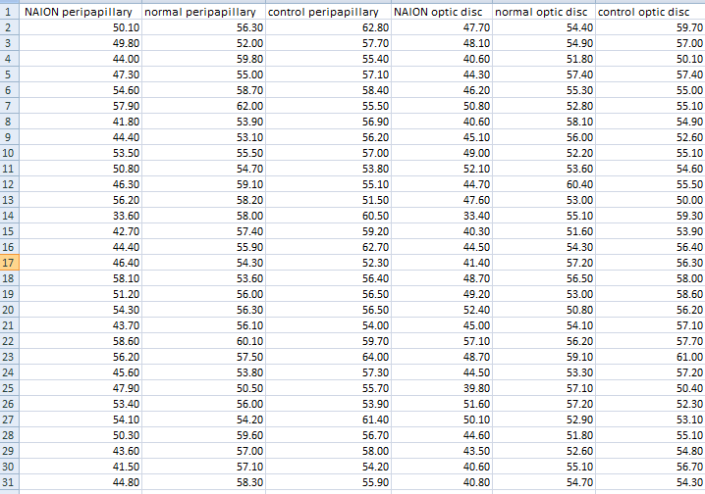
NAION peripapillary peripapillary vessel density in the affected side of NAION patients，normal peripapillary
peripapillary vessel density in the unaffected side of NAION patients，control peripapillary peripapillary vessel
density in control group，NAION optic disc optic disc vessel density in the affected side of NAION patients，
normal optic disc optic disc vessel density in the unaffected side of NAION patients，control optic disc optic disc
vessel density in control group

