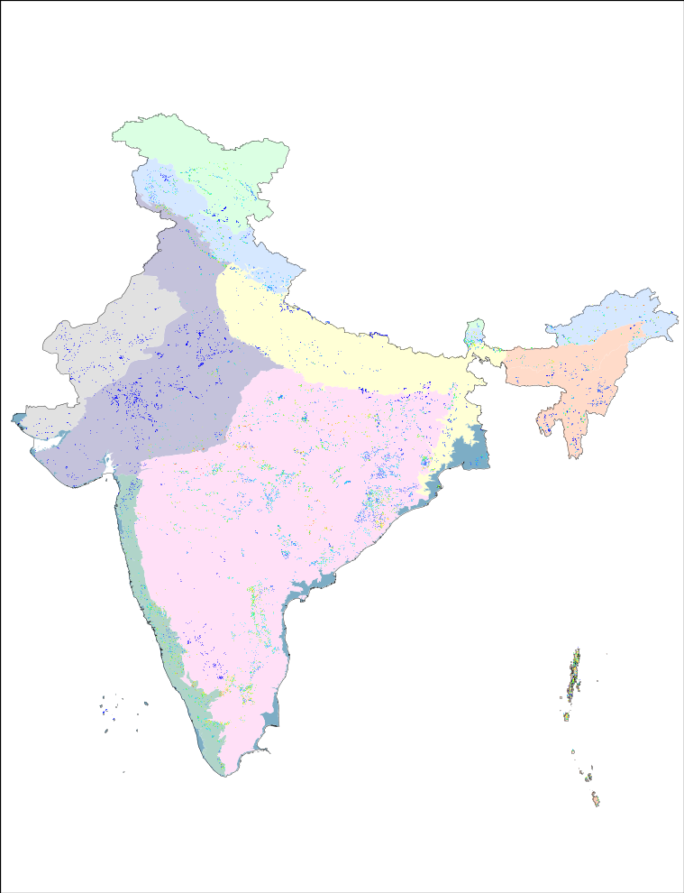

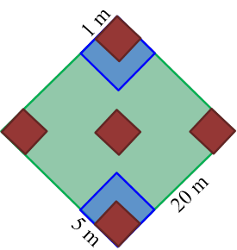
(i)
(ii)

Deccan Peninsula

Desert

Gangetic-Plain

Himalaya

North-East

Semi-Arid

Trans-Himalaya

Western-Ghats

Coasts

Islands

Fig.S1 (i) Species distribution in India in the backdrop of major bio-geographic zones as per Rodgers and Panwar (1988)
Number of species enumerated in 0.04 ha nested quadrats, with the maximum number of species recorded in a grid is 59 (adapted from Tripathi et al., 2017) (ii) a representation of nested quadrate showing tree/liana (20m), shrub/sapling (5m) and herb/seedling (1m) sample plots (adapted from Roy et al., 2008)

(i)
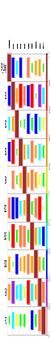
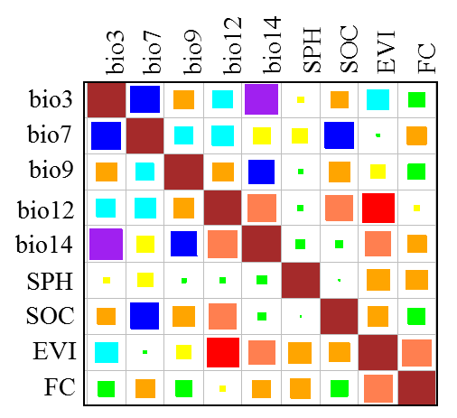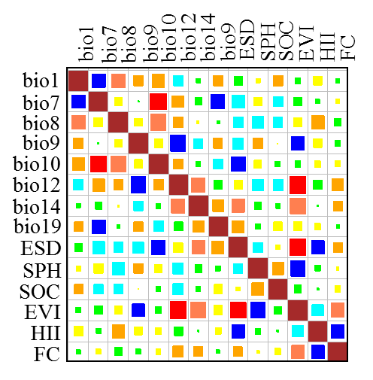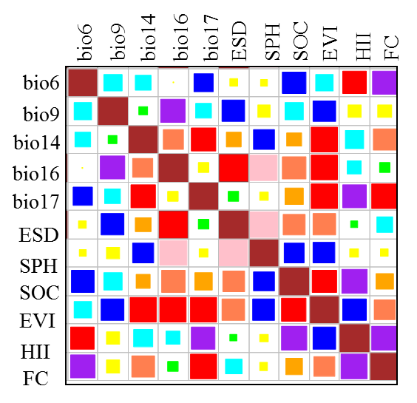
(iii)
(ii)
1 0.8 0.6 0.4 0.2
0
-0.2
-0.4
-0.6
-0.8
-1

Fig. S2 Corrplot showing the correlation among variables used in the species modelling for the (i) Arid and semi-arid (ii) Deccan Peninsula and (iii) Gangetic plain biogeographic zones
*please note that the variables having >0.7 correlations were considered to be collinear and are not shown here
*Temperature: bio1 = Annual Mean Temperature, bio 2 = Mean Diurnal Range, bio 3 = Isothermality, bio 4 = Temperature Seasonality, bio 5 = Max Temperature of Warmest Month, bio6 = Min Temperature of Coldest Month, bio7 = Temperature Annual Range, bio8 = Mean Temperature of Wettest Quarter, bio9 = Mean Temperature of Driest Quarter, bio10 = Mean Temperature of Warmest Quarter, bio11 = Mean Temperature of Coldest Quarter
*Water: bio12 = Annual Precipitation, bio13 = Precipitation of Wettest Month, bio14 = Precipitation of Driest Month, bio15 = Precipitation Seasonality, bio 16 = Precipitation of Wettest Quarter, bio17 = Precipitation of Driest Quarter, bio18 = Precipitation of Warmest Quarter, bio19 = Precipitation of Coldest Quarter
SOC= soil organic carbon, SPH= soil PH, EVI= enhanced vegetation index, ESD= standard deviation of elevation, HII= human influence index, FC= fire count

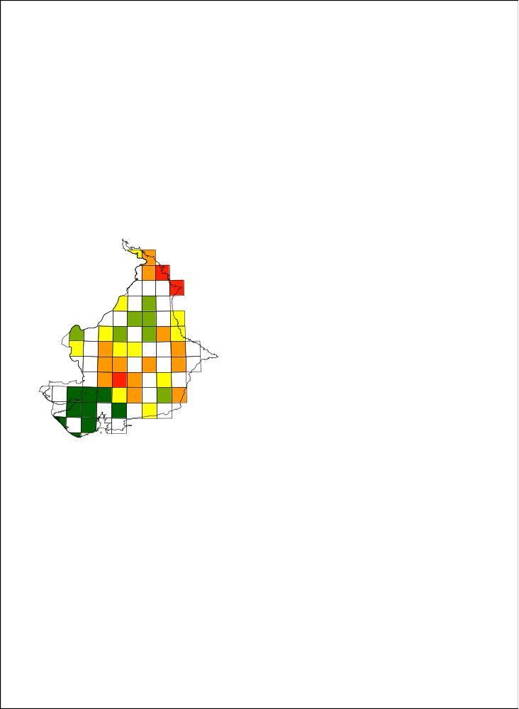
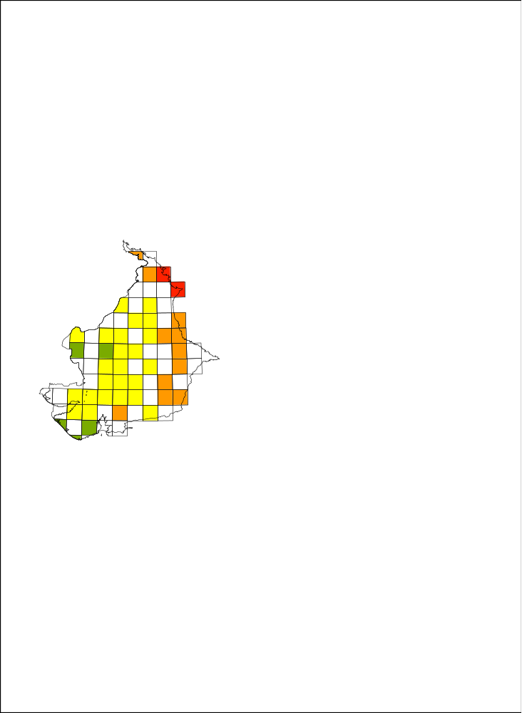
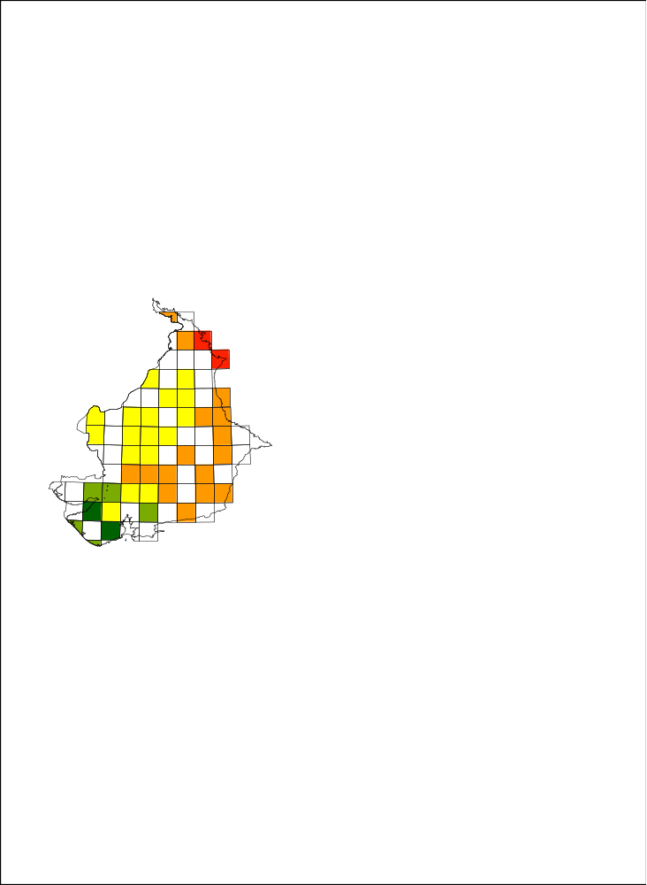
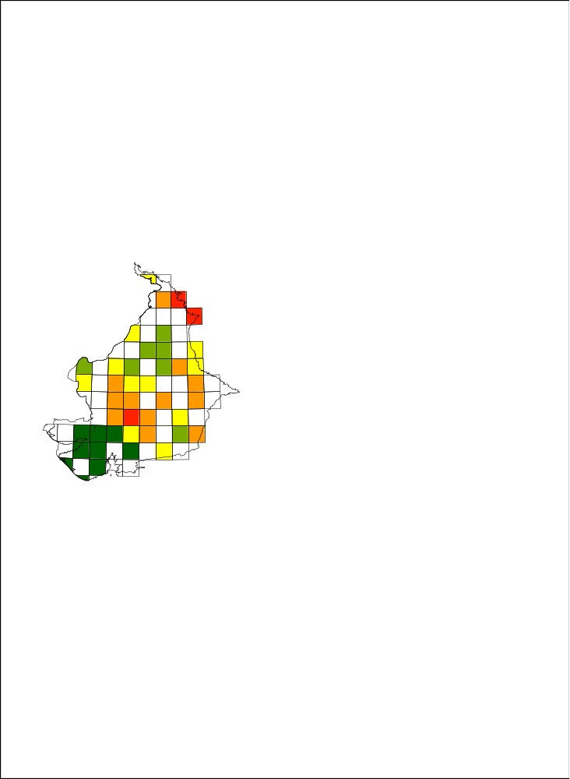
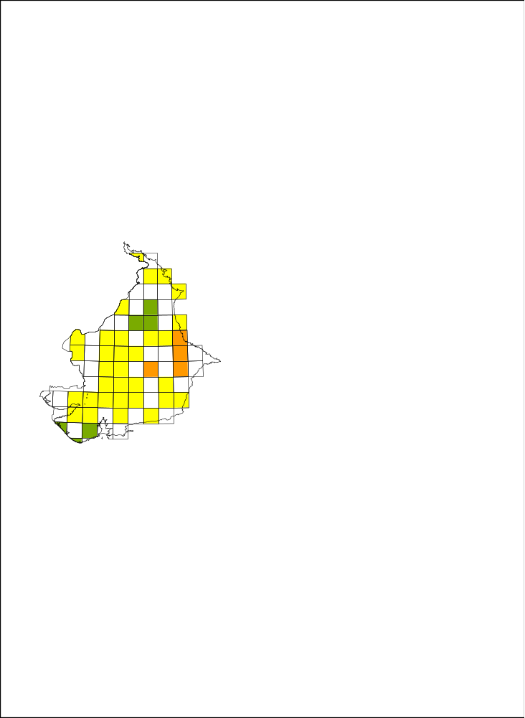
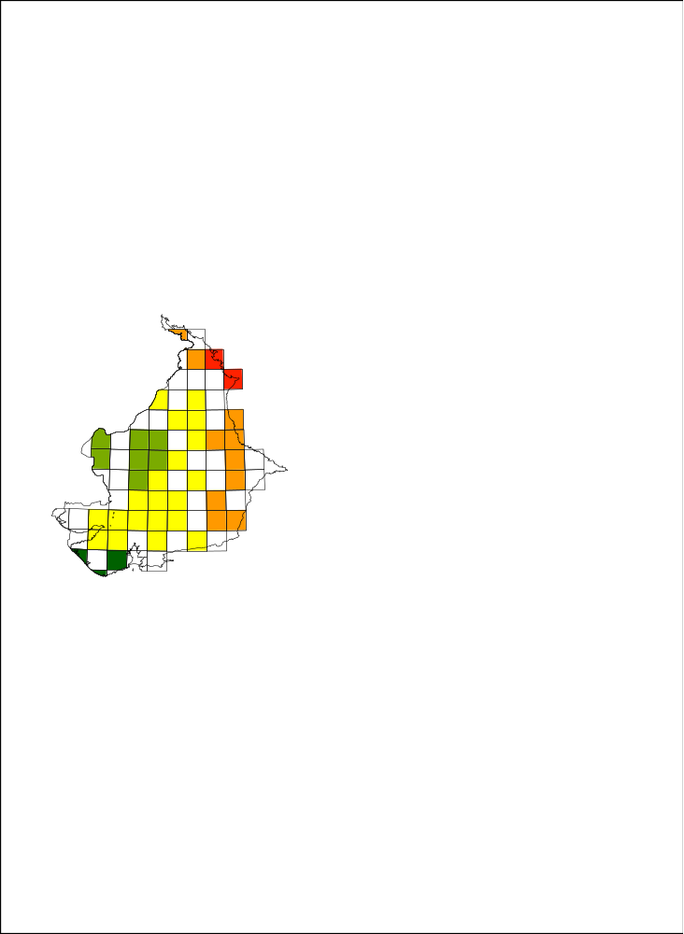
(i)
(ii)
(iii)
(iv)
(v)
3 - 40
41 - 80
81 - 160
161 - 320
321 - 517
(vi)

Fig S3 (a) Mapped model results for training data showing differences among model species richness predictions for arid &
semi-arid zone for a combination of B7,B13 and B14 showing (i) Observed (ii) GLM (iii) RF (iv) GBM (v) SVMR (vi) SVML
*bio 7 = Temperature Annual Range, bio13 = Precipitation of Wettest Month, bio14 = Precipitation of Driest Month

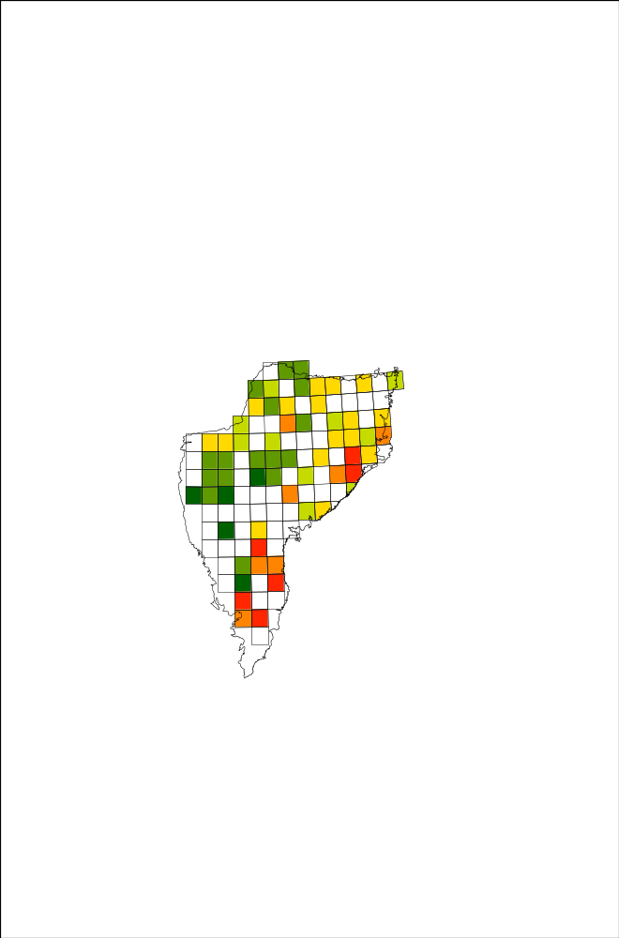
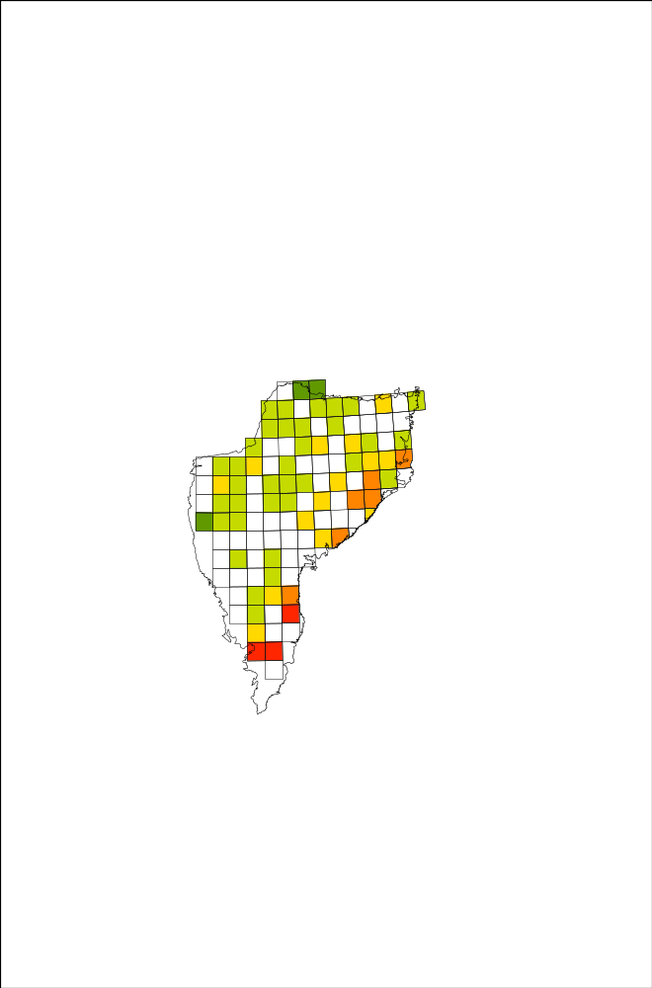
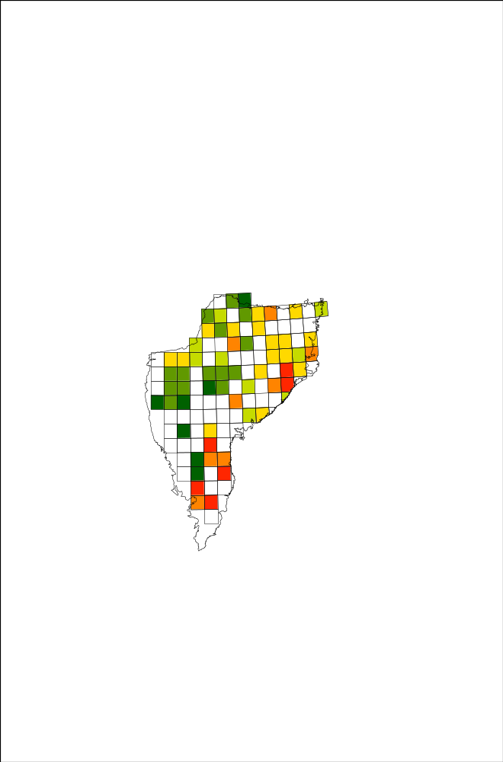
(iii)
(ii)
(i)

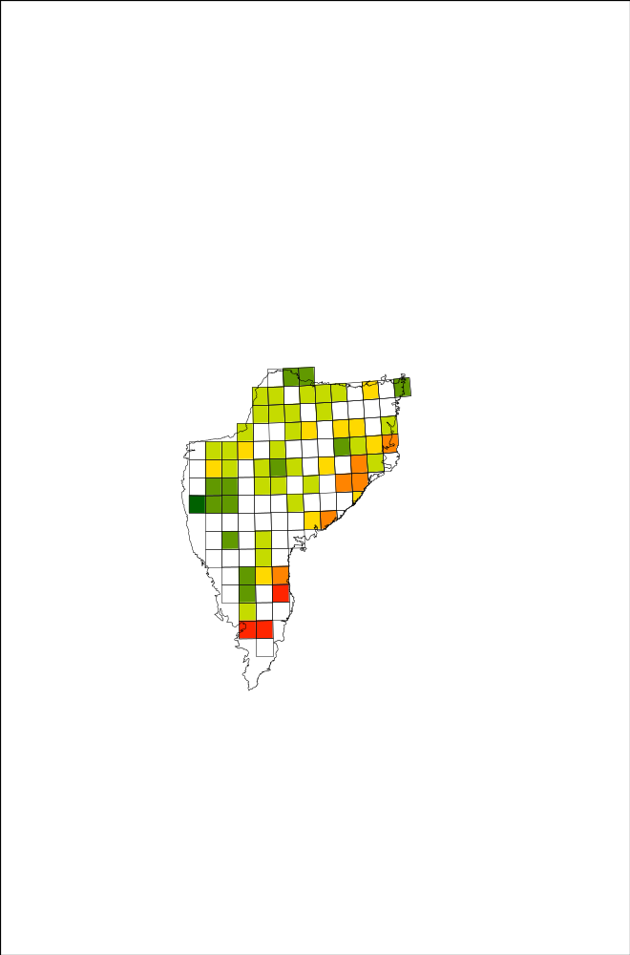
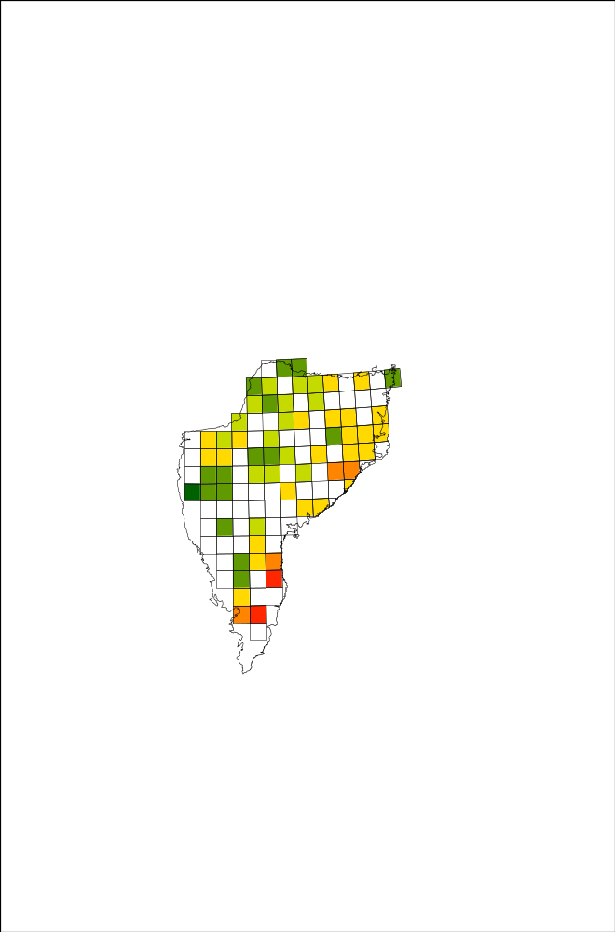
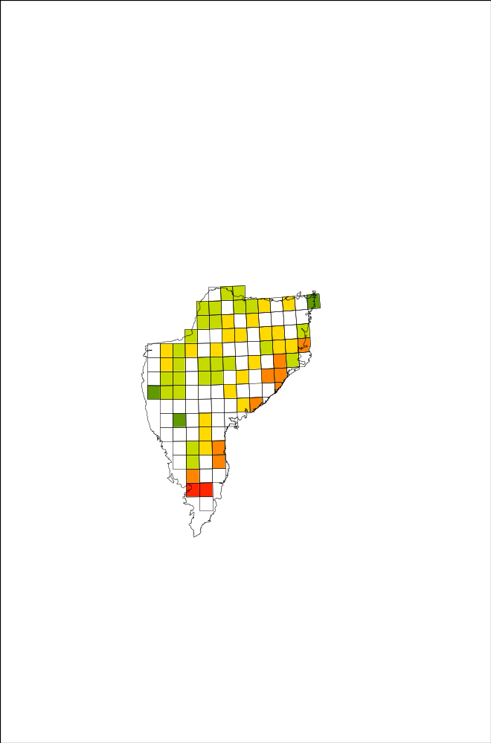
(vi)
(iv)
(v)

46 - 100
101 - 160
161 - 220
221 - 300
301 - 410
411 - 610

Fig S3 (b) Mapped model results for training data showing differences among model species richness predictions for arid & Deccan peninsula zone
for a combination of B10,B14, B19,ESD,HII showing (i) Observed (ii) GLM (iii) RF (iv) GBM (v) SVMR (vi) SVML
*bio 10 = Mean Temperature of Warmest Quarter, bio14 = Precipitation of Driest Month, bio 19 = Precipitation of Coldest Quarter,
ESD= standard deviation of elevation, HII= human influence index
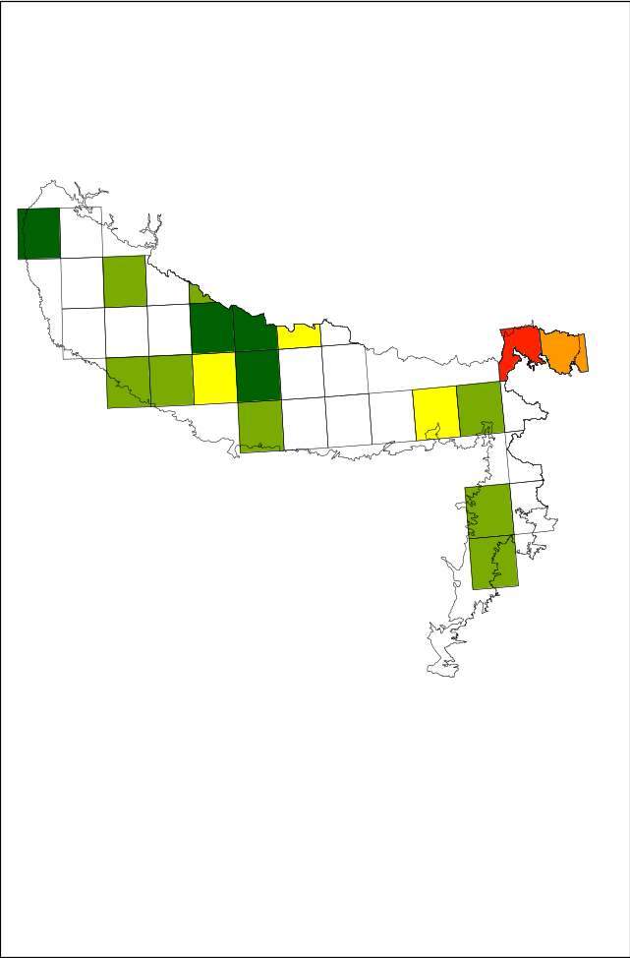
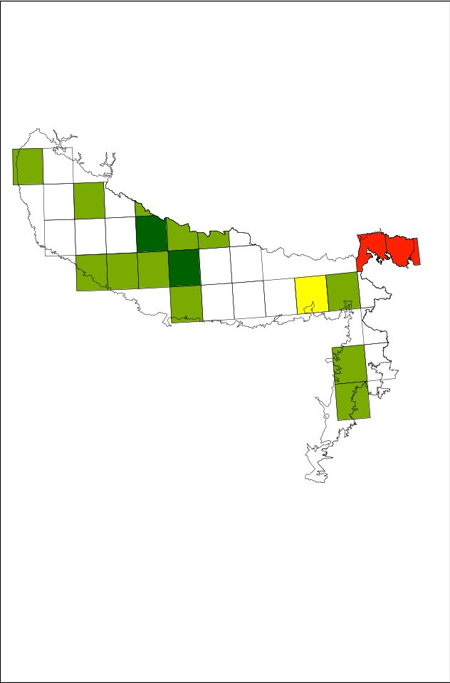
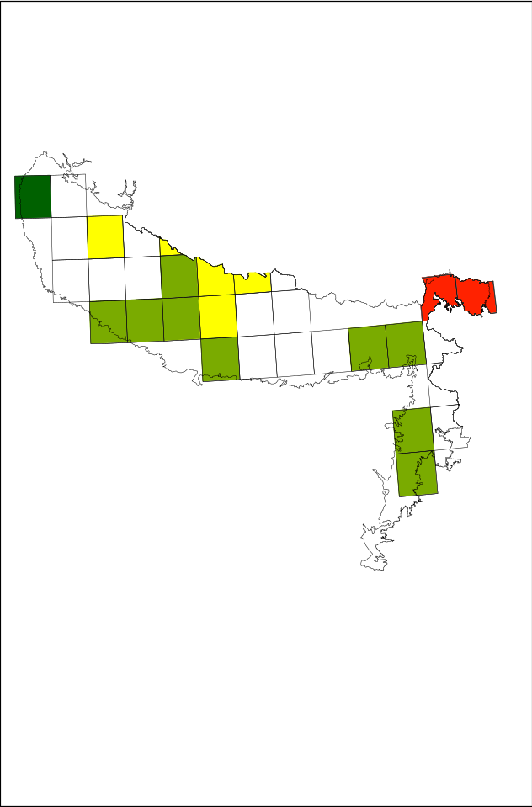
(iii)
(ii)
(i)

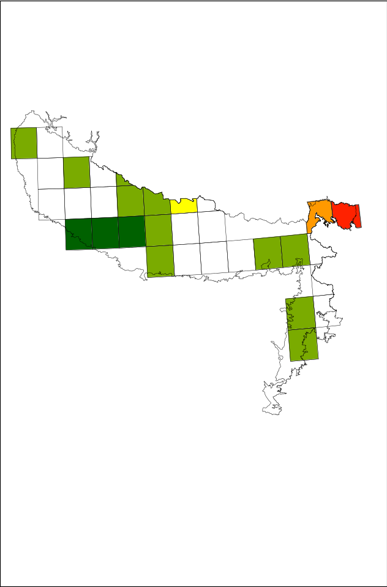
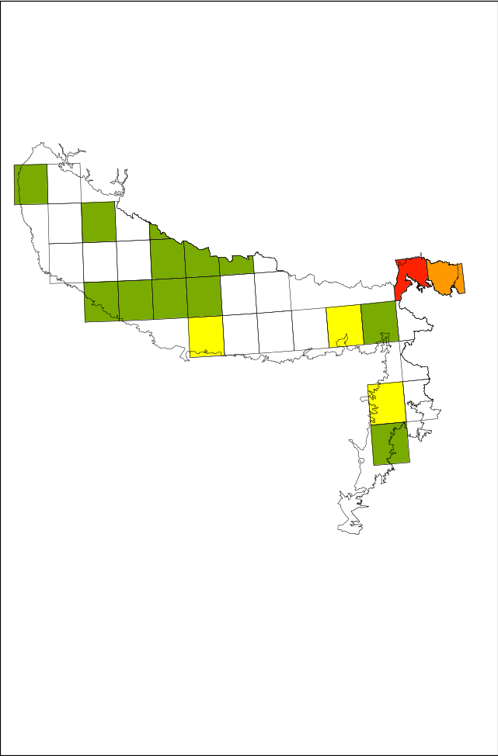
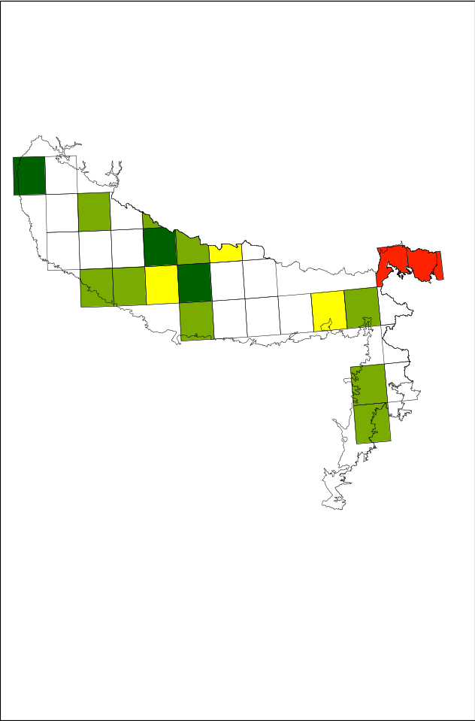
(vi)
(v)
(iv)
28 - 50
51 - 90
91 - 130
131 - 315
316 - 623

Fig S3 (c) Mapped model results for training data showing differences among model species richness predictions for Gangetic plain zone
for a combination of bio 9 and bio16 showing (i) Observed (ii) GLM (iii) RF (iv) GBM (v) SVMR (vi) SVML
*bio 9 = Mean Temperature of Driest Quarter, bio16 = Precipitation of Wettest Quarter,

Table S1: Table showing the sources and resolution of various environmental datasets used in the present study
Variables |  | Source | Download Site | Resolution
Climate
Energy*  (Temperature) | bio1,bio2,bio3,bio4,bio5,bio6,bio7,bio8,bio9,bio10,bio11 | BIOCLIM | http://www.worldclim.org/current | 30 arc-seconds
Water* (Precipitation) | bio12,bio13,bio14,bio15,bio16,bio17,bio18,bio19
Topographic | Elevation | Shuttle radar topographic mission (SRTM) | http://srtm.csi.cgiar.org/ | 90 m
 | Topographic ruggedness index (TRI) | Shuttle radar topographic mission (SRTM) | http://srtm.csi.cgiar.org/ | 90 m
 | Slope | Shuttle radar topographic mission (SRTM) | http://srtm.csi.cgiar.org/ | 90 m
Edaphic | Soil organic carbon (SOC) | Food and Agriculture organization (FAO) soil portal | http://www.fao.org/soils-portal/soil-survey/soil-maps-and-databases/harmonized-world-soil-database-v12/en/ | 30 arc-second
 | Soil PH (SPH) | Food and Agriculture organization (FAO) soil portal |  | 30 arc-second
Anthropogenic | Human influence index (HII) | Socioeconomic data and application centre (SEDAC) | http://sedac.ciesin.columbia.edu/data/set/wildareas-v2-human-footprint-geographic | 1km
Vegetation indices | Normalized difference vegetation index (NDVI), Enhanced vegetation index, (EVI) product MOD13Q1 | Land Processes Distributed Active Archive Center (LP-DAAC) | http://lpdaac.usgs.gov/  https://reverb.echo.nasa.gov/ | 250
*Temperature: bio1 = Annual Mean Temperature, bio2 = Mean Diurnal Range , bio3 = Isothermality, bio4 = Temperature Seasonality, bio5 = Max Temperature of Warmest Month, bio6 = Min Temperature of Coldest Month, bio7 = Temperature Annual Range, bio8 = Mean Temperature of Wettest Quarter, bio9 = Mean Temperature of Driest Quarter, bio10 = Mean Temperature of Warmest Quarter, bio11 = Mean Temperature of Coldest Quarter
*Water: bio12 = Annual Precipitation, bio13 = Precipitation of Wettest Month, bio14 = Precipitation of Driest Month, bio15 = Precipitation Seasonality, bio16 = Precipitation of Wettest Quarter, bio17 = Precipitation of Driest Quarter, bio18 = Precipitation of Warmest Quarter, bio19 = Precipitation of Coldest Quarter
Table S2: Zone wise plant richness (i.e. number of species) and number of sampling quadrates laid per 1˚ grid in India
Deccan Peninsula
Grid ID | No. of species | No. of plots | Grid ID | No. of species | No. of plots
1 | 133 | 38 | 47 | 211 | 38
2 | 94 | 18 | 48 | 208 | 125
3 | 141 | 59 | 49 | 254 | 75
4 | 186 | 134 | 50 | 46 | 8
5 | 123 | 67 | 51 | 266 | 87
6 | 231 | 67 | 52 | 476 | 153
7 | 303 | 161 | 53 | 100 | 20
8 | 237 | 114 | 54 | 345 | 77
9 | 161 | 109 | 55 | 402 | 87
10 | 291 | 89 | 56 | 73 | 11
11 | 141 | 55 | 57 | 449 | 105
12 | 254 | 91 | 58 | 460 | 132
13 | 229 | 40 | 59 | 389 | 66
14 | 217 | 44 | 60 | 609 | 242
15 | 355 | 82 | 61 | 99 | 27
16 | 106 | 105 | 62 | 143 | 50
17 | 221 | 58 | 63 | 178 | 73
18 | 295 | 105 | 64 | 156 | 68
19 | 245 | 67 | 65 | 350 | 137
20 | 268 | 49 | 66 | 233 | 49
21 | 255 | 50 | 67 | 256 | 151
22 | 189 | 110 | 68 | 147 | 90
23 | 189 | 126 | 69 | 114 | 47
24 | 258 | 70 | 70 | 335 | 87
25 | 283 | 236 | 71 | 201 | 71
26 | 198 | 48 | 72 | 163 | 60
27 | 396 | 208 | 73 | 191 | 75
28 | 124 | 36 | 74 | 158 | 170
29 | 116 | 36 | 75 | 58 | 20
30 | 131 | 76 | 76 | 145 | 88
31 | 144 | 196 | 77 | 78 | 10
32 | 140 | 78 | 78 | 102 | 28
33 | 251 | 97 | 79 | 181 | 58
34 | 462 | 199 | 80 | 394 | 146
35 | 272 | 105 | 81 | 98 | 55
36 | 128 | 23 | 82 | 40 | 15
37 | 114 | 25 | 83 | 236 | 66
38 | 73 | 47 | 84 | 276 | 55
39 | 110 | 50 | 85 | 110 | 54
40 | 203 | 49 | 86 | 48 | 8
41 | 354 | 192 | 87 | 42 | 6
42 | 414 | 208 | 88 | 168 | 105
43 | 71 | 9 | 89 | 304 | 65
44 | 109 | 23 | 90 | 99 | 25
45 | 91 | 12 | 91 | 132 | 37
46 | 308 | 104 | 92 | 383 | 96
Arid & semi-arid-zone
1 | 92 | 51 | 16 | 95 | 54
2 | 166 | 47 | 17 | 165 | 38
3 | 384 | 89 | 18 | 91 | 29
4 | 517 | 157 | 19 | 159 | 99
5 | 93 | 39 | 20 | 286 | 80
6 | 47 | 6 | 21 | 175 | 44
7 | 62 | 16 | 22 | 307 | 78
8 | 43 | 6 | 23 | 226 | 77
9 | 123 | 14 | 24 | 290 | 72
10 | 61 | 30 | 25 | 289 | 132
11 | 116 | 44 | 26 | 364 | 181
12 | 66 | 43 | 27 | 288 | 72
13 | 76 | 43 | 28 | 136 | 31
Grid ID | No. of species | No. of plots | Grid ID | No. of species | No. of plots
14 | 278 | 84 | 29 | 6 | 12
15 | 156 | 35 | 30 | 19 | 10
31 | 19 | 11 | 46 | 43 | 20
32 | 158 | 53 | 47 | 34 | 14
33 | 216 | 78 | 48 | 134 | 17
34 | 45 | 5 | 49 | 62 | 19
35 | 217 | 49 | 50 | 179 | 63
36 | 3 | 9 | 51 | 324 | 104
37 | 9 | 5 | 52 | 137 | 27
38 | 8 | 25 | 53 | 88 | 32
39 | 121 | 17 | 54 | 123 | 33
40 | 17 | 7 | 55 | 115 | 32
41 | 28 | 13 | 56 | 34 | 35
42 | 18 | 9 | 57 | 13 | 13
43 | 260 | 64 | 58 | 268 | 39
44 | 285 | 83 | 59 | 14 | 6
45 | 94 | 18
Gangetic plain
Grid ID | No. of species | No. of plots | Grid ID | No. of species | No. of plots
1 | 38 | 5 | 13 | 77 | 17
2 | 64 | 24 | 14 | 130 | 36
3 | 66 | 27 | 15 | 82 | 26
4 | 43 | 9 | 16 | 90 | 68
5 | 50 | 20 | 17 | 51 | 37
6 | 95 | 25 | 18 | 106 | 87
7 | 86 | 33 | 19 | 28 | 8
8 | 69 | 17 | 20 | 167 | 58
9 | 128 | 39 | 21 | 77 | 13
10 | 28 | 6 | 22 | 40 | 8
11 | 623 | 167 | 23 | 24 | 10

Supplementary Text
S1
Generalized Linear Model (GLM)
GLMs are regression type models used because of their strong statistical foundation and ability to realistically model ecological relationships (Austin, 2002). GLMs are extensions of linear models that can cope with non-normal distributions of response variable. The predictor variables are combined to produce a linear predictor which is related to expected value of the response variable through a link function i.e. logarithm or logit functions (Agresti, 1996). The best model is found by maximum likelihood estimation. Unlike classical linear models, the distribution of response variable in GLMs, other than Gaussian, may be of Poisson, binomial, negative binomial and gamma. In the present study we used Poisson probability distribution to model the plant species.

Generalized Boosted Model (GBM)
GBM fits a large number of simple models and combines the prediction through an ensemble to generate a robust estimate between predictor and response variable. In GBM, each individual model consists of classification or regression trees known as ‘boosted regression trees’ which is a numerical optimization for minimizing a loss function (i.e. deviance). GBMs produce a final model by progressively adding the tree through an iterative process that reduces the loss function (Elith et al. 2008). GBMs can produce a good fit even if the relationship of predictor and response variable is complex i.e. non-linear and noisy with outliers.
We used the tuning parameters as: 1, 5, and 10 for interaction.depth (the maximum depths of variable interactions), 5, 10 and 15 for n.minobsinnode (the minimum number of observations in the trees’ terminal nodes), 0.5 and 0.8 for bag.fraction (the fraction of the training set observations), and a sequence of n.trees from 500 to 1500 with increments of 500 for the total number of trees to fit. The shrinkage parameter applied to each tree in the expansion (shrinkage) was fixed to 0.01. The best tuning parameters were used to predict the species to compare with validation data.

Random Forest (RF)
RF is a machine learning ensemble classifier method and generates multiple trees with bootstrapping technique. The number of predictors used for the best split at each tree branch is a random subset of predictors and finally all the trees are aggregated by averaging (Prasad et al. 2006). RF runs efficiently with large database and can process thousands of variables without deletion thus handle the correlated variables well (Breiman 2001). RF is one of the most efficient and accurate algorithm in predicting species distribution (e.g. Iverson et al., 2008). We grew 500 trees at each model iteration and optimized the number of variables chosen randomly at each node.

Support Vector Machine (SVM)
SVM is a machine learning algorithm and belongs to the generalised linear classifiers. In the SVMs the eco-space (spanned by predictor variables) is separated by a hyper-plane into two target classes as suitable and unsuitable (Guo et al., 2005). The optimum criteria to find the hyper-plane is maximised distance to the nearest training data point. Using a kernel function e.g. linear and radial, the data points can be mapped in a high dimensional space (Drake et al. 2006). We used two kernels i.e. linear (SVML) and radial (SVMR) in our modelling. The sigma value was held constant with a C parameter of 0.25, 0.5 and 1 in radial kernel. The final values used to build the model were those with least RMSE.

