Appendix

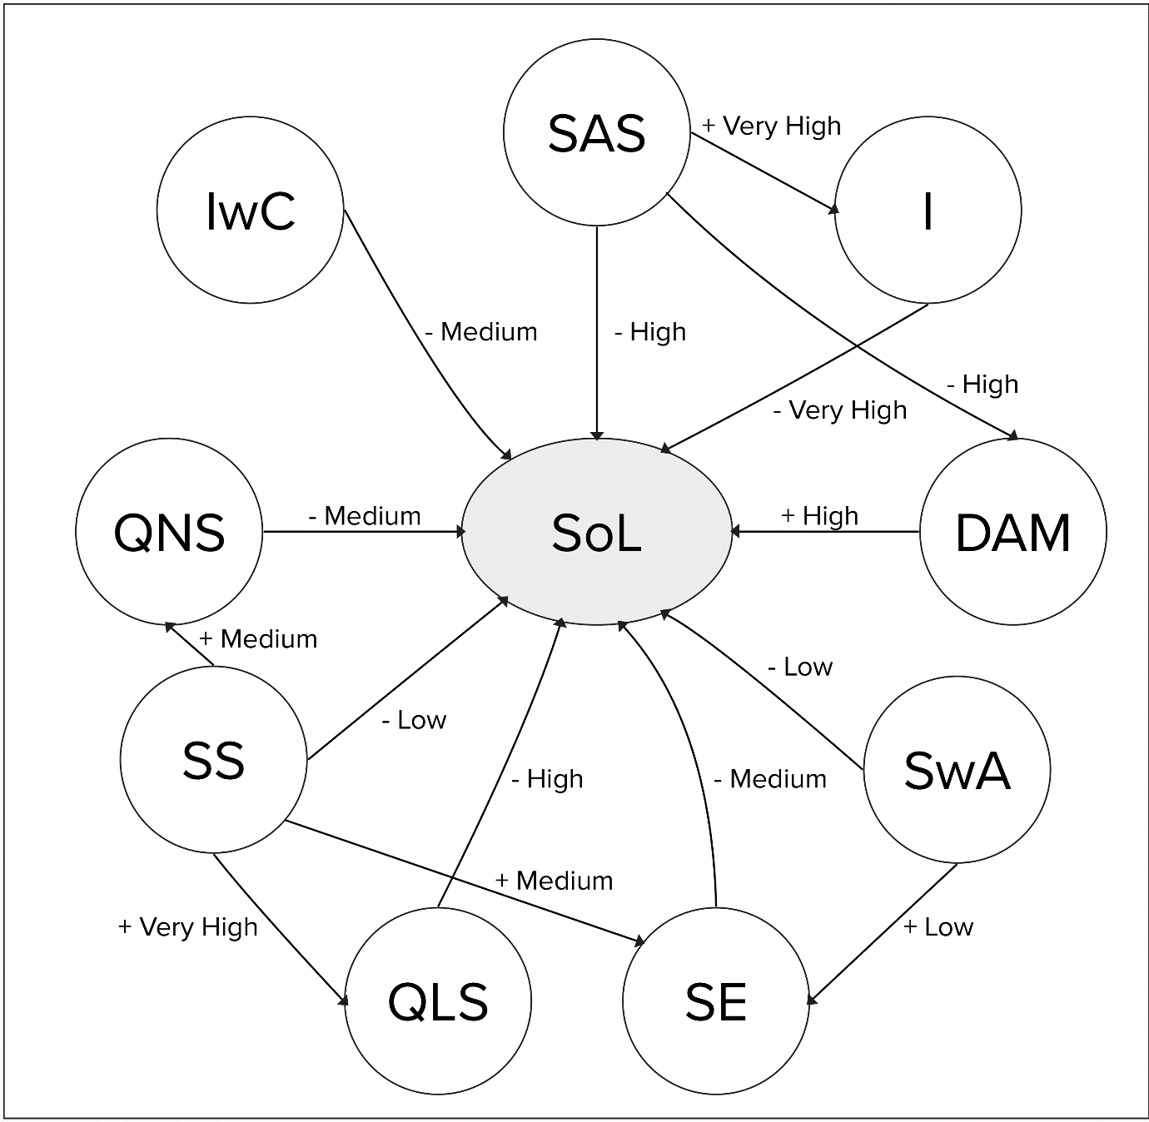
Figure 1. Identified strength of causal relations in the exemplary loneliness FCM using linguistic terms to express influence. This is the corresponding graphical representation of step 3 in the FCM construction process.
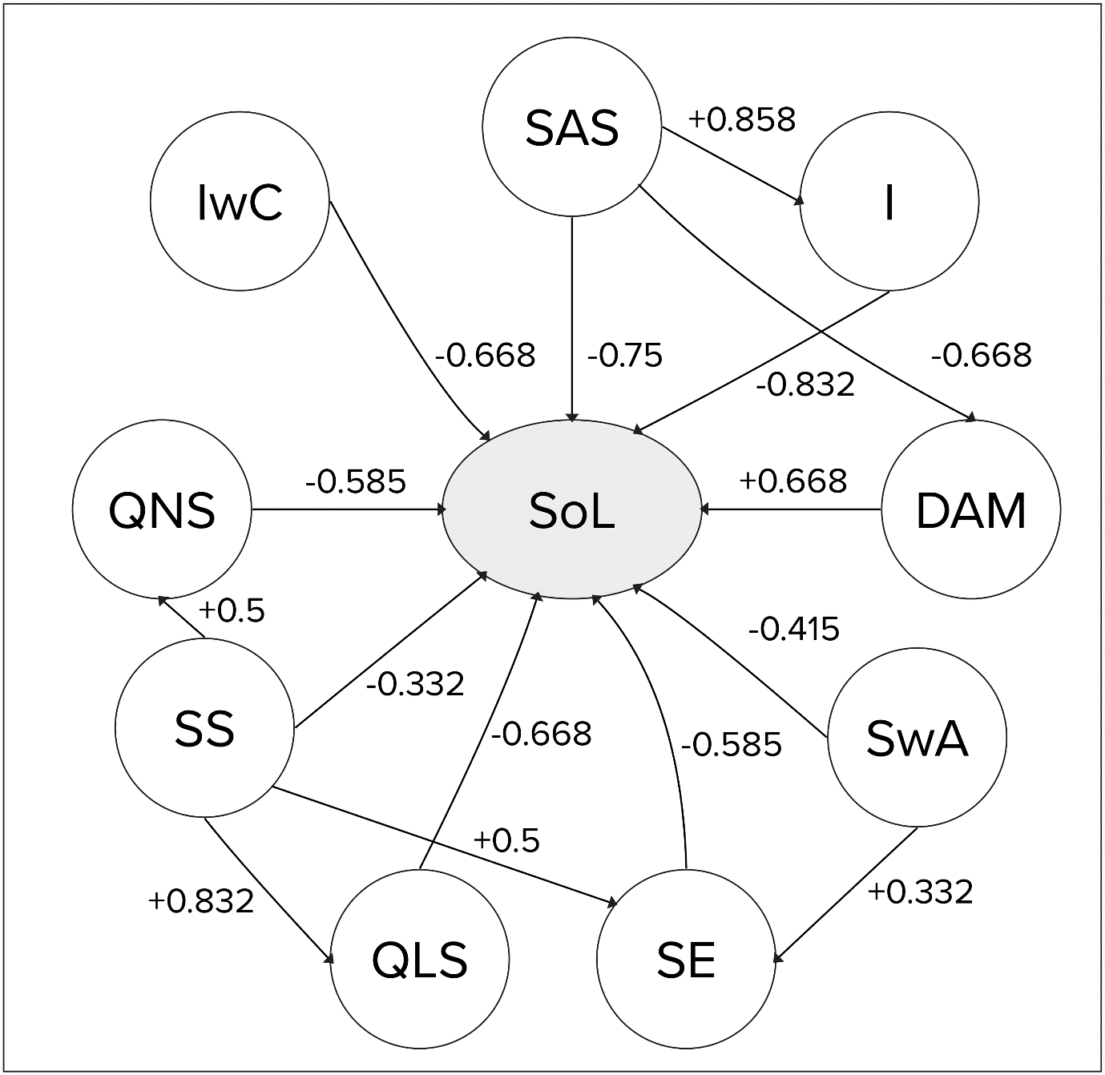
Figure 2. Identified strength of causal relations in the exemplary loneliness FCM using numeric weights to express influence. This is the corresponding graphical representation of step 4 in the FCM construction process.

