Kinesin superfamily members in gastric cancer
KinesinSubFamily | KIFs Membership
Kinesin1 | KIF5A KIF5B KIF5C
Kinesin2 | KIF3A KIF3B KIF3C KIF17
Kinesin3 | KIF1A KIF1B KIF1C KIF13A KIF13B KIF14 KIF16A KIF16B
Kinesin4 | KIF4A KIF4B KIF7 KIF21A KIF21B KIF27
Kinesin5 | KIF11
Kinesin6 | KIF20A KIF20B KIF23
Kinesin7 | KIF10
Kinesin8 | KIF18A KIF18B KIF19A KIF19B
Kinesin9 | KIF6 KIF9
Kinesin10 | KIF22
Kinesin11 | KIF26A KIF26B
Kinesin12 | KIF12 KIF15
Kinesin13 | KIF2A KIF2B KIF2C KIF24
Kinesin14A | KIFC1
Kinesin14B | KIF25 KIFC2 KIFC3
Table S1. KIFs membership and classification.

Table S2. Primer sequences of genes in the risk model used for qPCR.
gene | primer
KIF3C | Forward: ACCTGCAGGAACAGAAGGAGC
 | Reverse: GCATCTTCTCCTTCTCCTCCA
KIF17 | Forward: AAGGAGGCCACCAAGATCAAC
 | Reverse: GGCCTTGAGCTTCTTGATCTC
KIF24 | Forward: TGAACACACTCTCAACACCTTGC
 | Reverse: CCTCTGGCTGTCTTGACTGTACT
KIFC3 | Forward: CTGAACCTAGAGGTGCAGCAGAA
 | Reverse:TGATGACATACTTGACAGGTGGG

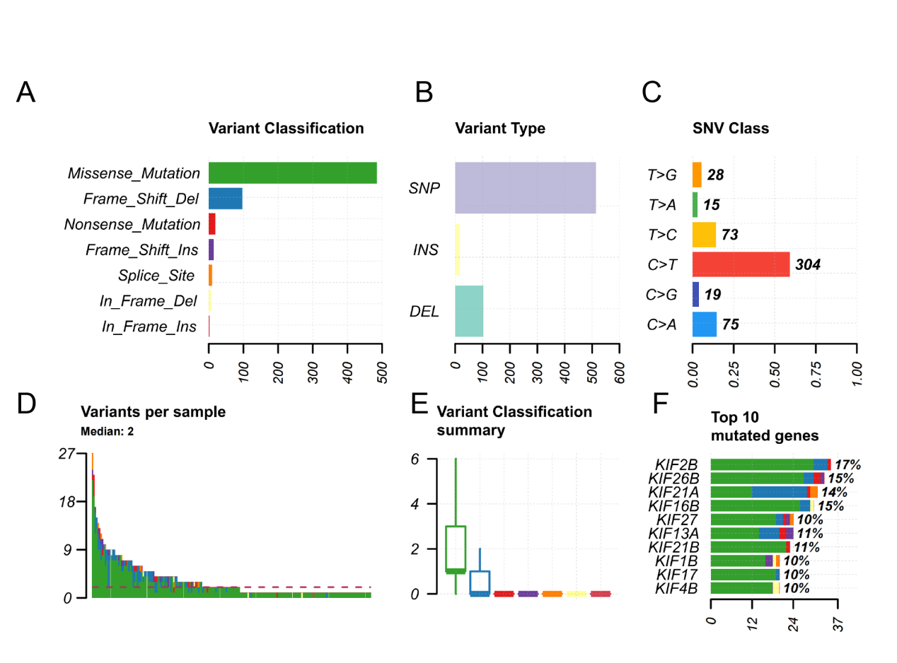
Figure S1. The overview of mutation profile of KIFs from the TCGA-STAD datasets. A. Variant classification. B. Variant type. C. SNV class. D. Variants per sample. E. Variant classification summary. F. Top 10 mutated genes.

Kinesin superfamily members in gastric cancer

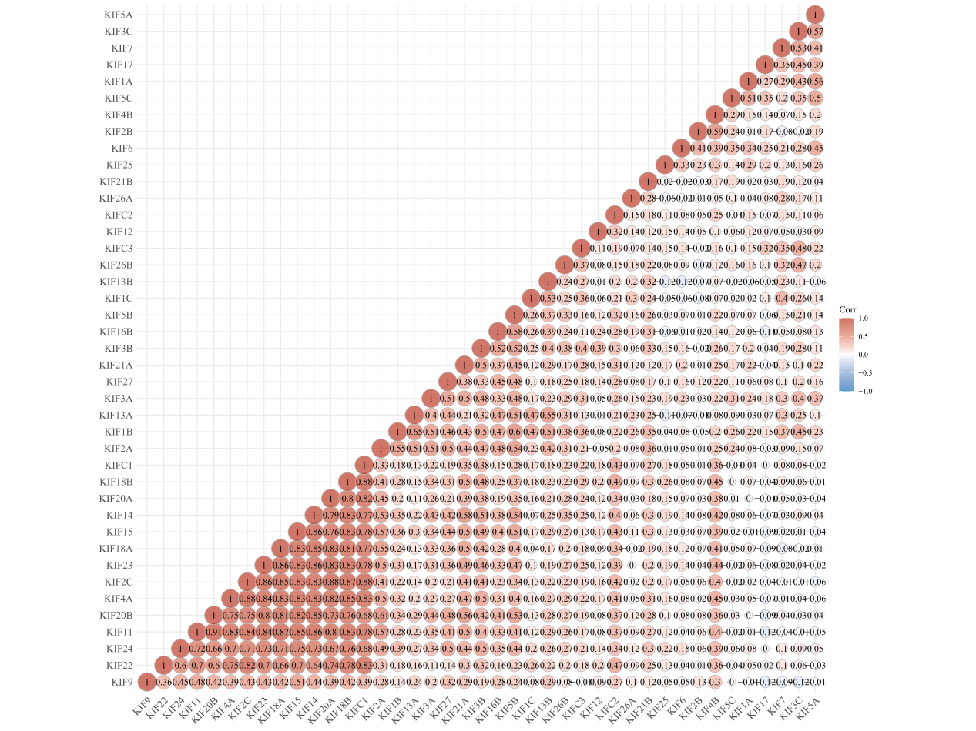

Figure S2. The correlation among KIFs. Red represents positive correlation; blue represents negative correlation. Correlation analysis was conducted by Spearman correlation analysis.

Figure S3. The univariate Cox regression analysis results indicated that 10 KIFs were significantly correlated with the survival of GC patients.

