Table S1. Primers and probes sequence
SNPs/Methylation |  | Upstream and downstream primer sequence
rs352163 | Primers | F: CGGAGTCCACCTCACATTTGT  R: GGGCAGTTGAAAATATTGAGCAA
rs352163 | Probes | FAM: CACCACTGCCCTCT-MGB  HEX: TTCACCACTACCCTCT-MGB
rs352169 | Primers | F: AGGACCCCTTCACTACCACTAATG  R: GAAATGAATGCCGTGAGGAAA
rs352169 | Probes | FAM: TTCACAATTCATCTCTTAC-MGB  HEX: TTCACAACTCATCTCT-MGB
rs104903 | Primers | F: CCCTCAGCTTCCCAAAGTTCT  R: CTCCACTATCCAGTTCTTTCTGCTT
rs104903 | Probes | FAM: ATTATAGGCTTGAGCCAC-MGB  HEX: ATTATAGGCATGAGCCAC-MGB
ALAS1- Methylated | Primers | F: GGTTTTAGCGGTATTTCGTTTC  R: AAACCCACTTCTTAAACTCTACGAA
ALAS1- Unmethylated | Primers | F: TGGTTTTAGTGGTATTTTGTTTTGA  R: AAACCCACTTCTTAAACTCTACAAA
SNPs, single nucleotide polymorphisms; ALAS1, 5-aminolevulinate synthase 1; F, forward; R, reverse; FAM, carboxy fluorescein; HEX, hexachloro fluorescein; MGB, minor groove binder.

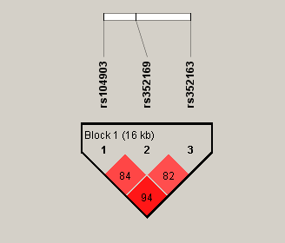
Figure S1. Linkage disequilibrium (LD) block constructed from 3 SNPs in ALAS1
(This LD plot was generated with the Haploview 4.2 software. Markers with LD are shown in red through pink (color intensity decreases with decreasing D′ value). D′ value shown within each square represents a pairwise LD relationship between the two polymorphisms.)

