Supplementary data for
Therapeutic effect of HSP70 for LM seeding of MB
Seung Ah Choi, Saehim Ha, Seung-Ki Kim, Do Won Hwang, Hyewon Youn, Sokhoeun Heng and Ji Hoon Phi

Supplementary Figure S1
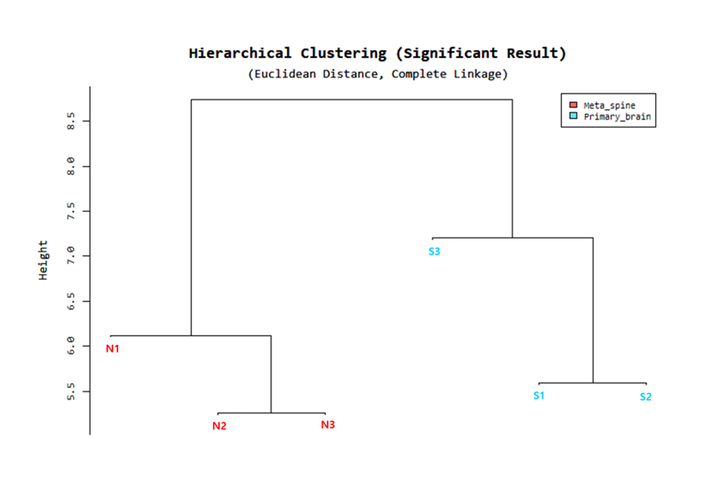
Supplementary Fig. S1. Relations of miRNA expression in cells at each stage for seeding (S3) and securing non-seeding cells (N3) by miRNA profiling. Cluster dendrogram. Features with significant difference at p < 0.05 were used for hierarchical clustering of samples by euclidean distance and average linkage, as indicated. Non-seeding (N, red color): isolated from tumors in brain tissues. Seeding (S, sky color): isolated from tumors in spinal cord tissues.

Supplementary Table S1. Differentially expressed genes in seeding cells (S3) vs non-seeding cells (N3).
Gene_Symbol | Gene_ID | mRNA Accession | S3/N3.fc | Gene Accession | Gene Description | Cytoband | mRna - Description
HSPA1B | 3304 | NM_005346 | 7.701289 | NM_005346 | heat shock 70kDa protein 1B | 6p21.3 | Homo sapiens heat shock 70kDa protein 1B (HSPA1B), mRNA.
HSPA1A | 3303 | NM_005345 | 7.520299 | NM_005345 | heat shock 70kDa protein 1A | 6p21.3 | Homo sapiens heat shock 70kDa protein 1A (HSPA1A), mRNA.
DNAJA1 | 3301 | NM_001314039 | 3.128780 | NM_001314039 | DnaJ (Hsp40) homolog, subfamily A, member 1 | 9p13.3 | Homo sapiens DnaJ (Hsp40) homolog, subfamily A, member 1 (DNAJA1), transcript variant 2, mRNA.
MIR1321 | 100302171 | NR_031710 | 3.115190 | NR_031710 | microRNA 1321 | Xq21.2 | Homo sapiens microRNA 1321 (MIR1321), microRNA.
HSPA8 | 3312 | NM_006597 | 3.097083 | NM_006597 | heat shock 70kDa protein 8 | 11q24.1 | Homo sapiens heat shock 70kDa protein 8 (HSPA8), transcript variant 1, mRNA.
DNAJB1 | 3337 | NM_001300914 | 2.696915 | NM_001300914 | DnaJ (Hsp40) homolog, subfamily B, member 1 | 19p13.2 | Homo sapiens DnaJ (Hsp40) homolog, subfamily B, member 1 (DNAJB1), transcript variant 2, mRNA.
FAM106A | 80039 | NR_026809 | 2.575745 | NR_026809 | family with sequence similarity 106, member A | 17p11.2 | Homo sapiens family with sequence similarity 106, member A (FAM106A), long non-coding RNA.
CYP4F30P | 100132708 | NR_023391 | 2.483079 | NR_023391 | cytochrome P450, family 4, subfamily F, polypeptide 30, pseudogene | 2q21.1 | Homo sapiens cytochrome P450, family 4, subfamily F, polypeptide 30, pseudogene (CYP4F30P), non-coding RNA.
ANKRD30BP2 | 149992 | NR_026916 | 2.431236 | NR_026916 | ankyrin repeat domain 30B pseudogene 2 | 21q11.2 | Homo sapiens ankyrin repeat domain 30B pseudogene 2 (ANKRD30BP2), non-coding RNA.
SNORD125 | 100113380 | NR_003686 | 2.394078 | NR_003686 | small nucleolar RNA, C/D box 125 | 22q12.2 | Homo sapiens small nucleolar RNA, C/D box 125 (SNORD125), small nucleolar RNA.

Supplementary Table S2. Open area of wound-healing assay (mm²)
Time point (h) | Non-seeding (N3) | Seeding (S3) | p value
0 | 4.00 ± 0.20 | 4.37 ± 0.54 | p > 0.05
12 | 3.47 ± 0.18 | 4.94 ± 1.41 | p < 0.001
24 | 3.07 ± 0.21 | 4.56 ± 1.39 | p < 0.001
36 | 3.08 ± 0.16 | 4.34 ± 1.34 | p < 0.001
48 | 3.20 ± 0.16 | 4.08 ± 1.40 | p < 0.05

Supplementary Table S3. The half maximal inhibitory concentration (IC50) in non-seeding (N3) and seeding cells (S3) (uM)
Groups | VER155008 | Apoptozole | JG98 | HA15 | TRC051384 | Elesclomol
N3 | 52.97 ± 4.26 | N/A | 6.25 ± 0.07 | 125.4 ± 3.11 | 19.14 ± 1.99 | N/A
S3 | 35.24 ± 5.31 | 382.05 ± 79.27 | 5.46 ± 0.49 | 41.1 ± 16.60 | 13.72 ± 1.44 | N/A

