Supplemental Methods

Cell lines
Human MV4-11 cells derived from peripheral blood and displaying lymphoblasts morphology and harbouring FLT3-ITD were used as the AML model. Wild-type and tyrosine kinase inhibitor-resistant human K562 cells (K562-WT and K562-DR, respectively) were used as the CML model. The MV4-11 cells were maintained in RPMI medium supplemented with 100 U/ml penicillin, 100 μg/ml streptomycin, and 12% FBS, under a humidified atmosphere (95/5% air/CO₂) at 37°C. Both types of K562 cells were maintained in a similar condition except the FBS concentration in the medium was 10%.

Uptake of lipopolymer/siRNA complexes
The cellular uptake of complexes was measured by using FAM-labeled scrambled siRNA and an unlabelled scrambled siRNA as a negative control. Complexes were prepared at a lipopolymer:siRNA (wt/wt) ratio of 6:1 (MV4-11) and 7.5:1 (K562), and at a lipofectamine RNAiMAX:siRNA (wt/wt) ratio of 2:1 with 40 nM siRNA for transfection. Transfected cells were harvested after 24 hours of treatment for processing for flow cytometry. Briefly, cells were collected in microcentrifuge tubes and washed (x3) with HBSS (pH 7.4) and then resuspended in 200 µl of HBSS (pH 7.4) to be transferred to 96 well plates. The cell-associated FAM-labeled siRNA was quantified on the BD Accuri C6 Plus (BD Biosciences) flow cytometer by measuring the mean fluorescence of cells and percentage of FAM-positive cell population using the FL1 channel. The mean fluorescence intensity values acquired for treated cells was normalized to that of the untreated cells and plotted. Since there was no difference between the signal from unlabeled control siRNA and untreated groups, the former was not shown in the plots.

Lipid Nanoparticle (LNP) composition and synthesis
For formulation of LNPs, siRNA was used as the aqueous phase. The ionizable lipid, D-Lin-MC3-DMA, with DSPC/cholesterol, and DMG-PEG-2000 were dissolved in absolute ethanol and mixed at a molar ratio of 50:10:38.5:1.5 as the organic phase, respectively. 0.75 ml of aqueous and 0.25 ml of organic solutions were prepared to obtain an N/P ratio of 7. Both solutions were loaded onto the NanoAssemblr® Benchtop cartridges using NanoAssemblr™ 1.5 apparatus (Precision NanoSystems Inc., Vancouver, Canada) at a temperature of 25°C. To allow the siRNA to encapsulate into LNPs, the aqueous/organic phase flow rate ratio was set at 3:1. Finally, 1 ml of LNPs were collected in a tube.

Gene primers for qPCR
The forward and reverse primers used to detect and amplify human FLT3, BCR-ABL, actin-beta (Actβ) and β-2 microglobulin (β2M) as endogenous housekeeping genes, and mouse Actβ were as follows: (i) hFLT3 with forward 5′-AGG GCA ACT ACT TTG AGA TGA G-3′ and reverse 5′-AGT ATC CGG TGT CGT TTC TTG-3'; (ii) hβ2M with forward 5′-CCA GCG TAC TCC AAA GAT TCA-3′ and reverse 5′-TGG ATG AAA CCC AGA CAC ATA G-3′; (iii) hBCR-ABL with forward 5’-CAT TCC GCT GAC CAT CAA TAA G-3’ and reverse 5’-GAT GCT ACT GGC CGC TGA AG-3’, (iv) hActβ with forward 5’-GCG AGA AGA TGA CCC AGA T-3’ and reverse 5’- CCA GTG GTA CGG CCA GA-3’, and (v) mouse Actβ with forward 5’-CAG CAA GCA GGA GTA CGA TG-3’ and reverse 5’-GGG TGT AAA ACG CAG CTC A-3’.

Gilteritinib (GTB) and GTB carrier formulation
For in vitro studies, GTB (MedChemExpress, Monmouth Junction, NJ) master stocks were prepared in DMSO at a concentration of 1 mM, from which working stocks at lower concentrations were made with RN-ase free water. For in vivo studies, GTB was prepared as a suspension by adding PEG300 followed by 1X PBS at a 1:1 (vol/vol) ratio (1st study) or 1:3 (vol/vol) ratio (2nd study). Aliquots of 100 µl were stored at -20°C. The corresponding drug carrier was prepared by mixing PEG300 and 1X PBS at a 1:1 (vol/vol) ratio (1st study) or 1:3 (vol/vol) ratio (2nd study) and stored at -20°C in 100 µl aliquots. Prior to intraperitoneal administration in mice, aliquots were thawed on ice and gently mixed with a pipette to ensure a uniform suspension.

Animal husbandry
Newly arrived NCG (ABL/VAF) mice (7-14 weeks old; Charles River Laboratories) were allowed to acclimatize to their new surroundings for at least 1 week before use, according to the institutional SOP. The animals were maintained at a ratio of 4-5 mice per shoebox cage in a biohazard containment system at Health Sciences Laboratory Animal Services (HSLAS) central facilities at the University of Alberta North Campus, Heritage Medical Research Centre (HMRC). The light was provided with 12 h on – 12 h off cycle. The mice were provided with plenty of bedding and additional toys for enrichment. Animals were randomly selected from each cage and assigned to the study groups. The animals receiving different treatments were housed in the same cage to maintain uniformity and they were typically monitored within 24 h post-injection.

Mouse leukemia xenograft models
After the acclimation of mice to the animal facility, the animals were restrained and injected with cells. For the subcutaneous AML MV4-11 and CML K562-DR models, a single injection of 2.5 - 5.0 x 10⁶ cells suspended in 100 µl of 60:40% RPMI:Matrigel medium was administered subcutaneously using a 26G syringe and sufficient time was given for establishment of human xenografts in mice. The length (l) and width (w) of the tumors were measured by external calipers every three days and tumor volume was calculated based on the formula: volume = length (l) * width² (w)² * 0.5. The animals were recruited to the study when the tumor volume was ≥50 mm³ or 100 mm³. For the systemic CML model, 5 x 10⁶ K562-DR cells suspended in 200 µl of RPMI media were administered using a 26G syringe intravenously via the lateral tail vein. Engraftment was assessed in initial studies through weekly peripheral blood draws to measure human CD34 levels by flow cytometry. Briefly, mice blood was collected by tail vein and treated with 1X red blood cell lysis buffer (BD Pharm LyseTM, BD Biosciences). The isolated samples from blood were passed through 40-micron cell strainer to attain single cell suspension following which they were stained with anti-human CD34 PE (Sysmex Canada Inc.) for 35 min at 4°C. Cells were washed twice to remove excess antibody and immediately analyzed on the BD LSRFortessa (BD Biosciences) flow cytometer.

Tissue recovery from animals
Animals were euthanized using CO₂ inhalation in accordance with the protocol designed for each study. Major organs (liver, kidneys, lungs, spleen, heart, bone marrow, and brain) were recovered and stored in RNAlater overnight at 4ºC and then transferred to – 80ºC freezer for storage until further analysis. In case of the systemic CML model, peripheral blood samples were processed immediately for human CD34 positive cells analysis by flow cytometry. The bone marrow samples were divided into two, with one half being processed right away for flow cytometry (to assess human CD34 positive cells) and TRIzol reagent was added to the other half (to extract RNA for subsequent qPCR analysis), which was stored at -80°C until further analysis.

Biodistribution of siRNA in tissues
Total RNA was extracted from a fraction of tissue (10 – 20 mg), as described in the main Methods (qPCR assay) section. Next, reverse transcription was performed using a proprietary custom-designed stem-loop primer (Thermo Fisher) or an in-house designed stem loop primer (BCR-ABL: 5’ GTC GTA TCC AGT GCA GGG TCC GAG GTA TTC GCA CTG GAT ACG ACA AAA GG 3’; FLT3: 5’ GTC GTA TCC AGT GCA GGG TCC GAG GTA TTC GCA CTG GAT ACG ACT AAT CT 3’) and using the TaqMan™ MicroRNA Reverse Transcription Kit (Thermo Fisher) according to the protocol outlined by the manufacturer, using 10 ng of total RNA as template. Once the cDNA was synthesized, the number of copies of siFLT3 or siBCR-Abl was measured by one of two methods (supplemental Figure 9) described below.
i) Droplet digital PCR (ddPCR): The equivalent of 0.0001 to 0.1 ng of cDNA were amplified using proprietary custom-designed MGB-TaqMan probes and forward/reverse primers from Thermo Fisher, or the following in-house designed oligonucleotides:
BCR-ABL: forward primer: 5’ CAC GCA GCA GAG TTC AAA 3’
BCR-ABL: MGB fluorescent probe: /56-FAM/CTG GAT ACG ACA AAA GG /3MGB-NFQ/
FLT3: forward primer: 5’ CAC GCA ATG CTA CCA ATT C 3’
FLT3: MGB fluorescent probe: /56-FAM/CA CTG GAT ACG ACT AAT CTT C/3MGB-NFQ/
Universal reverse primer: 5’ CCA GTG CAG GGT CCG AGG TA 3’
The cDNA templates, primers and probes were mixed with ddPCR™ Supermix for Probes (BioRad #1863010). Droplets were generated in a DG8™ Cartridges for QX200™/QX100™ Droplet Generator (BioRad #1864008) using Droplet Generation Oil for Probes (BioRad #1863005) in a QX100 Droplet Generator (BioRad). Droplets were read in a QX100 Droplet Reader, data collection and analysis was done using QuantaSoft Software (version 1.7; BioRad).
ii) Quantitative Real-Time PCR (qPCR): A standard curve was created with siRNA complexed with the appropriate lipopolymer at a lipopolymer:siRNA (w/w) ratio of 7.5:1. The starting concentration was 1 nM, followed by 1:5 serial dilutions for up to 8 points. For the qPCR reaction, 1 uL of cDNA or standard was used in combination with the TaqMan Universal Master Mix (ThermoFisher), proprietary custom-designed MGB-TaqMan probe, as well as forward and reverse primers. Thermocycling parameters were followed as per manufacturer’s instructions, and concentration of siRNA was calculated by extrapolating their C_{t} values to the standard curve.
Our methods were validated as they specifically detected siFLT3 or siBCR-Abl with the designed probes since no signal was present in the tumors of vehicle or siNC complexes treated animals (supplemental Figure 10).

Supplemental Tables

Table S1. Details of in vivo study assessing PEI-LA/siFLT3 complexes as a monotherapy
Group | n | RPMI (µl) | siRNA complexes (µl) | siRNA dose/injection (µg)
Vehicle | 7 | 200 | - | -
siNC complexes | 7 | - | 200 | 25
siFLT3 complexes | 7 | - | 200 | 25

Table S2. Details of in vivo study assessing PEI-LA/siFLT3 complexes in combination with high-dose GTB
Group | n | RPMI (µl) | siFLT3 complexes (µl) | GTB carrier (µl) | GTB (µl) | siFLT3 dose/injection (µg) | GTB dose/injection (µg)
Vehicle | 8 | 100 | - | 100 | - | - | -
siFLT3 complexes | 7 | - | 100 | 100 | - | 25 | -
GTB only | 8 | 100 | - | - | 100 | - | 250
GTB + siFLT3 complexes | 5 | - | 100 | - | 100 | 25 | 250

Table S3. Details of in vivo study assessing PEI-LA/siFLT3 complexes in combination with low-dose GTB
Group | n | RPMI (µl) | siFLT3 complexes (µl) | GTB carrier (µl) | GTB (µl) | siFLT3 dose/injection (µg) | GTB dose/injection (µg)
Vehicle | 7 | 100 | - | 100 | - | - | -
GTB only | 8 | 100 | - | - | 100 | - | 125
GTB + siFLT3 complexes | 7 | - | 100 | - | 100 | 25 | 125

Table S4. Details of in vivo study assessing PEI-Lau/siBCR-ABL complexes in a subcutaneous CML model
Group | n | RPMI (µl) | siRNA complexes (µl) | siRNA dose/injection (µg)
siNC complexes | 5 | - | 200 | 25
siBCR-ABL complexes | 6 | - | 200 | 25

Table S5. Details of in vivo study assessing PEI-Lau/siBCR-ABL complexes in a systemic CML model
Group | n | RPMI (µl) | siRNA complexes (µl) | siRNA dose/injection (µg)
siNC complexes | 10 | - | 200 | 25
siBCR-ABL complexes | 10 | - | 200 | 25

Table S6. Source and sequence information of siRNAs used in this study
siRNA | Source | Sequence
siFLT3 | IDT (Coralville, IA) | Sense: rArUrGrCrUrArCrCrArArUrUrCrArArGrUrGrArArGrArUdTdA  Antisense: rUrUrUrArCrGrArUrGrGrUrUrArArGrUrUrCrArCrUrUrCrUrArArU
siBCR-ABL | IDT and Biospring GmbH (Frankfurt, Germany) | Sense: rGrCrGrUrArUrUrArUrArCrGrCrGrArUrUrArAdCdG  Antisense: rArArGrGrGrCrUrUrUrUrGrArArCrUrCrUrGrCdTdT
siNC | Biospring | Sense: rGrCrGrUrArUrUrArUrArCrGrCrGrArUrUrArAdCdG  Antisense: rCrGrUrUrArArUrCrGrCrGrUrArUrArArUrArCdGdC

Supplemental Figures
A
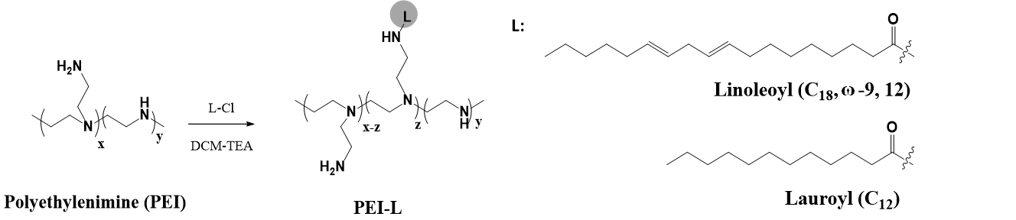
B
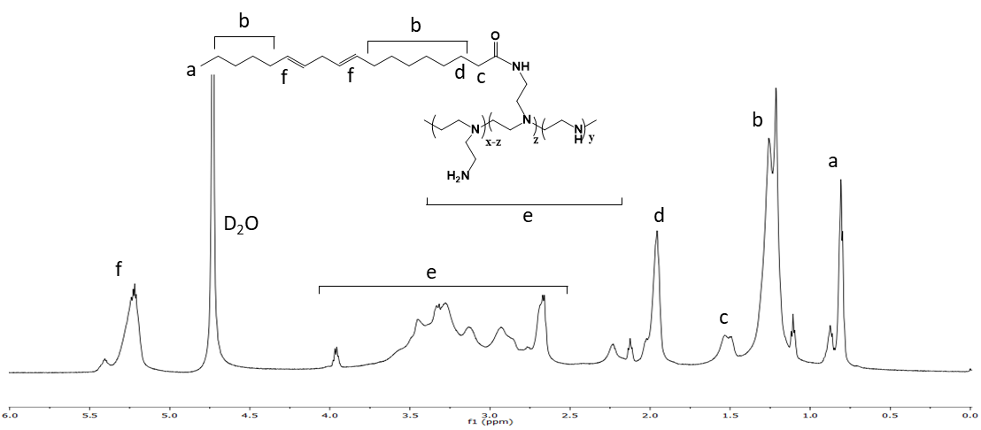
C
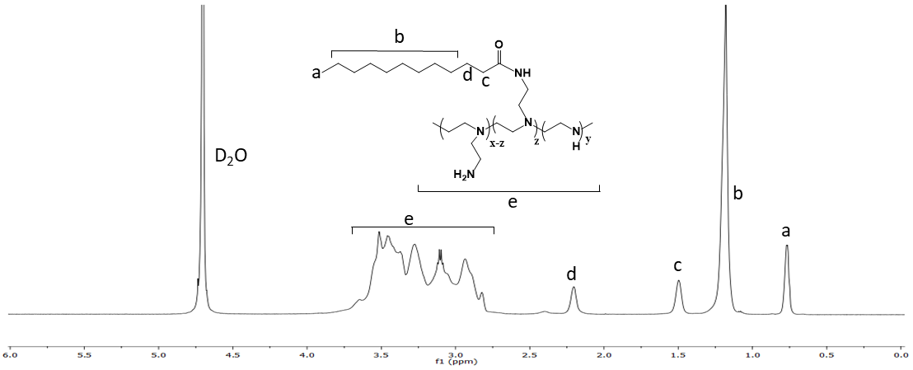
Figure S1. Lipopolymer synthesis and characterization. (A) Schematic illustration of lipopolymer synthesis used in this study. Typical ¹H-NMR spectra of (B) PEI-LA and (C) PEI-Lau in deuterated water (D₂O), where the resonances a-d correspond to lipid moieties.

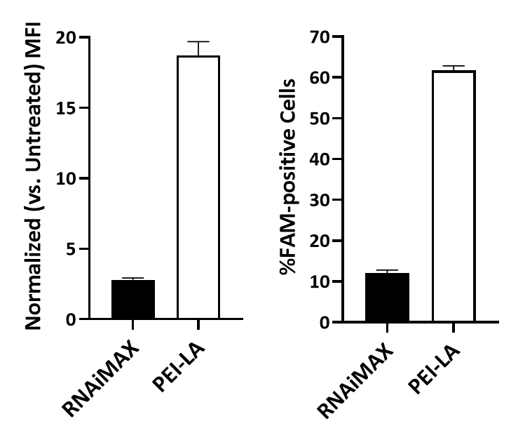
B
A
Figure S2. Lipopolymer mediated uptake of siRNA in MV4-11 cells. Comparison of cellular uptake of FAM-siRNA by LipofectamineTM RNAiMAX and PEI-LA in AML MV4-11 cells detected by flow cytometry 24 hours after treatment with complexes, shown as (A) mean fluorescence intensity normalized to that of the untreated control, and (B) percentage of FAM-positive cell population. Bars show mean + SD. MFI – mean fluorescence intensity.

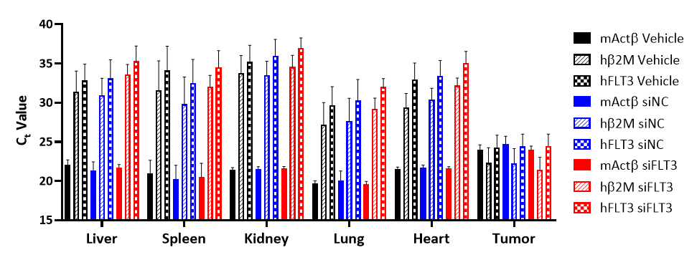
Figure S3. Leukemic cell burden in subcutaneous tumors and mouse organs in an AML xenograft model. Average C_{t} values of human Flt3 (hFLT3), human β2M (hβ2M), and mouse Actβ (mActβ) genes in tumors and indicated mouse organs from animals in each group as assessed by qPCR. Tumors and mouse organs were harvested four days after last intravenous administration of PEI-LA/siRNA complexes.

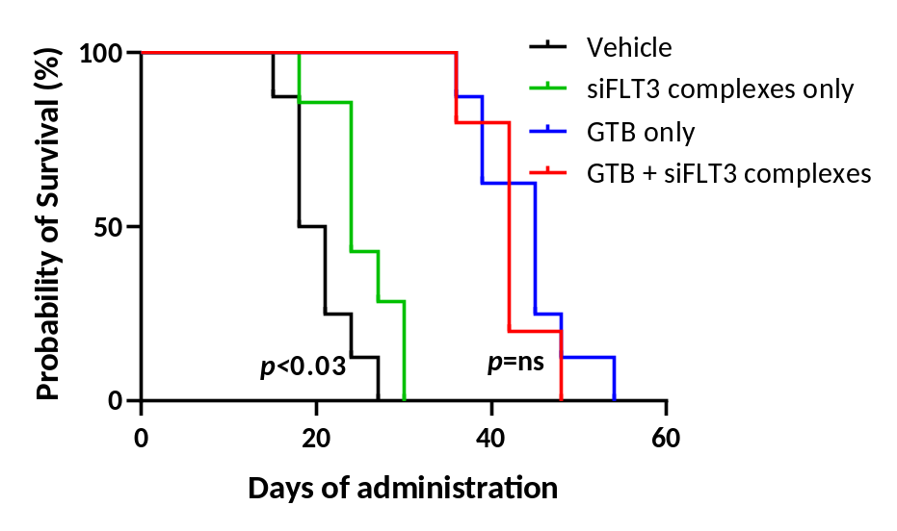
Figure S4. Combining PEI-LA/siFLT3 complexes with high-dose gilteritinib in MV4-11 subcutaneous xenograft model. Kaplan-Meier analysis curve of survival (endpoint defined as attainment of subcutaneous tumor volume ≥1000 mm³) in mice treated with 10 mg/kg gilteritinib intraperitoneally daily for 11 days, either with or without intravenous administration of PEI-LA/siRNA complexes (p<0.03, p=ns, Mantel-Cox test). GTB – gilteritinib.

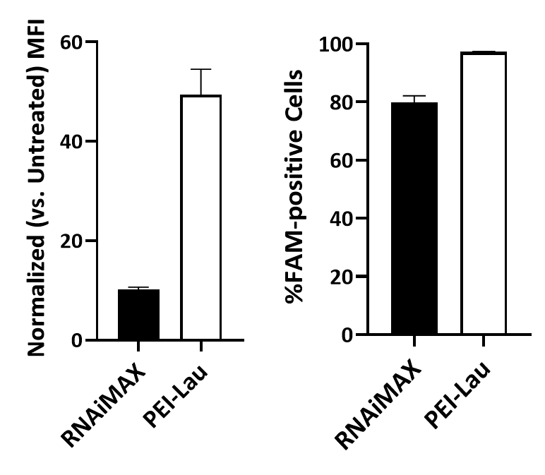
B
A
Figure S5. Lipopolymer mediated uptake of siRNA in K562 cells. Comparison of cellular uptake of FAM-siRNA by LipofectamineTM RNAiMAX and PEI-Lau in CML K562 cells detected by flow cytometry 24 hours after treatment with complexes, shown as (A) mean fluorescence intensity normalized to that of the untreated control, and (B) percentage of FAM-positive cell population. Bars show mean + SD. MFI – mean fluorescence intensity.

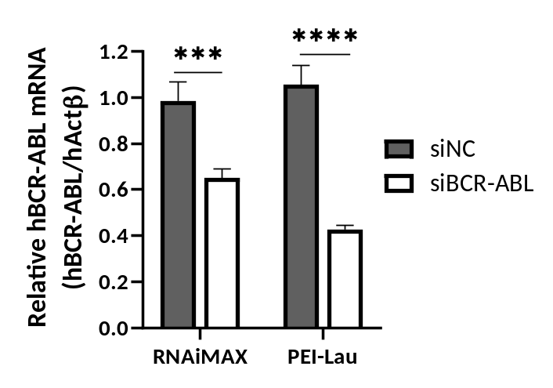
Figure S6. BCR-ABL silencing in K562 cells via siBCR-ABL delivered by Lipofectamine RNAiMAX and PEI-Lau. Comparison of BCR-ABL gene silencing brought about by siBCR-ABL complexes formulated with Lipofectamine RNAiMAX and PEI-Lau, measured by qPCR three days after treatment of K562 cells (****p < 0.0001, ***p < 0.0003; two-way ANOVA with Sidak’s multiple comparisons test). Bars show mean + SD.

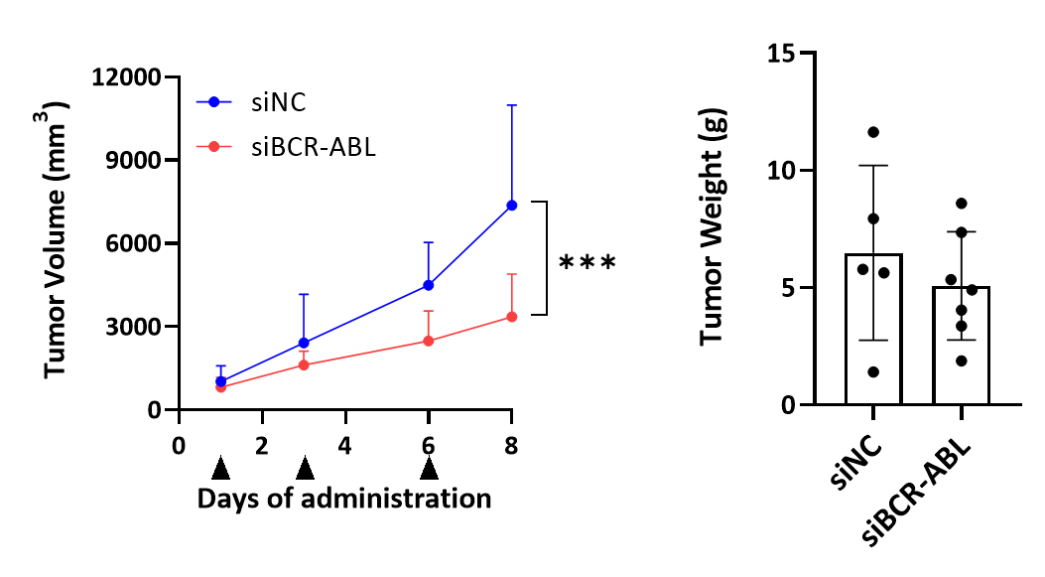
C
A
B
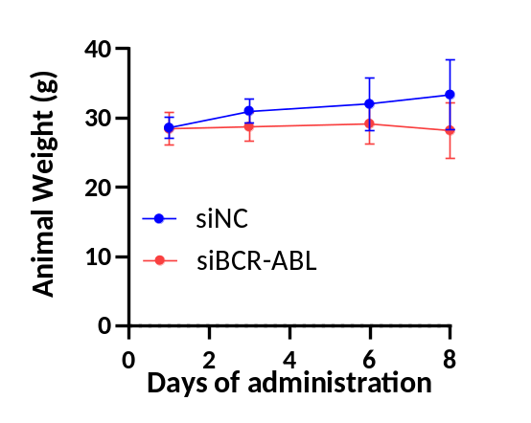
Figure S7. Effect of local treatment of PEI-Lau/siRNA complexes on K562 subcutaneous tumors. (A) Volume of K562 subcutaneous tumors treated three times by local administration of PEI-Lau/siRNA complexes at a siRNA dose of 1 mg/kg (***p < 0.001; two-way ANOVA with Sidak’s multiple comparisons test). Black arrows below the x-axis indicate time of administration of PEI-Lau/siRNA complexes. Bars show mean + SD. (B) Wet weight of subcutaneous K562 tumors harvested from mice after euthanization. Bars show mean ± SD. (C) Body weight of treated mice plotted as a function of time. Bars show mean ± SD.

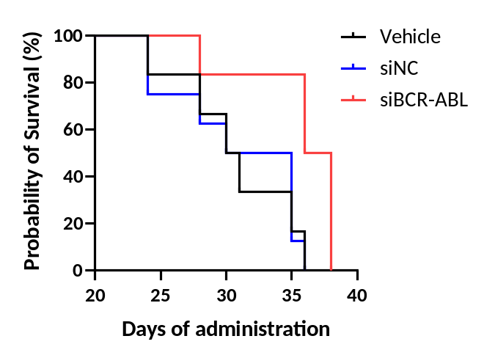
Figure S8. Effect of intravenous treatment of PEI-Lau/siRNA complexes on K562-DR systemic tumors. Kaplan-Meier analysis curve of survival (endpoint defined as attainment of body score ≥9) in mice treated with 1 mg/kg of siRNA using PEI-Lau/siRNA complexes from day 21 of intravenous cell inoculation five times each spaced 72 h apart. Median survival was similar between vehicle (30.5 days) and siNC complexes (32.5 days) treated groups but was enhanced with siBCR-ABL complexes treatment (37 days). p < 0.05, Mantel-Cox test.

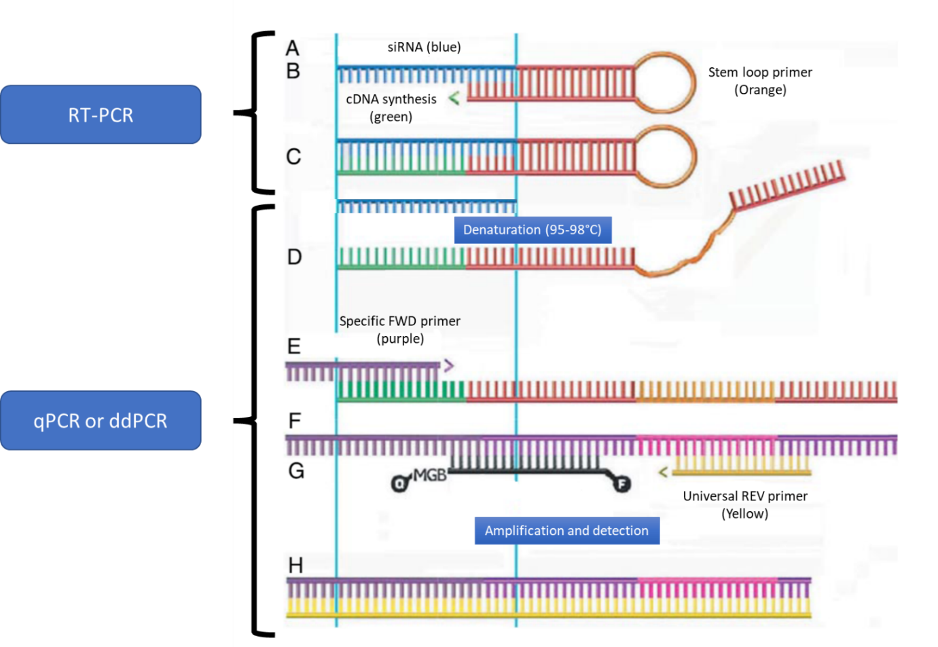
Figure S9. Schematic of the method used for the detection of siRNA concentration in different organs. The multi-step process consists of: A) the siRNA (blue) is bound by a specific stem loop primer (orange), B) a reverse transcriptase synthesizes the cDNA (green), which is complementary to the 5’ sequence of the siRNA, completing the loop as shown in C. D) During the denaturation step of qPCR or ddPCR, the stem loop structure opens up revealing sites for the annealing of specific forward primers. E) As amplification occurs and the complementary strand is synthesized (F), a site for the binding of REV universal primer and a fluorescent probe are created (G). Image modified from Kramer MF. Curr Protoc Mol Biol. 2011;Chapter 15(Unit 15.10):Figure 1.

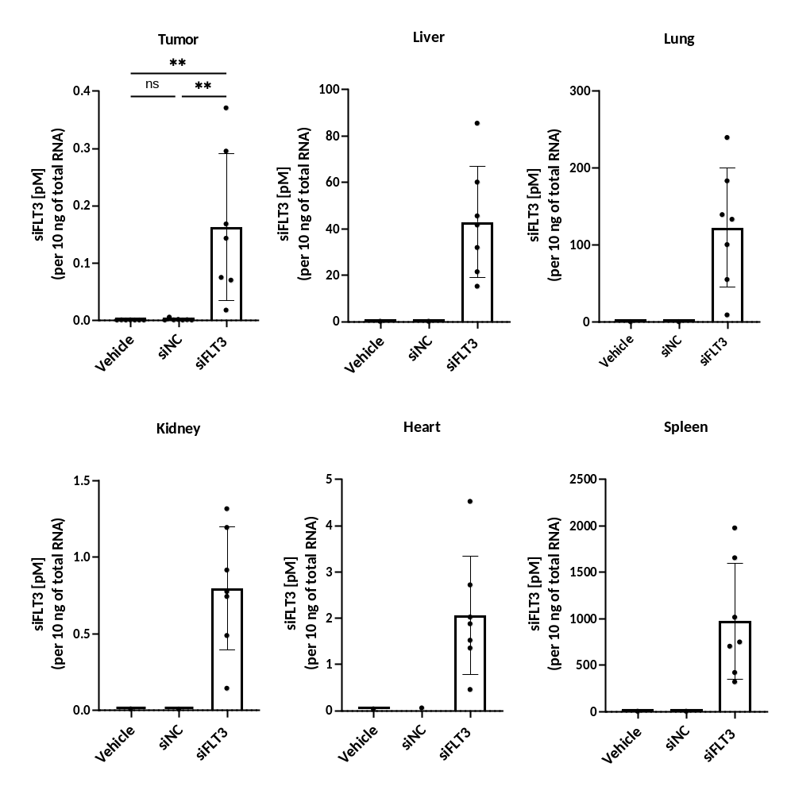
B
A
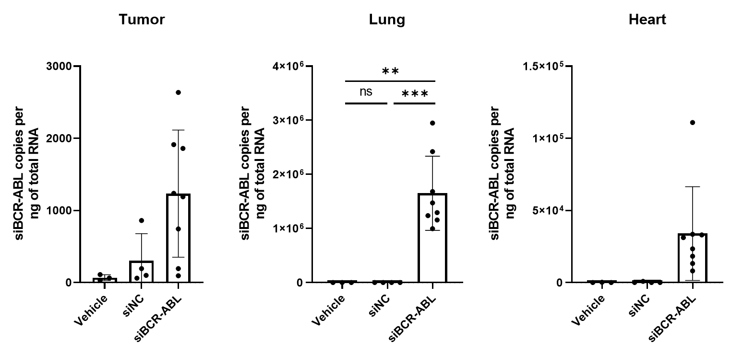
Figure S10. Biodistribution of siRNA in different mouse organs. (A) Quantification of siFLT3 in the subcutaneous tumor, liver, lung, kidney, heart and spleen of mice injected with either vehicle, siNC, or siFLT3 complexes, expressed as concentration of siRNA (pM) per 10 ng of total RNA extracted. The siRNA levels were detected by qPCR. Organ collection was done 4 days after the last siFLT3 injection. For tumors, all animals in each group were analyzed. For the remaining organs, one single mouse was randomly selected from the vehicle and siNC treated groups to validate the technique. (B) Quantification of siBCR-ABL in tumor, lung and heart of mice injected with either vehicle, siNC or siBCR-ABL complexes treated groups per ng of total RNA. The siRNA levels were detected by droplet digital PCR (ddPCR). ***p < 0.001, **p < 0.01; Ordinary one-way ANOVA followed by a Tukey's multiple comparisons test.

