Preventive potential of Lactobacillus johnsonii YH1136 against uric acid accumulation and hyperuricemia-induced damages in rats

Supplementary Information
Table.1 Target gene primer sequence
Gene | Forwards(5’-3’) | Reverse(5’-3’)
GLUT9 | GCCGAGGAGGACAAAGAACTG | CACCATCAGTGTTCCCACCA
ABCG2 | CCTCGATATGGCTTCACAGCTT | GGCCACATGATTCCTCCACA
OAT1  OAT4  XOD  IL-6  IL-1β  TNF-α  IL-10  IL-18  β-actin | GCCATACGATCATTCGCACC  TGCTGGTGGTGAAGATGACAG  TGACTGCGGATGAGTTGGTC  TAGTCCTTCCTACCCCAATTTCC  ATGAAAGACGGCACCCCAC  GATCGGTCCCAACAAGGAGG  GGGAGAGAAGCTGAAGACCC  CCTGAAGAAAATGGAGACCTGGAA  CGCGTCCACCCGCGAG | GGCCTGTCTGCCGAATCA  GGCTGCTGTTGATTTCTGGC  GTCCCACATAGCCCCAACTT  TTGGTCCTTAGCCACTCCTTC  GCTTGTGCTCTGCTTGTGAG  GCTTGGTGGTTTGCTACGAC  ACACCTTTGTCTTGGAGCTTATTA  TGGGGTTCACTGGCACTTTG  CCTGGTGCCTAGGGCG

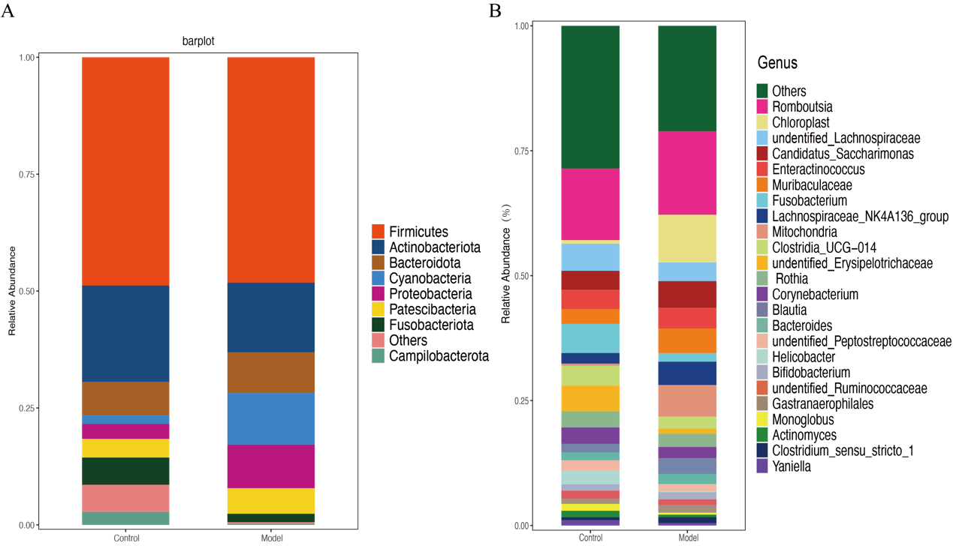
Fig. S1. The relative abundance of Bacteria from Phylum(A) and Genus(B) in the Duodenum
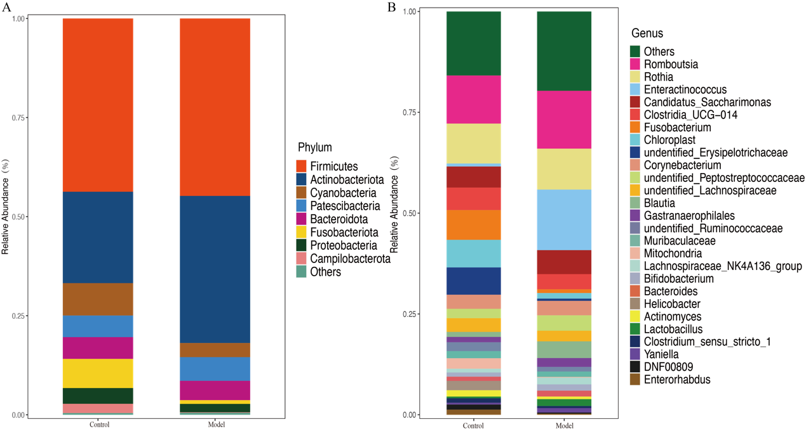
Fig. S2. The relative abundance of Bacteria from Phylum(A) and Genus(B) in the jejunum
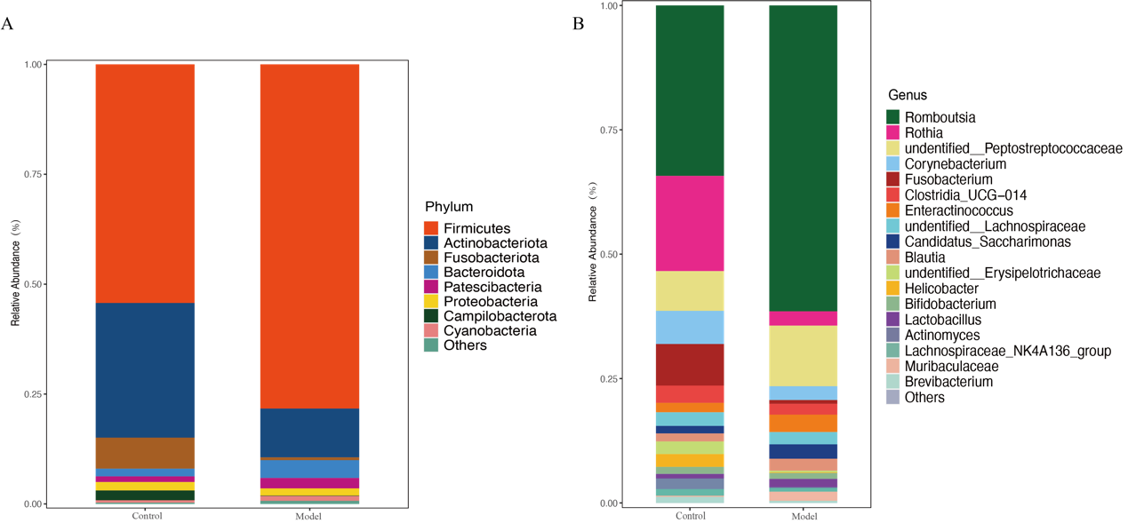
Fig. S3. The relative abundance of Bacteria from Phylum(A) and Genus(B) in the ileum
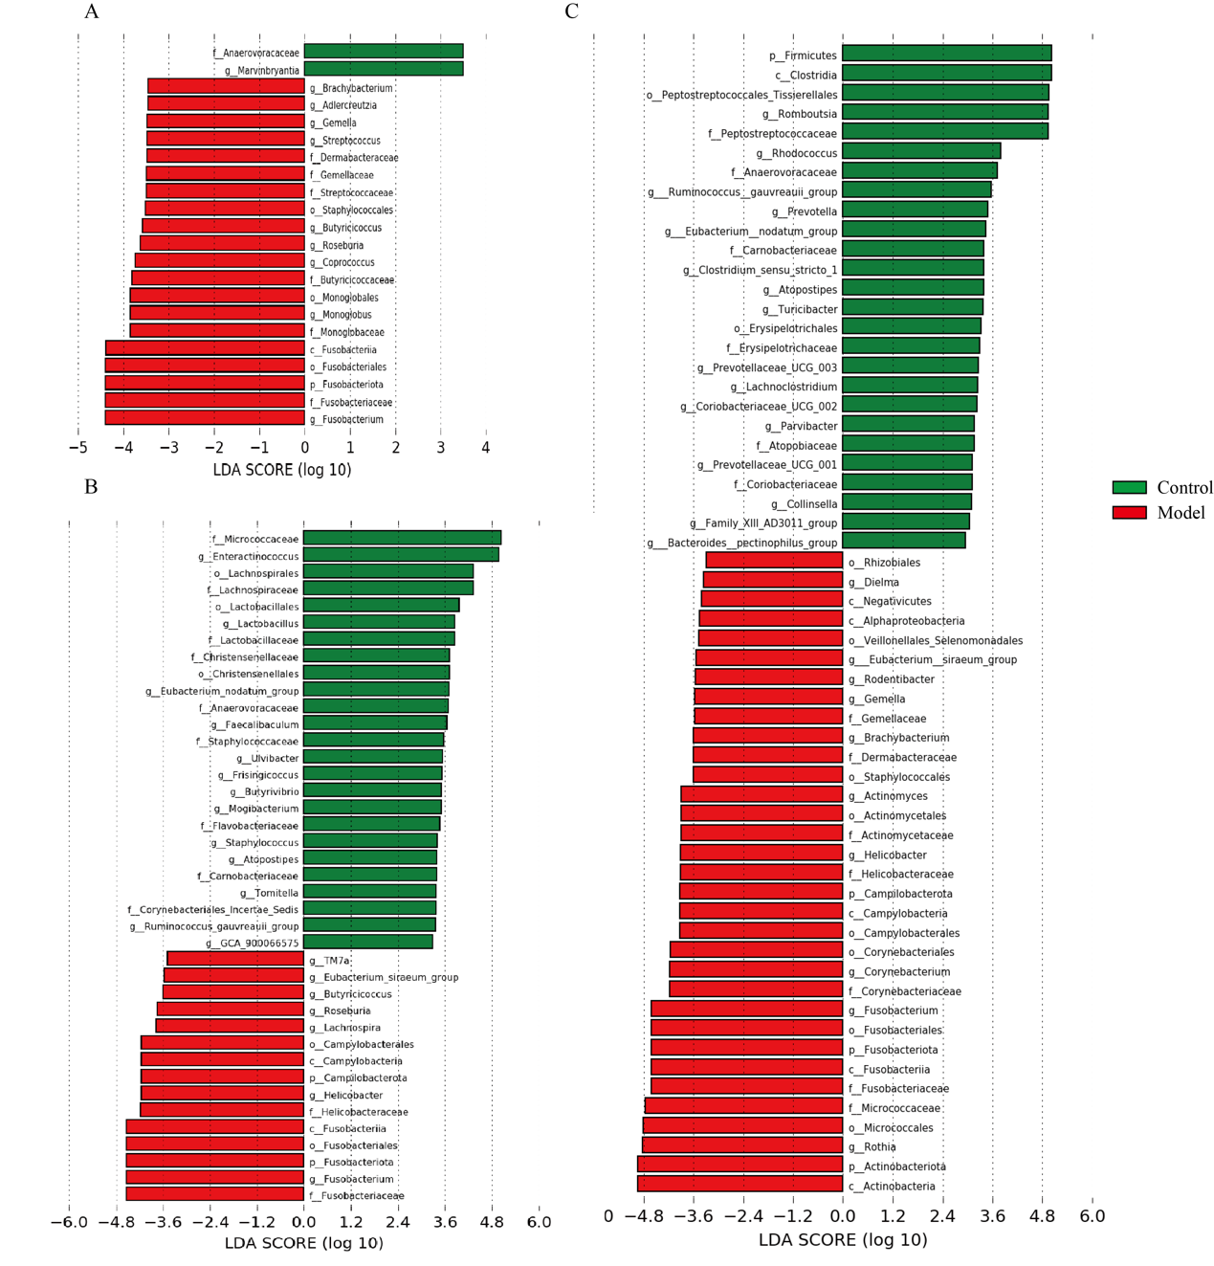
Fig. S4. Linear Discriminant Analysis Effect Size Analysis. Significantly discriminative taxa (Biomarkers) between the control and model groups of mice were displayed by LDA value distribution histogram in Duodenum(A), jejunum(B) and ileum(C). Only taxa meeting the LDA significance thresholds (>4) are shown. Different coloured bars and regions represent different groups.
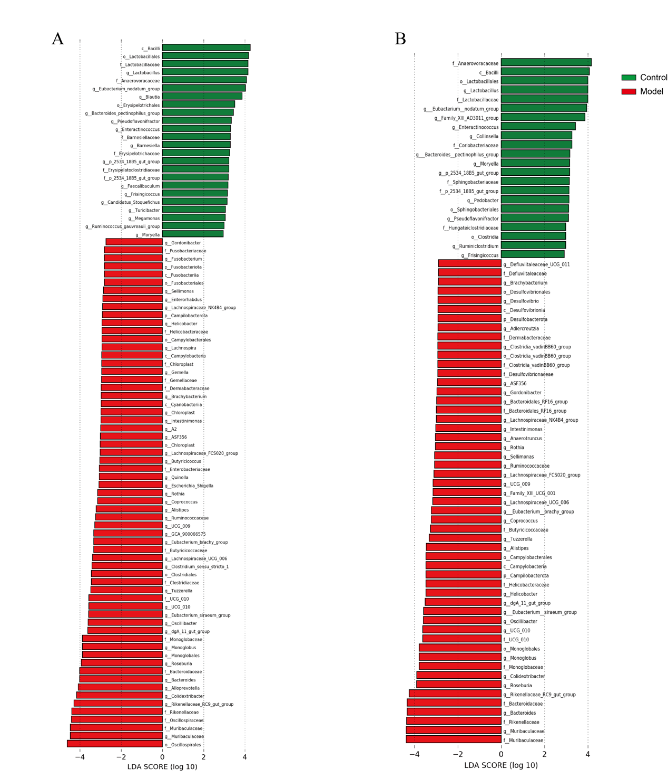
Fig.S5 Linear Discriminant Analysis Effect Size Analysis. Significantly discriminative taxa (Biomarkers) between the control and model groups of mice were displayed by LDA value distribution histogram in appendix(A) and colon(B). Only taxa meeting the LDA significance thresholds (>4) are shown. Different coloured bars and regions represent different groups.
Next, the classification of specific taxonomy groups of duodenal microorganisms’ species (e.g., phylum, family, and genus) was conducted. Most of the ASVs were assigned to 18 phyla and 310 genera, and in subsequent analysis we classified a relative abundance of <1% for “Others” (Fig. S1 A and B, phyla and genera with relative abundance ≥1%). At the phylum level (Fig. S1A), Firmicutes (48.89%, 11.72% to 83.58%), Actinobacteriota (20.63%, 5.28% to 66.54%), and Bacteroidota (7.16%, 0.31% to 27.73%) were the three major phyla in control group duodenal (percentages in parentheses are expressed as “mean relative abundance”, “minimum relative abundance to maximum relative abundance”). Unlike the control group, in the model group rat Cyanobacteria (11.05%, 0% to 42.14%) exhibited significant higher abundance, and the relative abundances of major phylum levels were lower than was that of the control group, including Firmicutes (48.20%, 9.91% to 96.44%) and Actinobacteriota (14.91%, 2.17% to 45.16%) (Fig.S1, Table.S1). Compared with group control, high uric acid feeding management induced an increase in the abundance of Cyanobacteria, Proteobacteria (9.33%, 0.15% to 31.14%), Bacteroidota (8.70%, 0.15% to 19.83%), and Patescibacteria (5.47%, 0.62% to 19.21%), while the abundance of Actinobacteriota, Fusobacteriota(1.78%, 0% to 9.84%), and Campilobacterota(0.23%, 0% to 2.48%) decreased (Fig.S1, Table.S1). At the genus level, Romboutsia(14.28%,1.55% to 38.89%), Fusobacterium(5.82%, 0.15% to 16.89%) and Clostridia_UCG-014(3.99%, 0% to 23.93%) were the three major genera in control group duodenal (Fig.S1B, Table.S1). For model group, the top three bacterial genera were Romboutsia (16.55%, 2.71% to 40.67%), Chloroplast (9.46%, 0% to 38.50%) and Mitochondria (6.26%, 0% to 30.52%) (Fig.S1, Table.S1). We noticed that the high uric acid diet caused significant changes in many bacterial genera compared to the duodenal flora of normal rats. In particular, the relative abundance of Chloroplast and Mitochondria increased significantly, while the relative abundance of Fusobacterium (1.70%, 0% to 9.84%) and Helicobacter (0.21%, 0% to 2.48%) decreased significantly (Fig.S1B, Table.S2). In addition, in Fig.S1 and Table.S3, we showed the changes in the composition and relative abundance of rat duodenal microorganisms after induction of a high uric acid model. Similarly, to fully explore the differences in the composition of the duodenum microorganisms between control and model group rats, it was also important to assess the specific taxonomic differences between the two groups. Pairwise comparisons between the two groups were performed using linear discriminant analysis effect size (LEfSe). The characteristics of these comparisons are presented in Fig.S4A, where we indicate the differential flora with a linear discriminant analysis (LDA) value of >2.
For the jejunum, the composition and abundance of microorganisms have different characteristics. A total of 99.72 % of the ASVs were classified into 14 phyla and 238 genera. Fig.S2A and B shows 8 phyla and 26 genera with relative abundance greater than 1%. For normal rats, Firmicutes (43.72%, 13.85% to 78.26%), Actinobacteriota (23.07%, 3.39% to 73.32%) and Cyanobacteria (8.18%, 0.15% to 48.34%) are the top three phyla (Fig.S2A, Table.S4). However, the main three phyla of jejunum in hyperuricemia group were Firmicutes (44.78%, 13.56% to 95.43%), Actinobacteriota (37.12%, 2.36% to 71.78%) and Patescibacteria (5.97%, 0.15% to 20.71%) (Fig.S1A, Table.S4). In rats fed with potassium oxonate, Actinobacteriota was significantly increased and Cyanobacteria, Fusobacteriota (0.96%, 0% to 4.35%) and Campilobacterota (0.14%, 0% to 1.18%) were significantly decreased compared to normal rats (Fig.S2A, Table.S4). In addition, compared with the duodenum of rats in the high uric acid group, we noted that the relative abundance of Actinobacteriota increased significantly from 14.91 % to 37.14 %, while other such as Firmicutes (from 48.20 % to 44.78 %), Cyanobacteria (from 11.05 % to 3.56 %), Bacteroidota (from 8.70 % to 4.88 %) and Proteobacteria (from 9.33% to 2.09%) decreased significantly (Fig.S2A, Table.S4). At the genus level, Romboutsia (11.9%, 1.84% to 48.12%), Rothia (9.91%, 0% to 55.93%) and Fusobacterium (7.37%, 0% to 37.80%) were the top three genera in healthy rats (Fig.S2B, Table.S5). Notably, the relative abundance of Enteractinococcus (15.01%, 0.07% to 53.28%) increased to 15.01% in the rat species of the high uric acid group, and it formed the top three genera with Romboutsia (14.33%, 2.73% to 69.27%) and Rothia (10.16%, 0.07% to 65.26%) (Fig.S2B, Table.S5). Continuous forced gavage of potassium oxonate significantly increased the relative abundance of Romboutsia, Enteractinococcus, Blautia (4.14%, 0.73% to 19.16%), Lactobacillus (1.70%, 0.07% to 6.04%) in the hyperuricemia group, while Fusobacterium (0.93%, 0% to 4.27%), Chloroplast (1.38%, 0% to 8.92%), Erysipelotrichaceae_uncultured (0.56%, 0% to 2.06%) decreased significantly. Compared with the duodenum of the high uric acid group, the relative abundance of Rothia (from 2.63% to 10.16%), Enteractinococcus (from 4.11% to 15.01%) and Lactobacillus (from 0.85% to 1.70%) in the jejunum increased significantly, while Chloroplast (from 9.46% to 1.38%), Muribaculaceae (from 4.87% to 1.31%), Mitochondria (from 6.26% to 0.17%) and Lachnospiraceae_NK4A136_ group (from 4.61% to 1.70%) decreased significantly. Tables S4,5 and 6 show in detail the composition and changes of other jejunal microbiota after hyperuricemia induced by potassium oxonate. Through LEfSe analysis, we found that the biomarkers of jejunum microbes in the high uric acid group were much more than those of the duodenal microbiota. The top three species in LDA score were Enteractinococcus, Lactobacillus and Eubacterium_nodatum_group, indicating that they had a greater impact on the differences between groups (Fig.S4B).
The changes of microflora in ileum of rats induced by hyperuricemia were obvious. 99.60 % of the detected ASVs were classified into 13 phyla and 227 genera, of which the relative abundance of 8 phyla and 19 genera was greater than 1%. For the ileum of normal rats, Firmicutes (54.28%, 9.71% to 91.43%), Actinobacteriota (30.64%, 5.39% to 63.75%) and Fusobacteriota (7.06%, 0.08% to 24.53%) were the three dominant bacteria. However, feeding potassium oxonate resulted in significant changes in these three bacteria in the high uric acid group, Firmicutes (from 54.28% to 78.31%) increased significantly, and Actinobacteriota (from 30.64% to 11.10%) and Fusobacteriota (from 7.06% to 0.63%) decreased significantly. This change changed the three dominant gates of the ileum in the hyperuricemia group into Firmicutes (78.31%, 46.94% to 98.73%), Actinobacteriota (11.10%, 0.37% to 38.61%) and Bacteroidota (4.05%, 0.08% to 19.76%). We noted that Bacteroidota increased from 1.76% to 4.05% and Campilobacterota decreased from 2.21% to 0.11% in the hyperuricemia group compared with the normal rats. Compared with the ileum and jejunum of the high uric acid group, we found that Firmicutes increased from 44.78 % to 78.31 %, while Actinobacteriota (from 37.13 % to 11.10 %), Patescibacteria (from 5.97 % to 2.37 %) and Cyanobacteria (from 3.56 % to 1.09 %) showed a decrease. At the genus level, the dominant genera of healthy rats were Romboutsia (28.95%, 0% to 75.71%), Rothia (16.17%, 1.39% to 50.04%) and Fusobacterium (7.06%, 0.08% to 24.53%). In contrast, the dominant bacteria in the hyperuricemia group were Peptostreptococcaceae _ unidentified (2.86%, 1.84% to 20.20%) and Enteractinococcus (9.98%, 0% to 12.86%) in addition to Romboutsia (50.39%, 6.65% to 94.08%). Potassium oxonate significantly increased Romboutsia (from 28.93% to 50.39%), Peptostreptococcaceae _ unidentified (from 6.74% to 9.98%), Enteractinococcus (from 1.59% to 2.86%) and Candidatus _ Saccharimonas (from 1.27% to 2.36%) in the ileum of hyperuricemic rats. while Rothia (from 16.17% to 2.36%), Fusobacterium (from 7.06% to 0.62%) and Corynebacterium (from 5.63% to 2.28%) were significantly decreased. Compared with the jejunum, it can be clearly seen that the abundance of Romboutsia (from 14.33% to 50.39%) and Peptostreptococcaceae_unidentified (from 3.81% to 9.98%) in the ileum of the high uric acid group increased. At the same time, the abundance of many genera also decreased, such as Enteractinococcus (from 15.02% to 2.86%), Rothia (from 10.16% to 2.36%), Candidatus _ Saccharimonas (from 3.59% to 2.36%), Blautia (from 4.14% to 1.98%) and Corynebacterium (from 3.59% to 2.28%). Among the ileal biomarkers, Romboutsia, Rodentibacter and Ruminococcus _ gauvreauii _ group were the top three genera with great influence on the difference between groups.

