Figure 1: Number of births in LCRH, Bomet; 2011-17
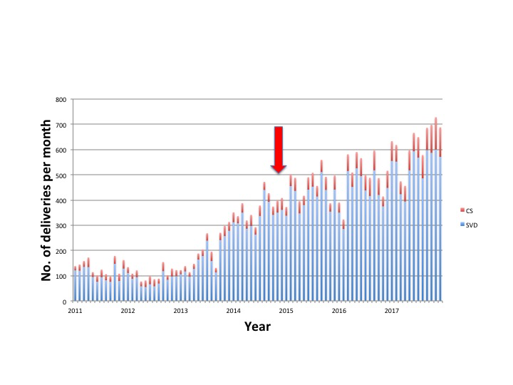
NB: The red arrow shows when Kenya Red Cross Society ambulance service were started

