Towards one health for dog-mediated human rabies elimination in Bangladesh: Achieving zero by 30
Sumon Ghosh^{ab*}, Mohammad Nayeem Hasan^{c}, Nirmalendu Deb Nath^{d}, Najmul Haider^{e}, Daleniece Higgins Jonesª, Md. Kamrul Islam^{b}, M. Mujibur Rahaman^{b}, Hasan Sayedul Mursalin^{b}, Nadim Mahmud^{b}, Md. Kamruzzaman^{b}, Md. Fazlay Rabby^{b}, Shotabdi Kar^{b}, Sayed Mohammed Ullah^{b}, Md. Rashed Ali Shah^{b}, Afsana Akter Jahan^{b}, Md. Sohel Rana^{f}, Sukanta Chowdhury^{g}, Md. Jamal Uddin^{c}, Thankam S. Sunilª, Be-Nazir Ahmed^{b}, Umme Ruman Siddiqui^{b}, S. M. Golam Kaisar^{b} and Md. Nazmul Islam^{b}

ª Department of Public Health, University of Tennessee, Knoxville, USA
^{b} Disease Control Unit, Communicable Disease Control, Directorate General of Health Services, Ministry of Health and Family Welfare, Bangladesh
^{c} Department of Statistics, Shahjalal University of Science and Technology, Sylhet, Bangladesh
^{d} Department of Biomedical and Diagnostic Sciences, University of Tennessee, Knoxville, USA
^{e} School of Life Sciences, Keele University, Staffordshire, the United Kingdom, ST5 5BG
^{f} Department of Livestock Services, Ministry of Fisheries and Livestock, Dhaka, Bangladesh
^{g} International Centre for Diarrhoeal Disease Research (icddr,b), Dhaka, Bangladesh

*Corresponding author. 382 HPER, 1914 Andy Holt Ave., Knoxville, TN 37996, USA
E-mail address: sumon.ghoshbd@gmail.com (S. Ghosh)

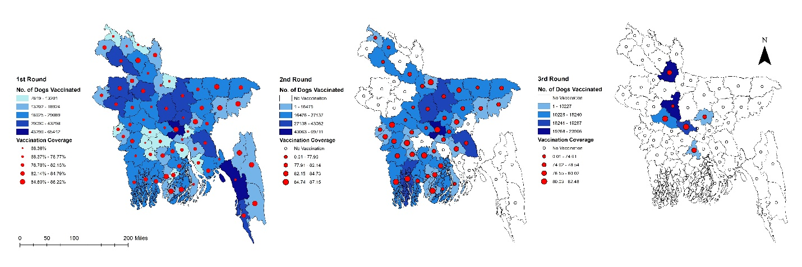

Supplementary Fig. 1: Scaling up mass dog vaccination (MDV) with vaccination coverage (%) in different districts of Bangladesh, 2011-2022. Left: Showing the number of dogs vaccinated (blue shadow) with coverage (red circles) during the first round of MDV. Middle: Showing the number of dogs vaccinated (blue shadow) with coverage (red circles) during the second round of MDV. Right: Showing the number of dogs vaccinated (blue shadow) with coverage (red circles) during the third round of MDV.
[Thirty-five districts (Narsingdi, Narayanganj, Munshiganj, Jamalpur, Sherpur, Mymensingh, Kishoreganj, Netrokona, Tangail, Sylhet, Sunamganj, Moulvibazar, Habiganj, Dinajpur, Panchagarh, Gopalganj, Rajbari, Satkhira, Bagerhat, Jessore, Khulna, Meherpur, Kushtia, Chuadanga, Narail, Jhenaidah, Magura, Barisal, Jhalokathi, Patuakhali, Pirojpur, Barguna, Bhola, Chandpur, and Cumilla) already having completed their second round of vaccination, while eight districts (Gaibandha, Sirajganj, Pabna, Gazipur, Manikganj, Madaripur, Nilphamari, and Dhaka) completed their third round of vaccination.]
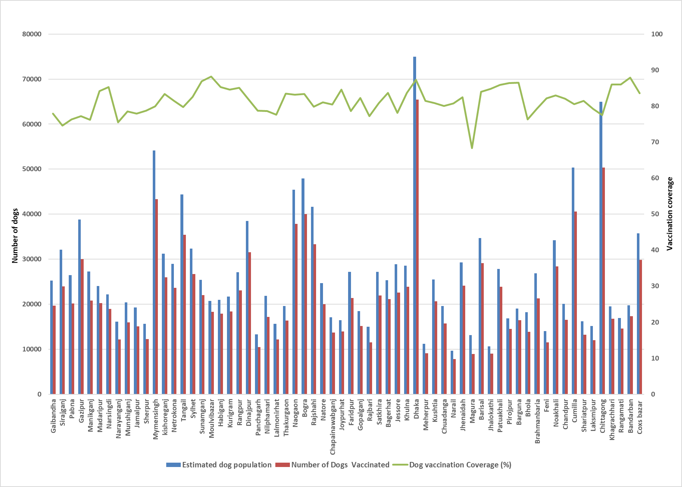
Supplementary Fig. 2: District-wise estimated dog population (blue bars), number of dogs vaccinated (red bars), and vaccination coverage (green line) in Bangladesh, 2011-2022.
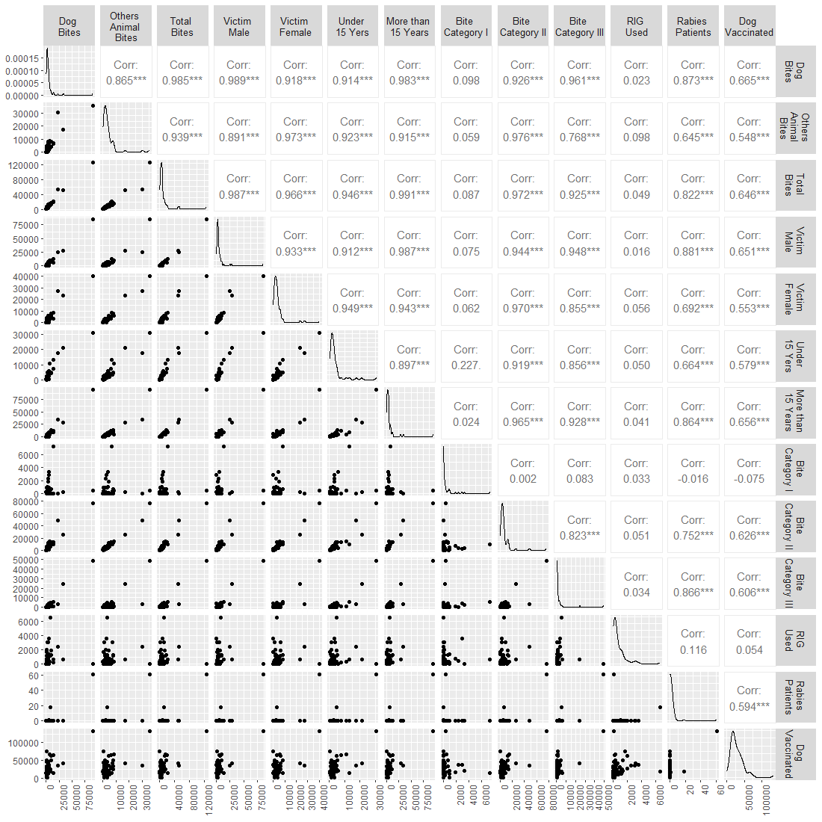
Supplementary Fig. 3: Spearman rank correlation coefficients between various factors for confirmed human rabies cases
The Spearman rank correlation coefficients between key rabies patient characteristics and ARV variables point to a statistically significant association between these two variables. Dog bites (r = 0.865, p<0.05), other animal bites (r = 0.909, p<0.05), and total bites (r = 0.996, p<0.05) all show a strong positive correlation with the ARV.

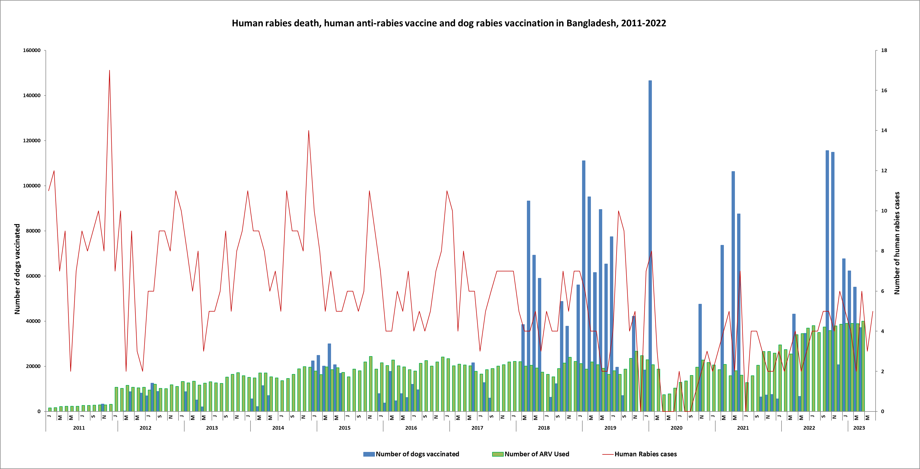
Supplementary Fig. 4: Month-wise trends of human rabies deaths with respect to anti-rabies vaccine and mass dog vaccination in Bangladesh, 2011-2022.
For the purpose of factor analysis, we opted for the 'principal components' method as our chosen solution approach^{1,2}. The count of factors resulting from the factor analysis denotes the potential sources of variance present within the data. These factors are ranked based on their significance. The foremost factor or principal component holds the highest eigenvalue, signifying the most pivotal contributor to the variance observed in the data. Conversely, the final factor represents the least influential process contributing to the overall chemical variance. The factor loadings are interpreted as correlation coefficients, elucidating the relationship between the variables and the factors. Through this approach, we extract a limited number of factors that generally encapsulate a similar amount of information as the original dataset. The observed variables are mathematically represented as linear combinations of these underlying factors, inclusive of error terms, illustrated as follows:
Z_{ij} a₁f_{1j} a₂ f_{2j} ....a_{m}f_{mj} e_{ij}
Where
Z_{ij}= Measured variable, a_{i}= ith Factor loading, f_{ij}= Factor score, e_{ij}= Error term
i=1, 2, 3,…m, j=1, 2, 3,…p
Cluster analysis, initially introduced by Tryon (1958), is a multivariate methodology designed to group cases together when their group memberships are not predetermined³. Essentially, it aims to categorize individuals or objects into unknown clusters, characterized by relatively consistent internal properties and notable differences between clusters, all based on a defined set of variables. These resulting groups are referred to as clusters. In the realm of biology, cluster analysis has long been employed in the field of taxonomy, where organisms are categorized into arbitrary groups based on shared characteristics, progressing from broader categories like kingdom down to more specific ones such as phylum, class, and so forth.
We utilized Hierarchical clustering method, which involves a sequence of either merging or dividing actions⁴. Notably, in the initial stages of this approach, there's no need to predefine the number of clusters. Hierarchical clustering constructs a cluster hierarchy, and the results are visually depicted through a Dendrogram. In this representation, each step of hierarchical clustering is portrayed as a fusion of two branches, progressively merging into a single branch, symbolizing the clusters derived at each stage of the process.

Supplementary Table 1: Rotated factors for the animal bite patients reported at the National Rabies Prevention and Control Centre (NRPCC) and District Rabies Prevention and Control Centres (DRPCCs) of Bangladesh, 2019–2022 (Extraction method**)
 | PC1 | PC2 | PC3
Dog Bites | 0.319 | -0.007 | -0.040
Other Animal Bites | 0.300 | -0.051 | 0.022
Total Bites | 0.322 | -0.022 | -0.020
Male Victim | 0.320 | 0.011 | -0.043
Female Victim | 0.309 | -0.043 | -0.024
Victim Under 15 Years | 0.303 | -0.188 | -0.058
Victim Equal or More than 15 Years | 0.320 | 0.051 | -0.011
Bite Category I | 0.024 | -0.918 | -0.158
Bite Category I | 0.312 | 0.041 | -0.005
Bite Category III | 0.302 | 0.001 | -0.025
RIG Used | 0.020 | -0.195 | 0.973
Rabies Patients | 0.272 | 0.125 | 0.108
Dog Vaccinated | 0.220 | 0.243 | 0.086
Eigenvalue | 9.59 | 1.08 | 1.01
Variance Explained (%) | 73.74 | 8.32 | 7.74
Cumulative Variance (%) | 73.74 | 82.06 | 89.80
** Three components extracted from the matrix; Extraction method = Principal component analysis; Loadings greater than 0.3 are in bold.
[Principal component analysis (PCA) has extracted three significant PCs with eigenvalues > 1, which explain about 90% of the total variance in the data set of rabies characteristics of Bangladesh. PC1, PC2 and PC3 account for 73.74%, 8.32% and 7.74% of the total variance, respectively. CA has indicated five clusters or groups. Group A, Group B, Group C, Group D and Group E, respectively, consists of 10%, 20%, 15%, 25% and 30% of the total sample points.]
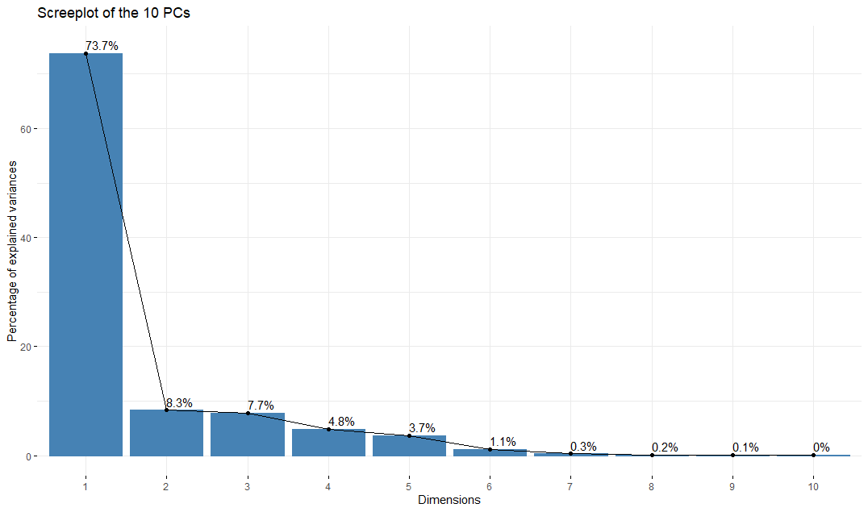
Supplementary Fig. 5: Scree plot with % of explained variance

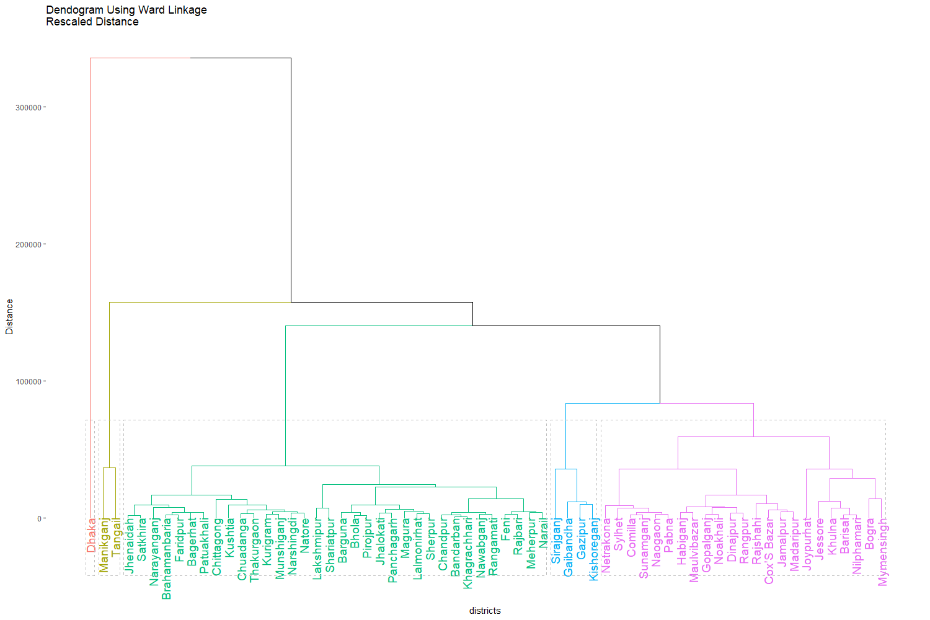
Supplementary Fig. 6: Dendrogram of Cluster Analysis of District Parameters for the animal bite patients reported at the reported at the National Rabies Prevention and Control Centre (NRPCC) and District Rabies Prevention and Control Centres (DRPCCs) of Bangladesh, 2019–2022
Supplementary Table 2: Cluster Groups and their Members (Districts) for the animal bite patients reported at the reported at the National Rabies Prevention and Control Centre (NRPCC) and District Rabies Prevention and Control Centres (DRPCCs) of Bangladesh, 2019–2022
Group | Members (Districts) | N (%)
A | Dhaka | 2 (10)
B | Munshiganj, Tangail | 4 (20)
C | Gaibandha, Gazipur, Kishoreganj, Sirajganj | 3 (15)
D | Bagerhat, Chittagong, Jhalokati, Jhenaidah, Khagrachhari, Kurigram, Kushtia, Lakshmipur, Lalmonirhat, Magura, Munshiganj, Narail, Narayanganj, Natore, Nawabganj, Netrakona, Nilphamari, Noakhali, Pabna, Panchagarh, Patuakhali, Pirojpur, Rajbari, Rajshahi, Rangamati, Rangpur, Satkhira, Shariatpur, Sherpur, Sirajganj, Sunamganj, Sylhet, Tangail, Thakurgaon | 5 (25)
E | Bagerhat, Bandarban, Barguna, Barisal, Bhola, Bogra, Brahamanbaria, Chandpur, Chittagong, Chuadanga, Comilla, Cox's Bazar, Dhaka, Dinajpur, Faridpur, Feni, Gaibandha, Gazipur, Gopalganj, Habiganj, Jamalpur, Jessore, Jhalokati, Jhenaidah, Joypurhat, Khagrachhari, Khulna, Kishoreganj, Kurigram, Kushtia, Lakshmipur, Lalmonirhat, Madaripur, Magura, Manikganj, Maulvibazar, Meherpur, Munshiganj, Mymensingh, Naogaon, Narail, Narayanganj, Narshingdi, Natore, Nawabganj, Netrakona, Nilphamari, Noakhali, Pabna, Panchagarh, Patuakhali, Pirojpur, Rajbari, Rajshahi, Rangamati, Rangpur, Satkhira, Shariatpur, Sherpur, Sirajganj, Sunamganj, Sylhet, Tangail, Thakurgaon | 6 (30)

Supplementary Table 3: Association with age category and various factors of rabies patients reported at the reported at the National Rabies Prevention and Control Centre (NRPCC) and District Rabies Prevention and Control Centres (DRPCCs) of Bangladesh, 2019–2022
 | Age Category |  |  | P-value
 | ≤15 | >15 | Total
Data Source
BITID | 10 (43.48) | 13 (56.52) | 23 (13.22) | 0.258
IDH | 46 (33.17) | 97 (67.83) | 143 (82.18)
Others | 1 (12.50) | 7 (87.50) | 8 (4.60)
Case Year
2019-2020 | 24 (28.92) | 59 (71.08) | 83 (47.70) | 0.384
2021-2023 | 33 (36.26) | 58 (63.74) | 91 (52.30)
Sex
Male | 46 (35.66) | 83 (64.34) | 129 (74.14) | 0.232
Female | 11 (24.44) | 34 (75.56) | 45 (25.86)
Residence
Rural | 54 (32.73) | 111 (67.27) | 165 (94.83) | 0.999
Urban | 3 (33.33) | 6 (66.67) | 9 (5.17)
Vaccination
Present | 5 (100.00) | 0 (0.00) | 5 (2.87) | 0.006
Absent | 52 (30.77) | 117 (69.23) | 169 (97.13)
Bites
Cat | 2 (20.00) | 8 (80.00) | 10 (5.75) | 0.416
Dog | 46 (35.38) | 84 (64.62) | 130 (74.71)
Others | 9 (26.47) | 25 (73.53) | 34 (19.54)
Total | 57 (32.76) | 117 (67.24)

Given that the outcome variable comprises binary repeated entries categorized by age groups, we employed a logistic mixed effects model (LMM). The rationale behind this choice lies in the LMM's ability to effectively handle repeated measurements within the same subject by incorporating subject-specific random effects, thus accounting for latent individual characteristics. Additionally, we employed a linear combination of predictor variables to model the log odds of the outcomes, particularly useful when data exhibit clustering or involve a combination of fixed and random effects. Initially, a comprehensive model was constructed, encompassing the chosen predictor variables. Subsequently, we employed a stepwise approach involving both backward and forward elimination techniques to derive the ultimate model. In the backward method, we progressively excluded the least statistically significant variable at each step, while in the forward method, we successively included highly significant variables. To validate the correct specification of the final model, we iteratively repeated the elimination procedure, manually incorporating all potential risk factors present in the initial comprehensive model.

Supplementary Table 4: Parameter estimates from the best fitting Model
Fixed effect | OR | Lower CL | Upper CL | P-value
Case Year | 0.90 | 0.90 | 0.91 | <0.001
Gender
Female | 1.60 | 0.73 | 3.50 | 0.243
Male | Reference
Residence
Urban | 0.69 | 0.16 | 3.01 | 0.624
Rural | Reference
Bites
Others | 0.78 | 0.13 | 4.50 | 0.778
Dog | 0.57 | 0.11 | 2.92 | 0.496
Cat | Reference

The data presented in Supplementary Table 4 demonstrate a decreased odds (OR = 0.90, 95% CI = 0.90, 0.91) of rabies occurrence among patients aged over 15 years when compared to those aged 15 years or younger, across the four observed time periods. Furthermore, our analysis revealed an elevated odds (OR = 1.60, 95% CI = 0.73, 3.50) of rabies infection among female patients aged over 15 years in comparison to their male counterparts aged 15 years or younger. These reduced odds were similarly associated with patients residing in urban areas, those affected by bites from animals other than dogs and cats, and those bitten by dogs, all within the greater than 15 years age group, as opposed to their rural counterparts aged 15 years or younger who were bitten by cats.

Supplementary Table 5: The Accession Codes deposited in GenBank were utilized to produce sequences in this study.
Accession Codes | Title
MW055178.1 | Lyssavirus rabies isolate GOA_A_25-04-2017 nucleoprotein (N) gene, complete cds
MW055159.1 | Lyssavirus rabies isolate GOA_B_15-12-2017 nucleoprotein (N) gene, complete cds
MW055148.1 | Lyssavirus rabies isolate GOA_B_15-11-2017 nucleoprotein (N) gene, complete cds
MW055174.1 | Lyssavirus rabies isolate GOA_A_02-01-2017 nucleoprotein (N) gene, complete cds
MW055173.1 | Lyssavirus rabies isolate GOA_A_22-05-2017 nucleoprotein (N) gene, complete cds
MW055189.1 | Lyssavirus rabies isolate GOA_A_14-11-2016 nucleoprotein (N) gene, complete cds
MW055164.1 | Lyssavirus rabies isolate GOA_B_04-03-2018 nucleoprotein (N) gene, complete cds
MW055171.1 | Lyssavirus rabies isolate GOA_A_30-12-2016 nucleoprotein (N) gene, complete cds
MW055160.1 | Lyssavirus rabies isolate GOA_A_31-08-2017 nucleoprotein (N) gene, complete cds
MW055163.1 | Lyssavirus rabies isolate GOA_A_06-04-2017 nucleoprotein (N) gene, complete cds
MW055184.1 | Lyssavirus rabies isolate GOA_A_13-02-2017 nucleoprotein (N) gene, complete cds
MW055179.1 | Lyssavirus rabies isolate GOA_A_26-12-2016 nucleoprotein (N) gene, complete cds
MW055183.1 | Lyssavirus rabies isolate GOA_A_11-01-2017 nucleoprotein (N) gene, complete cds
MH258816.1 | Lyssavirus rabies isolate India/dog/MVC-29/2014 nucleoprotein (N) mRNA, complete cds
MW055202.1 | Lyssavirus rabies isolate GOA_A_26-09-2016 nucleoprotein (N) gene, complete cds
MW055200.1 | Lyssavirus rabies isolate GOA_B_10-01-2017 nucleoprotein (N) gene, complete cds
MW055201.1 | Lyssavirus rabies isolate GOA_A_22-12-2017 nucleoprotein (N) gene, complete cds
MW055203.1 | Lyssavirus rabies isolate GOA_A_04-01-2018 nucleoprotein (N) gene, complete cds
MW055204.1 | Lyssavirus rabies isolate GOA_A_29-03-2017 nucleoprotein (N) gene, complete cds
MW055194.1 | Lyssavirus rabies isolate GOA_A_24-09-2017 nucleoprotein (N) gene, complete cds
MW055193.1 | Lyssavirus rabies isolate GOA_A_30-01-2018 nucleoprotein (N) gene, complete cds
MW055199.1 | Lyssavirus rabies isolate GOA_A_03-02-2018 nucleoprotein (N) gene, complete cds
MW055213.1 | Lyssavirus rabies isolate GOA_A_04-03-2018 nucleoprotein (N) gene, complete cds
KX434505.1 | Lyssavirus rabies isolate IMA-R146 nucleoprotein (N) gene, complete cds
KX434489.1 | Lyssavirus rabies isolate IAP-R91 nucleoprotein (N) gene, complete cds
KX434522.1 | Lyssavirus rabies isolate IGR-R206 nucleoprotein (N) gene, complete cds
KX434512.1 | Lyssavirus rabies isolate IAP-R192 nucleoprotein (N) gene, complete cds
KX434497.1 | Lyssavirus rabies isolate IKE-R111 nucleoprotein (N) gene, complete cds
KX434502.1 | Lyssavirus rabies isolate IKA-R132 nucleoprotein (N) gene, complete cds
KX434504.1 | Lyssavirus rabies isolate IKA-R144 nucleoprotein (N) gene, complete cds
KX434501.1 | Lyssavirus rabies isolate IKA-R129 nucleoprotein (N) gene, complete cds
KX434485.1 | Lyssavirus rabies isolate IKE-R78 nucleoprotein (N) gene, complete cds
KX434500.1 | Lyssavirus rabies isolate IKE-R121 nucleoprotein (N) gene, complete cds
KX434483.1 | Lyssavirus rabies isolate IKE-R73 nucleoprotein (N) gene, complete cds
KX434490.1 | Lyssavirus rabies isolate IKE-R94 nucleoprotein (N) gene, complete cds
KX434487.1 | Lyssavirus rabies isolate IKE-R87 nucleoprotein (N) gene, complete cds
KX434484.1 | Lyssavirus rabies isolate IKE-R77 nucleoprotein (N) gene, complete cds
KX434495.1 | Lyssavirus rabies isolate IKE-R109 nucleoprotein (N) gene, complete cds
KX434486.1 | Lyssavirus rabies isolate IKE-R86 nucleoprotein (N) gene, complete cds
KX434520.1 | Lyssavirus rabies isolate IGR-R204 nucleoprotein (N) gene, complete cds
KM979366.1 | Rabies virus strain NPBUF12-1 nucleoprotein gene, complete cds
JX944574.1 | Rabies virus isolate 3878-78(11008NEP) nucleoprotein (N) gene, complete cds
KX434509.1 | Lyssavirus rabies isolate IMA-R189 nucleoprotein (N) gene, complete cds
KX434510.1 | Lyssavirus rabies isolate IAP-R190 nucleoprotein (N) gene, complete cds
KX434511.1 | Lyssavirus rabies isolate IAP-R191 nucleoprotein (N) gene, complete cds
KX434516.1 | Lyssavirus rabies isolate IAP-R196 nucleoprotein (N) gene, complete cds
MW055133.1 | Lyssavirus rabies isolate A17-npval35 nucleoprotein (N) gene, complete cds
MW055134.1 | Lyssavirus rabies isolate GOA_A_10-03-2017 nucleoprotein (N) gene, complete cds
KX434519.1 | Lyssavirus rabies isolate IGR-R203 nucleoprotein (N) gene, complete cds
KM099393.1 | Rabies virus isolate RV-IGU-R202-Mongoose nucleoprotein (N) gene, complete cds
KF660246.1 | Rabies virus isolate IGU-200 nucleoprotein (N) gene, complete cds
KX434523.1 | Lyssavirus rabies isolate IGR-R207 nucleoprotein (N) gene, complete cds
AB910532.1 | Rabies virus N gene for nucleoprotein, complete cds, strain: Btn115
JX944567.1 | Rabies virus isolate 3878-09(11009NEP) nucleoprotein (N) gene, complete cds
AB699215.1 | Rabies virus N gene for nucleocapsid, complete cds, strain: BDR2
AB699216.1 | Rabies virus N gene for nucleocapsid, complete cds, strain: BDR3
AB699214.1 | Rabies virus N gene for nucleocapsid, complete cds, strain: BDR1
AB699219.1 | Rabies virus N gene for nucleocapsid, complete cds, strain: BDR7
AB699218.1 | Rabies virus N gene for nucleocapsid, complete cds, strain: BDR6
KX434517.1 | Lyssavirus rabies isolate IUP-R197 nucleoprotein (N) gene, complete cds
HE801588.1 | Rabies virus N gene for nucleoprotein, viral cRNA, isolate Pk 57
JX987736.1 | Rabies virus isolate 04029AFG nucleoprotein (N) gene, complete cds
HE801584.1 | Rabies virus N gene for nucleoprotein, viral cRNA, isolate Pk 26
HE801586.1 | Rabies virus N gene for nucleoprotein, viral cRNA, isolate Pk 55
HE801580.1 | Rabies virus N gene for nucleoprotein, viral cRNA, isolate Pk 20
HE801579.1 | Rabies virus N gene for nucleoprotein, viral cRNA, isolate Pk 19

References:
1. Iddrisu A-K, Besing Karadaar I, Gurah Junior J, Ansu B, Ernest D-A. Mixed effects logistic regression analysis of blood pressure among Ghanaians and associated risk factors. Scientific Reports 2023; 13(1): 7728.
2. Reyment RA, Jvreskog K. Applied factor analysis in the natural sciences: Cambridge University Press; 1996.
3. Tryon RC. Cumulative communality cluster analysis. Educational and Psychological Measurement 1958; 18(1): 3-35.
4. Chitra A, Rajkumar A. Paraphrase extraction using fuzzy hierarchical clustering. Applied Soft Computing 2015; 34: 426-37.

