Progress towards one health approach for dog-mediated human rabies elimination in Bangladesh: on the way to zero by 30
Sumon Ghosh^{ab*}, Mohammad Nayeem Hasan^{c}, Nirmalendu Deb Nath^{d}, Najmul Haider^{e}, Daleniece Higgins Jonesª, Md. Kamrul Islam^{b}, M. Mujibur Rahaman^{b}, Hasan Sayedul Mursalin^{b}, Nadim Mahmud^{b}, Md. Kamruzzam^{b}, Md. Fazlay Rabby^{b}, Shotabdi Kar^{b}, Sayed Mohammed Ullah^{b}, Md. Rashed Ali Shah^{b}, Afsana Akter Jahan^{b}, Md. Sohel Rana^{f}, Sukanta Chowdhury^{g}, Md. Jamal Uddin^{c}, Thankam S. Sunilª, Be-Nazir Ahmed^{b}, Umme Ruman Siddiqui^{b}, S. M. Golam Kaisar^{b} and Md. Nazmul Islam^{b}

ª Department of Public Health, University of Tennessee, Knoxville, USA
^{b} Disease Control Unit, Communicable Disease Control, Directorate General of Health Services, Ministry of Health and Family Welfare, Bangladesh
^{c} Department of Statistics, Shahjalal University of Science and Technology, Sylhet, Bangladesh
^{d} Department of Biomedical and Diagnostic Sciences, University of Tennessee, Knoxville, USA
^{e} School of Life Sciences, Keele University, Staffordshire, the United Kingdom, ST5 5BG
^{f} Department of Livestock Services, Ministry of Fisheries and Livestock, Dhaka, Bangladesh
^{g} International Centre for Diarrhoeal Disease Research (icddr,b), Dhaka, Bangladesh

*Corresponding author. 382 HPER, 1914 Andy Holt Ave., Knoxville, TN 37996, USA
E-mail address: sumon.ghoshbd@gmail.com (S. Ghosh)

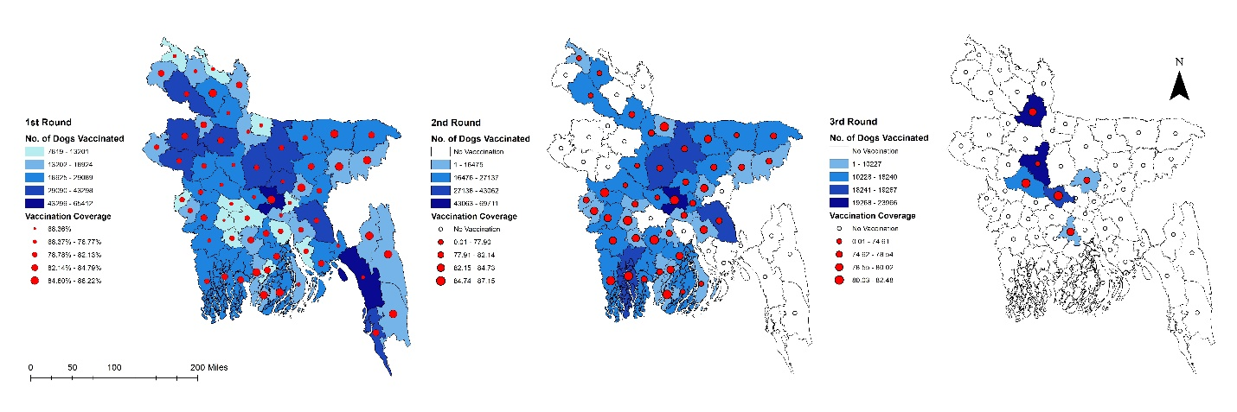

Supplementary Fig. 1: Scaling up mass dog vaccination (MDV) with vaccination coverage (%) in different districts of Bangladesh, 2011-2022. Left: Showing the number of dogs vaccinated (blue shadow) with coverage (red circles) during the first round of MDV. Middle: Showing the number of dogs vaccinated (blue shadow) with coverage (red circles) during the second round of MDV. Right: Showing the number of dogs vaccinated (blue shadow) with coverage (red circles) during the third round of MDV.
[Thirty-five districts (Narsingdi, Narayanganj, Munshiganj, Jamalpur, Sherpur, Mymensingh, Kishoreganj, Netrokona, Tangail, Sylhet, Sunamganj, Moulvibazar, Habiganj, Dinajpur, Panchagarh, Gopalganj, Rajbari, Satkhira, Bagerhat, Jessore, Khulna, Meherpur, Kushtia, Chuadanga, Narail, Jhenaidah, Magura, Barisal, Jhalokathi, Patuakhali, Pirojpur, Barguna, Bhola, Chandpur, and Cumilla) already having completed their second round of vaccination, while eight districts (Gaibandha, Sirajganj, Pabna, Gazipur, Manikganj, Madaripur, Nilphamari, and Dhaka) completed their third round of vaccination.]
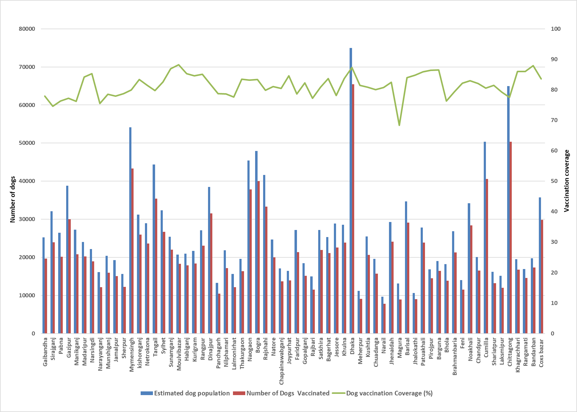
Supplementary Fig. 2: District-wise estimated dog population (blue bars), number of dogs vaccinated (red bars), and vaccination coverage (green line) in Bangladesh, 2011-2022.
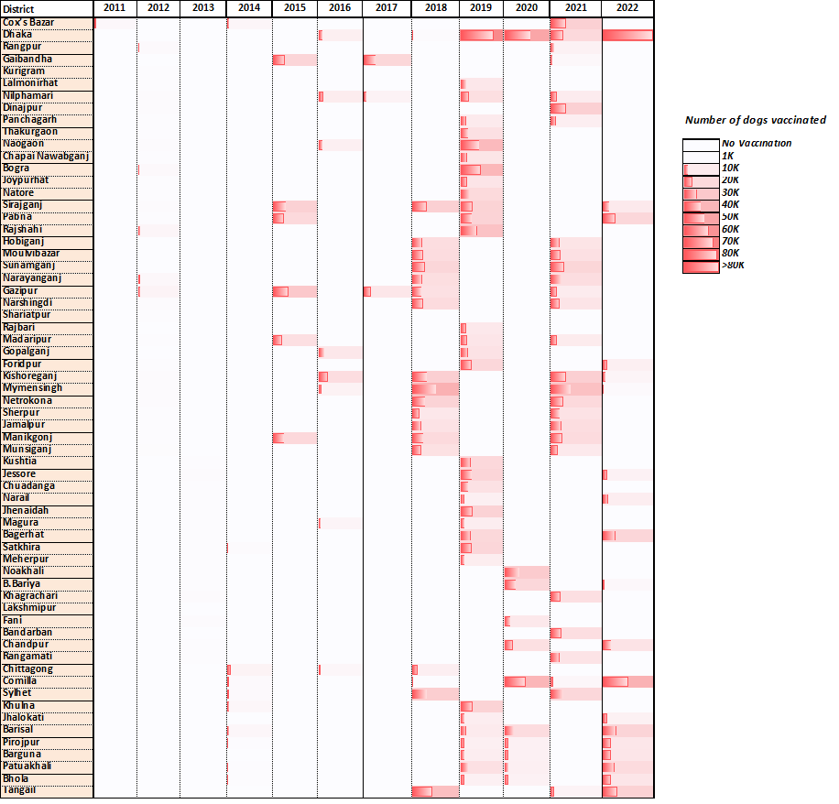
Supplementary Fig. 3: Year-wise scaling up mass dog vaccination (MDV) in different districts of Bangladesh, 2011-2022.
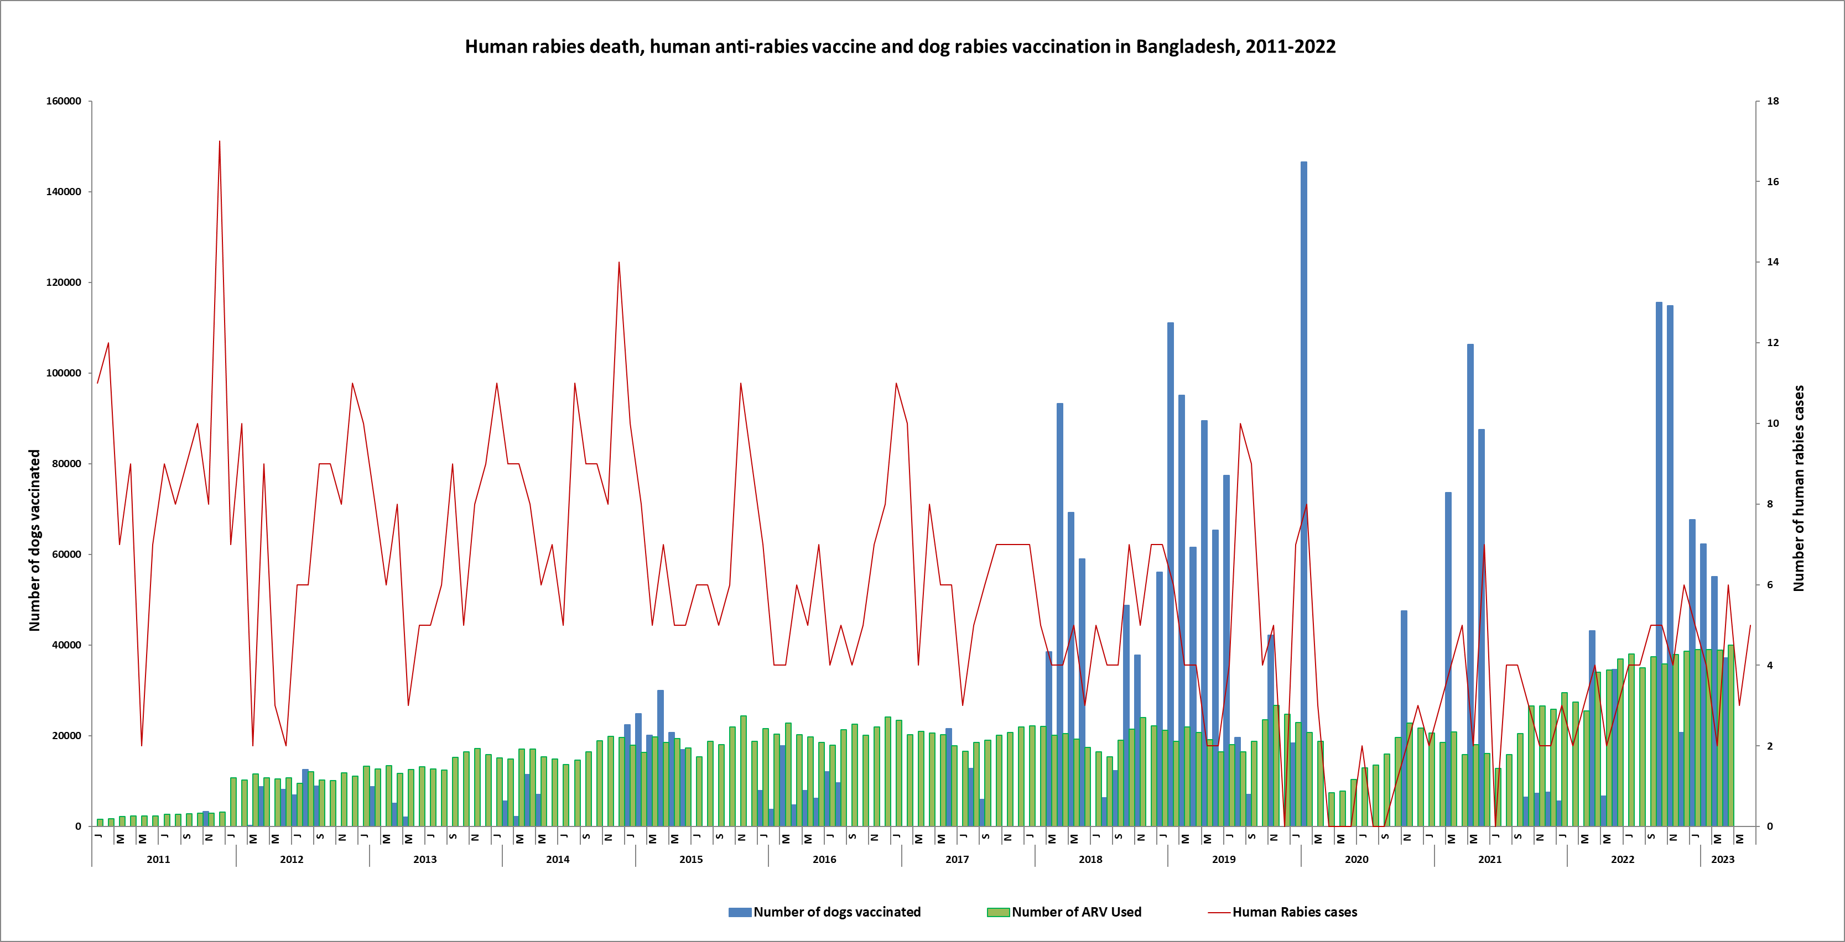

Supplementary Fig. 4: Month-wise trends of human rabies deaths with respect to anti-rabies vaccine and mass dog vaccination in Bangladesh, 2011-2022.

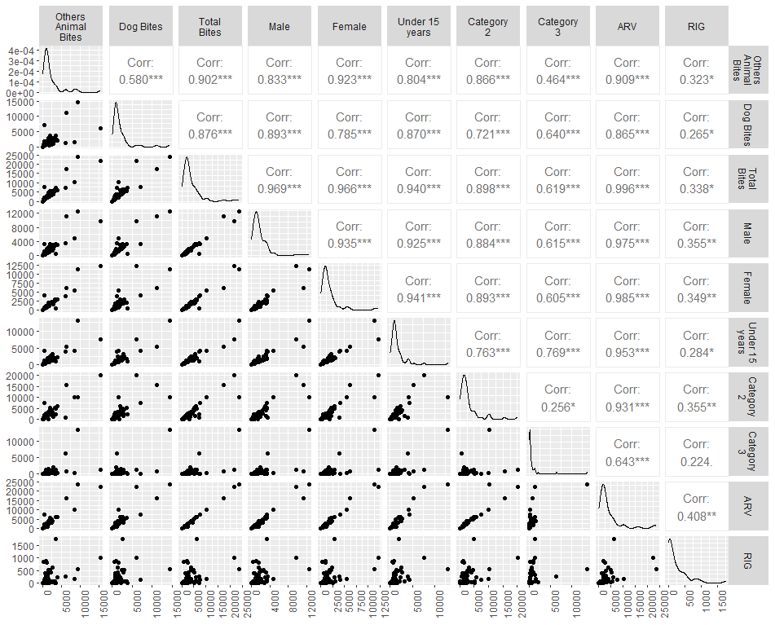
Supplementary Fig. 5: Spearman rank correlation coefficients between various factors for confirmed human rabies cases
The Spearman rank correlation coefficients between key rabies patient characteristics and ARV variables point to a statistically significant association between these two variables. Dog bites (r = 0.865, p<0.05), other animal bites (r = 0.909, p<0.05), and total bites (r = 0.996, p<0.05) all show a strong positive correlation with the ARV.

Table S1: Association with age category and various factors of rabies patients in Bangladesh.
 | Age Category |  | P-value
 | ≤15 | >15
Vaccination
Absent | 21 (13.04) | 14 (8.70) | 0.004*
Present | 0 (0.00) | 5 (3.11)
Sex
Female | 30 (18.63) | 10 (6.21) | 0.180
Male | 75 (46.58) | 46 (28.57)
Residence
Rural | 29 (18.01) | 13 (8.07) | 0.881
Urban | 6 (3.73) | 3 (1.86)

