Additional File 1: Flowchart of Patient Selection
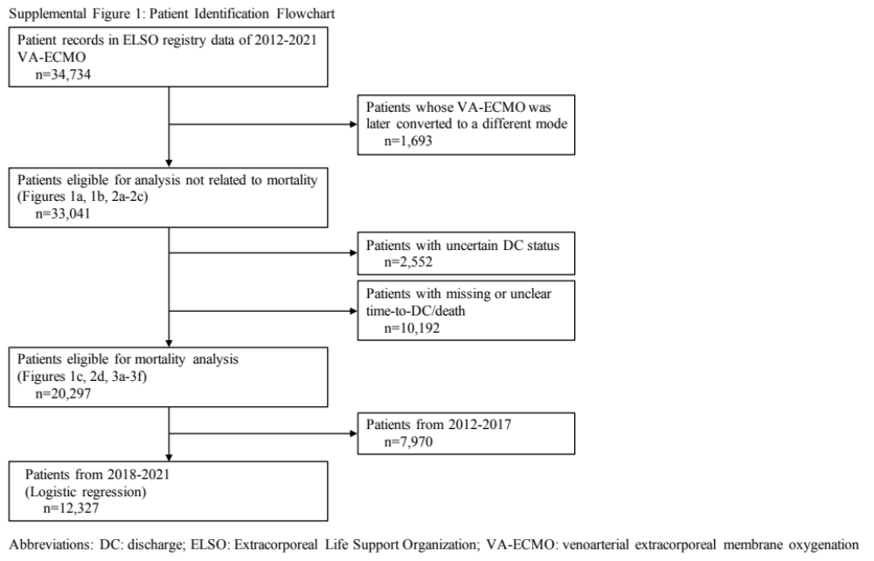
Abbreviations: DC: discharge; ELSO: Extracorporeal Life Support Organization; VA-ECMO: venoarterial extracorporeal membrane oxygenation

Additional File 2: Temporal Trends of 30-day Mortality in VA-ECMO patients*
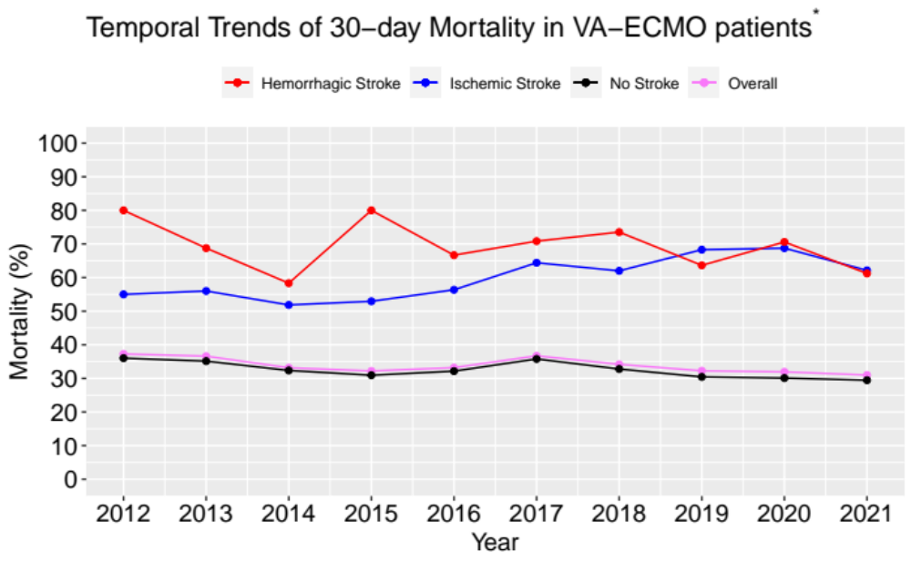
Abbreviations: *: 20,297 cases with complete mortality data; VA-ECMO: venoarterial extracorporeal membrane oxygenation

Additional File 3: Association between ELSO center volume and 30-day mortality
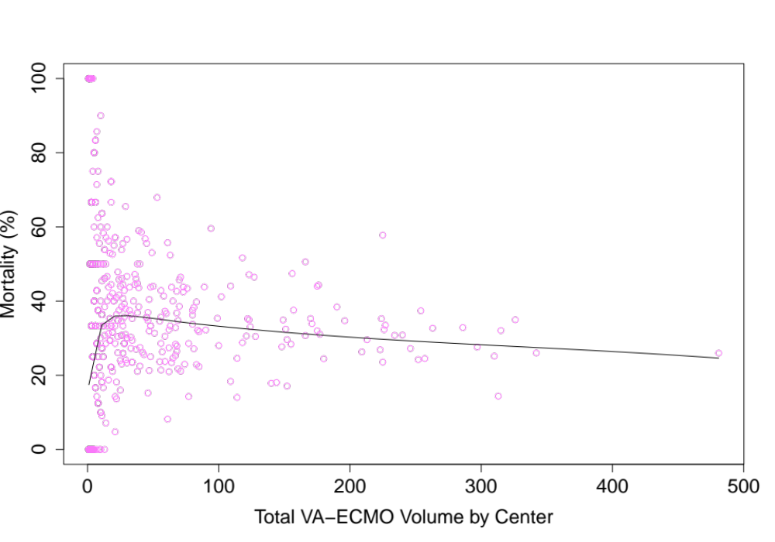
Abbreviations: VA-ECMO: venoarterial extracorporeal membrane oxygenation

Additional File 4: Logistic Regression of Variables Associated with 30-day Mortality^
 | Odds ratio | 95% CI | p-value
Age | 1.04 | [1.03-1.04] | <1×10⁻⁴
Female | 1.05 | [0.95-1.17] | 0.35
Total Center Volume | 0.997 | [0.997-0.998] | <1×10⁻⁴
Pre-ECMO ABG
pH | 9.01×10⁻⁷ | [2.98×10⁻²⁰-1.75×10⁷] | 0.38
PaO₂ | 1.00 | [0.9991-1.000] | 0.36
ABG at 24 hours of ECMO support
pH | 5.25×10⁻⁷ | [3.29×10⁻²⁰-5.41×10⁶] | 0.35
PaO₂ | 1.001 | [1.000-1.002] | 6.20×10⁻⁴
Pre-ECMO pH × 24h-pHª | 5.68 | [0.09-3.73×10²] | 0.41
Pre-ECMO PaO₂ × 24h-PaO₂^{b} | 1.00 | [1.00-1.00] | 0.56
ECMO Duration (days) | 1.01 | [1.01-1.02] | 3.00×10⁻⁴
ECMO Complications
Cardiac Arrhythmia | 1.07 | [0.92-1.25] | 0.35
Cardiopulmonary Bypass | 1.00 | [0.89-1.13] | 0.97
Gastrointestinal Hemorrhage | 1.68 | [1.30-2.17] | <1×10⁻⁴
Hemolysis (Moderate-Severe) | 1.33 | [0.98-1.80] | 0.06
Hemorrhagic Stroke | 3.24 | [2.14-4.94] | <1×10⁻⁴
Ischemic Stroke | 3.57 | [2.75-4.68] | <1×10⁻⁴
Neurosurgical Intervention | 2.29 | [0.61-9.61] | 0.23
Pump Failure | 0.95 | [0.46-1.91] | 0.89
Renal Replacement Therapy | 1.92 | [1.72-2.14] | <1×10⁻⁴
Ischemic Stroke × Hemorrhagic Stroke^{c} | 0.24 | [0.09-0.68] | 5.57×10⁻³

Abbreviations: ^:12,327 cases with complete mortality data from 2018-2021; ª: interaction term between pre-ECMO pH and 24 hour pH; ^{b}: interaction term between pre-ECMO PaO₂ and 24 hour PaO₂; ^{c}: interaction term between ischemic stroke and hemorrhagic stroke; ABG: arterial blood gas; CI: confidence interval; ECMO: extracorporeal membrane oxygenation

Additional File 5: Kaplan-Meier Curves and Hazard Functions for 30-day Survival by Presence or Absence of Strokes
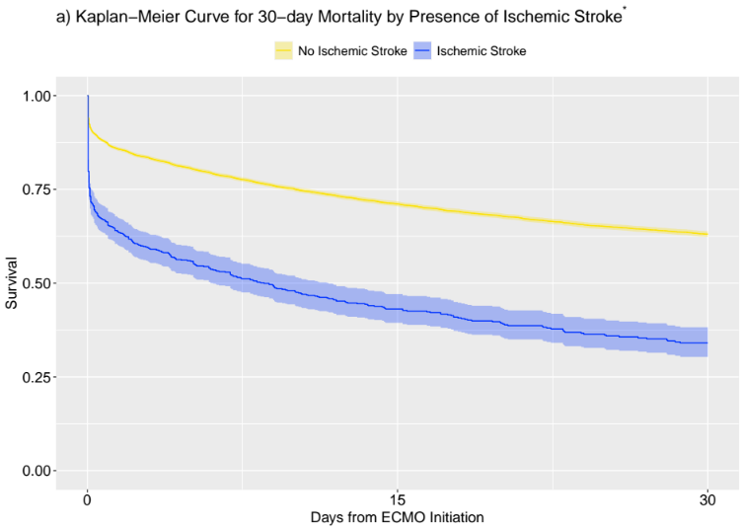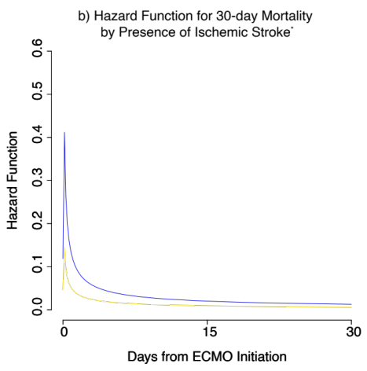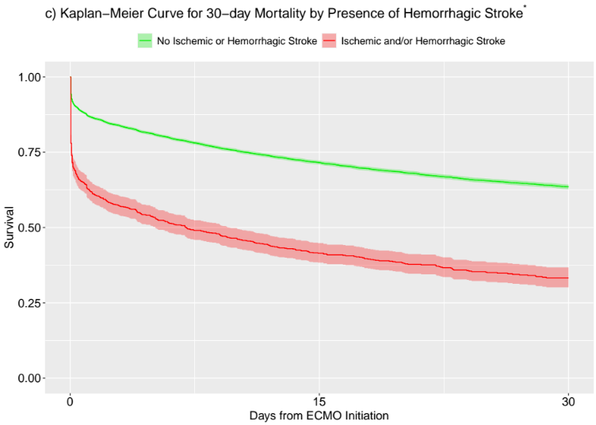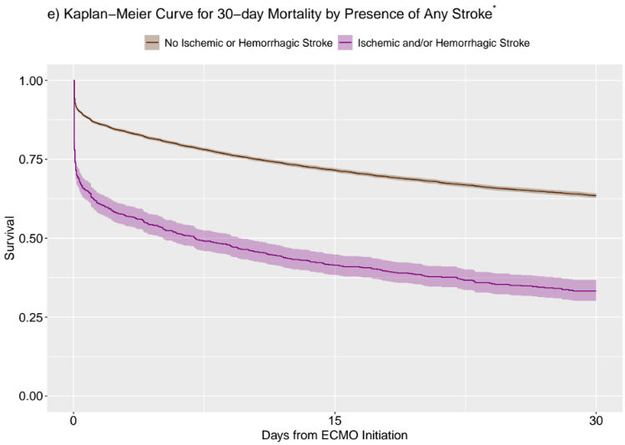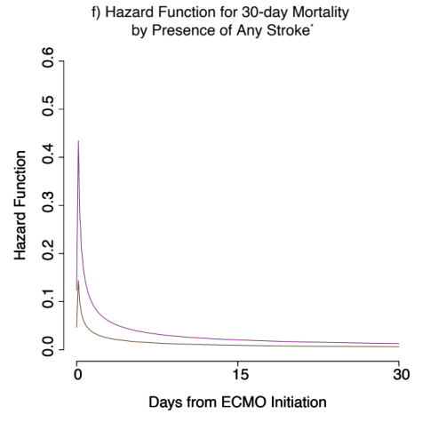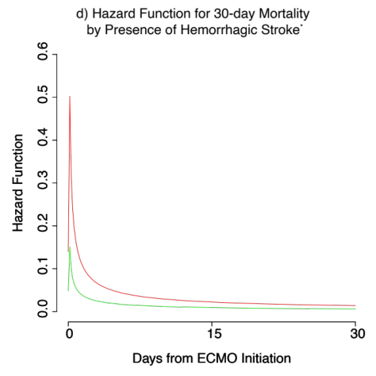
Abbreviations: *: 20,297 cases with complete mortality data; ECMO: extracorporeal membrane oxygenation

