Supplementary material S5
Figures X10: Distribution of the components of each of the 7 domains and score according to Likert scale.

Domain 1: Guide determinants
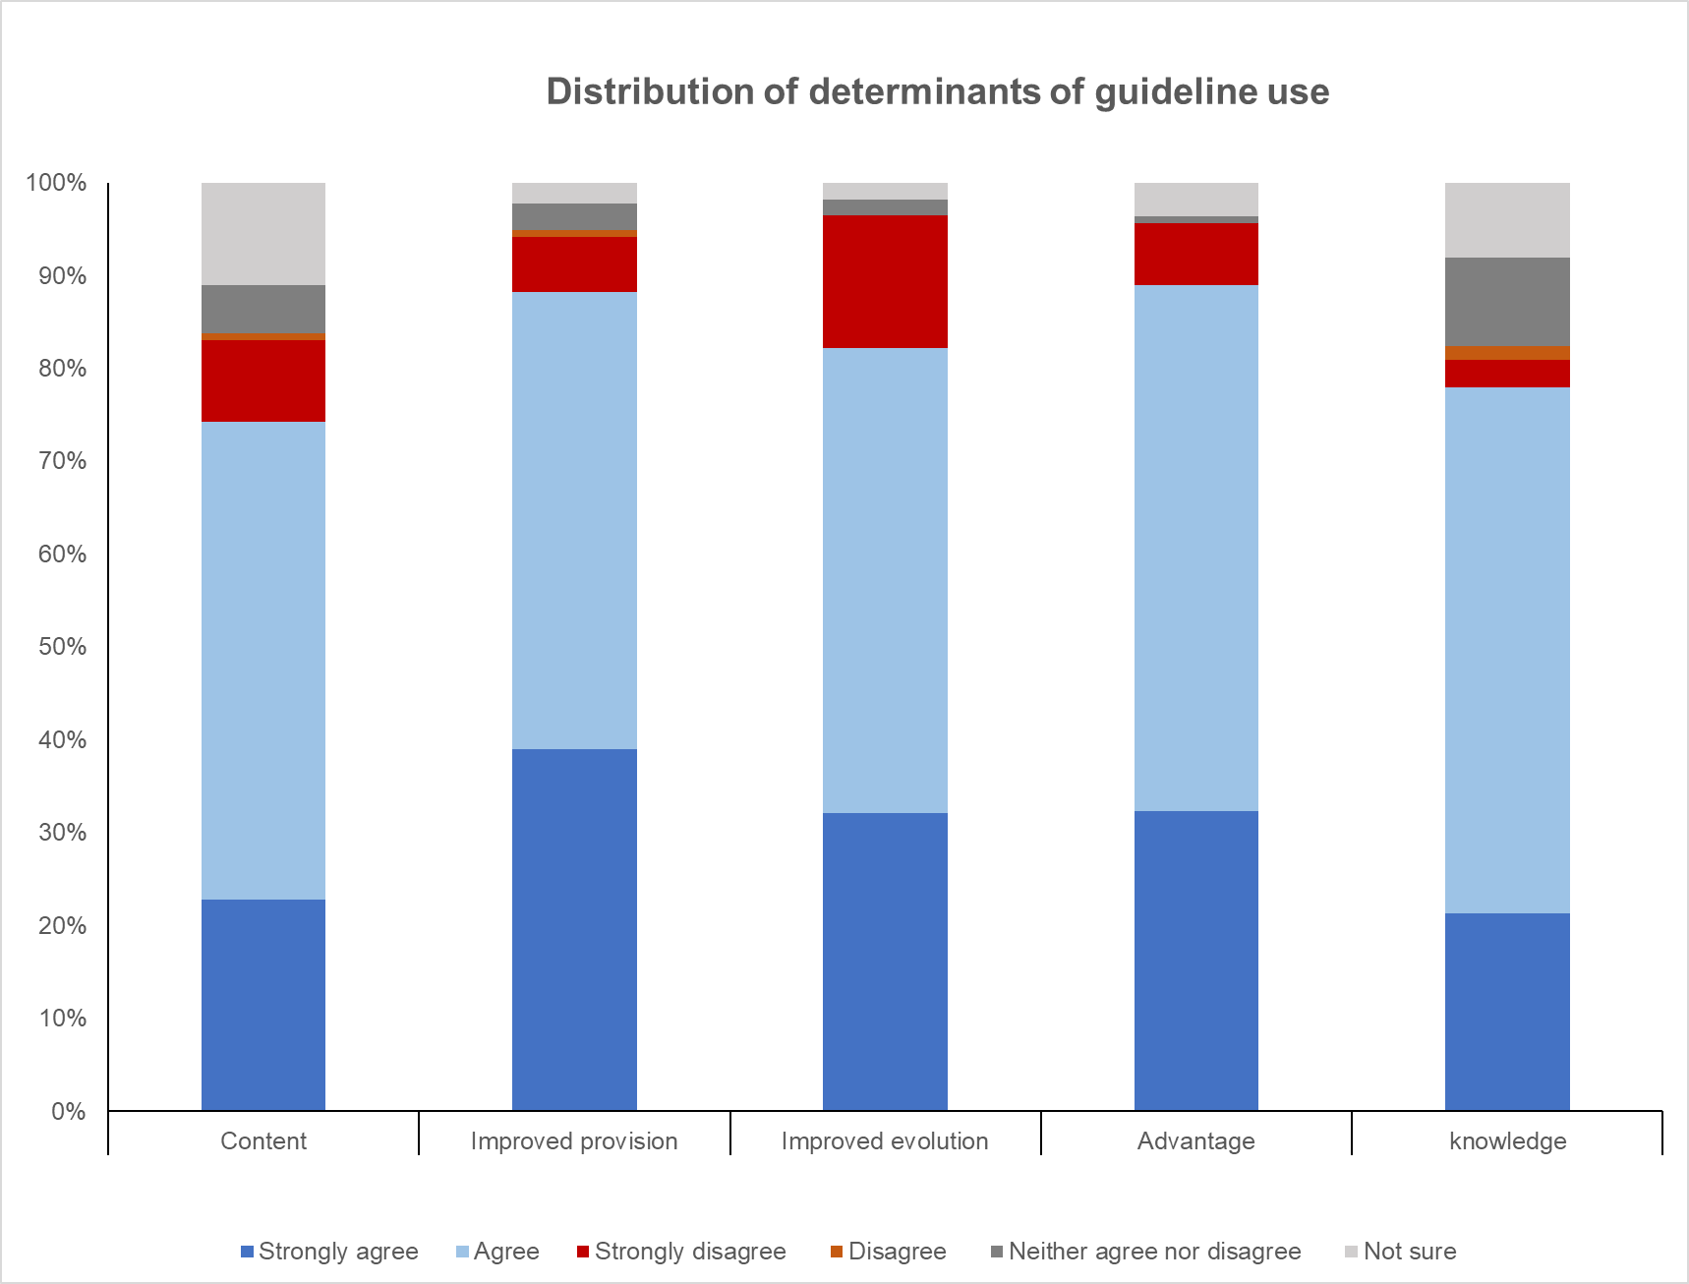

Figure 1A: Distribution of determinants of guideline use (content, Knowledge)

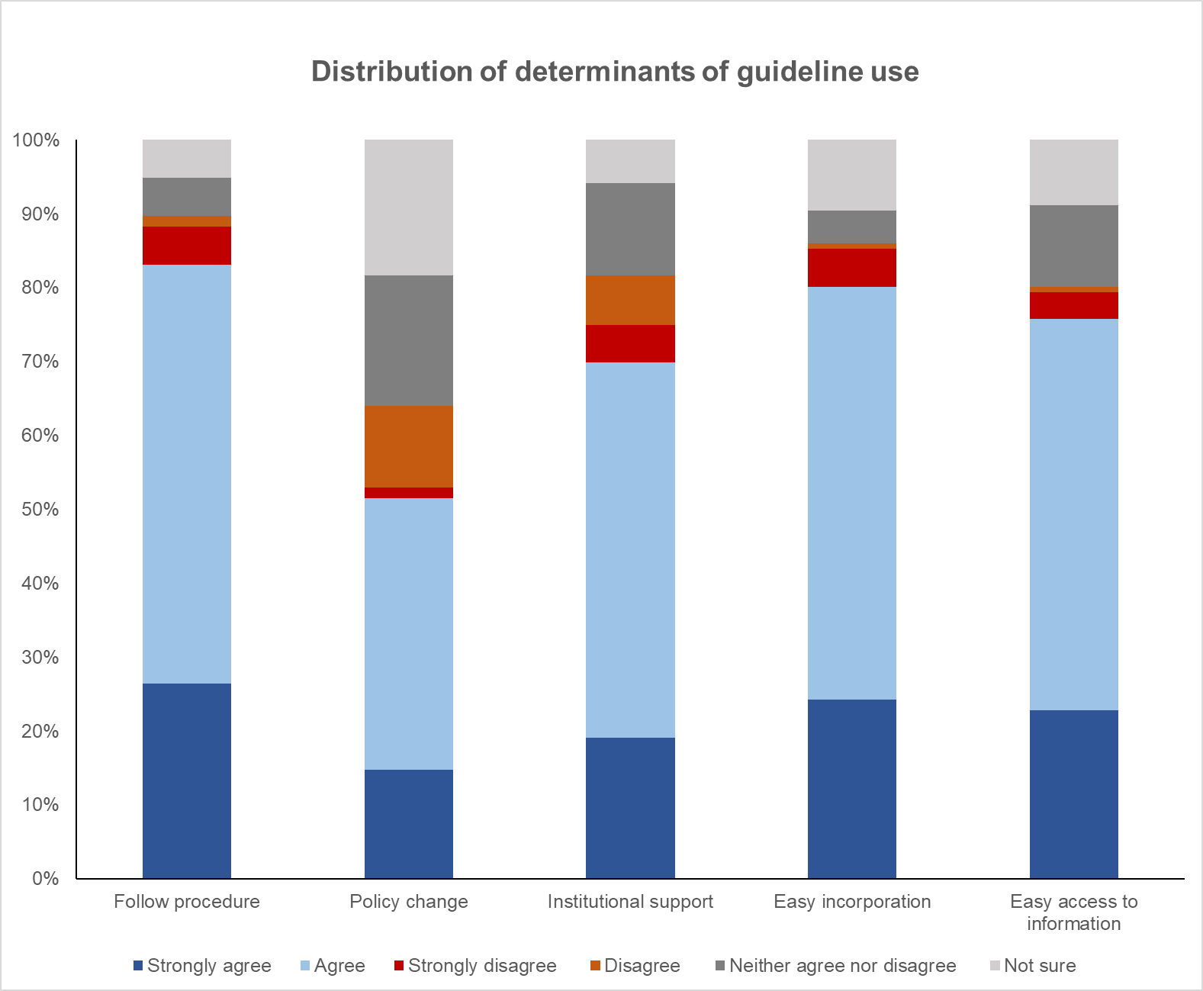

Figure 1B: Distribution of determinants of guideline use (Follow procedure, Policy change)

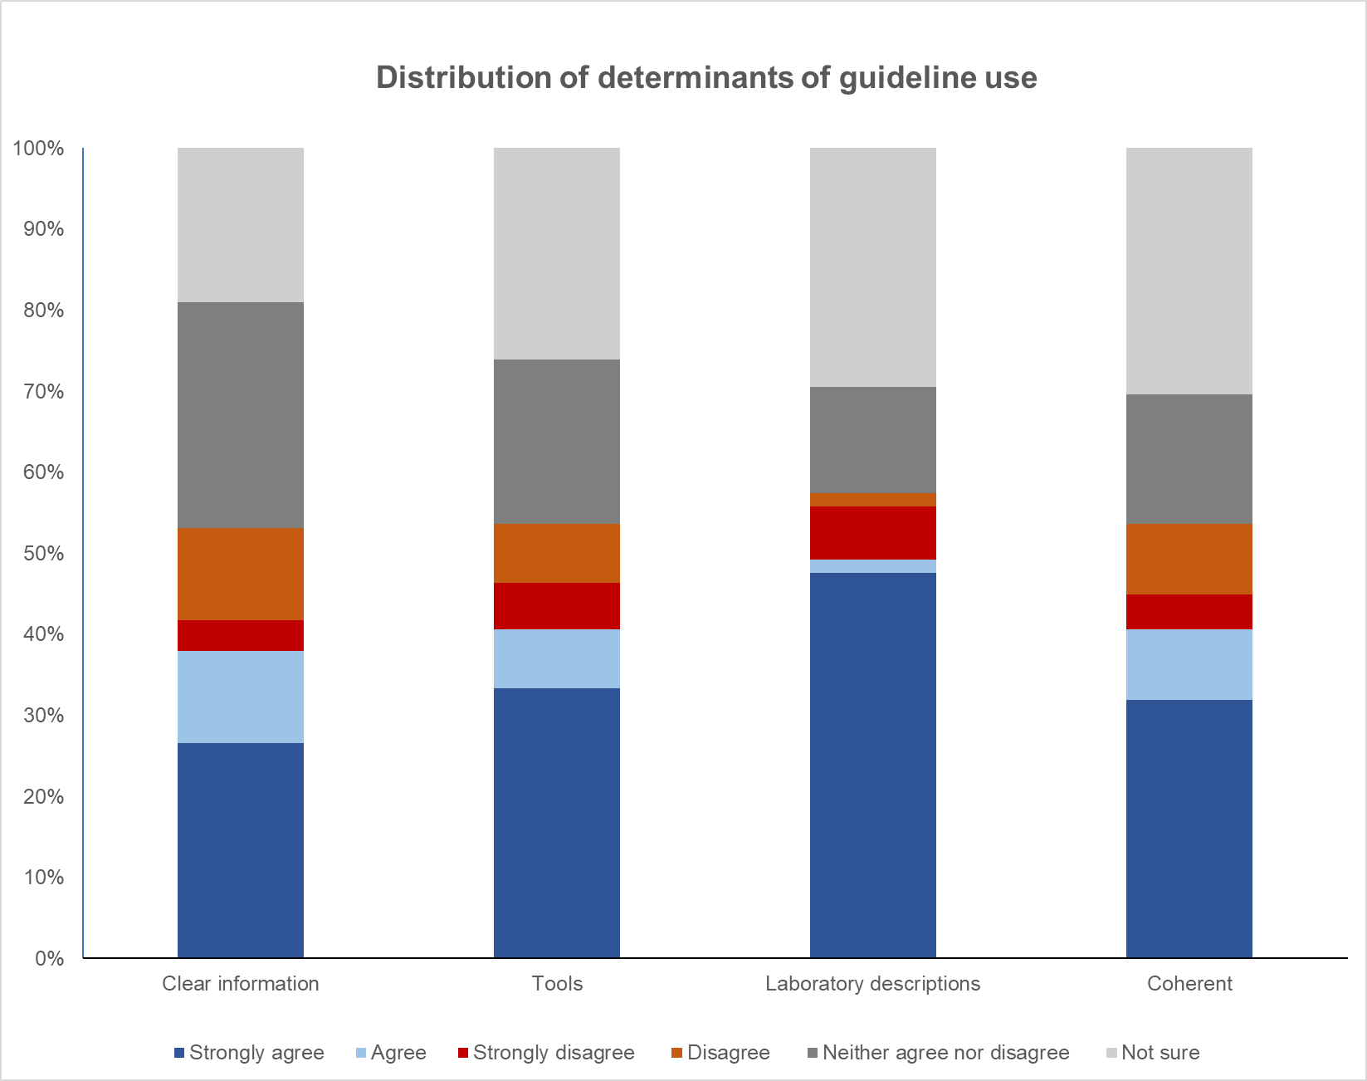

Figure 1C: Distribution of determinants of guideline use (clear information, tools)

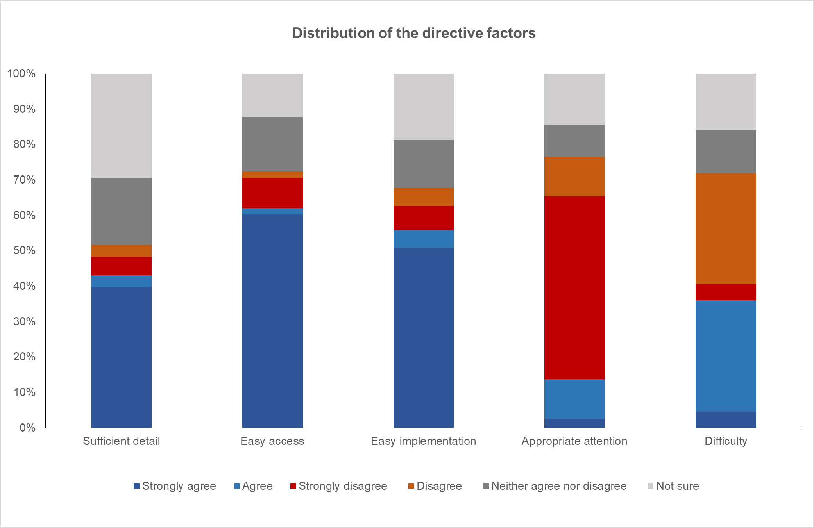

Figure 2: Participants' perceptions about the guide and its use

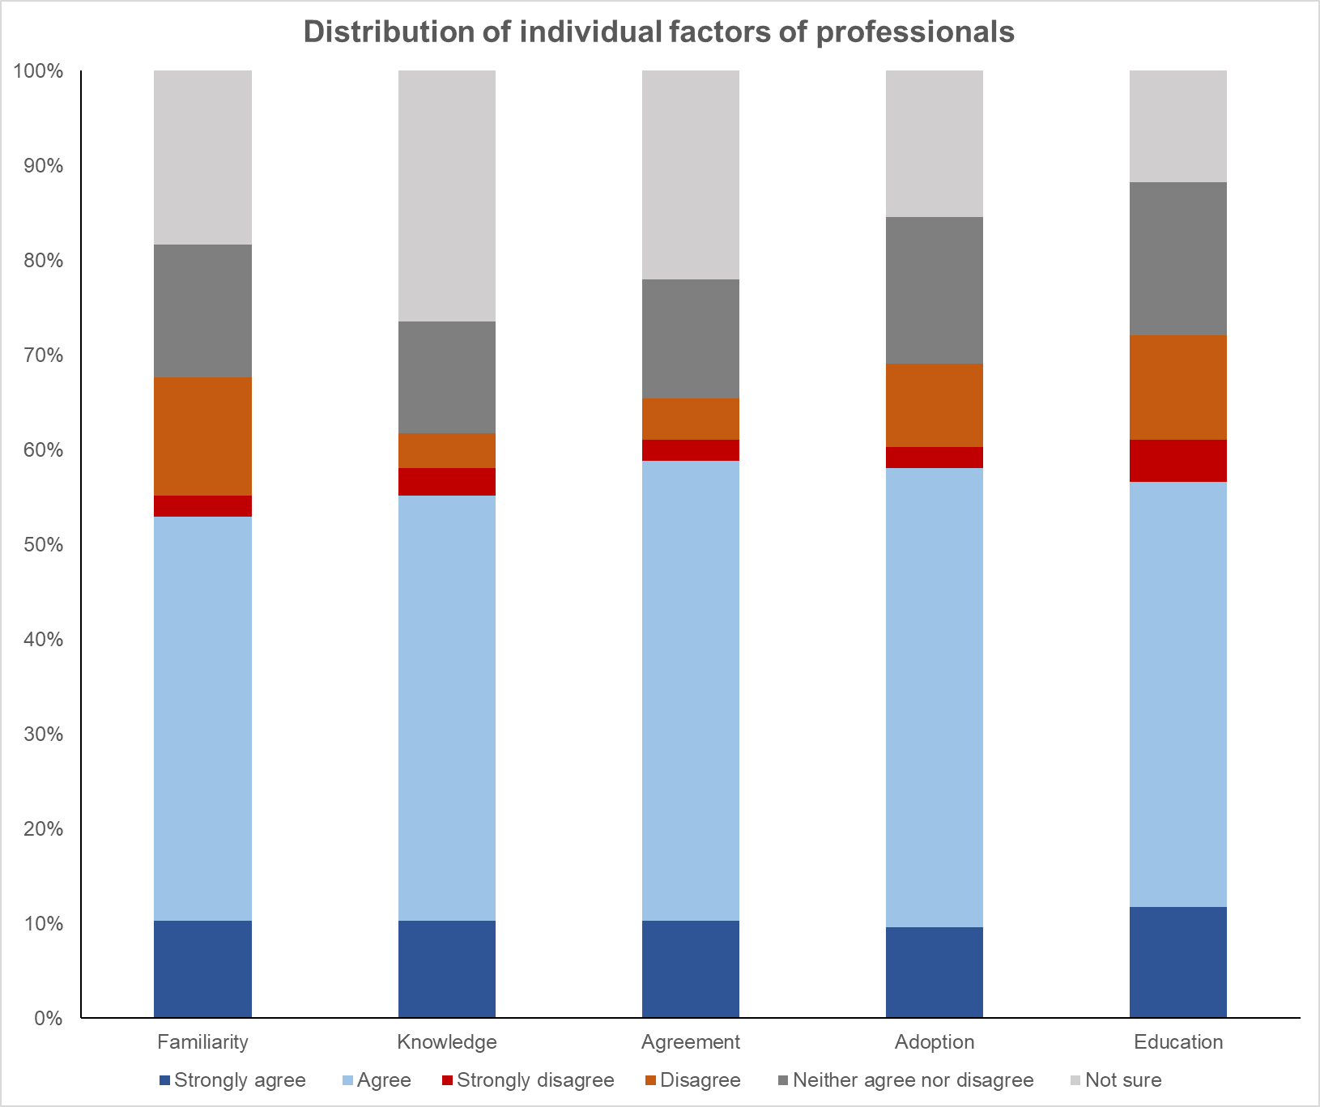
Domain 2: Individual factors of health professionals

Figure 3: Perception of individual factors of professionals

Domain 3: Patient factors
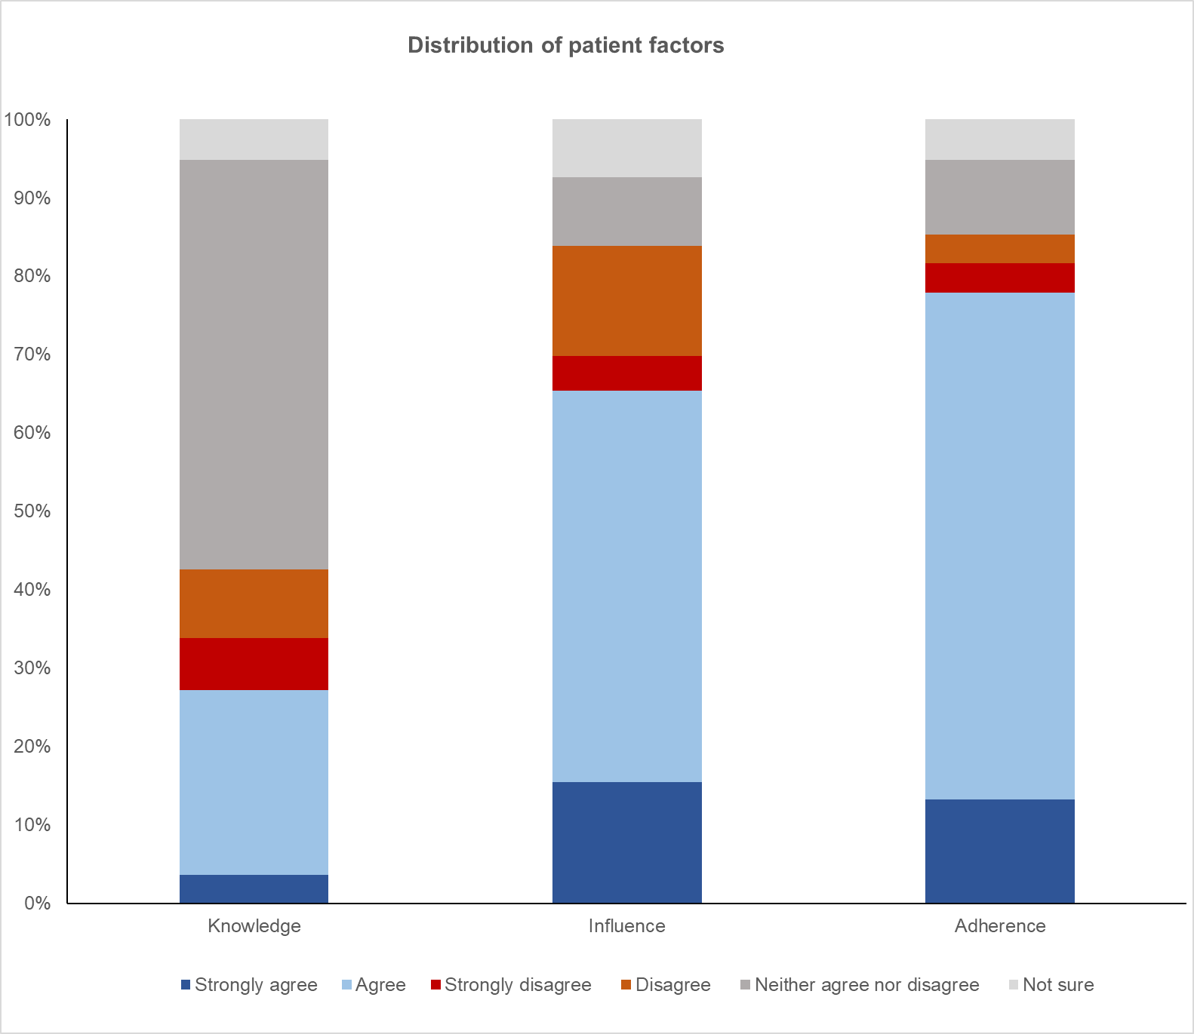

Figure 5: Perception of Patient Factors
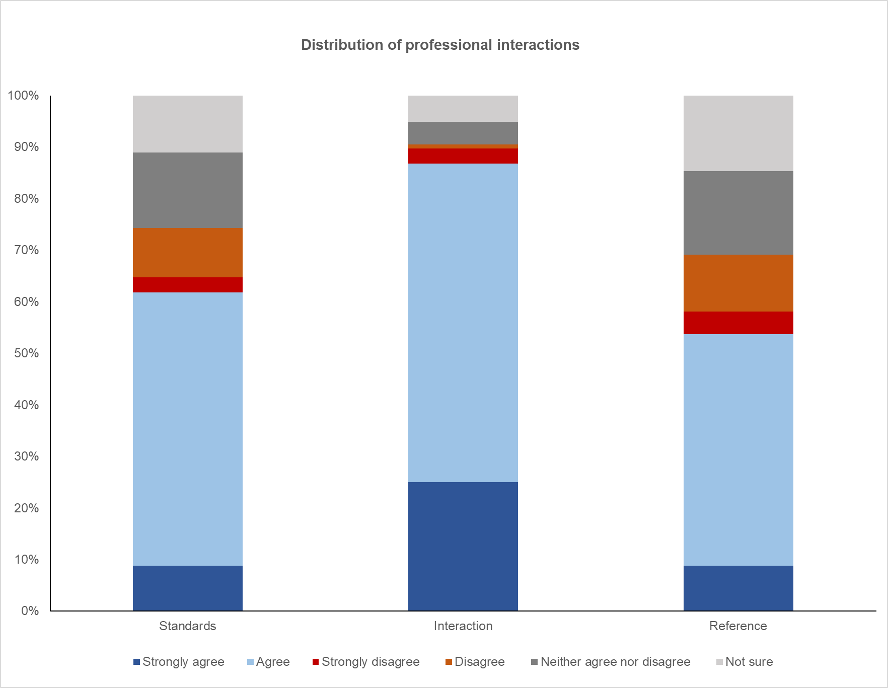
Domain 4: Professional Interactions

Figure 6: Perception of professional interactions

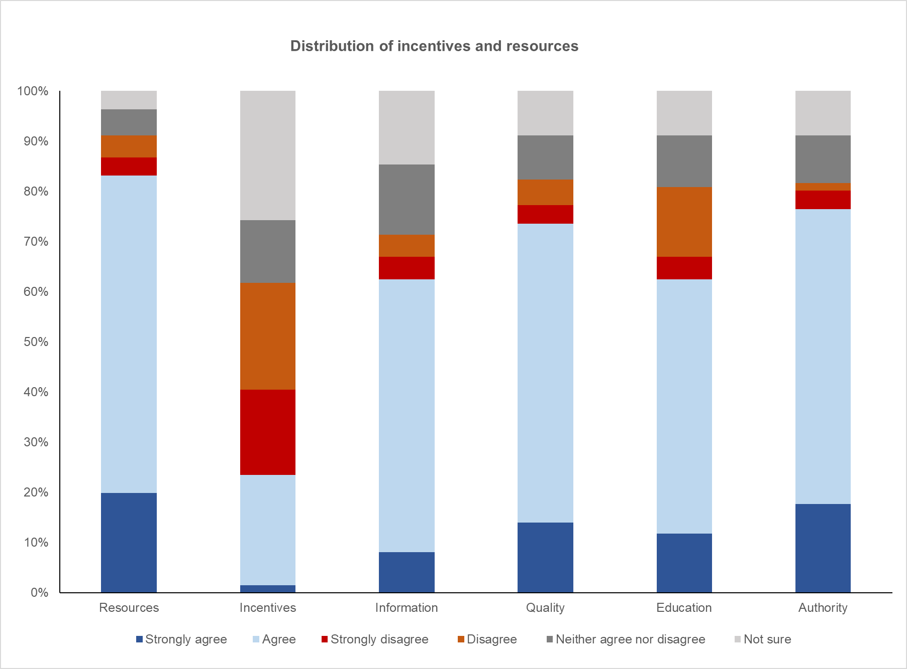
Domain 5: Incentives and resources

Figure 7: Perception of incentives and resources
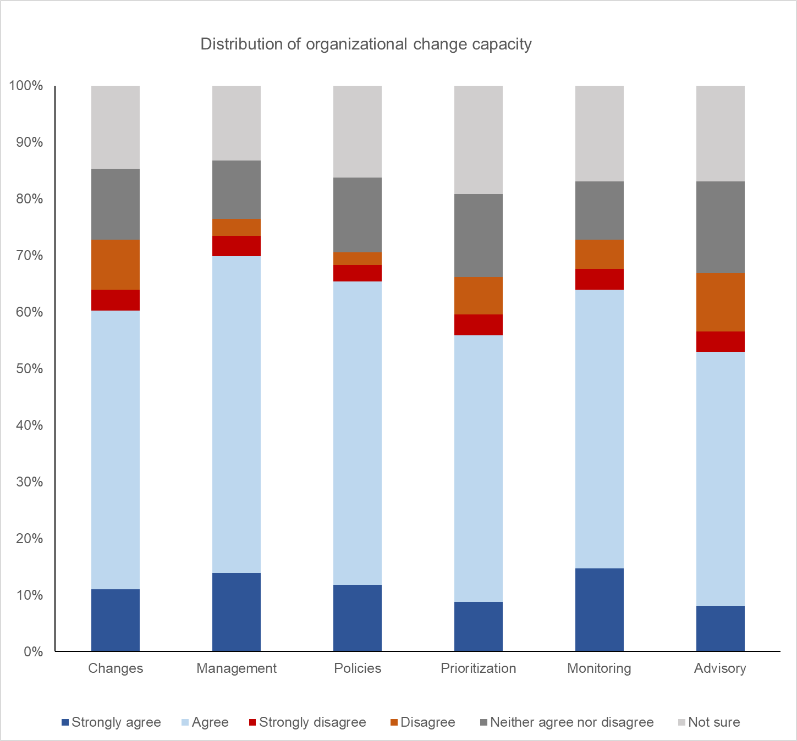
Domain 6: Capacity for organizational change

Figure 8: Perception of organizational change capacity

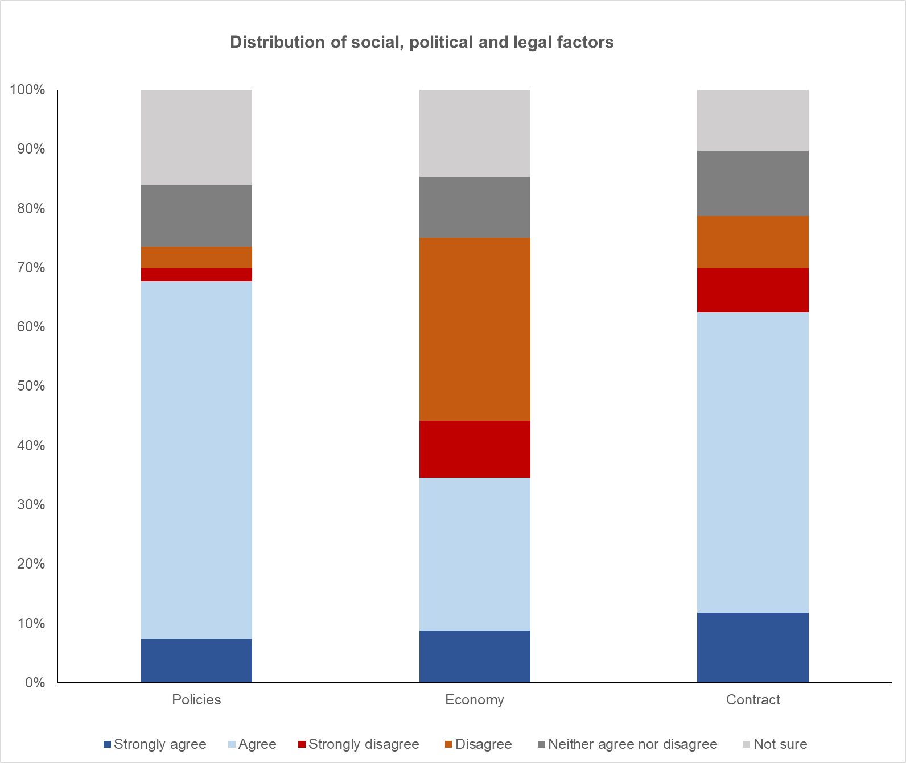
Domain 7: Social, political, and legal factors

Figure 9: Perception of social, political, and legal factors

