Appendix
Appendix A: Supplementary Result Figures
Shifts in dominant PFTs are primarily driven by moisture stress (droughts) and warming, resulting in a high vapor pressure deficit, which results in increased evapotranspiration. PCA and Correlation Analysis to determine the impact of various climatic factors on PFT dominance (Figures A1) reveal that droughts (moisture stress) had the most significant influence on PFT dominance, as indicated by the highest loading on PC1. This factor was followed by warming, which had a moderate effect on PFT dominance, and was represented by PC2, and decreased precipitation, which had a weaker influence and was represented by PC3. The explained variance ratios for the first three principal components were 0.57, 0.32, and 0.11, respectively.

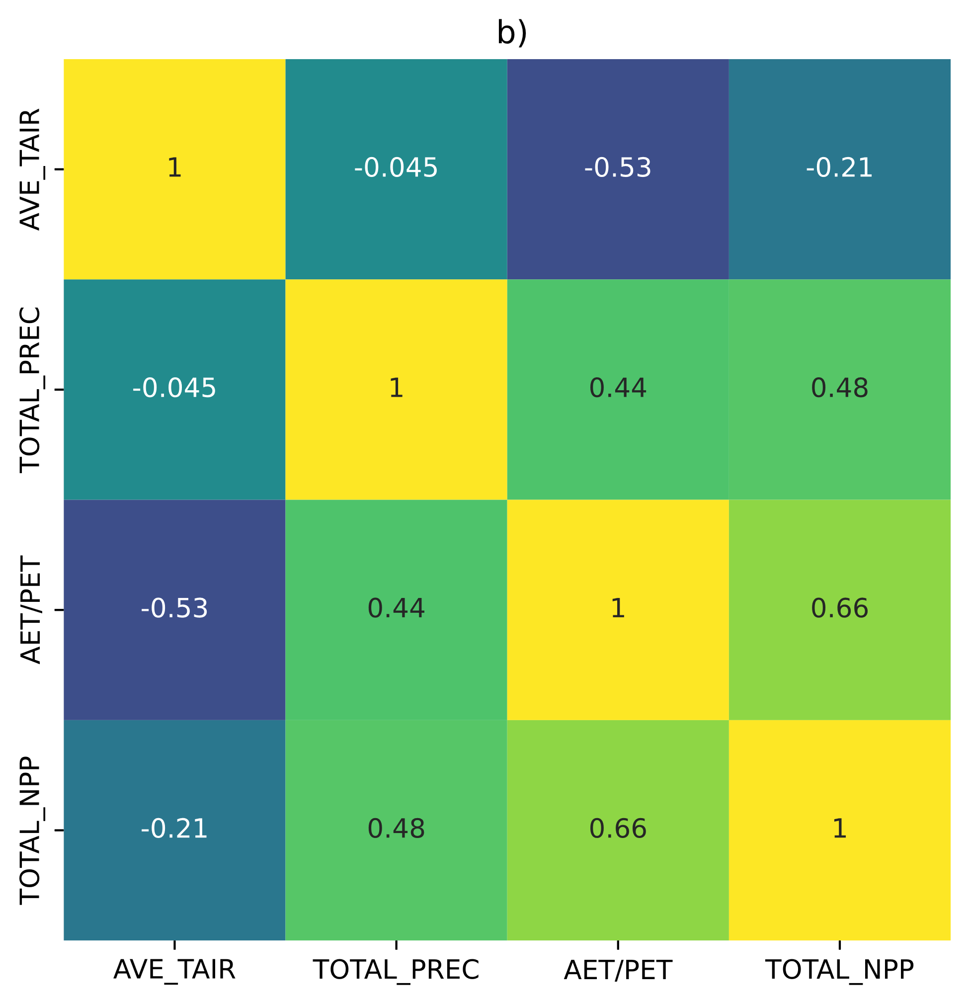
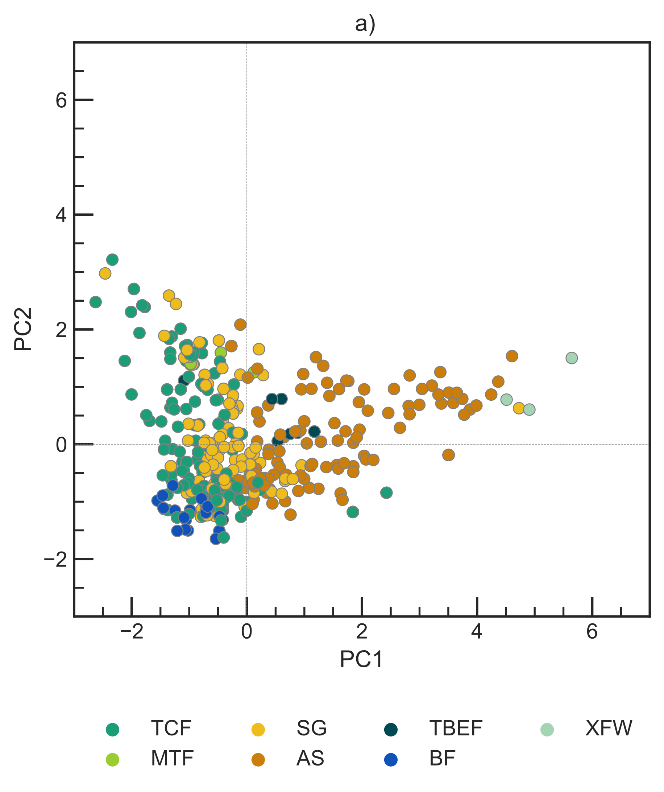

Figure A1. (a) Scatter plot of the first two principal components (PC1 and PC2) derived from a PCA of standardized climatic variables. (b) The correlation matrix for the subset of variables that determined dominant PFTs.

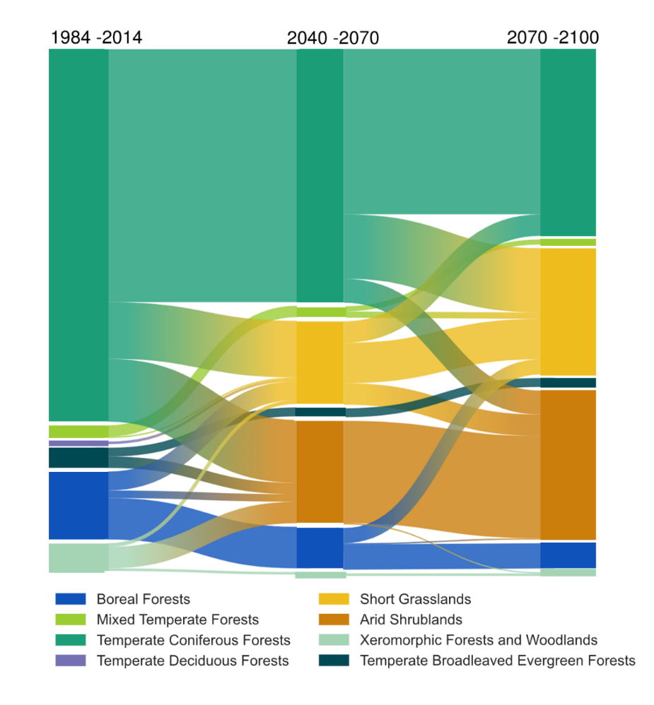
Figure A2. Types of shifts in dominant PFTs in the grids modelled.
The elevation-temperature space (Figures A3, A4) shows the projected changes in elevation for tree PFTs by the end of the century. The analysis indicates that there will be a significant shift in the distribution of PFTs. Higher elevation PFTs, such as boreal forest, migrate upslope, while coastal-Mediterranean PFTs, such as temperate broadleaved evergreens, are expected to migrate to lower elevations closer to the coast. Additionally, temperate conifers are projected to experience a contraction in their range, with a higher density at high elevations, suggesting that climate change will significantly impact the spatial distribution of PFTs.

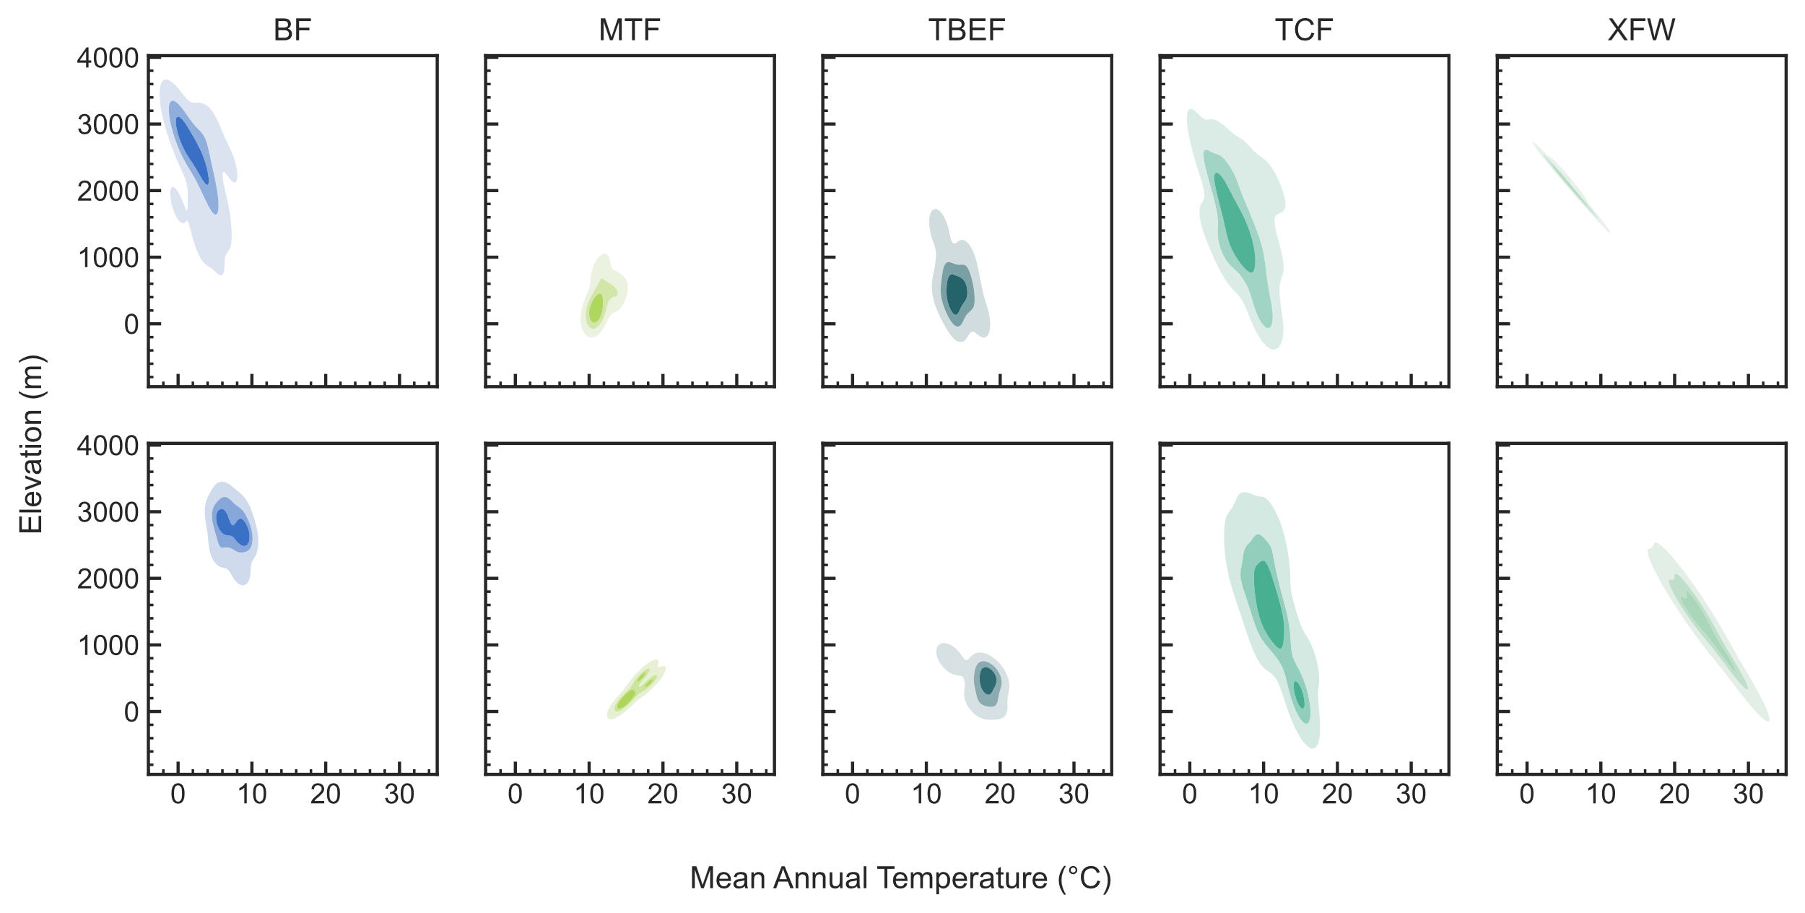
Figure A3. Elevation - Temperature space plots showing the change in tree PFTs mean elevation and mean annual temperature range by the end of the century (2070-2100, bottom row) compared to the 1984-2014 baseline (top row). PFTs are BF= Boreal Forests, MTF = Mixed Temperate Forests, TCF =Temperate Coniferous Forest, XFW: Xeromorphic Forests and Woodlands, and TBEF = Temperate Broadleaved Evergreen Forests

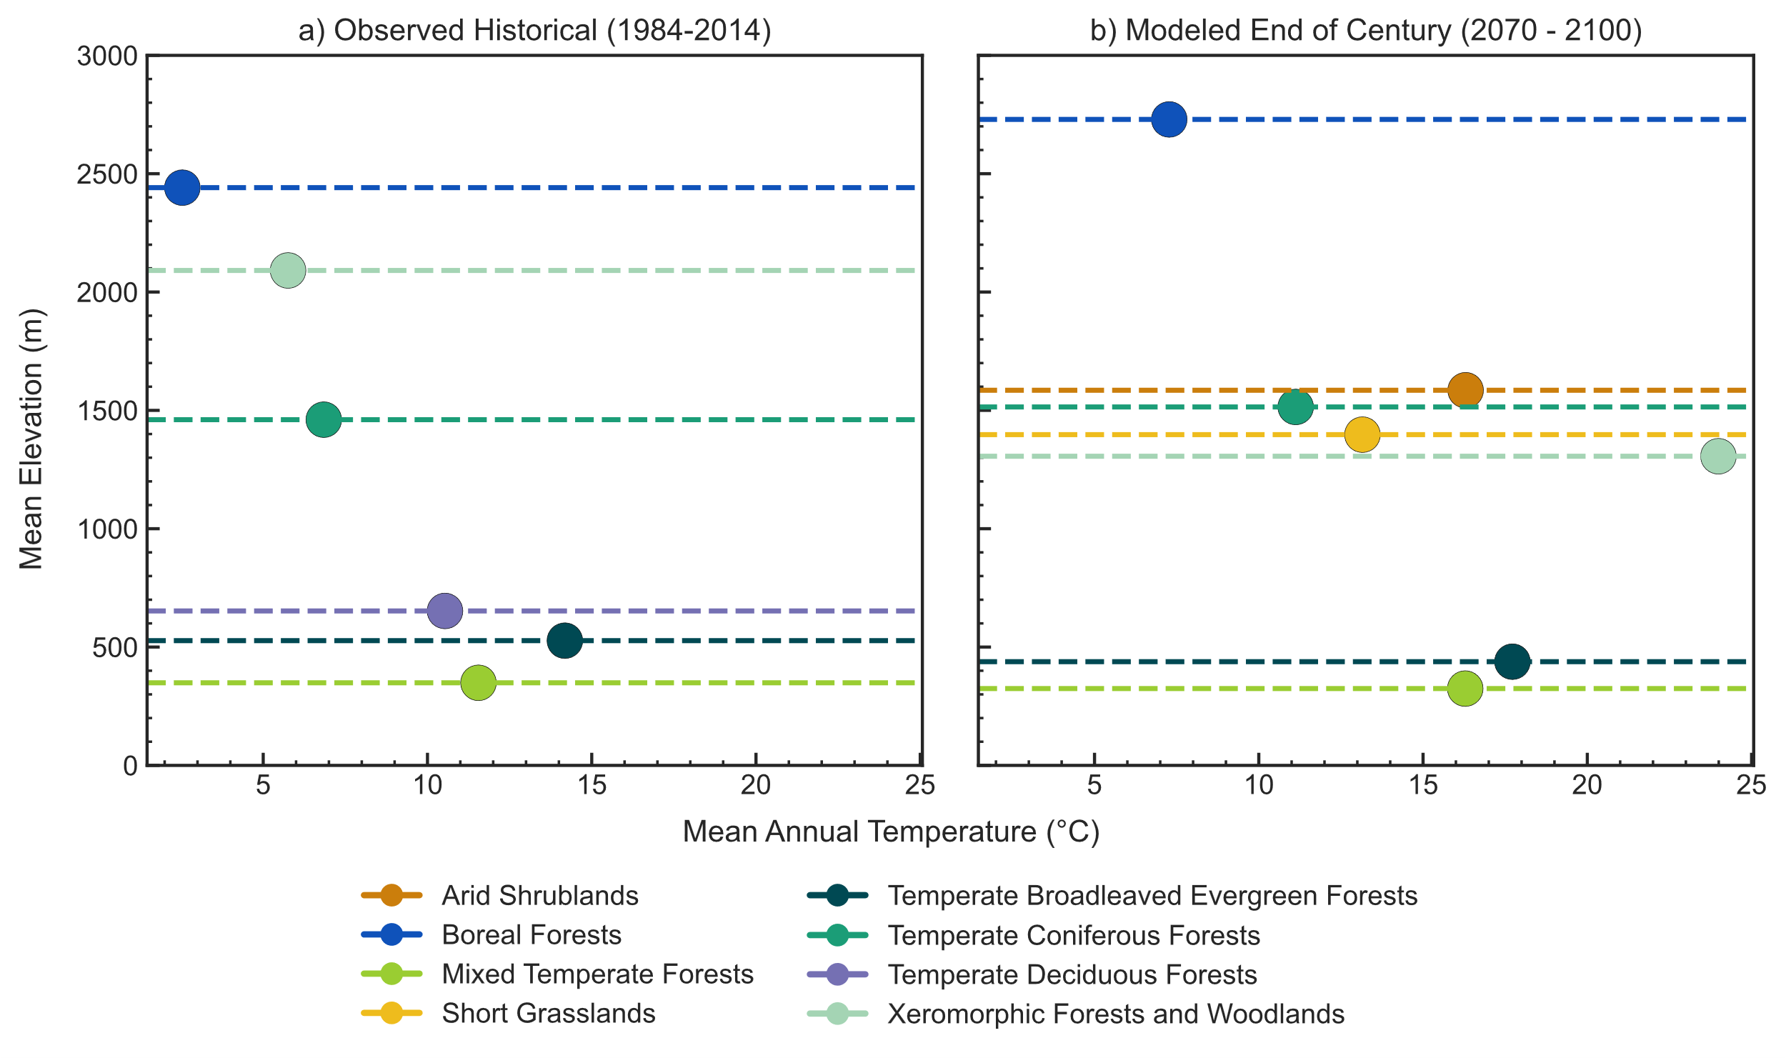
Figure A4. The change in PFTs mean elevation and mean annual temperature by the end of the century (2070-100) compared to the 1984-2014 baseline.
Appendix B: Definition of NCE
For NCE, carbon uptake is denoted as positive and carbon release is denoted as negative. NCE is strongly negative at the start when there are lots of replacement fires, since it is a measure of NEP minus the carbon lost by fire. Eventually, NCE more closely resembles NEP as there are fewer fires later in the century. NCE is calculated using the following equations:

$NCE=NEP-E_{c}$ Equation 1

$NEP=NPP-r_{h}-VOLAC$ Equation 2

where NCE is net carbon exchange, NEP is net ecosystem productivity, E_{c} is burned carbon, NPP is net primary productivity, r_{h} is heterotrophic respiration, and VOLAC is the proportion of standing dead that directly decomposes and volatizes CO₂ directly back to the atmosphere. In this study we excluded other conversion fluxes i.e., decay of agricultural and wood products from NEP and NCE calculations because human land use and land cover change are not considered. The NCE we calculate is equivalent to Net Biome Productivity (NBP), which is a measure of the balance between NPP and carbon losses due to heterotrophic respiration and wildfire.

Appendix C: TEM functions affecting GPP
TEM employs a parabolic function to assess the impact of temperature changes on the productivity of individual PFTs. An increase in temperature will enhance PFT productivity if the temperature falls on the cooler side of the peak of the parabola. However, if temperatures continue to rise beyond this peak value, then we see a decline in PFT productivity. CO₂ fertilization depends on the half-saturation constant (k_{c}), which is a measure of how efficiently plants can use CO₂ for photosynthesis. The k_{c} represents the concentration of CO₂ at which the rate of photosynthesis is half of its maximum potential⁴⁶. Lower k_{c} values indicate that a plant can more efficiently use CO₂ for photosynthesis, as it reaches half of its maximum photosynthetic rate at lower CO₂ concentrations (Table C1). CO₂ fertilization increases water use efficiency of tree PFTs, as it allows them to maintain high rates of photosynthesis with reduced water loss through transpiration (Figure C1). Thus, forests may be more resilient to future climatic changes than previously thought, as they could maintain or even increase productivity and carbon storage under warmer and wetter conditions. However, an increase in temperatures with a decrease in precipitation resulted in the loss of forests, as observed in grids where shrubs and grass are the dominant PFTs. Future models also show evapotranspiration rates increasing due to vegetation regrowth rather than decreasing as a result of reduced soil moisture. The enhanced transpiration relative to evaporation may also be the result of limited soil moisture and warmer atmosphere, which creates a gradient for moving water from the plant to the atmosphere and may also leave plants moisture stressed. (Figure C2).
Even though earlier studies demonstrated substantial CO₂ fertilization effect on forests, it is important to note that recent findings from FACE (Free Air CO₂ Enhancement) studies, such as The Eucalyptus FACE (EUCFACE)⁴⁷, and Birmingham Institute of Forest Research (BiForFACE)⁴⁸ concluded that the CO₂ fertilization effect may not be as potent as once believed. These studies suggest that the CO₂ fertilization effect might primarily occur in young, growing trees, rather than in mature trees. More research is therefore needed to better understand the effect of CO₂ fertilization.

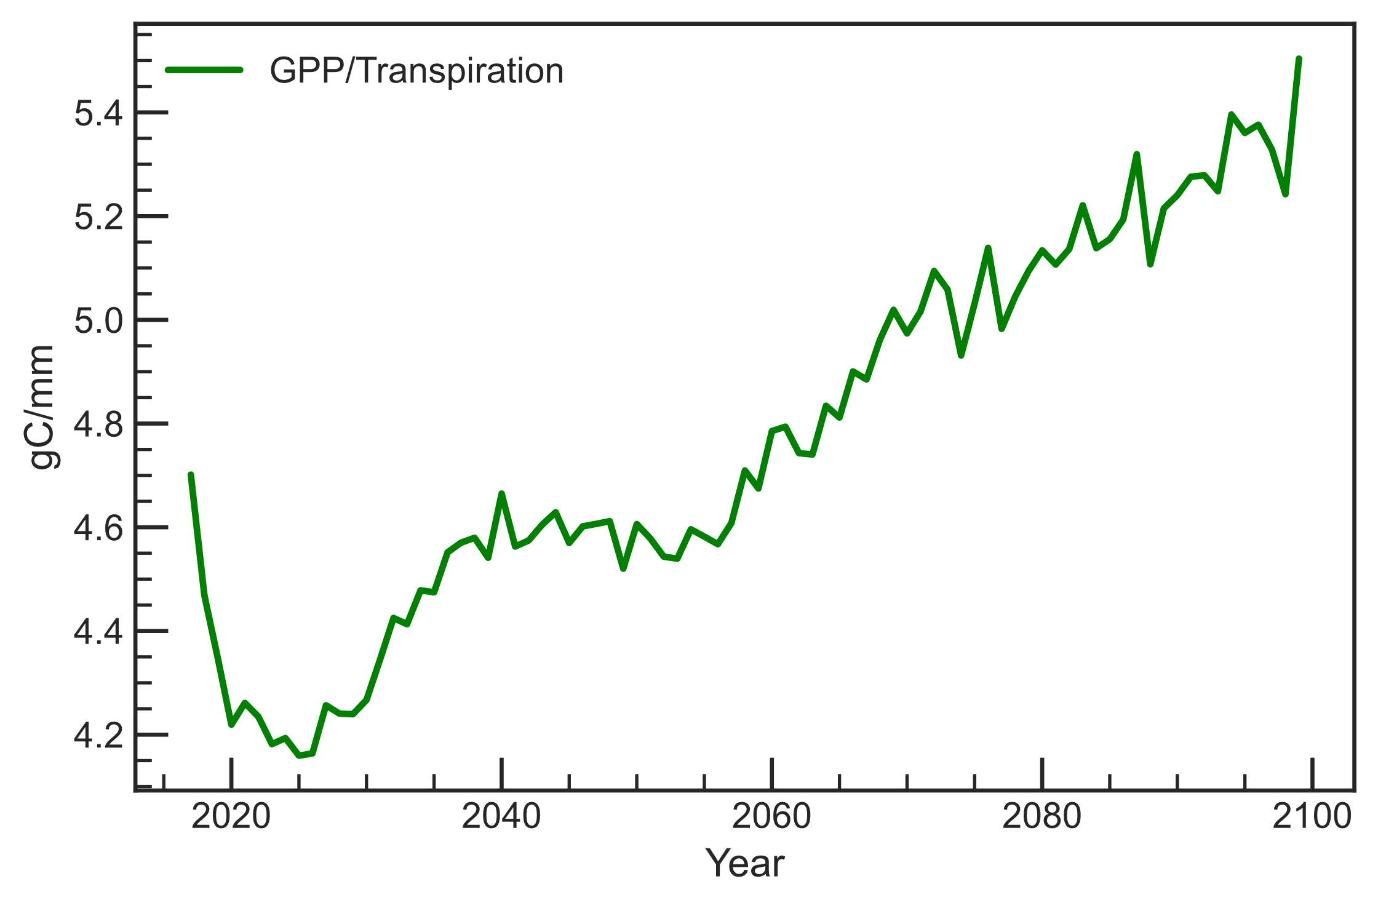
Figure C1 Water Use Efficiency (GPP/Transpiration) with respect to CO₂ fertilization for the remaining forested grids. Tree PFTs are more water efficient due to CO₂ fertilization.

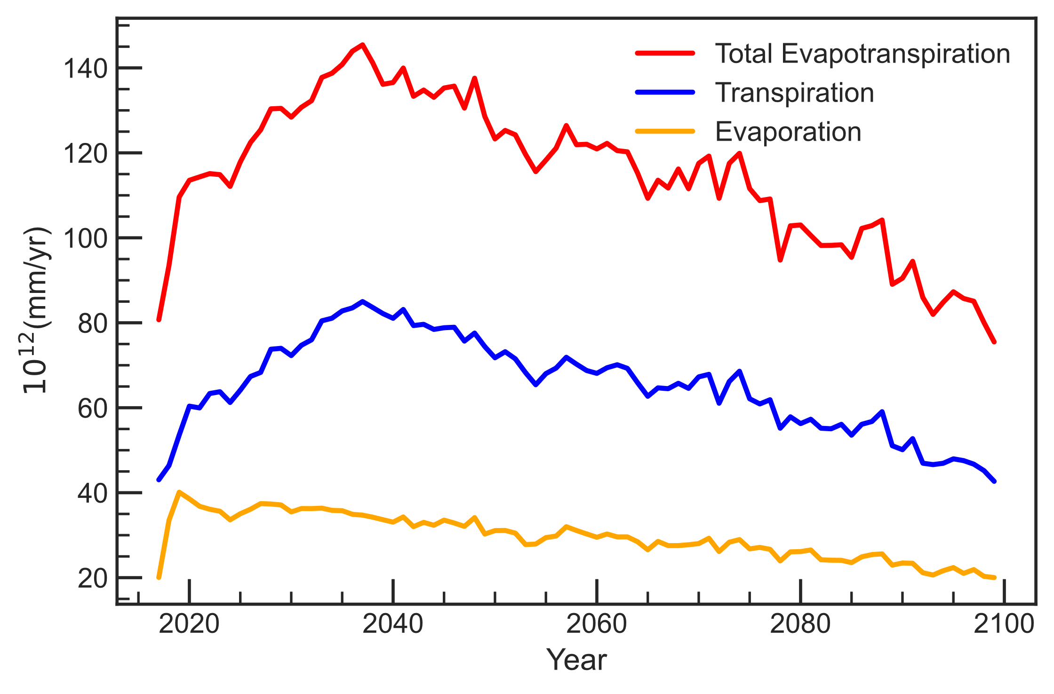
Figure C2 Partitioning between evaporation, transpiration, and the total water loss through evapotranspiration. Total evapotranspiration includes canopy interception.

Table C1 Temperature and k_{c} values determining GPP of PFTs in TEM. Temperature values are based on a parabolic function. The function determines the effects of temperature on primary productivity where the function equals zero above T_{max} and below T_{min}, and bell-shaped in between, with a peak at the optimum temperature. As the optimum temperature gets closer to T_{max} or T_{min}, the peak narrows, reflecting limited temperature range for PFT productivity. The k_{c} determines how efficiently each PFT uses CO₂, with higher kc indicating a stronger CO2 fertilization effect, based on a hyperbolic function.

PFT | k_{c} | T_{min} | T_{optmin} | T_{optmax} | T_{max}
Boreal Forest | 200 | -5 | 17 | 25 | 32
Temperate Coniferous Forest | 200 | -1 | 22 | 30 | 38
Temperate Deciduous Forest | 200 | 0 | 23 | 30.9 | 40
Short Grasslands | 40 | 0 | 13 | 32.7 | 38
Arid Shrublands | 120 | 1 | 15 | 35 | 44
Xeromorphic Forests and Woodlands | 200 | 0 | 19.1 | 33.1 | 38
Temperate Broadleaved Evergreen Forest | 200 | 5 | 19.5 | 32 | 35

Appendix D: TEM model evaluation

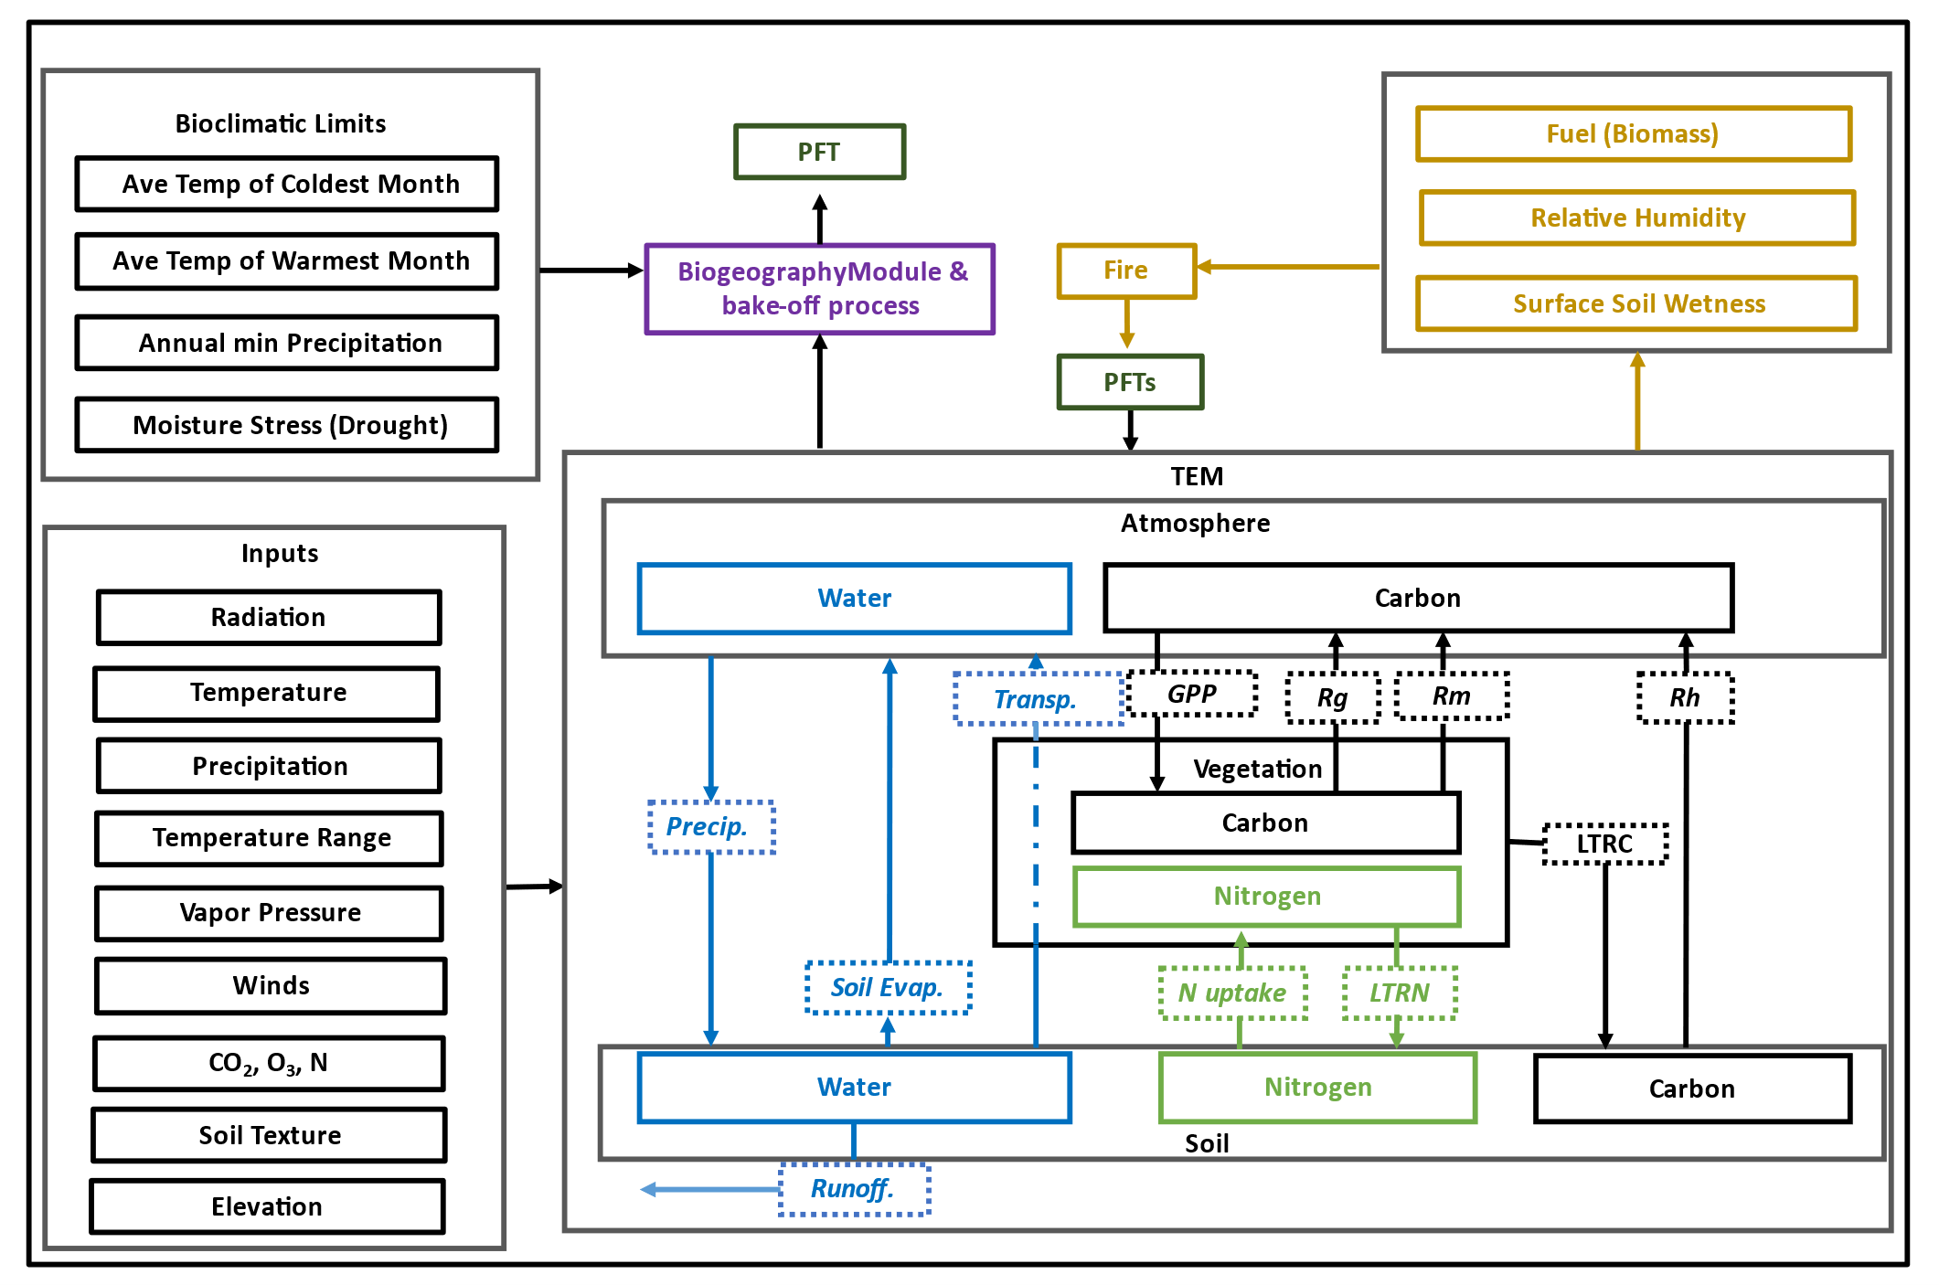

Figure D1 TEM model overview

Biomass Validation
Biomass validation is done by comparing vegetation carbon output of the TEM model, to both remotely sensed data and ground truth observations⁴⁹ (Figure D2) . A histogram of the difference shows both positive and negative biases in vegetation carbon. The maximum difference at the peak of the histogram is +1000 gC/m² for positive bias, and -2500 gC/m², for negative bias (Figures D3). One potential source of bias in our model outputs is the resolution of our vegetation cover dataset. At 0.5° by 0.5°, it may not accurately capture areas where the climate changes rapidly, such as transitions from deserts to wetter climates (i.e., high to low vegetation carbon). As a result, our resolution may not be fine enough to detect these changes and could lead to biased model outputs. Additionally, the calibration sites for each PFT may not accurately reflect the characteristics of the PFTs in the modeled grids given the species differences amongst the broad PFT categories. For example, the calibration of temperate coniferous forests in TEM is based on red pines (Pinus resinosa) at Harvard Forest in the northeastern US, which on average have lower biomass compared to temperate coniferous forests in the western U.S. e.g. spruces, and lodgepole pines, ehave higher biomass⁴⁹. The difference in biomass, however, does not affect the result of this study as shifts are driven by climatic changes.
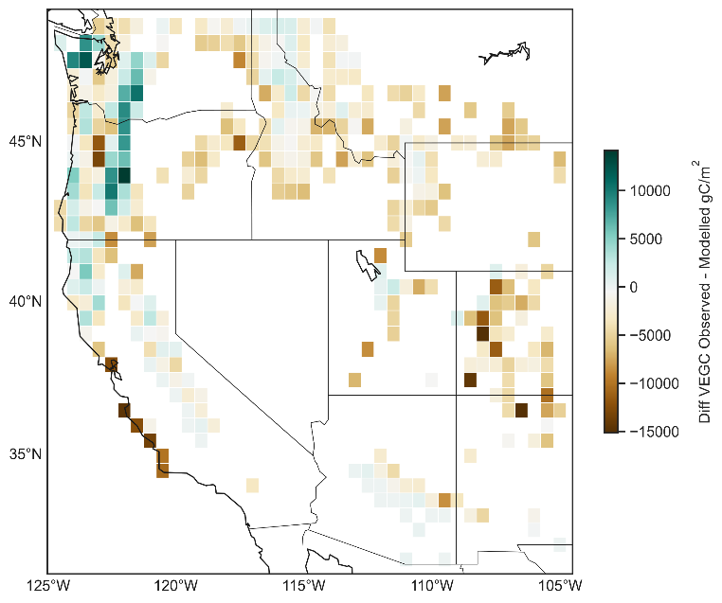
Figure D2 Vegetation carbon difference (Observed – Modeled) for western U. S forested grids (2010 - 2014) used for assessing the accuracy of TEM output values, data retrieved from the Comprehensive Forest Biomass Dataset for the USA⁴⁹.

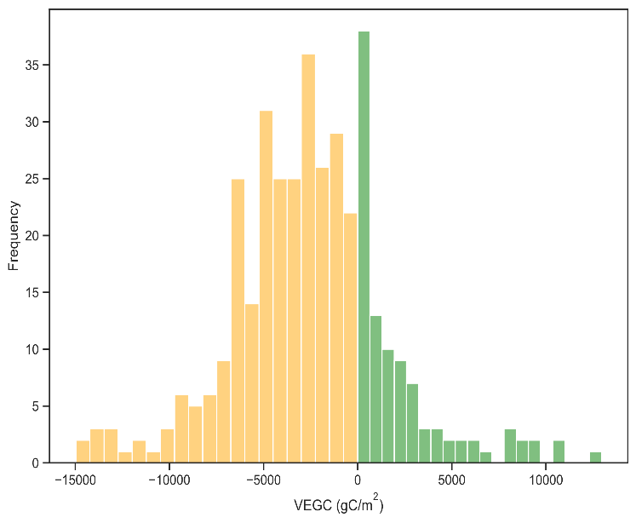
Figure D3 Vegetation carbon, negative and positive bias: used for assessing the accuracy of TEM output values. Data retrieved from the Comprehensive Forest Biomass Dataset⁴⁹.
Our analysis reveals that the model shows a positive bias in some areas and a negative bias in others, as evidenced by the frequency distributions of percent difference for all the grids. Specifically, we found that the positive bias frequency peaks at 38 with maximum mean vegetation carbon values of +1000 gCm⁻². On the other hand, the negative bias frequency peaks at 40 but with maximum mean vegetation carbon values of -2500 gCm⁻².

Biogeography Validation
Validation of the biogeography and NPP bakeoff module was done by applying the module to the historical run covering the period from 1750 to 2014, with focus on the most recent 30-year period from 1984 to 2014. Our biogeography module successfully reproduced the current dominant PFTs in 89% of the grid cells modeled, as demonstrated in Figure D4. Furthermore, the resulting vegetation distribution closely resembled ground truth obsevations⁴⁵ except for a few grid cells in the Southwest, where our model indicated shrubs as the dominant PFT instead of xeromorphic and woodland forests, which generally have low NPP because they grow in dry areas.⁵⁰NPP is a key factor driving the biogeography module during the historical period since the climate is favorable (not out of range) for most tree PFTs. The model, therefore, selects shrublands as the dominant PFTs as they are more productive in these grids than xeromorphic forests (Figure D4).
The source code of TEM, biogeography module, as well as the statistical analysis tools used in this study, are publicly available on GitHub (link) under the repository name TEM_Biogeography.

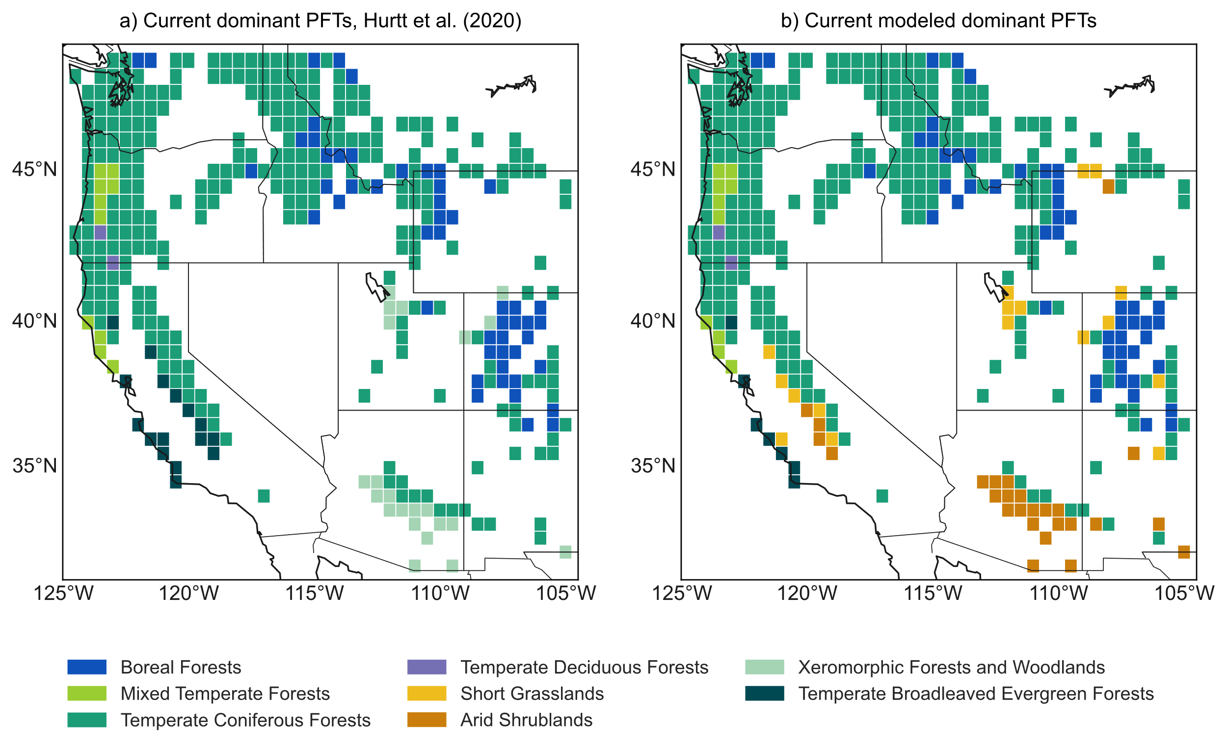

Figure D4 (a) Current western U.S. dominant tree PFT distribution⁴⁵. (b) Resulting vegetation distribution for the period (1984 – 2014) after applying biogeography module to the historical run (1750 – 2014). The biogeography module successfully reproduced current dominant PFTs in 89% of the grid cells modeled.

An important caveat is that our model cannot distinguish between different species. Therefore, further research is needed to investigate how individual key species within the remaining forests respond to climatic changes. In addition, our model uses a simple fire model to predict wildfires. Future studies could incorporate a more comprehensive fire model, considering ignition sources, spread, topography, and other fire determinants. Furthermore, we used fixed bioclimatic thresholds primarily informed by literature to determine changes in dominant PFTs. Thus, it would be valuable to explore how thresholds based on real-world observations compare to those we employed. Finally, it would be interesting to investigate whether true competition based on PFT physiology and environmental non-climatic factors—such as soil, topography, light, water, and nutrients—would more accurately represent vegetation dynamics compared to the current approach. Further studies in these areas would help refine our understanding of how climatic changes impact forest ecosystems.

