Supplementary Materials

Resistance evaluation of sweet orange (Citrus sinensis) cultivars to Xanthomonas citri subsp. citri

Danielle S. Y. Nanami¹, Gabriela Bissoli¹, Nayara N. Souza¹, Priscila Rosseto¹, Cristiane Mendes da Silva-Reis¹, Carlos A. Zanutto^{1*}, Clive H. Bock² and William M. C. Nunes¹

¹UEM - Departamento de Agronomia, Núcleo de Pesquisa em Biotecnologia Aplicada, Av. Colombo, 5790 – 87020-900 – Maringá, PR – Brazil.
²United States Department of Agriculture – USDA - Agricultural Research Service –ARS - Byron, Georgia, USA.

*corresponding author e-mail: cazanutto@uem.br

Supplementary Table S1. The generalized linear mixed models compared using a Gaussian inverse distribution to explain the effects of various fixed variables and covariates on the size of canker lesions on inoculated leaves.

ID | Modelª
$${NO}_{1}$$ | $$η_{ijk}= β_{0}+ α_{i}Variety + θ_{j}DAI + u_{0k}+ u_{1k}Variety+u_{2k}DAI$$
$${NO}_{2}$$ | $$η_{ijk}= β_{0}+ α_{i}Variety + θ_{j}DAI +u_{0k}+ u_{1k}DAI$$
$${NO}_{3}$$ | $$η_{ijk}= β_{0}+ α_{i}Variety + θ_{j}DAI +u_{1k}DAI$$
$${NO}_{4}$$ | $$η_{ijk}= β_{0}+ α_{i}Variety + θ_{j}DAI$$
ª In the models, α_i represents the effects due to i-th variety, θ_j the effects due to the j-th day after inoculation, u_k is the effect of the random part on the k-th leaf.
Supplementary Table S2. The estimates for the different variables in the fixed component of the selected model in trial 1.

Variable | Estimate | Standard Error | DF | t Value | Pr > |t|
Intercept | 1.0724 | 0.01727 | 193 | 62.11 | <.0001
Pera 59 | 0.05267 | 0.02153 | 420 | 2.45 | 0.0149
Pera Arapongas | 0.02156 | 0.02153 | 420 | 1.00 | 0.3174
Pera Bianchi/CC | -0.00222 | 0.02153 | 420 | -0.10 | 0.9179
Pera EEL | -0.01533 | 0.02153 | 420 | -0.71 | 0.4768
Hamlin | 0.1020 | 0.02153 | 420 | 4.74 | <.0001
Pera IAC | -0.02200 | 0.02153 | 420 | -1.02 | 0.3076
Pera IAC 2000/1 | 0.01522 | 0.01865 | 420 | 0.82 | 0.4148
Pera Ipiguá | 0.002889 | 0.02153 | 420 | 0.13 | 0.8933
Pera M5 | -0.01044 | 0.02153 | 420 | -0.49 | 0.6279
Pera Ovale Siracusa | -0.01067 | 0.02153 | 420 | -0.50 | 0.6206
Pera Ovale | 0.03533 | 0.02153 | 420 | 1.64 | 0.1016
Vermelha | 0.05600 | 0.02153 | 420 | 2.60 | 0.0096
Pera 58 | 0 | . | . | . | .
8 | 0.2083 | 0.01287 | 193 | 16.19 | <.0001
12 | 0.3113 | 0.01287 | 193 | 24.19 | <.0001
16 | 0.4333 | 0.01287 | 193 | 33.67 | <.0001
20 | 0.5241 | 0.01287 | 193 | 40.73 | <.0001
4 | 0 | . | . | . | .

Supplementary Table S3. The pairwise differences in trial 1 between the canker lesion diameter means for the 12 Pera sweet orange cultivars (and 2 controls) based on a Tukey-Kramer analysis. Only significant pairwise differences are presented.

Cultivar | Cultivar | Estimate | Standard Error | DF | t Value | Pr > |t|
59 | Bianch | 0.05489 | 0.02153 | 420 | 2.55 | 0.0112
59 | EEL | 0.06800 | 0.02153 | 420 | 3.16 | 0.0017
59 | Hamlin | -0.04933 | 0.02153 | 420 | -2.29 | 0.0225
59 | IAC | 0.07467 | 0.02153 | 420 | 3.47 | 0.0006
59 | IAC 2000/1 | 0.03744 | 0.01865 | 420 | 2.01 | 0.0453
59 | Ipiguá | 0.04978 | 0.02153 | 420 | 2.31 | 0.0213
59 | M5 | 0.06311 | 0.02153 | 420 | 2.93 | 0.0036
59 | Ovale Siracusa | 0.06333 | 0.02153 | 420 | 2.94 | 0.0035
59 | 58 | 0.05267 | 0.02153 | 420 | 2.45 | 0.0149
Arapongas | Hamlin | -0.08044 | 0.02153 | 420 | -3.74 | 0.0002
Arapongas | IAC | 0.04356 | 0.02153 | 420 | 2.02 | 0.0438
Bianchi/CC | Hamlin | -0.1042 | 0.02153 | 420 | -4.84 | <.0001
Bianchi/CC | Vermel | -0.05822 | 0.02153 | 420 | -2.70 | 0.0071
EEL | Hamlin | -0.1173 | 0.02153 | 420 | -5.45 | <.0001
EEL | Ovale | -0.05067 | 0.02153 | 420 | -2.35 | 0.0191
EEL | Vermel | -0.07133 | 0.02153 | 420 | -3.31 | 0.0010
Hamlin | IAC | 0.1240 | 0.02153 | 420 | 5.76 | <.0001
Hamlin | IAC 2000/1 | 0.08678 | 0.01865 | 420 | 4.65 | <.0001
Hamlin | Ipiguá | 0.09911 | 0.02153 | 420 | 4.60 | <.0001
Hamlin | M5 | 0.1124 | 0.02153 | 420 | 5.22 | <.0001
Hamlin | Ovale Siracusa | 0.1127 | 0.02153 | 420 | 5.23 | <.0001
Hamlin | Ovale | 0.06667 | 0.02153 | 420 | 3.10 | 0.0021
Hamlin | Vermelha | 0.04600 | 0.02153 | 420 | 2.14 | 0.0332
Hamlin | 58 | 0.1020 | 0.02153 | 420 | 4.74 | <.0001
IAC | IAC 20 | -0.03722 | 0.01865 | 420 | -2.00 | 0.0466
IAC | Ovale | -0.05733 | 0.02153 | 420 | -2.66 | 0.0081
IAC | Vermelha | -0.07800 | 0.02153 | 420 | -3.62 | 0.0003
IAC 2000/1 | Vermelha | -0.04078 | 0.01865 | 420 | -2.19 | 0.0293
Ipiguá | Vermelha | -0.05311 | 0.02153 | 420 | -2.47 | 0.0141
M5 | Ovale | -0.04578 | 0.02153 | 420 | -2.13 | 0.0341
M5 | Vermelha | -0.06644 | 0.02153 | 420 | -3.09 | 0.0022
Ovale Siracusa | Ovale | -0.04600 | 0.02153 | 420 | -2.14 | 0.0332
Ovale Siracusa | Vermelha | -0.06667 | 0.02153 | 420 | -3.10 | 0.0021
Vermelha | 58 | 0.05600 | 0.02153 | 420 | 2.60 | 0.0096

Supplementary Table S4. The estimates for the different variables in the fixed component of the selected model in trial 1.

Variable | Estimate | Standard Error | DF | t Value | Pr > |t|
Intercept | 1.1401 | 0. 03198 | 29 | 35.66 | <.0001
Pera 59 | -0. 01467 | 0. 04388 | 584 | -0. 33 | 0. 7383
Pera Arapongas | -0. 01289 | 0. 04388 | 584 | -0.29 | 0. 7691
Pera Bianchi/CC | -0. 09422 | 0. 04388 | 584 | -2.15 | 0. 0322
Pera EEL | -0. 09467 | 0. 04388 | 584 | -2.16 | 0. 0314
Hamlin | 0. 003556 | 0. 04388 | 584 | 0.08 | 0. 9354
Pera IAC | -0. 1460 | 0. 04388 | 584 | -3.33 | 0. 0009
Pera IAC 2000/1 | -0. 06956 | 0. 03800 | 584 | -1.83 | 0. 0677
Pera Ipiguá | -0. 04133 | 0. 04388 | 584 | -0.94 | 0. 3466
Pera M5 | -0. 00200 | 0. 04388 | 584 | -0.05 | 0. 9637
Pera Ovale Siracusa | 0. 02978 | 0. 04388 | 584 | 0.68 | 0. 4976
Pera Ovale | 0. 001889 | 0. 04388 | 584 | -0.59 | 0. 5537
Vermelha | -0. 05978 | 0. 04388 | 584 | -1.36 | 0. 1736
58 | 0 | . | . | . | .
8 | 0. 1200 | 0. 01251 | 584 | 9.82 | <.0001
12 | 0. 2017 | 0. 01251 | 584 | 16.50 | <.0001
16 | 0. 2744 | 0. 01251 | 584 | 22.46 | <.0001
20 | 0.3699 | 0.01251 | 584 | 30.27 | <.0001
4 | 0 | . | . | . | .

Supplementary Table S5. The pairwise differences in trial 2 between the canker lesion diameter means for the 12 Pera sweet orange cultivars (and 2 controls) based on a Tukey-Kramer analysis. Only significant pairwise differences are presented.

Cultivar | Cultivar | Estimate | Standard Error | DF | t Value | Pr > |t|
59 | IAC | 0.1313 | 0. 04388 | 584 | 2.99 | 0. 0029
Arapon | IAC | 0.1331 | 0.04388 | 584 | 3.03 | 0.0025
Bianch | Hamlin | -0.09778 | 0.04388 | 584 | -2.23 | 0.0262
Bianch | M5 | -0.09222 | 0.04388 | 584 | -2.10 | 0.0360
Bianch | O. Sir | -0.1240 | 0.04388 | 584 | -2.83 | 0.0049
Bianch | 58 | -0.09422 | 0.04388 | 584 | -2.15 | 0.0322
EEL | Hamlin | -0.09822 | 0.04388 | 584 | -2.24 | 0.0256
EEL | M5 | -0.09267 | 0.04388 | 584 | -2.11 | 0.0351
EEL | O. Sir | -0.1244 | 0.04388 | 584 | -2.84 | 0.0047
EEL | 58 | -0.09467 | 0.04388 | 584 | -2.16 | 0.0314
Hamlin | IAC | 0.1496 | 0.04388 | 584 | 3.41 | 0.0007
IAC | IAC 20 | -0.07644 | 0.03800 | 584 | -2.01 | 0.0447
IAC | Ipiguá | -0.1047 | 0.04388 | 584 | -2.39 | 0.0174
IAC | M5 | -0.1440 | 0.04388 | 584 | -3.28 | 0.0011
IAC | O. Sir | -0.1758 | 0.04388 | 584 | -4.01 | <.0001
IAC 20 | O. Sir | -0.09933 | 0.03800 | 584 | -2.61 | 0.0092
O. Sir | Vermelha | 0.08956 | 0.04388 | 584 | 2.04 | 0.0417

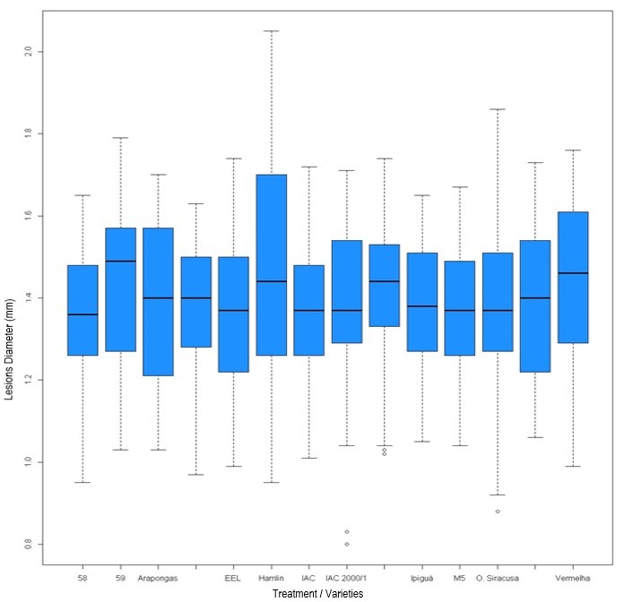
Supplementary Figure S1. Box-plots showing the characteristics of the lesion diameter samples at 20 days for each of the 12 Pera sweet orange cultivars (and 2 controls) in trial 1.

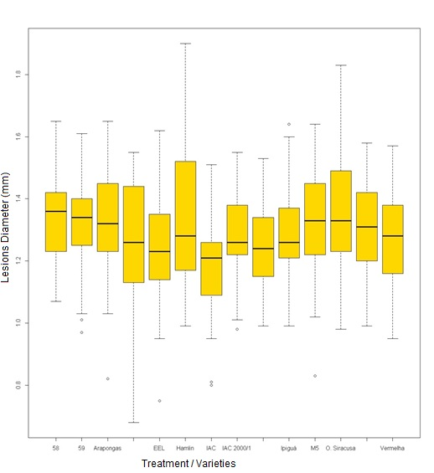
Supplementary Figure S2. Box-plots showing the characteristics of the lesion diameter samples at 20 days for each of the 12 Pera sweet orange cultivars (and 2 controls) in trial.2.

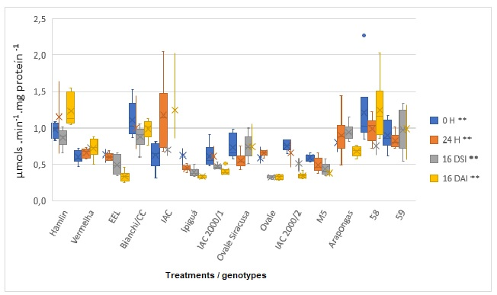
Supplementary Figure S3. Box plots showing the activity of peroxidase in 12 Pera sweet orange cultivars (and 2 controls) inoculated with Xanthomonas citri subsp. citri, at different times after inoculation (H: hours after inoculation, DSI: Days without inoculation, DAI: days after inoculation). Bars indicate the mean ± standard deviation.

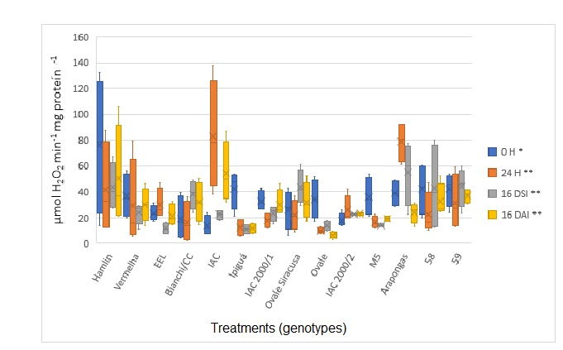
Supplementary Figure S4. Box plots showing the activity of catalase in 12 Pera sweet orange cultivars (and 2 controls) inoculated with Xanthomonas citri subsp. citri, at different times after inoculation (H: hours after inoculation, DSI: Days without inoculation, DAI: days after inoculation). Bars indicate the mean ± standard deviation.

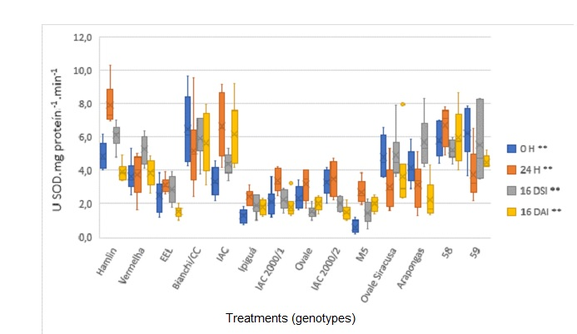

Supplementary Figure S5. Box plots showing the activity of superoxide dismutase in 12 Pera sweet orange cultivars (and 2 controls) inoculated with Xanthomonas citri subsp. citri, at different times after inoculation (H: hours after inoculation, DSI: Days without inoculation, DAI: days after inoculation). Bars indicate the mean ± standard deviation.

