Supplementarily Material
Disentangling the microbial genomic traits associated with aromatic hydrocarbon degradation in a jet fuel-contaminated aquifer

K.J. Hidalgo^{a,b}, V.B. Centurion^{c}, L.N. Lemosª, A.U. Soriano^{d}, E. Valoni^{d}, M.P. Baessa^{d}, H.H. Richnow^{e,f}, C. Vogt^{e}, and V.M. Oliveiraª

ª Microbial Resources Division, Research Center for Chemistry, Biology and Agriculture (CPQBA), University of Campinas – UNICAMP, Av. Alexandre Cazellato, 999, ZIP 13148-218, Paulínia, SP, Brazil,
^{b} Graduate Program in Genetics and Molecular Biology, Institute of Biology, University of Campinas (UNICAMP), Rua Monteiro Lobato 255, Cidade UniversitáriaZIP 13083-862, Campinas, SP, Brazil.
^{c} Department of Biology, University of Padova, Via U. Bassi 58/b, 35121 Padua, Italy
^{d} PETROBRAS/ R&D Center (CENPES), Av. Horácio Macedo, 950. ZIP 21941-915 Cidade Universitária, Ilha do Fundão, Rio de Janeiro, Brazil
^{e} Department of Isotope Biogeochemistry, Helmholtz Centre for Environmental Research (UFZ), Permoserstrasse 15 04318 Leipzig, Germany
^{f} Isodetect GmbH, Deutscher Platz 5b, 04103 Leipzig, Germany

Fig. S1. Nonpareil curves for the metagenomic datasets in this study. The horizontal dashed line indicates 95% average coverage. The empty circles indicate the data actual size and estimated average coverage of individual metagenomes, and the lines after the circles are projections of the fitted models.

Fig. S2. MAG distribution based on completeness and contamination assessed by CheckM.

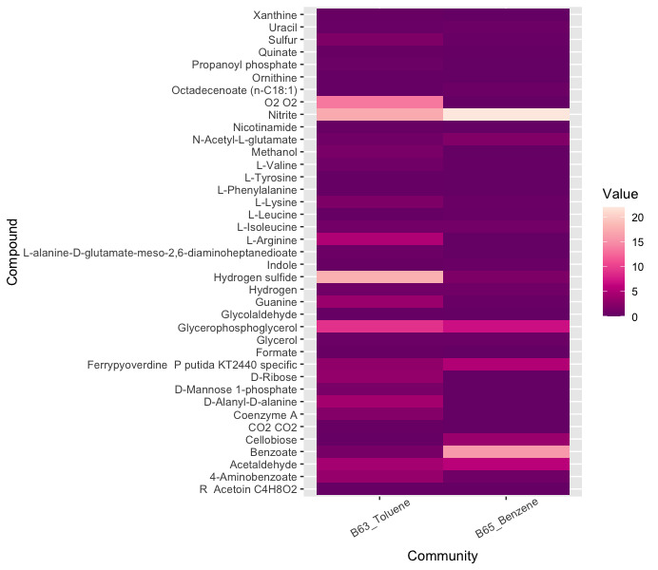
Fig. S3 Smetana values for cross-feeding metabolites obtained for in-situ microcosms B63 amended with toluene and B65 amended with benzene. The Smetana score is calculated as the sum of all interspecies metabolite exchanges. These values were normalized by the total value of the Smetana score and showed in percentage.

Fig. S4 Cytoscape model of the cross-feeding interactions (Smetana score > 0.2). (a) Toluene-amended BACTRAP; (b) Benzene-amended BACTRAP. Nodes correspond to MAGs from each community. Arrows or edges represent cross-feeding metabolites. The width of the arrows represents the Smetana score (0.0 – 1.0). Each edge color represents a metabolite interaction, as follows: green- NO₂; purple- benzoate; orange- 4-aminobenzoate; blue- H₂S. Black edges represent other metabolite interactions.

¹ Corresponding author: K.J. Hidalgo E-mail: khidalgo@javeriana.edu.co Telephone: +55 19 98172 1510

