Cation exchange strategy to construct a targeting nanoprobe for enhanced positive MR imaging capability
Siyu Chen¹, Haitao Sun⁴ ,Yingyan Zheng⁵, Qian Chen³, Yu Luo*², Hangrong Chen*³ and Quan Zhou*¹
¹Department of Radiology, Third Affiliated Hospital of Southern Medical University (Academy of Orthopedics Guangdong Province), Southern Medical University, Guangzhou, Guangdong 510630, P. R. China
²School of Chemical Science and Engineering, Tongji University, 1239 Siping Road, Shanghai 200092, P. R. China
³Country State Key Laboratory of High-Performance Ceramics and Superfine Microstructure, Shanghai Institute of Ceramics, Chinese Academy of Sciences, 1295 Ding-Xi Road, Shanghai 200050, P. R. China
⁴Shanghai Institute of Medical Imaging, Department of Interventional Radiology, Zhongshan Hospital, Fudan University, No. 180 Fenglin Road, Xuhui District, Shanghai 200032, P. R. China
⁵Department of Radiology, Huashan Hospital, Fudan University, 12 Middle Wulumuqi Road, Jingan District, Shanghai, 200040, P. R. China
Corresponding Author
*E-mail: yuluo@tongji.edu.cn (Y.L.).
*E-mail: hrchen@mail.sic.ac.cn (H. C.).
*E-mail: zhouquan3777@smu.edu.cn (Q. Z.).

Figure S1. SEM element line scanning analysis of TUG.
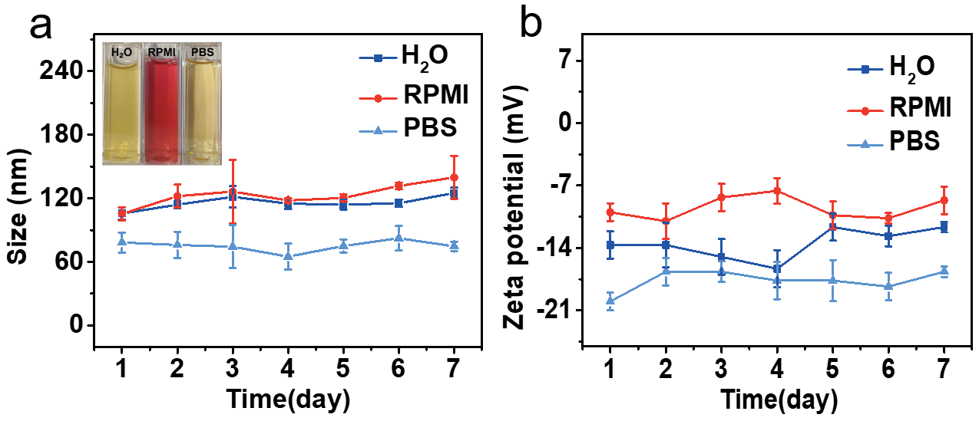
Figure S2. (a) Photo of TUG dispersed in deionized water, PBS, and serum contained medium for 3 months (inset) and hydrated particle sizes of the TUG dispersed in deionized water, PBS, and serum contained medium for 7 days. (b) Zeta potentials of the TUG dispersed in water, PBS, and medium for 7 days.

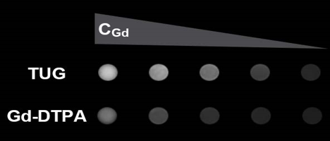
Figure S3. MRI imaging of TUG aqueous solution at different Gd concentrations (0.6, 1.2, 2.4, 4.8, 9.6 mM) taken by 3.0 T clinical MR imaging system under the following parameters: FOV = 60 × 60 mm; matrix = 256 × 256; section thickness = 2 mm; TR =1200 ms; TE = 17 ms.
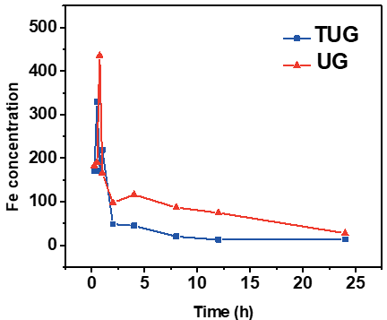
Figure S4. In vivo blood circulation time of TUG and UG. The healthy Balb/c mice were injected with TUG and UG (1 mg/mL, 250 μL) and then 10 μL blood were taken from tail vein at the fixed time points (0 min, 5 min, 30 min, 1 h, 2 h, 4 h, 8 h, 12 h, 24 h) and sent for ICP-OES.
Figure S5. Hematological assay of healthy Balb/c mice after intravenous injection of TUG (15 mg.kg⁻¹) for 14 days. The mice without treatment was used as control.

Figure S6. Representative MRI gray images of tumors. (a) MRI images of subcutaneous tumor in Balb/c nude mice after injection of TUG and Gd-DTPA; (b) MRI images of tumor in situ in Balb/c nude mice after injection of TUG and Gd-DTPA

