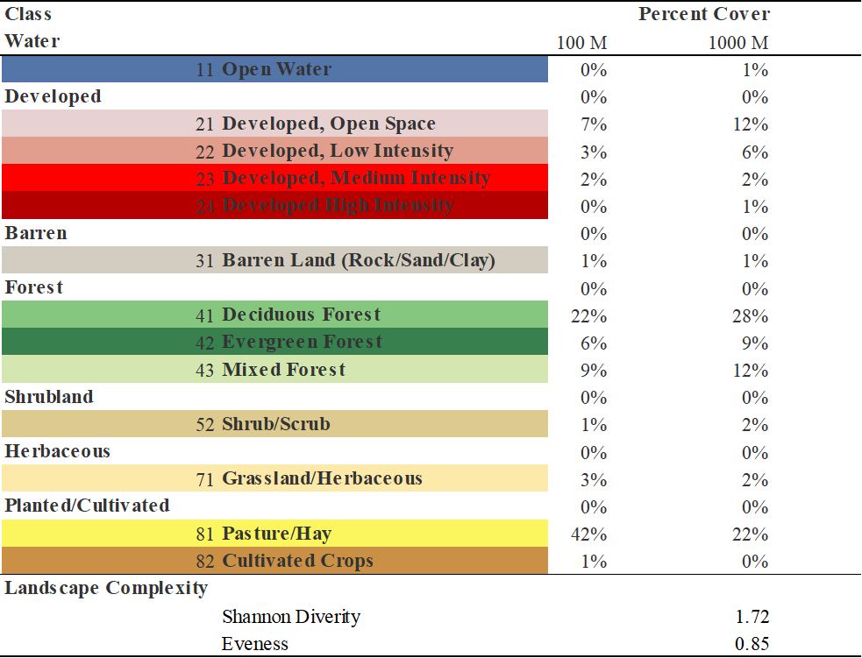
Table 1. An index table of all NLCD land cover types identified throughout all locations and their percent occupation at both 100 meters and 1000 meters for all 69 point locations.

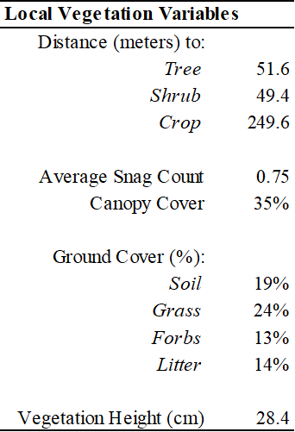
Table 2. Index of all vegetation variables used and average of each for all locations.
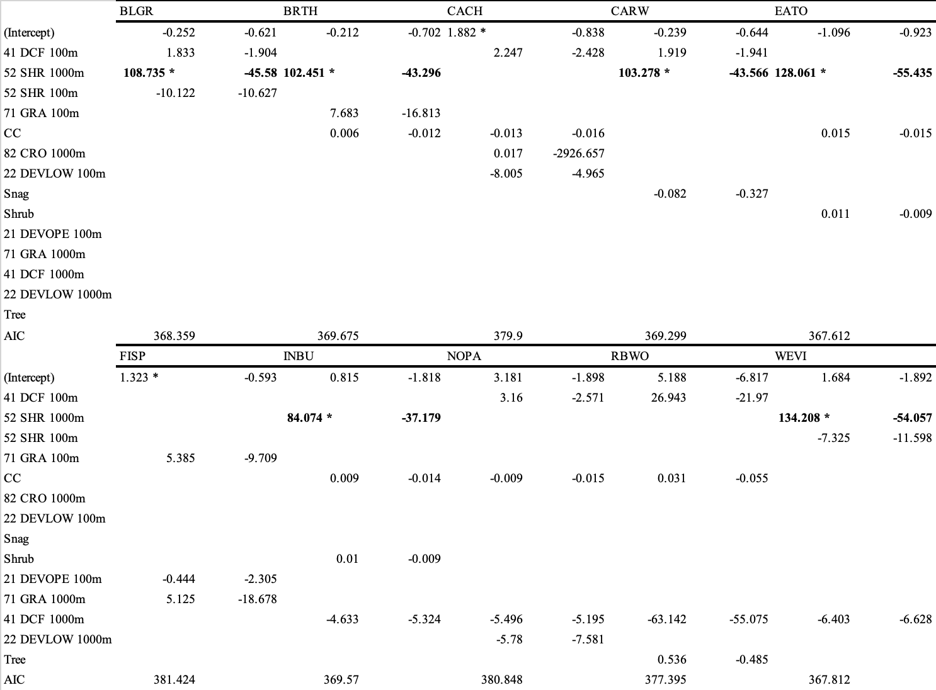

Table 3. Occupancy estimates table for 10 species and their top model in regards to NLCD land cover types.

