FLUENT ANALYSIS OF DIAMOND WEDGED WING
AT AN AOA 3$°$

Fluid flow -Fluent analysis has been performed based on the above-tabulated conditions on the diamond wedged wing with an AOA of 3 degrees and the results are formulated below. Required Solver settings and a detailed method of approach can be accessed by using the accompanying Research datasheet.

No. | Parameters | Settings
1 | Type of Solver | Pressure-Based Solver
2 | Energy Equation | On
3 | Viscous Model | Two Equations, Standard k - E Turbulent Model
4 | Fluid Medium | Air as Ideal Gas
5 | Operating Altitude | 1500 m
6 | Operating Pressure | 84643 Pascal
7 | Operating Temperature | 278.4 K (Correspond to the Altitude).
8 | Free Stream Velocity | Mach 2.0.
9 | Boundary Condition | a. Inlet as Pressure Far-Field. b. Outlet as Pressure Far-Field.
10 | Angle of attack | 3 Degrees

Table 1: Representation of primary Parameters and Settings used in the analysis

Cells | Faces | Nodes
1337130 | 2712652 | 243010

Table 2: Representation of Mesh size

Name | Type | Min Orthogonal Quality | Max Aspect Ratio
farfield | TetCell | 0.0013133841 | 463.98002

Table 3: Representation of Mesh Quality

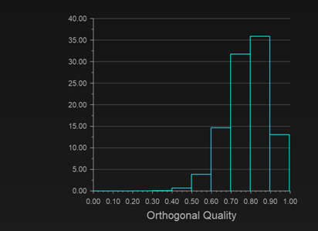

Figure E.1: Orthogonal Quality chart showing excellent mesh

lift | 9676.548 N
drag | 5047.931 N

Table 4: Report definitions (Lift and Drag)

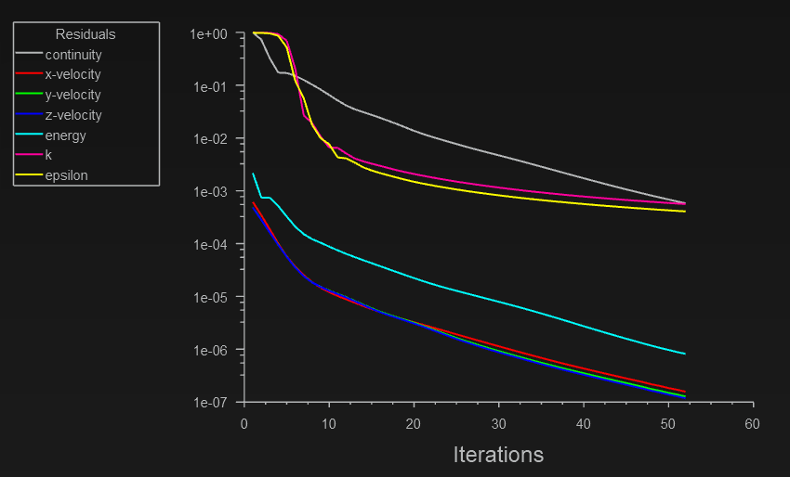
Figure E.2: Representation of Residual plot

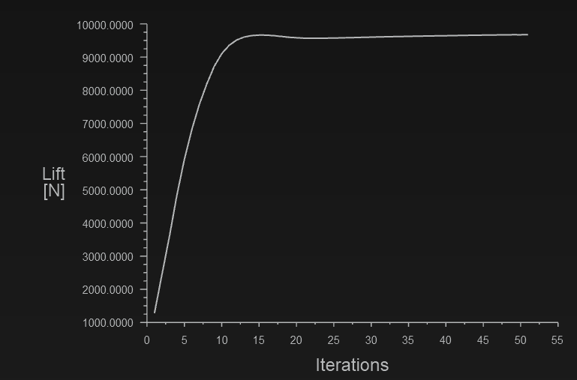
Figure E.3: Representation of Lift plot

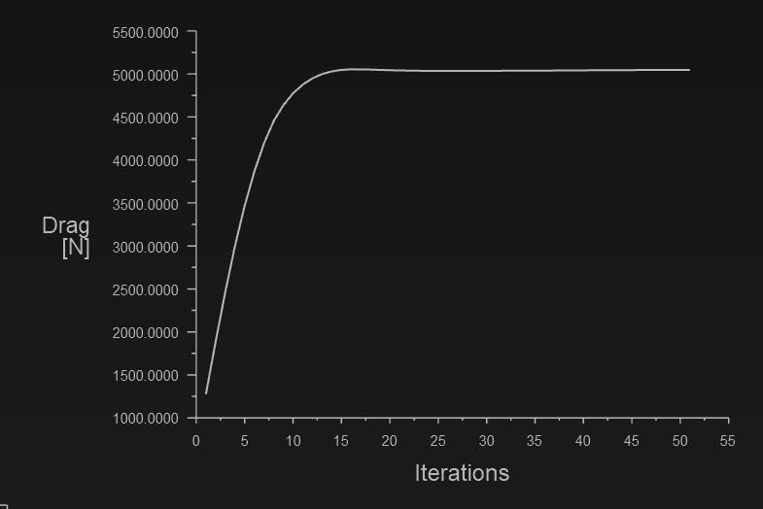
Figure E.4: Representation of Drag plot

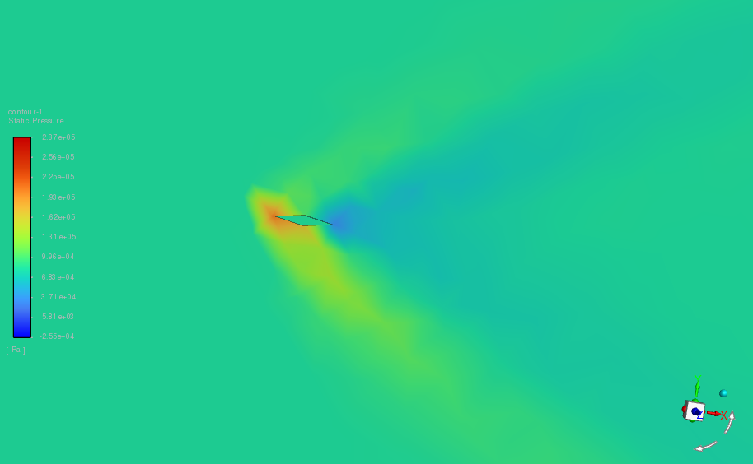
Figure E.5: Representation of propagation of filled shockwaves around the Diamond wedge airfoil (Static pressure contour)

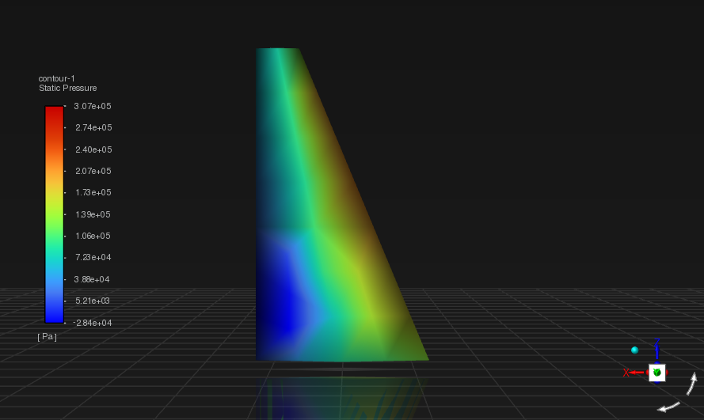
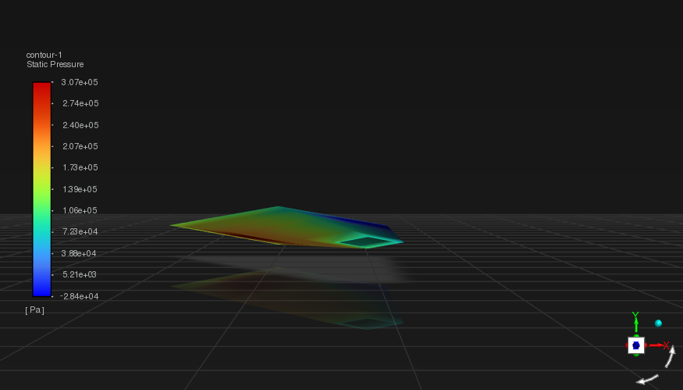
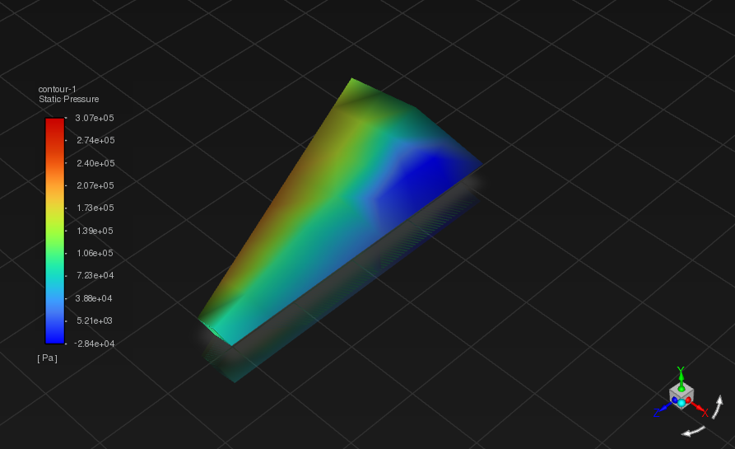
Figure E.6: Representation of Static pressure contours
The maximum Static pressure value has been found to be 3.07e+05 Pa The minimum Static pressure value has been found to be -2.84e+04 Pa

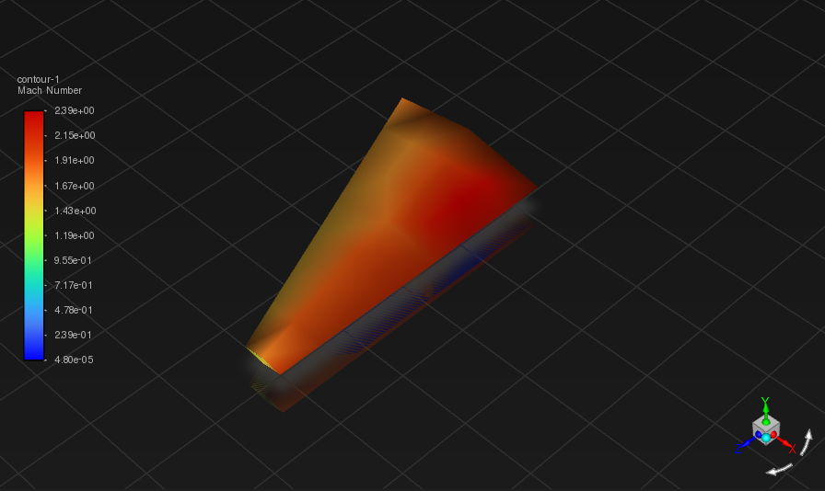
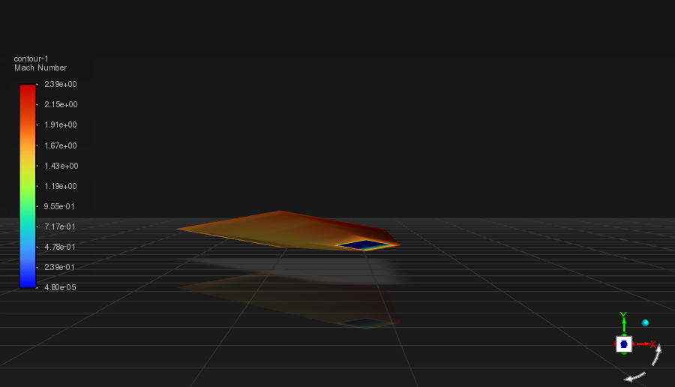
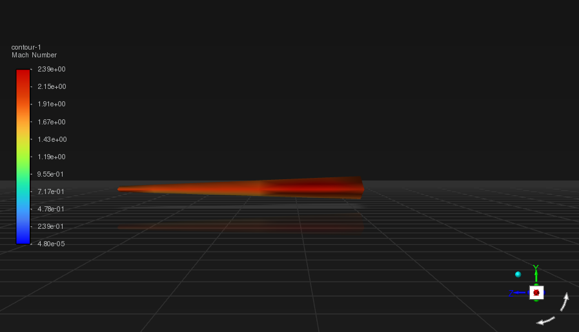
Figure E.7: Representation of Velocity-Mach contours

The range at which the wing exhibits Mach value lies between 1.85 to 2.39 with 2.31 being the maximum value specifically at the surface of immediate contact with the penetrating air.

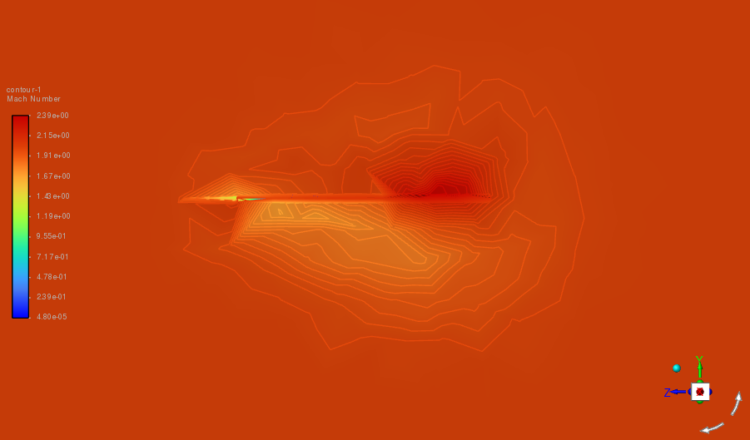
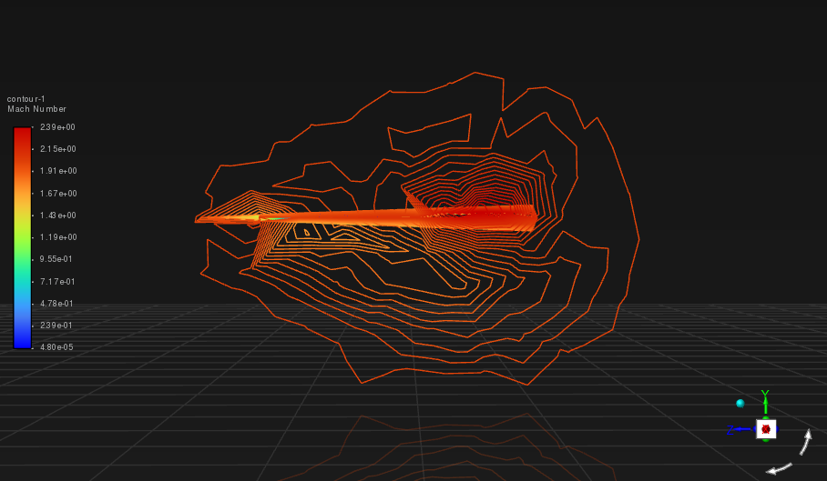
Figure E.8: Representation of shockwaves on a plane perpendicular to the direction of fluid flow (Velocity-Mach contour)

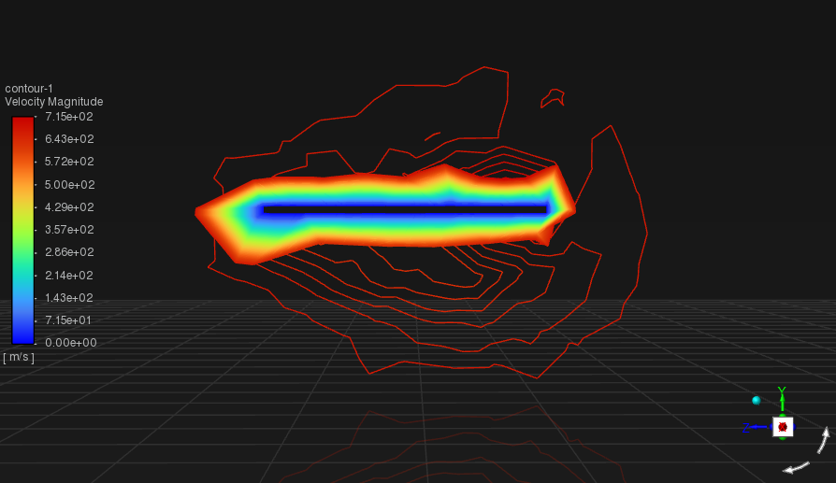
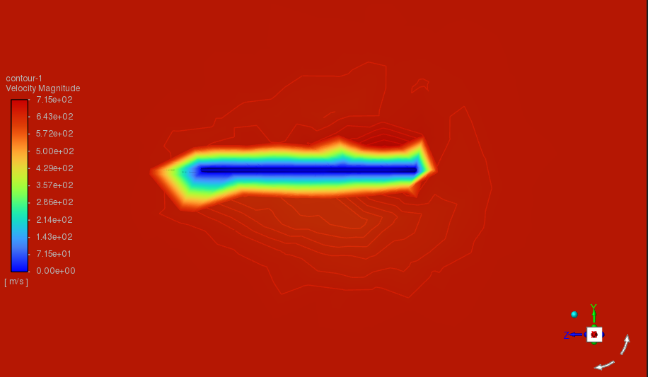 Figure E.9: Representation of shockwaves on a plane perpendicular to the direction of fluid flow (Velocity Magnitude contour)

The distribution of velocity magnitude across the wing is clear by the cross-sectional contour view provided by Fig E.9. It shows that the circumferential area of the wing has a maximum velocity of 715 m/s and the hollow region in the inside is where the minimum velocity of fluid flow is obtained with 0 m/s

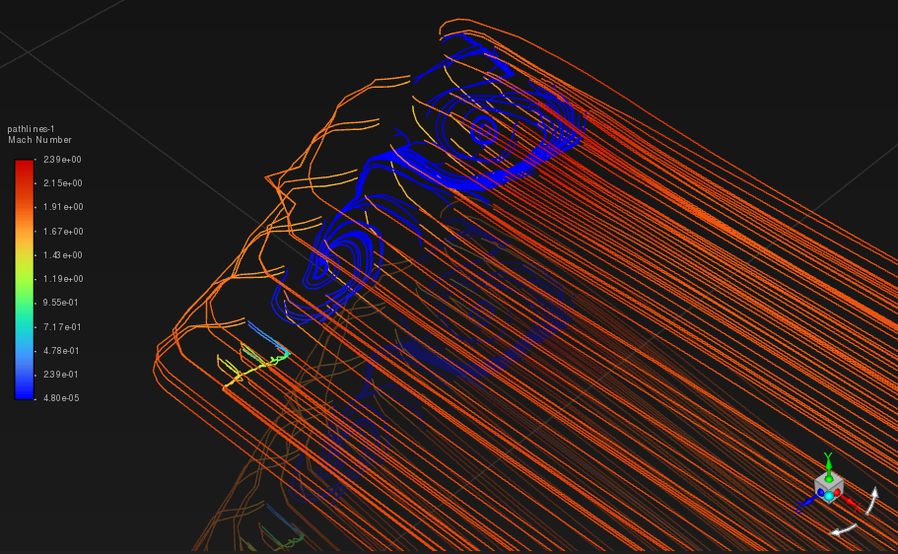
Figure E.10: Representation of pathlines indicating the vortices

The swirling movement of considerable pathlines indicates the vortex generation with Higher mach as represented which in turn induces the practical phenomenon of instability and thus leads to flutter/Self-excited oscillation. The vortices induced here are of higher intensity with the swirling movement covering larger regions as compared to the vortices induced in the same wing with AOA 1 and 2 degrees.

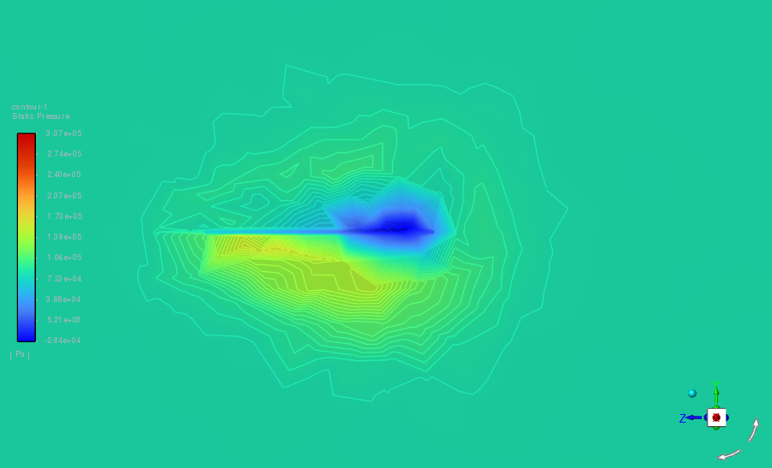
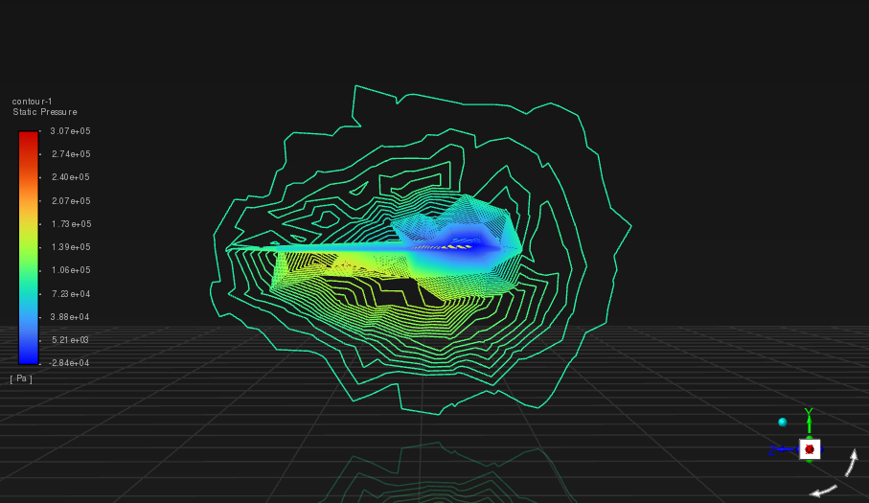
Figure E.11: Representation of shockwaves on a plane perpendicular to the direction of flow of fluid (Static pressure contour)

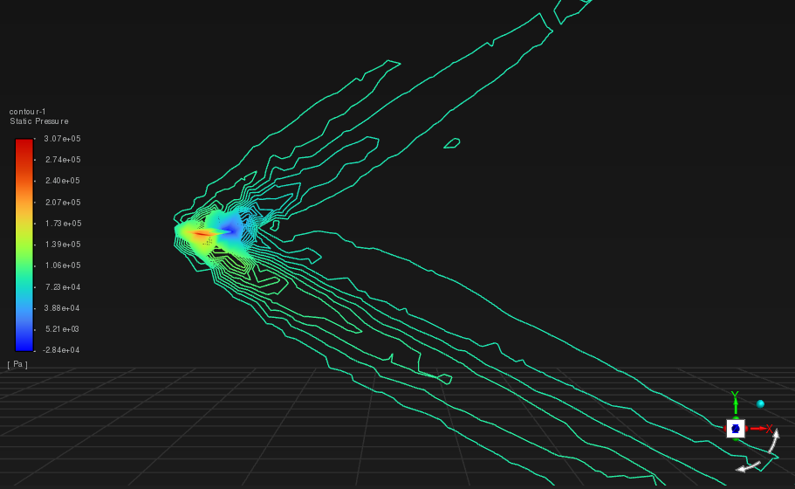
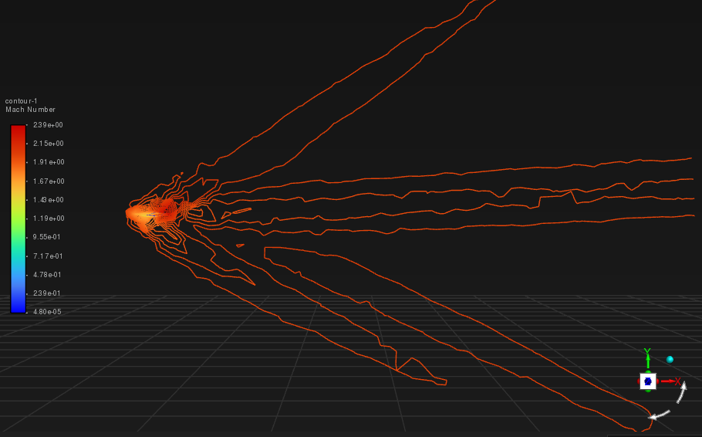
Figure E.12: Representation of propagation of unfilled shockwaves around the Diamond wedge airfoil (Static pressure/ Mach contour respectively)

STRUCTURAL ANALYSIS OF DIAMOND WEDGED WING
AT AN AOA 3$°$

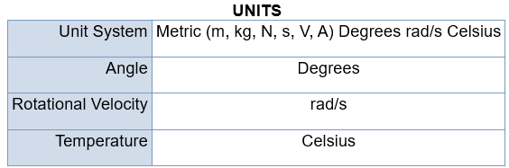
Figure F.1: Representation of units

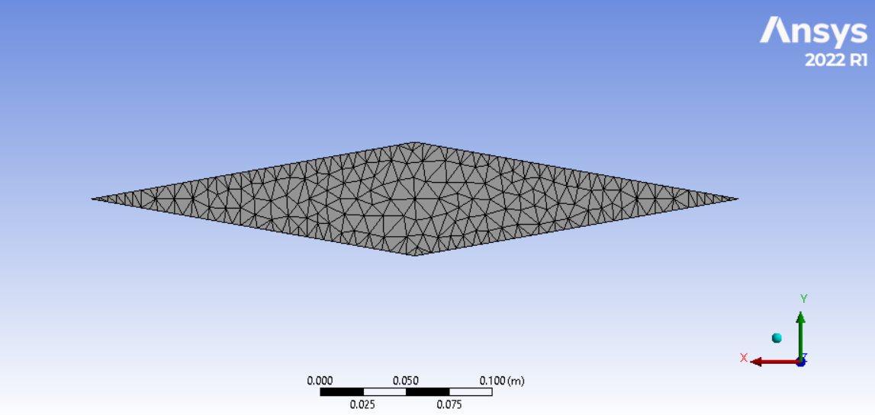
Figure F.2: Representation of Mesh

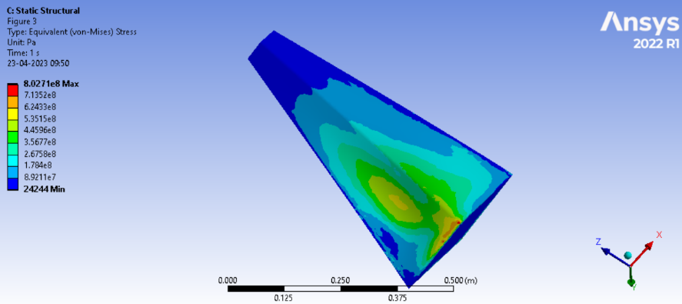
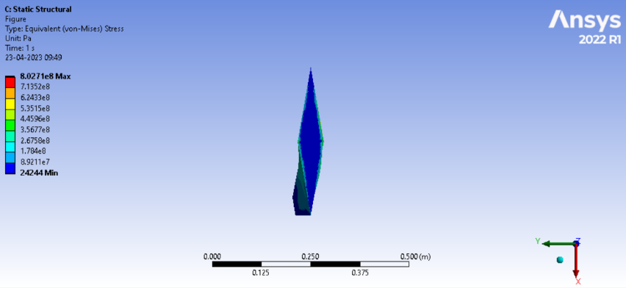
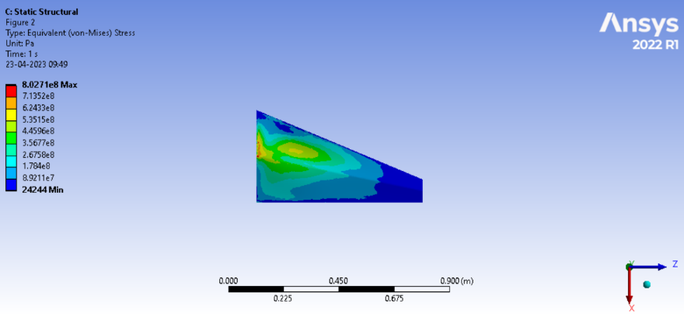
Figure F.3: Representation of Equivalent stress
The maximum value of Von-mises stress is found to be 8.0271e08 Pa whereas the minimum value is found to be 24244 Pa

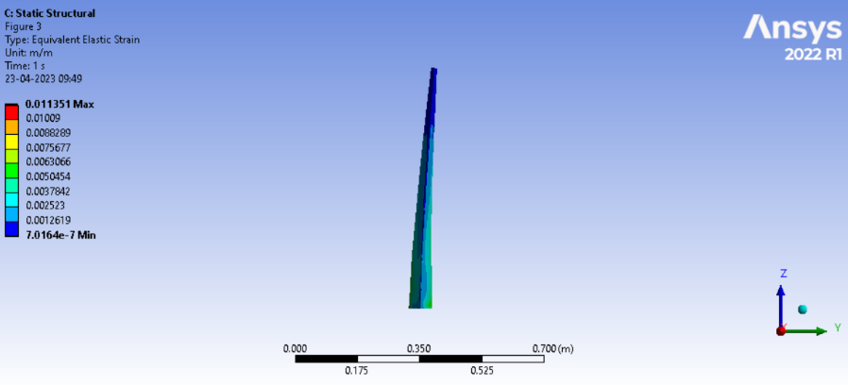
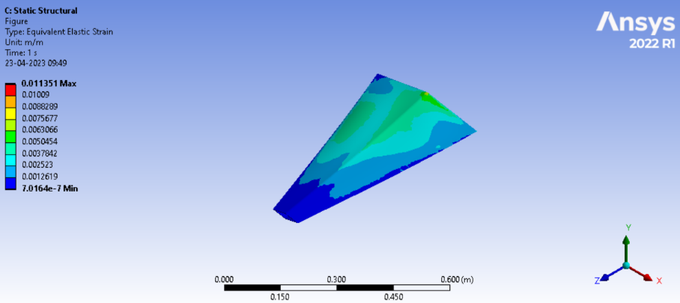
Figure F.4: Representation of Equivalent elastic strain

The maximum value of Strain is found to be 0.011351 and the minimum value is in the order of e-7 with a precise value of 7.0164e-7

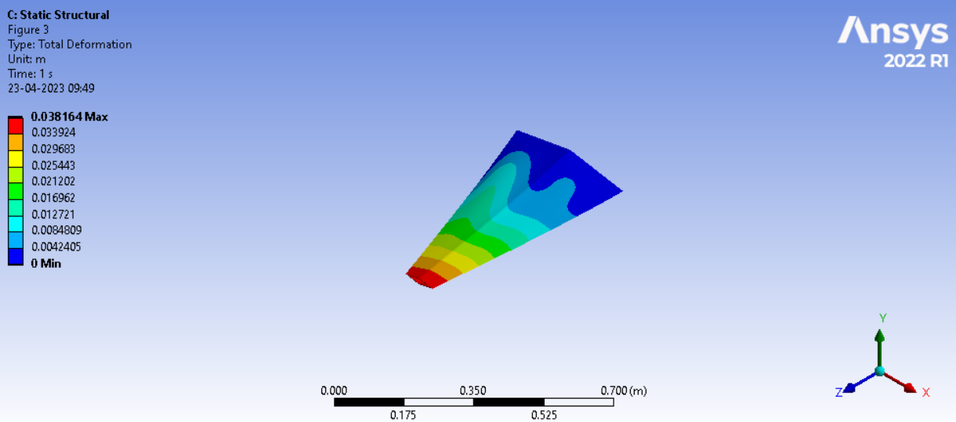
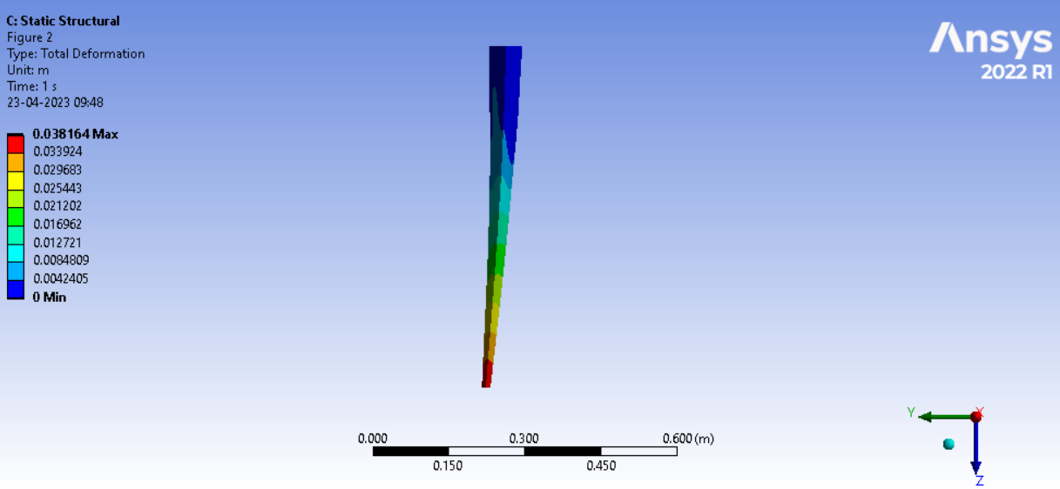
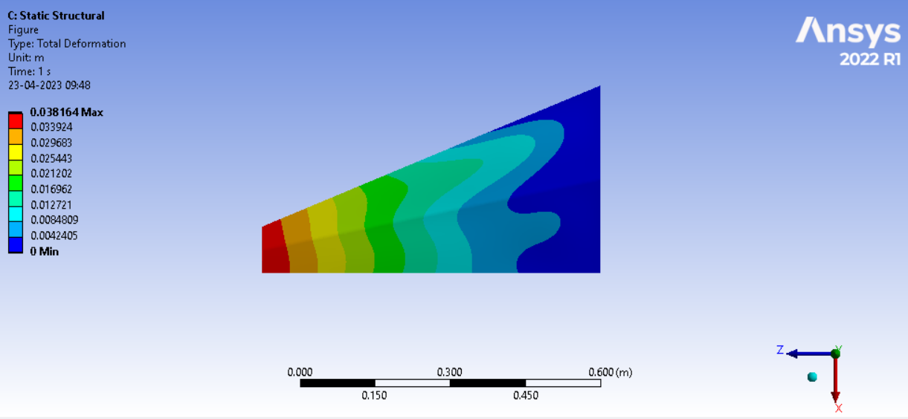
Figure F.5: Representation of total deformation

The maximum value of Total deformation was found to be 0.038164 m and is vividly seen in the wing tip as the wing tip acts as the free end of a supposed cantilever beam for instance which is more susceptible to deformation. The minimum value of Total deformation is 0 m at the fixed part of the wing

FLUENT ANALYSIS ON WING 2
AT AN AOA 3$°$

Fluid flow -Fluent analysis has been performed based on the above-tabulated conditions on the Customised wing 2 with an AOA of 3 degrees and the results are formulated below. Required Solver settings and a detailed method of approach can be accessed by using the accompanying Research datasheet.

No. | Parameters | Settings
1 | Type of Solver | Pressure-Based Solver
2 | Energy Equation | On
3 | Viscous Model | Two Equations, Standard k - E Turbulent Model
4 | Fluid Medium | Air as Ideal Gas
5 | Operating Altitude | 1500 m
6 | Operating Pressure | 84643 Pascal
7 | Operating Temperature | 278.4 K (Correspond to the Altitude).
8 | Free Stream Velocity | Mach 2.0.
9 | Boundary Condition | a. Inlet as Pressure Far-Field. b. Outlet as Pressure Far-Field.
10 | Angle of attack | 3 Degrees

Cells | Faces | Nodes
1717046 | 3483859 | 312346
Table 1: Representation of primary Parameters and Settings used in the analysis

Table 2: Representation of Mesh size

Name | Type | Min Orthogonal Quality | Max Aspect Ratio
farfield | TetCell | 0.00059586577 | 466.67949

Table 3: Representation of Mesh Quality

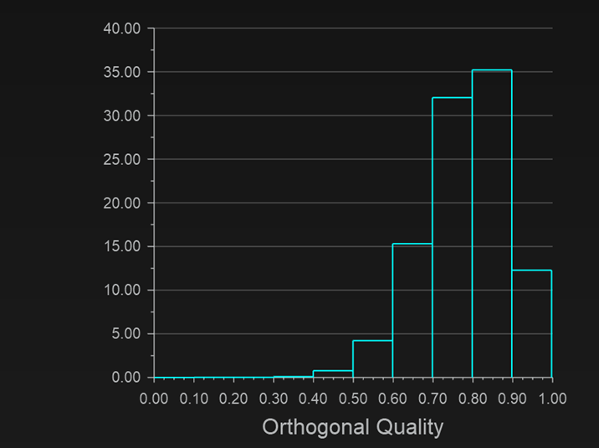

Figure K.1: Orthogonal Quality chart showing excellent mesh

Lift | 12704.68 N
drag | 13682.92 N

Table 4: Report definitions (Lift and Drag)

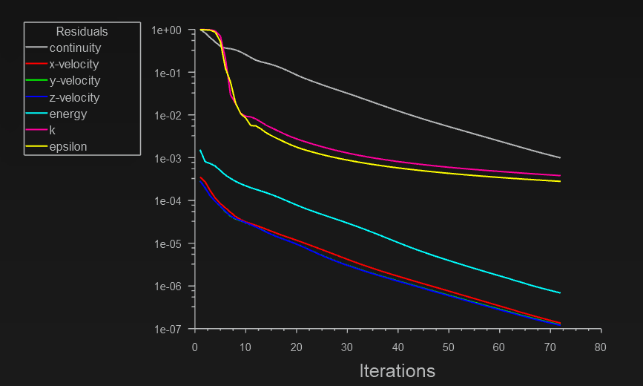
Figure K.2: Representation of Residual plot

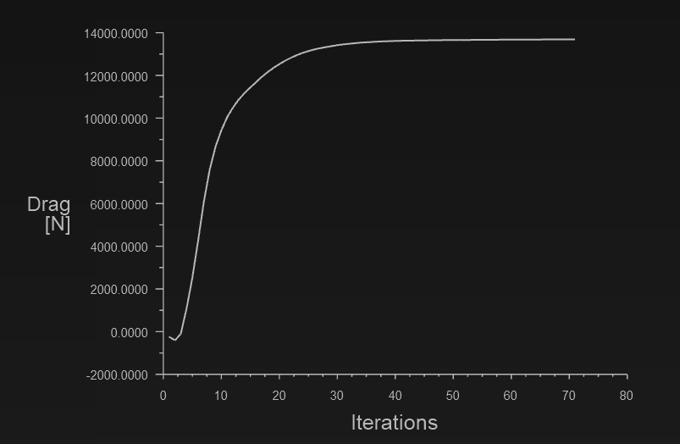
Figure K.3: Representation of Drag plot

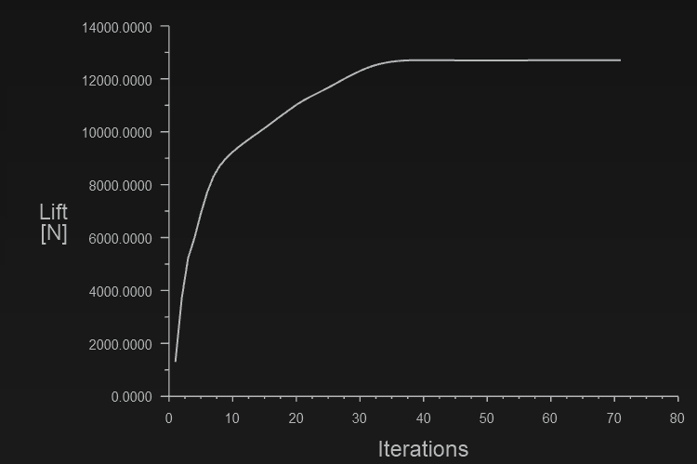
Figure K.4: Representation of Lift plot

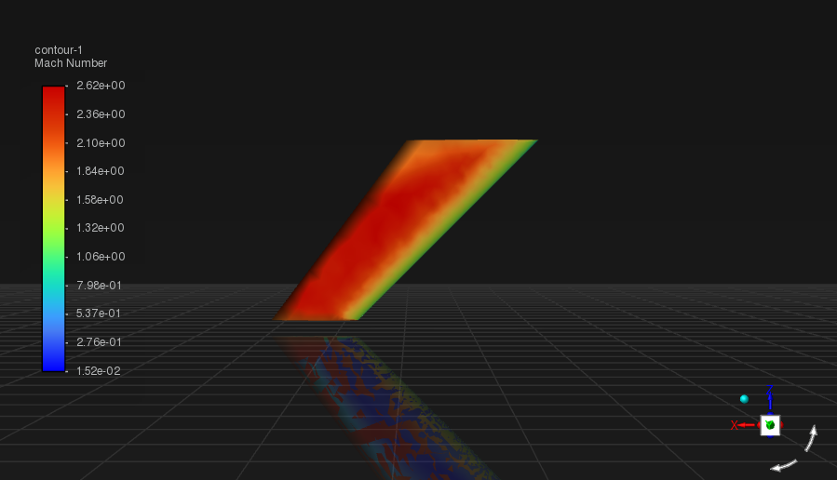
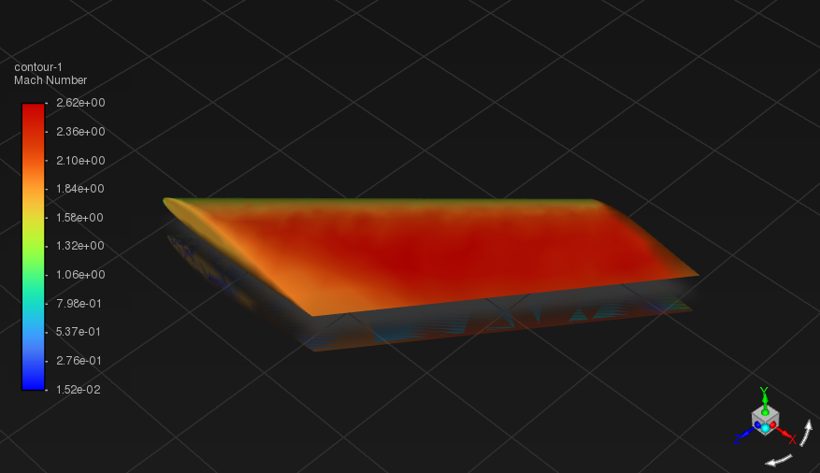
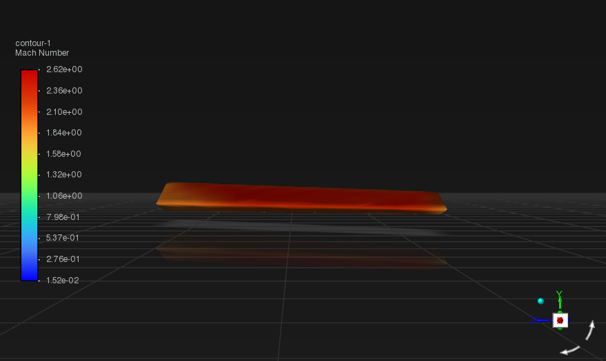
Figure K.5: Representation of Velocity-Mach contours
The range at which the wing exhibits Mach value lies between 1.3 to 2.62 with 2.62 being the maximum value specifically at the surface of immediate contact with the penetrating air.

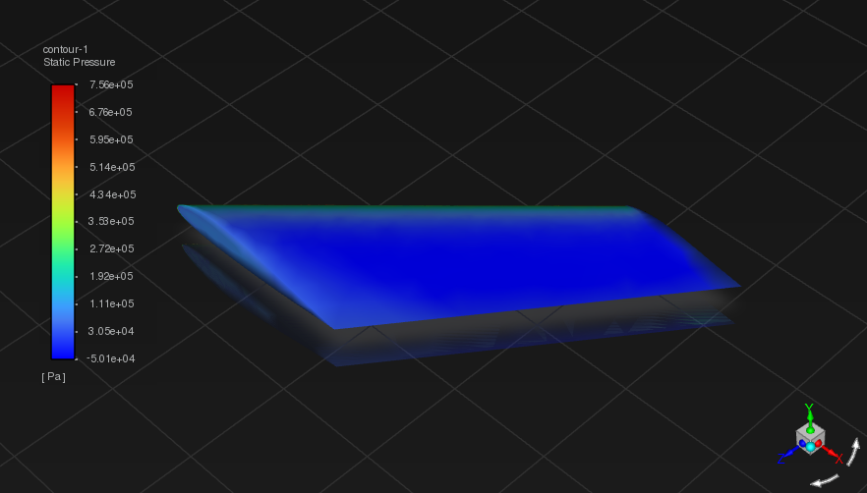
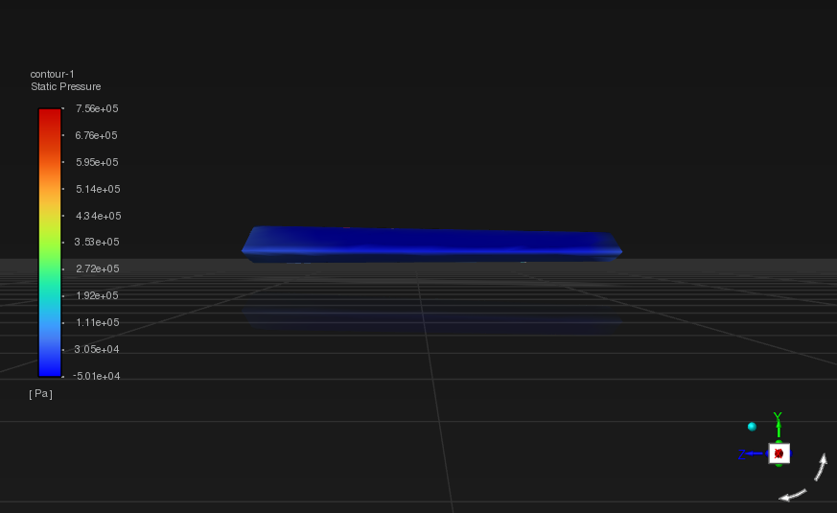

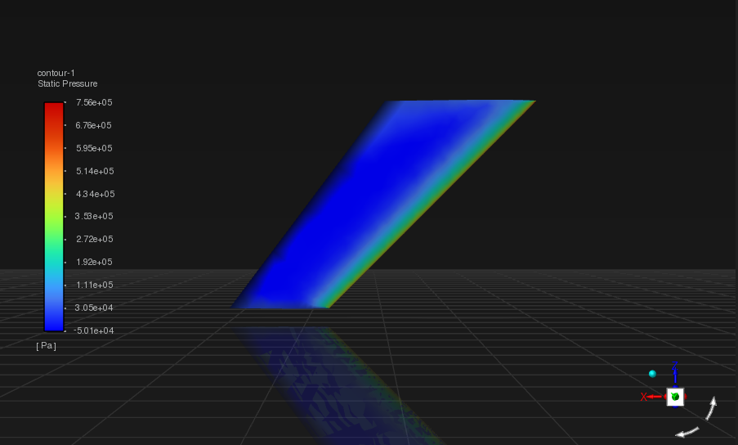
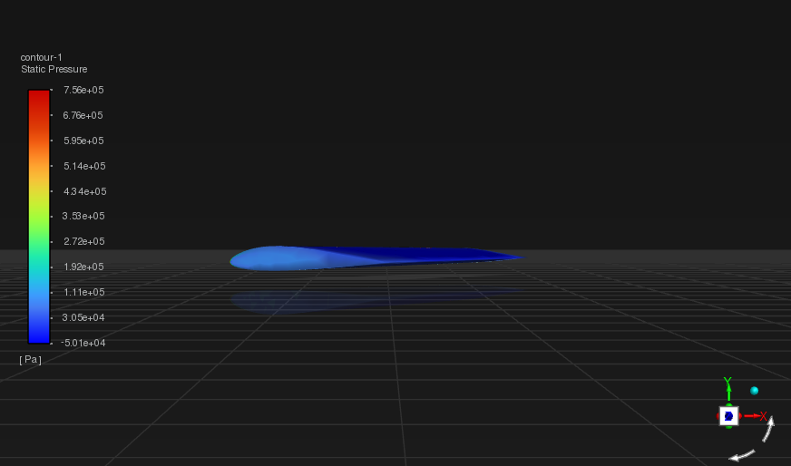
Figure K.6: Representation of Static pressure contours
The maximum Static pressure value has been found to be 7.56e+05 Pa The minimum Static pressure value has been found to be -5.01e+04 Pa

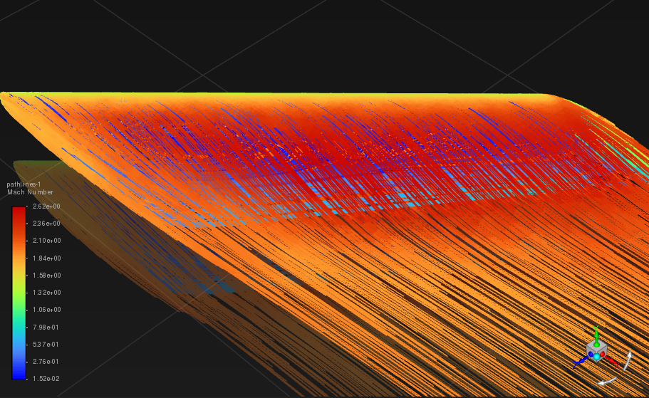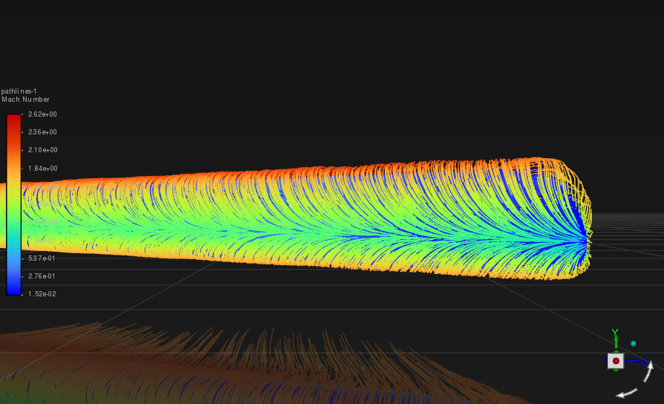
Figure K.7: Representation of pathlines

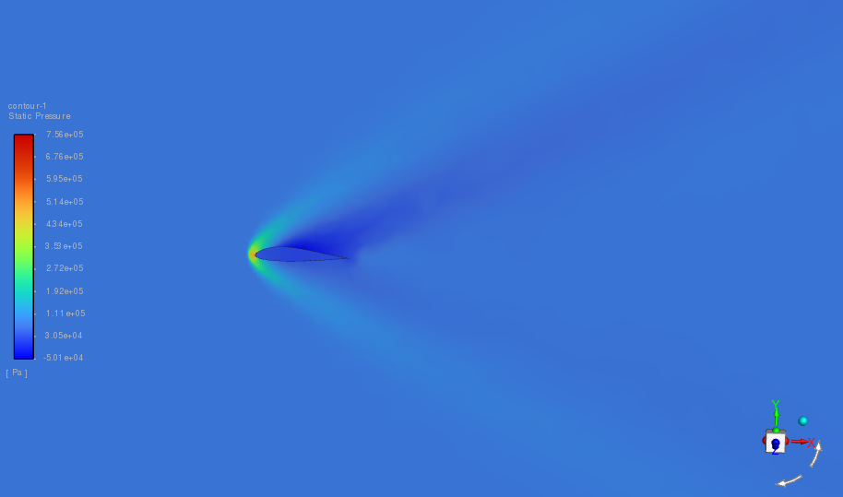
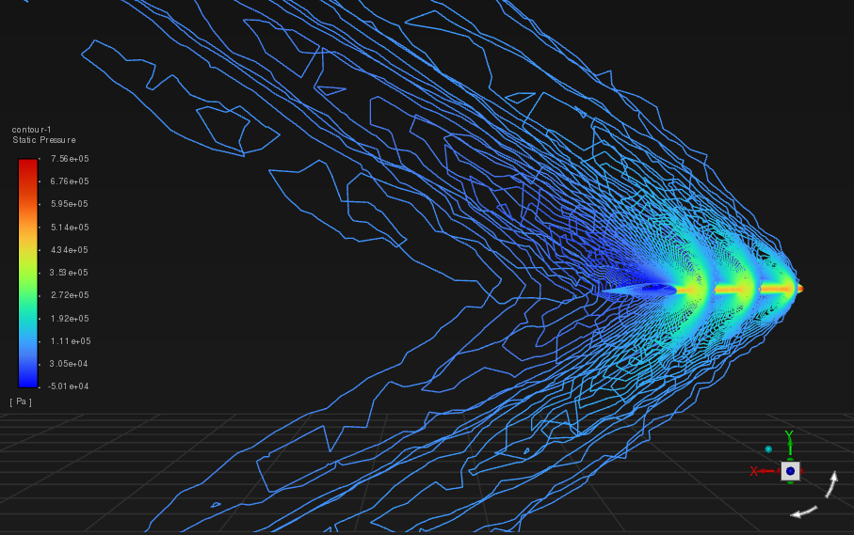
Figure K.8: Representation of propagation of filled/unfilled shockwaves around the airfoil (Static pressure contour)

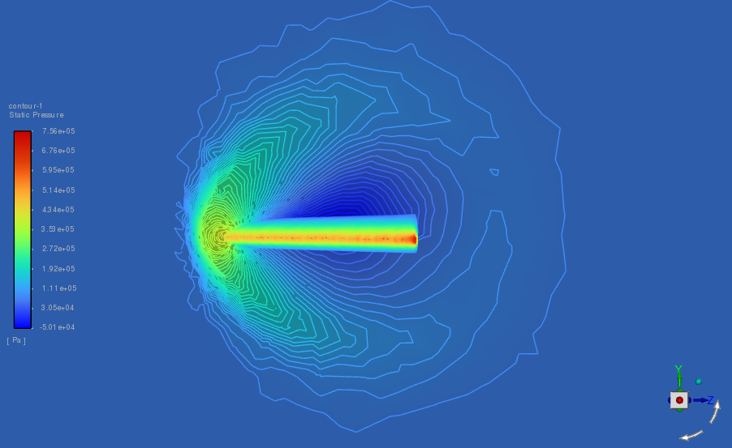
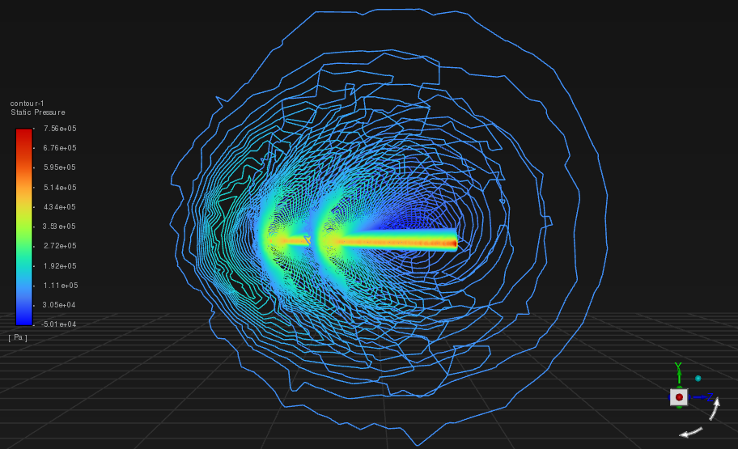
Figure K.9: Representation of shockwaves on a plane perpendicular to direction of flow of fluid (Static pressure contour)

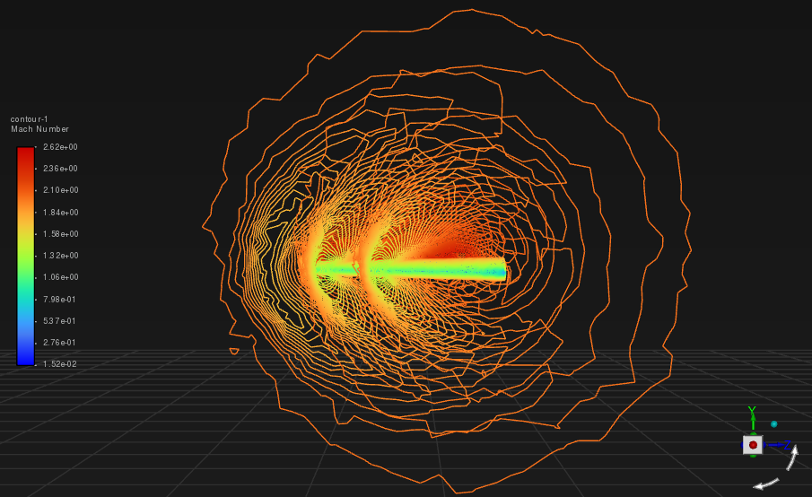
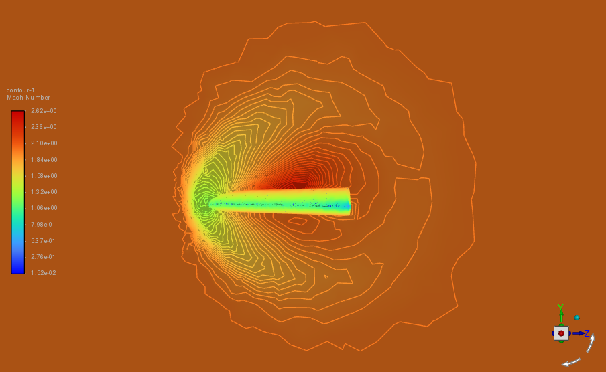
Figure K.10: Representation of shockwaves on a plane perpendicular to direction of fluid flow (Velocity-Mach contour)

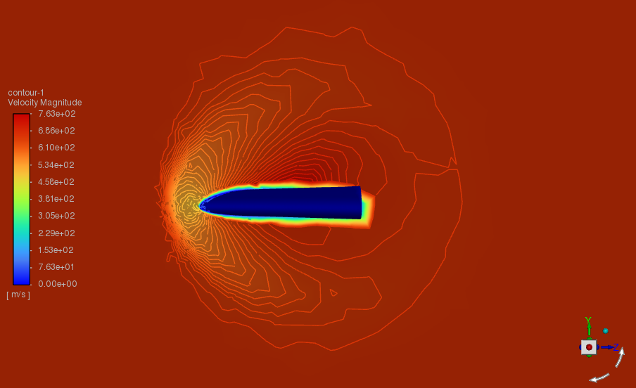
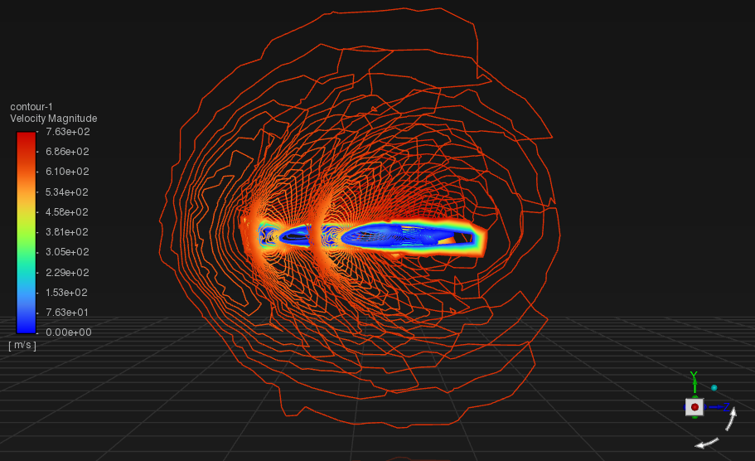
Figure K.11: Representation of shockwaves on a plane perpendicular to direction of fluid flow (Velocity Magnitude contour)
The distribution of velocity magnitude across the wing is clear by the cross-sectional contour view provided by Fig K.11. It shows that the circumferential area of the wing has a maximum velocity of 763 m/s and the hollow region in the inside is where the minimum velocity of fluid flow is obtained with 0 m/s

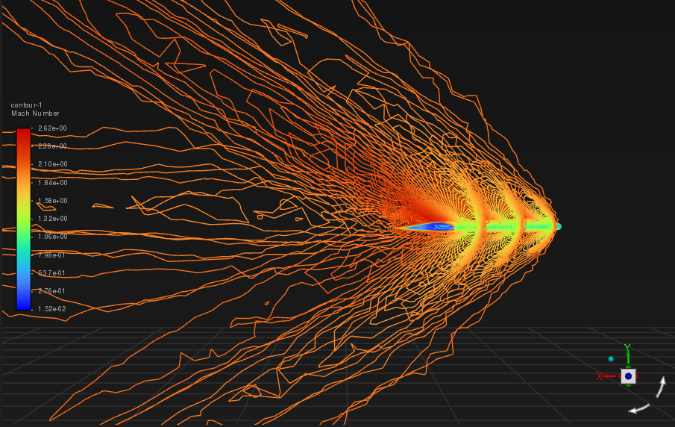
Figure K.12: Representation of propagation of unfilled shockwaves around the airfoil (Velocity-Mach contour)

STRUCTURAL ANALYSIS ON WING 2
AOA 3$°$
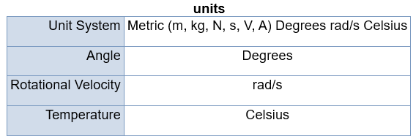
Figure L.1: Representation of units

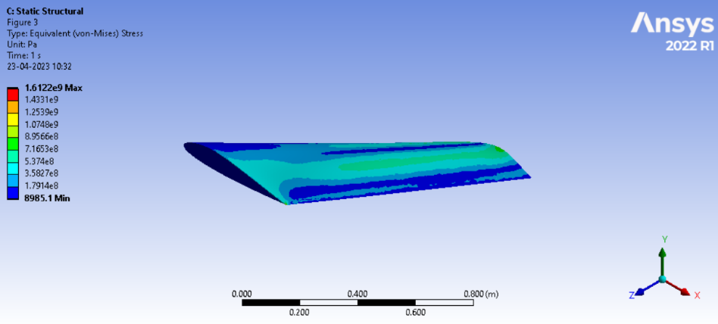

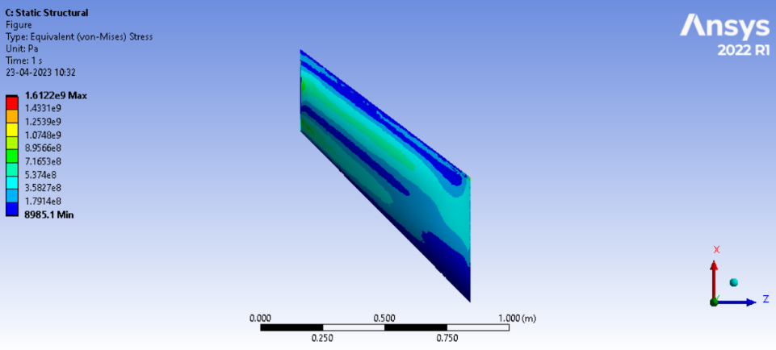
Figure L.2: Representation of Equivalent stress
The maximum value of Von-mises stress is found to be 1.6122e09 Pa whereas the minimum value is found to be 8985.1 Pa

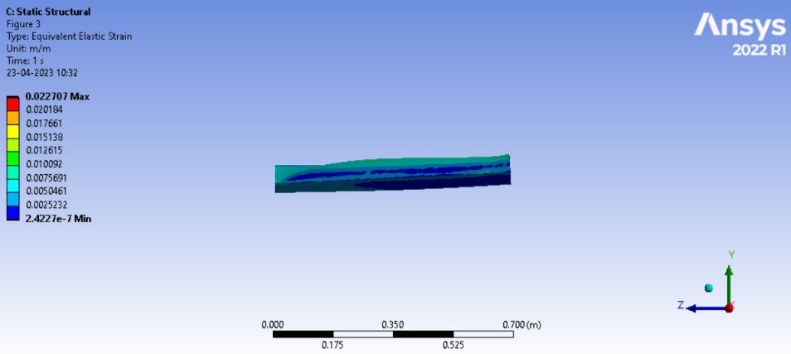
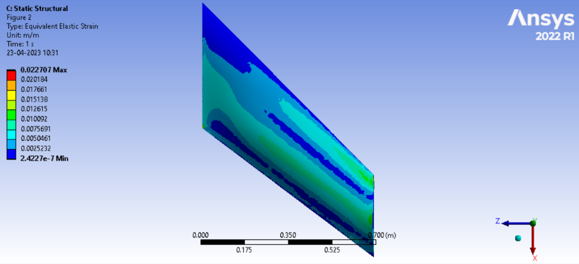
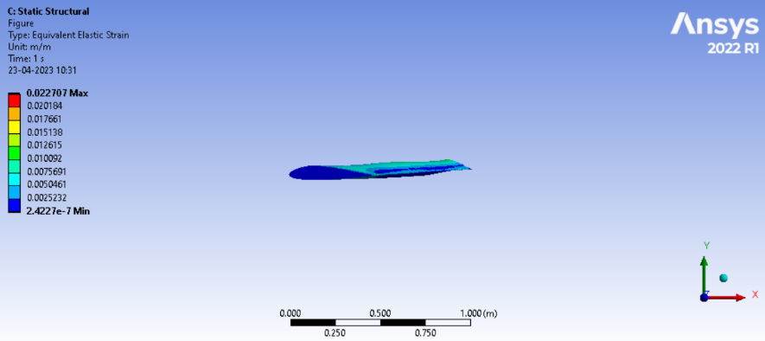
Figure L.3: Representation of Equivalent elastic strain

The maximum value of Strain is found to be 0.00604064 and the minimum value is in the order of e-7 with a precise value of 3.731e-7

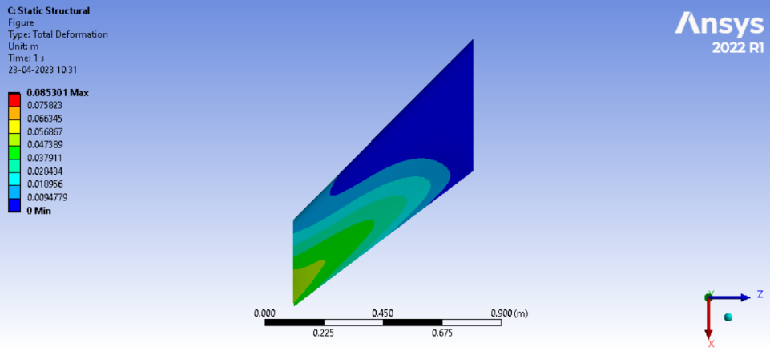
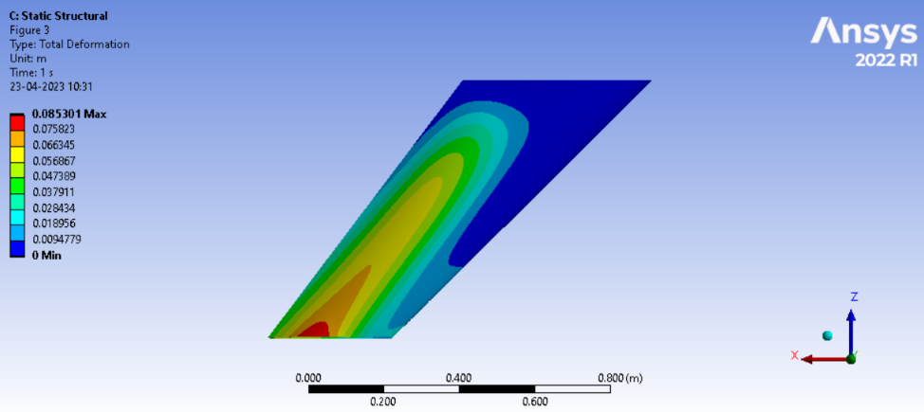
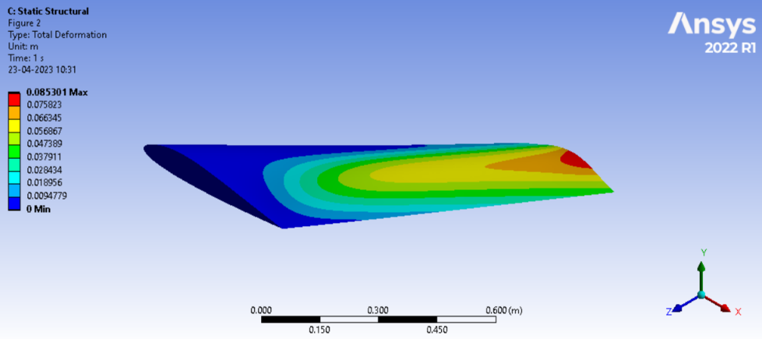
Figure L.4: Representation of total deformation

The maximum value of Total deformation was found to be 0.085301 m and is vividly seen in the wing tip as the wing tip acts as the free end of a supposed cantilever beam for instance which is more susceptible to deformation. The minimum value of Total deformation is 0 m at the fixed part of the wing

