Supplementary information for

DTPA-Receptor – A novel reporter gene system for the specific and sensitive PET imaging of CAR-T cells and AAV transduced cells

Authors:
Volker Morath^{1,} * (v.morath@tum.de, ORCID: 0000-0001-7636-0537)
Katja Fritschle^{1,} * (katja.fritschle@tum.de, ORCID: 0000-0002-5443-9663)
Linda Warmuth² (linda.warmuth@tum.de, ORCID: 0000-0003-3324-7731)
Markus Anneser³ (markus.anneser@tum.de, ORCID: 0000-0002-8876-4747)
Sarah Dötsch² (sarah.doetsch@tum.de, ORCID: 0000-0003-1712-4619)
Milica Zivanic¹ (zivanic.m15@gmail.com, ORCID: 0000-0002-4967-5709)
Luisa Krumwiede¹ (LKrumwiede@gmx.net, ORCID: 0000-0001-5695-1575)
Philipp Bösl¹ (philipp.boesl@tum.de, ORCID: 0000-0003-2981-9741)
Tarik Bozoglu⁴ (tarik.bozoglu@tum.de, ORCID: 0000-0002-6545-2150)
Stephanie Robu¹ (stephanie.robu@tum.de, ORCID: 0009-0000-3281-0372)
Silvana Libertini⁵ (silvana.libertini@novartis.com, ORCID: 0000-0003-2633-1564)
Susanne Kossatz¹ (s.kossatz@tum.de, ORCID: 0000-0002-1908-1782)
Christian Kupatt⁴ (christian.kupatt@tum.de, ORCID: 0000-0002-3611-1218)
Markus Schwaiger¹ (markus.schwaiger@tum.de, ORCID: 0000-0002-2305-7144)
Katja Steiger⁶ (katja.steiger@tum.de, ORCID: ORCID: 0000-0002-7269-5433)
Dirk H. Busch² (dirk.busch@tum.de, ORCID: 0000-0001-8713-093X)
Arne Skerra³ (skerra@tum.de, ORCID: 0000-0002-5717-498X)
Wolfgang A. Weber^{1, #} (w.weber@tum.de, ORCID: 0000-0002-7854-4345)

*Authors contributed equally.
#To whom correspondence should be addressed.

Affiliations:
¹Department of Nuclear Medicine, University Clinic rechts der Isar, School of Medicine, Technical University of Munich, 81675 Munich, Germany
²Institute for Medical Microbiology, Immunology and Hygiene, Technical University of Munich, 81675 Munich, Germany
³Lehrstuhl für Biologische Chemie, School of Life Sciences, Technical University of Munich, 85354 Freising, Germany
⁴Deutsches Zentrum für Herz-Kreislaufforschung (DZHK), 80636 Munich, Germany & Medizinische Klinik I, Klinikum rechts der Isar, School of Medicine, Technical University of Munich, 81675 Munich, Germany
⁵Novartis Institutes for BioMedical Research (NIBR), 4056 Basel, Switzerland
⁶Institute of Pathology, School of Medicine, Technical University of Munich, 81675 Munich, Germany

Keywords: reporter gene imaging, ATMP, synthetic biomarker, positron emission tomography (PET), cell tracking

Online Methods
Cloning of plasmids
Construction of plasmids, e.g., for the production of retrovirus- and adeno-associated virus-based vectors, was accomplished by standard cloning techniques. Genes were synthesized by Twist Bioscience (San Francisco, CA) or Eurofins Genomics (Ebersberg, Germany). Correctness was confirmed by restriction digestion and by Sanger sequencing (Eurofins Genomics).
Cell culture
Eucaryotic cells were cultured at 37 °C in a humidified 5% CO₂ atmosphere and were regularly tested by PCR for potential mycoplasma contamination. Cell lines were cryo-preserved in Recovery freezing medium (Gibco, Thermo Fisher Scientific, Waltham, MA) and stored in the vapor phase of liquid nitrogen. The Jurkat T cell line (obtained from Prof. Bernhard Küster, TU Munich), Prostate carcinoma cell line PC3 (obtained from the American Type Culture Collection (ATCC), Manassas, VA), and Raji-GFP-fLuc cells (expressing green fluorescent protein (GFP) and firefly luciferase (fLuc); obtained from Prof. Stanley Riddell, Fred Hutchinson Cancer Center Seattle) were cultured in Roswell Park Memorial Institute (RPMI) 1640 medium with GlutaMAX supplement, 10% (v/v) fetal bovine serum (FBS) and 1% (v/v) penicillin/streptomycin (pen/strep) stock solution (10,000 U/ml / 10 mg/ml; all from Gibco). Human embryonic kidney (HEK293T) cells (obtained from Prof. Gil Westmeyer, TU Munich) were cultured in Dulbecco’s Modified Eagle Medium (DMEM) with 10% FBS and 1% pen/strep. Adherent cells were detached by washing with Dulbecco’s balanced Salt Solution without Calcium, Magnesium, or Phenolred (DPBS) and incubated in 0.25% Trypsin-EDTA (both from Gibco) for 5 to 10 min at 37 °C. Cells were sedimented by centrifugation at 300g. For primary CAR-T cells, the RPMI medium with GlutaMAX was supplemented with 10% FBS and 5% (v/v) SC⁺-stock solution (stock concentration: 100 mM HEPES, 20% pen/strep, 1 g/l Gentamycin, 1 mM β-Mercaptoethanol and with 200 U/ml Interleukin-2 (IL-2; PreproTech, Cranbury, NJ) for expansion or 80 U/ml for maintenance.
Generation of adeno-associated viral vectors
AAV vector production was performed as described before¹. In short, HEK293T packaging cells were triple transfected using PEI MAX (Polysciences, Warrington, PA). Producer cells containing AAV9-DTPA-R viral vectors were lysed by three freeze-thaw cycles, and subsequently, vectors were purified by iodixanol gradient centrifugation and a final size-exclusion chromatography. Titering of AAV9 vectors was performed by a set of primers annealing in the inverted terminal repeats².
Gene transfer by retroviral transduction and cell line creation
Human cell lines (Jurkat, HEK293T, and PC3) stably expressing different reporter gene variants, and primary human T cells expressing a CAR expression cassette were generated by retroviral gene transfer. To this end, RD114 cells were transiently transfected with the expression cassette via the CaCl₂-precipitation method. After 48 hours, the supernatant containing the viral particles was harvested. PBMCs were isolated via density gradient centrifugation using Pancoll human (PanBiotech, Aidenbach, Germany; density: 1.077 g/ml) and activated with 360 U/ml IL-2 (PeproTech) and 2.25 µl/ml CD3/CD28 Expamer³ (Juno Therapeutics, BMS). After 48 hours, human cell lines and PBMCs were transduced via spinoculation. Transduced cells were expanded for 14 days and subsequently stained with anti-V5-tag-AF488 (Alexa Fluor 488) antibody for fluorescent activated cell sorting using a FACSAria Fusion Sorter (Becton Dickinson, Franklin Lakes, NJ) for cell lines or MoFlo Astrios Sorter (Beckman Coulter, Brea, CA) for PBMCs. For the cell lines Jurkat and HEK293T, the 10% highest expressing clones were isolated, the cell line PC3 was sorted twice for the 10% highest expressing clones. For CAR-T cells, all positive clones were isolated by cell sorting. The absence of viral vectors in the resulting cell line was confirmed by RT-PCR with appropriate primers.
Flow cytometry of cell culture samples
Surface marker expression was measured using flow cytometry. To this end, cells were stained with a 1:1,000 dilution of Zombie Violet viability stain (BioLegend, San Diego, CA), followed by washing with FACS buffer (5% FBS in DPBS). Subsequently, cells were stained with the following antibodies for 1 h on ice: anti-human CD3-AF488 clone HIT3a (1:20), CD4-AF488 clone OCT4 (1:20), CXCR3-AF488 clone G025H7 (1:20), CD69-APC clone FN50 (1:50) and Streptavidin-FITC (1:400) for CAR detection (all BioLegend) and anti-V5-tag antibody clone SV5-Pk1 (Bio-Rad, Hercules, CA) conjugated to AF488-NHS (Lumiprobe, Hannover, Germany) in house (3.1 µg/ml). After that, cells were washed three times and resuspended in 100 µl FACS buffer. Flow cytometry analysis was done on a LSR-Fortessa flow cytometer (Becton Dickinson) using excitation lasers at 405, 488, 561 and 640 nm and bandpass filters for FITC (530/30 nm), BV421 (450/40 nm), PE-Texas-Red (610/20 nm), APC (670/14 nm) and Alexa 700 (730/45 nm). For the quantification of the number of fluorescent molecules per cell, Quantum MESF kits (Bangs Laboratories, Fishers, IN) were used. Alexa Fluor 488 MESF beads (for AF488 labeled antibodies) or FITC-5 MESF beads (for CFSE and Streptavidin-FITC) were analyzed in the flow cytometer on the same day in FACS buffer. Results were analyzed using FlowJo software (ver. 10.8.1, Becton Dickinson).
Flow cytometry of mouse samples
Blood samples were collected from mice and coagulation was prevented by adding 10 µl heparin (Heparin-Natrium-25,000; Ratiopharm, Ulm, Germany) per 50 µl blood. Mice were euthanized, and tissue samples were directly harvested and kept on ice in RPMI medium. Cells from mouse spleen were isolated by passing the dissected organ through a 70 µm cell strainer (Corning, Corning, New York). For the analysis of CAR-T cells found in hollow bones of mice, the joints were removed mechanically, and subsequently, the bone marrow was gently flushed out using a 30G cannula attached to a 1 ml syringe filled with RPMI medium. For all samples, red blood cells were lysed by incubation in ammonium chloride (ACT) lysis buffer (0.17 M NH₄Cl, 0.17 M Tris/HCl, pH 7.5) at room temperature. Upon incubation, the reaction was stopped by adding an equal amount of cold RPMI medium, and samples were centrifuged at 1,500 rpm and 4 °C. Spleen samples were once incubated in 5 ml ACT buffer for 5 min. Bone marrow samples were lysed in 3 ml ACT buffer for 3 min. Blood samples were lysed once in 10 ml for 10 min and a second time in 3 ml for 5 min in ACT buffer. Upon red blood cell lysis, the samples were resuspended in 100 µl FACS buffer (2% BSA in PBS), cell numbers were determined, and a maximum of 1×10⁷ cells were used for antibody staining.
Cell suspensions prepared from tissues and organs were mixed with 10 µl of counting beads (Thermo Fisher Science 123count eBeads counting beads, with 1.009.000 eBeads/ml) to extrapolate cell numbers of the whole sample. Samples were washed and incubated in 1:400 diluted Fc-Block (BioLegend, purified anti-mouse CD16/32 clone 93) for 20 min on ice. After washing, samples were resuspended in antibody master mix and incubated for 20 min on ice in the dark. The antibody master mix contained the following antibodies: anti-human EGFR(t)-PE clone AY13 (1:2,000) or anti-V5-tag-PE clone TCM5 (1:500), anti-human CD3-APC clone UCHT1 (1:200), anti-human CD8-APC-efluor780 clone OKT8 (1:100), anti-human CD45-krome orange clone J33 (1:50) and Streptavidin-efluor450 (1:50). For compensation non-transduced PBMCs were stained with different αCD8-antibodies conjugated to fluorescent dyes: PE clone OKT8 (1:50), APC clone RPA-T8 (1:200), APC-efluor780 clone OKT8 (1:100), pacific orange clone 3B5 (1:50), efluor450 clone OKT8 (1:100). Upon incubation cells were pelleted and resuspended in FACS buffer containing propidium iodide (1:100), centrifuged, resuspended, and filtered through a 40 µm cell strainer (Corning) and washed in FACS buffer. Flow cytometry analysis was done on a CytoFLEX S flow cytometer (Beckman Coulter, Brea, CA) using excitation lasers at 405, 488, 561, and 638 nm and bandpass filters for FITC (525/40 nm), BV421 (450/45 nm), PE-Texas-Red (610/20 nm), APC (660/20 nm) and Alexa 700 (780/60 nm). Results were analyzed using FlowJo software (ver. 10.8.0, Becton Dickinson). A representative gating strategy for lymphocyte gating can be seen in supplementary figure 11.
Activation of T cells
For activation, T cells were seeded into 6-well plates at a density of 0.5×10⁶ cells/ml in activation medium (cell culture medium containing 2.5 µg/ml (3.3 nM) Ionomycin solved in 10% DMSO (BioGems, Westlake Village, CA) and 0.5 µg/ml (0.8 nM) Phorbol 12-myristate 13-acetate (PMA; InvivoGen, Toulouse, France; solved in DMSO)) or control medium (cell culture medium with equal DMSO content (0.035% v/v)). After 24 h, the medium was removed, cells were washed with DPBS and cultured in the same volume of cell culture medium for another 48 h before they were analyzed by flow cytometry.
CFSE proliferation assay
Proliferation was analyzed using the Carboxyfluorescein succinimidyl ester (CFSE) cell division tracker kit (BioLegend) according to the manufacturer’s instructions. In brief, 1×10⁷ cells were washed with DPBS and resuspended in 333 µl CFSE working solution. After staining for 20 min at 37 °C in the dark, cells were washed once with medium and treated as stated under ‘Activation of T cells’. After 1 h (t₀), 0.5×10⁶ cells of each cell line (non-activated) were fixed with neutral-buffered 4% formaldehyde solution (Otto Fischar, Saarbrücken, Germany) for 10 min, washed twice with DPBS and stored till the final evaluation in DPBS at 4 °C. After cultivation for 3 days, cells were stained with an anti-CD69-APC antibody (T cell activation marker), fixed as described above and analyzed by flow cytometry.
The doubling time (see formula I) was calculated using the Quantum MESF kit FITC (Bangs Laboratories) and the provided sheet to calculate the MESF from the median fluorescence intensity (FITC).
$t=\frac{d}{\log_{2}(\frac{MESF t_{0}}{MESF t_{1}})}$ (I)
Calculating the standard deviation representing the broadness of the peak was done using formula II to calculate the error propagation for the robust SD (rSD) provided by the FlowJo software, with x1 being the timepoint directly after CFSE staining and x2 being the timepoint of analysis.
$SD=\sqrt{{(\frac{df^{'}\left(x\right)}{dx_{1}})}^{2}*{{rSD}_{x1}}^{2}+{(\frac{df^{'}\left(x\right)}{dx_{2}})}^{2}*{{rSD}_{x2}}^{2}}$ (II)
Quantification of absolute receptor numbers by flow cytometry
The absolute number of receptors per cell was calculated using the Quantum MESF kit Alexa Fluor 488 (Bangs Laboratories). MESF beads allowed the correlation of fluorescent signal measured in the flow cytometer and known numbers of fluorophores in the reference particles. Median fluorescence of wild type Jurkat cells or CAR-T^{EGFRt} cells (V5-tag negative) stained with the V5-antibody was subtracted from the fluorescent signals measured, and calculation of the median MESF was done using the provided evaluation template. The degree of labeling (DOL) for each antibody was provided by BioLegend or, in the case of the anti-V5-antibody (clone SV5-Pk1), measured using a Nanophotometer NP80 (Implen, Munich, Germany). One antibody was assumed to bind two V5-tag epitopes for calculating antibodies per cell. The calculation is shown in formula III.
${receptors}/{cell}=\frac{MESF}{DOL}*2$ (III)
For receptor quantification in CAR-T cells (1 replicate), the robust SD provided by FlowJo software was used to determine the standard deviation by formula IV with m being the slope of the calibration curve.
$SD=\sqrt{{(\frac{2m}{DOL})}^{2}*{rSD}^{2}}$ (IV)
MACS sorting
Magnetic-activated cell sorting was done using a MiniMACS starting kit with MS columns and anti-mouse IgG MicroBeads (both Miltenyi Biotec, Bergisch Gladbach, Germany). Approximately 1×10⁷ cells were labeled with 1 µg/ml mouse anti-V5-tag antibody in 2 ml (unconjugated or AF488-conjugated clone SV5-Pk1, Bio-Rad) for 1 h at 4 °C and washed twice with FACS buffer. The MACS sorting was done according to the manufacturer’s instructions, and purity was analyzed via flow cytometry.
Fluorescence microscopy
Black 96-well µ-plates (ibidi, Gräfelfing, Germany) were coated with 6.6 ng/ml poly-D-lysine (Gibco) for 1 h at room temperature and washed with PBS three times before drying. PC3 or HEK293T cells were detached using Trypsin-EDTA (0.25%), and 10,000 cells/well were seeded in 200 µl respective medium and cultured overnight. Cells were fixed with 4% paraformaldehyde (Sigma-Aldrich, St. Louis, MO) in PBS for 10 min at 4 °C, and after two washing steps with PBS, blocking was done with PBS containing 3% BSA for 1 h at room temperature. Subsequently, the blocking buffer was replaced by primary anti-V5-tag antibody SV5-Pk1 (Bio-Rad) diluted 1:500 (1 mg/ml stock solution) in PBS with 3% BSA and 0.1% Tween-20 (Carl Roth, Karlsruhe, Germany) in a volume of 100 µl. After 1 h at room temperature, the wells were washed with PBS, and the secondary antibody (1:20,000 F(ab$’$)₂-fragment of rabbit-anti-mouse IgG conjugated to AF488; Invitrogen, Waltham, MA) in PBS with 3% BSA and 0.1% Tween-20 was added for another hour at room temperature. Cell nuclei were stained using Hoechst 33342 solution (1:20 in PBS; Thermo Fischer Scientific) for 10 min. Before the acquisition, the wells were washed again with PBS. Fluorescence microscopy images were acquired using an EVOS M7000 system (Thermo Fisher Scientific) using the DAPI (Ex 357/44 nm, Em 447/60 nm), GFP (Ex 482/25 nm, Em 524/24 nm), and TexasRed (Ex 585/29 nm, Em 628/32 nm) fluorescent channels.
Western blot analysis
Protein expression was analyzed by semi-dry fluorescent Western blot analysis. Jurkat cells (1×10⁷ cells) were harvested and lysed in 500 µl RIPA-buffer (Thermo Fisher Scientific) containing protease inhibitors (1 tablet per 10 ml; cOomplete Mini Protease Inhibitor Cocktail, Roche, Basel, Switzerland) for 15 min under mild agitation on ice. After centrifugation at 13,200 rpm for 15 min, 400 µl of the supernatant was transferred in a fresh microcentrifuge tube and snap-frozen in liquid nitrogen.
Bradford assay (Pierce Coomassie Protein-Assay-Kit, Thermo Fisher Scientific) was used to quantify the total protein amount. For PNGase F (New England Biolabs, Ipswich, MA) digestion 67.5 µg of cell lysates was denatured by incubation at 98 °C for 10 min in denaturing buffer (New England Biolabs). In a total of 20 µl, 2 µl GlycoBuffer 2, 2 µl of 10% NP-40 and 1 µl PNGase F (all from New England Biolabs) were added, and the reaction was incubated at 37 °C for 1 hour. Samples were prepared by adding reducing Laemmli buffer followed by 5 min incubation at 95 °C, 2 min centrifugation at 13,000 rpm. The supernatant was stored at -20 °C. 5 µl of Chameleon Duo pre-stained protein ladder (LI-COR, Lincoln, NE) was used as protein ladder. A 4–20% SDS-PAGE precast gel (GenScript Biotech, Piscataway Township, NJ) was loaded with 35 µg of protein for each cell line and separated at 120 V for 100 min. An Immobilon-P PVDF membrane (Merck Millipore, Burlington, MA) was activated in methanol for 5 min and equilibrated for at least 30 min in transfer buffer (25 mM Tris/HCl, 192 mM glycine, 0.1% SDS, 20% (v/v) MeOH, pH 8.3). After protein transfer in a semi-dry blotting chamber (Biometra, Göttingen, Germany) for 1 h at 300 mA, the membrane was washed with methanol and rinsed with water. After washing in TBS-T (10 mM Tris/HCl, 150 mM NaCl, pH 7.5 with 0.1% Tween-20) for 15 min, the membrane was blocked in TBS with 3% BSA for 1 h at room temperature under mild agitation. The primary anti-V5-tag antibody SV5-Pk1 (Bio-Rad) was diluted 1:2,000 in TBS-T with 3% BSA. For normalization, an anti-β-actin antibody conjugated to Dylight CW680 (clone AbD12141, Bio-Rad) was added at a dilution of 1:5,000. After incubating at 4 °C overnight with mild agitation, the membrane was washed three times with TBS-T for 15 min each at room temperature. The secondary IRDye800-conjugated goat anti-mouse antibody (LI-COR) was diluted in TBS-T with 3% BSA and 0.1% SDS at a dilution of 1:20,000, and the membrane was incubated for 1 h at room temperature under mild agitation. After three washing steps in TBS-T, the fluorescence signals were detected using an Odyssey XF imaging system (LI-COR) in the 700 and 800 nm channels.
DNA and RNA extraction from cells
Jurkat cell were washed with DPBS and counted. Aliquots containing 5×10⁶ cells were pelleted and snap frozen in liquid nitrogen after removing the supernatant. DNA was extracted using the DNeasy Blood & Tissue Kit (#69506; Qiagen, Hilden, Germany) according to manufacturer’s instructions. The optional RNase A digestion during proteinase K digestion was performed to eliminate RNA contaminants. DNA was eluted with 100 µl of buffer AE. RNA was extracted using RNeasy Plus Mini kit (74136; Qiagen) according to manufacturer’s instructions. Contaminating DNA was eliminated with the additional on-column DNase digestion step. RNA was eluted in 30 µl RNase-free water. Total DNA and RNA were quantified using a Nanodrop (Witec AG, Heitersheim, Germany).
RNA and DNA extraction from tissues
Tissue samples from mice were harvested directly upon euthanasia, rinsed in water, pat-dried, weight was measured and transferred into a cryovial and snap frozen in liquid nitrogen. Samples were stored at -80 °C. DNA was extracted from ~25 mg of tissue (except for spleen, where ~10 mg were used) with the DNeasy 96 Blood & Tissue Kit (#69582; Qiagen) and according to manufacturer’s instructions. Briefly, samples were transferred to Lysing Matrix D Tubes prefilled with 400 µl of 10% proteinase K in buffer ATL and mechanically fragmented by shaking with a Precellys Evolution Lyser (3x 30 s at 7600 rpm) before overnight incubation at 56 °C on a thermoshaker. 6 µl of RNase A (100 mg/ml) was added to ensure RNA-free genomic DNA. The volume of buffer AL/ethanol was adapted according to the sample volume (~600 µl). The remaining steps were performed as per protocol. DNA was eluted with 100 µl of buffer AE. RNA was extracted from ~25 mg using the RNeasy Mini Kit (#74106; Qiagen) with the additional on-column DNase digestion step, according to the manufacturer’s instructions. Briefly, all tissues were transferred to Lysing Matrix D tubes prefilled with 600 µl of RLT buffer with 1% β-Mercaptoethanol. Tubes were shaken with a Precellys Evolution Lyser (30 s at 7600 rpm), cooled on ice, and quickly centrifuged. Lysates were transferred in new Eppendorf tubes and centrifuged for 3 minutes at full speed. Supernatants were transferred in a new Eppendorf tube, and one volume (~600 µl) of 70% ethanol was added to the samples. Remaining steps were performed according to instructions. RNA has been eluted with 50 µl of RNase-free water (only 30 µl for heart and muscle). Total DNA and RNA were quantified using a Nanodrop nanophotometer (Witec AG).
ddPCR for viral quantification
Viral genomes from human cells and murine tissues were quantified by droplet digital PCR (ddPCR) using, respectively, a probe-based assay for two sequence regions located in the V5-CD4 region of the reporter gene and for bGHpA regulatory element. Human Ribonuclease P protein subunit p30 (RPP30, for cells) and murine Transferrin Receptor (Tfrc; for tissues) were used as reference genes (normalizer) for diploid genome calculation. Assays info are listed in table 1.
Table 1: Primer pairs used for ddPCR
 | Forward | Reverse | Probe | Provider | Cat number
V5-CD4 | TCA ACC CAT GGC TCT GAT CG | CAC CGC ACG CAA AAG AAG AT | /56-FAM /TGG CGG AGT /ZEN/TGC TGG ACT GC /3IABkFQ/ | IDT | N/A
bGHpA | GCC AGC CAT CTG TTG T | GGA GTG GCA CCT TCC A | /56-FAM /TCC CCC GTG /ZEN /CCT TCC TTG ACC /3IABkFQ/ | IDT | N/A
RPP30 | AGA TTT GGA CCT GCG AGC G | GAG CGG CTG TCT CCA CAA GT | HEX -TTC TGA CCT GAA GGC TCT GCG CG-BHQ-1 | Microsynth | N/A
DTPA | AACCGCGAGTACTTCAGCAT | ACGATGTGATTCTCGGGCAG | /56-FAM /TCT CTG CTC /ZEN /GGC CGG ACC AA /3IABkFQ/ | IDT | N/A
Tfrc | N/A | N/A | Vic /TAMRA | Thermo | 4458366
18S | N/A | N/A | FAM /MGB | Thermo | Hs99999901_s1

The ddPCR was performed with a QX200 AutoDG Droplet Digital PCR system (Bio-Rad) according to the manufacturer’s protocol. Each 25 µl ddPCR reaction contained 12.5 µl of 2x ddPCR SuperMix for probes (no dUTP; 1863024; Bio-Rad), 12.5 ng template DNA, 0.5X NotI-HF restriction enzyme (R3189L; New England Biolabs) and probe-based assays. Custom-made forward and reverse primers were used at a final concentration of 500 nM and labelled probes at 250 nM. Commercially available Tfrc was used 0.25X. Each target was run in duplicate. bGHpA and Tfrc were run in duplex. Reactions were prepared in a 96-well plate (12001925; Bio-Rad). Following droplet generation on the AutoDG, the plate was sealed with a pierceable foil heat seal (1814040; Bio-Rad). PCR was performed with the following program: 95 °C for 10 min, 40 amplification cycles (94 °C for 30 s and 60 °C for 60 s), 10 minutes at 98 °C, followed by a cooling step at 4 °C until plate was measured using a QX200 droplet reader (Bio-Rad). Thresholds were manually set for each sample by averaging the peaks for the positive and the negative droplets. Vector copy numbers are reported as copies/cell. The number of cells was calculated by dividing the number of copies obtained from the normalizer (Tfrc or RPP30) by 2.
RT-qPCR
cDNA was synthesized from 300 ng of total RNA using the High-Capacity cDNA Reverse Transcription Kit (4368813; Thermo Fisher Scientific), including the optional RNase Inhibitor (N8080119; Thermo Fisher Scientific), in a final volume of 20 µl. Retrotranscription was performed for 10 min at 25 °C, followed by 120 min at 37 °C and 5 min at 85 °C. Quantitative PCR (qPCR) was performed using TaqMan Fast Advanced Master Mix (4444557; Thermo Fisher Scientific) and 2 µl of cDNA/well in a final volume of 20 µl/well. Each target was analyzed in triplicates. The standard program (50 °C for 2 min, 95 °C for 10 min, followed by 40 cycles at 95 °C for 15 s and 60 °C for 60 s) was performed on the 7900HT Fast Real-Time PCR system (Thermo Fisher Scientific). Custom made probe-based assays for V5-CD4 and for DTPA-R were, respectively, used for transgene expression in cells and tissues (see table 1). A commercially available assay for 18S was used to normalize for total input RNA. For each target, the average ∆Ct (Ct values for target - Ct values for the normalizer 18S) was used to calculate target expression in arbitrary units from 2^-∆Ct.
Chromium-51 release assay
The cytotoxic effector function of CAR-T cells on the CD19 positive target cell line Raji-GFP-fLuc was investigated by the release of radioactive γ-emitting chromium-51. Target cells were labeled with 50 µCi ⁵¹Cr (sodium chromate in saline, t_{1/2}=27.71 d, PerkinElmer, Waltham, MA) for 1 h at 37 °C in a humidified 5% CO₂ atmosphere. Cells were washed three times with medium, and 10,000 cells were plated in a 96-well V-bottom plate. Effector cells were added in different ratios in a final volume of 150 µl per well in triplicates. To assess spontaneous and maximum release, target cells were cultured in cell culture medium or medium with 2% SDS, respectively. After 4 h at 37 °C, the plate was centrifuged for 5 min at 300g at room temperature. The released ⁵¹Cr-activity in the supernatant was quantified using a Wizard² automated gamma counter (PerkinElmer). Specific lysis was calculated by formula V.
$specific lysis [\%]= \frac{release in sample-spontaneous release}{maximum release-spontaneous release}*100$ (V)
Real-time cell-killing assay
Target cell killing by CD19-CAR-T cells was analyzed using an xCELLigence real-time cell analysis system (ACEA Bioscience, San Diego, CA) according to the manufacturer’s instructions. Transgenic HEK293-CD19 target cells and HEK293T control cells were seeded into a 96-well glass electronic microplate (Agilent) in triplicates (15,000 cells/well) for each condition. After 24 h growth phase, different ratios of effector T cells were added to the respective wells. In addition, a control for target cell growth (with normal culture medium), and another control for total cell killing (4% SDS) were included. The growth of the target cells was measured for 72 h. Data were analyzed using RTCA software pro (ver. 2.0.0.1301, ACEA Bioscience).
Chemical synthesis of radioligand precursors
Precursors for radiofluorination were prepared by standard chemical synthesis techniques (Fig. S6); a detailed protocol of the optimized synthesis is currently in preparation. The non-radioactive precursors for [¹⁸F]F-Nic-Glu₂-PEG₄-colchicine were prepared on 2-CTC-resin (100–200 mesh from Carbosynth, Staad, Switzerland), starting with Fmoc-NH-PEG₄-COOH (Iris Biotech, Marktredwitz, Germany), and Fmoc-D-Glu(OtBu)-OH followed by Boc-D-Glu(OtBu)-OH (both abcr, Karlsruhe, Germany) following standard solid state synthesis protocols. D-Glu was used instead of the proteinogenic L-Glu building block to increase the stability against proteolytic cleavage in vivo. The reaction product was cleaved from the resin and conjugated to NH₂-CHX-A’’-DTPA (Macrocyclics, Plano, TX) or deacetylcolchicine, which was prepared from colchicine (BOC Sciences, Shirley, NY) according to Bagnato et al.⁴. The conjugation product was deprotected and conjugated to TMA-nicotinic-acid-tetrafluorophenol ester (as described in Zhou et al.⁵) yielding the final precursor molecules, which was purified by C18-HPLC. Quality control of the final products included analytical high-performance liquid chromatography (HPLC) as well as ESI-TOF on a maXis mass spectrometer with an electrospray ionization (ESI) source (Bruker Daltonics, Bremen, Germany) and ¹H/¹³C-NMR on a 500 MHz NMR spectrometer (Bruker, Billerica, MA). The final product was lyophilized in individual portions, which were stored at -20 °C until use.
Radiofluorination of [¹⁸F]F-DTPA
For ¹⁸F radiolabeling, the aqueous [¹⁸F]F⁻ produced via ¹⁸O(p,n)¹⁸F reaction in a PETtrace 880 cyclotron (GE healthcare, Chicago, IL) was passed through an anion exchange cartridge Sep-Pak QMA carbonate Plus Light cartridge (46 mg; equilibrated with 10 ml deionized water (_{di}H₂O, Milli-Q); Waters, Milford, MA). Radiolabeling was done manually or on a Modular-Lab Standard synthesis module (Eckert & Ziegler, Berlin, Germany). Briefly, the [¹⁸F]F⁻ anion was eluted with 700 µl 1.5 M Tetrabutylammonium (TBA) hydroxide solution, and the water was evaporated at 95 °C for 5 min followed by azeotropic drying of [¹⁸F]F⁻using anhydrous acetonitrile (0.001% H₂O max.; Merck Millipore) for 5 min twice. The labeling reaction was started by adding 1 mg TMA-Nic-D-Glu₂-PEG₄-CHX-A’’-DTPA precursor, solved in 500 µl anhydrous dimethyl sulfoxide (DMSO, (0.005% H₂O max.; VWR, Radnor, PA) to the reaction vial. After 10 min labeling at 95 °C, 2 ml _{di}H₂O was added, and the product was separated on a 250×10 mm C18 reversed-phase HPLC column (Multospher 100 RP 10-5µ; CS Chromatographie-Service, Langerwehe, Germany) using an isocratic 18% MeCN with 0.1% Trifluoroacetic acid (TFA) flow. The collected product was diluted with _{di}H₂O and passed through a preconditioned Sep-Pak C18 classic cartridge (Waters). The cartridge was flushed with 15 ml _{di}H₂O, and the product was eluted with 1 ml EtOH. To the product, 200 µl of a 0.15 M NH₄OAc buffer pH 5.5 with 20 mM terbium^{III} chloride hexahydrate (AlfaAesar, Haverhill, MA), and 200 µl _{di}H₂O was added, and complexation was completed at 55 °C for 15–30 min until the ethanol evaporated. After the labeling, 1 ml DPBS was added to precipitate the free terbium and the tube containing the product was briefly centrifuged in a tabletop centrifuge, and the supernatant containing the [¹⁸F]F-Nic-D-Glu₂-PEG₄-CHX-A’’-DTPA•Tb radioligand ([¹⁸F]F-DTPA) was used for further experiments.
Determination of the LogD_{7.4}
The octanol/PBS partitioning coefficient (LogD_{7.4}) was determined by mixing 500 µl 1-octanol and radioligand (~0.5 MBq) in 500 µl PBS and vigorous shaking at 2,850 rpm for 5 min. After centrifugation at 13,000 rpm, a volume of 100 µl from both phases was transferred to a new tube, and the activity was measured in a Wizard² gamma counter (PerkinElmer). LogD_{7.4} was calculated using formula VI.
${logD}_{7.4}=\log{\frac{activity (1­octanol)}{activity (PBS)}}$ (VI)
High-performance liquid chromatography (HPLC)
For preparative HPLC, a Shimadzu prominence system composed of two LC-20AP pumps, a SPD-M20A photodiode array detector, and a CBM-20A communication module (all Shimadzu, Kyoto, Japan) was used. Separation was done using a ReproSil-Pur 120 C18-AQ column (250×30 mm, 5 µm particle size; Dr. Maisch, Ammerbuch, Germany). The liquid phase was water and acetonitrile (VWR) with 0.1% TFA.
Analytical HPLC was conducted using a system composed of two LC-30AD pumps, a SIL-30AC autosampler, a SPD-M20A photodiode array detector, a RF-20A fluorescence detector, and a CTO-20AC column oven (all Shimadzu, Kyoto, Japan). Radioactivity was quantified using a Raytest GABI detector (Elysia-Raytest, Straubenhardt, Germany). The system is controlled using Chromeleon Chromatography Data System software version 6.80 (Dionex, Sunnyvale, CA). For analysis, a Chromolith HighResolution RP-18e (100×4.6 mm; Merck kGaA, Darmstadt, Germany) column.
Binding assay
General procedure: Cell binding assays were conducted with the respective radioligand and PC3 or Jurkat cells expressing DTPA-R-mRuby3, DTPA-R, Colchi-R or not transduced wild type controls. Binding Assays were conducted in PBS with 2% bovine serum albumin (PBS_{BSA}). For binding studies with adherent PC3 cells PBS_{BSA} was complemented with Ca²⁺ and Mg²⁺ ions by adding 1/400 of a stock solution (10 g/l CaCl₂, 10 g/l MgSO₄·6 H₂O) yielding PBS_{BSA/Ca/Mg} to reduce undesired cell detachment during incubation and washing steps. At the end of the experiment cell fractions were lysed in 1 M NaOH to obtain for each sample a solution with equal volume and homogeneous radioactivity distribution to ensure identical measurement geometries. Radioactivity was quantified in a Wizard² automated gamma counter (PerkinElmer) with appropriate detection windows.
To determine the half-maximal inhibitory concentration (IC₅₀) of CHX-A’’-DTPA•⁹⁰Y, Jurkat^{DTPA-R-mRuby3} cells were washed once with PBS and transferred to conical tubes (1×10⁶ cells/tube). For competition, cells were incubated with increasing concentrations (each in quadruplicates) of not radioactive p-NH₂-Bn-CHX-A''-DTPA•⁸⁹Y for 1 h on ice (p-NH₂-Bn-CHX-A''-DTPA purchased from Macrocyclics). Subsequently, radioactive p-NH₂-Bn-CHX-A''-DTPA•⁹⁰Y (⁹⁰YCl₃ in 0.05 M HCl purchased from PerkinElmer) was added in a final concentration of 10 pM and incubated on ice for 1 h and subsequently cells were washed three times with PBS. From the cell-bound radioactivity the IC₅₀ value was calculated by formula VII.
$y=\min{+ \frac{max-min}{1+{10}^{\left(\log\left({IC}_{50}-x\right)\right)×slope}}}$ (VII)
To study binding and internalization of the [¹⁸F]F-DTPA radioligand, PC3^{DTPA-R} and PC3^{Colchi-R} cells were plated two days prior to the experiment onto 6-well plates (0.4×10⁶ cells/well). For competitive blocking the cells were incubated in 1 ml of 100 µM CHX-A’’-DTPA•Tb for 30 min at 37 °C or prior to the addition of the radioligand. The medium or CHX-A’’-DTPA•^{nat}Tb solution was removed, and cells were incubated with 0.5 MBq [¹⁸F]F-DTPA in 1 ml PBS_{BSA/Ca/Mg} for 15 sec / 60 min at 4 / 37 °C as indicated (each in triplicates). Following incubation, cells were washed twice with PBS_{BSA/Ca/Mg} and twice with PBS. To separate the internalized and surface-bound fraction of [¹⁸F]F-DTPA, cells were incubated with 1 ml Accutase (Gibco) for 30 min at 37 °C. Cells were subsequently centrifuged at 300 g for 5 min and washed three times with PBS (cell bound, non-cleavable activity), and all supernatant fractions were collected (surface bound, Accutase-cleavable activity).
Stability assay of the radioligand
Stability of the [¹⁸F]F-DTPA radioligand was tested by size-exclusion chromatography (SEC) using the analytical HPLC system described before. A Superdex 30 Increase (10/300 GL, Cytiva, MA) column and PBS as liquid phase at a 0.5 ml/min flow rate was used. As a control for degraded radioligand [¹⁸F]F-DTPA was chemically hydrolyzed in 6 M HCl at 90 °C for 1 h. NaOH was added to achieve a neutral pH before chromatography. 10 fmol of ¹⁹F-Glu₂-PEG₄-DTPA and NH₂-CHX-A’’-DTPA were labeled with 1 MBq ¹⁷⁷Lu in NH₄OAc buffer pH 5.5 for 30 min at room temperature and analyzed by SEC. The produced radioligand and the urine from mice injected i.v. with [¹⁸F]F-DTPA were directly used for analysis.
In vivo models
Mice were purchased from Charles River (Sulzfeld, Germany) and were housed in a specific-pathogen-free (SPF) environment in Sealsafe Next Greenline individually ventilated cages (IVC; Techniplast, Buguggiate, Italy). Mice strains included C57BL/6 (C57BL/6NCrl, strain code 027), CD1-nude (Crl:CD1-Foxn1^{nu}, strain code 086), and NSG (NOD.Cg-Prkdc^{SCID}Il2rg^{tm1Wjl}/SzJ, strain code 614). Animal experiments were conducted in accordance with animal welfare regulations in Germany and with permission from the District Government of Upper Bavaria (approvals ROB-55.2-2532.Vet_216-15, Vet_21-127, and Vet_02-21-41) and the institutional guidelines. Results from animal experiments are trackable by unique institutional animal numbers (#xxx). Female animals were used for most experiments to decrease biological variation, except for the biodistribution study investigating the sex-specificity of [¹⁸F]F-DTPA biodistribution. Mice were kept under 12-h day-night cycle and had access to ad libitum chow and water.
Xenograft models of prostate carcinoma were engrafted by subcutaneous injection of 5×10⁶ transgenic PC3 cells in a 1:1 mix with Matrigel Matrix (Phenol Red-Free; Corning, Glendale, AZ) above the shoulder of CD1-nude mice. [¹⁸F]F-DTPA or [¹⁸F]F-colchicine PET imaging was conducted around 20 days post tumor implantation when the tumors reached a diameter of 0.5 to 1 cm.
AAV9 viral vectors encoding an expression cassette for DTPA-R (AAV9-DTPA-R) were intravenously injected via the tail vein into CD1-nude or C57BL/6 mice. AAV doses used for experiments were inspired by the manufacturer’s dosage guide for Zolgensma, where 1.1×10¹⁴ vg/kg are clinically used for i.v. injection into humans. For CD1-nude and C57BL/6 mice with a body weight of 24.3±1.1 g at the beginning of the longitudinal AAV9-imaging cohort, this corresponds to a dose of ~2.5×10¹² vg/mouse. In vivo transduction was imaged by [¹⁸F]F-DTPA PET imaging either 7 days p.i. (comparison of different titers) or for the longitudinal evaluation on days 14, 21, and 28 p.i.. Organs from mice were harvested and either fixed in neutral-buffered 4% formaldehyde solution for IHC or frozen for DNA/RNA extraction (see RNA and DNA extraction from tissues). Sectioning of paraffin blocks with kidneys and adrenals only yielded one central section of the adrenal out of n=3 organs embedded (for correlation of IHC and PET).
CAR-T cell distribution and proliferation was followed in NSG mice with a systemic B cell lymphoma. The tumor was engrafted by tail vein injection of 5×10⁵ Raji-fLuc-GFP⁺ cells. After 7 days, 2×10⁶ CAR-T cells, either expressing the reporter protein DTPA-R or as a control EGFRt⁶, were intravenously injected. PET/MR imaging was done on days 4, 8, 15, 22, and 30 after CAR-T cell administration (longitudinal cohort). To correlate PET images and ex vivo analysis, mice were either sacrificed directly after imaging (endpoint cohort on day 8 and 15) or one day later (longitudinal cohort on day 16 and 31). Bones (femur, tibia, humerus) and half of the spleen were used for flow cytometry analysis (see flow cytometry of mouse samples) while the other organs were fixed in neutral-buffered 4% formaldehyde solution for IHC.
PET/MR imaging
Animals were injected intravenously via the tail vein with 10 to 12 MBq of [¹⁸F]F-DTPA or [¹⁸F]F-colchicine diluted in DPBS and were either imaged dynamically over a 90 min period or kept awake for maximal renal excretion until static PET measurement started at t=90 min. PET acquisition was conducted for 20 min using a nanoScan PET/MR system with 3T field strength and two PET rings (Mediso Medical Imaging Solutions, Budapest, Hungary). For anatomical orientation, T1 weighted MRI images were subsequently recorded using FSE2D planar or GRE 3D 0.25 iso sequences using a mouse body coil. Raw data were reconstructed using the Tera-Tomo 3D algorithm with normalization and correction for randoms, dead time, and decay with no correction for attenuation or scatter, yielding a resolution of 0.7 mm. All reconstructed PET data were analyzed using Inveon Research Workplace (ver. 4.2; Siemens Medical Solutions, Knoxville, TN) by 3D isocontour set at 50% of the maximum intensity voxel, spheres with a diameter of 10 to 40 pixels or by 3D volume of interest (VOI) calculating %ID/g or activity. PET signals caused by external contamination of the animal were not included in the evaluation (mouse #741).
Detection limit / Spot-Assay
The maximal signal capacity was determined using a phantom study for which 2×10⁵ Jurkat cells were incubated with 1 MBq/ml [¹⁸F]F-DTPA in PBS_{BSA} for 30 min, washed three times with PBS_{BSA} , counted, and diluted to final concentrations. PET measurements were conducted for 60 min in a phantom consisting of two 8-well 0.2 ml PCR tube strips (VWR) filled with a volume of 10 µl each.
A spot assay was used to determine the number of DTPA-R⁺ T cells detectable if localized subcutaneously. Therefore 40 µl containing 4×10³ up to 64×10³ Jurkat^{DTPA-R} cells or 4×10³ up to 250×10³ CAR-T^{DTPA-R} cells in DPBS were subcutaneously injected into CD1-nude mice at 6 different spots on the back of the animal. As a negative control, one of the spots was injected with Jurkat cells not expressing the DTPA-R but Colchi-R with 64×10³ or 250×10³ cells, respectively. [¹⁸F]F-DTPA was injected intravenously following the cell injection, and PET imaging was done after a 90 min excretion period for 20 min. A VOI for each spot was drawn and the %ID was calculated without any background correction (formula VIII). The background in each animal was quantified by drawing five randomly placed spheres in different tissues and calculating the mean for the obtained signals.
$\%ID={\%ID}_{mean}/g\left(lesion\right)*Volume(lesion \left[g\right])$ (VIII)

To calculate the detection limit in the CAR-T model, a VOI was drawn over each hollow bone, including only the region used for ex vivo analysis (excluding signal originating from the joint heads), and the %ID was calculated. Background signal in the extremities (forearms and legs separately) of the control mice (CAR-T^{EGFRt}) was calculated by averaging the signal in the same regions over all 6 scans. This value was then subtracted individually for the front and hind legs from the signal in the mice with CAR-T^{DTPA-R} cells and the %ID in the VOI was calculated (formula VIII).
${\%ID}_{cor}={[\%ID}_{mean}/g\left(lesion\right)-{\%ID}_{mean}/g\left(background\right)]*Volume(lesion [g])]$ (IX)
The resulting signal was correlated with the cell number obtained by flow cytometry. The equation of this linear correlation was used to calculate the signals obtained from individual small lesions in animals treated with CAR^{DTPA-R} to determine a detection limit in a therapeutic setting.
Histology
Tissue samples from animal experiments were fixed in neutral-buffered 4% formaldehyde solution for 48 h at room temperature and subsequently transferred into PBS at 4° C. Bones were decalcified in Osteosoft (Merck Millipore) for 4 to 20 days. Samples were dehydrated using an automated system (ASP300S; Leica Biosystems, Nussloch, Germany), followed by embedding in paraffin. Serial 2 µm sections were cut using a rotary microtome (HM355S; ThermoFisher Scientific) and subjected to histological and immunohistological analysis. Hematoxylin and eosin (HE) staining was performed on deparaffinized sections with Eosin and Mayer’s Haemalaun (Morphisto, Frankfurt am Main, Germany). Immunohistochemistry was performed using a Bond RXm system (Leica Biosystems) with primary antibodies against the V5-tag (clone SV5-Pk1; 1:500; Bio-Rad) and human CD19 (clone D4V4B; 1:600; Cell Signaling Technology, Danvers, MA). In brief, slides were deparaffinized using deparaffinization solution (Leica Biosystems), incubated with Epitope retrieval solution 1 (corresponding to citrate buffer, pH 6) or with Epitope retrieval solution 2 (corresponding to EDTA-based buffer, pH 9) for 30 min. The primary antibody was incubated at given dilutions for 15 min, and the bound antibody was detected with the polymer refine and/or refine red detection kit without post-primary reagent or with an intermediate rabbit anti-mouse secondary antibody (all Leica Biosystems). All IHC slides were counterstained using hematoxylin. Slides were scanned using an Aperio AT2 digital pathology slide scanner, and representative image regions were prepared using Aperio ImageScope (ver. 12.4) software (both Leica Biosystems). The positive cell fraction was analyzed using QuPath⁷ (ver. 0.3.2) software.
Data analysis & figure preparation
Statistical analysis was done in Prism software (ver. 9.3.1; GraphPad, San Diego, CA). Error bars indicate Standard deviation (SD) if not stated otherwise, and statistical significance was evaluated by unpaired Student’s t-test or ANOVA. P values of <0.05 were considered as significant (p<0.05 = *; p<0.01 = **; p<0.001 = ***; p<0.0001 = ****). Multivariate analysis of the AAV titer cohort was done by correlating the mean values of all variables (dose, viral genomes, mRNA levels) for each group with the same dose with the mean PET signal obtained by multiple linear regression analysis. Figures were assembled using Inkscape (ver. 1.2.1; www. inkscape.org), and image processing was done using Gimp (ver. 2.10.30; www.gimp.org). Data were plotted using Prism software (ver. 9.3.1; GraphPad, San Diego, CA). Chemical structures were drawn using ChemDraw (ver. 21.0.0). Protein structures were visualized using PyMol (ver. 2.5.2).

References
1. Bozoglu, T. et al. Endothelial Retargeting of AAV9 In Vivo. Adv Sci (Weinh) 9, e2103867 (2022).
2. Aurnhammer, C. et al. Universal real-time PCR for the detection and quantification of adeno-associated virus serotype 2-derived inverted terminal repeat sequences. Hum Gene Ther Methods 23, 18-28 (2012).
3. Poltorak, M.P. et al. Expamers: a new technology to control T cell activation. Sci Rep 10, 17832 (2020).
4. Bagnato, J.D., Eilers, A.L., Horton, R.A. & Grissom, C.B. Synthesis and characterization of a cobalamin-colchicine conjugate as a novel tumor-targeted cytotoxin. J Org Chem 69, 8987-8996 (2004).
5. Zhou, Z., Zalutsky, M.R. & Vaidyanathan, G. Labeling a TCO-functionalized single domain antibody fragment with ¹⁸F via inverse electron demand Diels Alder cycloaddition using a fluoronicotinyl moiety-bearing tetrazine derivative. Bioorg Med Chem 28, 115634 (2020).
6. Wang, X. et al. A transgene-encoded cell surface polypeptide for selection, in vivo tracking, and ablation of engineered cells. Blood 118, 1255-1263 (2011).
7. Bankhead, P. et al. QuPath: Open source software for digital pathology image analysis. Sci Rep 7, 16878 (2017).
8. Kjeldsen, L., Johnsen, A.H., Sengelov, H. & Borregaard, N. Isolation and primary structure of NGAL, a novel protein associated with human neutrophil gelatinase. J Biol Chem 268, 10425-10432 (1993).
9. Feiner, I.V.J. et al. Pre-targeting with ultra-small nanoparticles: boron carbon dots as drug candidates for boron neutron capture therapy. J Mater Chem B 9, 410-420 (2021).

Gene Sequences
The gene sequence of the DTPA-R gene along with the translated amino acid sequence.

PacI 10 20 30 40 50 60
1 CTTAATTAAGCCGCCACCATGCCTCTCGGACTGCTGTGGCTTGGACTGGCTCTGCTGGGA 60
Lcn2 signal peptide
MetProLeuGlyLeuLeuTrpLeuGlyLeuAlaLeuLeuGly

70 80 90 100 110 120
61 GCACTGCATGCTCAGGCCCAGGATAGCACCAGCGATCTGATTCCAGCTCCTCCACTGAGC 120
CHX-DTPA•Me binding Anticalin CL31d
AlaLeuHisAlaGlnAlaGlnAspSerThrSerAspLeuIleProAlaProProLeuSer

130 140 150 160 170 180
121 AAGGTGCCCCTGCAGCAGAACTTCCAGGACAACCAATTCCATGGGAAGTGGTATCAAGTG 180
LysValProLeuGlnGlnAsnPheGlnAspAsnGlnPheHisGlyLysTrpTyrGlnVal

190 200 210 220 230 240
181 GGCAGAGCCGGAAATGCCGCTCCTCCTGAAGATCCTGAACTGCTGCTGCTGACAGCCCAG 240
GlyArgAlaGlyAsnAlaAlaProProGluAspProGluLeuLeuLeuLeuThrAlaGln

250 260 270 280 290 300
241 ACCTACGAGCTGAAAGAGGACAAGAGCTACGACGTGACCGCCGTGCGGTTCCGGAAGAAG 300
Asp⁸⁵ (no N-glycosylation))
ThrTyrGluLeuLysGluAspLysSerTyrAspValThrAlaValArgPheArgLysLys

310 320 330 340 350 360
301 ATGTGCGAGTACCTGACCATGACCTTCGTGCCTGGATCTCAGCCTGGCGAGTTCACCCTG 360
MetCysGluTyrLeuThrMetThrPheValProGlySerGlnProGlyGluPheThrLeu

370 380 390 400 410 420
361 GGCAACATCAAGAACTACCCCGGCCTGACCAGCTACTTCGTCAGAGTGGTGTCCACCAAC 420
GlyAsnIleLysAsnTyrProGlyLeuThrSerTyrPheValArgValValSerThrAsn

430 440 450 460 470 480
421 TACAACCAGCACGCCATGGTGTTCTTCAAGAAGGTCCAGCAGAACCGCGAGTACTTCAGC 480
TyrAsnGlnHisAlaMetValPhePheLysLysValGlnGlnAsnArgGluTyrPheSer

490 500 510 520 530 540
481 ATCTCTCTGCTCGGCCGGACCAAAGAGCTGACCAGCGAACTGAAAGAGAACTTCATCCGG 540
IleSerLeuLeuGlyArgThrLysGluLeuThrSerGluLeuLysGluAsnPheIleArg

550 560 570 580 590 600
541 TTCTCCAAATCTCTGGGCCTGCCCGAGAATCACATCGTGTTCCCCGTGCCTATCGACCAG 600
PheSerLysSerLeuGlyLeuProGluAsnHisIleValPheProValProIleAspGln

ClaI 610 620 630 640 650 660
601 TGCATCGATGCCAGCGGCAAGCCCATTCCTAATCCTCTGCTGGGCCTCGATTCTACTGGC 660
V5-tag
CysIleAspAlaSerGlyLysProIleProAsnProLeuLeuGlyLeuAspSerThrGly

670 680 690 700 710 720
661 GCGCCTGCTTCTCCTGTTCAACCCATGGCTCTGATCGTGCTTGGCGGAGTTGCTGGACTG 720
transmembrane domain from CD4
AlaProAlaSerProValGlnProMetAlaLeuIleValLeuGlyGlyValAlaGlyLeu

730 740 750 760 770 780
721 CTGCTGTTTATCGGCCTGGGCATCTTCTTTTGCGTGCGGTGCAGACATAGGCGGAGAGCC 780
LeuLeuPheIleGlyLeuGlyIlePhePheCysValArgCysArgHisArgArgArgAla

790 MluI
781 TCTACCGGTTAAACGCGT 798
SerThrGlyEnd

The gene sequence of the Colchi-R gene is given along with the translated amino acid sequence.

PacI 10 20 30 40 50 60
1 CTTAATTAAGCCGCCACCATGCCTCTCGGACTGCTGTGGCTTGGACTGGCTCTGCTGGGA 60
Lcn2 signal peptide
MetProLeuGlyLeuLeuTrpLeuGlyLeuAlaLeuLeuGly

70 80 90 100 110 120
61 GCACTGCATGCTCAGGCCCAGGATAGCACCAGCGATCTGATTCCAGCTCCTCCACTGAGC 120
CHX-DTPA•Me binding Anticalin CL31d
AlaLeuHisAlaGlnAlaGlnAspSerThrSerAspLeuIleProAlaProProLeuSer

130 140 150 160 170 180
121 AAGGTGCCCCTGCAGCAGAACTTCCAGGACAACCAATTCCATGGGGAGTGGTATGTGGTA 180
LysValProLeuGlnGlnAsnPheGlnAspAsnGlnPheHisGlyGluTrpTyrValVal

190 200 210 220 230 240
181 GGTGTCGCCGGCAATGGTTTCCTCAGAGAAGATAAAGATCCGATTAAAATGGCGGCCACC 240
GlyValAlaGlyAsnGlyPheLeuArgGluAspLysAspProIleLysMetAlaAlaThr

250 260 270 280 290 300
241 ATCTACGAATTAAAAGAAGACAAGTCTTATAACGTGACCTTTATGAAGTTTCCAATGAAG 300
Asn⁸⁵ allows N-glycosylated
IleTyrGluLeuLysGluAspLysSerTyrAsnValThrPheMetLysPheProMetLys

310 320 330 340 350 360
301 AAATGCGAGTACATGACCGACACGCTGGTTCCTGGAAGTCAGCCCGGCGAGTTTATCCTT 360
LysCysGluTyrMetThrAspThrLeuValProGlySerGlnProGlyGluPheIleLeu

370 380 390 400 410 420
361 GGCAATATCAAGAGTGAACCTGGATACACATCTTGGCTCGTGCGCGTCGTGTCAACAAAC 420
GlyAsnIleLysSerGluProGlyTyrThrSerTrpLeuValArgValValSerThrAsn

430 440 450 460 470 480
421 TATAATCAGCACGCTATGGTGTTCTTTAAGGCTGTTCAACAGAATCGGGAGGACTTTTTC 480
TyrAsnGlnHisAlaMetValPhePheLysAlaValGlnGlnAsnArgGluAspPhePhe

490 500 510 520 530 540
481 ATTACTCTTTACGGAAGGACAATAGAGCTGACCTCCGAGCTGAAGGAGAACTTTATTCGA 540
IleThrLeuTyrGlyArgThrIleGluLeuThrSerGluLeuLysGluAsnPheIleArg

550 560 570 580 590 600
541 TTCTCCAAATCTCTGGGCCTGCCCGAGAATCACATCGTGTTCCCCGTGCCTATCGACCAG 600
PheSerLysSerLeuGlyLeuProGluAsnHisIleValPheProValProIleAspGln

ClaI 610 620 630 640 650 660
601 TGCATCGATGCCAGCGGCAAGCCCATTCCTAATCCTCTGCTGGGCCTCGATTCTACTGGC 660
V5-tag
CysIleAspAlaSerGlyLysProIleProAsnProLeuLeuGlyLeuAspSerThrGly

670 680 690 700 710 720
661 GCGCCTGCTTCTCCTGTTCAACCCATGGCTCTGATCGTGCTTGGCGGAGTTGCTGGACTG 720
transmembrane domain from CD4
AlaProAlaSerProValGlnProMetAlaLeuIleValLeuGlyGlyValAlaGlyLeu

730 740 750 760 770 780
721 CTGCTGTTTATCGGCCTGGGCATCTTCTTTTGCGTGCGGTGCAGACATAGGCGGAGAGCC 780
LeuLeuPheIleGlyLeuGlyIlePhePheCysValArgCysArgHisArgArgArgAla

790 MluI
781 TCTACCGGTTAAACGCGT 798
SerThrGlyEnd

Figure S1
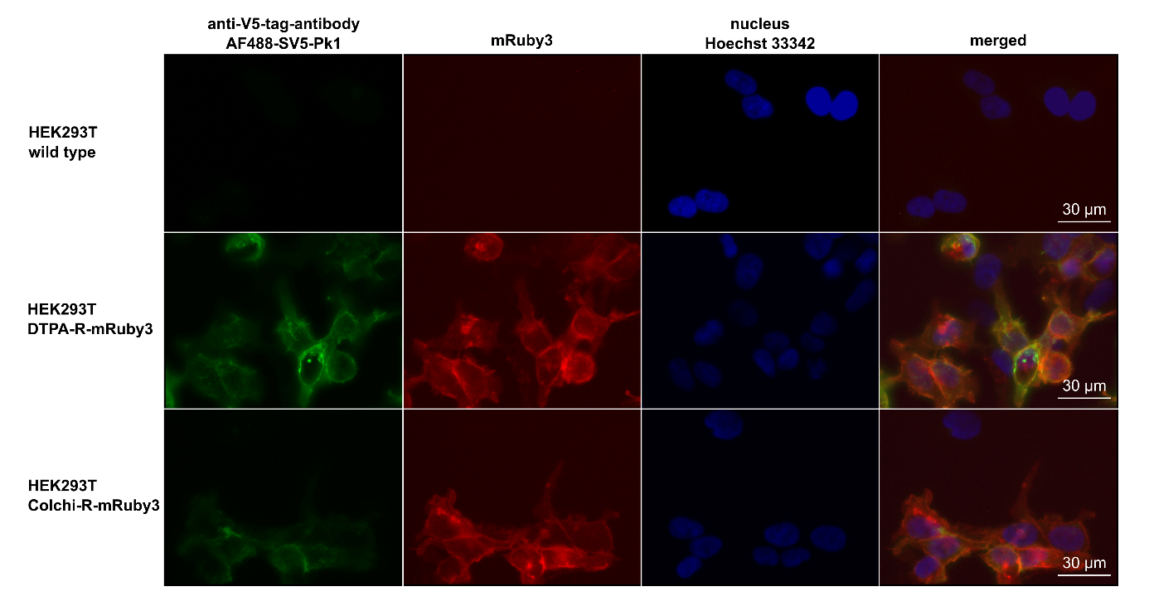
Figure S1: Fluorescence microscopy of HEK293T^{DTPA-R-mRuby3} and HEK293T^{Colchi-R-mRuby3}
HEK293T cells were transduced with retroviral vectors encoding the DTPA-R-mRuby3 or Colchi-R-mRuby3. Cells were stained with an AlexaFluor488-conjugated anti-V5-tag antibody and Hoechst 33342 and subsequently analyzed by fluorescence microscopy.

Figure S2
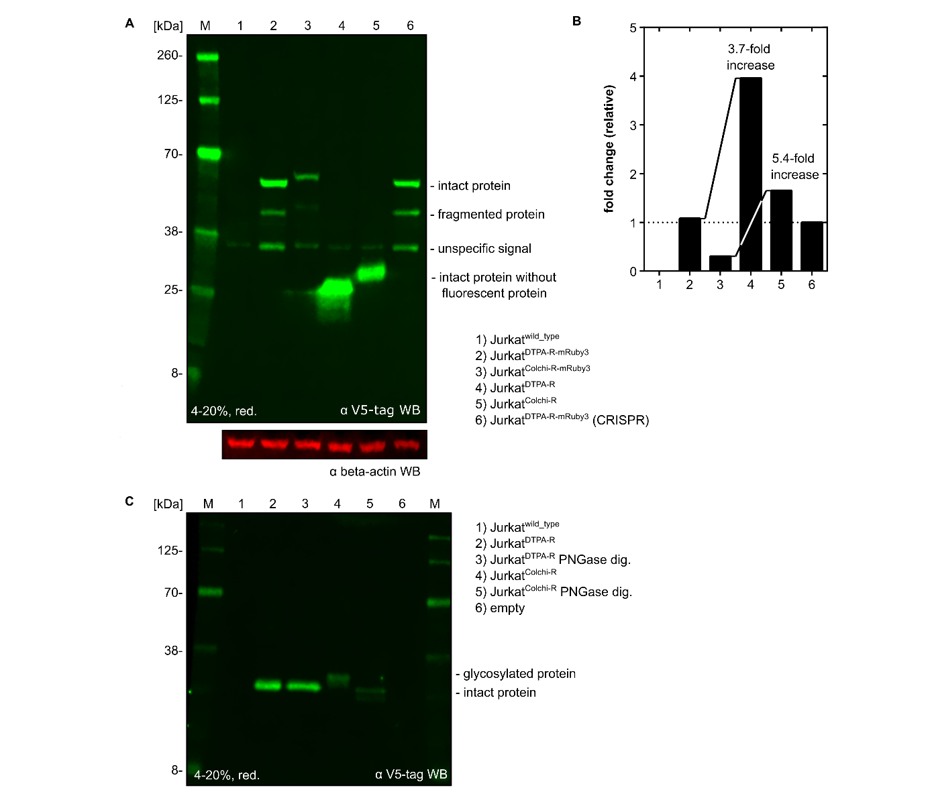
Figure S2: Reporter protein cleavage studies using anti-V5 Western blot analysis
(A) Jurkat cell lines transduced with different versions of the reporter genes DTPA-R and Colchi-R were cultured and lysed using RIPA-buffer. After electrophoretic separation by SDS-PAGE, a Western blot was conducted against the V5-tag and beta-actin as a loading control. While reporter proteins featuring a mRuby3 fluorescent protein showed an additional band indicating a potential proteolytic fragmentation, reporter proteins with no fluorescent protein were higher expressed and showed no unexpected bands. In all lanes, an unspecific band, presumably a protein from the Jurkat cell, was detected. DTPA-R bands migrated slightly lower compared to Colchi-R, which can be explained by the loss of the N-glycosylation site of Lcn2 in the coding sequence of DTPA-R but not in Colchi-R. (B) Quantification of fluorescence signals of individual bands allowed the quantitative comparison of relative expression levels. Expression levels were increased by omitting the intracellular fluorescent protein and using DTPA-R over Colchi-R. (C) Western blot analysis of DTPA-R and Colchi-R reporter protein before and after enzymatic removal of N-linked oligosaccharides by PNGase F. Larger molecular size before digestion and clear down-shift after PNGase F treatment indicate N-glycosylation, presumably at Asn⁸⁵ (natural glycosylation site within Lcn2)⁸ in Colchi-R but not DTPA-R (where this amino acid was mutated to Asp⁸⁵).

Figure S3
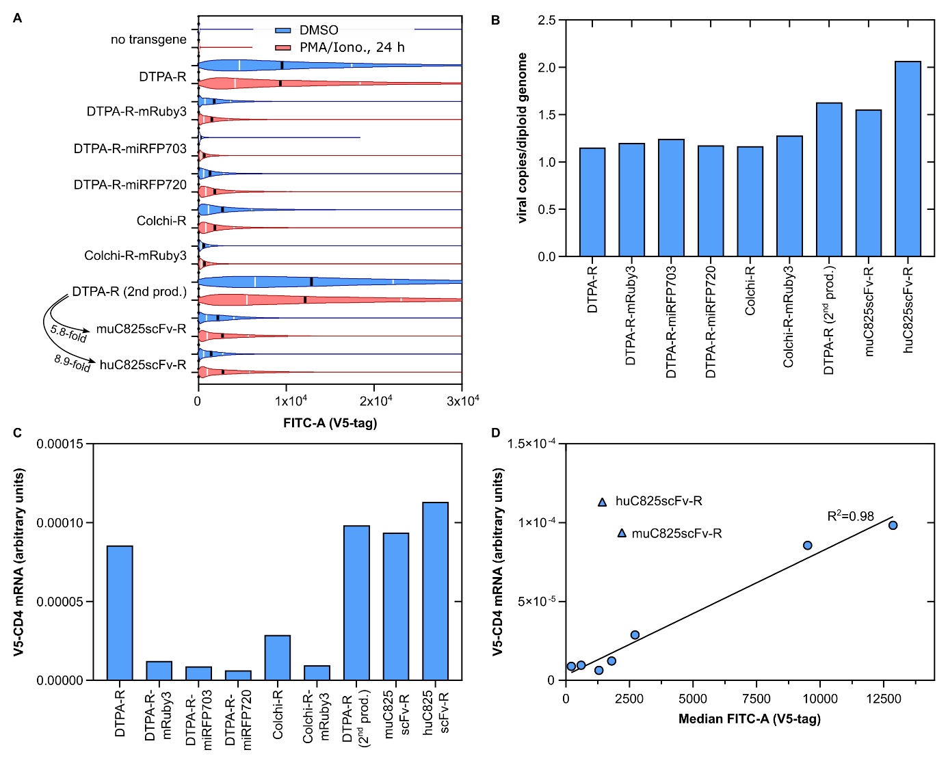
Figure S3: Expression analysis of Anticalin vs. C825 scFv-based reporter proteins
(A) Jurkat cell lines transduced with reporter proteins containing the Anticalins binding CHX-A’’-DTPA•metal or colchicine, or the single chain variable fragment (scFv) binding DOTA•metal complexes were stained with AlexaFluor488-conjugated SV5-Pk1 anti-V5-tag antibody. Subsequently, the fluorescence was quantified by flow cytometry. The median is shown as black bars, quartiles as white bars, and 100,000 total events were analyzed each. (B) Average number of genomic transgene insertions by retroviral gene transfer quantified by ddPCR. (C) The C825 scFv-based reporter genes show similarly high mRNA levels in qPCR comparable to DTPA-R. (D) While a linear correlation between mRNA level and surface-accessible protein levels was found for Anticalin-based reporters, the C825 scFv-based reporters showed low reporter protein densities on the cell surface, hinting towards a superior folding and/or stability of DTPA-R compared to scFv-Rs.

Figure S4
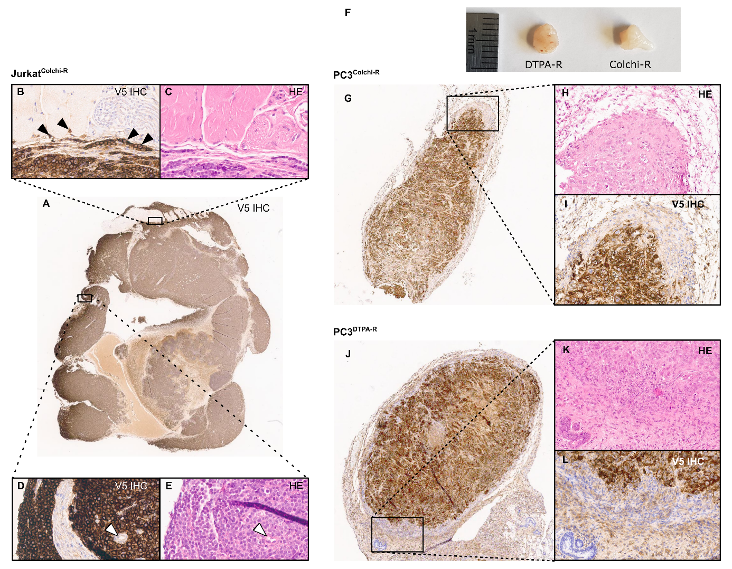
Figure S4: Immunohistochemistry of subcutaneous xenograft tumors using a V5-tag antibody
Jurkat^{Colchi-R} (A–E), PC3^{Colchi-R} (G–I), and PC3^{DTPA-R} (J–L) cells were used to inoculate subcutaneous xenograft tumors, and after sacrificing the animals, the tumor tissue was subjected to immunohistochemical analysis. Consecutive sections were stained with anti-V5-tag Immunohistochemistry (B, D, I, L) and hematoxylin and eosin (HE; C, E, H, K). Horseradish peroxidase (HRP) results in a strong chromogenic membranous stain for both tumor cell lines and both reporter proteins investigated. For the Jurkat T cell line, single-cell infiltrating in the murine tissue are clearly identifiable (black arrowheads in B), and blood vessels are visible through the absence of brown precipitate (white arrowheads in E,F).

Figure S5
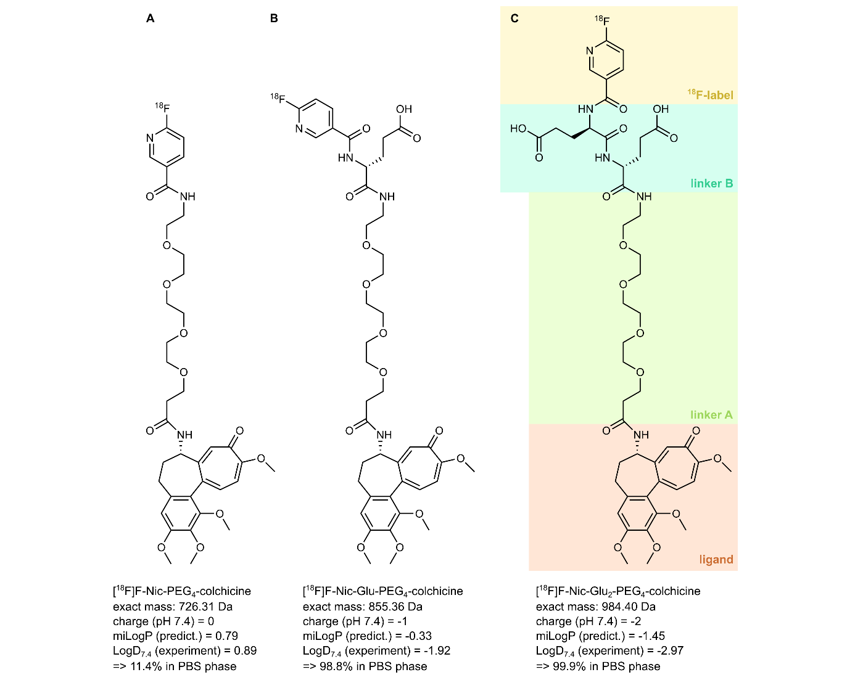
Figure S5: Hydrophilicity engineering of [¹⁸F]F-Nic-PEG₄-colchicine
(A–C) Radioligands for indirect targeting of colchicine-binding reporter protein Colchi-R. The design includes a nicotinic acid with an ¹⁸F-label, a PEG₄ linker, and the colchicine molecule, which functions as a ligand moiety bound by the Anticalin. Initial radioligand (A) without additional hydrophilic amino acid, (B) with one or (C) with two D-Glu residues. Besides the chemical structure, the charge at physiological pH, a predicted partitioning coefficient (miLogP; www.molinspiration.com/cgi-bin/properties), and the experimentally determined LogD_{7.4} are given.

Figure S6
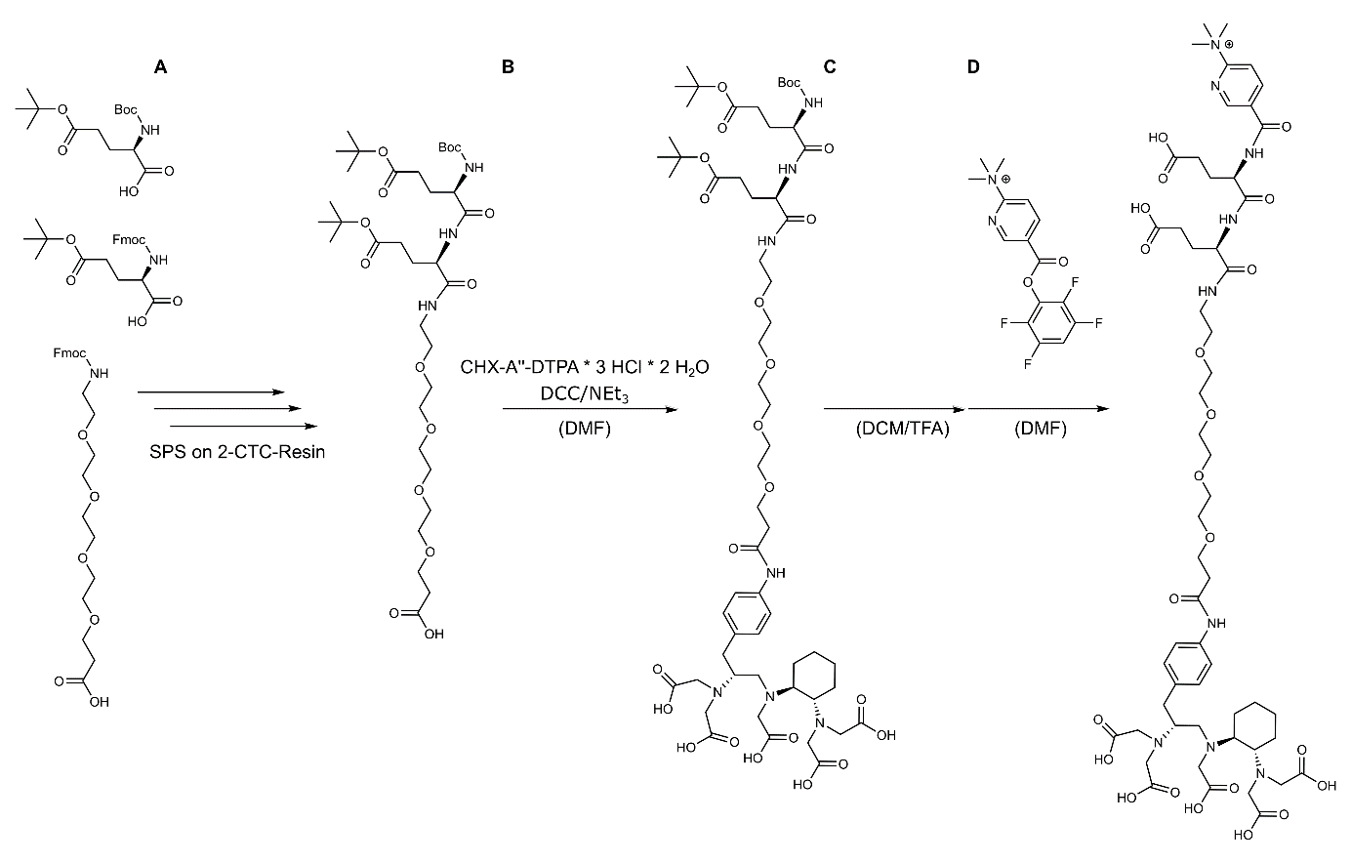
Figure S6: Preparation of TMA-Py-Glu₂-PEG₄-CHX-A’’-DTPA precursor
(A) Solid Phase Synthesis (SPS) on 2-CTC resin following standard protocol. (B) Coupling of the linker to DTPA (commercially available from Macrocylics, Plano, TX) with Dicyclohexylcarbodiimid (DCC) in DMF, r.t. for 18 h. (C) Deprotection in TFA/DCM (1:1) at r.t. for 5 h. (D) The activated Nicotinic acid (Nic) ester was prepared according to the literature protocol⁹, coupling was performed in DMF at r.t. for 18 h.

Figure S7
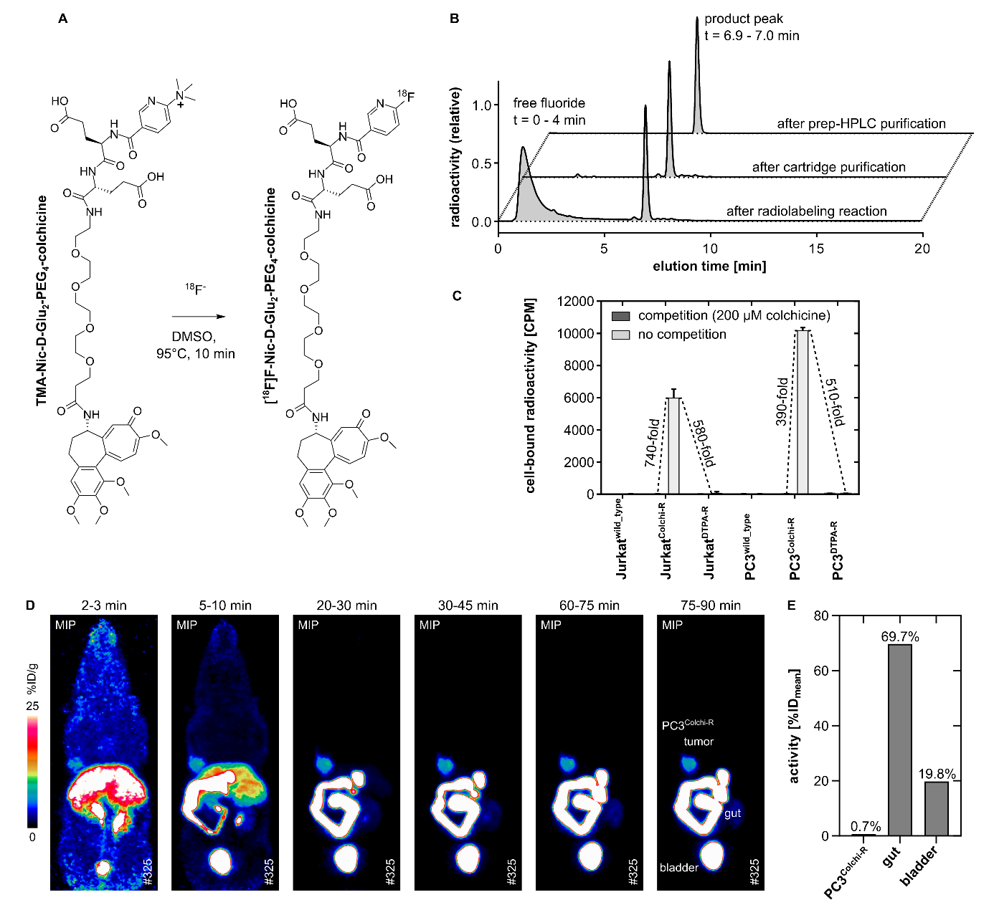
Figure S7: Preparation and analysis of [¹⁸F]F-Nic-Glu₂-PEG₄-colchicine
(A) The radioligand [¹⁸F]F-Nic-Glu₂-PEG₄-colchicine (=[¹⁸F]F-colchicine) was produced by direct radio-fluorination of the precursor molecule TMA-Nic-Glu₂-PEG₄-colchicine, followed by PSH-H⁺ cartridge purification and subsequent preparative HPLC (250×10 mm C18 reversed-phase, isocratic), followed by a C18 cartridge purification. (B) Quality control was performed by analytical HPLC using a Chromolith C18 reversed-phase column with a gradient elution (5–55% MeCN, 0.1% TFA). In the reaction product, free fluorine and a single fluorinated product were visible. Cartridge purification on PSH-matrix removed free fluorine, and the HPLC further increased purity by isolating the [¹⁸F]F-colchicine radioligand from minor impurities. (C) Binding studies of [¹⁸F]F-colchicine were conducted on untransduced PC3 cells and sub-cell lines expressing Colchi-R and DTPA-R. The binding of [¹⁸F]F-colchicine was highly specific for PC3^{Colchi-R} cells when compared to the PC3^{DTPA-R} control cells (510-fold), and the binding to the Colchi-R reporter protein on PC3 cells could be blocked by the previous addition of a high molar excess of 200 µM colchicine, which saturated binding sites (390-fold). (D–E) Finally, the pharmacokinetic profile of [¹⁸F]F-colchicine was tested in a dynamic PET study. To this end, CD1-nude mice bearing a PC3^{DTPA-R} and a PC3^{Colchi-R} xenograft tumor above the shoulders, were injected i.v. with the radioligand. (D) In the 2-3 min time frame [¹⁸F]F-colchicine is predominantly accumulated in the liver, indicating a mainly hepato-biliary excretion profile. (E) VOI quantification of the last time frame of the dynamic PET scan (t=75-90 min) revealed that 69.7 %ID was present in the gastrointestinal tract (gut), while only 0.7 %ID was taken up in the PC3^{Colchi-R} tumor and 19.8 %ID was excretion via the renal route and accumulated in the bladder.

Figure S8
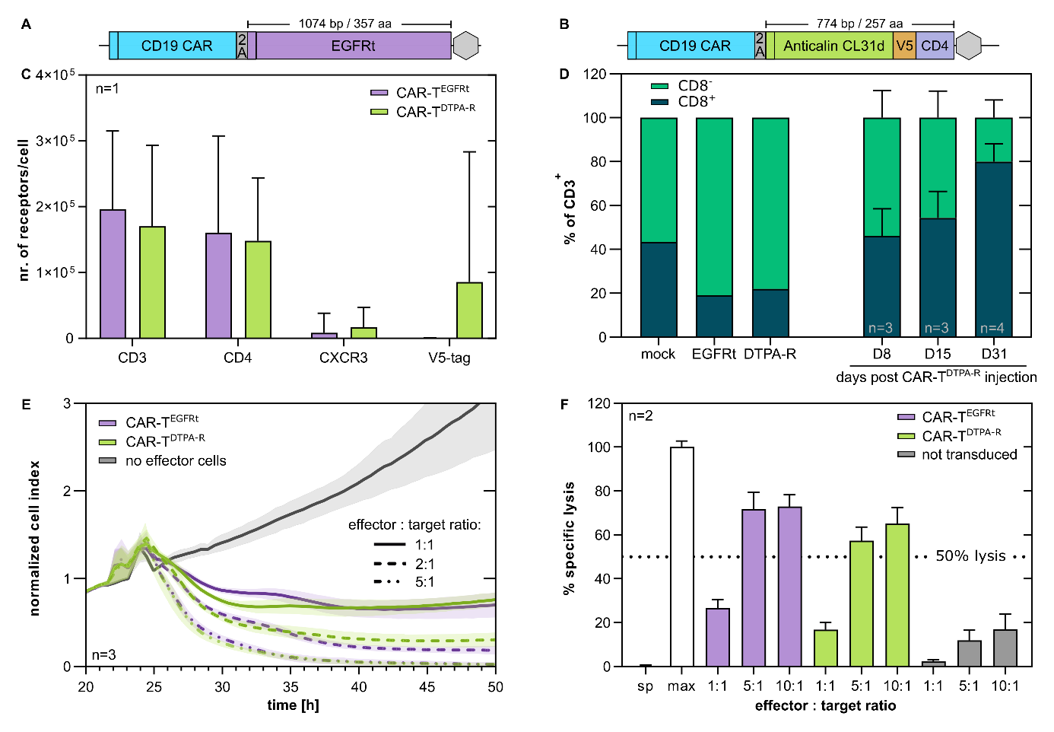
Figure S8: Functional analysis of CAR-T cells expressing EGFRt or DTPA-R
(A–B) Based on an established retroviral vector encoding a CD19 Chimeric Antigen Receptor (CAR) and the truncated EGFR (EGFRt), a new plasmid in which EGFRt was replaced by the DTPA-R gene (B) was constructed. (C–E) These two plasmids were used for retroviral gene transfer into human PBMCs, and these CAR-T cells were then subjected to different assays. (C) Surface expression of important T cell surface markers was quantified by flow cytometry using MESF beads, including the T cell receptor (CD3), the co-stimulatory receptor CD4, and a chemokine receptor CXCR3 as well as the DTPA-R reporter gene (V5-tag). Error bars indicate distribution (biological variation) in one experiment. (D) Exemplary quality control of primary CAR-T cell batches used for in vivo CAR-T cell studies before injection and from the blood during systemic Raji lymphoma treatment. (E) HEK293^{CD19} cells were seeded into 96-well xCELLigence plates, and the effect of different CAR-T cells on target cell confluence was measured in real time by changes in electric current. (F) Cell lysis of CD19-positive tumor cell line Raji was investigated by loading the tumor cells with radioactive chromium-51 and quantifying radioactivity in the supernatant after a 4 h incubation in the presence of respective CAR-T cells. Specific lysis was calculated, taking spontaneous release (sp) and maximum release (max) into account.

Figure S9
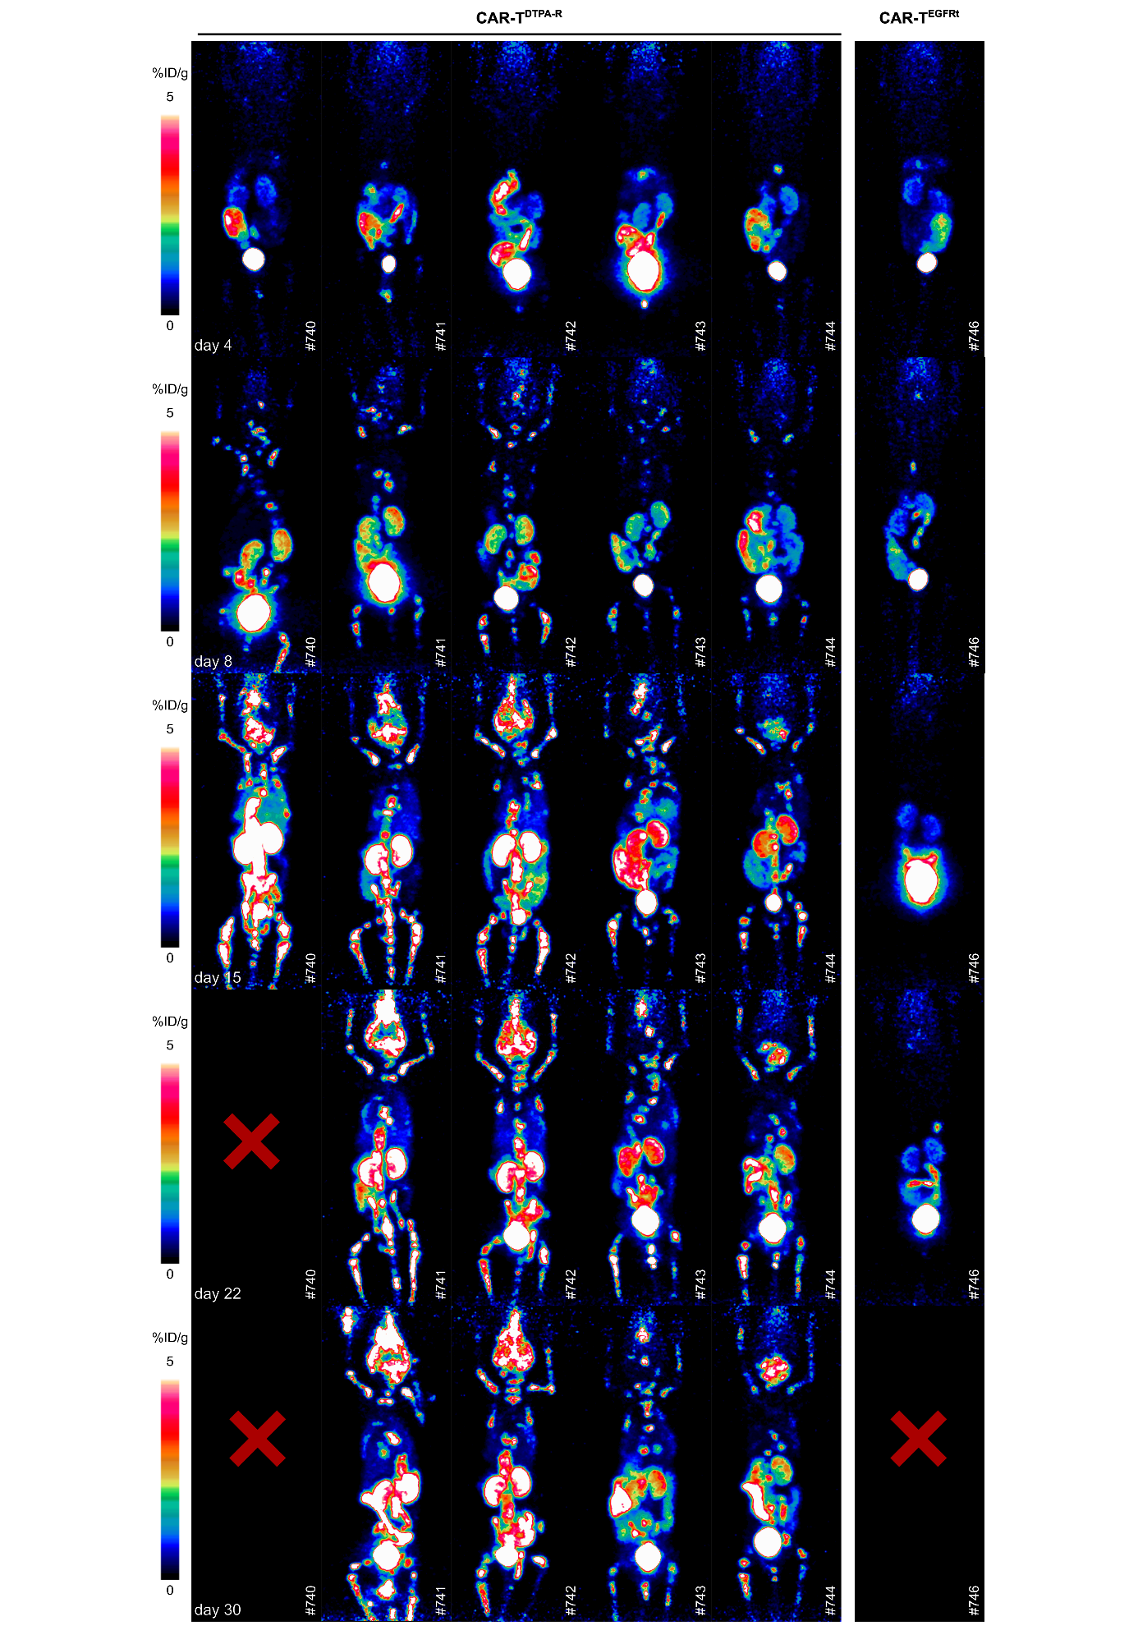
Figure S9: Complete cohort overview for longitudinal CAR-T imaging
A cohort of six NSG mice (♀) was injected i.v. with 5×10⁵ Raji B cell lymphoma cells, which are known to home to the bone marrow. After 7 days, the mice were injected with 2×10⁶ CAR-T^{DTPA-R} cells (five animals) and one control animal with 2×10⁶ CAR-T^{EGFRt} cells. To follow the proliferation and migration of the CAR-T^{DTPA-R} cells, at days 4, 8, 15, 22, and 30 after CAR-T cell injection, an [¹⁸F]F-DTPA PET scan was recorded for 20 minutes.

Figure S10
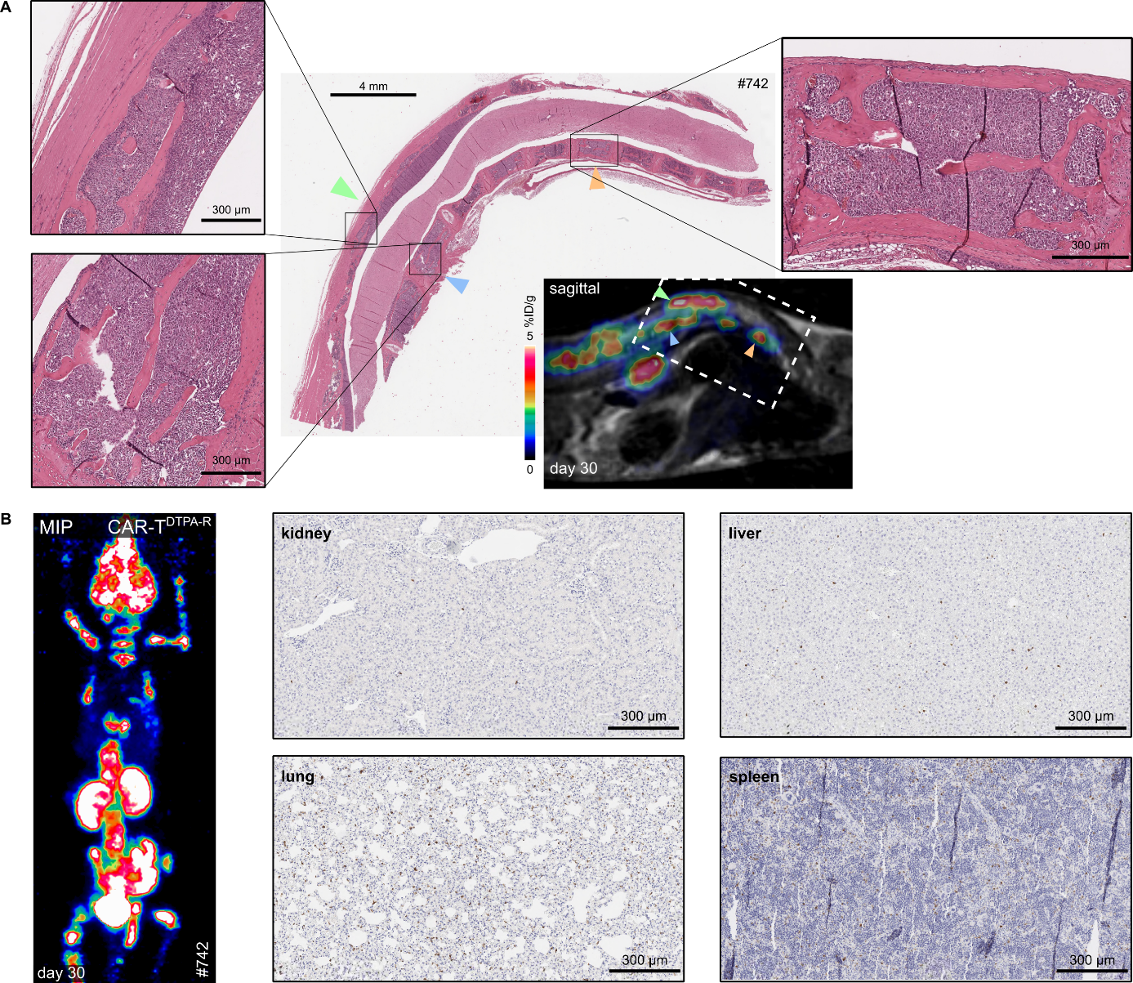
Figure S10: Histological analysis of a mouse from the longitudinal CAR-T study
Additional histological analysis of mouse #742 (longitudinal CAR-T cohort injected with anti-CD19-CAR-T^{DTPA-R} cells, see Fig. 9). (A) HE stained section of the sagittal spine section with relevant regions magnified. (B) MIP image at the end of the study (day 30). IHC detects V5-tag-positive cells (DTPA-R) in the lung and spleen but only a minor accumulation of CAR-T^{DTPA-R} cells in kidney and liver tissue.

Figure S11
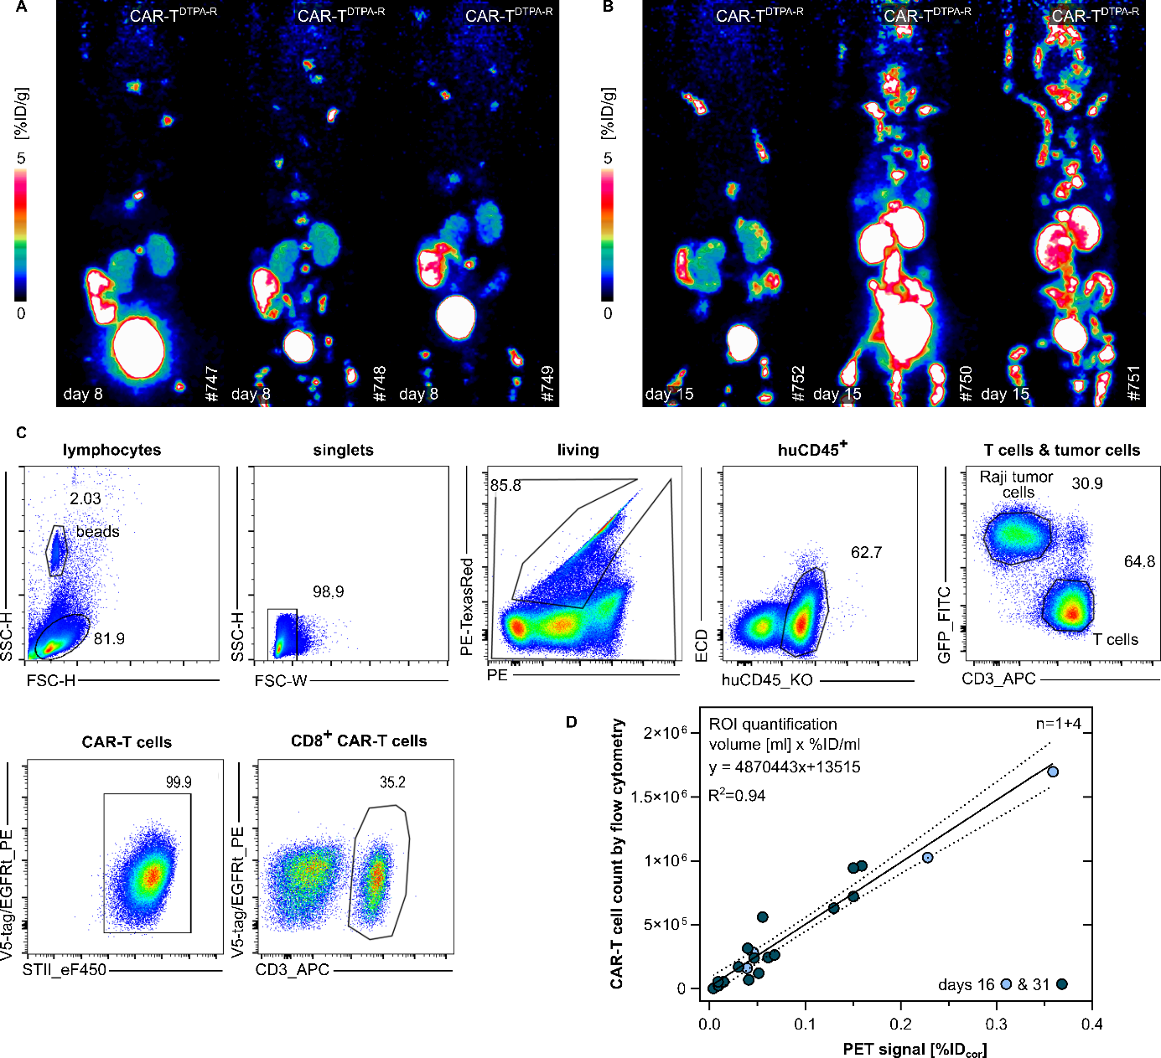
Figure S11: Cohort overview for CAR-T cell end-point study and flow cytometry analysis of mouse tissue samples
Two cohorts of three NSG mice (♀) and one control mouse each were injected i.v. with 5×10⁵ Raji B cell lymphoma cells, which are known to home to the bone marrow. After 7 days, the mice were injected with 2×10⁶ αCD19-CAR-T^{DTPA-R} or in case of the control mouse with 2×10⁶ αCD19-CAR-T^{EGFRt} cells. These cohorts conducted in parallel to the longitudinal CAR-T cell cohort allowed the ex vivo analysis of animals at a time point at which the longitudinal experiment was not completed yet. For this reason, (A) at day 8 or (B) day 15 after CAR-T cell injection, a [¹⁸F]F-DTPA PET scan was recorded, and the animals were subsequently sacrificed. (C) Flow cytometry gating of the bone marrow of the extremities of mice treated with αCD19-CAR-T cells. (D) Correlation of PET signal and number of CAR-T^{DPTA-R} cells in the bone marrow of mice from the longitudinal cohort. Mice were sacrificed one day after the last PET imaging.

Figure S12
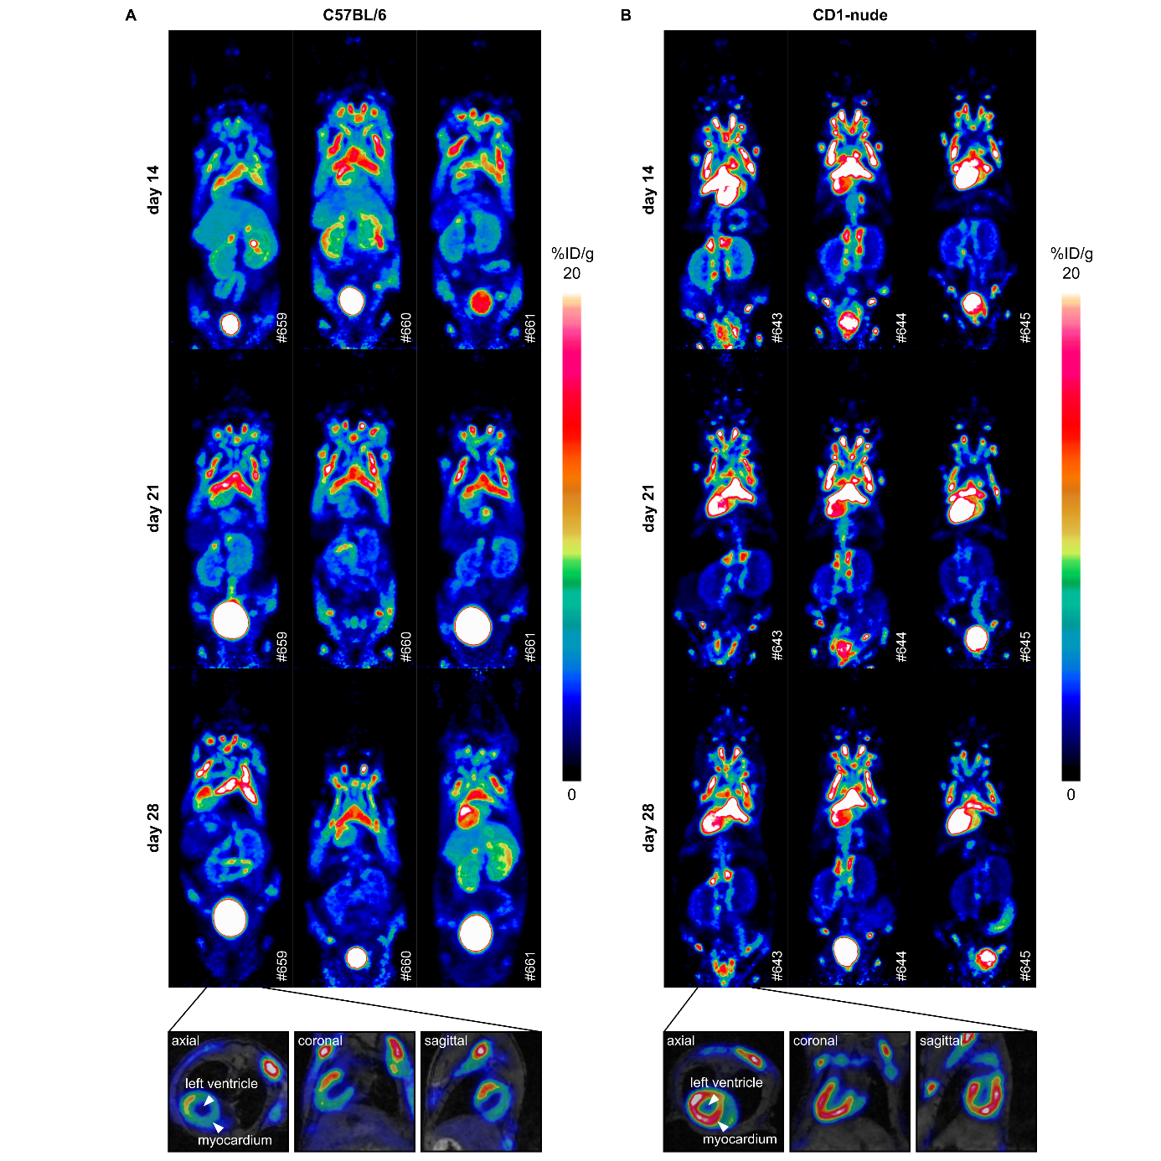
Figure S12: Complete cohort overview for AAV9 longitudinal study
For the longitudinal AAV9 study, two cohorts of three ♀ C57BL/6 and three CD1-nude mice were injected i.v. with (2.5×10¹² vg/mouse). On days 14, 21, and 28 after AAV injection, an [¹⁸F]F-DTPA PET scan was recorded for 20 minutes. For each mouse strain, cross-sectional images of the heart in three orientations are depicted, clearly showing the left ventricle.

Figure S13
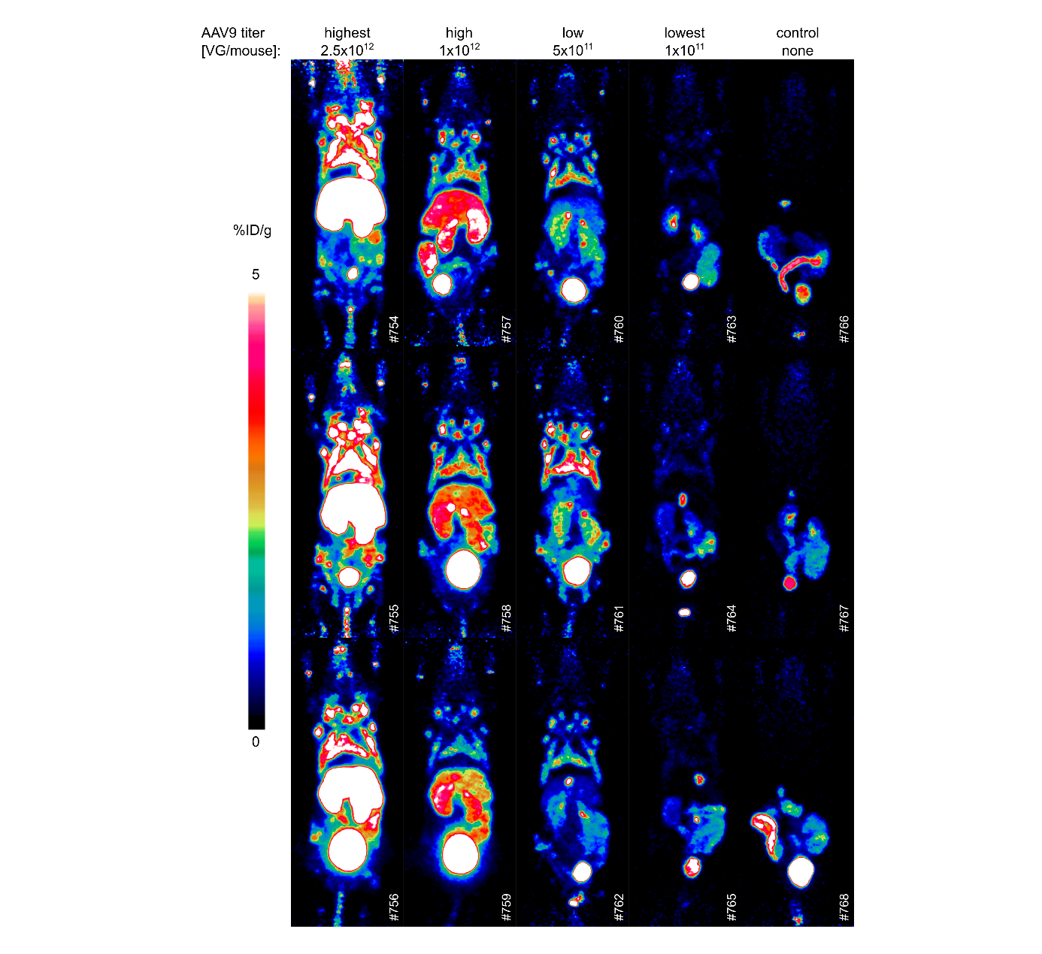
Figure S13: Complete cohort overview for AAV9 titer study
Five cohorts of three ♀ C57BL/6 mice were injected i.v. with four different concentrations (highest: 2.5×10¹², high: 1×10¹², low: 5×10¹¹; lowest: 1×10¹¹ vg/mouse) or with PBS. On day 7, after AAV injection, an [¹⁸F]F-DTPA PET scan was recorded for 20 minutes.

