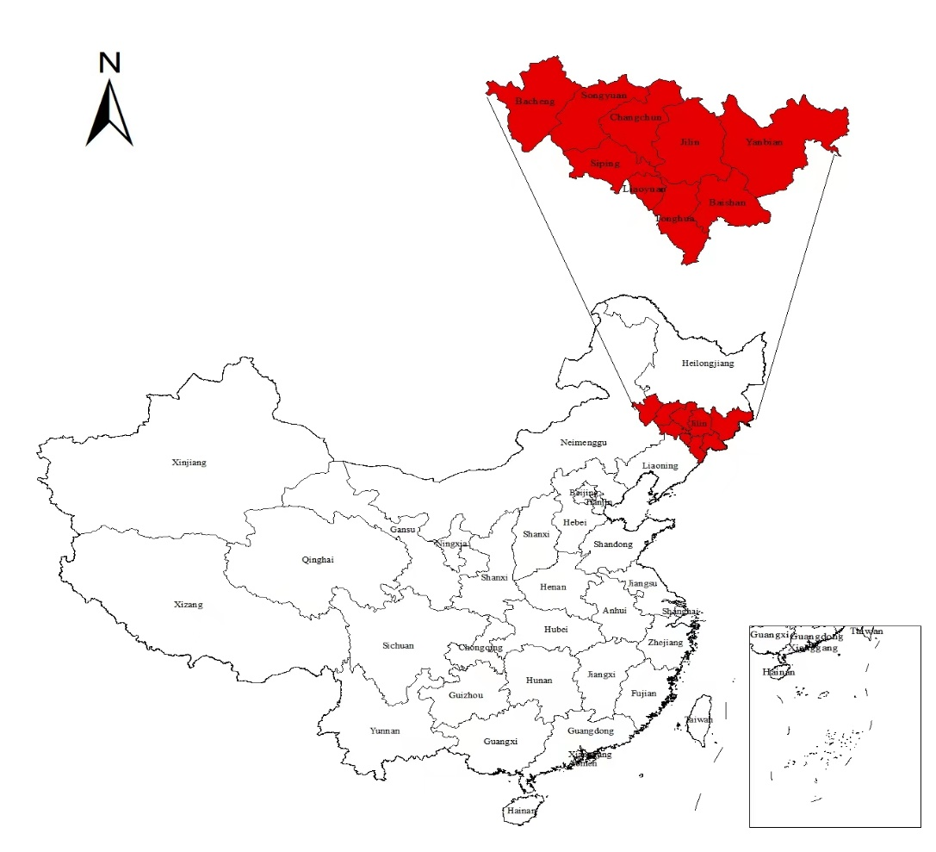
Fig. 1. Study area in China.

