Supplementary Material

Identification of METTL3 as a myeloid-related prognosis biomarker in hepatocellular carcinoma using bioinformatics analysis and engineered mice model

Qing Wang^{1,2†*}, He Wang^{3†}, Changjie Yang⁴, Xiao Wang¹, Jiaxiang Meng^{2,5*}

*Correspondence:

Qing Wang, Department of Medical Oncology, Zhongshan Hospital, Fudan University School of Medicine, Shanghai 200032, China;

E-mail: wang.qing2@zs-hospital.sh.cn;

Jiaxiang Meng, Department of General Surgery, Shanghai Ninth Hospital, School of Medicine, Shanghai Jiaotong University, Shanghai 200127, China;

E-mail: 122051@sh9hospital.org.cn.
- Supplementary Figures
  - Supplementary Figures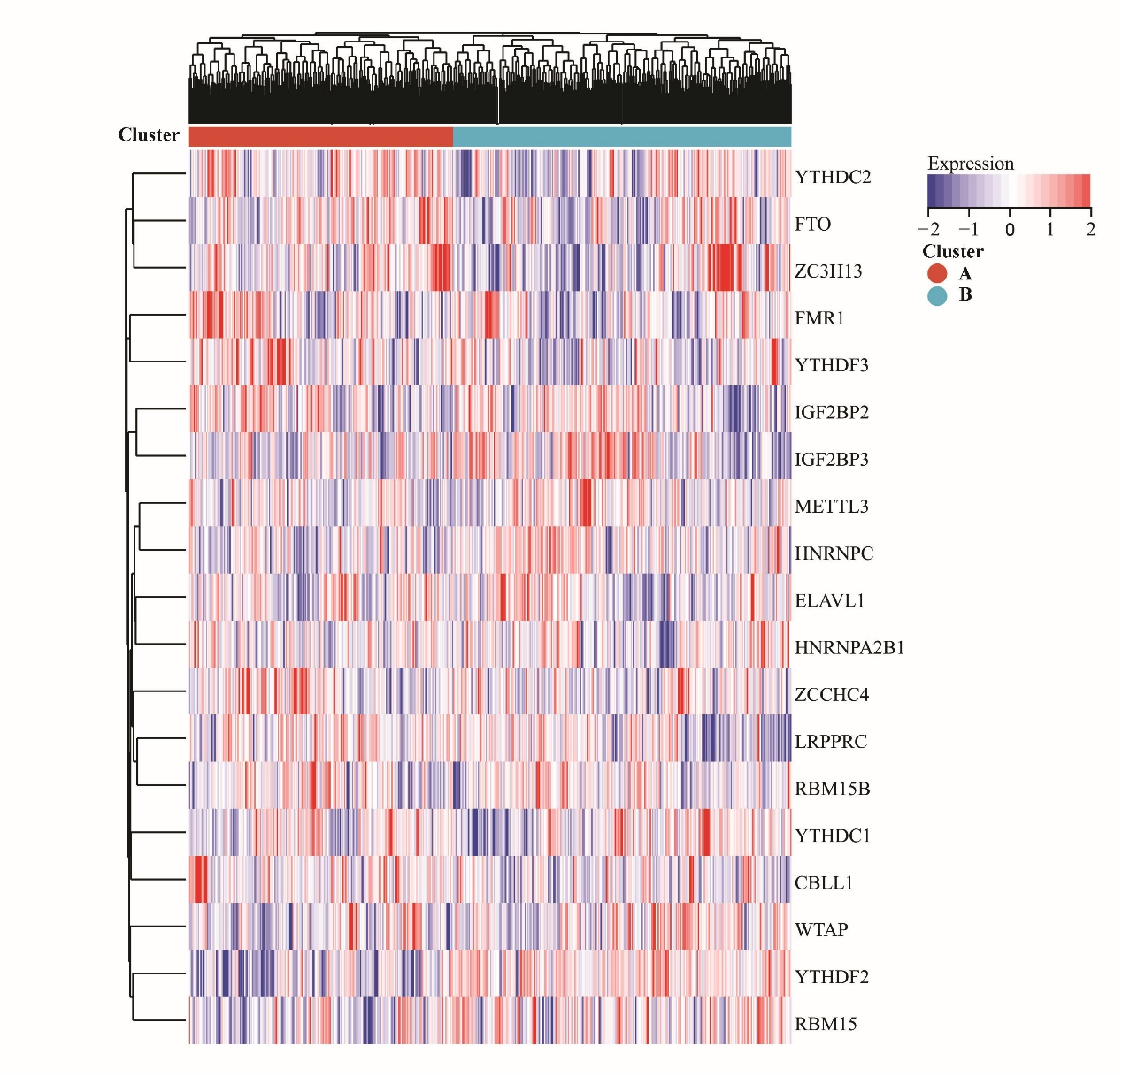

Supplementary Figure 1 | Result of unsupervised clustering of m6A regulators in testing database. We constructed testing databases consisted a total of 536 HCC patients from IGCG, GSE14520, and GSE76427 cohorts with clinic information of HCC patients to confirm the validation of m6A prognostic value. The expression signature of the m6A genes set was clustered into A and B. 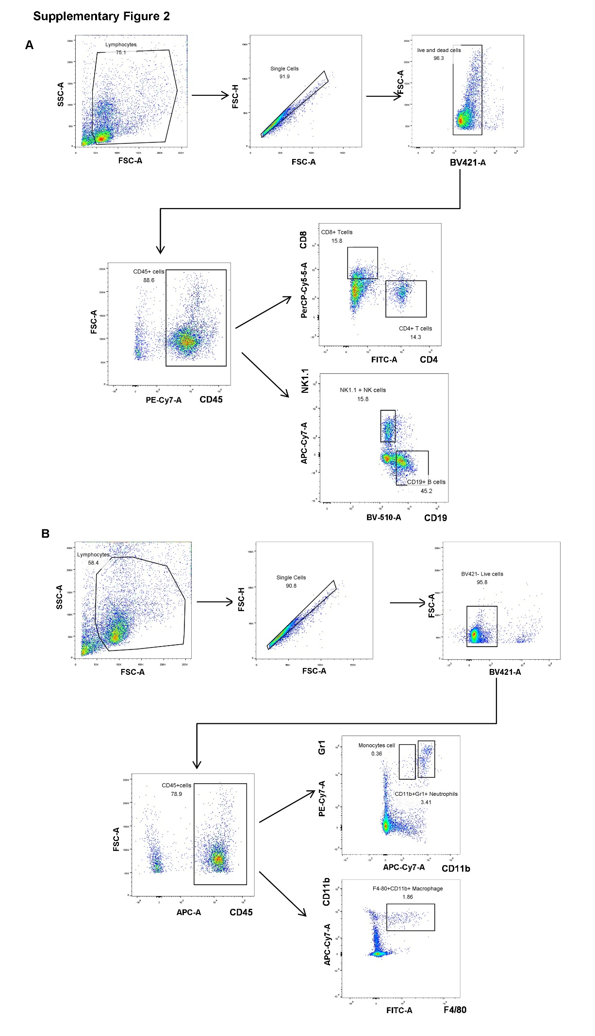 Supplementary Figure 2 | Representative gating strategy of flow cytometry analysis. (A) The gating strategy employed to analyze CD4/CD8/NK/B cells. (B) Gating strategy employed to analyze Monocytes/Neutrophils/Macrophage cells.

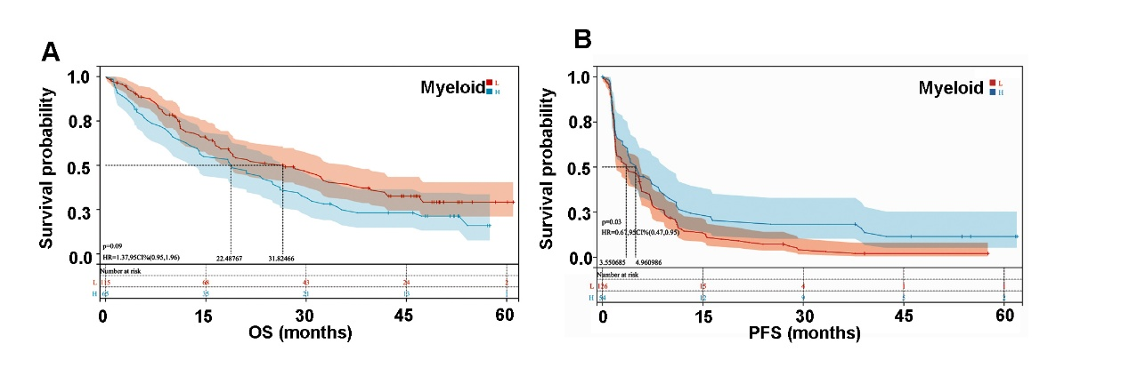

Supplementary Figure 3 | Correlation of myeloid infiltration with overall survival and progression-free survival following anti-PD-1 treatment. (A) OS of TCGA-HCC patients with high or low myeloid infiltration was plotted with Kaplan-Meier curves;(B) PFS of TCGA-HCC patients with high or low myeloid infiltration was plotted with Kaplan-Meier curves.

