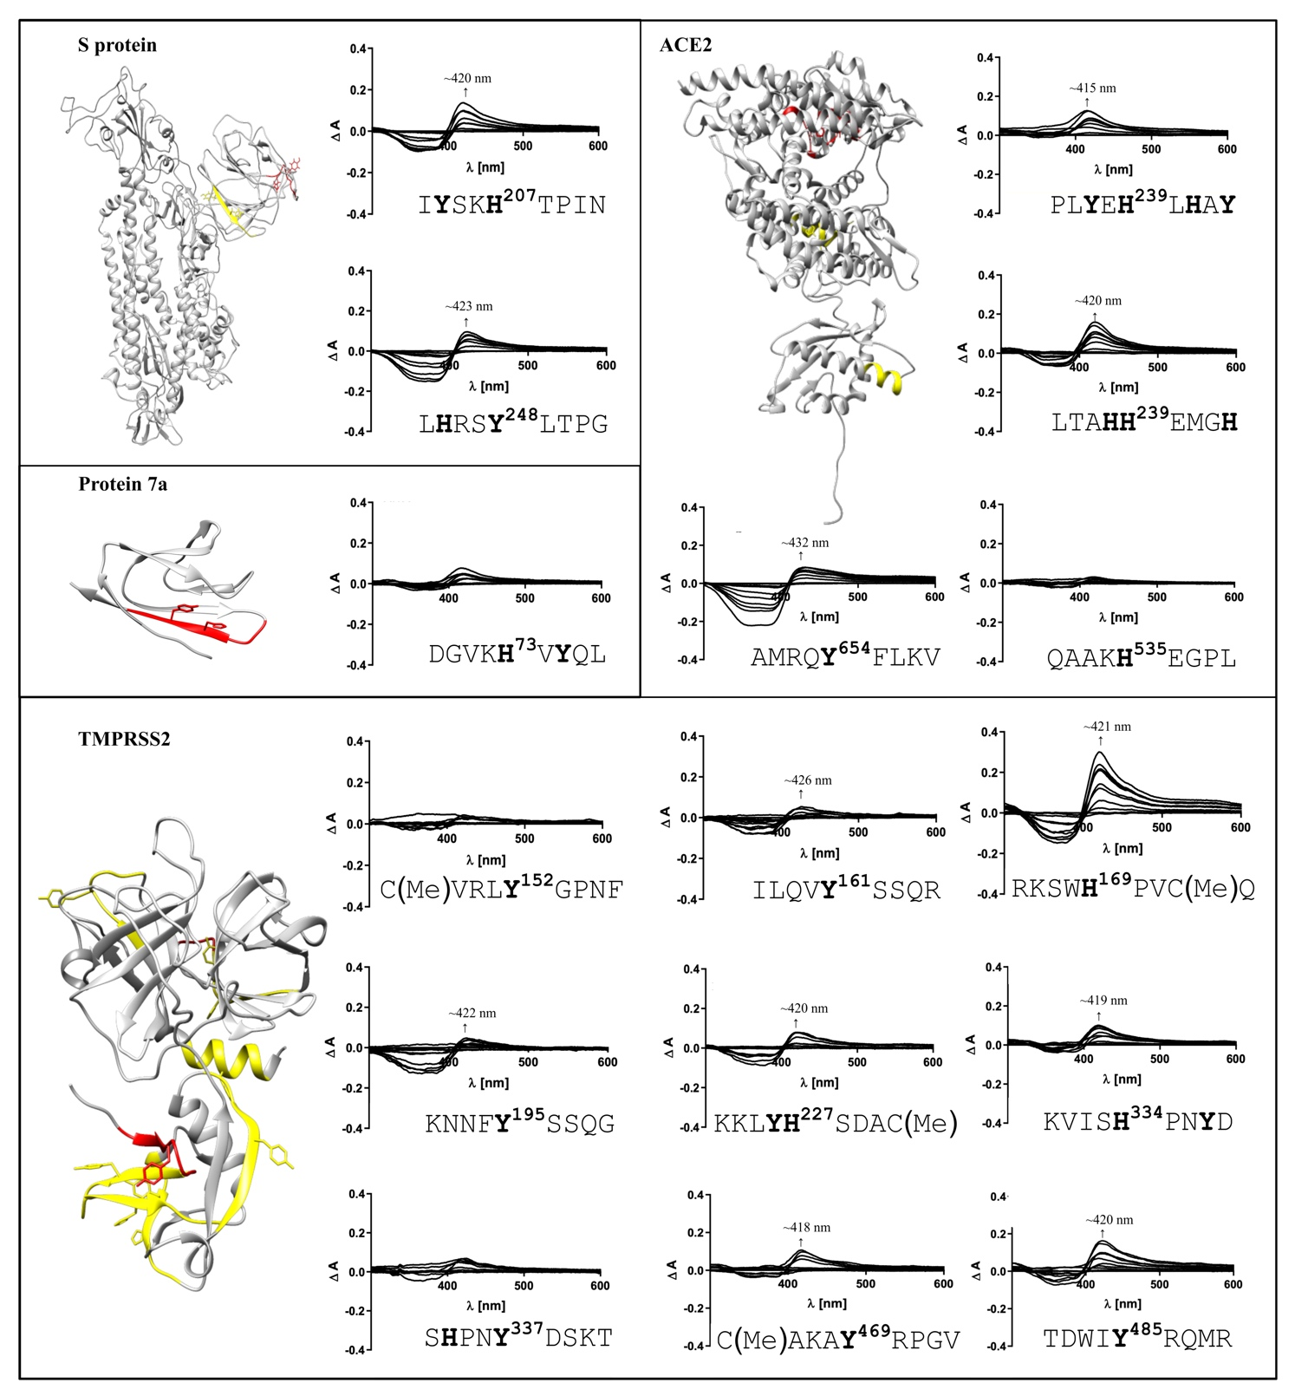
Additional file 7

Additional file 7. Binding data of subordinate motifs in SARS-CoV-2 proteins (i.e., S protein and protein 7a) and human host cell proteins (i.e., ACE2 and TMPRSS2). The location of non-binding (red) sequence stretches and moderately binding HBMs (yellow) are highlighted in the respective structure of the proteins (C-I-TASSER model of S protein monomer [1]; PDBs: 6W37 (protein 7a), 6M18 (ACE2); Swiss-model: O15393 (TMPRSS2). Where the heme-binding affinity could not be determined, HBMs are also marked in yellow.

References
1. Zhang C, Zheng W, Huang X, et al (2020) Protein structure and sequence reanalysis of 2019-nCoV genome refutes snakes as its intermediate host and the unique similarity between Its spike protein Insertions and HIV-1. J Proteome Res 19:1351–1360. https://doi.org/10.1021/acs.jproteome.0c00129

