Appendix
Fig. A1: Histogram EQ-5D-5L index scores at admission for (a) total hip replacement and (b) total knee replacement patients
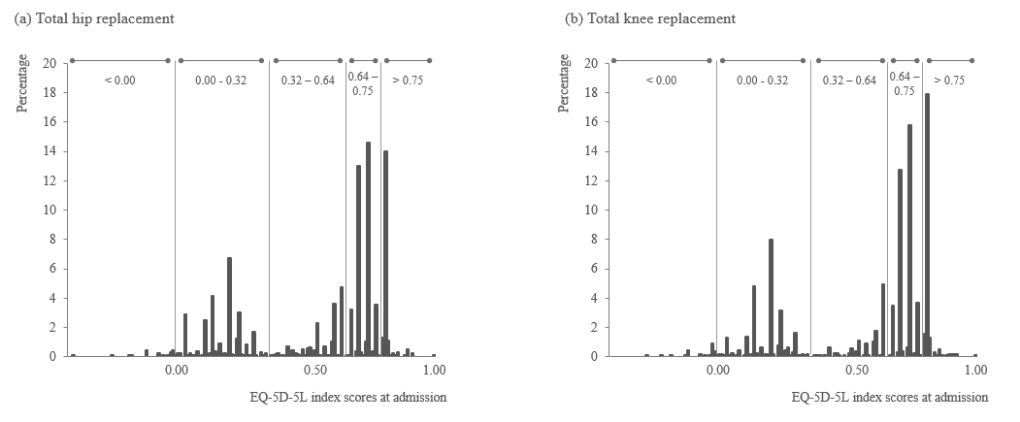
Fig. A2: MIs after 12 months – impact on patient sample – anchor pain for (a) total hip replacement and (b) total knee replacement
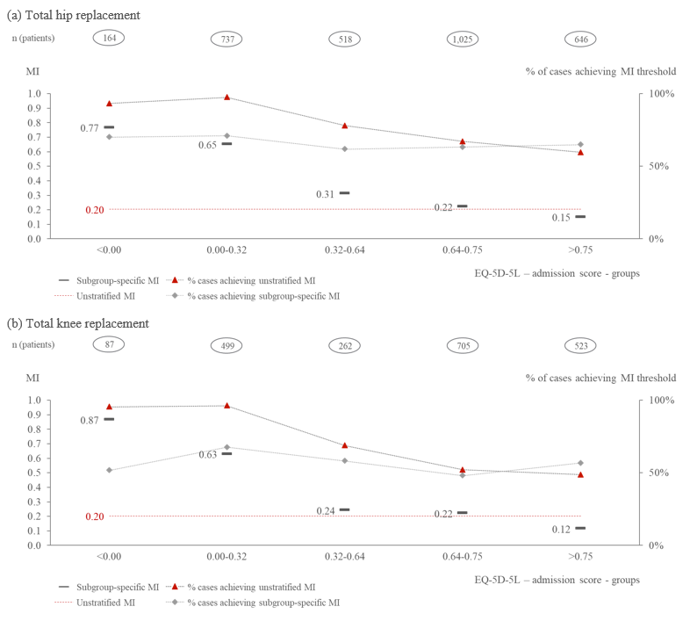
Table A1: MI thresholds with only one level improvement in the anchor – 12 months
 | Anchor 1: Mobility |  | Anchor 2: Pain
Total hip replacement
12-months | MCID | N (AUC) | MCID | N (AUC)
Overall | 0.264 | 1,994 (0.68) | 0.204 | 2,380 (0.80)
Grouped by admission score
<0.00 | 0.889 | 158 (0.95) | 0.750 | 91 (0.76)
0.00-0.32 | 0.741 | 600 (0.93) | 0.652 | 349 (0.73)
0.32-0.64 | 0.242 | 386 (0.93) | 0.304 | 363 (0.91)
0.64-0.75 | 0.173 | 797 (0.95) | 0.225 | 984 (0.97)
>0.75 | 0.023 | 53 (0.96) | 0.123 | 593 (0.97)
Total knee replacement
12-months | MCID | N (AUC) | MCID | N (AUC)
Overall | 0.228 | 1,328 (0.67) | 0.203 | 1,766 (0.84)
Grouped by admission score
<0.00 | 0.884 | 81 (0.91) | 0.841 | 60 (0.73)
0.00-0.32 | 0.706 | 414 (0.88) | 0.630 | 327 (0.73)
0.32-0.64 | 0.223 | 198 (0.88) | 0.223 | 192 (0.93)
0.64-0.75 | 0.174 | 581 (0.92) | 0.222 | 692 (0.97)
>0.75 | 0.001 | 54 (0.92) | 0.115 | 495 (0.97)
Notes: Minimal improvements are defined as an improvement of one health level in either, mobility or pain; N = Sample size; AUC = Area under the curve – a measure of fit for ROC curves.

Table A2: Changes in EQ-5D-5L item responses for patients after total hip and knee replacement
Total hip replacement
EQ-5D-5L score admission groups | <0.00 | 0.00-0.32 | 0.32-0.64 | 0.64-0.75 | >0.75
Number of observations in group | 164 | 737 | 521 | 1028 | 664
Q1 - Mobility | +0.23 | +0.48 | +0.96 | +0.61 | -0.03
Q2 - Self-Care | +0.64 | +0.12 | +0.50 | +0.04 | -0.03
Q3 - Usual Activities | +0.78 | +0.73 | +1.17 | +0.46 | +0.28
Q3 - Pain / Discomfort | +1.19 | +1.38 | +1.05 | +0.66 | +0.74
Q5 - Anxiety / Depression | +0.53 | +0.22 | +0.42 | +0.17 | +0.01
Total knee replacement
Number of observations in group | 87 | 500 | 263 | 705 | 548
Q1 - Mobility | +0.08 | +0.40 | +0.84 | +0.55 | -0.03
Q2 - Self-Care | +0.45 | -0.01 | +0.22 | -0.04 | -0.05
Q3 - Usual Activities | +0.17 | +0.28 | +0.73 | +0.13 | +0.05
Q3 - Pain / Discomfort | +0.78 | +1.15 | +0.81 | +0.45 | +0.53
Q5 - Anxiety / Depression | +0.53 | +0.22 | +0.42 | +0.11 | -0.01
Note: Each question has five levels of response (no problems, slight problems, moderate problems, severe problems, extreme problems/unable to).

