Associations between Long-term Ozone Exposure and Lung Function in Chinese Young Adults: A Longitudinal Cohort Study

Supplementary Material

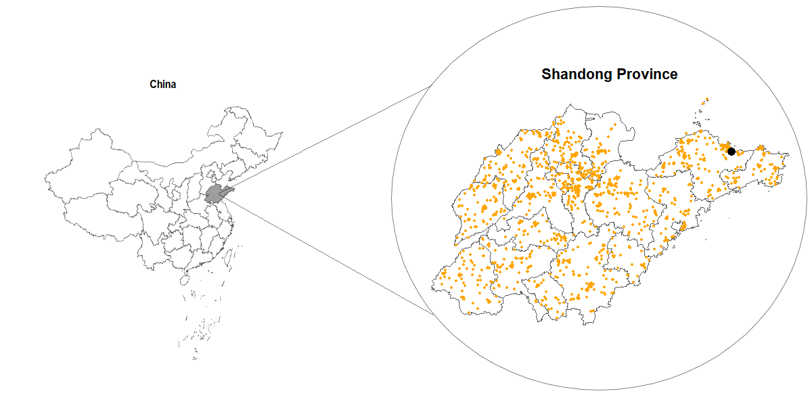
Fig. S1 Geographical distribution of the study population
Note: The gray area on the left represents Shandong Province; The yellow dots on the right represent participants' residential address and the black dot represents the school address.

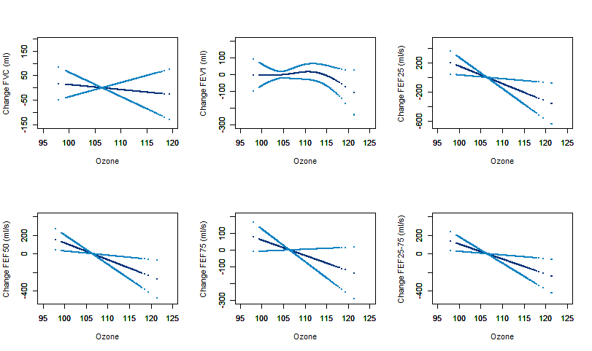Figure. S2. Exposure–Response curves for the relationships of Ozone with lung function parameters. The Y-axes for lung function denote changes in these parameters.

Table S1. Associations between IQR increase in the average ozone concentrations and changes in lung function parameters in young adults.
Lung Function | Model1 |  | Model2
Lung Function | Difference (95% CI) | p | Difference (95% CI) | p
FVC (ml) | -19.2 (-82.2,43.8) | 0.55 | -49.8 (-121.6,21.9) | 0.17
FEV1 (ml) | -19.2 (-73.1,34.7) | 0.49 | -50.6 (-111.9,10.8) | 0.11
FEF25 (ml/s) | -204.3 (-361.6,-47) | 0.01 | -243.6 (-422.7,-64.4) | 0.01
FEF50 (ml/s) | -146.3 (-264.1,-28.4) | 0.02 | -177.7 (-311.4,-43.9) | 0.01
FEF75 (ml/s) | -65.0(-158.1,28.0) | 0.17 | -66.2 (-171.9,39.5) | 0.22
FEF25-75 (ml/s) | -132.8 (-239.2,-26.4) | 0.01 | -146.9 (-267.6,-26.1) | 0.02
Note: The Model1 adjusted for ozone, sex, age, BMI, lifestyle factors (smoking status, alcohol drinking, physical activity), respiratory disease history, home location (rural or urban areas), socioeconomic status, temperature, relative humidity; The Model2 adjusted for short-term ozone exposure (lag01) based on the above.

Table S2. The association between IQR increase in the average ozone concentrations and changes in lung function parameters stratified by sex.
Lung Function | Male |  | Female
Lung Function | Difference (95% CI) | p | Difference (95% CI) | p
FVC (ml) | -34.4 (-140.8,72) | 0.53 | -7.8 (-82.3,66.7) | 0.84
FEV1 (ml) | -8.0 (-98.4,82.3) | 0.86 | -32.2 (-97.1,32.7) | 0.33
FEF25 (ml/s) | -79.9 (-355.1,195.4) | 0.57 | -311.1 (-492.6,-129.6) | <0.01
FEF50 (ml/s) | -72.1 (-274.6,130.4) | 0.49 | -232.2 (-370.0,-94.4) | <0.01
FEF75 (ml/s) | -42.7 (-205.3,119.9) | 0.61 | -101.1 (-208.3,6.2) | 0.07
FEF25-75 (ml/s) | -62.3 (-246.2,121.5) | 0.51 | -209.4 (-333.4,-85.5) | <0.01

Table S3. The association between IQR increase in the average ozone concentrations and changes in lung function parameters stratified by BMI.
Lung Function | BMI_Low |  | BMI_High
Lung Function | Difference (95% CI) | p | Difference (95% CI) | p
FVC (ml) | -22 (-91.9,48.0) | 0.54 | -11.0 (-152.4,130.5) | 0.88
FEV1 (ml) | -10.6 (-71.1,50.0) | 0.73 | -49.6 (-167.9,68.6) | 0.41
FEF25 (ml/s) | -129.2 (-306.3,48) | 0.15 | -421.0 (-764.1,-77.9) | 0.02
FEF50 (ml/s) | -84.0 (-217.2,49.2) | 0.22 | -337.3 (-591.5,-83) | 0.01
FEF75 (ml/s) | -9.8 (-115.1,95.5) | 0.86 | -246.5 (-447.1,-45.9) | 0.02
FEF25-75 (ml/s) | -68.7 (-189.3,51.8) | 0.26 | -332.3 (-560.8,-103.9) | <0.01
Note: BMI_Low: <24kg/m²; BMI_High: ≥24 kg/m²

Table S4. The association between IQR increase in the average annual ozone concentrations in 11 months before the lung function measurement and lung function parameters
Lung Function | 10Month |  | 11Month
Lung Function | Difference (95% CI) | p | Difference (95% CI) | p
FVC (ml) | -14.3 (-65.2,36.6) | 0.58 | -15.8 (-72,40.4) | 0.58
FEV1 (ml) | -13.8 (-57.4,29.7) | 0.53 | -15.3 (-63.5,32.8) | 0.53
FEF25 (ml/s) | -164.4 (-291.5,-37.3) | 0.01 | -181.6 (-322.1,-41.2) | 0.01
FEF50 (ml/s) | -116.8 (-211.7,-21.9) | 0.02 | -129.1 (-234,-24.2) | 0.02
FEF75 (ml/s) | -51.8 (-126.8,23.2) | 0.18 | -57.2 (-140.1,25.6) | 0.18
FEF25-75 (ml/s) | -106.3 (-191.9,-20.6) | 0.02 | -117.4 (-212.1,-22.8) | 0.02

Table S5. The association between IQR increase in the average ozone concentrations and changes in lung function parameters After excluding smoking participants.
Lung Function | Excluding smoker
Lung Function | Difference (95% CI) | p
FVC (ml) | -11.3 (-74.5,51.8) | 0.73
FEV1 (ml) | -13.8 (-67.9,40.3) | 0.62
FEF25 (ml/s) | -210.2 (-368.2,-52.3) | 0.01
FEF50 (ml/s) | -149.3 (-267.6,-30.9) | 0.01
FEF75 (ml/s) | -63.7 (-157.3,30.0) | 0.18
FEF25-75 (ml/s) | -133.7 (-240.1,-27.4) | 0.01

