Table 2. Distribution of light and daylight factor value in elbow models
 | First Stage |  |  | Second Stage
Elbows Variables | E1 | E2 | E3 | E4 | E5 | E6 | E7 | E8
Elbows Variables | d=0 | d=0.21 | d=0.21 | d=0.21 | d=0.21 | d=0.21 | d=0.21 | d=0.21
Elbows Variables | 30° angle 3 module | 30° angle 3 module  (concave connect) | 30° angle 3 module  (linear connect) | 15° angle 6 module | 15°-60° angle 3 module | 45° angle 2 module | 90° angle single module | Circular single module
Model | 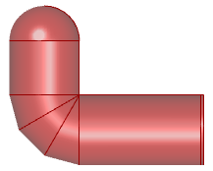 | 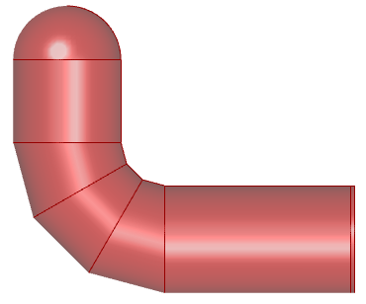 | 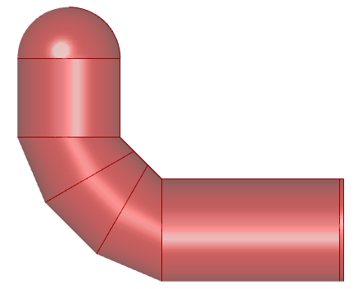 | 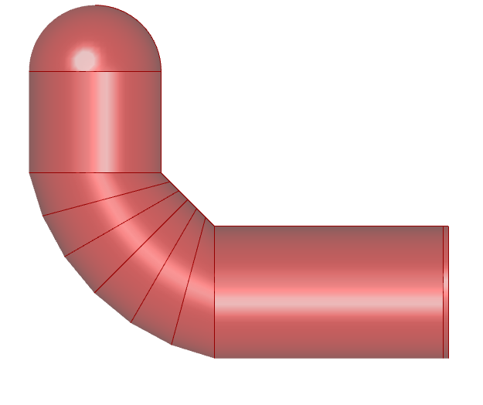 | 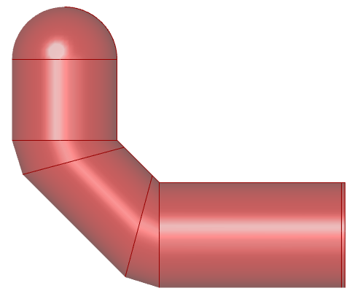 | 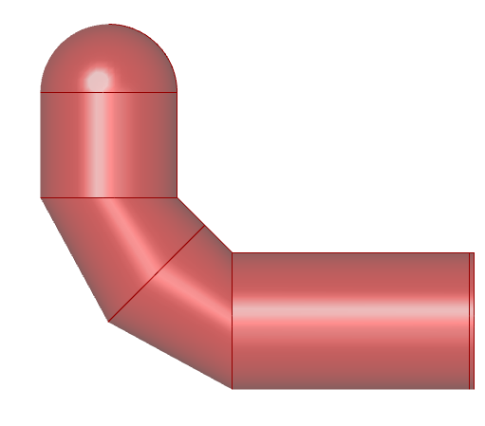 | 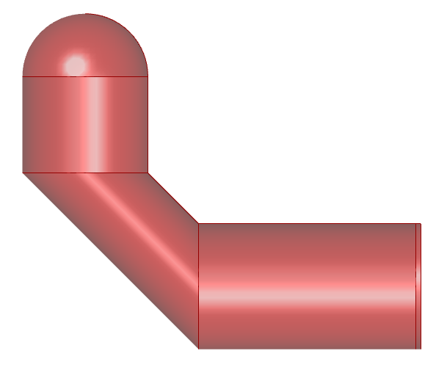 | 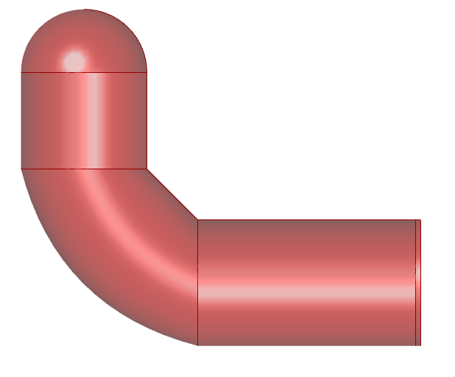
Distribution of light | 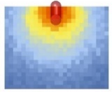 | 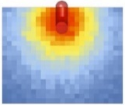 | 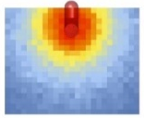 | 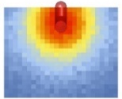 | 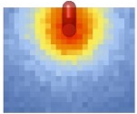 | 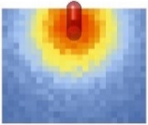 | 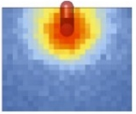 | 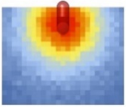
Maximum illuminance | 139 lx | 146 lx | 159 lx | 163 lx | 155 lx | 146 lx | 139 lx | 153 lx
Average illuminance | 38 lx | 44 lx | 48 lx | 49 lx | 40 lx | 42 lx | 33 lx | 43 lx

