Supplemental Figures
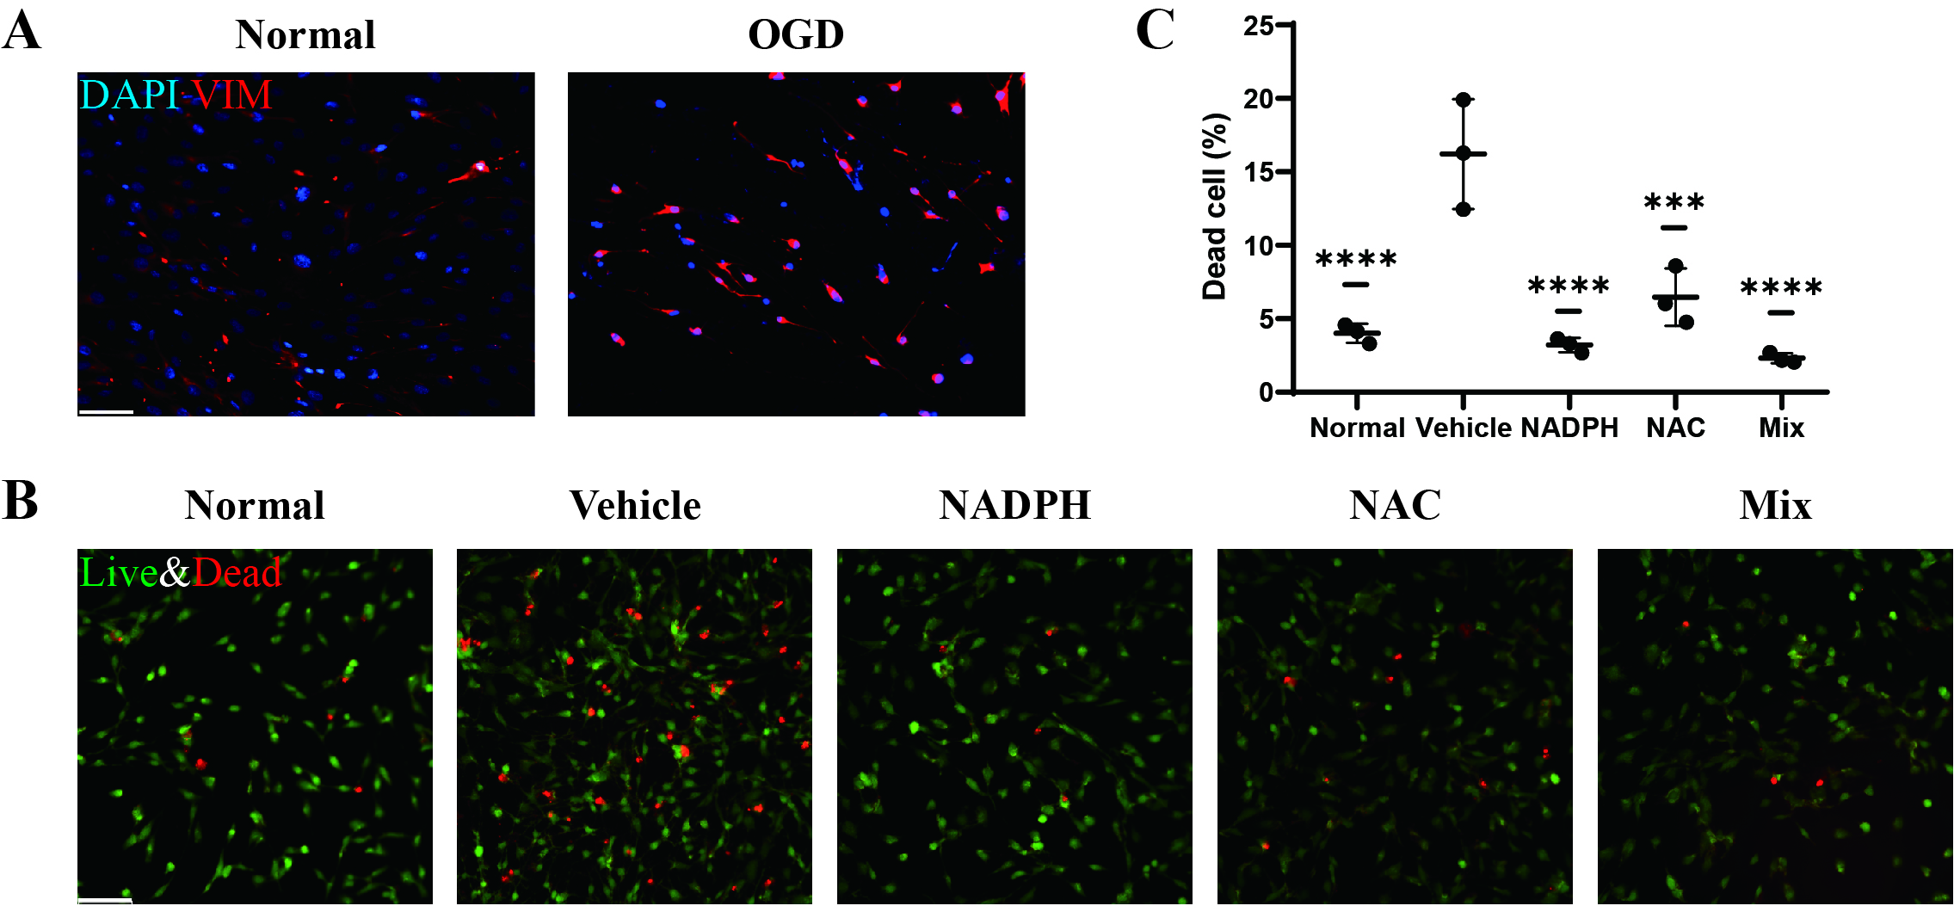
Figure S1. (A) VIM immunofluorescent images of Müller cells before and after ODG injury. (B) Representative live and dead cell staining of normal Müller cells and NADPH/NAC-treated OGD-injured Müller cells and (C) statistics of dead cell rate. Error bars = SD. Scale bars = 100 μm. Comparisons were conducted by one way ANOVA. ***: p < 0.001; ****: p < 0.0001.
Figure S2. (A) Representative Transwell assay images of normal Müller cells and NADPH/NAC-treated OGD-injured Müller cells, cocultured with supernatant from RGCs that have undergone OGD, and (B) statistics of migrated Müller cell number. (C) Representative DHE staining images of normal Müller cells and different concentrated NADPH/NAC-treated OGD-injured Müller cells and (D) statistics of DHE relative fluorescent intensity. Error bars = SD. Scale bars = 100 μm. Comparisons were conducted by one way ANOVA. **: p < 0.01; ****: p < 0.0001.
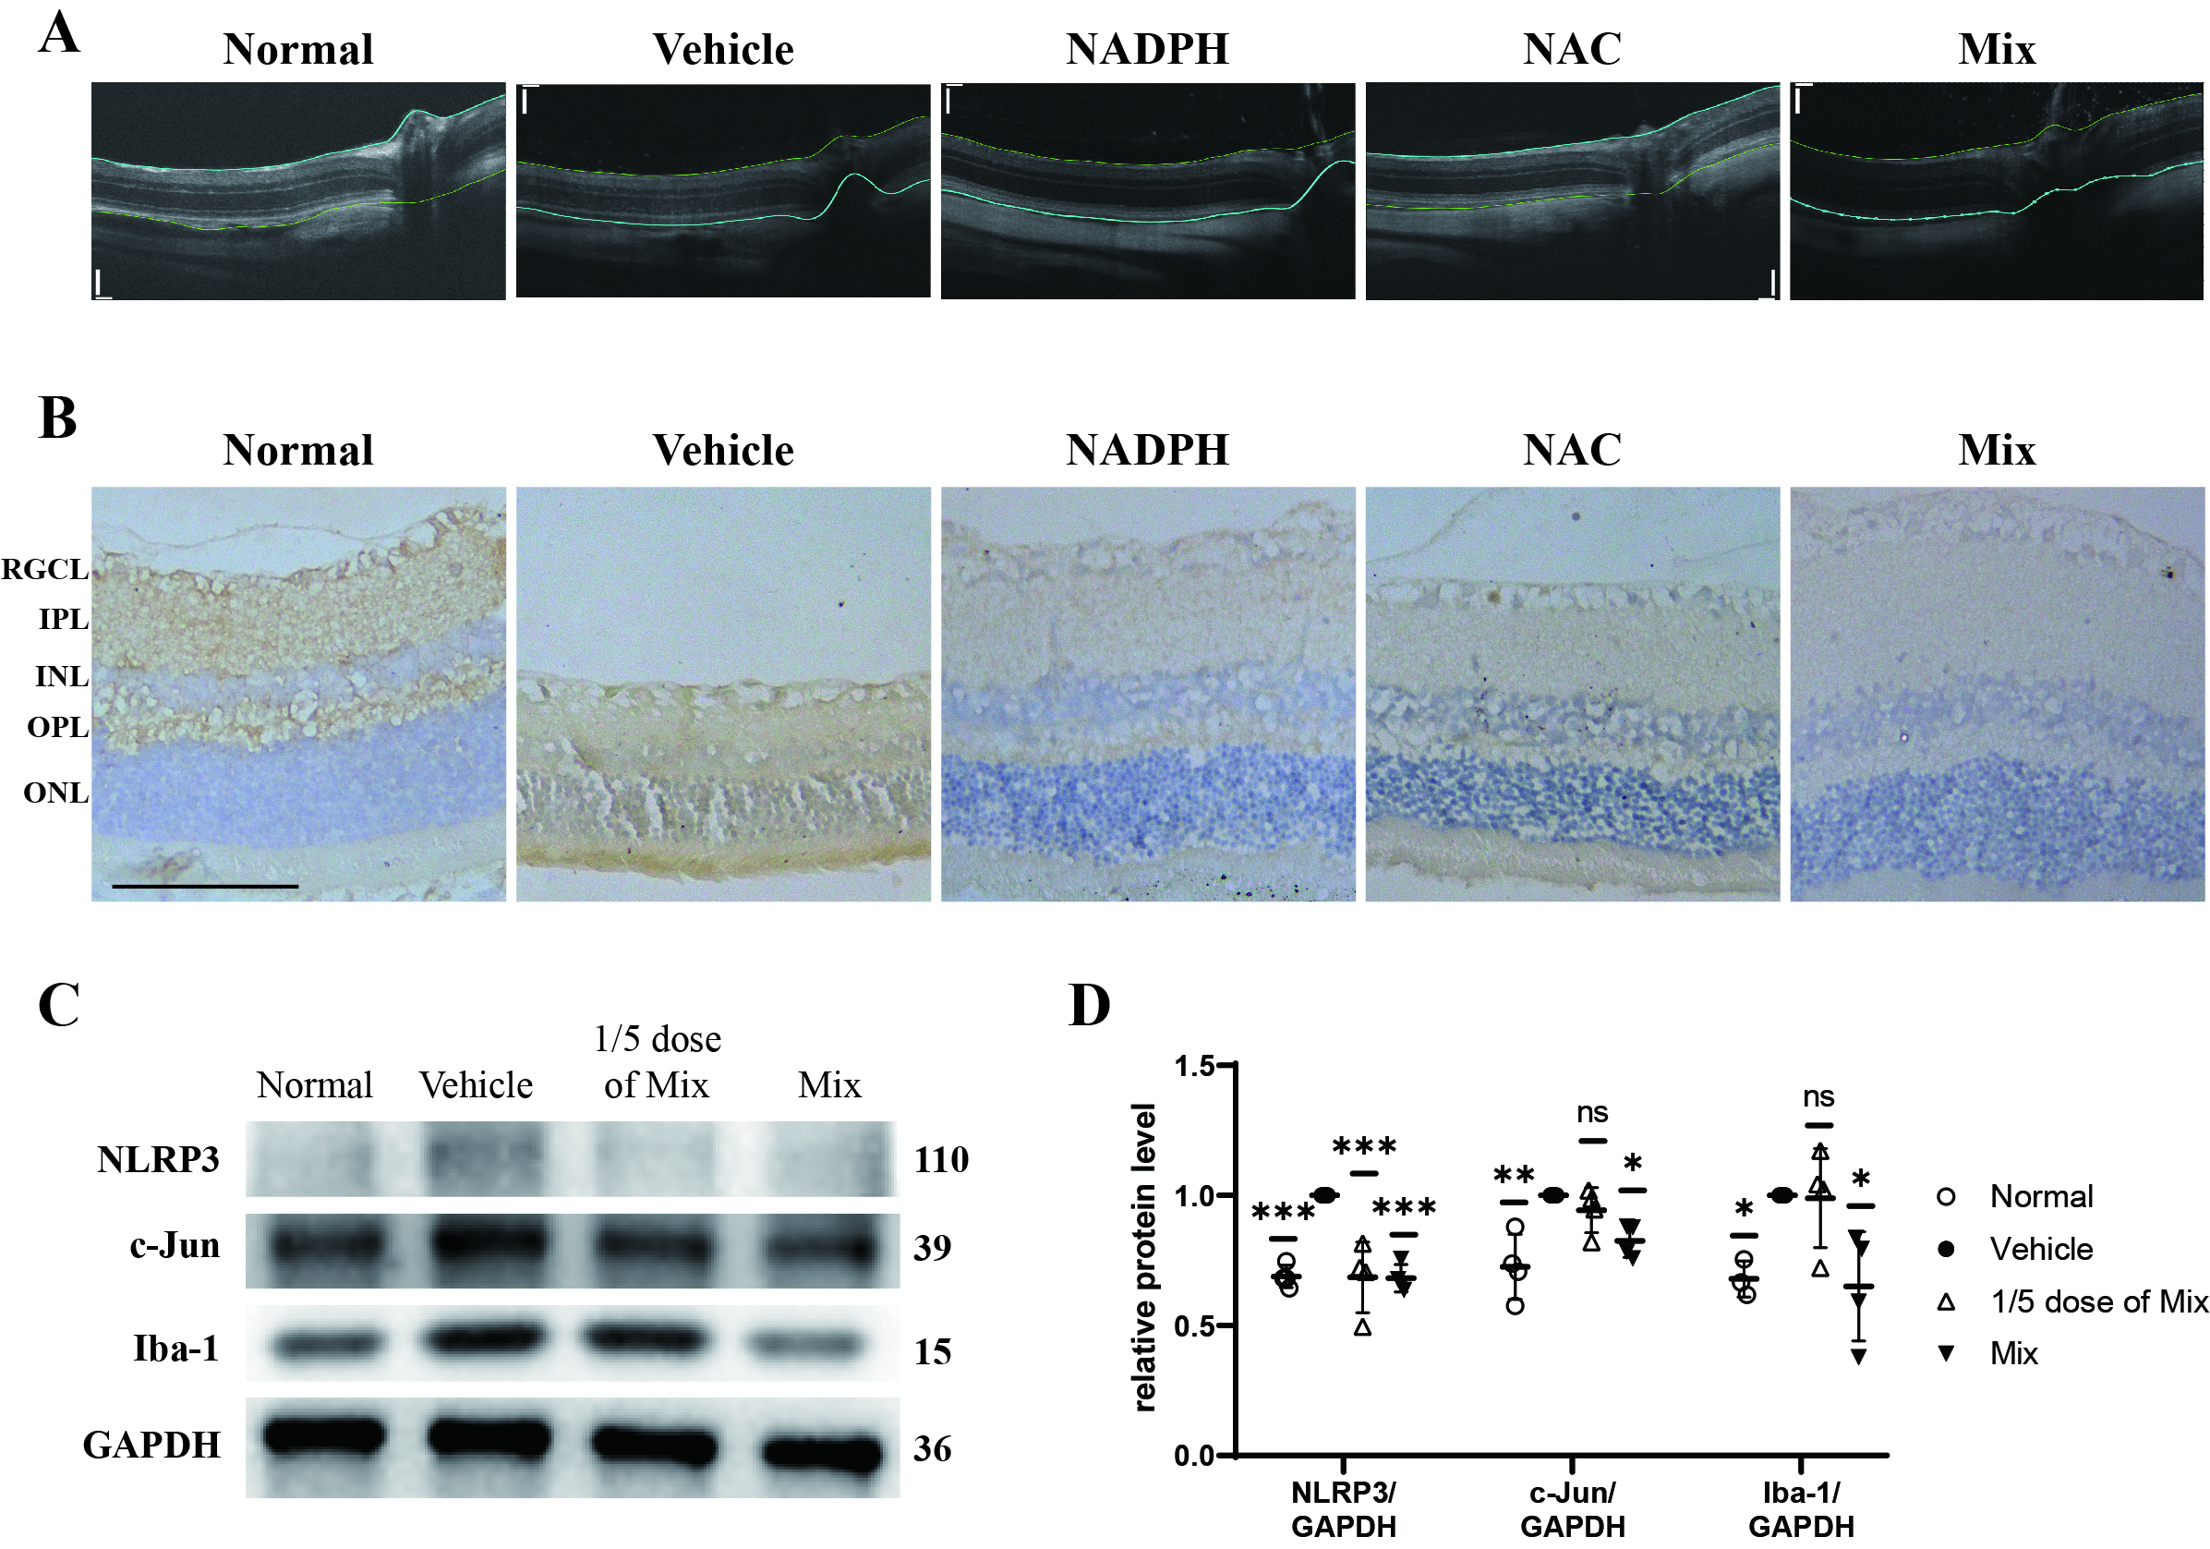
Figure S3. (A) Representative OCT images of a healthy rat retina and NADPH/NAC-treated COH rat retinas. Color lines delineated edges of retinas. (B) Representative p-p38 IHC images of a healthy rat retina and NADPH/NAC-treated COH rat retinas. (C) WB blots (numbers beside: molecular weight; unit: kDa) of NLRP3, c-Jun, Iba-1 from a healthy rat retina and different concentrated NADPH & NAC-treated COH rat retinas, and (D) statistics of its gray value. Error bars = SD. Scale bars = 100 μm. Comparisons were conducted by one way ANOVA. *: p < 0.05; **: p < 0.01; ***: p < 0.001.

