Nature Communications

Supplementary Materials for
Reaction hijacking inhibition of P. falciparum asparagine tRNA synthetase

Stanley C. Xie et al.
Corresponding authors: Elizabeth Winzeler (ewinzeler@health.ucsd.edu), Michael Griffin (mgriffin@unimelb.edu.au), Matthew Todd (matthew.todd@ucl.ac.uk), Leann Tilley (ltilley@unimelb.edu.au)

Spectra for compounds synthesized in this work:

OSM-S-106:

OSM-E-32:

OSM-S-488:

OSM-LO-80:

OSM-LO-81:

OSM-S-137:

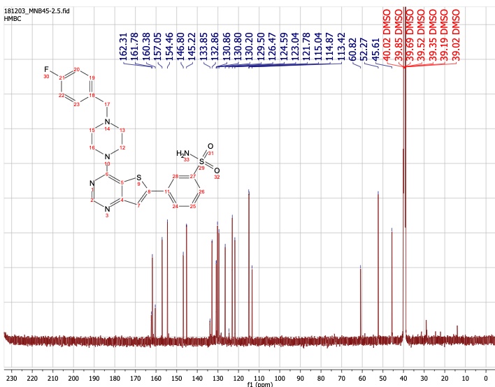

OSM-LO-87:

OSM-LO-88:

OSM-S-106-Asn adduct:
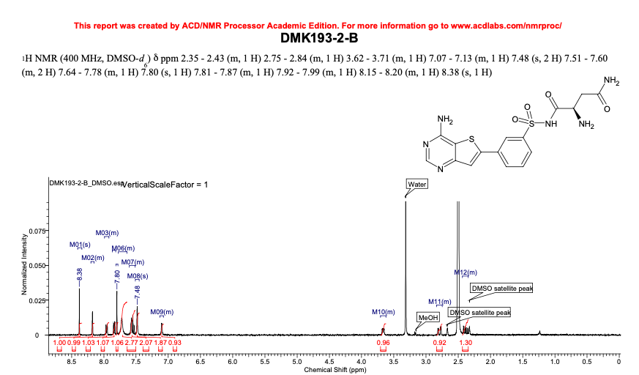
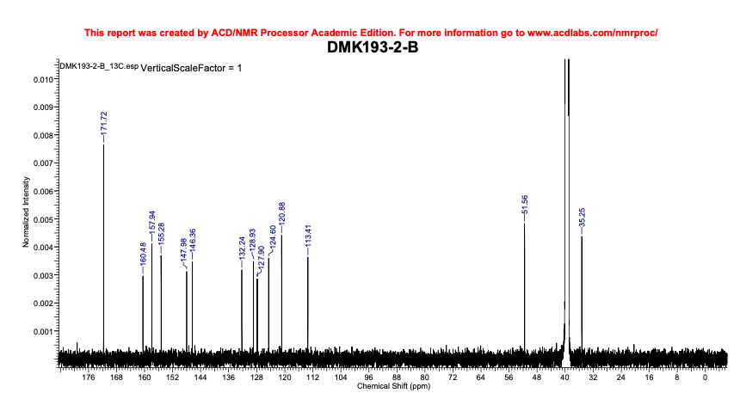

Asn-AMS adduct:
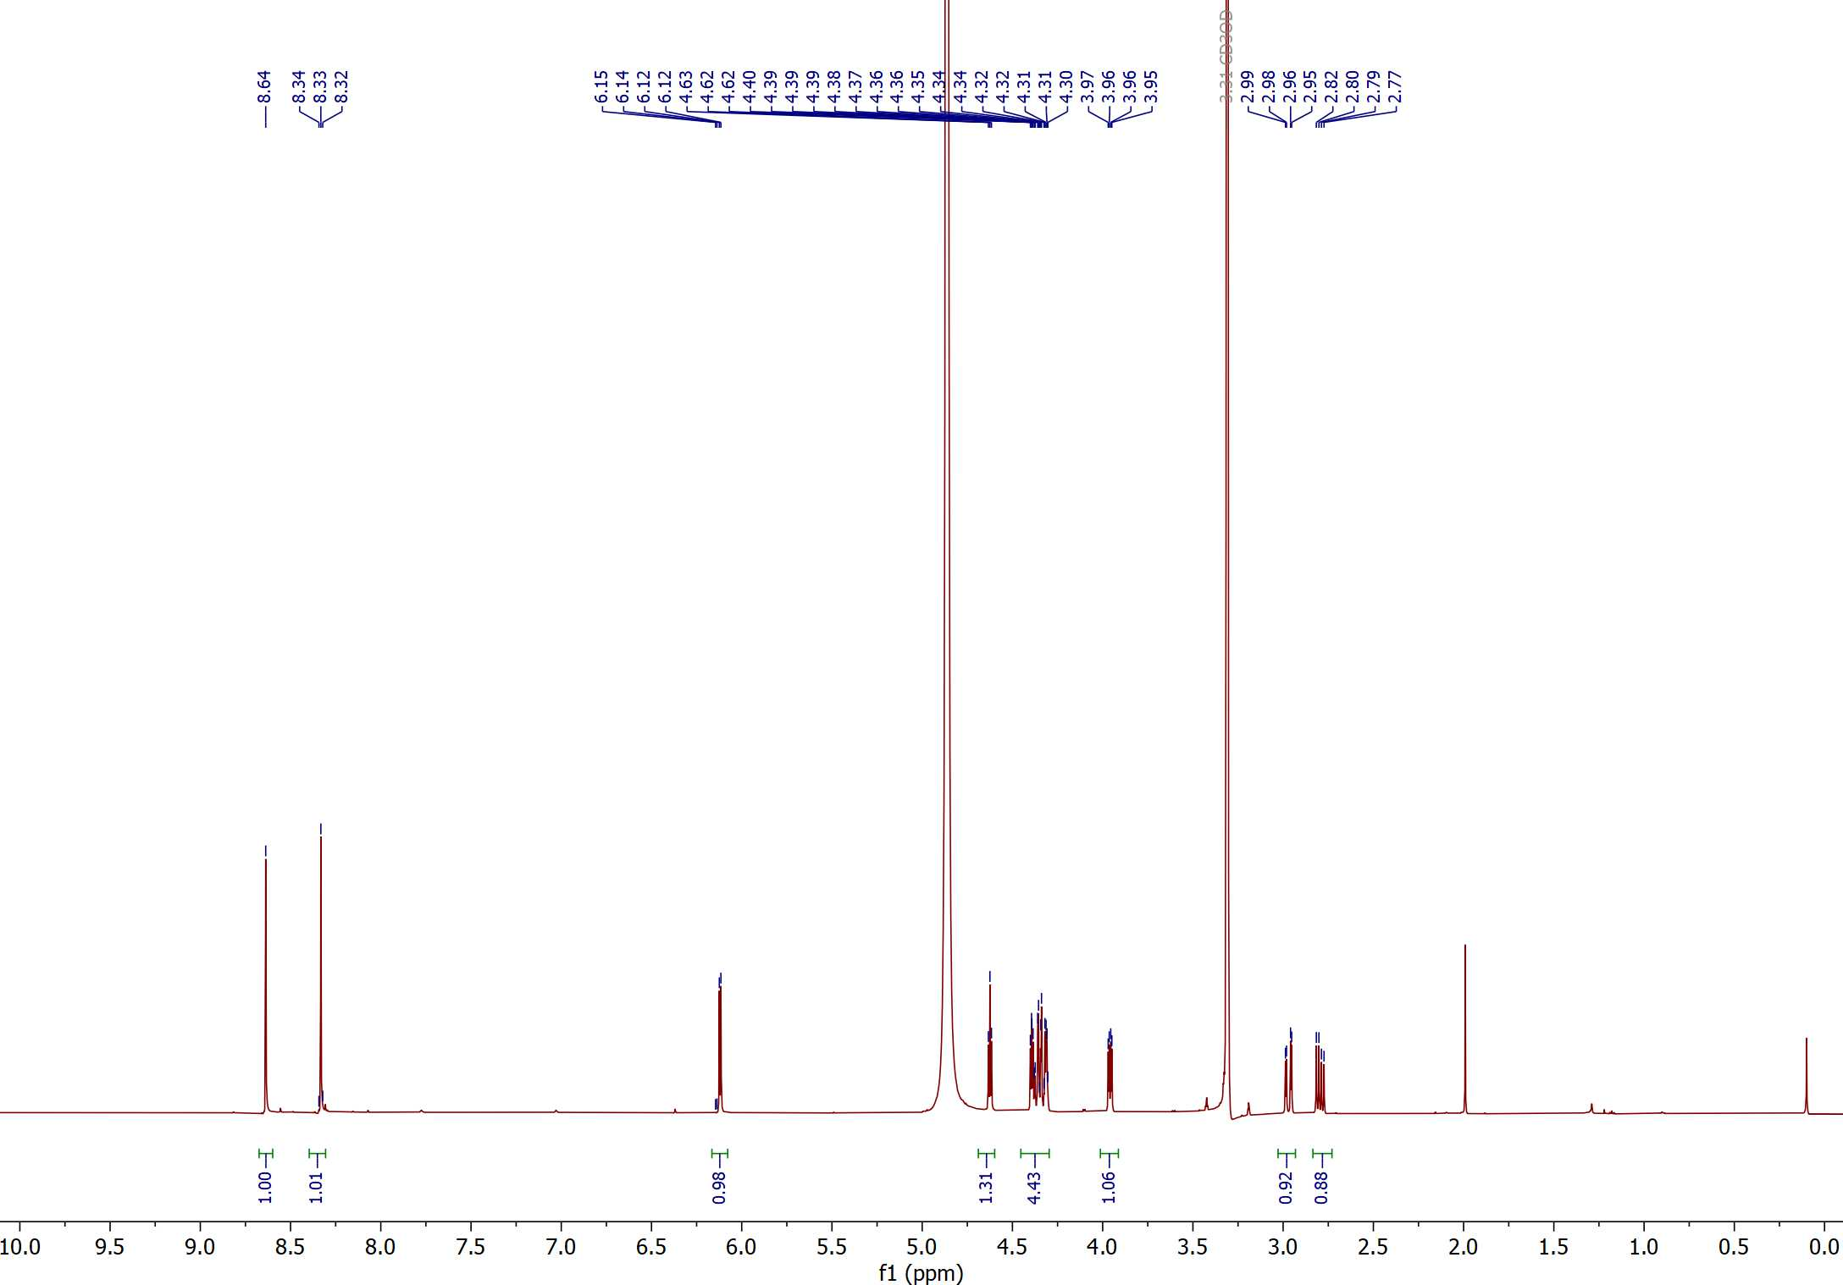

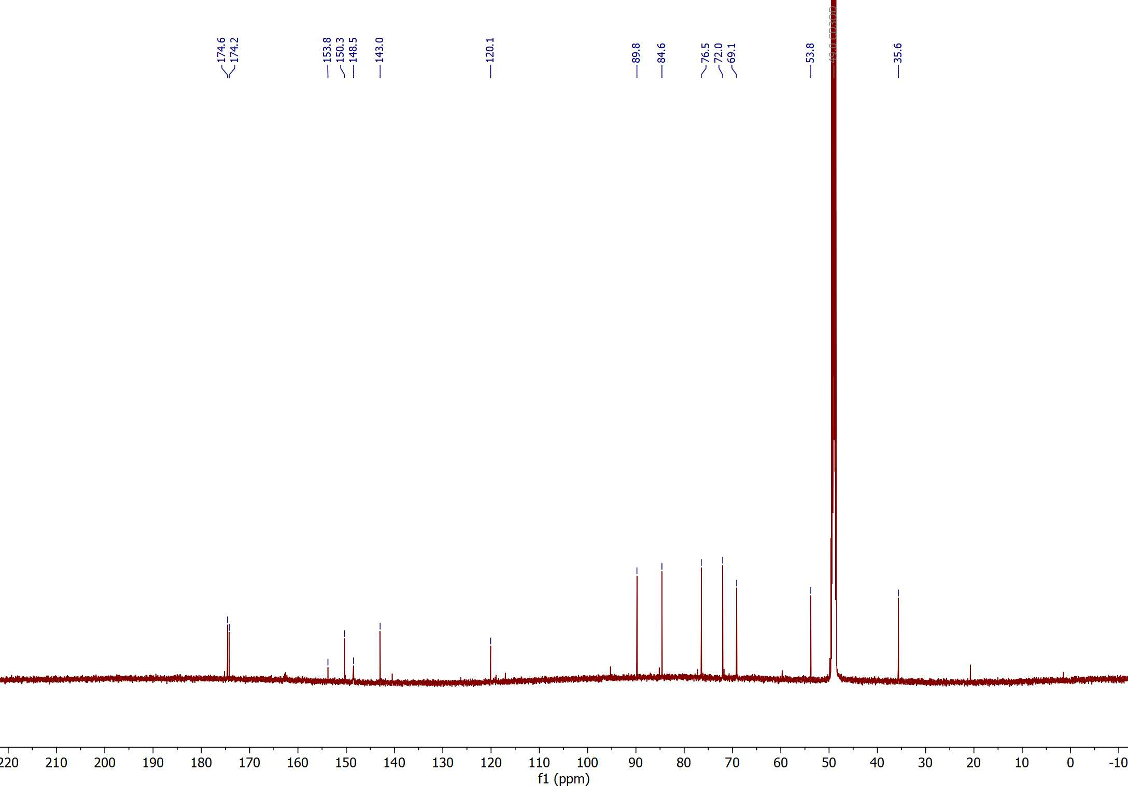

Asn-OSM-S-106：

