Aqueous extract of CAP-ash: An innovative approach for Suzuki-Miyaura coupling reaction in palladium catalyzed ligand-free condition

Rupesh C. Patil*, Suresh S. Patil
Synthetic Research Laboratory, PG Department of Chemistry, PDVP College (affiliated to Shivaji University, Kolhapur) Tasgaon, Sangli (MS), India-416312
*Corresponding author, Email: patilrupesh984@gmail.com
Supporting Information

Contents:
- XRF analysis of CAP-ash
- Measurements and chemicals
- Procedure for solvent preparation
- General procedure for the Suzuki reaction
- Spectral data of compounds
- ¹H and ¹³C NMR Spectra for some compounds

XRF analysis:
Preset Sample Data
Sample Name | SampleC | Dilution Material | SampleC
Description |  | Sample Mass (g) | 4
Method | Powder | Dilution Mass (g) | 0
Job Number | Rupesh_Patil | Dilution Factor | 1
Sample State | Powder, 24 mm | Sample rotation | Yes
Sample Type | Powder | Date of Receipt | ########
Sample Status | AXXAXXXA | Date of Evaluation | ########
Results
The error is the statistical error with 1 sigma confidence interval
Loss of Ignition | 48.7244 | %
Z | Symbol | Element | Norm. Int. | Concentration |  | Abs. Error
14 | SiO2 | Silicon | 0 | < 0.0011 | % | 0 | %
13 | Al2O3 | Aluminum | 105.9728 | 0.53 | % | 0.017 | %
19 | K2O | Potassium | 8106.982 | 40.5 | % | 0.06 | %
20 | CaO | Calcium | 606.219 | 4.346 | % | 0.032 | %
22 | TiO2 | Titanium | 14.0226 | 0.0748 | % | 0.0039 | %
11 | Na2O | Sodium | 0 | < 0.014 | % | 0 | %
12 | MgO | Magnesium | 328.3715 | 6.729 | % | 0.074 | %
15 | P2O5 | Phosphorus | 11154.28 | 11.62 | % | 0.02 | %
25 | MnO | Manganese | 30.5528 | 0.02743 | % | 0.00081 | %
26 | Fe2O3 | Iron | 766.1545 | 0.4701 | % | 0.0023 | %
16 | S | Sulfur | 6973.779 | 17220 | ppm | 30 | ppm
17 | Cl | Chlorine | 25163.31 | 29030 | ppm | 40 | ppm
23 | V | Vanadium | 1.4844 | 49 | ppm | 19 | ppm
24 | Cr | Chromium | 2.6373 | < 1.0 | ppm | 0 | ppm
27 | Co | Cobalt | 1.715 | < 3.0 | ppm | 0 | ppm
28 | Ni | Nickel | 5.145 | 6.7 | ppm | 0.8 | ppm
29 | Cu | Copper | 122.1391 | 177.5 | ppm | 2.4 | ppm
30 | Zn | Zinc | 150.3572 | 165.6 | ppm | 1.9 | ppm
31 | Ga | Gallium | 0 | < 0.5 | ppm | 0 | ppm
32 | Ge | Germanium | 0 | < 0.5 | ppm | 0 | ppm
33 | As | Arsenic | 0 | < 0.5 | ppm | 0 | ppm
34 | Se | Selenium | 0.9656 | < 0.4 | ppm | -0.4 | ppm
35 | Br | Bromine | 317.5617 | 128.9 | ppm | 1 | ppm
37 | Rb | Rubidium | 1458.521 | 348.8 | ppm | 1.3 | ppm
38 | Sr | Strontium | 559.3323 | 120.5 | ppm | 0.7 | ppm
39 | Y | Yttrium | 0 | < 0.5 | ppm | 0 | ppm
40 | Zr | Zirconium | 1.8669 | 6 | ppm | 1.7 | ppm
41 | Nb | Niobium | 0 | < 1.0 | ppm | 0 | ppm
42 | Mo | Molybdenum | 1.5383 | 2.8 | ppm | 0.8 | ppm
47 | Ag | Silver | 0 | < 2.0 | ppm | 0 | ppm
48 | Cd | Cadmium | 0 | < 2.0 | ppm | 0 | ppm
50 | Sn | Tin | 6.9897 | 11 | ppm | 1.2 | ppm
51 | Sb | Antimony | 2.3 | 0.1 | ppm | 0.1 | ppm
52 | Te | Tellurium | 3.9728 | < 3.0 | ppm | 0 | ppm
53 | I | Iodine | 5.3617 | 13 | ppm | 3.3 | ppm
55 | Cs | Cesium | 5.7202 | 41 | ppm | 11 | ppm
56 | Ba | Barium | 13.6657 | 97 | ppm | 11 | ppm
57 | La | Lanthanum | 8.3189 | 63 | ppm | 12 | ppm
58 | Ce | Cerium | 0 | < 2.0 | ppm | 0 | ppm
68 | Er | Erbium | - | < 5.1 | ppm | 0 | ppm
70 | Yb | Ytterbium | - | < 2.0 | ppm | 0 | ppm
72 | Hf | Hafnium | 0.1585 | < 1.0 | ppm | 0 | ppm
73 | Ta | Tantalum | 1.8159 | < 1.0 | ppm | 0 | ppm
74 | W | Tungsten | 0 | < 1.0 | ppm | 0 | ppm
80 | Hg | Mercury | 0.6341 | < 1.0 | ppm | 0 | ppm
81 | Tl | Thallium | 3.0697 | 2 | ppm | 0.4 | ppm
82 | Pb | Lead | 5.5773 | 4.9 | ppm | 0.6 | ppm
83 | Bi | Bismuth | 0.2162 | < 0.1 | ppm | -0.1 | ppm
90 | Th | Thorium | 13.9217 | 7.1 | ppm | 0.5 | ppm
92 | U | Uranium | 19.1243 | 1.4 | ppm | 0.2 | ppm
 |  | Sum |  | 69.04 | %

- Measurements and chemicals
All chemicals used in study were purchased from Merck (India) and Sigma Aldrich and used without further purification, except Bael fruit ash. Proton (¹H) and carbon-13 (¹³C) NMR spectra were recorded with a 400 MHz-bruker NMR instrument in DMSO as a solvent with tetramethylsilane (TMS) as an internal standard. Chemical shifts (δ) are reported in ppm. The completion of reaction and purity of products was monitored by TLC on Merck silica gel (60 F254) plates.
- Preparation of catalyst
The Custard apple (Annona squamosa) fruit peels were collected from a local agricultural farm. These peels have attached impurities that were removed before use by washing with distilled water, dried in the oven then cut into small pieces. After heating in a muffle furnace up to 800°C soft solid ash is obtained from small pieces. 5 gm soft ash was further suspended in 50 mL distilled water and carefully stirred for 1h at room temperature. CAP-ash water extract was obtained by simple filtration. The clear extract obtained was nominated as CAP-ash water extract (Fig.1) and utilized for the SM-coupling reaction.
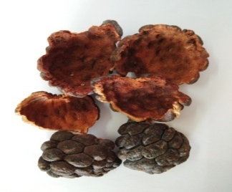 | 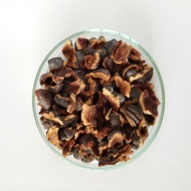 | 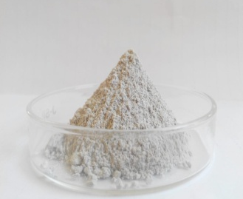 | 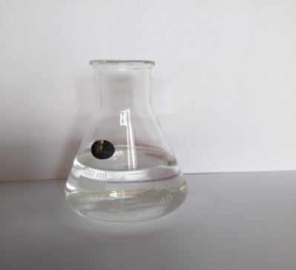
(a) | (b) | (c) | (d)
Fig. 1 Preparation of water extract

- General experimental procedure for Suzuki-Miyaura coupling reaction
All the Suzuki-Miyaura coupling reactions were conducted under air atmosphere in dried glassware. In a 25 mL round bottom flask equipped with a magnetic stirrer, aryl bromide (1.0 mmol), phenylboronic acid (1.2 mmol), Pd(OAc)₂ (0.5 mol%), water extract (3 mL) and EtOH (3 mL) were placed. The resulting reaction mixture was stirred at room temperature for appropriate time mentioned in Table 2. The progress of reactions was monitored by TLC. After completion of reaction, the bi-aryl product was extracted with ethyl acetate (3 × 10 mL). The organic layers were washed with brine. The combined organic layer was collected, dried over Na₂SO₄ and concentrated in vacuo. The residue was purified by column chromatography on silica gel to give corresponding pure bi-aryl products. The bi-aryl compounds were characterized by comparing ¹H, ¹³C NMR spectral data with authentic samples.

- Spectral data of compounds

4-nitrobiphenyl (Table 2, entry 3b)
¹H NMR (DMSO-d6, 400 MHz): δ_{H} (ppm) 7.42-7.52 (m, 3H), 7.61-7.64 (m, 2H), 7.72-7.75 (dd, 2H), 8.28-8.31 (dd, 2H). ¹³C NMR (DMSO-d6, 400 MHz): δ_{C} (ppm) 147.60, 147.06, 138.74, 129.12, 128.89, 127.77, 127.35, 124.07
Biphenyl-4-carbonitrile (Table 2, entry 3c)
¹H NMR (DMSO-d6, 400 MHz): δ_{H} (ppm) 7.73 (d, 2 H, J = 8.4 Hz), 7.69 (d, 2 H, J = 8.5 Hz), 7.58 (t, 2H,), 7.48 (t, 2 H), 7.42-7.37 (m, 1 H); ¹³C NMR (DMSO-d6, 400 MHz): δ_{C} (ppm) 145.5, 139.6, 132.5, 129.0, 128.5, 127.6, 127.5, 127.37, 127.34, 127.32, 127.1, 118.8, 110.7;
4- acetyl biphenyl (Table 2, entry 3d)
¹H NMR (DMSO-d6, 400 MHz): δ_{H} (ppm) 2.64 (s, 3H), 7.37-7.50 (m, 3H), 7.62 (d, 2H), 7.67 (d, 2H), 8.02-8.05(d, 2H); ¹³C NMR (DMSO-d6, 400 MHz): δ_{C} (ppm) 197.74, 145.77, 139.86, 135.83, 128.93, 128.89, 128.21, 127.25, 127.20, 26.64.
Biphenyl-4-carbaldehyde (Table 2, entry 3e)
¹H NMR (DMSO-d6, 400 MHz): δ_{H} (ppm) 1.08 (s, 1 H), 7.95 (d, 2 H, J = 1.5 Hz), 7.79 (d, 2 H, J = 1.5 Hz), 7.65 (d, 2 H), 7.49 (t, 2 H), 7.43 (t, 1 H); ¹³C NMR (DMSO-d6, 400 MHz): δ_{C} (ppm) 192.2, 145.8, 137.6, 133.5, 130.6, 130.3, 129.9, 128.1, 127.9, 127.8, 127.6, 127.5, 127.4;
3-nitro biphenyl (Table 2, entry 3f)
¹H NMR (DMSO-d6, 400 MHz): δ_{H} (ppm) 7.41-7.45 (m, 1H), 7.47-7.52 (m, 2H,), 7.59-7.64 (m, 3H), 7.90-7.93 (d, 1H), 8.18-8.21 (d, 1H), 8.45-8.46 (t, 1H); ¹³C NMR (DMSO-d6, 400 MHz): δ_{C} (ppm) 148.74, 142.88, 138.67, 133.03, 129.69, 129.15, 128.53, 127.15, 122.02, 121.96.
4-methoxybiphenyl (Table 2, entry 3g)
¹H NMR (DMSO-d6, 400 MHz): δ_{H} (ppm) 3.9 (s, 3H), 6.96-6.99 (d, 2H), 7.25-7.31(m, 1H), 7.39-7.43 (t, 2H), 7.51-7.56 (m, 4H). ¹³C NMR (DMSO-d6, 400 MHz): δ_{C} (ppm) 159.12, 140.81, 133.76, 128.69, 128.13, 126.71, 126.63, 114.17, 55.32
1,1'-biphenyl]-4-amine (Table 2, entry 3h)
¹H NMR (DMSO-d6, 400 MHz): δ_{H} (ppm) 6.74—6.78 (d, 2H), 7.08-7.10 (d, 2H), 7.24-7.42 (m, 4H), 7.44-7.48 (d, 1H), 7.49-7.58 (m, 2H). ¹³C NMR (DMSO-d6, 400 MHz): δ_{C} (ppm) 145.79, 141.14, 131.58, 128.64, 127.99, 126.87, 126.61, 126.38, 126.23, 117.76, 115.36, 113.89.
3-Methoxybiphenyl (Table 2, entry 3i)
¹H NMR (DMSO-d6, 400 MHz): δ_{H} (ppm) 7.62-7.59 (m, 2 H), 7.49-7.45 (m, 2 H), 7.41-7.38 (m, 2 H), 7.19-7.18 (m, 1 H), 7.14-7.12 (m, 1 H), 6.90 (ddd, 1 H), 3.86 (s, 3 H); ¹³C NMR (DMSO-d6, 400 MHz): δ_{C} (ppm) 161.7, 139, 129, 128.8, 128.5, 127.6, 127.5, 127.37, 127.34, 127.32, 127.2, 113, 57
4-phenyl benzophenone (Table 2, entry 3j)
¹H NMR (DMSO-d6, 400 MHz): δ_{H} (ppm) 7.38-7.43 (m, 1H), 7.46-7.52 (m, 4H), 7.58-7.66 (m, 3H), 7.69-7.72 (m, 2H), 7.82-7.85 (m, 2H), 7.88-7.91 (m, 2H). ¹³C NMR (DMSO-d6, 400 MHz): δ_{C} (ppm) 196.33, 145.22, 139.96, 137.75, 136.22, 132.35, 130.71, 129.98, 128.95, 128.29, 128.16, 127.28, 126.95.
1, 1’;4’,1'' terphenyl (Table 2, entry 3k)
¹H NMR (DMSO-d6, 400 MHz): δ_{H} (ppm) 7.35-7.39 (t, 2H), 7.46-7.49 (t, 4H), 7.70-7.72 (d, 4H), 7.76 (s, 4H). ¹³C NMR (DMSO-d6, 400 MHz): δ_{C} (ppm) 139.57, 139.12, 128.97, 127.51, 127.17, 126.55
- Spectral data of isolated compounds

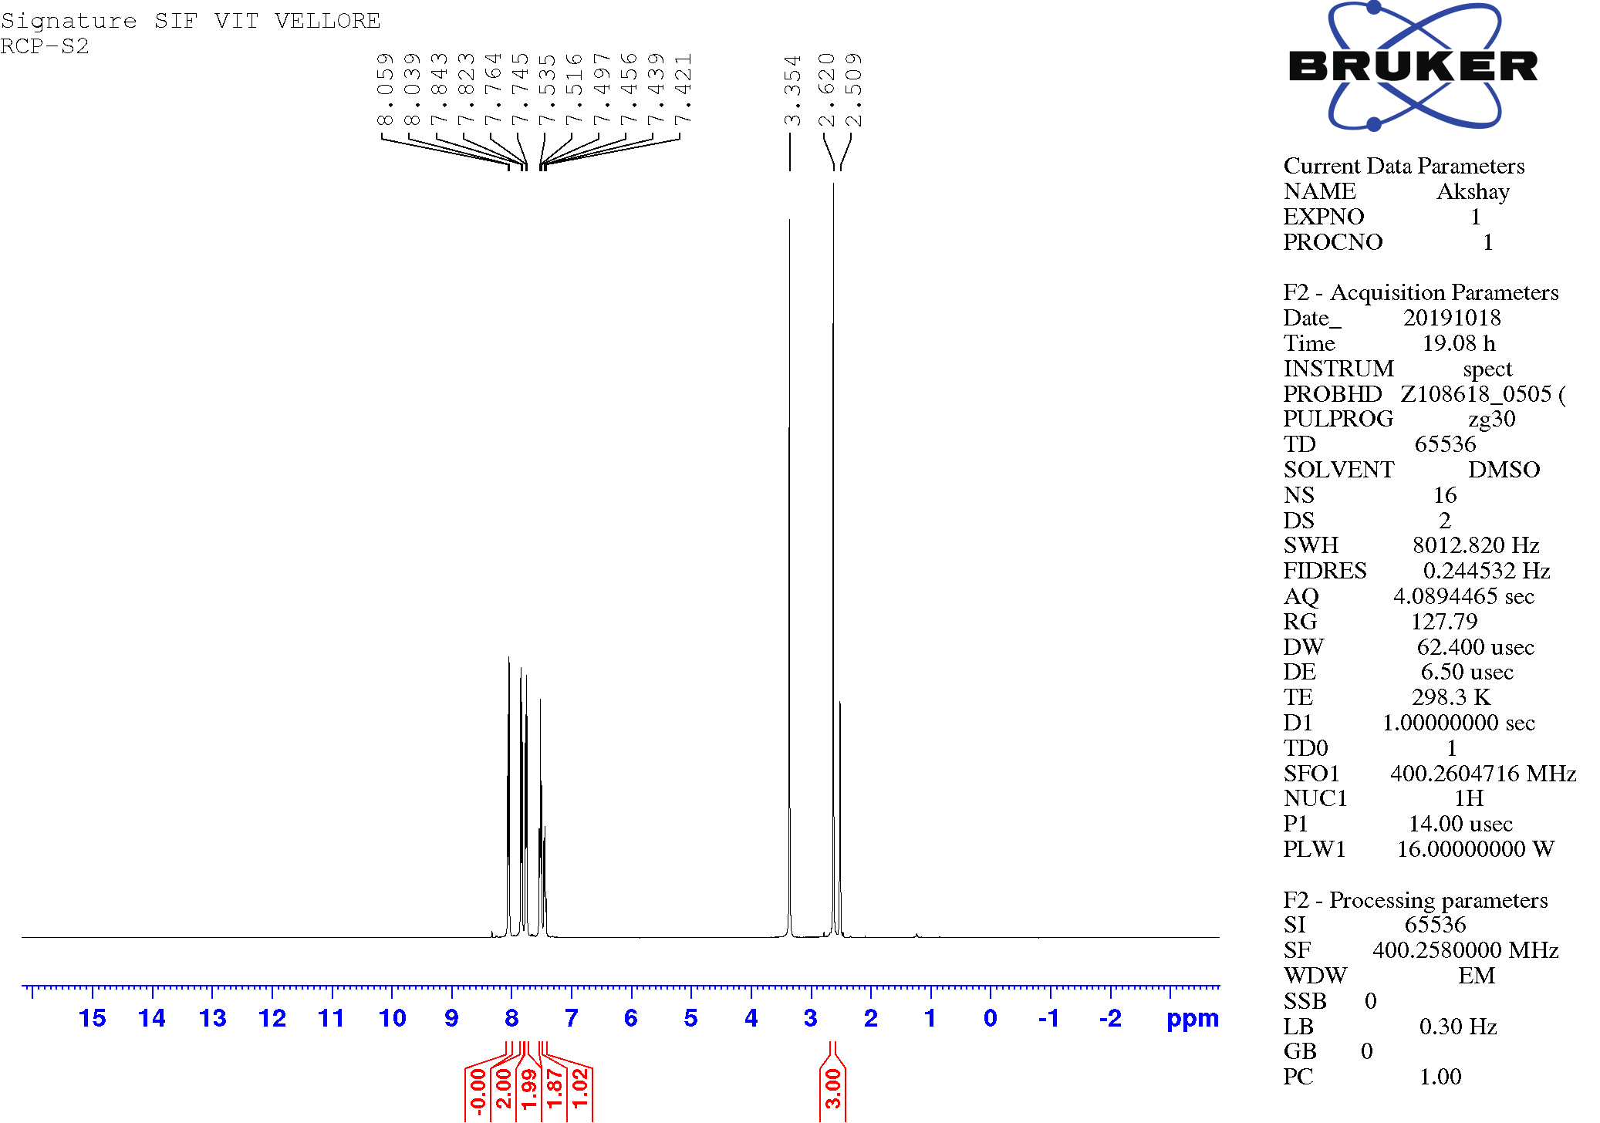
Fig. 1. ¹H NMR spectrum of compound 3j
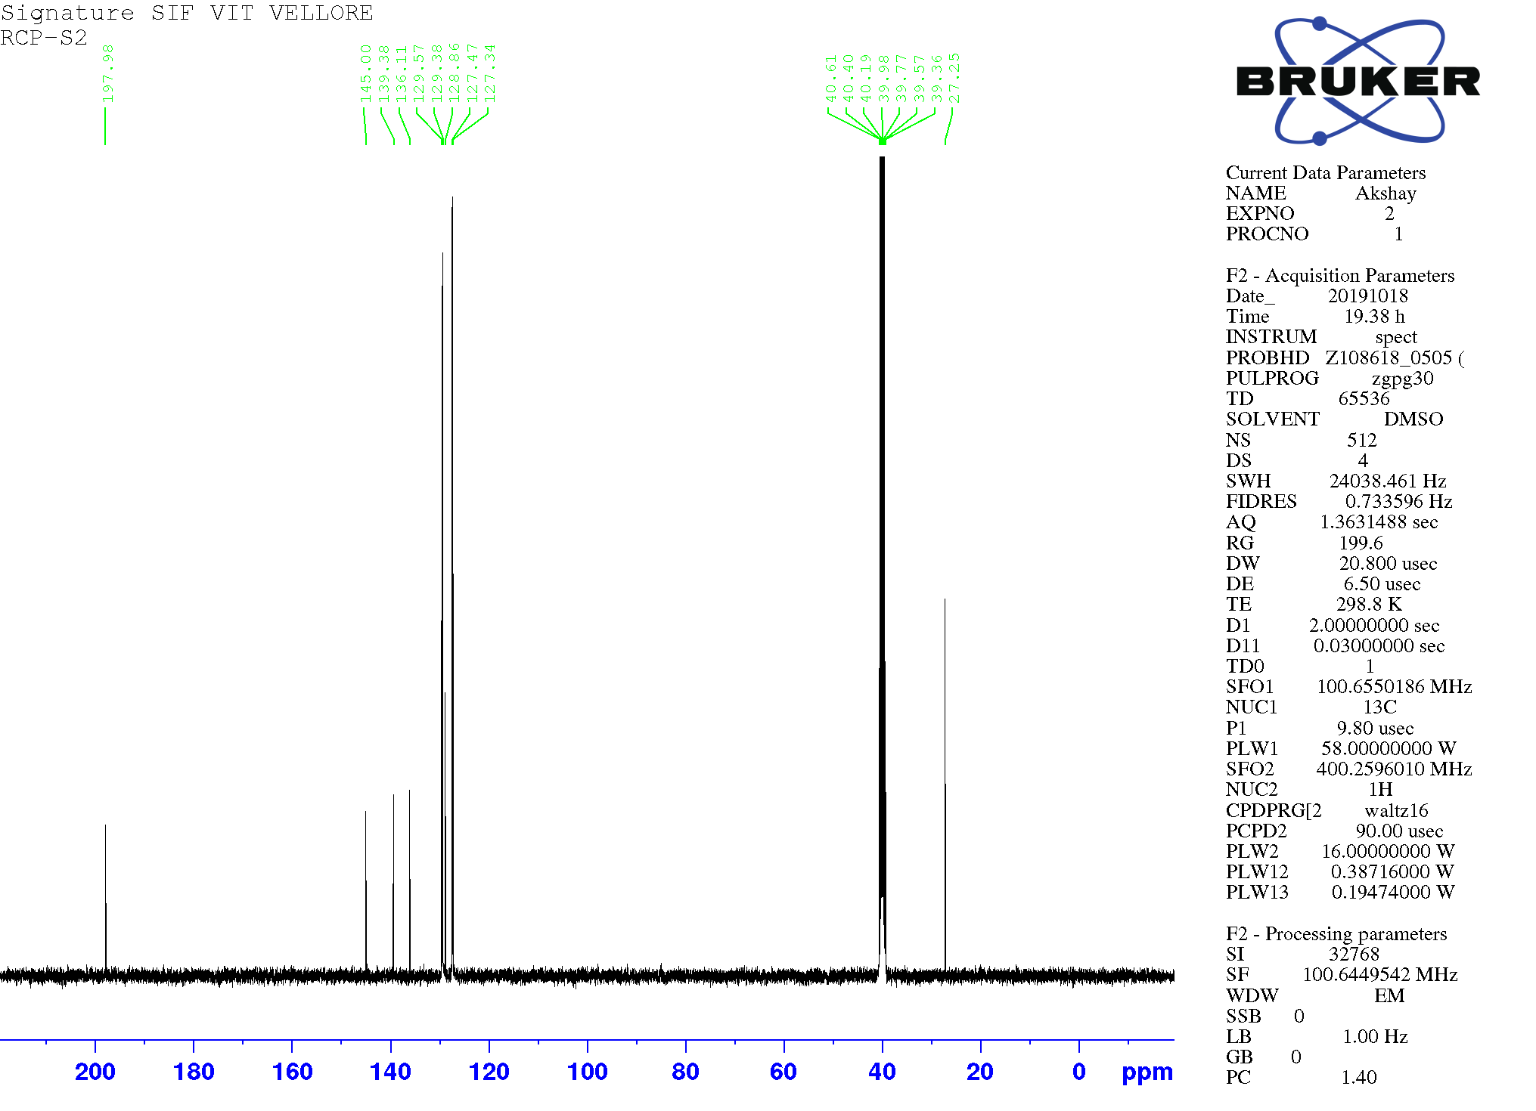
Fig. 2. ¹³C NMR spectrum of compound 3j
Fig. 3. Mass spectrum of compound 3j
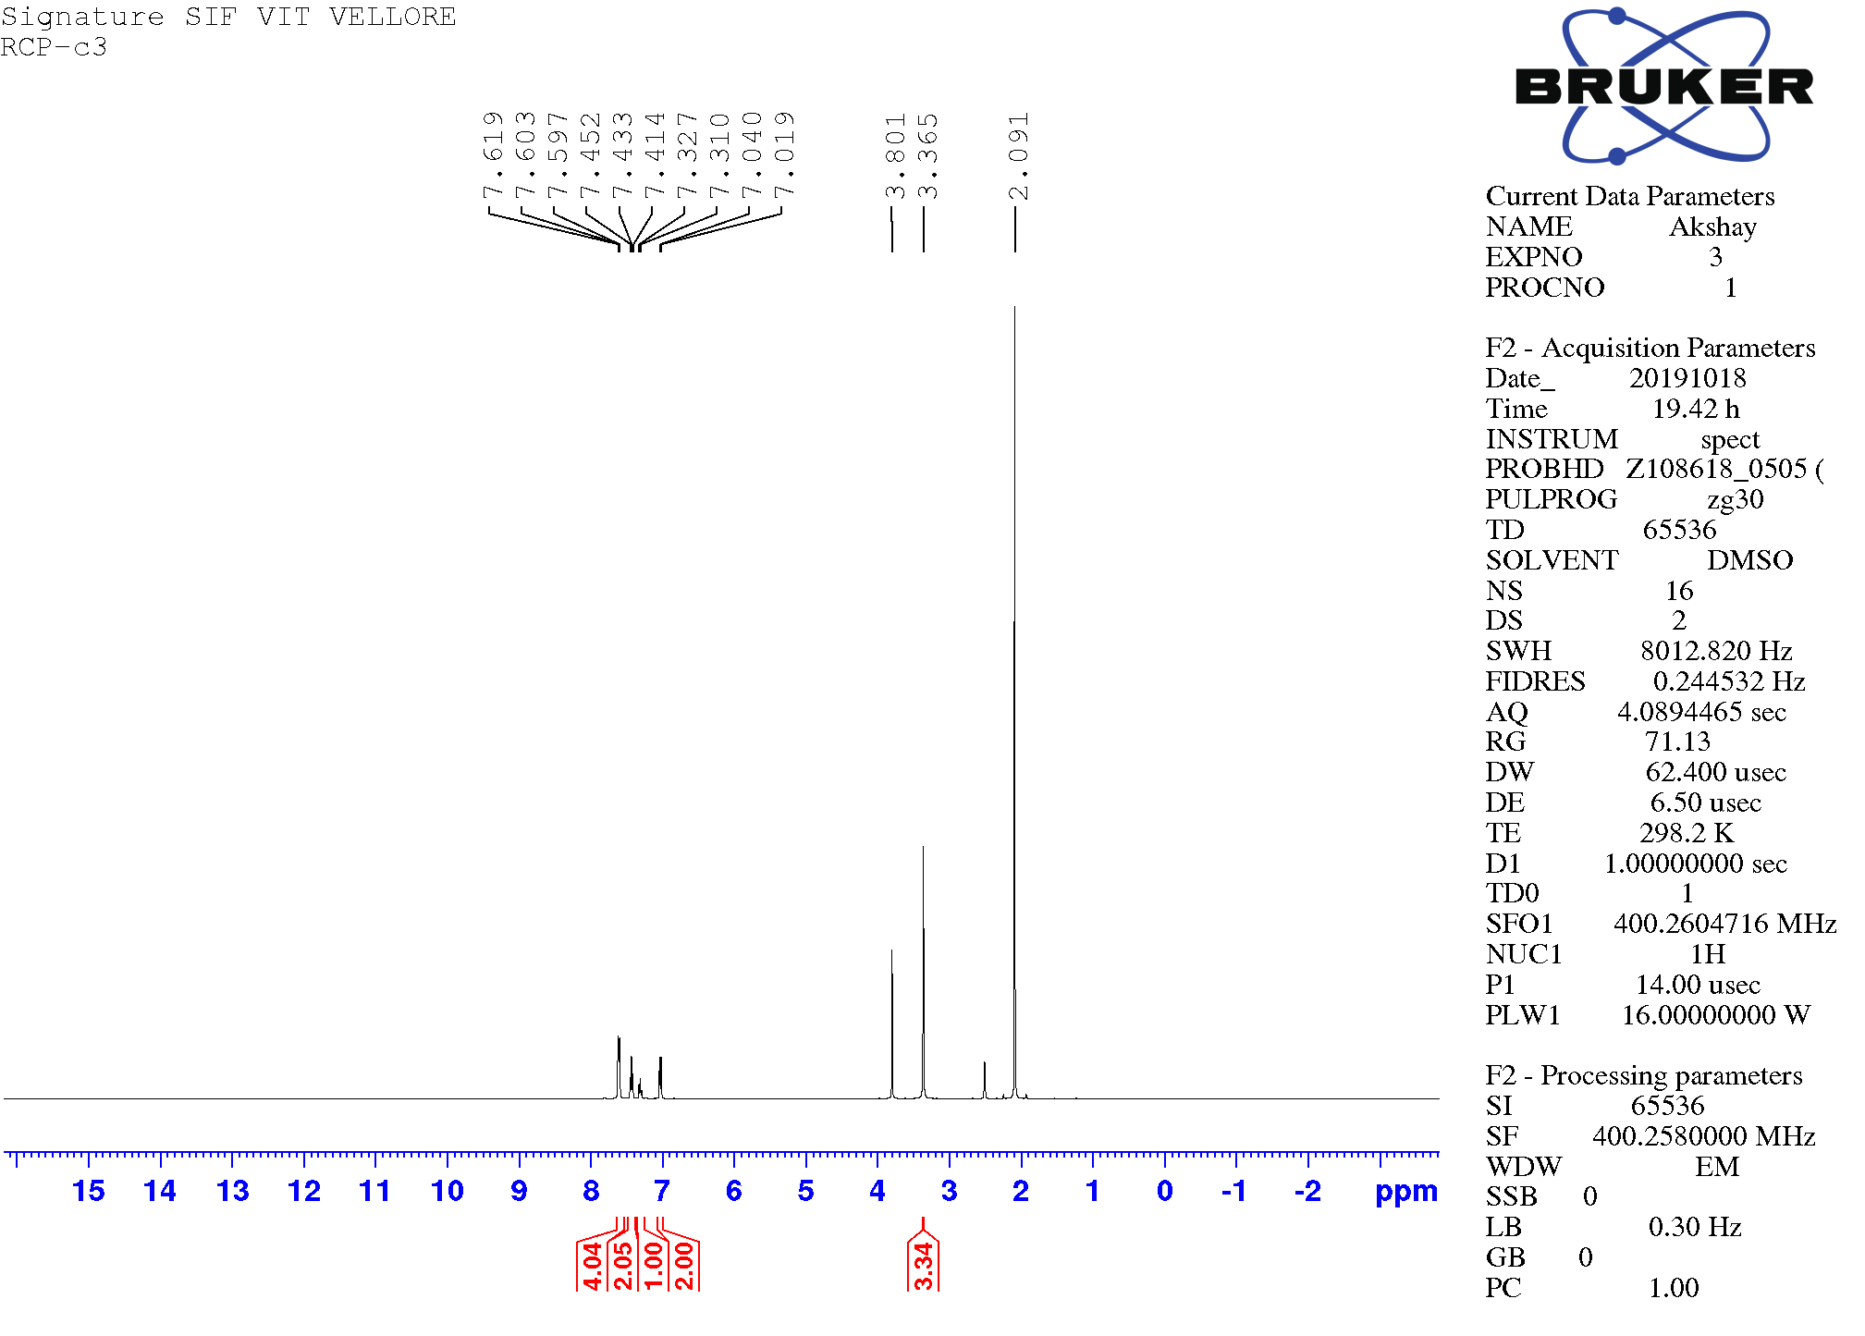
Fig. 4. ¹H NMR spectrum compound 3g
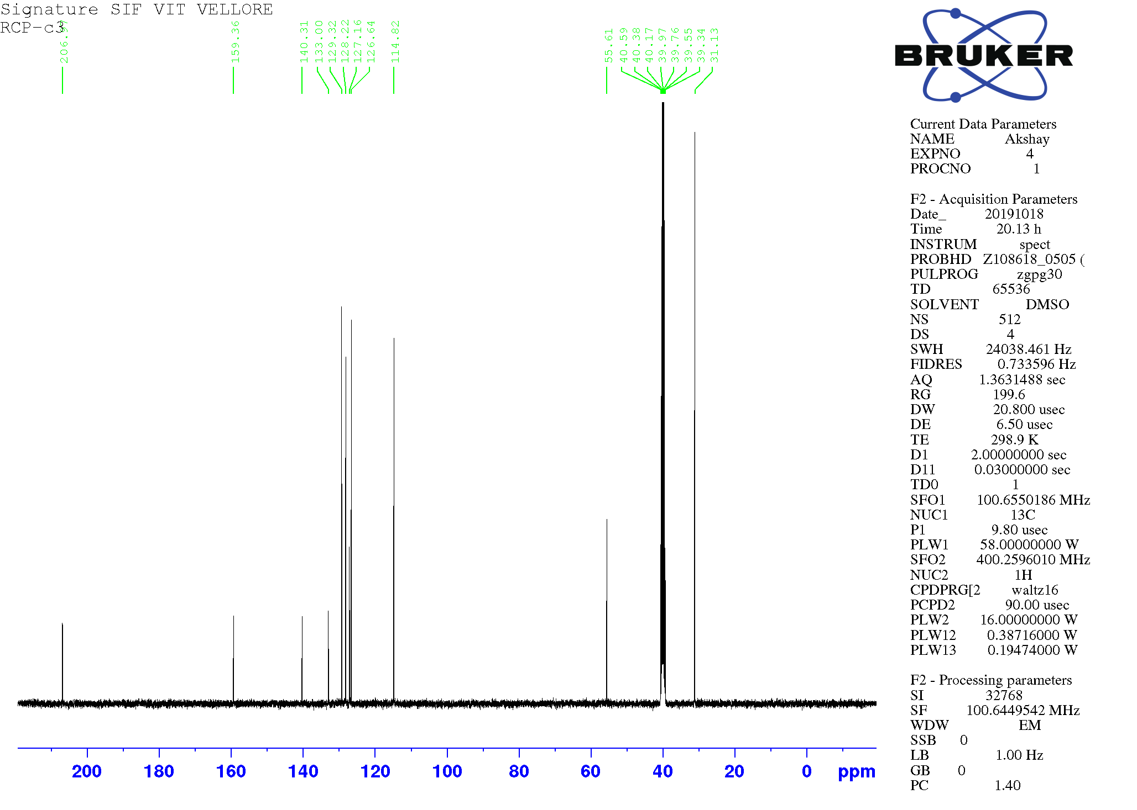
Fig. 5. ¹³C NMR spectrum of compound 3g
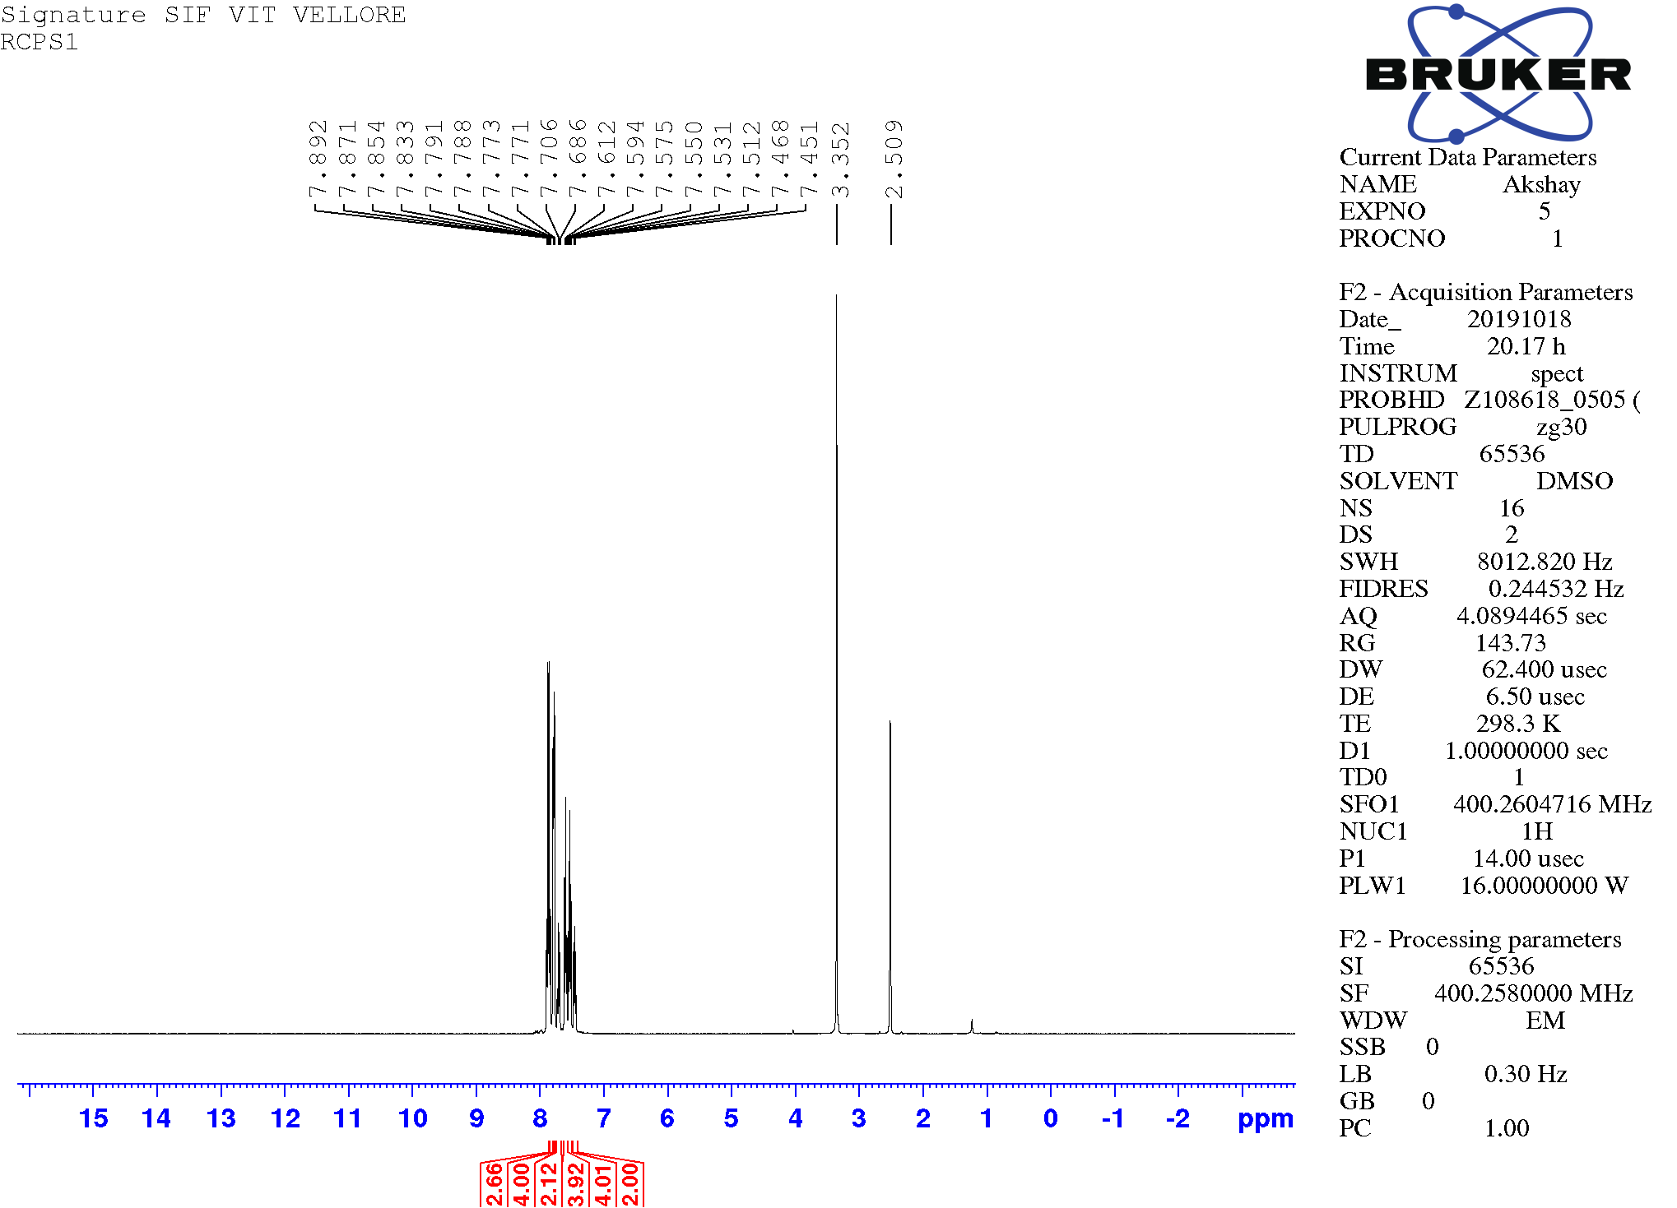
Fig. 6. ¹H NMR spectrum of compound 3d
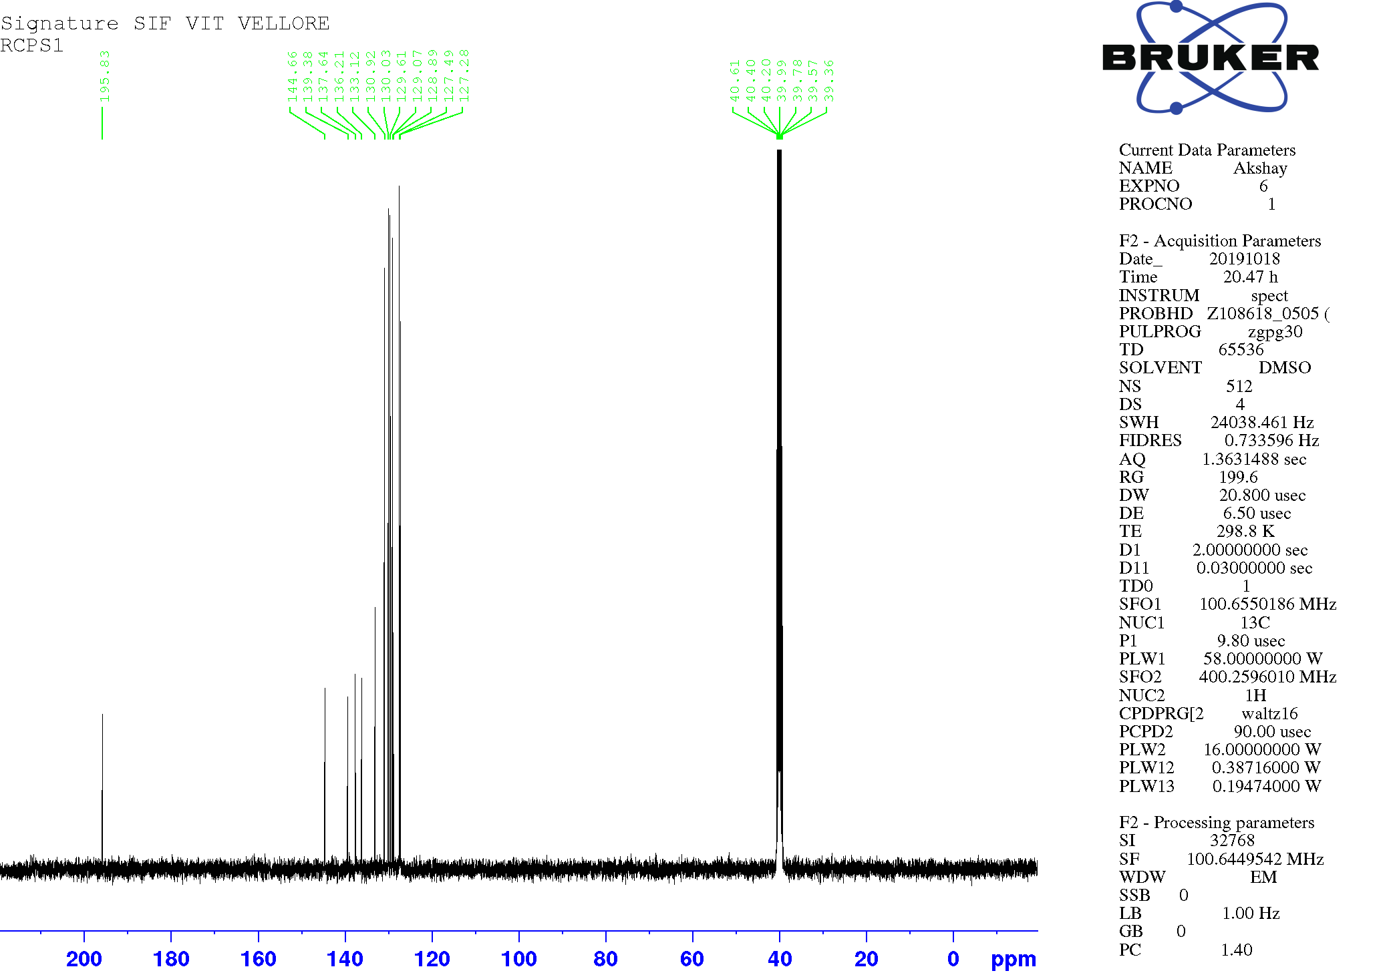
Fig. 7. ¹³C NMR spectrum of compound 3d
Fig. 8. Mass spectrum of compound 3f

