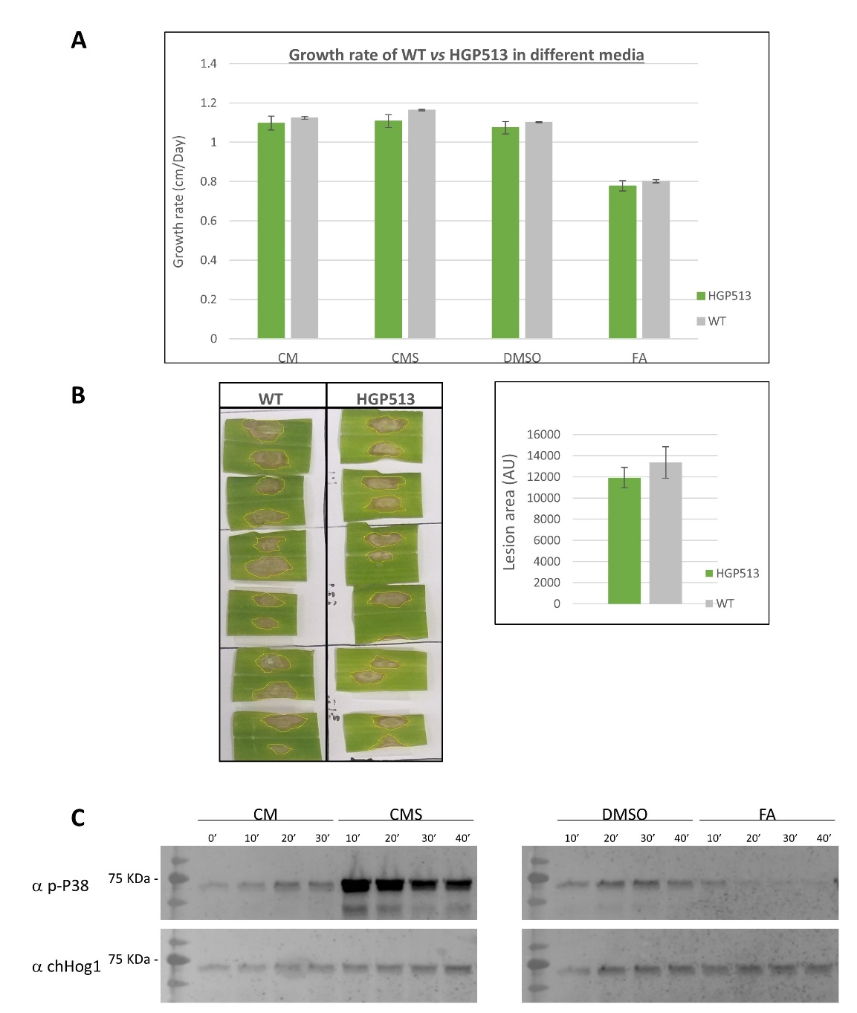

Figure S1. Functional validation of Hog1:GFP fusion protein strain (HGP513) in comparison to the WT. A. C. heterostrophus WT strain C4 and cells expressing Hog1:GFP fusion protein (HGP513) were grown on selective plates as indicated: CM (Control), CMS (CM supplemented with 1 M sorbitol for osmotic stress), DMSO (CM supplemented with DMSO, the ferulic acid solvent) or FA (CM supplemented with DMSO and 2 mM ferulic acid). Colony diameter was measured for 8 days. B. The strains were inoculated by agar blocks on the third leaf of 3-week-old maize plants and incubated for 96 h in a clear plastic bag to provide 100% relative humidity. Lesion areas were measured. Error bars indicate SEM for 6 leaves, 12 lesions. t test p-value > 0.05 C. Cells expressing Hog1:GFP fusion protein were grown and treated as for Figure 1A. Samples were collected by scraping from the plates immediately, or after the indicated times. Proteins extracted were subjected to immunoblot analysis using anti phospho P38 antibody or anti total ChHog1 antibody.

Figure S2. Hog1:Gfp localization: timeline of response to osmotic stress, phenolic acids and heat shock. C. heterostrophus cells expressing Hog1:GFP fusion protein were prepared, treated, fixed and imaged as for Figure 1. Sampling was at 10, 30 and 60 min after which induction media was removed, cells were washed once with CM and incubated for an additional 1 h in fresh CM (60 min-R).

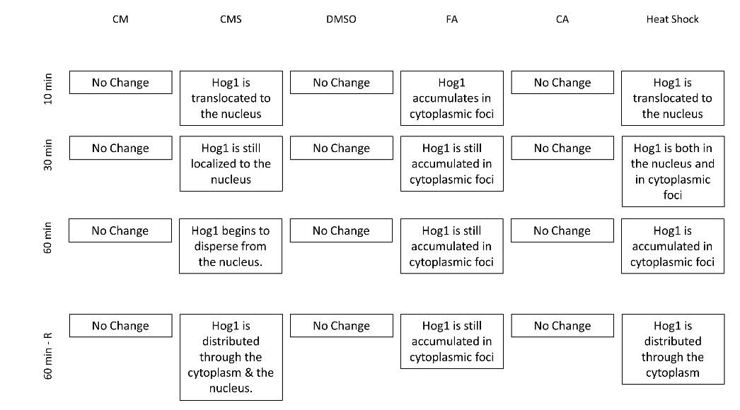
A. summary of treatments and results.
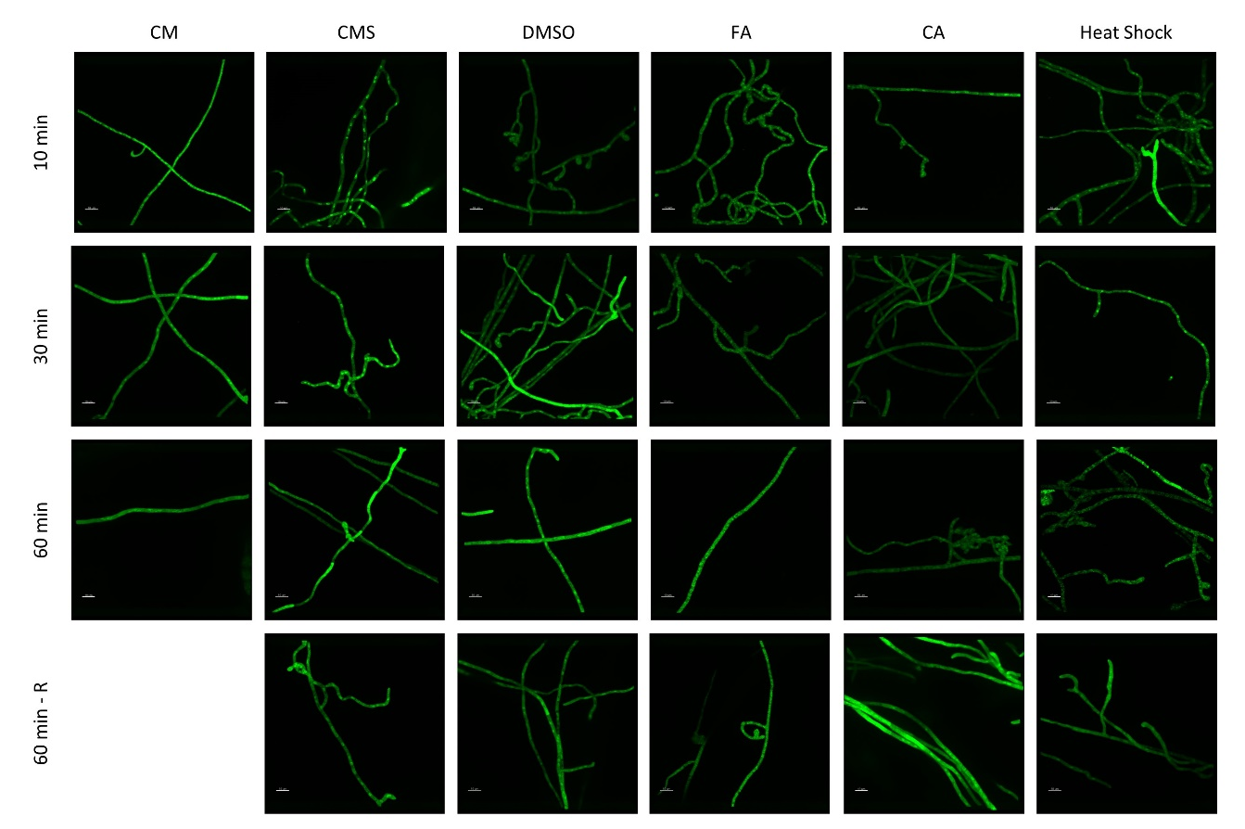
B. GFP channel
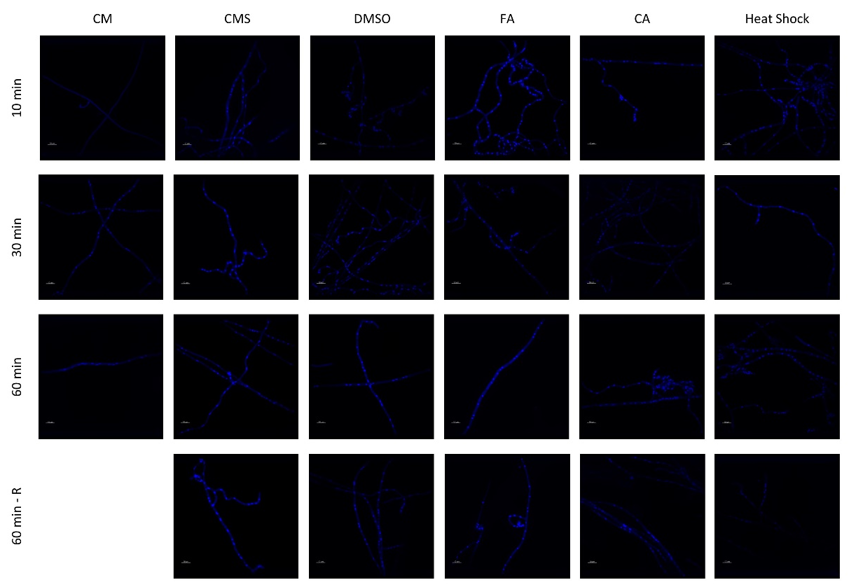
C. DAPI channel

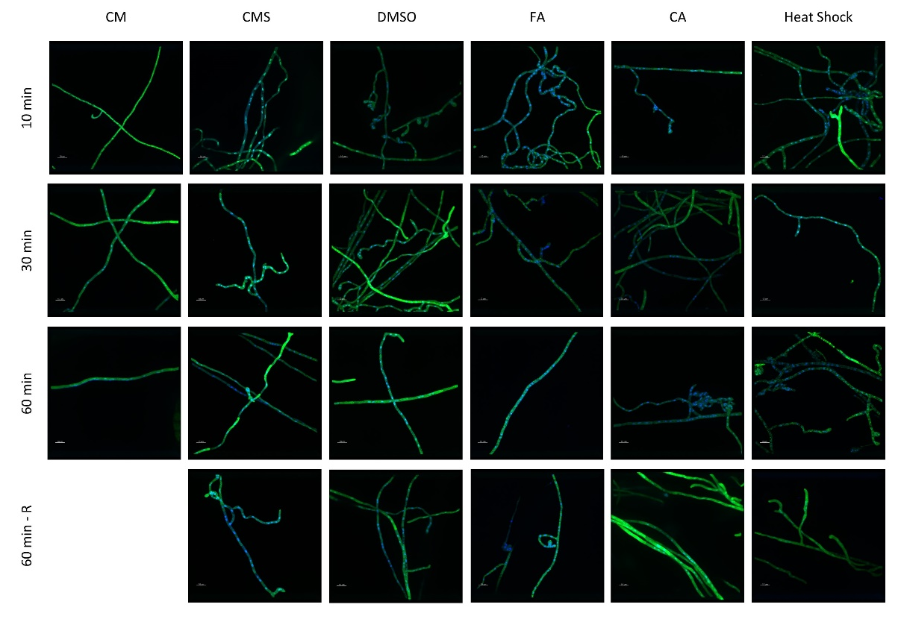

D. GFP & DAPI channels overlay.

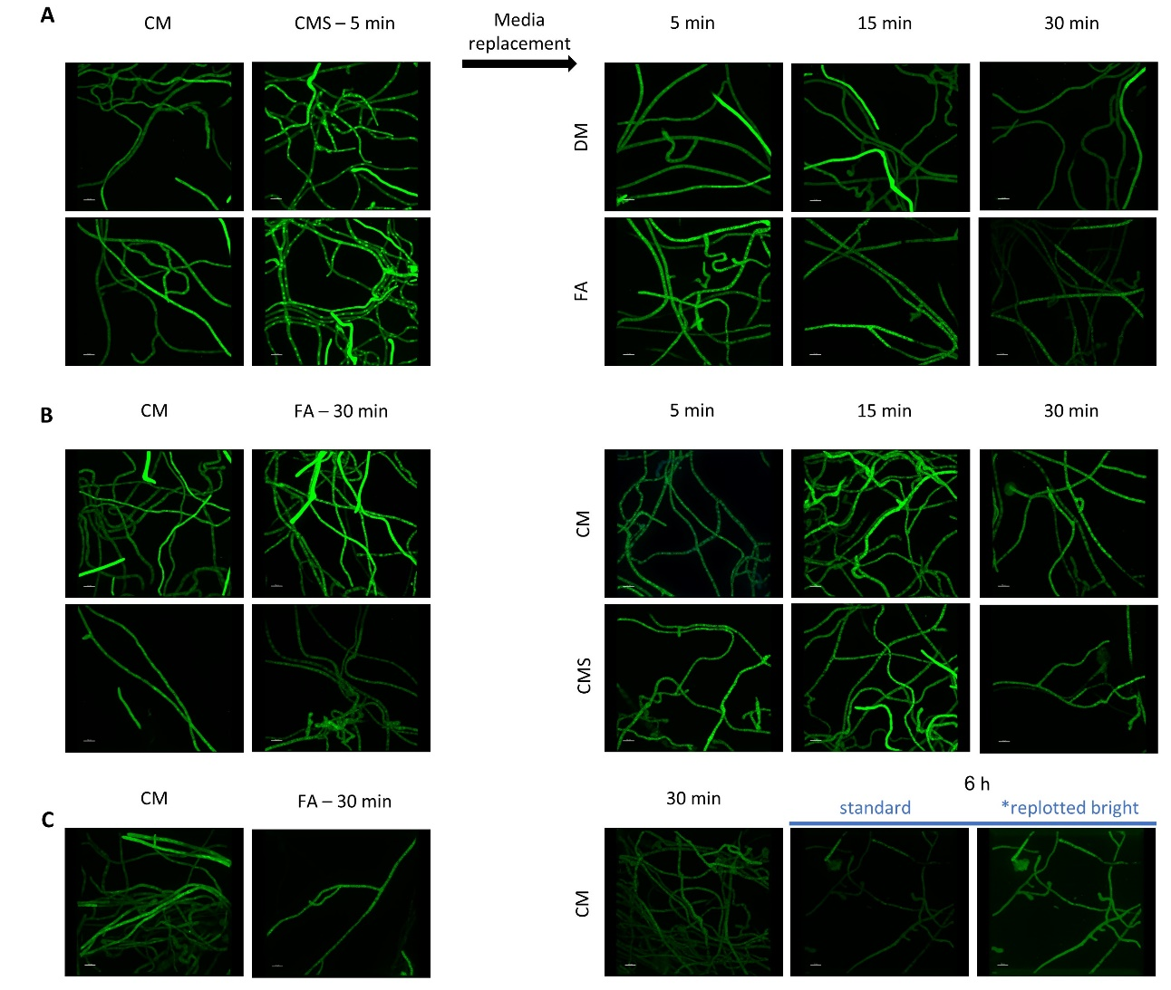

Figure S3. Sequential and combined induction. C. heterostrophus cells expressing Hog1:GFP fusion protein, were grown and prepared as for Figure 1. Sequential induction (SI) was done as follows:
A. SI CMS-FA – CM media was replaced with CMS, incubated 5 min at RT, the medium was removed, and cells were exposed to either: DMSO (CM supplemented with DMSO) or FA.
B . SI FA-CMS – CM was replaced with FA, incubated 30 min at RT, the medium was removed, and cells were exposed to either CM or CMS.
C. SI FA-CM- CM was replaced with FA, incubated 30 min at RT and then the medium was removed, and cells were returned to CM in order to follow foci abolishment. The final panel (6 h) is replotted at higher brightness to aid visualization despite loss of fluorescence over 6 h; note that by 6 h after removal of FA most foci have disappeared.

Figure S4. Localization of Hog1:GFP in comparison to peroxisomes and mitochondria.

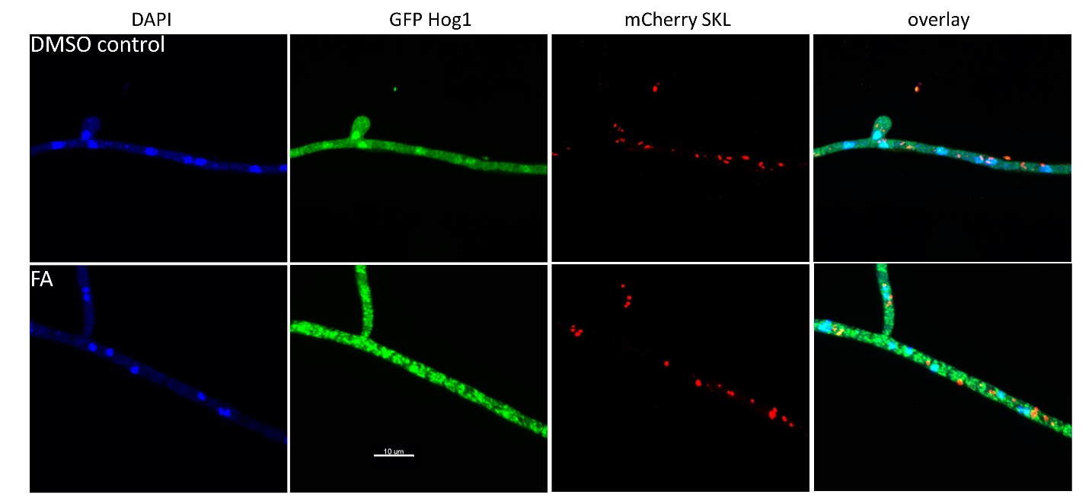

A. A peroxisomal marker does not colocalize with Hog1:GFP. C. heterostrophus cells expressing Hog1:GFP fusion protein and mCherry (under Pgpd1 promotor) with a SKL signal peptide at the C-terminus were prepared and imaged as for Figure 1.

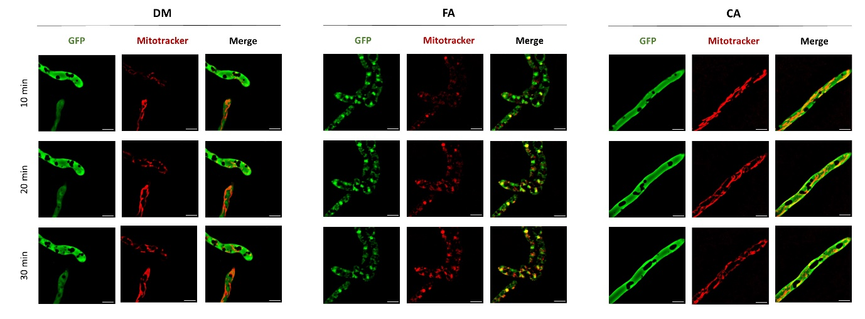
B. Mitochondrial dynamics in relation to Hog1:Gfp. C. heterostrophus cells expressing Hog1:GFP fusion protein were induced as indicated, stained with MitotrackerTM Deep Red, imaged as for Figure 1 and processed using FIJI ImageJ tool with background subtraction.

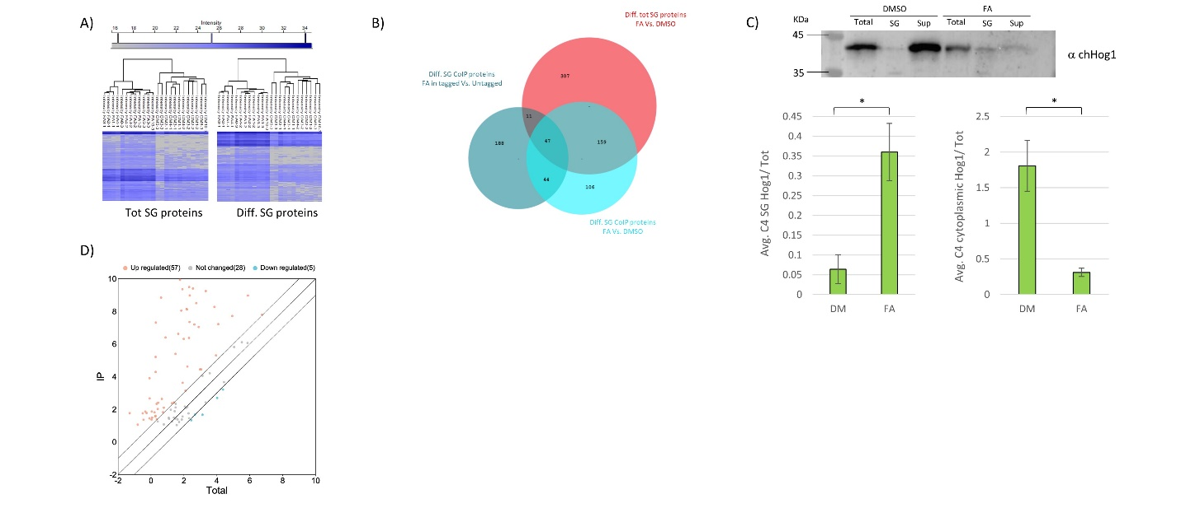
Figure S5.
- Heat map of the total proteins identified in the SG fraction and proteins differentially elevated in the tot SG FA fraction (3 biological repeats,12 technical repeats, p-value < 0.05, log fold change > 1)
- Venn Diagram of differential proteins elevated in the tot SG FA fraction vs Co-IP SG FA fraction from both tagged and untagged Hog1
- WB quantitation of WT Hog1 SG prepared from FA and control samples. * - T test p-value < 0.05
- Scatter plot of Bound Protein in Hog1:GFP Co-IP vs Total SGs fraction. Orange dots indicate mRNAs significantly enriched (fold enrichment >2) in Hog1:GFP Co-IP.

