Supplemental Material for “Unravelling Ultralow Thermal Conductivity in Double Perovskite Cs₂AgBiBr₆: Dominant Wave-like Phonon Tunnelling, Strong Quartic Anharmonicity and Lattice Instability”
Jiongzhi Zheng ^{1,2}, Changpeng Lin ^{3,4}, Chongjia Lin¹, Geoffroy Hautier², Ruiqiang Guo^{5,}, Baoling Huang ^{1,6,7,}
¹Department of Mechanical and Aerospace Engineering, The Hong Kong University of Science and Technology, Clear Water Bay, Kowloon, Hong Kong
²Thayer School of Engineering, Dartmouth College, Hanover, New Hampshire, 03755, USA
³Theory and Simulation of Materials (THEOS), Ecole Polytechnique Federale de Lausanne, CH-1015 Lausanne, Switzerland
⁴National Centre for Computational Design and Discovery of Novel Materials (MARVEL),
Ecole Polytechnique Federale de Lausanne, CH-1015 Lausanne, Switzerland
⁵Thermal Science Research Center, Shandong Institute of Advanced Technology, Jinan, Shandong Province, 250103, China
⁶HKUST Foshan Research Institute for Smart Manufacturing, Hong Kong University of Science and Technology, Clear Water Bay, Kowloon, Hong Kong, China
⁷HKUST Shenzhen-Hong Kong Collaborative Innovation Research Institute, Futian, Shenzhen 518055, China

Contents
I. Atomic participation ratio projected on the phonon dispersions 2
II. Calculated atomic displacement parameters 2
III. Harmonic and anharmonic phonon dispersions and atom-decomposed partial and total phonon density of states 4
IV. Comparison of the experimentally measured and theoretically calculated phonon energies 5
V. Calculated room temperature phonon dispersion in comparison with Raman results 6
VI. Calculated phonon group velocity 6
VII. Comparison of the experimentally measured and theoretically calculated specific heat 6
VIII. Calculated phonon scattering rates with neglecting modes 7
IX. Calculated spectral and cumulative phonon thermal conductivity 7
X. Calculated phonon scattering rates 8
XI. Mode grȕneisen parameters projected onto the phonon dispersions 8
XII. Calculated participation ratio projected onto the phonon bands 9
XIII. Calculated phonon mean free paths 9

- Atomic participation ratio projected on the phonon dispersions
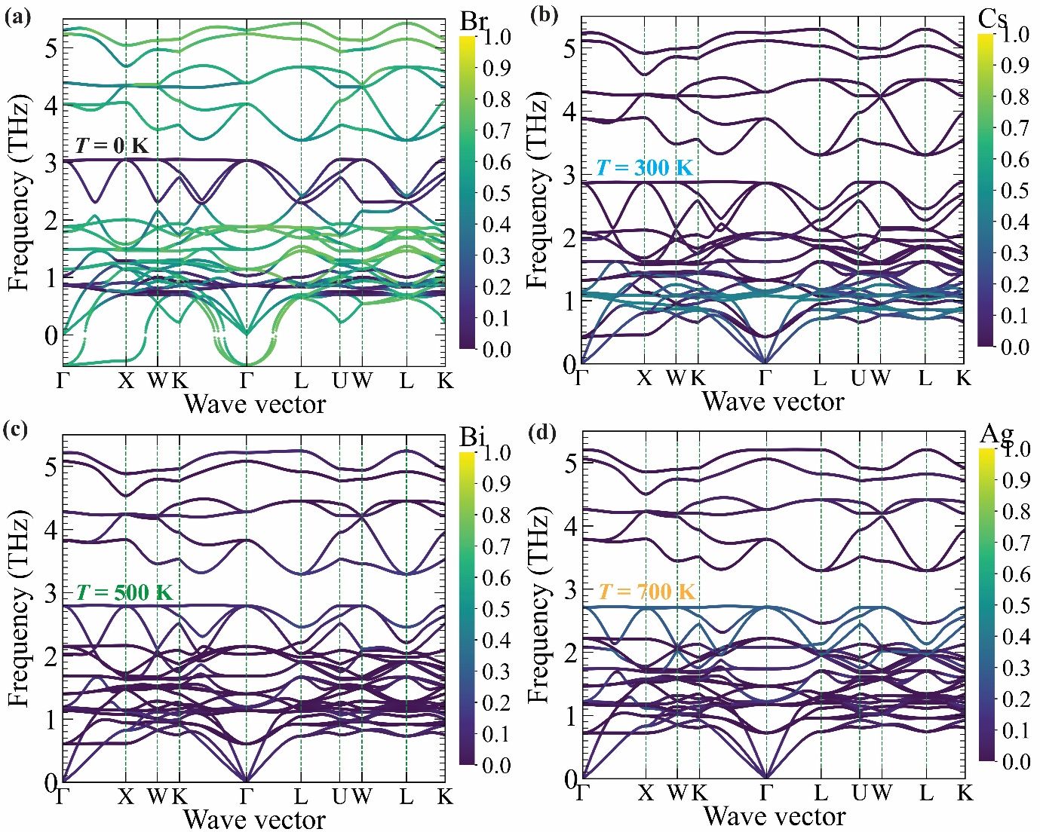
Fig. S1. The color-coded atomic participation ratio (APR) of double perovskite Cs₂AgBiBr₆ projected onto the phonon bands at finite temperatures. (a) Br atom at T = 0 K. (b) Cs atom at T = 300 K. (c) Bi atom at T = 500 K. (d) Ag atom at T = 700 K.

- Calculated atomic displacement parameters
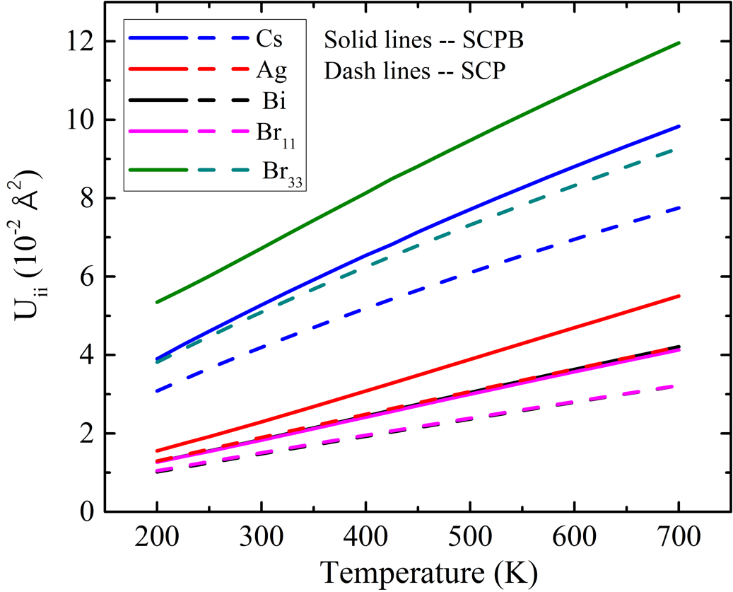
Fig. S2. Comparison of atomic displacement parameters calculated using the SCP and SCPB methods, respectively.

- Harmonic and anharmonic phonon dispersions and atom-decomposed partial and total phonon density of states
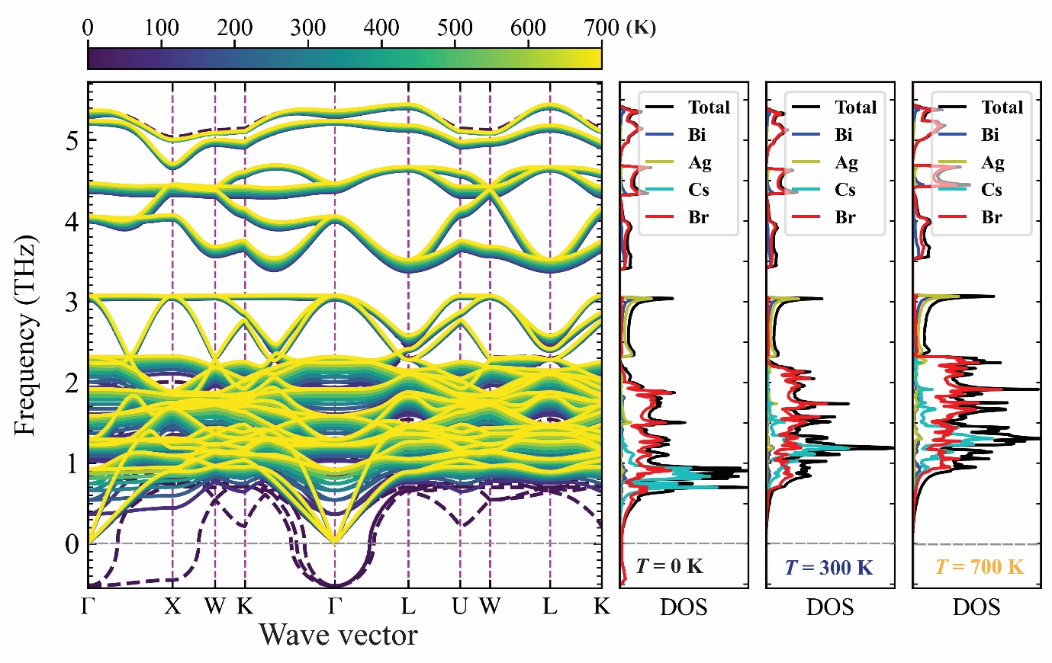
Fig. S3. Calculated harmonic phonon dispersion at T = 0 K in comparison with the anharmonic phonon dispersions calculated at finite temperatures (100 K-700 K). Atom-decomposed partial and total phonon densities of states at T = 0 (HA), 300, and 700 K are shown on the right panel.

- Comparison of the experimentally measured and theoretically calculated phonon energies
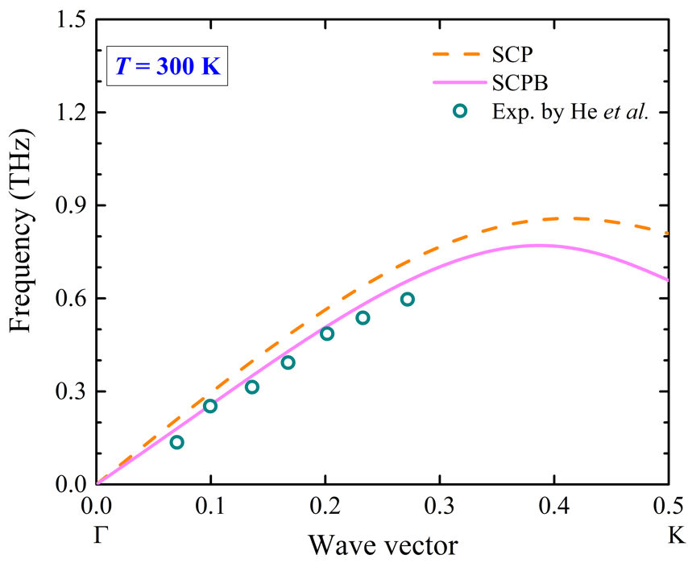
Fig. S4. Calculated room temperature phonon dispersions along the G-K line using SCP and SCPB methods, respectively, compared with experimental data [1].

- Calculated room temperature phonon dispersion in comparison with Raman results
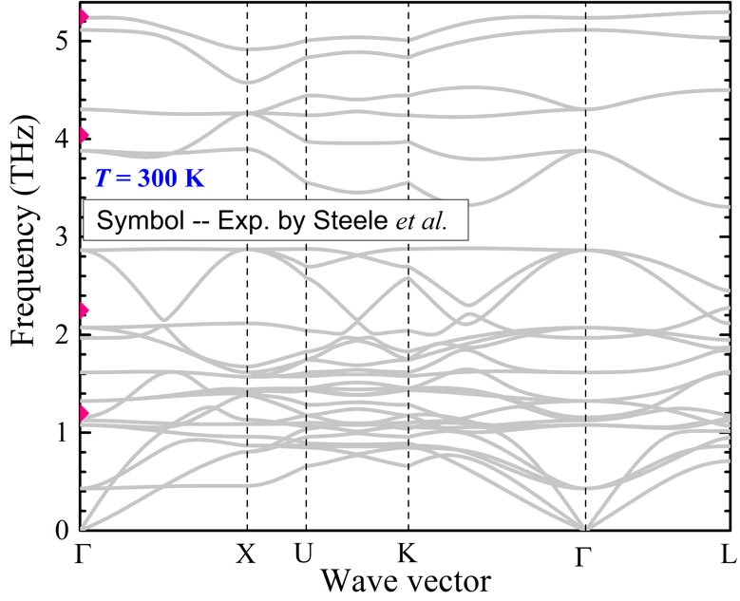
Fig. S5. Phonon dispersions calculated using SCPB approximation in comparison with Raman results [2].

- Calculated phonon group velocity
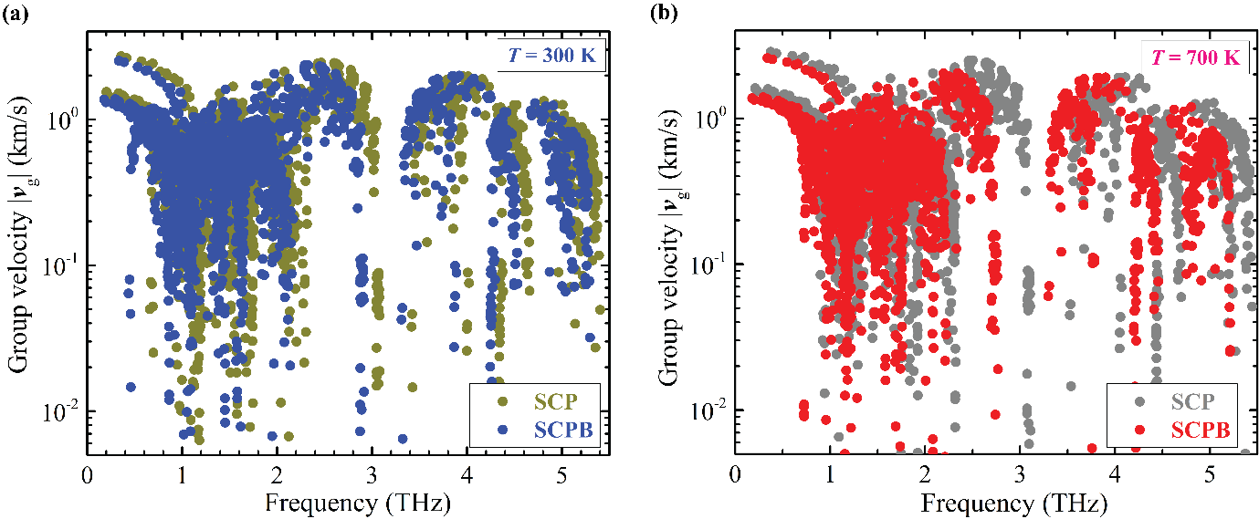
Fig. S6. (a) Comparison of group velocity at T = 300 K calculated using the SCP and SCPB methods, respectively. (b) The same as (a), but T = 700 K.

- Comparison of the experimentally measured and theoretically calculated specific heat
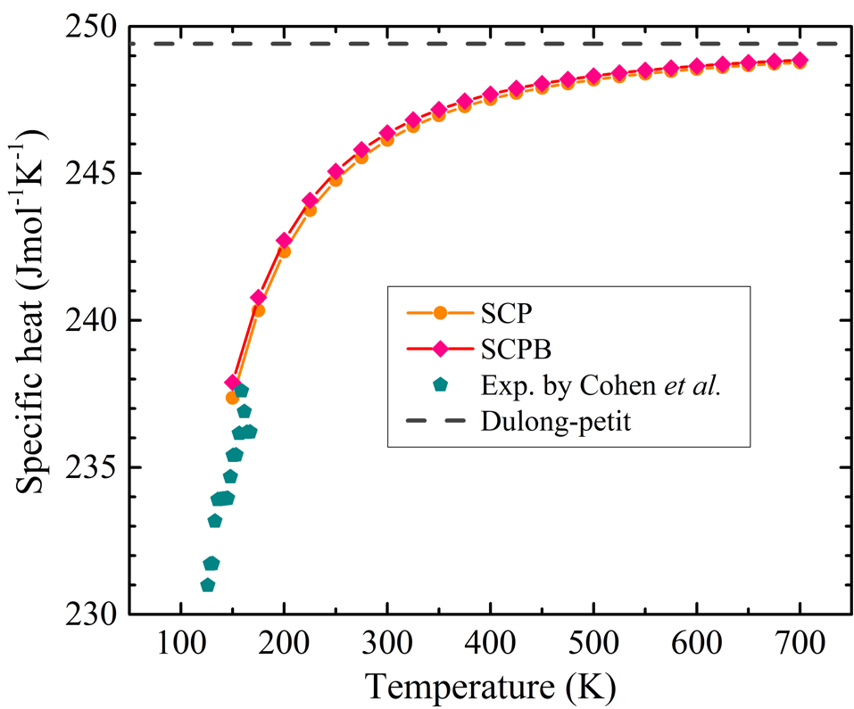
Fig. S7. Calculated temperature-dependent specific heat using SCP and SCPB methods, in comparison with experimental results [3].

- Calculated phonon scattering rates with neglecting modes
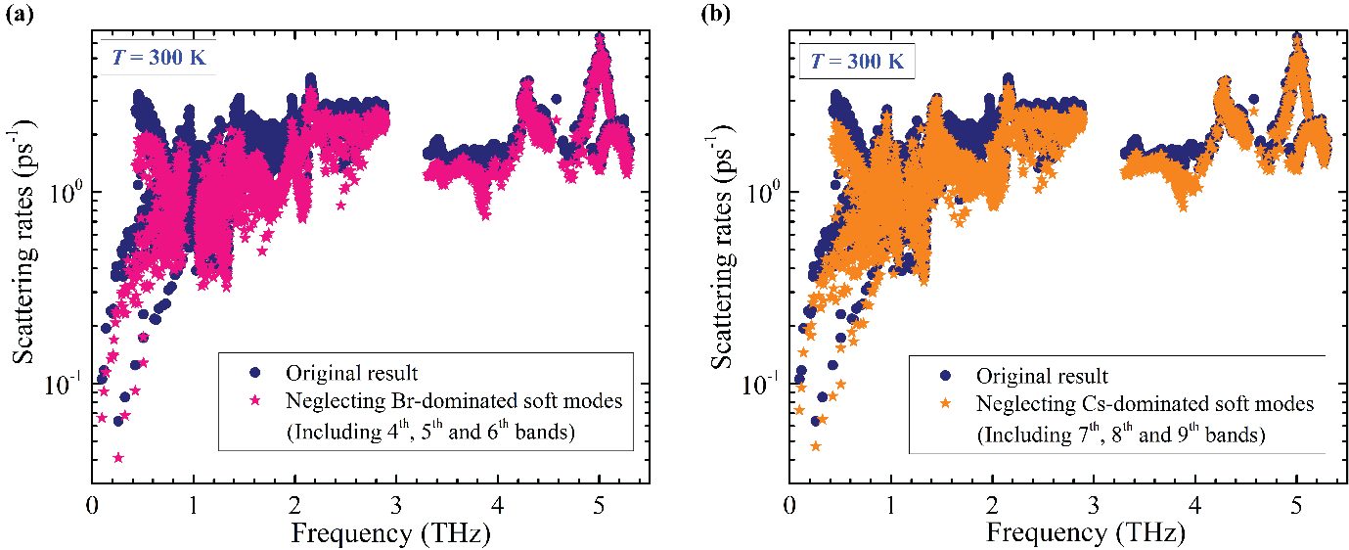

Fig. S8. (a) Comparison of phonon scattering rates at T = 300 K calculated with the original phonon dispersions and those neglecting Br-dominated soft modes (including 4th, 5th, and 6th phonon bands). (b) The same as (a), but with those neglecting Cs-dominated soft modes (including 7th, 8th, and 9th phonon bands).

- Calculated spectral and cumulative phonon thermal conductivity
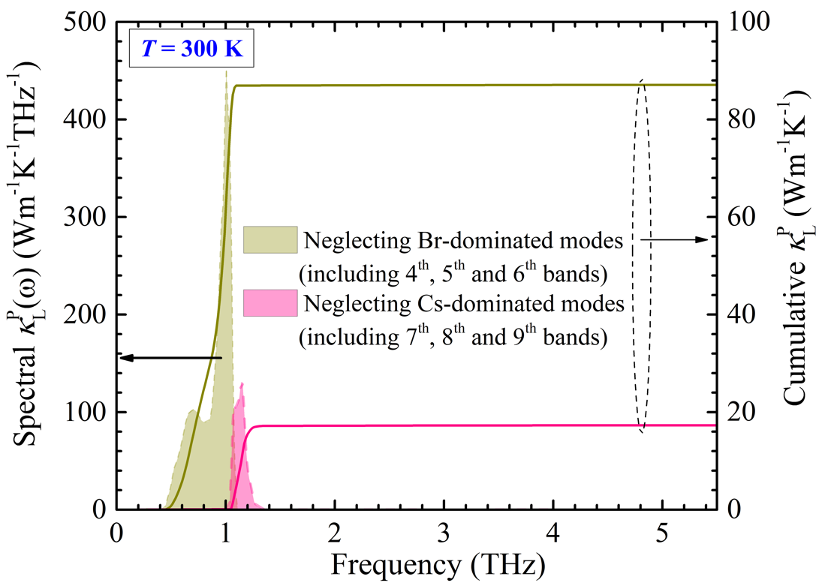
Fig. S9. Comparison of spectral and cumulative thermal conductivity at T = 300 K calculated using phonon dispersions with neglecting Br- or Cs-dominated modes, respectively.

- Calculated phonon scattering rates
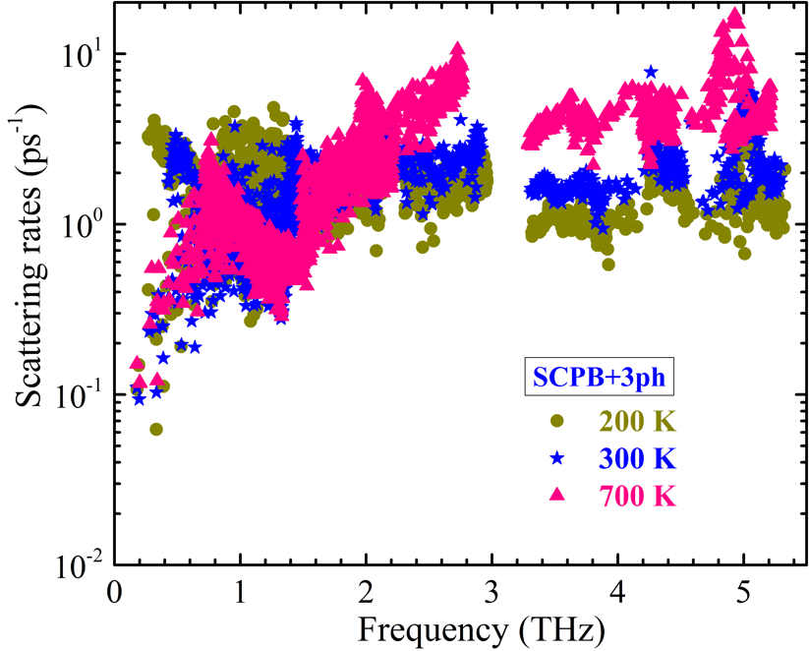
Fig. S10. Comparison of phonon scattering rates calculated using the SCPB+3ph model at T = 200, 300 and 700 K, respectively.

- Mode grȕneisen parameters projected onto the phonon dispersions
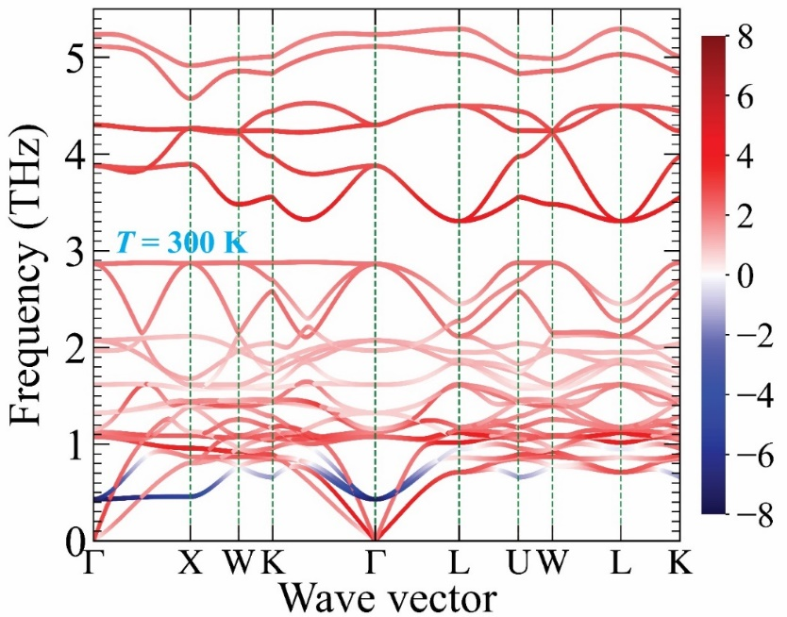
Fig. S11. Calculated mode gruneisen parameter projected onto the phonon dispersions at room temperature.

- Calculated participation ratio projected onto the phonon bands
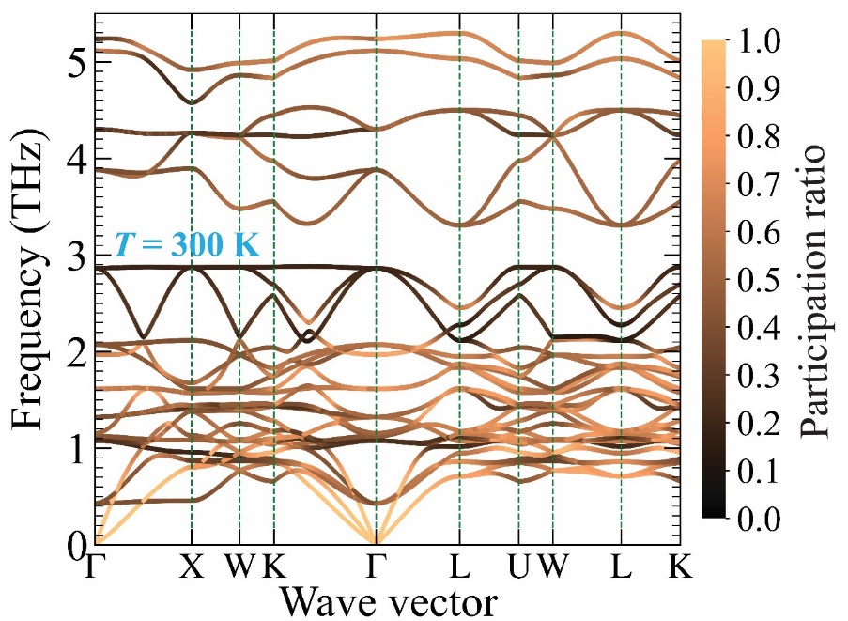
Fig. S12. Calculated participation ratio projected onto the phonon dispersions along high-symmetry paths in the Brillouin zone at room temperature.

- Calculated phonon mean free paths
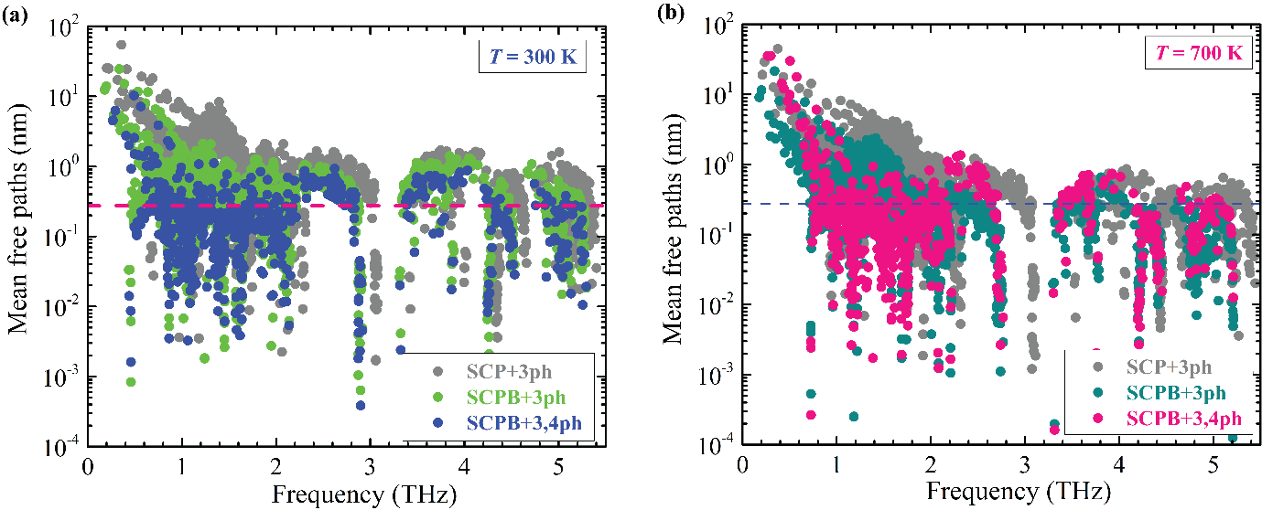
Fig. S13. (a) Comparison of phonon mean free paths at T = 300 K calculated using three different levels of thermal transport theory, i.e., SCP+3ph, SCPB+3ph and SCPB+3,4ph models, respectively. (b) The same as (a), but T = 700 K.

References
[1] X. He, M. Krogstad, M. K. Gupta, T. Lanigan-Atkins, C. Mao, F. Ye, Y. Liu, T. Hong, S. Chi, and H. Wei, arXiv preprint arXiv:2112.04717 (2021).
[2] J. A. Steele, P. Puech, M. Keshavarz, R. Yang, S. Banerjee, E. Debroye, C. W. Kim, H. Yuan, N. H. Heo, and J. Vanacken, ACS nano 12, 8081 (2018).
[3] A. Cohen, T. M. Brenner, J. Klarbring, R. Sharma, D. H. Fabini, R. Korobko, P. K. Nayak, O. Hellman, and O. Yaffe, Adv Mater 34, 2107932 (2022).

ruiqiang.guo@iat.cn
mebhuang@ust.hk

