Supporting Information (SI)

Enhanced efficiency of refractory organic pollutant degradation over a wide pH range by peroxymonosulfate activated by cobalt-doped FeS

Yanting Pan, Feng Zhang, Ziyang Zhou, Feng jiang, Xiaoming Wang, Hui Yin, Wenfeng Tan, Xionghan Feng*

Key Laboratory of Arable Land Conservation (Middle and Lower Reaches of Yangtze River), Ministry of Agriculture and Rural Affairs of the People’s Republic of China, College of Resources and Environment, Huazhong Agricultural University, Wuhan 430070, People’s Republic of China

*Corresponding author:
Xionghan Feng, Tel: +86 27 87280271; fax: +86 27 87288618;
E-mail: fxh73@mail.hzau.edu.cn

Text S1. The details of characterizations.
The phase composition of the catalyst samples was analysed using a Bruker Advanced D8 X-ray diffractometer with Cu-Ka radiation (XRD) in the 2θ range of 5–85° and a scan step size of 10°. The morphology of the as-prepared Co-doped FeS was observed using scanning electron microscopy (FE-SEM) (Hitachi S-4800 with an acceleration voltage of 2–30 kV). The morphology and crystal structure were further analysed using a high-resolution transmission electron microscope (HR-TEM) (FEI TECNAI G2 F20, USA) equipped with an energy dispersive X-ray (EDX) detector system and elemental composition information was obtained. XPS was performed using a photoelectron spectrometer (Thermo Fisher, USA) equipped with a dual X-ray source using Al-Kα and the binding energy of each element was calibrated using the C1s peak (284.8 eV). The Brunauer–Emmett–Teller Specific surface area and pore size distribution were determined by nitrogen adsorption–desorption isotherm measurements at 77 k on a surface area and porosity analyser (Micrometrics, ASAP 2020). The Co content of the synthesised samples was determined through acid dissolution using 1:1 HCl.

Text S2. UPLC-QTOF-MS/MS Analytic methods.
The BPS intermediates were identified by ultra-performance liquid chromatography quadrupole time of flight mass spectrometry (UPLC-QTOF-MS/MS) (Agilent 1290 UPLC/6540 Q-TOF). The details were provided in Supporting Information (Text S1). Chromatography was performed with an Agilent 1290 UPLC liquid Chromatography on a Waters BEH C18 (2.1×50 mm, 1.7 μm), which was maintained at 40 °C. The mobile phase was composed of methanol and ultrapure water containing 0.1% (v/v) formic acid, and gradient elution was performed at a flow rate of 0.4 mL/min. The initial mobile phase composition (5% methanol) was maintained, followed by a linear gradient progressed from 5% to 40% in 3 min, and then 40% methanol, followed by a linear gradient progressed from 40% to 98% from 3 to 15 min and kept for 7 min at 98%. Finally, the mobile methanol, followed by a linear gradient, progressed from 98% to 5% from 22 to 22.1 and was kept for 3 min. The chromatographic method was performed in the negative scan mode, and the mass spectra were recorded across the range of 50–1000 m/z. The mass spectrometry conditions were as follows: curtain gas, 30; ion source gas 1 (psi), 55; ion source gas 2 (psi), 50; collision energy, – 35 ± 15; temperature, 350 °C; and injection volume, 5 µL(Gao et al., 2018b).

Text S3. The effects of reaction parameters on catalytic efficiency
The degradation performance of BPS was discussed by utilising 7% Co-FeS as a Fenton-like catalyst, considering the influence of pH, catalyst concentration, PMS concentration, and temperature.
The catalytic performance of the 7% Co-FeS/PMS system was considerably dependent on the catalyst dosage, as demonstrated in Fig. S12a. Within 30 min, the BPS degradation efficiency increased from 93.3% to 98.1% as the catalyst dosage increased from 0.02 g/L to 0.1 g/L, with the degradation kinetic rate also increasing rapidly. This catalyst dosage increase provided more active sites for PMS activation, resulting in faster BPS degradation(Li et al., 2018). However, when the dosage exceeded 0.1 g/L under the same reaction conditions, increasing the catalyst dosage did not improve the degradation rate, as the high-concentration catalyst provided sufficient or saturated active sites for PMS (1 mM)(Gao et al., 2018a). A catalyst loading of 0.1 g/L was adequate for complete BPS removal. Therefore, a catalyst dosage of 0.1 g/L was selected for subsequent experiments.
In Fig. S12b, the impact of the initial PMS concentration on BPS degradation is demonstrated. The removal rate of BPS increased from 60.0% to 98.1% as PMS concentration increased from 0.2 mM to 1 mM, demonstrating that an increase in PMS concentration promoted BPS degradation. This indicates that a higher PMS concentration would accelerate BPS degradation by generating more reactive species(Wang et al., 2017). However, at 1.5 mM of PMS, there was no significant impact on the BPS degradation (97.4%). For the subsequent experiments, the PMS concentration was optimised as 1.0 mM, considering the balance between cost and degradation performance.
The catalytic degradation of organic contaminants in advanced oxidation processes is highly dependent on the solution pH(Li et al., 2018). To determine the effect of pH on BPS degradation, the study investigated initial pH values ranging from 3 to 11 using optimum experimental parameters (0.1 g/L 7% Co-FeS dosage and 1 mM PMS concentration). The pH change during the reaction was negligible, with a difference of less than 0.05 between the initial and final pH. Fig. S12c indicates that both highly acidic and highly alkaline conditions had adverse effects on BPS degradation, and the optimal initial pH range was between 6 and 9. The 7% Co-FeS/PMS system showed a similar degradation performance of BPS at initial pH values of 6.0, 8.0, and 9.0, with removal percentages of 99.2%, 99.8%, and 99.7%, respectively. However, the removal capacity of BPS declined when the initial pH decreased to 4.0 or increased to 11. Within 30 min, only 10.0% and 36.9% of the BPS were degraded at initial pH values of 3 and 4, respectively. This may be attributed to the high concentration of H⁺, which limited the dissociation of PMS, thus inhibiting the activation of PMS(Wang et al., 2017; Hong et al., 2019). In addition, H₂SO₅ could partially replace HSO₅⁻ and weaken the electrostatic attraction between the catalyst and PMS. Under highly alkaline conditions (pH 11), the degradation rate of BPS was significantly reduced. The abundance of OH⁻ ions in an alkaline environment may deplete SO₄^{•-} (SO₄^{•-} + OH⁻ → SO₄²⁻ + OH•), thereby interrupting the chain reaction and generating other reactive species(Liu et al., 2021; Peng et al., 2021). PMS also undergoes self-decomposition to SO₅²⁻, which is unable to generate SO₄^{•-}(Guo et al., 2021), further hindering the catalytic performance. Notably, the pH_{pzc} of 7% Co-FeS was approximately 6.75 (Fig. S11), and increasing the initial pH would increase the negative surface charge of 7% Co-FeS. Therefore, the negative surface charge on the catalyst surface could inhibit the interaction between HSO₅⁻ and the catalyst, thus not conducive to PMS activation(Li et al., 2020; Ali et al., 2021). Despite the inhibitory effects of highly alkaline conditions, the 7% Co-FeS/PMS system still exhibited a BPS degradation efficiency exceeding 55.7%, indicating its feasibility for a wide range of pH applications.
A series of experiments were conducted to investigate how the reaction temperature affects the degradation of BPS. The temperatures used in the experiments were 10.0, 25.0, 35.0, 45.0 and 55.0 ± 0.2 °C. The degradation rate of BPS was measured at each temperature. As shown in Fig. S12d, the degradation rate of BPS increased with temperature from 20.0 to 50.0 °C, as demonstrated by the increase in degradation rate constants (k) from 0.052 min⁻¹ at 10 °C to 0.281 min⁻¹ at 55 °C. This result suggests that BPS degradation efficiency is enhanced as reaction temperature increases, owing to the production of sulfate radicals being a temperature-driven process(House, 1962). Higher temperatures promoted the generation of sulfate radicals, which favoured the transformation of BPS. However, in practical applications, increasing the wastewater temperature would require more investment and operating costs. Therefore, the 7% Co-FeS/PMS system is a promising method for removing certain organic pollutants from water at ambient temperatures.

Fig. S1. XRD patterns of x% Co-FeS (x=20, 30 and 50, respectively)

Fig. S2. Effect of Phosphate Buffer and Titrator Controlled pH on BPS Degradation. ([BPS] = 20 mg/L, [PMS] = 1.0 mM, [catalyst] = 0.1 g/L, [phosphate buffer] = 50 mM, pH₀ = 6.0, T = 25 ± 2°C)
Fig. S3. FESEM images of (a) FeS, (b) pristine 7% Co-FeS, (c) 7% Co-FeS after reaction, (d) HRTEM images of pristine 7% Co-FeS. STEM image of (e) pristine 7% Co-FeS and (f, g, h) the corresponding elemental (Fe, Co, S) mapping images, (i) EDS analysis of 7% Co-FeS composite.

Fig. S4. Cobalt ions dissolved out after the reaction of different metal sulfides. ([BPS] = 20 mg/L, [PMS] = 1.0 mM, [catalyst] = 0.1 g/L, [phosphate buffer] = 50 mM, pH₀ = 6.0, T = 25 ± 2°C)

Fig. S5. XRD patterns of 7% Co-FeS before and after reaction.

Fig. S6. Effects of the different actual water substrates on BPS degradation. ([BPS] = 20 mg/L, [PMS] = 1.0 mM, [catalyst] = 0.1 g/L, [phosphate buffer] = 50 mM, pH₀ = 6.0, T = 25 ± 2°C). Different water substrates were extracted from South Lake (Class VI), East Lake (Class III), sea water and tap water, respectively.

Fig. S7. Effect of radical scavengers on the degradation of BPS. ([BPS] = 20 mg/L, [PMS] = 1.0 mM, [catalyst] = 0.1 g/L, [phosphate buffer] = 50 mM, pH₀ = 6.0, T = 25 ± 2°C)
Fig. S8. (a) Effect of dissolve oxygen on the degradation of BPS; (b) dissolve oxygen
([BPS] = 20 mg/L, [PMS] = 1.0 mM, [catalyst] = 0.1 g/L, [phosphate buffer] = 50 mM, pH₀ = 6.0, T = 25 ± 2°C)

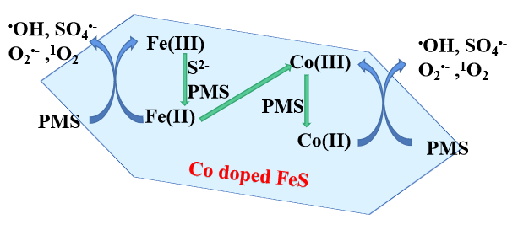
Fig. S9. Proposed mechanism of BPS degradation in the 7% Co-FeS /PMS system.

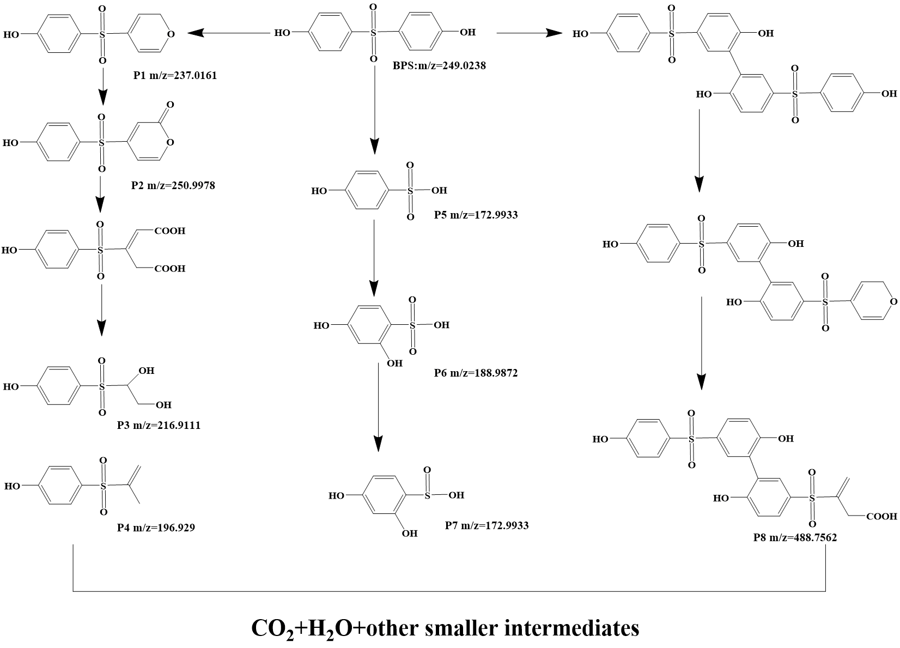
Fig. S10. Possible BPS degradation pathways in the 7% Co-FeS /PMS system.

Fig. S11. pH_{pzc} of 7% Co-FeS by Zeta potential method.

Fig. S12. The influence of different parameters on BPS degradation. (a) catalyst dosage ([BPS] = 20 mg/L, [PMS] = 1.0 mM, [phosphate buffer] = 50 mM, pH₀ = 6.0, T = 25 ± 2°C); (b) PMS concentration ([BPS] = 20 mg/L,[catalyst] = 0.1 g/L, [phosphate buffer] = 50 mM, pH₀ = 6.0, T = 25 ± 2°C); (c) initial pH ([BPS] = 20 mg/L, [catalyst] = 0.1 g/L, [PMS] = 1.0 mM, [phosphate buffer] = 50 mM, T = 25 ± 2°C); (d) temperature ([catalyst] = 0.1 g/L, [BPS] = 20 mg/L, [PMS] = 1.0 mM, [phosphate buffer] = 50 mM, pH₀ = 6.0).

Table S1. Surface properties and chemical composition of synthetic catalysts

Sample | SSA (m2/g) | Pore Volume (cm3/g) | Mackinawite (%) | Pyrrhotite (%) | Initial added (%) | Measured (%)
FeS | 2.65 | 0.0014 | 0 | 100
2% Co-FeS | 8.88 | 0.0058 | 34.96 | 65.04 | 2 | 1.01
5% Co-FeS | 8.55 | 0.0030 | 55.30 | 44.70 | 5 | 4.10
7% Co-FeS | 6.61 | 0.016 | 49.18 | 50.82 | 7 | 6.29
10% Co-FeS | 23.67 | 0.016 | 68.51 | 31.49 | 10 | 10.41
15% Co-FeS | 20.77 | 0.013 | 71.20 | 28.80 | 15 | 16.12
20% Co-FeS | 25.39 | 0.016 | 90.57 | 9.43 | 20 | 21.66
CoS₂ | 20.37 | 0.013

Table S2. The reaction rate constants K and R² fitted by quasi-secondary rate equations in the Co-FeS/PMS system under different experimental conditions.

Experiment |  | K (min⁻¹) | R²
Recycling | 1st | 0.2 | 0.89
Recycling | 2rd | 0.15 | 0.81
Recycling | 3nd | 0.13 | 0.79
Recycling | 4th | 0.12 | 0.78
Recycling | 5th | 0.12 | 0.77
Recycling | 6th | 0.12 | 0.78
Coexisting substances | Control | 0.21±0.00075 | 0.79
Coexisting substances | NaCl 1mM | 0.22±0.00070 | 0.94
Coexisting substances | NaCl 10mM | 0.21±0.0023 | 0.94
Coexisting substances | NaCl 100mM | 0.16±0.0032 | 0.93
Coexisting substances | Na₂CO₃ 1mM | 0.17±0.00035 | 0.93
Coexisting substances | Na₂CO₃ 10mM | 0.15±0.00080 | 0.98
Coexisting substances | Na₂CO₃ 20mM | 0.13±0.00045 | 1
Coexisting substances | Na₂CO₃ 30mM | 0.092±0.0019 | 0.99
Coexisting substances | NaNO₃ 1mM | 0.19±0.0023 | 0.92
Coexisting substances | NaNO₃ 10mM | 0.18±0.0036 | 0.94
Coexisting substances | NaNO₃ 100mM | 0.16±0.0064 | 0.93
Coexisting substances | HA 5mgC/L | 0.18±0.0011 | 0.95
Coexisting substances | HA 10mgC/L | 0.15±0.0018 | 0.94
Coexisting substances | HA 15mgC/L | 0.15±0.0038 | 0.96
Radical scavengers | EtOH 10mM | 0.059±0.000090 | 0.9
Radical scavengers | EtOH 100mM | 0.037±0.000090 | 0.83
Radical scavengers | TBA 10mM | 0.10±0.0013 | 0.95
Radical scavengers | TBA 100mM | 0.092±0.00055 | 0.95
Radical scavengers | NaN₃ | 0.0017±0.00020 | 0.89
Radical scavengers | FFA | 0.0013±0.000050 | 0.66
Radical scavengers | SOD | 0.20±0.0031 | 0.93
Radical scavengers | ρ-BQ | 0.18±0.0040 | 0.77
Dissolve oxygen | N₂ | 0.21±0.00040 | 0.81

Table S3. BPS degradation intermediates identified with UPLC-QTOF-MS/MS.
Name | Formula | m/z | Molecular Structure
BPS | C₁₂H₁₀O₄S | 249.0238 | 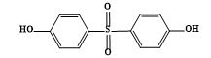
P1 | C₁₁H₁₀O₄S | 237.0161 | 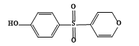
P2 | C₁₁H₈O₅S | 250.9978 | 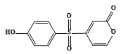
P3 | C₈H₁₀O₅S | 216.9111 | 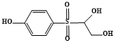
P4 | C₉H₁₀O₃S | 196.929 | 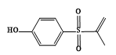
P5 | C₆H₆O₄S | 172.9933 | 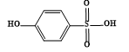
P6 | C₆H₆O₅S | 188.9872 | 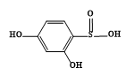
P7 | C₆H₆O₄S | 172.9933 | 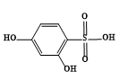
P8 | C₂₂H₁₈O₉S₂ | 488.7562 | 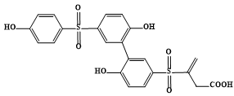

Reference
Ali, J., Shahzad, A., Wang, J., Ifthikar, J., Lei, W., Aregay, G.G., Chen, Z., Chen, Z., 2021. Modulating the redox cycles of homogenous Fe(III)/PMS system through constructing electron rich thiomolybdate centres in confined layered double hydroxides. Chemical Engineering Journal 408, 127242.
Gao, J., Liu, Y., Xia, X., Wang, L., Dong, W., 2018a. Fe_{1-x}Zn_{x}S ternary solid solution as an efficient Fenton-like catalyst for ultrafast degradation of phenol. Journal of Hazardous Materials 353, 393-400.
Gao, Y., Jiang, J., Zhou, Y., Pang, S., Ma, J., Jiang, C., Yang, Y., Huang, Z., Gu, J., Guo, Q., Duan, J., Li, J., 2018b. Chlorination of bisphenol S: Kinetics, products, and effect of humic acid. Water Research 131, 208-217.
Guo, Y., Yan, L., Li, X., Yan, T., Song, W., Hou, T., Tong, C., Mu, J., Xu, M., 2021. Goethite/biochar-activated peroxymonosulfate enhances tetracycline degradation: Inherent roles of radical and non-radical processes. Science of The Total Environment 783, 147102.
Hong, Y., Peng, J., Zhao, X., Yan, Y., Lai, B., Yao, G., 2019. Efficient degradation of atrazine by CoMgAl layered double oxides catalyzed peroxymonosulfate: Optimization, degradation pathways and mechanism. Chemical Engineering Journal 370, 354-363.
House, D.A., 1962. Kinetics and mechanism of oxidation by peroxodisulfate Chemical Reviews 62, 185–203.
Li, J., Xu, M., Yao, G., Lai, B., 2018. Enhancement of the degradation of atrazine through CoFe₂O₄ activated peroxymonosulfate (PMS) process: Kinetic, degradation intermediates, and toxicity evaluation. Chemical Engineering Journal 348, 1012-1024.
Li, S., Huang, J., Li, X., Li, L., 2020. The relation of interface electron transfer and PMS activation by the H-bonding interaction between composite metal and MCM-48 during sulfamethazine ozonation. Chemical Engineering Journal 398, 125529.
Liu, S., Zhang, Z., Huang, F., Liu, Y., Feng, L., Jiang, J., Zhang, L., Qi, F., Liu, C., 2021. Carbonized polyaniline activated peroxymonosulfate (PMS) for phenol degradation: Role of PMS adsorption and singlet oxygen generation. Applied Catalysis B: Environmental 286, 119921.
Peng, Y., Tang, H., Yao, B., Gao, X., Yang, X., Zhou, Y., 2021. Activation of peroxymonosulfate (PMS) by spinel ferrite and their composites in degradation of organic pollutants: A Review. Chemical Engineering Journal 414, 128800.
Wang, Q., Shao, Y., Gao, N., Chu, W., Chen, J., Lu, X., Zhu, Y., An, N., 2017. Activation of peroxymonosulfate by Al₂O₃-based CoFe₂O₄ for the degradation of sulfachloropyridazine sodium: Kinetics and mechanism. Separation and Purification Technology 189, 176-185.

