Supplementary Material

Wolbachia improves the performance of an invasive fly after a diet shift
Gwenaëlle Deconninck^{1,*}, Jordy Larges¹, Hélène Henri², Laureen Beaugeard¹, Vincent Foray¹, Sylvain Pincebourde¹

¹ UMR CNRS 7261 Institut de Recherche sur la Biologie de l’Insecte, Université de Tours, Parc Grandmont, 37200 Tours, France
² UMR CNRS 5558 Laboratoire de Biométrie et Biologie Évolutive, Université de Lyon 1, 43 boulevard 11 novembre, 69622 Villeurbane Cedex, France

* Corresponding author: gwen.02100@hotmail.fr

ORCID of the authors:
  - Gwenaëlle Deconninck : 0000-0003-2002-0992
  - Vincent Foray : 0000-0002-1561-1934
  - Laureen Beaugeard : 0000-0002-3696-734X
  - Sylvain Pincebourde : 0000-0001-7964-5861

Characterization method of the bacterial and fungi communities of Wolbachia-uninfected D. suzukii flies before and after microbiota restoration with Wolbachia-infected fly’s faeces

Material and Methods

To restore W– flies’ microbiota, we followed the method by Strunov et al. (2022). Briefly, 15 W+ males were transferred in bottles containing fresh standard cornmeal medium to let them contaminate the medium with their faeces. Males were removed after 3 days and about 20 W– flies were transferred into each ‘faeces contaminated’ vial. After 5 days of egg laying, flies were removed. Emerged F1 W– flies were transferred into a new ‘faeces contaminated vial’. These operations were repeated until F3 W– flies emerged. The microbiota was then considered restored.
To compare W– D. suzukii flies before and after the restoration of their microbiota with the faeces of W+ flies, six females from each treatment were placed in ethanol to eliminate their cuticular microbiota. Each female was then placed individually in 2 ml tubes with a 5 mm stainless steel bead. The tubes were left at –80°C for 15 min and then grinded in a tissue-lyzer (Retsch) at 20 Hz for 2 min. DNA from each sample was then extracted using Zymobiomics Magbead DNA Kit (Zymo). In each tube, 550 µL of lysis buffer was added and mixed well. This buffer was then transferred to the tubes provided in the kit containing the ZR Bashing Beads and vortexed for 40 minutes.
The sequencing library was prepared according to Illumina 16S Metagenomic Sequencing Library guidelines (‘16S Metagenomic Sequencing Library Preparation’, n°15044223 Rev.B) but using Invitrogen's Platinum II Hotstart PCR Mastermix. ﻿16S rRNA gene was amplified with 16S V3-V4 gene primers 341F (5′-TCG TCG GCA GCG TCA GAT GTG TAT AAG AGA CAG CCT ACG GGN GGC WGC AG-3′) and 805R (5′-TCT CGT GGG CTC GGA GAT GTG TAT AAG AGA CAG GAC TAC HVG GGT ATC TAA TCC-3′) for bacteria, ﻿as previously described (Klindworth et al. 2013); and with ITS3-ITS4 primers 3F (5′-TCG TCG GCA GCG TCA GAT GTG TAT AAG AGA CAG GCA TCG ATG AAG AAC GCA GC-3′) and 4R (5′-GTC TCG TGG GCT CGG AGA TGT GTA TAA GAG ACA GTC CTC CGC TTA TTG ATA TGC-3′) for fungi, as previously described (White et al. 1990). Primers were synthesized with overhang adapters (in italics) for index attachment and Illumina sequencing adapters. For each sample, consisting of one individual, triplicates were performed consisting of three PCR reactions containing 200nM of each primer, 12.5 µL Invitrogen Platinum II Hotstart PCR masterMix and 2µL of DNA template for 16S amplification or 4µL for ITS2 amplification, resulting in a final volume of 25 µL. Reaction conditions were 94°C for 2 min followed by 35 cycles of 98°C for 5 sec and 55°C for 15 sec. A negative PCR control was performed under the same conditions, except the addition of DNA. Each amplification product was checked on agarose gel to verify that only specific amplification was present. All replicates were then pooled by sample before purification. The second amplification step, adding multiplexing indices and Illumina sequencing adapters, was performed by Microsynth AG (Switzerland), as well as PE sequencing of the library on Illumina NovaSeq instrument for 500 cycles (2 x 250 bp). FASTQ sequencing data were taxonomically assigned by Microsynth AG using RDP and unite databases.

Results

16S gene bacterial sequences
Between 91,464 and 177,598 raw reads were obtained per sample (mean ± sd: 128,509 ± 28,994). After filtering and trimming, the final number of merged pairs per sample ranged from 35,393 to 107,118 (mean ± sd: 73,670 ± 22,769). Taxonomic identification at the genus level was retained, as taxonomic assignment at the species level is unreliable (see details in the "16SOTUs_unfiltered" tab of the « sup_file1.xlsx » file). The vast majority of sequences belong to the genus Acetobacter (between 89.7 and 100% per sample, see details in tab « 16Sfiltered_Aggregated_taxonomy » of the file « sup_file1.xlsx »). Several alpha diversity indices were calculated (see details in the "16Salpha" tab of the « sup_file1.xlsx » file) and showed no significant difference between individuals with restored microbiota versus W– flies that were not exposed to faeces of W+ flies (Wilcoxon tests, p = 0.96).

ITS2 fungi sequences
Between 62,296 and 156,170 raw reads were obtained per sample (mean ± sd: 96,297 ± 25,853). After filtering and trimming, the final number of merged pairs per sample ranged from 8,768 to 65,740 (mean ± sd: 23,270 ± 14,415). One sample, designated B7E, with an excessively low number of reads (2,035) was excluded from the dataset. In all samples, the majority of sequences belonged to the genus Saccharomyces, ranging from 27.8 to 99.5%. Note that sample B5E, with the lowest proportion of Saccharomyces sequences, is also the sample with the highest proportion (21.3%) of unassigned sequences (see details in tab « 16Sfiltered_Aggregated_taxonomy » of the file « sup_file1.xlsx »). A second genus, Wallemia, was present in all but one sample (D7E). Its frequency was much lower, ranging from 1.6 to 30.6%. No significant differences were found between the two groups, with or without the microbiota restoration treatment (Wilcoxon tests, p = 0.12).

Bibliography

Klindworth A, Pruesse E, Schweer T, et al. (2013) Evaluation of general 16S ribosomal RNA gene PCR primers for classical and next-generation sequencing-based diversity studies. Nucleic Acid Res 41(1):e1. https://doi.org/10.1093/nar/gks808
White TJ, Bruns T, Lee S, Taylor J (1990) Amplification and direct sequencing of fungal ribosomal RNA Genes for phylogenetics. In: PCR Protocols, a Guide to Methods and Applications. pp 315–322

File S1: Data about the bacterial and fungi communities of Wolbachia-uninfected D. suzukii flies before and after microbiota restoration with Wolbachia-infected fly’s faeces

Sup Mat S2 contains six tabs:
16SOTUs_unfiltered: Unfiltered OTU table with raw reads number per sample per OTU, taxonomic assignment, confidence index in assignment by rank and FASTA sequences
16S_alpha: Alpha diversity indices calculated for each sample
16Sfiltered_Aggregated_taxonomy: Aggregate relative abundance by genus
ITSOTUs_unfiltered: unfiltered OTU table with raw reads number per sample per OTU, taxonomic assignment, confidence index in assignment by rank and fasta sequences
ITS_alpha: alpha diversity indices calculated for each sample
ITSfiltered_Aggregated_taxonomy: Aggregate relative abundance by genus

Table S1 Amino acid and micronutrient analyses of the two diets. Analyses carried out by Eurofins©

Quantity per 100 g | Corn diet | Grape diet | Unit
Amino acids
Alanine | 77.3 | 79.7 | mg
Arginine | 66.4 | 50.5 | mg
Aspartic acid | 88.1 | 85.0 | mg
Cystéine + Cystine | < 6 | < 6 | mg
Glutamic acid | 143.0 | 132.0 | mg
Glycine | 42.9 | 43.3 | mg
Histidine | 21.5 | 24.5 | mg
Hydroxyproline | < 200 | < 200 | mg
Isoleucine | 41.0 | 39.4 | mg
Leucine | 85.7 | 71.6 | mg
Lysine | 54.8 | 59.0 | mg
Methionine | < 24 | < 24 | mg
Ornithine | < 50 | < 50 | mg
Phénylalanine | 46.7 | 45.2 | mg
Proline | 53.7 | 43.4 | mg
Serine | 51.3 | 48.5 | mg
Threonine | 39.9 | 39.5 | mg
Tryptophan | 10.4 | 10.2 | mg
Tyrosine | 40.2 | 28.6 | mg
Valine | 51.9 | 52.1 | mg
Water-soluble vitamins
B1 vitamin - thiamine | 28.0 | 30.0 | µg
B2 vitamin - riboflavin | 33.2 | 23.0 | µg
B6 vitamin - pyridoxine | 35.8 | 34.0 | µg
B9 vitamin - folates, folic acid | 18.8 | 17.1 | µg
Trace elements
Iron - Fe | 390.0 | 360.0 | µg

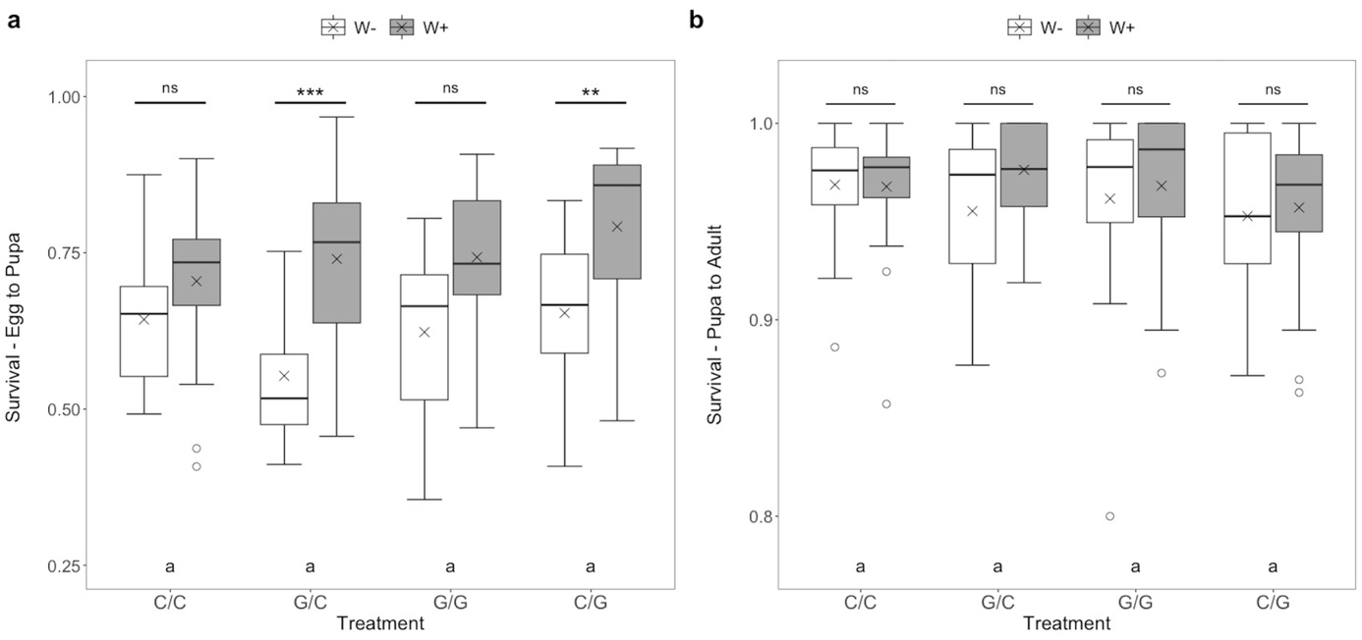

Fig. S1 Influence of diet treatment and Wolbachia infectious status (W+ or W-) on Drosophila suzukii survival with (A) Egg to pupa, and (B) Pupa to adult survival. The treatments are the same as in Fig 1. Analysis of variance (ANOVA) was performed after square root transformation. Statistically significant differences are represented either by different letters or by stars (**: p < 0.01, ***: p < 0.001; ns: non-significant)

Table S2 Summary of results for generalized linear models for egg-to-pupa and pupa-to-adult survival. Df = degree of freedom; Dev. = deviance; P > |ꭓ²| = P-value

 | Survival  Egg to pupa |  |  |  | Survival  Pupa to Adult
Effect | Df | Dev. | P > |ꭓ²| |  | Df | Dev. | P > |ꭓ²|
Wolbachia (Wol) | 1 | 0.546 | <0.0001 |  | 1 | 0.022 | 0.177
Laying diet (LD) | 1 | 0.051 | 0.054 |  | 1 | 0.011 | 0.335
Diet shift (S) | 1 | 0.012 | 0.343 |  | 1 | 0.004 | 0.540
Wol × LD | 1 | 0.003 | 0.631 |  | 1 | 0.005 | 0.524
Wol × S | 1 | 0.049 | 0.061 |  | 1 | 0.004 | 0.581
LD × S | 1 | 0.031 | 0.132 |  | 1 | 0.029 | 0.122
Wol × LD × S | 1 | 0.016 | 0.280 |  | 1 | 0.017 | 0.232

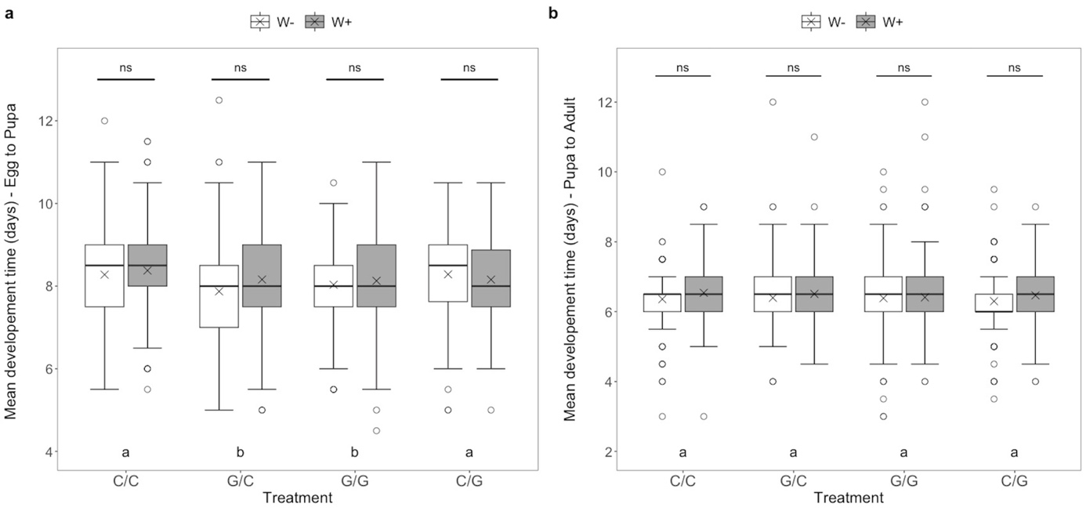
Fig. S2 Influence of diet treatment and Wolbachia infectious status (W+ or W-) on Drosophila suzukii mean development time in days with (A) Egg to pupa, and (B) Pupa to adult mean development time. The treatments are the same as in Fig. 1. Analysis of variance (ANOVA) was performed after square root transformation. Statistically significant differences are represented either by different letters or by stars (ns: non-significant)

Table S3 Summary of results for generalized linear models for egg-to-pupa and pupa-to-adult development time. Df = degree of freedom; Dev. = deviance; P > |ꭓ²| = P-value

 | Development time  Egg to pupa |  |  |  | Development time  Pupa to Adult
Effect | Df | Dev. | P > |ꭓ²| |  | Df | Dev. | P > |ꭓ²|
Wolbachia (Wol) | 1 | 2.1 | 0.151 |  | 1 | 7.6 | 0.0004
Laying diet (LD) | 1 | 1.0 | 0.324 |  | 1 | 1.8 | 0.088
Diet shift (S) | 1 | 1.6 | 0.209 |  | 1 | 0.0 | 0.844
Wol × LD | 1 | 3.8 | 0.052 |  | 1 | 0.4 | 0.447
Wol × S | 1 | 0.5 | 0.483 |  | 1 | 0.3 | 0.477
LD × S | 1 | 23.5 | <0.0001 |  | 1 | 0.0 | 0.900
Wol × LD × S | 1 | 5.2 | 0.024 |  | 1 | 1.4 | 0.130

