A novelty of the influence of impedance property on graphite filled hybrid epoxy composites in antibacterial and antifouling performance in the marine environment.
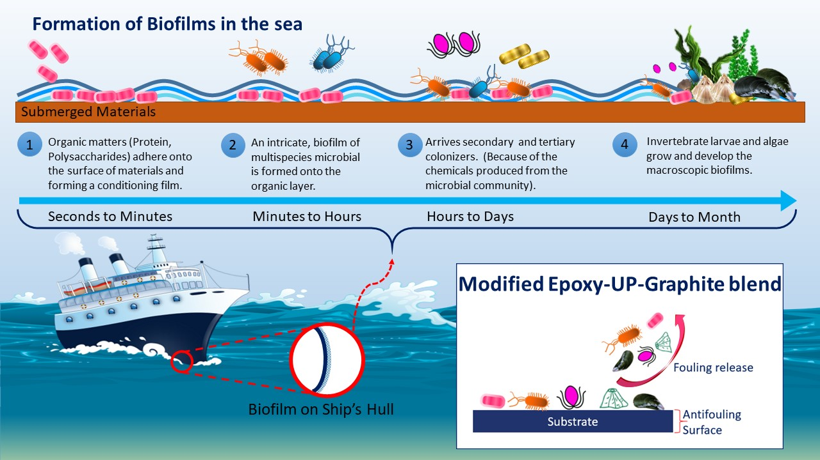

Highlights:
- We created novel graphite incorporated with UP hardened epoxy polymer composites for the obstruction of marine biofouling. The epoxy composite mix easily crosslinks with graphite and exhibits exceptional biofouling performance in a continual marine environment.
- The electrical conductivity of this graphite incorporated epoxy mix is also a reason to show a better performance.
- Finding in this work assigned a harmless to the ecosystem against biofouling material, offering another answer for the issue initiated by biofouling in maritime navigation.

