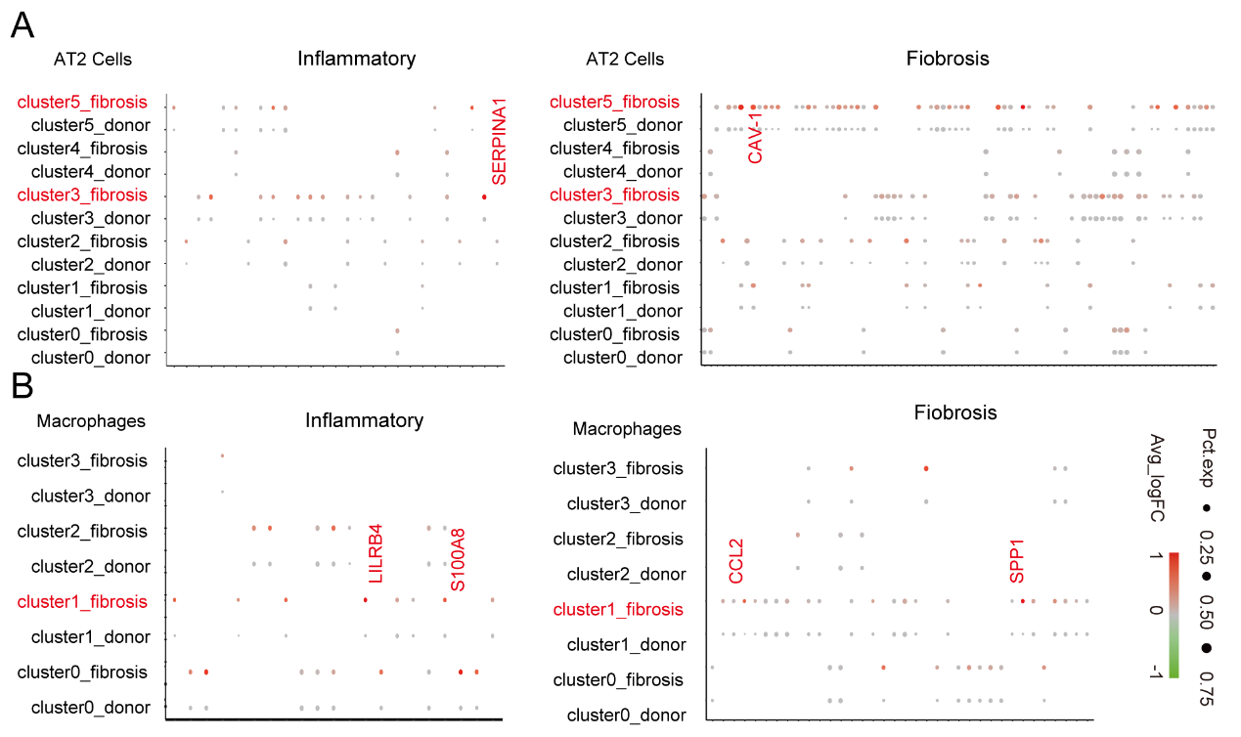
Fig.S1 During fibrosis, different populations of alveolar epithelial cells and alveolar macrophages emerged(A). Expression levels of inflammation- and fibrosis-related genes in 6 clusters of AT2 cells emerged during fibrosis(B).Expression levels of inflammation- and fibrosis-related genes in 4 clusters of AMS cells emerged during fibrosis, separated by donor or pulmonary fibrosis origin.Dot size corresponds to the percentage of cells in the cluster expressing a gene, and dot color corresponds to the average expression level for the gene in the cluster.

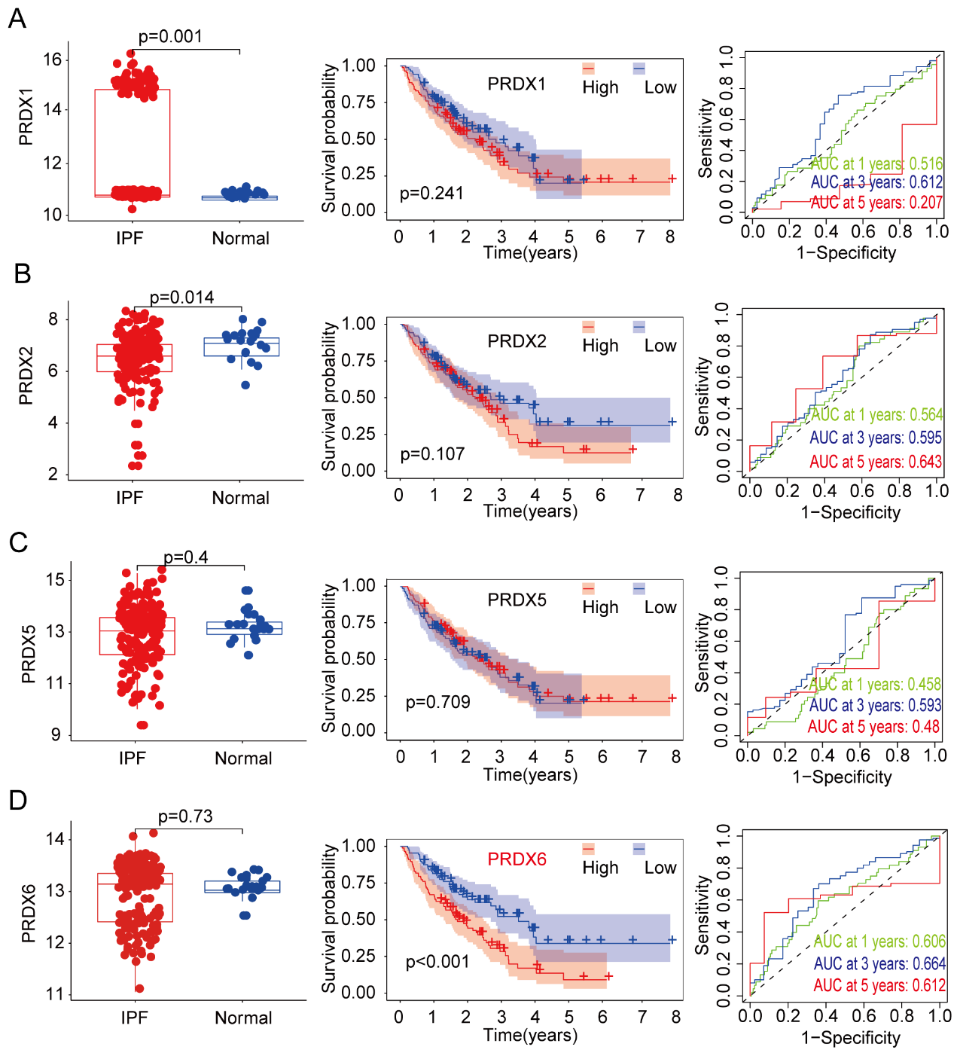
Fig.S2 Expression and prognostic analysis of PRDXs in the BALF of IPF (A).Expression, prognosis, and efficacy analysis of PRDX1 in the BALF of IPF patients(B).Expression, prognosis, and efficacy analysis of PRDX2 in the BALF of IPF patients(C).Expression, prognosis, and efficacy analysis of PRDX5 in the BALF of IPF patients(D).Expression, prognosis, and efficacy analysis of PRDX6 in the BALF of IPF patients.
*, P<0.05; **, P<0.01; ***, P<0.001; ns, not significant.

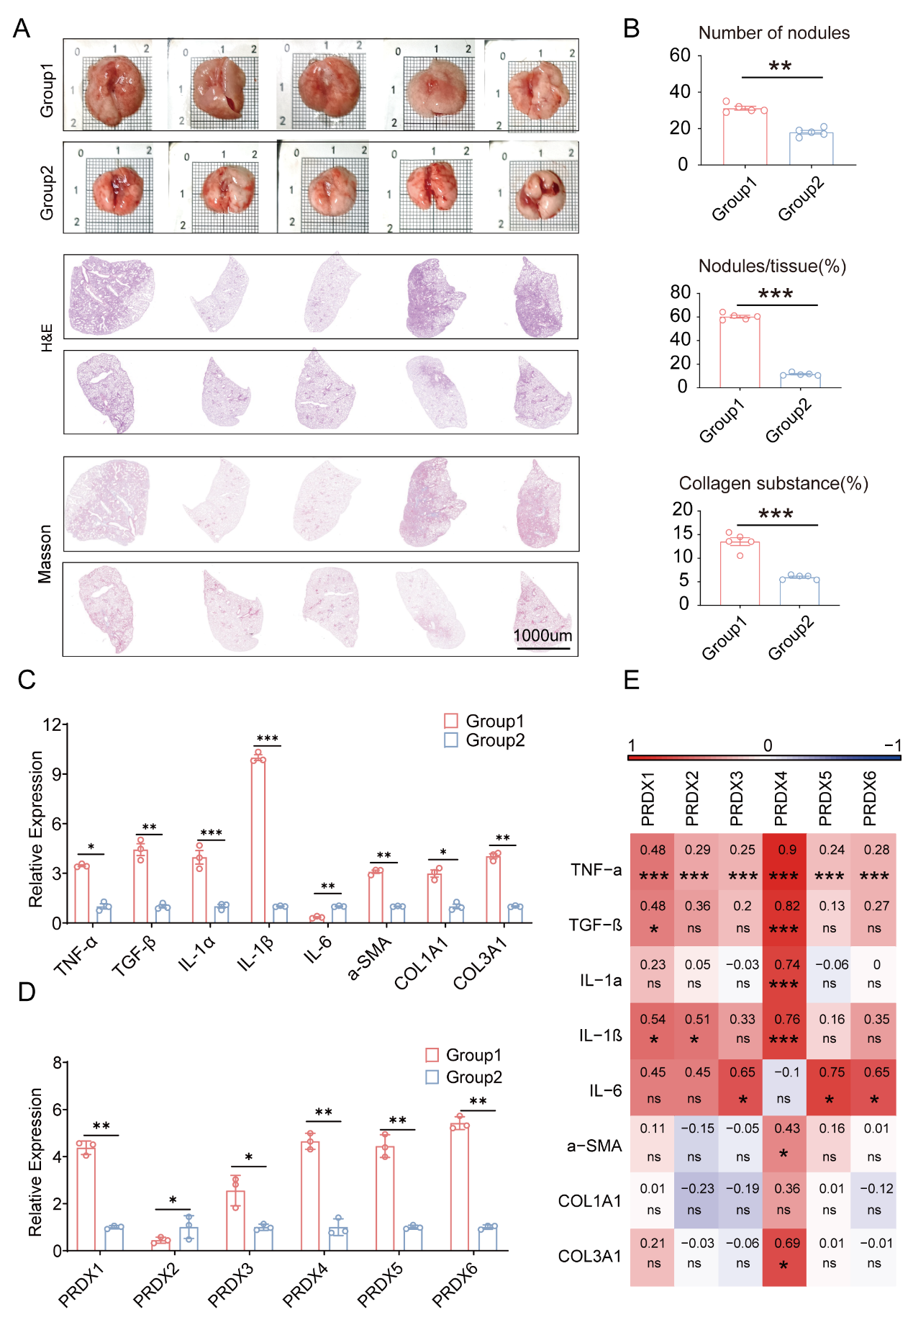
Fig.S3 Lung Tissue Pathology and Analysis(A).Images of fresh lung tissue and H&E and Masson staining analysis in the two groups of mice(B).Bar graphs showing the number of silica nodules in mouse lung tissue, the percentage of nodules relative to the total area, and quantification of collagen content (each point represents one mouse)(C,D).Gene expression profiles of inflammation, fibrosis, and PRDXs in mouse lung tissue (triplicate experiments per group)(E).Correlation analysis of PRDXs expression with inflammation and fibrosis-related gene expression in mouse lung tissue, with color and intensity representing the magnitude of correlation (red indicating positive correlation, blue indicating negative correlation, and values indicating the Pearson correlation coefficient).
*, P<0.05; **, P<0.01; ***, P<0.001; ns, not significant.

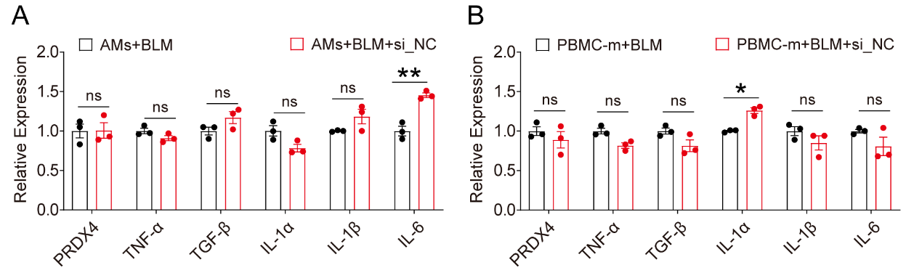
Fig.S4 Affects of si_NC on the Expression of Inflammatory Factors in AMS and PBMC cells(A).Effects of si_NC on the expression of inflammatory factors in BLM-treated AMS cells (triplicate experiments per group)(B).Effects of si_NC on the expression of inflammatory factors in BLM-treated PBMC-m cells (triplicate experiments per group).

